Supplementary Information for
Calcium carbonate instability and graphite formation in shallow subduction zones
by Shen et al.

SUPPLEMENTARY MATERIALS
Methods
Supplementary Figures S1 to S10
Supplementary Table S1
Supplementary References S1 to S27

METHODS
Sample preparation and characterization. The starting material was CaCO₃ powder with a purity of 99.95 % and particle size of less than 10 µm from Alfa Aesar company. It was analyzed using Raman spectroscopy, and the calcite spectrum was in good agreement with previous studies¹. The CaCO₃ powder was sintered in a muffle furnace at 400 ˚C for 24 h to remove moisture contamination and then kept in a drying oven at 120 ˚C before high-pressure experiments.

Large volume press (LVP) experiments. All high-pressure experiments were conducted using the cubic-anvil high-pressure apparatus installed in the Center for High Pressure and Technology Advanced Research (HPSTAR). The pressure calibrations were performed using bismuth and quartz^{2,3}. The sample assembly for the high-pressure experiments was shown in Figure S1. A pyrophyllite cube with a side length of 38.5 mm and a center hole diameter of 20.0 mm was used as a pressure-transmitting medium. An MgO tube with a center hole diameter of 12.0 mm in the middle was placed inside the pyrophyllite cube, and next to the MgO tube was the heater. A nickel foil was used as the furnace under Re-ReO₂ (RRO) and Ni-NiO (NNO) buffered conditions, and graphite was used as the heater under the C-CO₂ (CCO) buffered conditions. Another MgO tube was placed between the furnace and the capsule, serving as the insulation. MgO tubes were sintered at 1100 ˚C for an overall duration of 10 hours to remove moisture and organic matter, and thus the influence of impurities on carbonate reduction was eliminated. The welded capsule was placed in the MgO tube. All the materials were kept in the drying oven at 120 ˚C to avoid water absorption before sample assembly. A K-type thermocouple (NiCr-NiAl) was put in a four-hole alumina ceramic tube and placed against the center of the capsule to measure the temperature. The fluctuation was usually within ±5 ˚C in each run. Experiments were performed at 1.2-3.0 GPa and 230-1200 ˚C with durations of 1-40 hours and a summary of the experimental conditions is given in Table S1. During experiments, it usually took 120 s to raise the pressure to the target value at room temperature, and then the current was switched on. Temperature was raised to the target temperature by increasing the power within 3 min. At the end of some experiments, the sample was quenched by switching off the power, and the temperatures of the others were gradually decreased by reducing the power in 5 min while the pressure was maintained. The pressure was then released in 10 min at room temperature. Recovered capsules were cut by a diamond wire saw for further analyses on the run products.
Oxygen fugacity in the experiments was controlled by the conventionally-adopted solid-state oxygen buffer pairs, including RRO, NNO and CCO from highly oxidizing to relatively reducing conditions. The fO₂ range was from ~ 1-2 log units below FMQ to 2-3 log units above FMQ. We used two different assembly methods to verify the reliability of the results (Figure S1). In RRO buffered experiments, the Pt tube (OD 3.8 mm, ID 3.4 mm, and the length 5.0 mm) was prepared as a welded outer capsule. The platinum tubes were burned at 1000 ˚C in a muffle furnace for 24 hours and then cleaned using ultrasonic for 1 hour to remove impurities. We examined the permeability of the welded Pt tube by putting CaCO₃ powder into a Pt tube, and then the welded Pt tube was sintered at 800 ˚C for 8 hours in a muffle furnace with the heating rate of 5 ˚C/min, where CaCO₃ would decompose into CaO and CO₂. The weights of the welded Pt tube were recorded prior to and after heating and no weight loss was observed, indicating that the Pt tube was well sealed.
According to previous studies, MgO cannot react with CaCO₃. CaCO₃ + MgO is more stable than MgCO₃ + CaO under the experimental P-T conditions in our study⁴. Therefore, we chose MgO as capsules, isolating the sample from the buffers while ensuring the flow of oxygen. We analyzed the boundary between the CaCO₃ sample and MgO capsule after experiments and found that the boundary was clear and no evident chemical reaction was observed (Figure S10). Therefore, an MgO tube with a bottom and a cap (OD ~ 3.3 mm, ID ~ 1.6 mm, and the length ~ 2.0 mm) was used as an inner capsule to prevent reactions between the CaCO₃ samples and the surrounding buffers. The CaCO₃ sample tablet with a diameter of 1.5 mm and length of 1.5 mm was placed in the MgO tube. Then. rhenium and rhenium dioxide powder for RRO buffer (mass ratio=1:1) was filled in all the gaps to maintain the RRO oxygen fugacity conditions. In the NNO buffered experiments, we used two methods to control oxygen fugacity to ensure our experimental results were robust. The first one employed the same assembly as in the RRO buffered experiments (Run #701). The second method used the welded Ni tube (OD 6.0 mm, ID 5.0 mm, and the length 6 mm) as the outer capsules, and the MgO (OD 3.0 mm, ID 1.5 mm, and length 2.5 mm) was used as an inner capsule. Pure NiO powder was filled in the gap (~ 50 vol.%) to control the ƒO₂. Similar experimental assemblies have been quantitatively studied by Rubie et al.⁵ for controlling oxygen fugacity, and the effectiveness has been demonstrated in detail^{5,6}. Results were the same from the use of the two different assembly configurations. In addition, in the CCO buffered experiments, the graphite heater was used to control ƒO₂, and MgO (OD 10.0 mm, ID 4.0 mm, and the length 16.0 mm) was used as an insulation and capsule.

Laser Raman spectroscopic measurements. Raman spectra were collected using a Renishaw Rm1000 Raman microscope equipped with a 250 mm spectrometer focal length. The Raman signal was excited using the 532 nm wavelength of an Ar⁺ laser, delivering a maximum power of 20 mW focused onto an ~ 2 µm spot by a Nikon L Plan EPI 20X, 0.35 objective. The spectral resolution was about 2 cm⁻¹ with a holographic diffraction grating of 1200/1800 lines/mm. From Raman spectra, we confirmed graphite and Ca(OH)₂ in some run products (Figure S4). CaO does not possess Raman-active modes⁷ and due to the reaction of CaO with water during the cutting and polishing of the recovered samples, Ca(OH)₂ was detected instead. Raman peaks attributed to calcite were detected at 146, 274, 705, 1082, 1436, and 1750 cm⁻¹. Raman peaks attributed to aragonite were detected at 141, 169, 200, 700, 1081, 1460, and 1574 cm⁻¹ (ref. 8). Raman peaks attributed to graphite/amorphous carbon were detected at ~ 1340 cm⁻¹ (D-band) and ~ 1600 cm⁻¹ (G-band)⁸. Raman peaks attributed to Ca(OH)₂ were detected at 3607 and 3640 cm⁻¹, consistent with the Raman peaks of Ca(OH)₂ formed by the reaction of CaO with water⁷. Under RRO buffered conditions, no graphite was observed. Under NNO and CCO buffered conditions, we observed evident graphite and Ca(OH)₂ with CaCO₃ in aragonite phase. But no graphite was found from CaCO₃ in calcite phase (e.g. Run #419 and #520-2). Additionally, the graphitization fractions of Run # 424, #809, #812, and #513 were derived from the ratio of Raman peak intensity between graphite at ~ 1600 cm⁻¹ and aragonite at ~ 1460 cm⁻¹, which has been normalized to Run #513 (3.0 GPa, 850 ˚C, 12 h).

In-house x-ray diffraction measurements. XRD measurements were carried out on the recovered samples by using a single crystal x-ray diffractometer (D8 VENTURE, Brucker) at HPSTAR, Beijing. We used Mo Kα radiation with a wavelength of 0.71073 Å. The voltage was 50.0 kV with the current of 1.400 mA. The x-ray beam was focused to a beam size of ~ 100 μm in diameter at the sample position, and the diffraction patterns were collected by a MAR CCD detector. The x-ray diffraction patterns of CeO₂ powder were collected for the calibration of laboratory x-ray diffraction equipment. In the x-ray diffraction patterns of the recovered samples, we confirmed the CaO while the diffraction lines of graphite were largely overlapped by that of aragonite (Figures S8). In addition, the buffer pairs were analyzed after experiments. Coexistence of both components indicates the buffers were effective (Figures S9).

Scanning electron microscopy (SEM). Textures and compositions of the experimental products were determined using a scanning electron microprobe (JEOL, JSM-7900F). The recovered samples were polished using Al₂O₃ sandpaper and polishing liquid. After that, the samples were coated with Pt or Al and analyzed with an accelerating voltage of 15 kV and an electron beam current of 10 nA. The EDS counting time was 20 s for each position. From SEM and EDS results, we confirmed graphite and CaO in the run products and obvious recrystallization after experiments. A large amount of graphite formed in the aragonite phase under NNO, CCO and IW buffered conditions. The graphite flakes formed between the grains (Figure S6). EDS results showed that the CaO was distributed in the visible portions of lighter shade of grey next to graphite plates (Figure S7).

Metallographic microscope analysis. Textures of the recovered sample were also analyzed by a metallographic microscope (RX50M, Ningbo Sunny Optical Technology Company). It showed that the graphite flakes were obliquely embedded in the aragonite (Figure S6).

Thermogravimetric (TG) analysis. Thermogravimetric curves of the samples before and after experiments were carried out by using a thermal gravimetric analyzer with a resolution of 0.1 µg (HQT-4, Beijing Hengjiu Scientific Instrument Factory). The sample mass was 1.65, 1.53, and 1.83 mg for TG analysis of the fresh sample, and the quenched samples (Run #812 and #513), respectively. The temperature ranged from room temperature to 1100 °C with an error of ± 0.1 °C. The airflow was N₂ with a flow velocity of 50 mL/min. We calculated the proportion of graphitization of aragonite using the TG data with the formulae as follows:
$$C \left(wt.\%\right)=\frac{W_{A}}{W_{A}+W-W_{C}}$$
$$W_{C}=W-W∙{X_{degas}/X}_{{CO}_{2}}$$
$$W_{A}=W_{C}/X_{C+CaO}$$
where C, W, W_{C}, W_{A}, and X_{degas} represent the proportion of graphitization of CaCO₃, the total mass of the analyzed sample, the weight of graphite and CaO in the sample, the weight of graphitized CaCO₃, and the total mass loss, respectively. In addition, $X_{{CO}_{2}}$ = 0.44 and $X_{C+CaO}$ = 0.68 were used for pure CaCO₃.

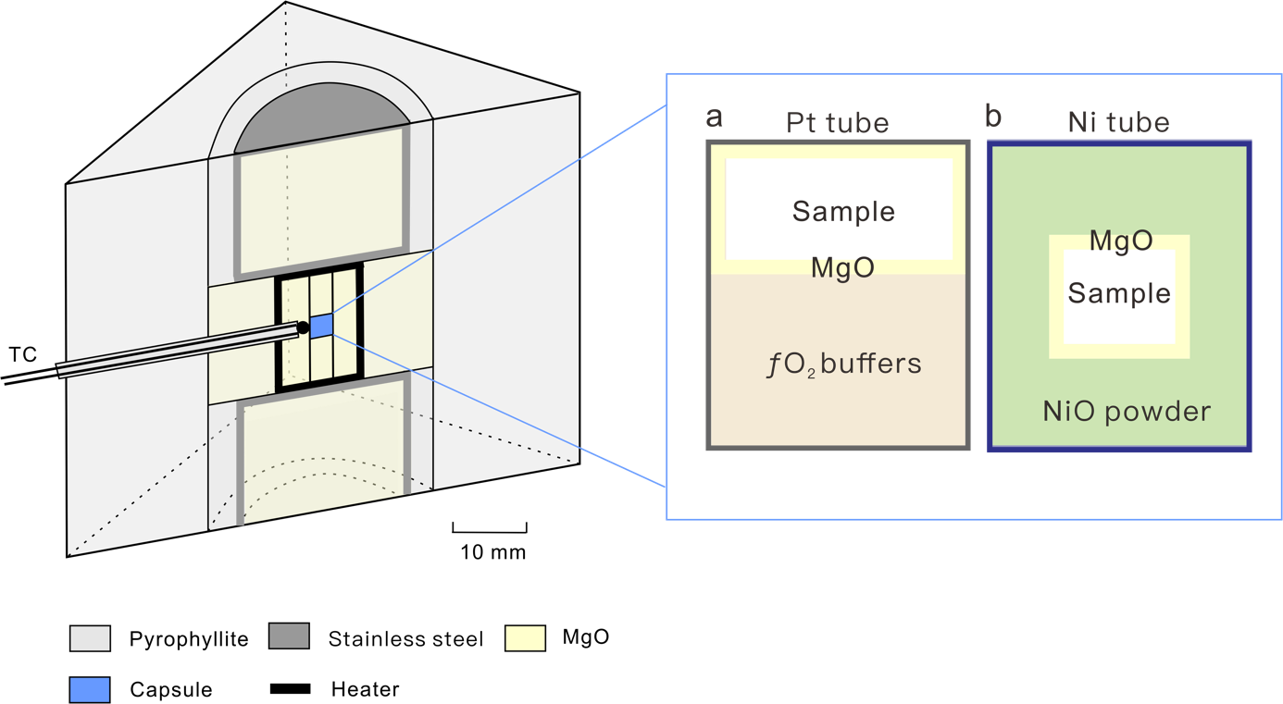

Extended Data Figure S1 | The two different sample assemblies in our LVP experiments. The assembly (a) was used under RRO (a mass ratio of Re:ReO₂=1:1) buffered experiments and Run #701 (a mass ratio of Ni:NiO=1:1). The assembly (b) was used in the rest experiments under NNO buffered conditions. The details were introduced in Methods.
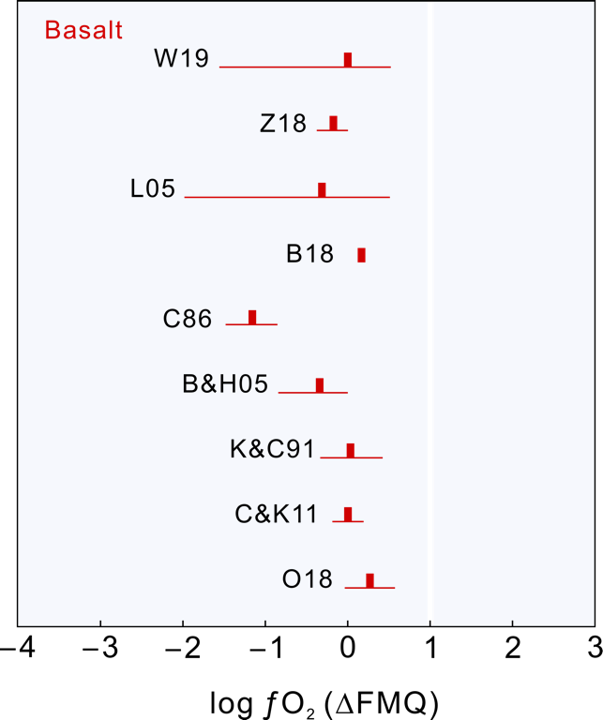

Extended Data Figure S2 | Oxygen fugacity calculated for mid-ocean ridge basalts (MORB). Oxygen thermobarometry measurements indicate that the oxygen fugacity of MORB falls within ±1 log units of the fayalite-magnetite-quartz (FMQ) oxygen buffer⁹⁻¹⁷. Abbreviations: W19, Wang et al. (2019); Z18, Zhang et al. (2018); L05, Lee et al. (2005); B18, Berry et al. (2018); C86, Christie et al. (1986); B&H05, Bezos and Humler (2005); K&C 91, Kress and Carmichael (1991); C&K11, Cottrell and Kelley (2011); O18, O’Neill et al. (2018).

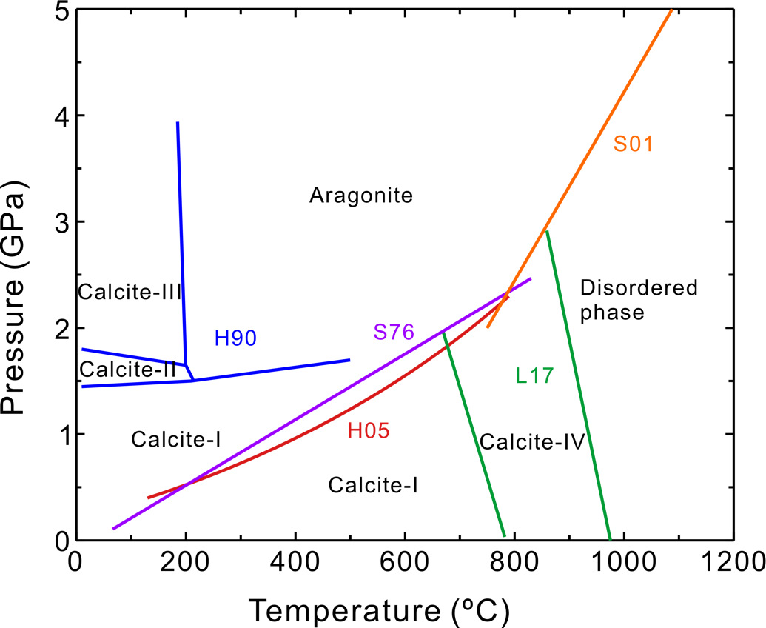

Extended Data Figure S3 | Phase diagram of CaCO₃ at high pressure and high temperature. Different phases are marked in the corresponding stable region. Abbreviations: H90, Hess et al.¹⁸; S76, Salje and Viswanathan¹⁹; H05, Hacker et al.²⁰; L17, Litasov et al.²¹; S01, Suito et al.²².
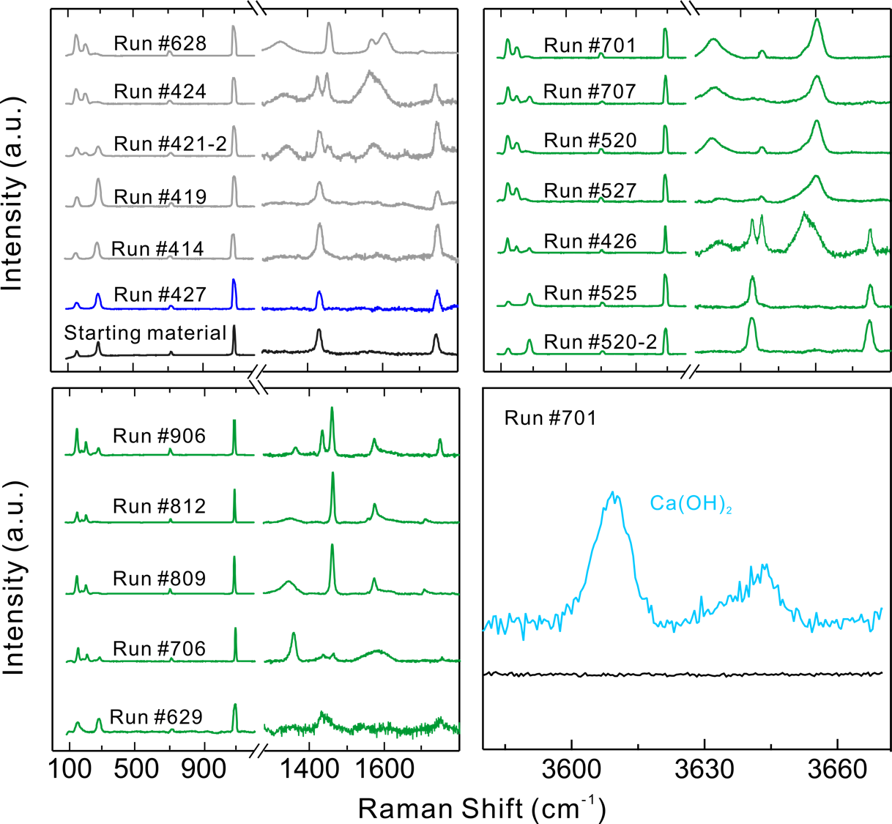
Extended Data Figure S4 | Raman spectra of the run products. The black, grey, dark blue and olive curves in the left and right top panels represent the Raman spectra of fresh CaCO₃, and the recovered samples under CCO, RRO and NNO buffered conditions. CaO does not possess Raman-active modes. The light blue curves in the right bottom panel represent the Raman spectra of Ca(OH)₂ (Run #701), indicating CaO reacted with water during cutting and polishing. The run numbers were marked above the curves. See Table S1 for specific experimental conditions. Graphite was observed together with aragonite. Raman peaks attributed to calcite were detected at 146, 274, 705, 1082, 1436, and 1750 cm⁻¹. Raman peaks attributed to aragonite were detected at 141, 169, 200, 700, 1081, 1460, and 1574 cm⁻¹ (ref. 18). Raman peaks attributed to graphite/amorphous carbon were detected at ~ 1340 cm⁻¹ (D-band) and ~ 1600 cm⁻¹ (G-band)⁸. Raman peaks attributed to Ca(OH)₂ were detected at ~ 3607 and ~ 3640 cm⁻¹ (ref. 7).

Extended Data Figure S5 | The SEM images of the recovered sample from Run #421. Under CCO buffered conditions at 3.0 GPa and 1100˚C, CaCO₃ entered the disordered phase and transformed back into calcite after annealing. No graphite was observed. The sample was coated with Al.
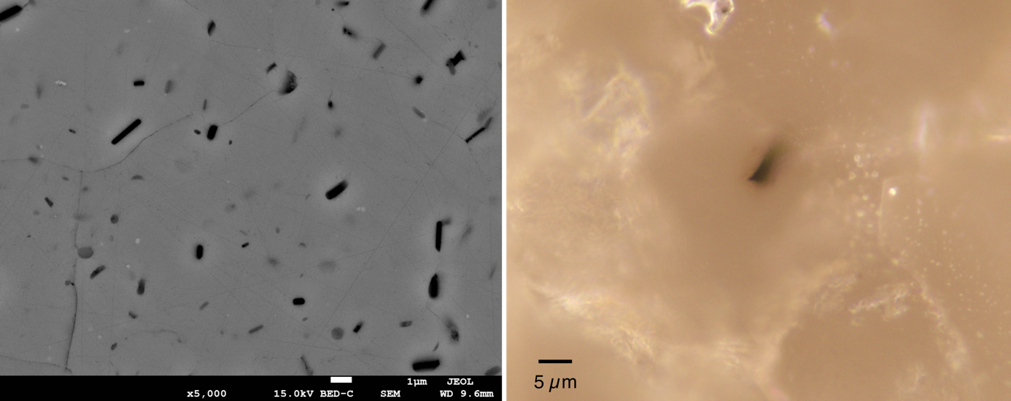

Extended Data Figure S6 | Scanning electron microscope and metallographic microscope images of the recovered samples from Run #520. Graphite flakes and voids were present in the run products of CaCO₃ aragonite based on the back-scattered electron (BSE) images. The sample was coated with Al. From the metallographic microscope image, it showed that the graphite flake was obliquely embedded in the aragonite.

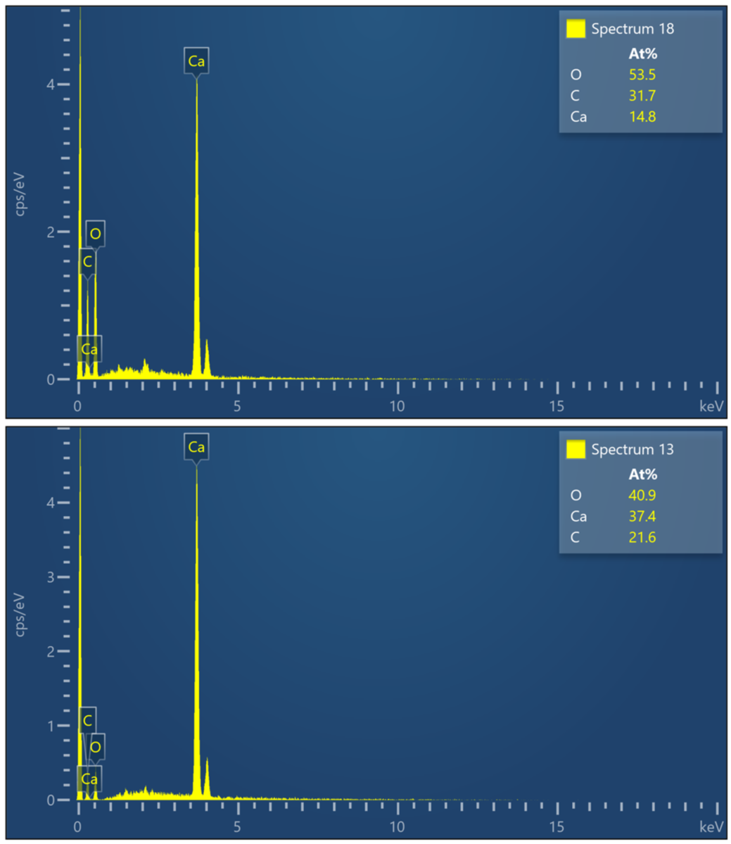

Extended Data Figure S7 | EDS spectra of the recovered sample from Run #520. The top spectrum is aragonite, and the bottom one is CaO. CaO is distributed next to graphite with the Ca:O atomic ratio of about 1:1. We note that the carbon content was not elaborately calibrated and less reliable with respect to the calcium and oxygen contents in these measurements. The sample was coated with Pt.

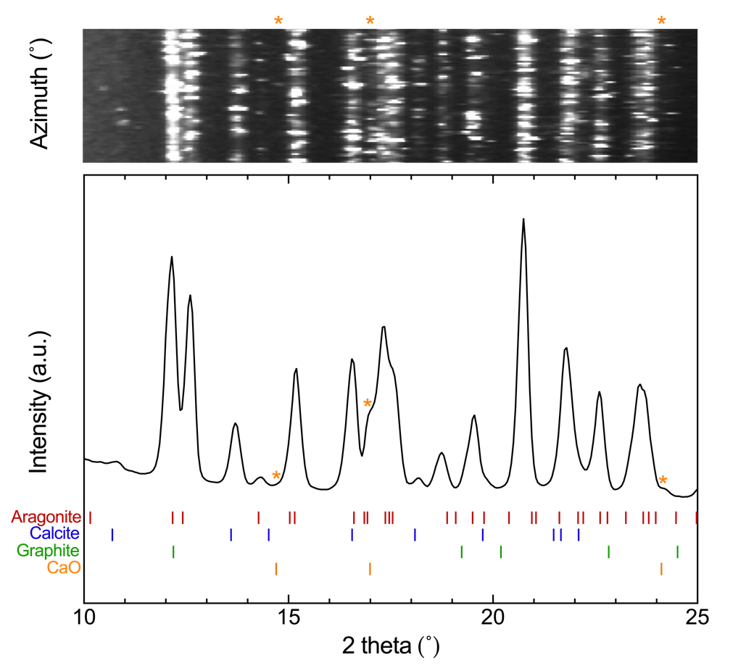

Extended Data Figure S8 | The XRD pattern of the recovered sample for Run #513. X-ray diffraction peaks are indexed according to De Villiers et al.²³ for aragonite, Maslen et al. for calcite²⁴, Natta et al.²⁵ for CaO, and Hassel et al.²⁶ for graphite. The diffraction peaks of aragonite and graphite are overlapped with each other, and the diffraction lines of CaO were marked with asterisks (*). The x-ray wavelength was 0.71073 Å.
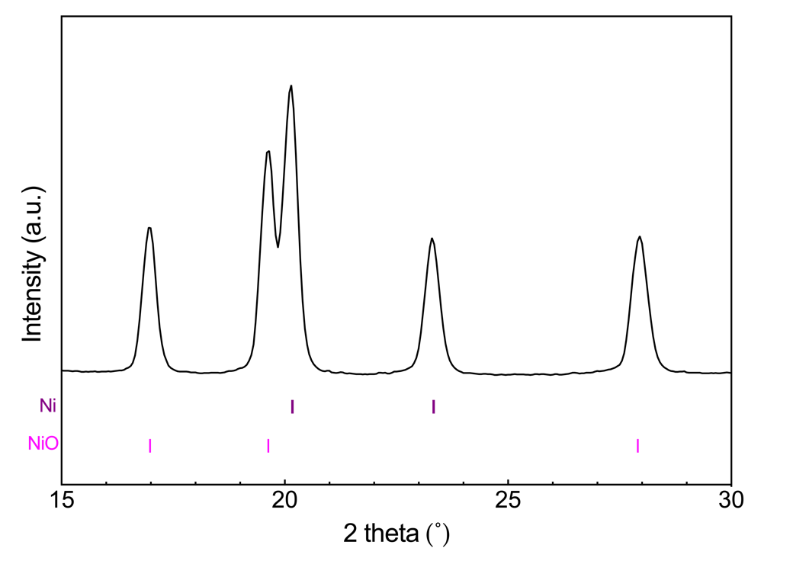

Extended Data Figure S9 | The XRD pattern of the Ni-NiO buffer from the recovered sample for Run #701. Both Ni and NiO were preserved in the recovered sample, indicating the buffers were effective during high P-T experiments. Indexing of diffraction peaks is according to Wyckoff²⁷ for Ni and NiO. The x-ray wavelength was 0.71073 Å.

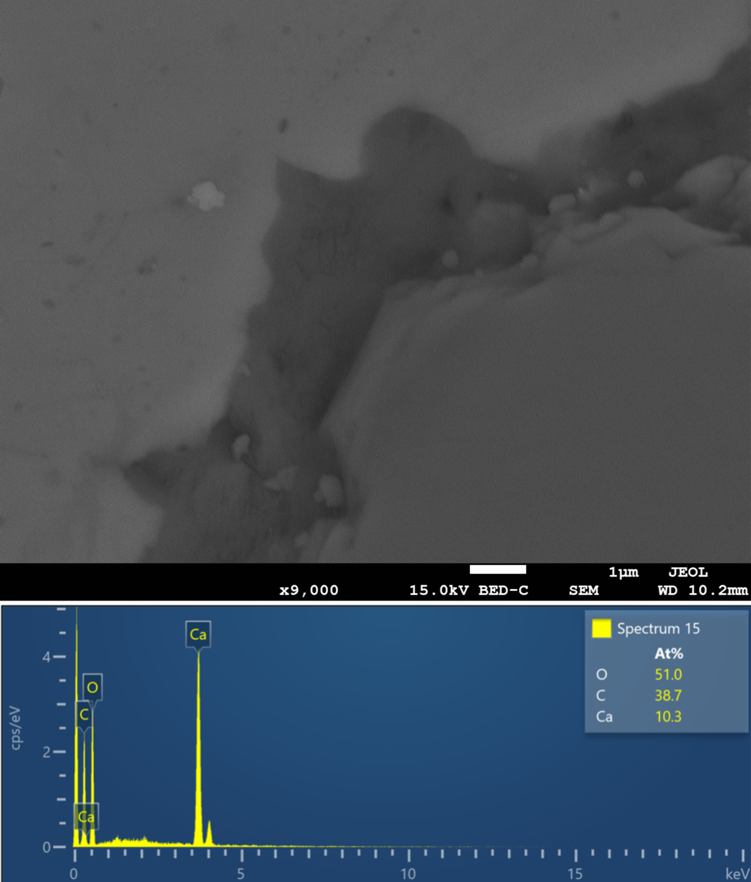
Extended Data Figure S10 | The boundary between CaCO₃ and the MgO capsule recovered from Run #701. The boundary was clear with no evidenced chemical reaction occur. The sample was coated with Pt.

Extended Data Table S1. The conditions and run products of LVP experiments.
Run No. | ƒO₂  buffer | Pressure  (GPa) | Temperature  (˚C) | Duration  (h) | Run products
427 | RRO | 3.0 | 900 | 2 | Cc
727 | RRO | 3.0 | 750 | 8 | Arg
426 | NNO | 3.0 | 900 | 2 | Arg, Cc, Gr, CaO
513 | NNO | 3.0 | 850 | 12 | Arg, Cc, Gr, CaO
520 | NNO | 3.0 | 500 | 8 | Arg, Gr, CaO
520-2 | NNO | 1.2 | 660 | 12 | Cc
525 | NNO | 2.2 | 1100 | 8 | Cc
527 | NNO | 2.2 | 450 | 8 | Arg, Gr, CaO
629 | NNO | 1.6 | 300 | 8 | Cc
701 | NNO | 2.5 | 650 | 8 | Arg, Cc, Gr, CaO
706 | NNO | 1.7 | 330 | 8 | Arg, Cc, Gr, CaO
707 | NNO | 1.8 | 530 | 8 | Arg, Cc, Gr, CaO
809 | NNO | 3.0 | 850 | 2 | Arg, Gr, CaO
812 | NNO | 3.0 | 850 | 6 | Arg, Gr, CaO
906 | NNO | 1.9 | 230 | 12 | Arg, Cc, Gr, CaO
414 | CCO | 3.0 | 1150 | 2 | Cc
419 | CCO | 3.0 | 1200 | 2 | Cc
421 | CCO | 3.0 | 1100 | 2 | Cc
421-2 | CCO | 3.0 | 900 | 1 | Arg, Cc, Gr, CaO
424 | CCO | 3.0 | 850 | 2 | Arg, Gr, CaO
628 | CCO | 2.5 | 630 | 2 | Arg, Gr, CaO

Cc: calcite
Arg: aragonite
Gr: graphite

SUPPLEMENTARY REFERENCES
1 Gunasekaran, S., Anbalagan, G. & Pandi, S. Raman and infrared spectra of carbonates of calcite structure. J. Raman Spectrosc. 37, 892-899 (2006).
2 Ono, S. High-pressure phase transition of bismuth. High Pressure Res. 38, 414-421 (2018).
3 Swamy, V., Saxena, S. K., Sundman, B. & Zhang, J. A thermodynamic assessment of silica phase diagram. J. Geophys. Res. 99, 11787-11794 (1994).
4 Santos, S. S. M., Marcondes, M. L., Justo, J. F. & Assali, L. V. C. Stability of calcium and magnesium carbonates at Earth's lower mantle thermodynamic conditions. Earth Planet. Sci. Lett. 506, 1-7 (2019).
5 Rubie, D. C., Karato, S., Yan, H. & O'Neill, H. S. C. Low differential stress and controlled chemical environment in multianvil high-pressure experiments. Phys. Chem. Miner. 20, 315-322 (1993).
6 Rubie, D. C. Characterising the sample environment in multianvil high-pressure experiments. Phase Transit. 68, 431-451 (1999).
7 Schmid, T. & Dariz, P. Shedding light onto the spectra of lime: Raman and luminescence bands of CaO, Ca(OH)₂ and CaCO₃. J. Raman Spectrosc. 46, 141-146 (2015).
8 Dychalska, A. et al. Study of CVD diamond layers with amorphous carbon admixture by Raman scattering spectroscopy. Mater. Sci.-Poland 33, 799-805 (2015).
9 Lee, C.-T., Leeman, W., Canil, D. & Li, Z.-X. Similar V/Sc systematics in MORB and arc basalts: Implications for the oxygen fugacities of their mantle source regions. J. Petrol. 46, 2313-2336 (2005).
10 Wang, J. et al. Oxidation state of arc mantle revealed by partitioning of V, Sc, and Ti between mantle minerals and basaltic melts. J. Geophys. Res. 124, 4617-4638 (2019).
11 Bezos, A. & Humler, E. The Fe³⁺/ΣFe ratios of MORB glasses and their implications for mantle melting. Geochim. Cosmochim. Acta 69, 711-725 (2005).
12 Kress, V. & Carmichael, I. The compressibility of silicate liquids containing Fe₂O₃ and the effect of composition, temperature, oxygen fugacity and pressure on their redox states. Contrib. Mineral. Petrol. 108, 82-92.
13 Zhang, H. L., Cottrell, E., Solheid, P. A., Kelley, K. A. & Hirschmann, M. M. Determination of Fe³⁺/ΣFe of XANES basaltic glass standards by Mössbauer spectroscopy and its application to the oxidation state of iron in MORB. Chem. Geol. 479, 166-175 (2018).
14 Berry, A. J., Stewart, G. A., O'Neill, H. S. C., Mallmann, G. & Mosselmans, J. F. W. A re-assessment of the oxidation state of iron in MORB glasses. Earth Planet. Sci. Lett. 483, 114-123 (2018).
15 Christie, D. M., Carmichael, I. S. E. & Langmuir, C. H. Oxidation states of mid-ocean ridge basalt glasses. Earth Planet. Sci. Lett. 79, 397-411 (1986).
16 Cottrell, E. & Kelley, K. A. The oxidation state of Fe in MORB glasses and the oxygen fugacity of the upper mantle. Earth Planet. Sci. Lett. 305, 270-282 (2011).
17 O'Neill, H. S. C., Berry, A. J. & Mallmann, G. The oxidation state of iron in mid-ocean ridge basaltic (MORB) glasses: Implications for their petrogenesis and oxygen fugacities. Earth Planet. Sci. Lett. 504, 152-162 (2018).
18 Hess, N. J., Exarhos, G. J. & Ghose, S. Raman spectroscopy at simultaneous high pressure and temperature: phase relations of CaCO₃ and the lattice dynamics of the calcite CaCO₃(II) phase transition. In Recent Trends in High Pressure Research; Proc. X IIIth AIRAPT International Conference on High Pressure Science and Technology, (ed. Singh, A. K.) 236–241 (Oxford & IBH Publishing Co. Pvt, Ltd., New Delhi, 1991).
19 Salje, E. & Viswanathan, K. The phase diagram calcite-aragonite as derived from the crystallographic properties. Contrib. Mineral. Petrol. 55, 55-67 (1976).
20 Hacker, B. R., Rubie, D. C., Kirby, S. H. & Bohlen, S. R. The calcite→aragonite transformation in low-Mg marble: Equilibrium relations, transformations mechanisms, and rates. J. Geophys. Res. 110, 1-16 (2005).
21 Litasov, K. et al. P-V-T equation of state of CaCO₃ aragonite to 29 GPa and 1673 K: In situ X-ray diffraction study. Phys. Earth Planet. Inter. 265, 82-91 (2017).
22 Suito, K. et al. Phase relations of CaCO₃ at high pressure and high temperature. Am. Mineral. 86, 997-1002 (2001).
23 Yalcın, S., Chateigner, D., Le Pluart, L., Gascoin, S. & Eve, S. Investigation of structural and mechanical properties of BioCaCO₃-LDPE composites. Met. Mater. Int. 1, 29-43 (2019).
24 Maslen, E. N., Streltsov, V. A. & Streltsova, N. R. X-ray study of the electron density in calcite, CaCO₃. Acta Crystallogr. B: Struct. Sci. Cryst. Eng. Mater. 49, 636-641 (1993).
25 Natta, G. & Passerini, L. Soluzioni solide, isomorfismo e simmorfismo tra gli ossidi dei metalli bivalenti. Sistemi: CaO-CdO, CaO-MnO, CaO-CoO, CaO-NiO, CaO-MgO. Gazz. Chim. Ital. 59, 129-154 (1929).
26 Hassel, O. & Mark, H. The crystal structure of graphite. Physik. Z 25, 317-337 (1924).
27 Wyckoff, R. W. G. Crystal Structures (Comparative Studies in Behavioral Science). Vol. 1 (Interscience publishers New York, 1963).

