Identification of Novel Coumarin-Based Chalcones as Estrogen Receptor α Inhibitors Through Experimental and Computational Approaches
Sadiq Abubakar^{[1,3]}, Noor Zafirah Ismail^{[1]}, Melati Khairuddean*^{[1]}, Salizawati Muhamad Salhimi^{[2]}, Mohammad Al-Amin^{[2]}, Tutik Dwi Wahyuningsih^{[4]}
[1] Mr. S. Abubakar, Dr. Z. Ismail, Associate Prof. Dr. M. Khairuddean, Mr. B. I. Bakar
School of Chemical Sciences
Universiti Sains Malaysia, 11800, Penang, Malaysia
E-mail: melati@usm.my
[2] Mr. M. Al-Amin, Dr. S. M. Salhimi
School of Pharmaceutical Sciences
Universiti Sains Malaysia, 11800, Penang, Malaysia
[3] Mr. S. Abubakar
Department of Pure and Industrial Chemistry
Bayero University Kano, 3011, Nigeria
[4] Tutik Dwi Wahyuningsih
Department of Chemistry, Faculty of Mathematics and Natural Sciences
Universitas Gadjah Mada, Yogyakarta 55281, Indonesia

Corresponding author: Associate Prof. Dr. M. Khairuddean
E-mail: meldean1965@gmail.com

Supporting Information

Spectral Analysis
3-Acetyl-2H-chromen-2-one (coumarin 1)
Yield: 92 %. Colour: white powder. Mw: 188.18 gmol⁻¹. Mp: 120-122 ℃. IR (ν, cm⁻¹): 3058 (C_{sp}²-H), 2929 (C_{sp}³-H), 1722 (C=O), 1676 (C=O), 1551 (C=C aromatic), 1202 (C-O). ¹H NMR (500 Hz, CDCl₃, ppm): δ_{H}=8.50 (1H, s, H-4), 7.67-7.63 (2H, m, H-5, 7), 7.37 (1H, d, J=10 Hz, H-8), 7.34 (1H, t, J=5 Hz, H-6), 2.72 (3H, s, H-2′). ¹³C NMR (125 MHz, CDCl₃, ppm): δ_{C}=196.5 (C-1′), 159.2 (C-2), 155.3 (C-9), 147.5 (C-4), 134.4 (C-5), 130.2 (C-7), 125.0 (C-6), 124.4 (C-3), 118.2 (C-10), 116.7 (C-8), 30.6 (C-2′).
4-Acetyl-8-methoxy-2H-chromen-2-one (coumarin 2)
Yield: 92 %. Colour: white powder. Mw: 188.18 gmol⁻¹. Mp: 120-122 ℃. IR (ν, cm⁻¹): 3058 (C_{sp}²-H), 2929 (C_{sp}³-H), 1722 (C=O), 1676 (C=O), 1551 (C=C aromatic), 1202 (C-O). ¹H NMR (500 Hz, CDCl₃, ppm): δ_{H}=8.50 (1H, s, H-4), 7.67-7.63 (2H, m, H-5, 7), 7.37 (1H, d, J=10 Hz, H-8), 7.34 (1H, t, J=5 Hz, H-6), 2.72 (3H, s, H-2′). ¹³C NMR (125 MHz, CDCl₃, ppm): δ_{C}=196.5 (C-1′), 159.2 (C-2), 155.3 (C-9), 147.5 (C-4), 134.4 (C-5), 130.2 (C-7), 125.0 (C-6), 124.4 (C-3), 118.2 (C-10), 116.7 (C-8), 30.6 (C-2′).
3-Acetyl-8-ethoxy-2H-chromen-2-one (coumarin 3)
Yield: 94 %. Colour: yellow powder. Mw: 232.24 gmol⁻¹. Mp: 156-168 ℃. IR (ν, cm⁻¹): 2988 (C_{sp}²-H), 2901 (C_{sp}³-H), 1717 (C=O), 1674 (C=O), 1460 (C=C aromatic), 1276 (C-O), 1206 (C-O), 1090 (C-C). ¹H NMR (500 Hz, CDCl₃, ppm): δ_{H}=8.46 (1H, s, H-4), 7.23 (1H, t, J=5, H-6), 7.21 (1H, d, J=10 Hz, H-5), 7.17 (1H, d, J=10 Hz, H-7), 4.19 (2H, q, H-3′), 2.72 (3H, s, H-2′), 1.51 (3H, s, H-4′). ¹³C NMR (125 MHz, CDCl₃, ppm): δ_{C}=195.7 (C-1′), 158.9 (C-2), 147.8 (C-4), 146.4 (C-8), 145.2 (C-9), 124.8 (C-5), 124.5 (C-3), 121.2 (C-6), 118.9 (C-10), 117.1 (C-7), 65.1 (C-3′), 30.6 (C-2′), 14.7 (C-4′).

3E-[3-(1-Methyl-1H-pyrrol-2-yl)acryloyl]-2H-chromen-2-one, 1a
Yield: 62 %. Colour: orange solid. Mw: 279.08 gmol⁻¹. Mp: 162-165 °C. IR (ν cm⁻¹): 3091 (C_{sp}²-H), 2942 (C_{sp}³-H), 1724 (C=O), 1675 (C=O), 1553 (C=C vinyl), 1454 (C=C aromatic), 1327 (C-N). ¹H NMR (500 Hz, CDCl₃, ppm): δ_{H}=8.62 (1H, s, H-4), 7.94 (1H, d, J=10, H-5), 7.73 (1H, t, J=10 Hz, H-6), 7.70 (1H, d, J=15 Hz, H-3′), 7.48 (1H, d, J=10 Hz, H-8), 7.42 (1H, t, J=10 Hz, H-7), 7.35 (1H, d, J=15 Hz, H-2′), 7.13 (1H, d, H-5″), 6.87 (1H, d, H-3″), 6.19 (1H, d, H-4″), 3.76 (3H, s, H-6″). ¹³C NMR (125 MHz, CDCl₃, ppm): δ_{C}=186.4 (C-1′), 159.0 (C-2), 154.7 (C-9), 146.7 (C-4, C-3′), 134.4 (C-3), 133.0 (C-2″), 130.7 (C-2′), 130.0 (C-7), 126.4 (C-5″), 125.3 (C-5, C-6), 119.0 (C-8), 116.6 (C-3″), 114.4 (C-10), 110.2 (C-4″), 34.6 (C-6″).
3E-[3-(5-Methylfuran-2-yl)acryloyl]-2H-chromen-2-one, 1b
Yield: 61 %. Colour: yellow solid. Mw: 380.27 gmol⁻¹. Mp: 160-163 ℃. IR (ν cm⁻¹): 3046 (C_{sp}²-H), 2929 (C_{sp}³-H), 1729 (C=O), 1611 (C=O), 1548 (C=C vinyl), 1458 (C=C aromatic), 1251 (C-O). ¹H NMR (500 Hz, CDCl₃, ppm): δ_{H}=8.54 (1H, s, H-4), 7.68 (1H, d, J=15 Hz, H-3′), 7.65 (1H, d, J=5 Hz, H-5), 7.62 (1H, d, J=5 Hz, H-7), 7.58 (1H, d, J=15 Hz, H-2′), 7.39 (1H, d, J=10 Hz, H-8), 7.34 (1H, t, H-6), 6.69 (1H, d, J=5 Hz, H-3″), 6.13 (1H, d, J=5 Hz, H-4″), 2.39 (3H, s, H-6″). ¹³C NMR (125 MHz, CDCl₃, ppm): δ_{C}=186.2 (C-1′), 159.4 (C-2), 156.9 (C-5″), 155.2 (C-2″), 150.5 (C-9), 147.7 (C-4), 134.1 (C-5), 131.2 (C-3′), 130.1 (C-7), 125.7 (C-3), 125.0 (C-2′), 119.7 (C-6), 119.4 (C-2″), 118.6 (C-10), 116.8 (C-8), 109.7 (C-4″) 14.2 (C-6″).
3E-[3-(Thiophen-2-yl)acryloyl]-2H-chromen-2-one, 1c
Yield: 84 %. Colour: pale yellow solid. Mw: 282.31 gmol⁻¹. Mp: 157-159 ℃. IR (ν cm⁻¹): 3041 (C_{sp}²-H), 1724 (C=O), 1606 (C=O), 1553 (C=C vinyl), 1449 (C=C aromatic), 1202 (C-O). ¹H NMR (500 Hz, CDCl₃, ppm): δ_{H}=8.57 (1H, s, H-4), 8.00 (1H, d, J=15 Hz, H-3′), 7.74 (1H, d, J=15 Hz, H-2′), 7.68 (1H, d, J=5 Hz, H-7), 7.65 (1H, d, J=10 Hz, H-5), 7.39 (1H, d, J=10 Hz, H-8), 7.41 (1H, d, H-6), 7.35 (1H, t, H-5″), 7.22 (1H, d, J=5 Hz, H-3″), 6.76 (1H, dd, J=5 Hz, H-4″). ¹³C NMR (125 MHz, CDCl₃, ppm): δ_{C}=185.9 (C1′), 159.3 (C-2), 155.2 (C-9), 148.0 (C-4), 140.4 (C-2″), 137.4 (C-3′), 134.2 (C-7), 132.5 (C-5), 130.0 (C-2′), 129.7 (C-6), 128.4 (C-5″), 125.2 (C-8), 125.0 (C-3), 122.7 (C-3″), 118.5 (C-10), 116.7 (C-4″).
3E-[3-(5-Methylthiophen-2-yl)acryloyl]-2H-chromen-2-one, 1d
Yield: 79 %. Colour: yellow solid. Mw: 296.34 gmol⁻¹. Mp: 148-150 ℃. IR (ν cm⁻¹): 3051 (C_{sp}²-H), 2915 (C_{sp}³-H), 1724 (C=O), 1603 (C=O), 1571 (C=C vinyl), 1454 (C=C aromatic), 1204 (C-O). ¹H NMR (500 Hz, CDCl₃, ppm): δ_{H}=8.55 (1H, s, H-4), 7.93 (1H, d, J=15 Hz, H-3′), 7.66 (1H, d, J=5 Hz, H-5), 7.64 (1H, t, J=5 Hz, H-7), 7.59 (1H, d, J=15 Hz, H-2′), 7.39 (1H, d, J=10 Hz, H-8), 7.34 (1H, t, J=10 Hz, H-6), 7.22 (1H, d, J=5, H-3″), 6.76 (1H, d, J=5 Hz, H-4″), 2.53 (3H, s, H-6″). ¹³C NMR (125 MHz, CDCl₃, ppm): δ_{C}=186.0 (C-1′), 159.4 (C-2), 155.3 (C-9), 147.8 (C-4), 145.9 (C-5″), 138.7 (C-2″), 138.1 (C-3′), 134.2 (C-3″), 133.6 (C-7), 130.1 (C-4″), 127.1 (C-2′), 125.5 (C-3), 125.1 (C-5), 121.5 (C-6), 118.7 (C-10), 116.8 (C-8), 16.2 (C-6″).
3E-[3-(5-Bromothiophen-2-yl)acryloyl]-2H-chromen-2-one, 1e
Yield: 64 %. Colour: brown solid. Mw: 359.94 gmol⁻¹. Mp: 177-179 ℃. IR (ν cm⁻¹): 3051 (C_{sp}²-H), 1724 (C=O), 1606 (C=O), 1553 (C=C vinyl), 1454 (C=C aromatic), 1246 (C-O). ¹H NMR (500 Hz, CDCl₃, ppm): δ_{H}=8.58 (1H, s, H-4), 7.86 (1H, d, J=15 Hz, H-3′), 7.68 (1H, d, J=5 Hz, H-5), 7.66 (1H, d, J=15 Hz, H-2′), 7.64 (1H, t, J=5 Hz, H-7), 7.40 (1H, d, J=5 Hz, H-6), 7.36 (1H, d, J=5 Hz, H-8), 7.14 (1H, d, H-3″), 7.06 (1H, d, J=5 Hz, H-4″). ¹³C NMR (125 MHz, CDCl₃, ppm): δ_{C}=185.7 (C-1′), 159.3 (C-2), 155.2 (C-9), 148.2 (C-4), 142.0 (C-2″), 136.4 (C-3″), 134.3 (C-4″), 132.7 (C-7), 131.4 (C-3′), 130.1 (C-5), 125.0 (C-6), 124.9 (C-3), 122.9 (C-2′), 118.5 (C-10), 117.4 (C-5″), 116.7 (C-8).
3E-[3-(1-Methyl-1H-pyrrol-2-yl)acryloyl]-8-methoxy-2H-chromen-2-one, 2a
Yield: 49 %. Colour: orange solid. Mw: 309.10 gmol⁻¹. Mp: 158-160 ℃. IR (ν cm⁻¹): 2942 (C_{sp}²-H), 2882 (C_{sp}³-H), 1724 (C=O), 1606 (C=O), 1566 (C=C vinyl), 1472 (C=C aromatic), 1268 (C-N), 1241 (C-O). ¹H NMR (500 Hz, CDCl₃, ppm): δ_{H}=8.55 (1H, s, H-4), 7.98 (1H, d, J=15 Hz, H-3′), 7.66 (1H, d, J=10 Hz, H-5), 7.64 (1H, d, J=10 Hz, H-7), 7.59 (1H, d, J=15 Hz, H-2′), 7.39 (1H, d, J=10 Hz, H-5″), 7.35 (1H, t, J=10 Hz, H-6), 7.22 (1H, d, J=5, H-3″), 6.76 (1H, dd, J=5 Hz, H-4″), 3.95 (3H, s, H-6″), 2.52 (1H, s, H-5). ¹³C NMR (125 MHz, CDCl₃, ppm): δ_{C}=186.0 (C-1′), 159.4 (C-2), 155.3 (C-8), 147.8 (C-4), 146.2 (C-9), 145.9 (C-3), 138.7 (C-2″), 134.2 (C-3′), 133.6 (C-6), 130.0 (C-5), 127.1 (C-2′), 125.0 (C-7), 121.5 (C-3″), 118.7 (C-10), 116.8 (C4″), 55 .9 (C-11), 36.3 (C-6″).
3E-[3-(5-Methylfuran-2-yl)acryloyl]-8-methoxy-2H-chromen-2-one, 2b
Yield: 58 %. Colour: yellow solid. Mw: 310.31 gmol⁻¹. Mp: 172-174 ℃. IR (ν cm⁻¹): 3046 (C_{sp}²-H), 2843 (C_{sp}³-H), 1724 (C=O), 1603 (C=O), 1566 (C=C vinyl), 1472 (C=C aromatic), 1198 (C-O). ¹H NMR (500 Hz, CDCl₃, ppm): δ_{H}=8.52 (1H, s, H-4), 7.69 (1H, d, J=15 Hz, H-3′), 7.58 (1H, d, J=15 Hz, H-2′), 7.26 (1H, d, J=10 Hz, H-5), 7.23 (1H, t, J=10 Hz, H-6), 7.18 (1H, d, J=5 Hz, H-7), 6,68 (1H, d, H-3″), 6.13 (1H, d, H-4″), 3.99 (3H, s, H-11), 2.39 (3H, s, H-6″). ¹³C NMR (125 MHz, CDCl₃, ppm): δ_{C}=186.8 (C-1′), 158.8 (C-2), 158.6 (C-5″), 157.1 (C-2″), 150.2 (C-8), 147.7 (C-4), 146.7 (C-3′), 144.4 (C-6), 130.9 (C-9), 125.3 (C-5), 125.0 (C-3″), 122.1 (C-7), 120.0 (C-3), 119.1 (C-2′), 116.8 (C-4″), 110.5 (C-10) 56.6 (C-11), 14.2 (C-6″).
3E-[3-(Thiophen-2-yl)acryloyl]-8-methoxy-2H-chromen-2-one, 2c
Yield: 86 %. Colour: pale yellow solid. Mw: 312.34 gmol⁻¹. Mp: 157-159 ℃. IR (ν cm⁻¹): 3082 (C_{sp}²-H), 1724 (C=O), 1603 (C=O), 1575 (C=C vinyl), 1467 (C=C aromatic), 1201 (C-O). ¹H NMR (500 Hz, CDCl₃, ppm): δ_{H}=8.53 (1H, s, H-4), 7.99 (1H, d, J=15 Hz, H-3′), 7.73 (1H, d, J=15 Hz, H-2′), 7.44 (1H, d, J=5 Hz, H-5″), 7.40 (1H, d, J=5 Hz, H-3″), 7.24 (1H, d, J=10 Hz, H-5), 7.21 (1H, t, J=10 Hz, H-6), 7.18 (1H, d, H-7), 7.08 (1H, dd, J=5 Hz, H-4″), 3.99 (3H, s, H-11). ¹³C NMR (125 MHz, CDCl₃, ppm): δ_{C}=186.7 (C-1′), 158.7 (C-2), 148.1 (C-4), 147.0 (C-8), 144.9 (C-9), 140.4 (C-2″), 137.4 (C-3′), 132.4 (C-3″), 129.7 (C-5″), 128.3 (C-4″), 125.3 (C-3), 124.8 (C-5), 122.7 (C-2′), 121.1 (C-6), 119.1 (C-10), 115.7 (C-7) 56.3 (C-11).
3E-[3-(5-Methylthiophen-2-yl)acryloyl]-8-methoxy-2H-chromen-2-one, 2d
Yield: 77 %. Colour: yellow solid. Mw: 326.37 gmol⁻¹. Mp: 180-182 ℃. IR (ν cm⁻¹): 3068 (C_{sp}²-H), 2848 (C_{sp}³-H), 1724 (C=O), 1603 (C=O), 1575 (C=C vinyl), 1472 (C=C aromatic), 1268 (C-N). ¹H NMR (500 Hz, CDCl₃, ppm): δ_{H}=8.52 (1H, s, H-3′), 7.92 (1H, d, J=15 Hz, H-3), 7.59 (1H, d, J=15 Hz, H-2), 7.24 (1H, d, J=5 Hz, H-3″), 7.21 (1H, d, J=5 Hz, H-5′), 7.18 (1H, t, J=5 Hz, H-7′), 6.75 (1H, d, H-4″), 3.99 (3H, s, H-4), 2.52 (3H, s, H-5). ¹³C NMR (125 MHz, CDCl₃, ppm): δ_{C}=186.0 (C-1), 158.7 (C-1′), 147.9 (C-3′), 147.0 (C-8′), 145.7 (C-5″), 144.8 (C-9′), 138.5 (C-2″), 138.0 (C-3), 133.5 (C-3″), 126.9 (C-2), 125.5 (C-2′), 124.7 (C-4″), 121.4 (C-6′), 121.1 (C-5′), 119.2 (C-4′), 115.6 (C-7′), 56.3 (C-4), 16.0 (C-5).
3E-[3-(5-Bromothiophen-2-yl)acryloyl]-8-methoxy-2H-chromen-2-one, 2e
Yield: 57 %. Colour: brown solid. Mw: 391.24 gmol⁻¹. Mp: 198-200 ℃. IR (ν cm⁻¹): 3091 (C_{sp}²-H), 2839 (C_{sp}³-H), 1706 (C=O), 1606 (C=O), 1589 (C=C vinyl), 1480 (C=C aromatic), 1282 (C-O). ¹H NMR (500 Hz, CDCl₃, ppm): δ_{H}=8.55 (1H, s, H-4), 7.86 (1H, d, J=15 Hz, H-3′), 7.66 (1H, d, J=15 Hz, H-2′), 7.28 (1H, d, J=5 Hz, H-5), 7.21 (1H, t, J=10 Hz, H-6), 7.19 (1H, d, J=10 Hz, H-7), 7.14 (1H, d, H-3″), 7.05 (1H, d, H-4″), 4.00 (3H, s, H-10). ¹³C NMR (125 MHz, CDCl₃, ppm): δ_{C}=186.8 (C-1′), 158.7 (C-2), 148.4 (C-4), 147.1 (C-8, 9), 142.0 (C-2″), 136.3 (C-3′), 132.6 (C-3″), 131.3 (C-2′), 125.1 (C-3), 124.8 (C-4″), 123.0 (C-6), 121.2 (C-5), 119.1 (C-10), 117.4 (C-5″), 115.8 (C-7), 56.39 (C-11).
3E-[3-(1-Methyl-1H-pyrrol-2-yl)acryloyl]-8-ethoxy-2H-chromen-2-one, 3a
Yield: 59 %. Colour: orange solid. Mw: 323.34 gmol⁻¹. Mp: 184-186 ℃. IR (ν cm⁻¹): 3091 (C_{sp}²-H), 2843 (C_{sp}³-H), 1706 (C=O), 1606 (C=O), 1589 (C=C vinyl), 1476 (C=C aromatic), 1350 (C-N), 1241 (C-O), 1115 (C-C). ¹H NMR (500 Hz, CDCl₃, ppm): δ_{H}=8.52 (1H, s, H-4), 7.77 (1H, d, J=15 Hz, H-3′), 7.63 (1H, d, J=15 Hz, H-2′), 7.55 (1H, d, H-5″), 7.24 (1H, d, J=5 Hz, H-5), 7.21 (1H, d, J=10 Hz, H-7), 7.17 (1H, t, J=10 Hz, H-6), 6.77 (1H, d, J=5 Hz, H-3″), 6.51 (1H, d, H-4″), 4.21 (2H, q, J=10 Hz, H-11), 2.73 (3H, s, H-6″), 1.52 (3H, t, J=10 Hz, H-12). ¹³C NMR (125 MHz, CDCl₃, ppm): δ_{C}=186.3 (C-1′), 158.8 (C-2), 151.7 (C-8), 148.1 (C-4), 146.4 (C-3′), 145.5 (C-9), 145.1 (C-3), 130.9 (C-5″), 125.4 (C-2″), 124.7 (C-2′), 121.5 (C-5), 121.1 (C-6), 119.2 (C-10), 116.9 (C-7), 116.9 (C-3″), 112.7 (C-4″), 65.1 (C-11), 30.6 (C-6″), 14.7 (C-12).
3E-[3-(5-Methylfuran-2-yl)acryloyl]-8-ethoxy-2H-chromen-2-one, 3b
Yield: 71 %. Colour: yellow solid. Mw: 324.33 gmol⁻¹. Mp: 191-193 ℃. IR (ν cm⁻¹): 3061 (C_{sp}²-H), 2979 (C_{sp}³-H), 1733 (C=O), 1603 (C=O), 1544 (C=C vinyl), 1467 (C=C aromatic), 1255 (C-O), 1182 (C-O), 1115 (C-C). ¹H NMR (500 Hz, CDCl₃, ppm): δ_{H}=8.53 (1H, s, H-4), 7.69 (1H, d, J=15 Hz, H-3′), 7.59 (1H, d, J=15 Hz, H-2′), 7.25 (1H, d, J=5 Hz, H-5), 7.21 (1H, t, J=10 Hz, H-6), 7.19 (1H, d, J=5 Hz, H-7), 6.71 (1H, d, J=5 Hz, H-3″), 6.16 (1H, d, J=5, H-4″), 4.24 (2H, q, J=10 Hz, H-11), 2.41 (3H, s, H-6″), 1.55 (3H, t, J=10 Hz, H-12). ¹³C NMR (125 MHz, CDCl₃, ppm): δ_{C}=186.6 (C-1′), 158.8 (C-2), 157.1 (C-5″), 150.1 (C-8), 147.8 (C-4), 145.9 (C-2″), 144.3 (C-9), 130.9 (C-3′), 125.8 (C-3), 125.3 (C-6), 121.8 (C-2′), 120.7 (C-5), 120.0 (C-3″), 119.5 (C-7), 117.5 (C-10), 110.5 (C-4″) 64.9 (C-11), 15.0 (C-6″), 14.2 (C-12).
3E-[3-(Thiophen-2-yl)acryloyl]-8-ethoxy-2H-chromen-2-one, 3c
Yield: 73 %. Colour: pale yellow solid. Mw: 326.37 gmol⁻¹. Mp: 147-149 ℃. IR (ν cm⁻¹): 3091 (C_{sp}²-H), 2979 (C_{sp}³-H), 1724 (C=O), 1603 (C=O), 1571 (C=C vinyl), 1462 (C=C aromatic), 1268 (C-O), 1115 (C-C). ¹H NMR (500 Hz, CDCl₃, ppm): δ_{H}=8.53 (1H, s, H-4), 8.00 (1H, d, J=15 Hz, H-3′), 7.73 (1H, d, J=15 Hz, H-2′), 7.46 (1H, d, J=5 Hz, H-5″), 7.41 (1H, d, J=5 Hz, H-3″), 7.25 (1H, d, J=5, Hz, H-5), 7.23 (1H, d, J=5 Hz, H-6), 7.18 (1H, d, J=5 Hz, H-7), 7.09 (1H, dd, J=5 Hz, H-4″), 4.21 (2H, q, J=10 Hz, H-11), 1.53 (3H, t, H-12). ¹³C NMR (125 MHz, CDCl₃, ppm): δ_{C}=186.3 (C-1′), 159.1 (C-2), 148.3 (C-4), 146.5 (C-8), 145.2 (C-9), 140.6 (C-2″), 137.5 (C-3′), 132.5 (C-5″), 129.8 (C-3″), 128.4 (C-4″), 125.4 (C-3), 124.4 (C-2′), 122.9 (C-6), 121.2 (C-5), 119.4 (C-10), 117.1 (C-7) 65.2 (C-11), 14.8 (C-12).
3E-[3-(5-Methylthiophen-2-yl)acryloyl]-8-ethoxy-2H-chromen-2-one, 3d
Yield: 71 %. Colour: yellow solid. Mw: 340.39 gmol⁻¹. Mp: 162-164 ℃. IR (ν cm⁻¹): 3041 (C_{sp}²-H), 2879 (C_{sp}³-H), 1724 (C=O), 1603 (C=O), 1580 (C=C vinyl), 1467 (C=C aromatic), 1196 (C-O), 1120 (C-C). ¹H NMR (500 Hz, CDCl₃, ppm): δ_{H}=8.51 (1H, s, H-4), 7.92 (1H, d, J=15 Hz, H-3′), 7.59 (1H, d, J=15 Hz, H-2′), 7.24 (1H, d, J=5 Hz, H-5), 7.22 (1H, d, J=5 Hz, H-6), 7.21 (1H, t, J=5 Hz, H-3″), 7.17 (1H, dd, J=5 Hz, H-7), 6.75 (1H, dd, J=5 Hz, H-4″), 4.21 (2H, q, J=10 Hz, H-11), 2.52 (3H, s, H-6″), 1.53 (3H, t, H-12). ¹³C NMR (125 MHz, CDCl₃, ppm): δ_{C}=186.2 (C-1′), 159.1 (C-2), 148.1 (C-4), 146.5 (C-8), 145.8 (C-5″), 145.2 (C-9), 138.7 (C-2″), 138.1 (C-3′), 133.6 (C-3″), 127.1 (C-4″), 125.6 (C-3), 124.8 (C-2′), 121.6 (C-6), 121.2 (C-5), 119.4 (C-10), 117.0 (C-7) 65.2 (C-11), 16.1 (C-6″), 14.8 (C-12).

3E-[3-(5-Bromothiophen-2-yl)acryloyl]-8-ethoxy-2H-chromen-2-one, 3e
Yield: 65 %. Colour: brown solid. Mw: 405.26 gmol⁻¹. Mp: 176-178 ℃. IR (ν cm⁻¹): 3078 (C_{sp}²-H), 2988 (C_{sp}³-H), 1706 (C=O), 1603 (C=O), 1575 (C=C vinyl), 1467 (C=C aromatic), 1251 (C-O), 1174 (C-C); ¹H NMR (500 Hz, CDCl₃, ppm): δ_{H}=8.54 (1H, s, H-4), 8.03 (1H, d, J=5 Hz, H-3″), 7.85 (1H, d, J=15 Hz, H-3′), 7.65 (1H, d, J=15 Hz, H-2′), 7.36 (1H, d, H-4″), 7.23 (1H, dd, J=5 Hz, H-5), 7.17 (1H, t, J=10 Hz, H-6), 7.06 (1H, d, H-7), 4.22 (2H, q, J=10 Hz, H-11), 1.53 (3H, t, H-12). ¹³C NMR (125 MHz, CDCl₃, ppm): δ_{C}=186.9 (C-1′), 158.9 (C-2), 148.4 (C-4), 146.4 (C-8), 145.1 (C-9), 142.0 (C-2″), 136.3 (C-3″), 132.6 (C-3′), 131.3 (C-4″), 125.0 (C-3), 124.8 (C-2′), 123.0 (C-6), 121.1 (C-5), 119.2 (C-10), 117.3 (C-5″), 117.1 (C-7) 65.1 (C-11), 14.7 (C-12).

FT-IR, ¹H-NMR and ¹³C-NMR spectra of compounds 1(a-e), 2(a-e) and 3(a-e).
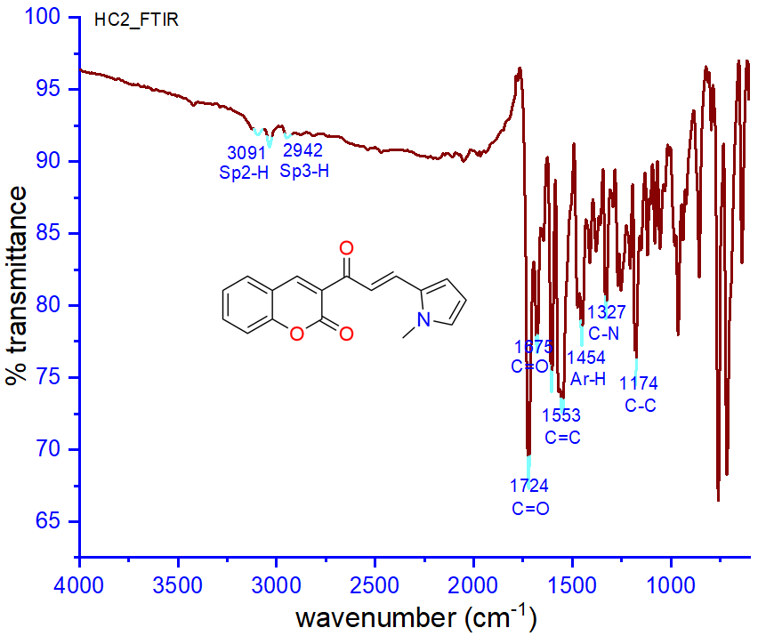
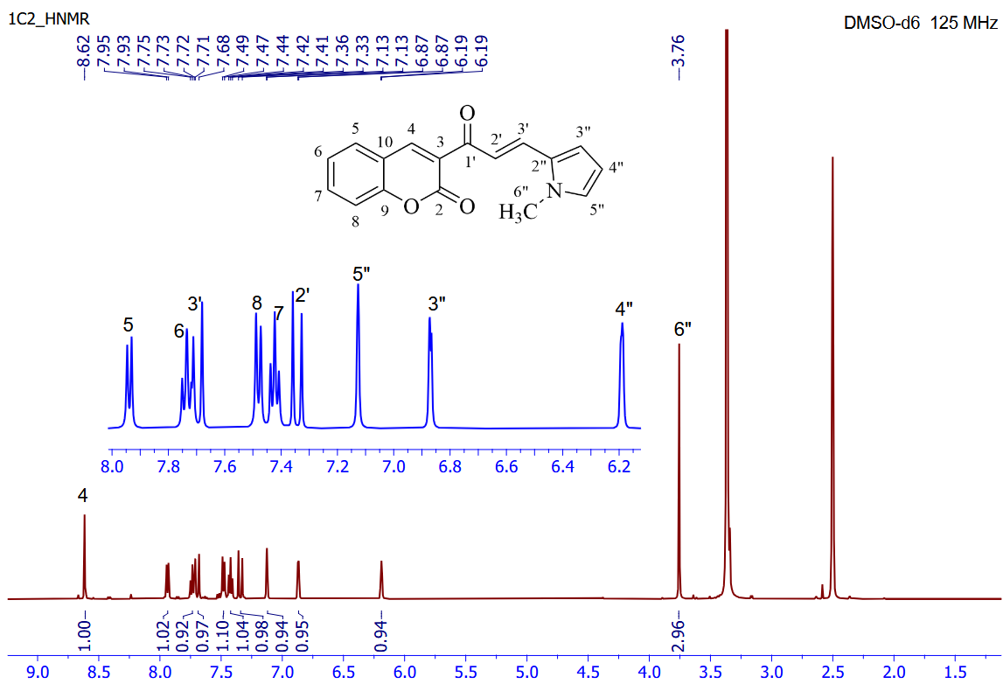
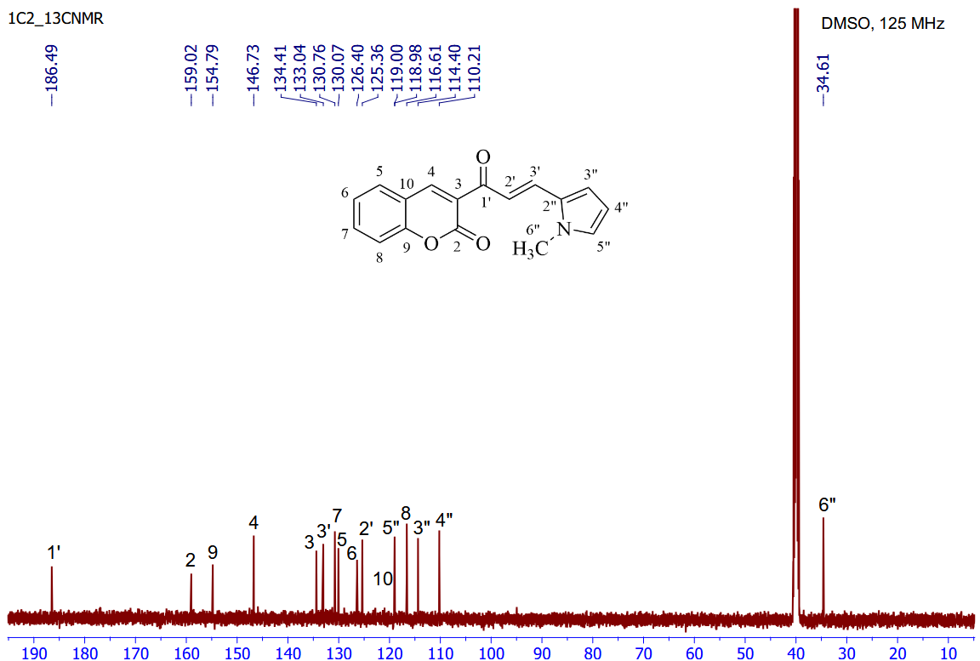

Figure S1. FT-IR, ¹H-NMR and ¹³C-NMR spectra of compound 1a. (500 MHz, DMSO).
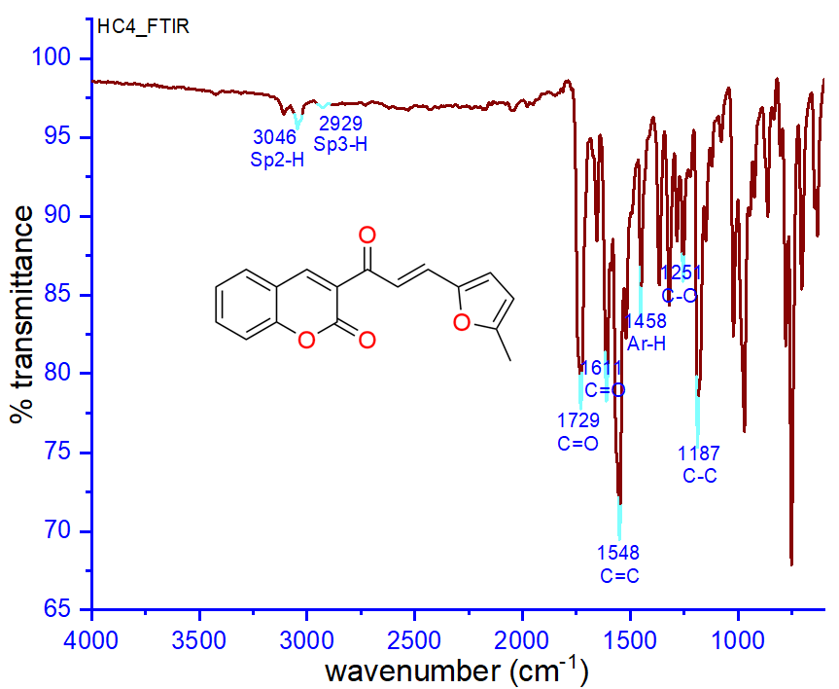
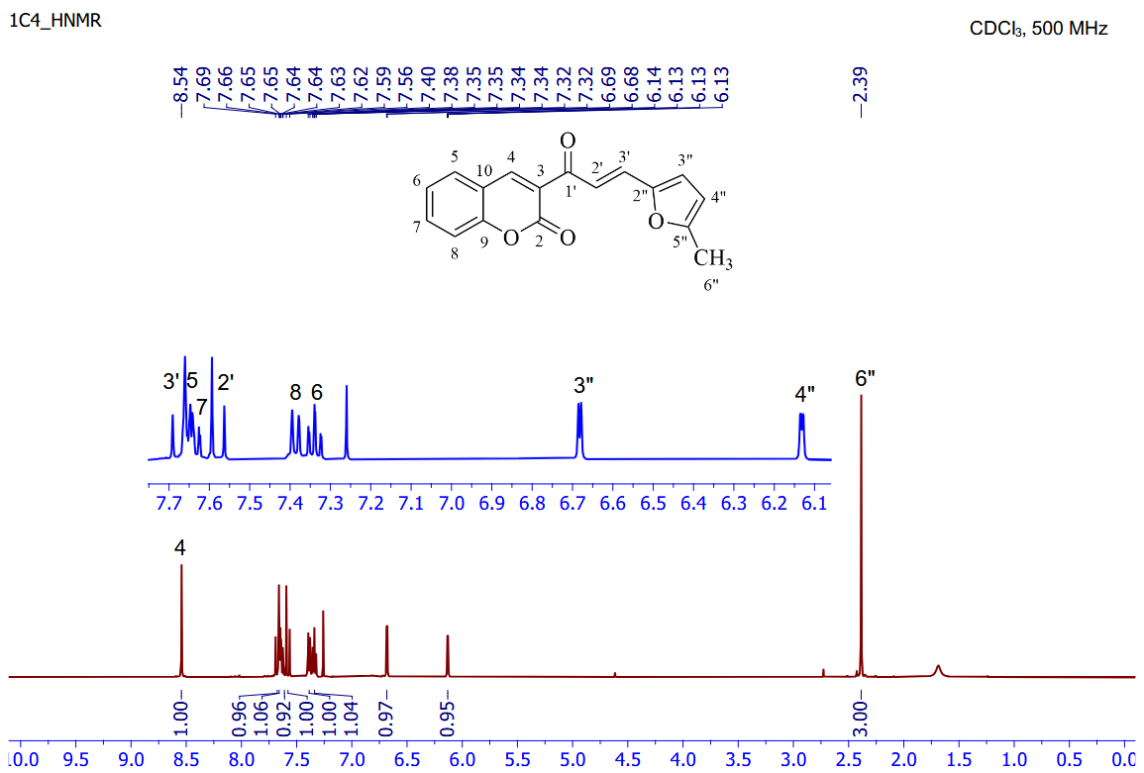
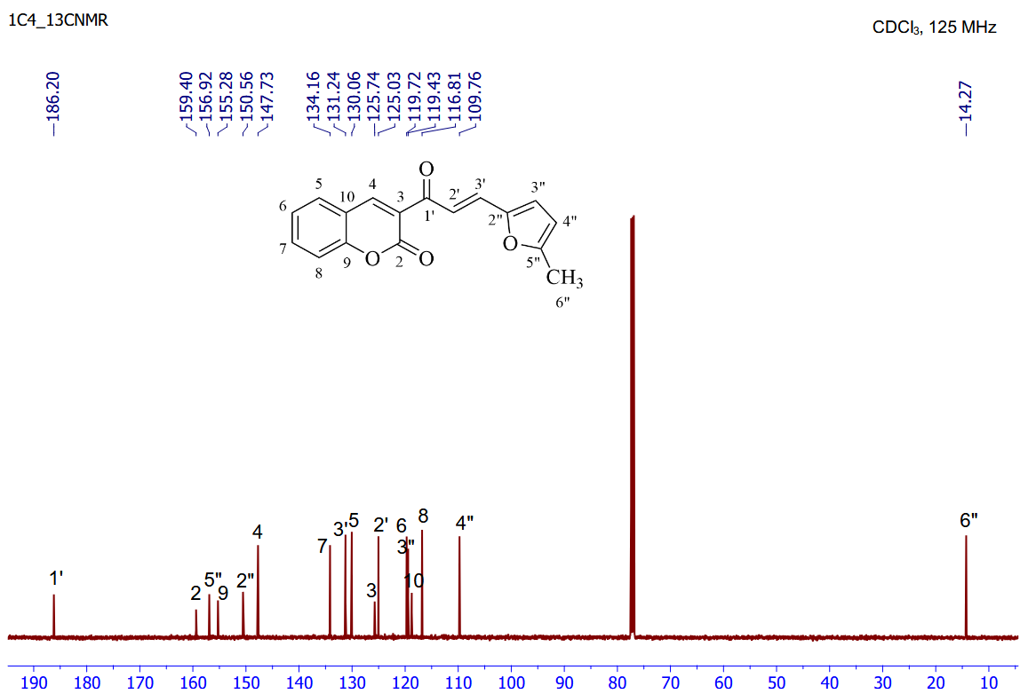

Figure S2. FT-IR, ¹H-NMR and ¹³C-NMR spectra of compound 1b. (500 MHz, CDCl₃).
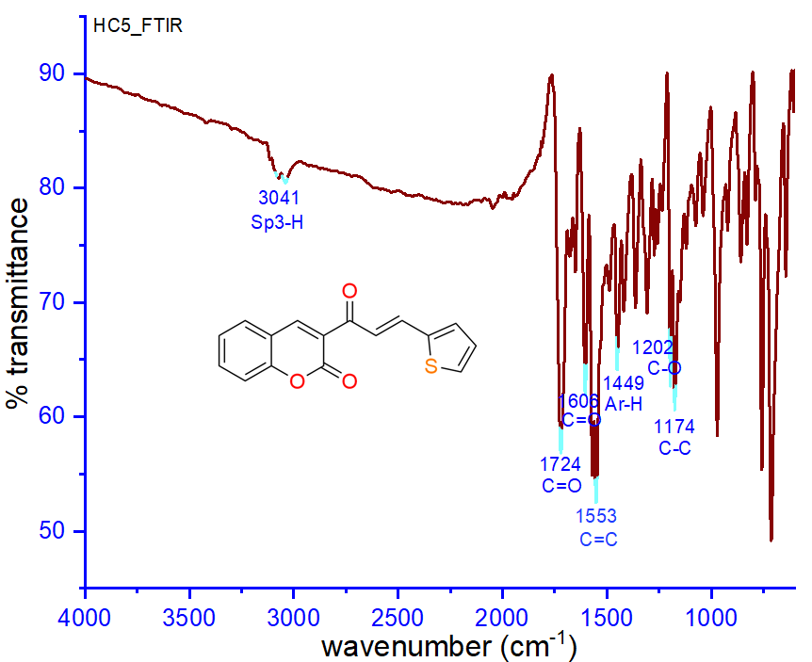

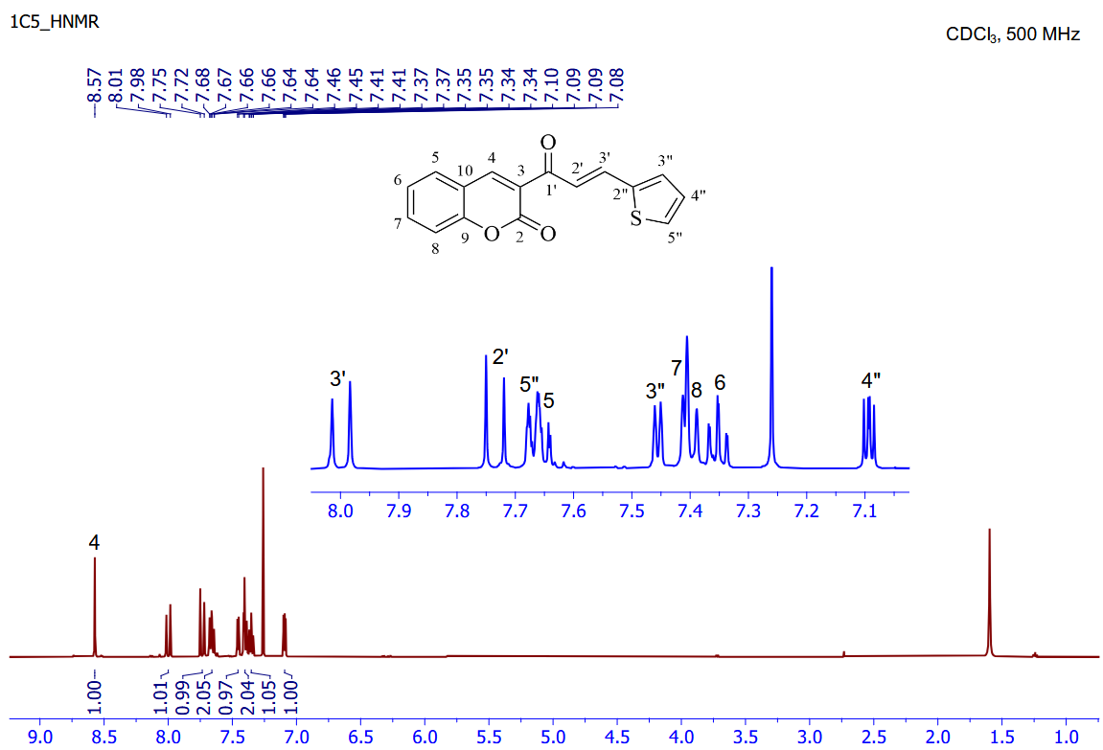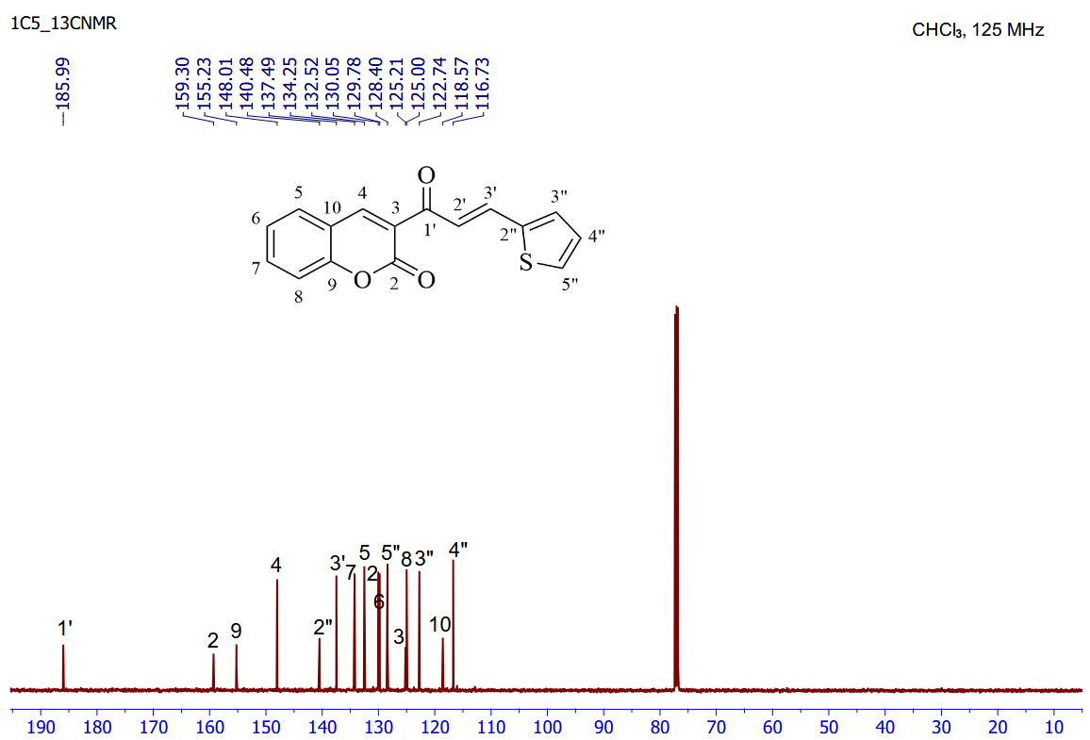

Figure S3. FT-IR, ¹H-NMR and ¹³C-NMR spectra of compound 1c. (500 MHz, CDCl₃).

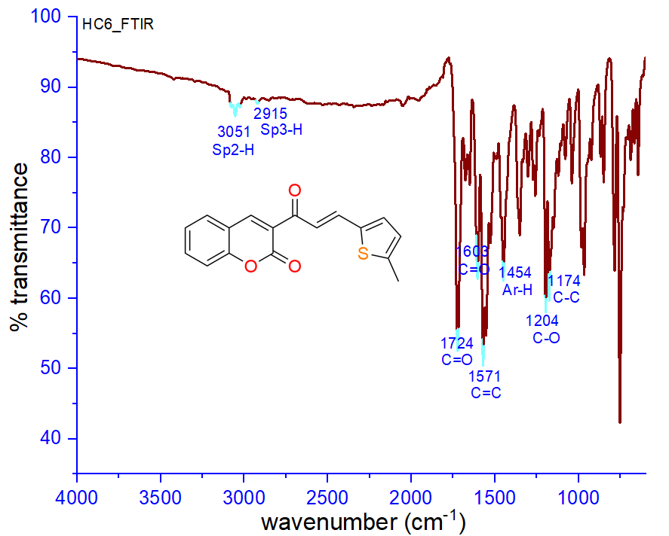
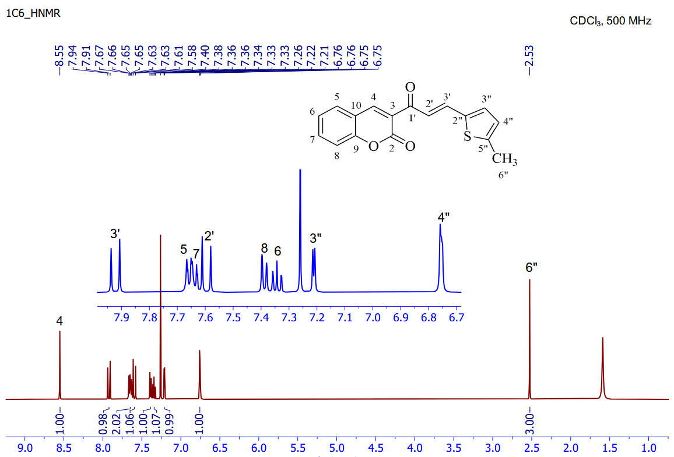
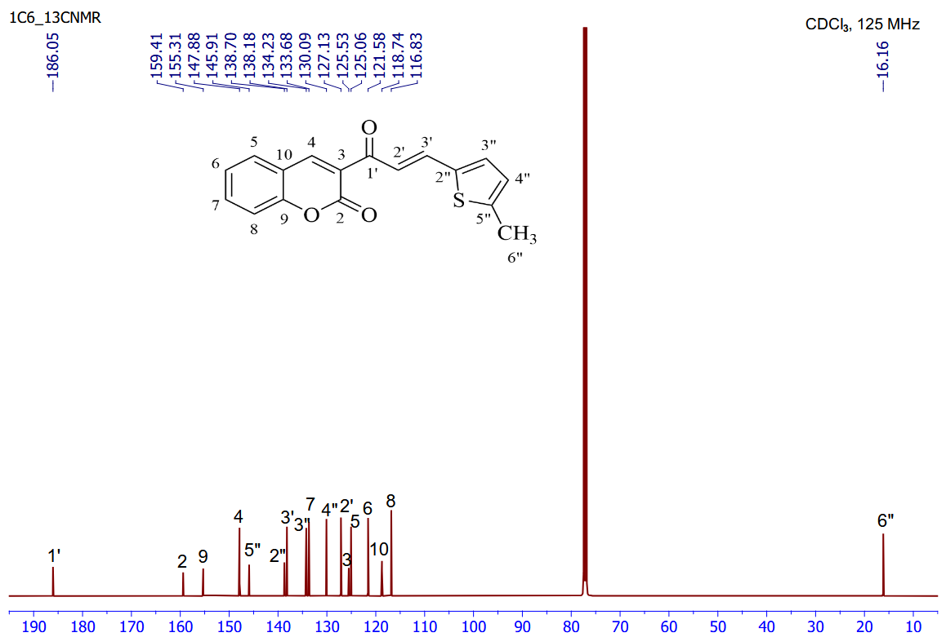

Figure S4. FT-IR, ¹H-NMR and ¹³C-NMR spectra of compound 1d. (500 MHz, CDCl₃).

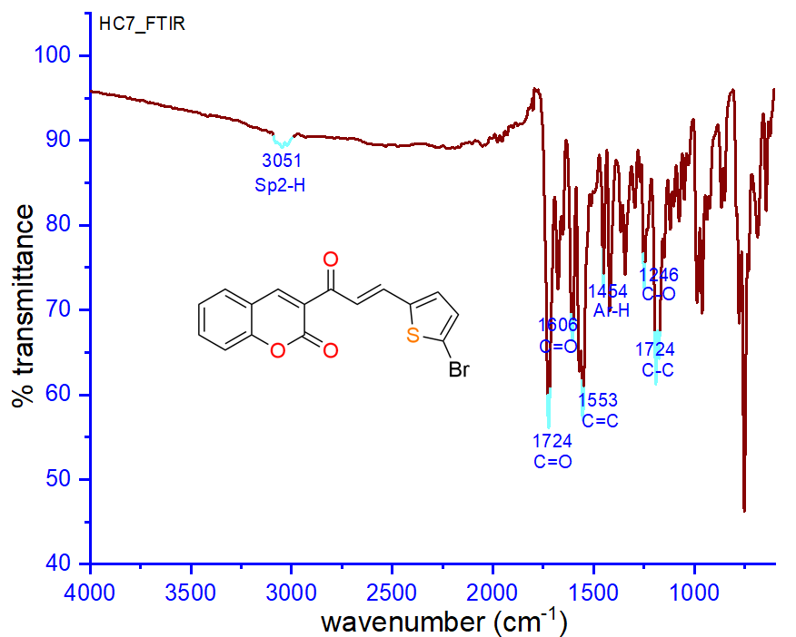
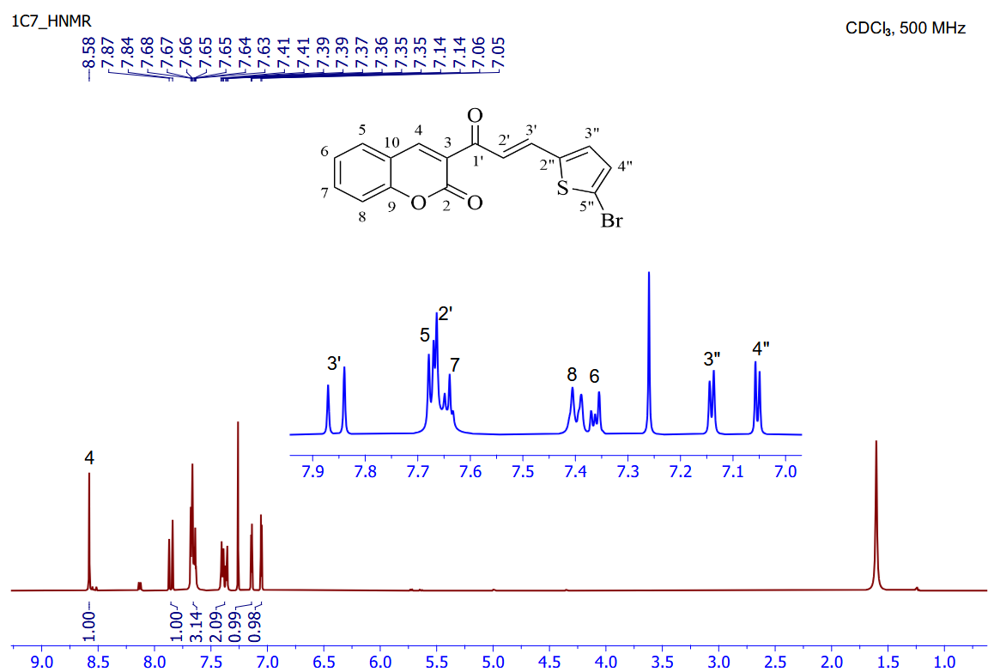
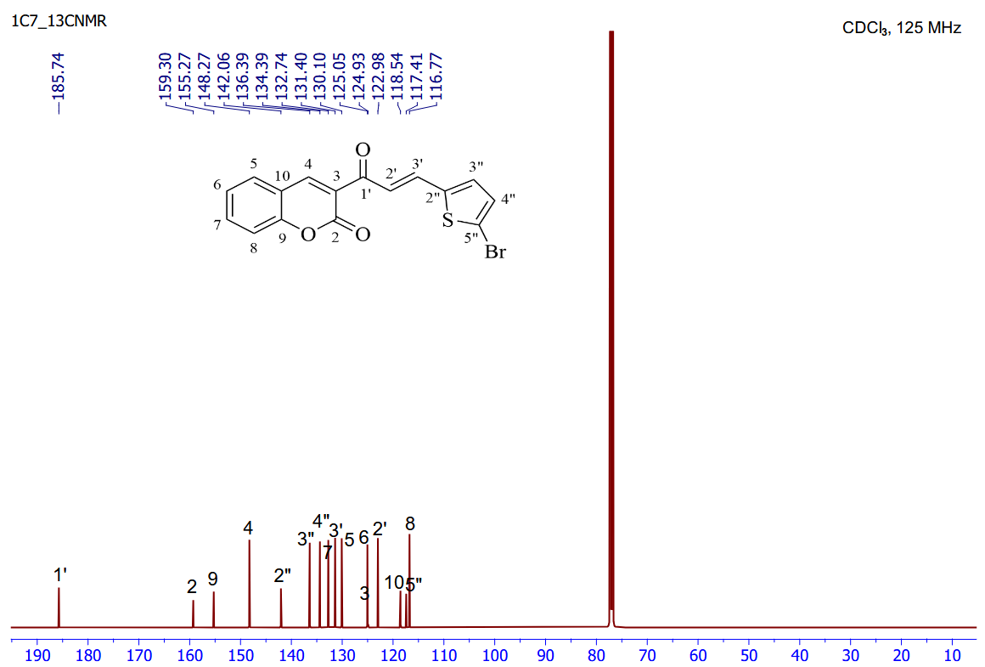

Figure S5. FT-IR, ¹H-NMR and ¹³C-NMR spectra of compound 1e. (500 MHz, CDCl₃).

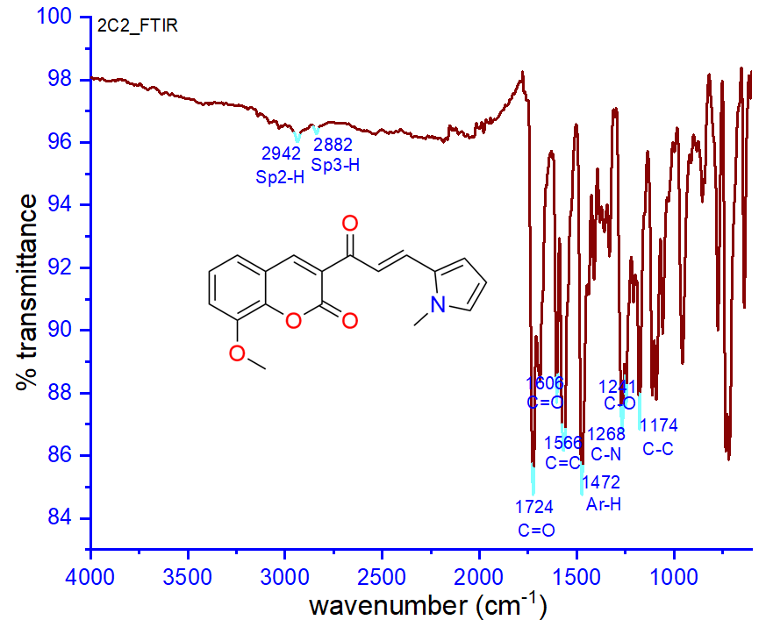
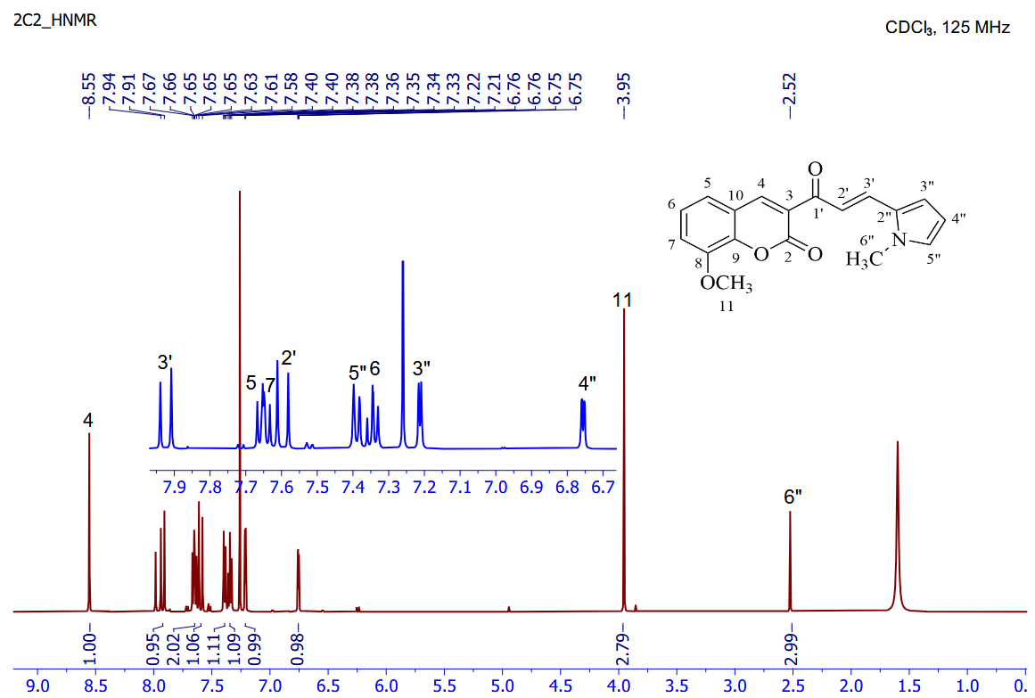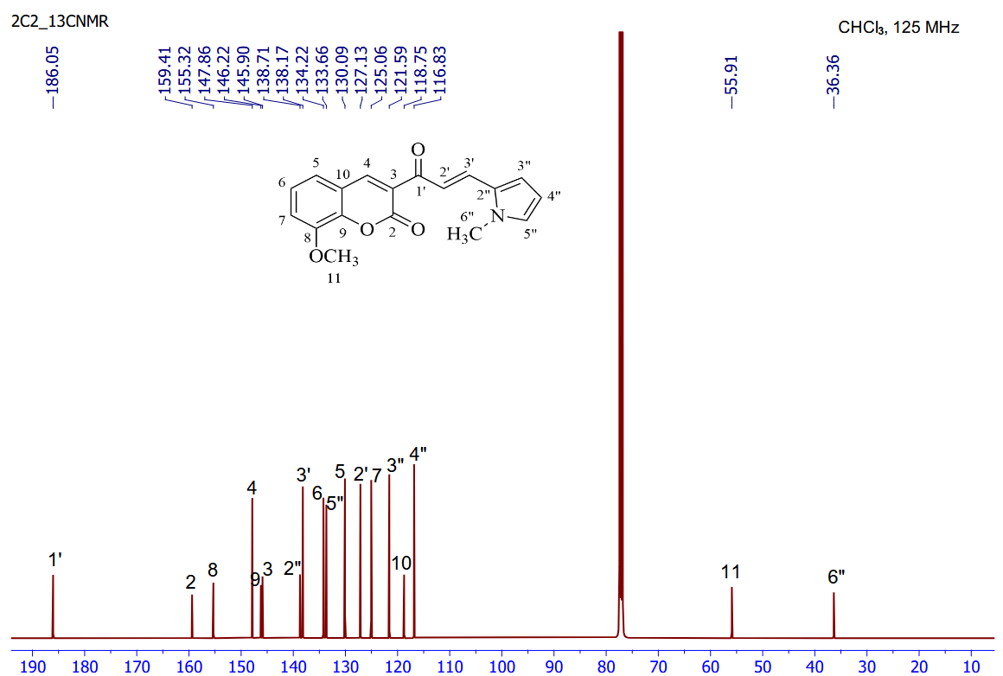

Figure S6. FT-IR, ¹H-NMR and ¹³C-NMR spectra of compound 2a. (500 MHz, CDCl₃).

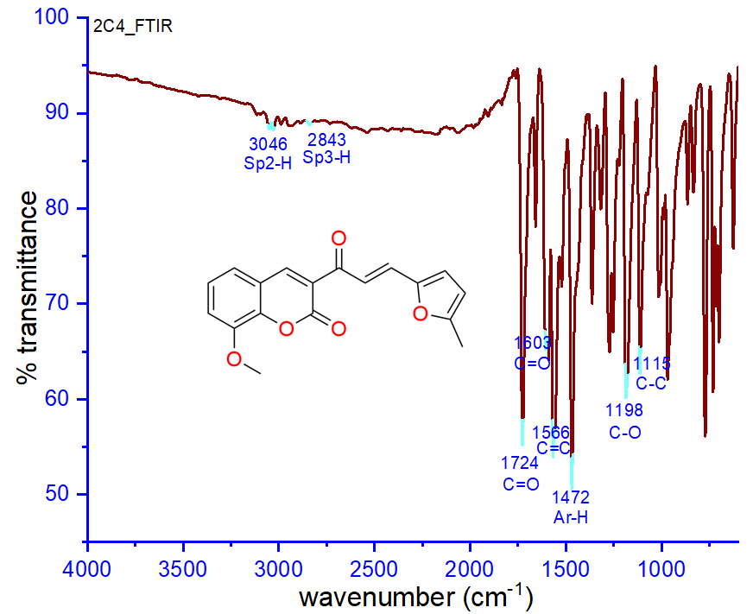

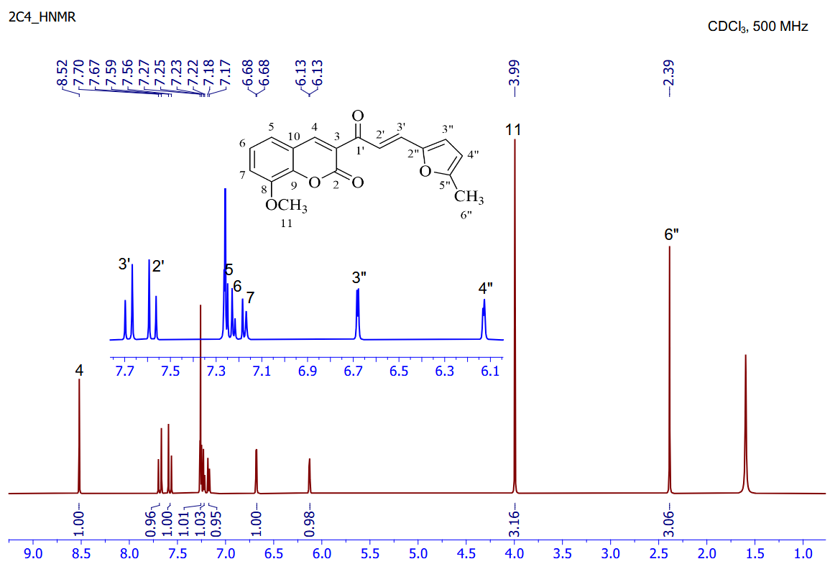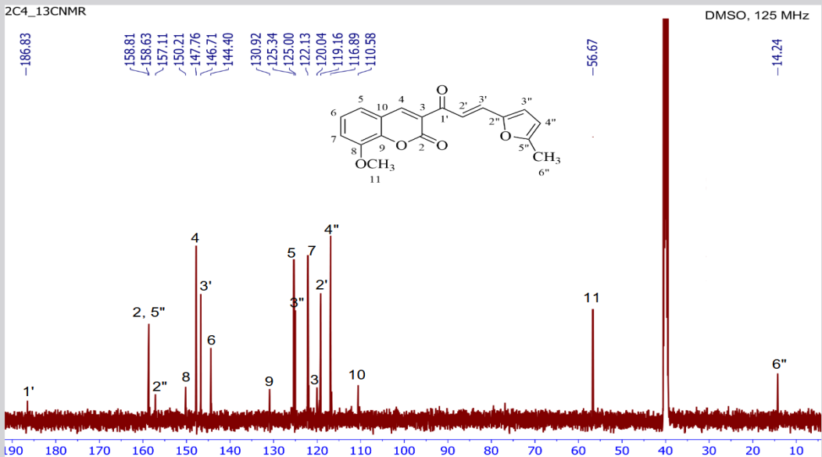

Figure S7. FT-IR, ¹H-NMR and ¹³C-NMR spectra of compound 2b. (500 MHz, CDCl₃, DMSO).
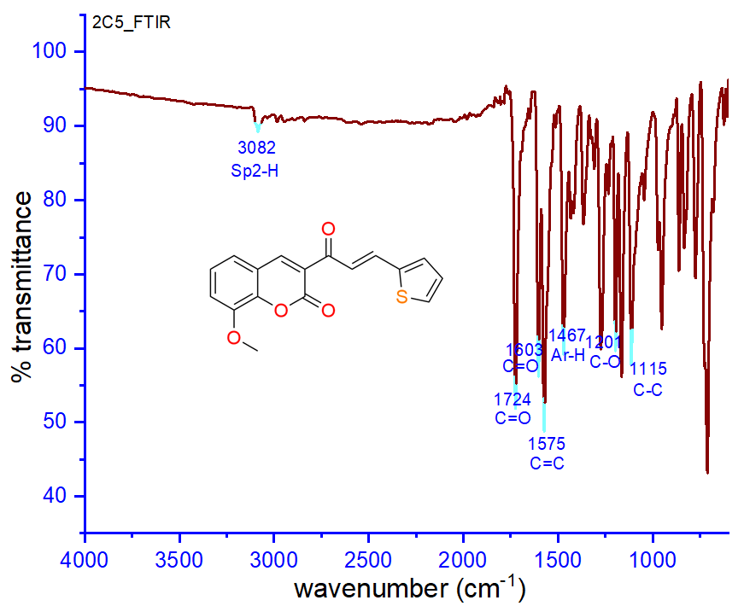

Figure S8. FT-IR, ¹H-NMR and ¹³C-NMR spectra of compound 2c. (500 MHz, CDCl₃).
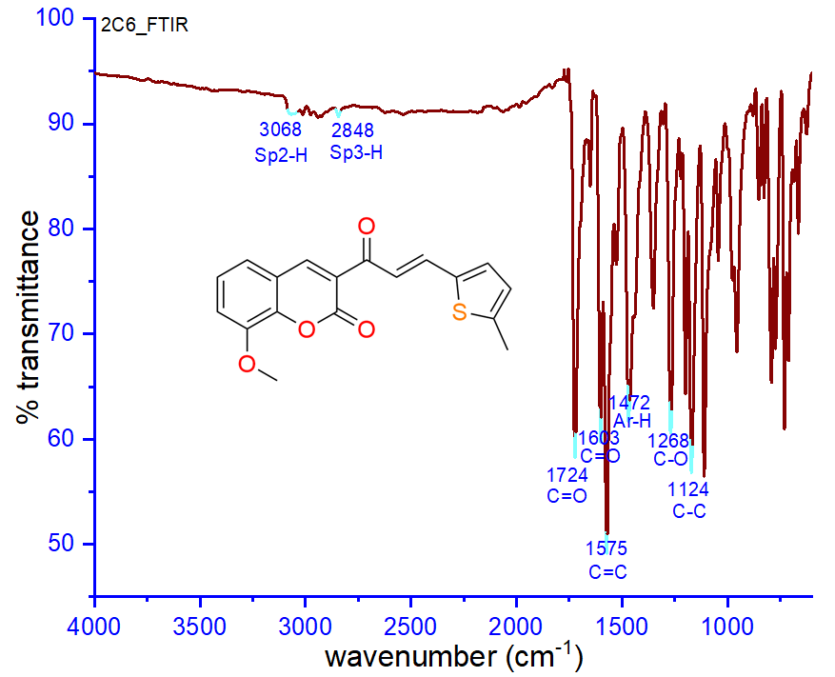

Figure S9. FT-IR, ¹H-NMR and ¹³C-NMR spectra of compound 2d. (500 MHz, CDCl₃).
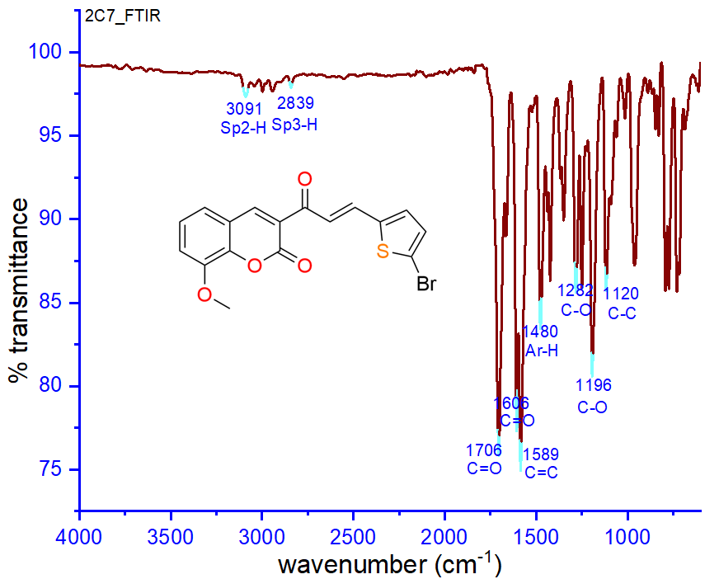
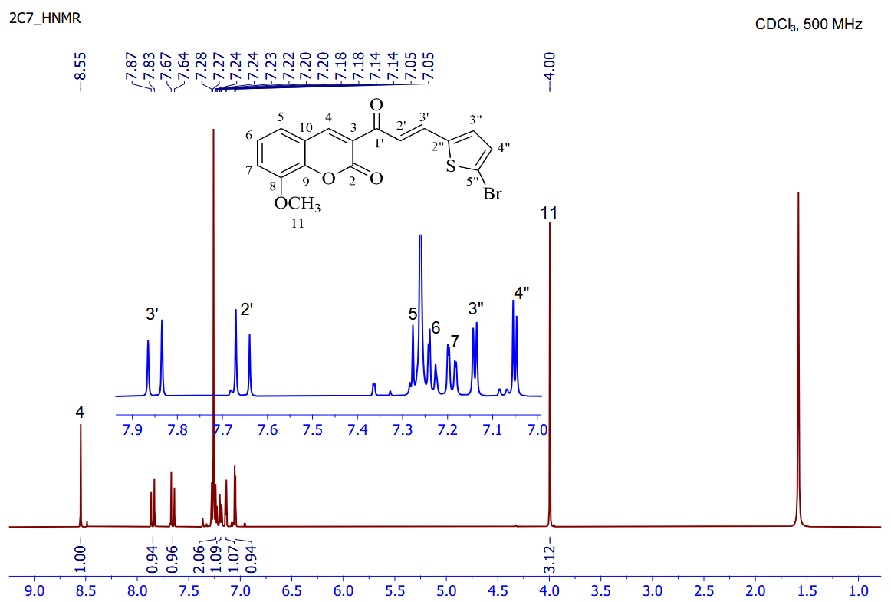
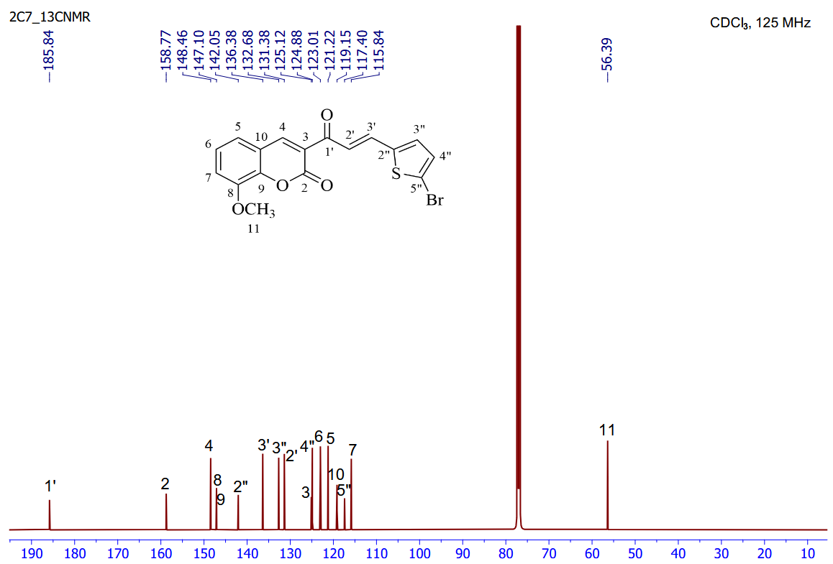

Figure S10. FT-IR, ¹H-NMR and ¹³C-NMR spectra of compound 2e. (500 MHz, CDCl₃).

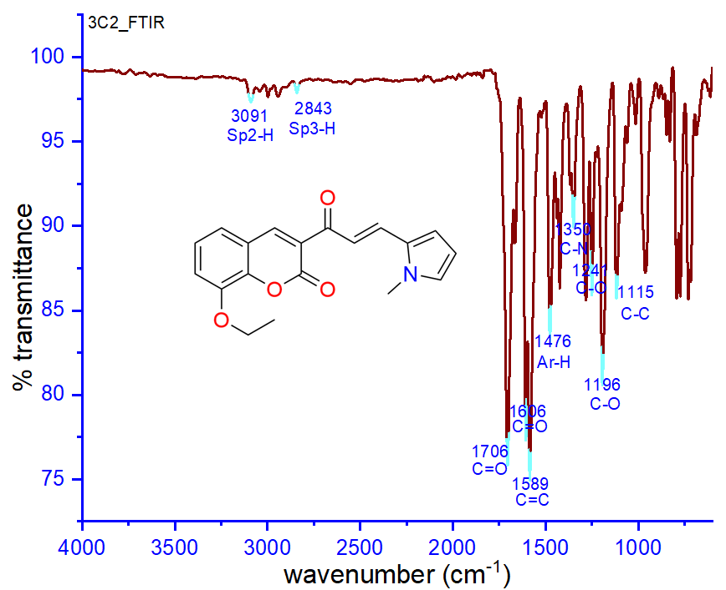
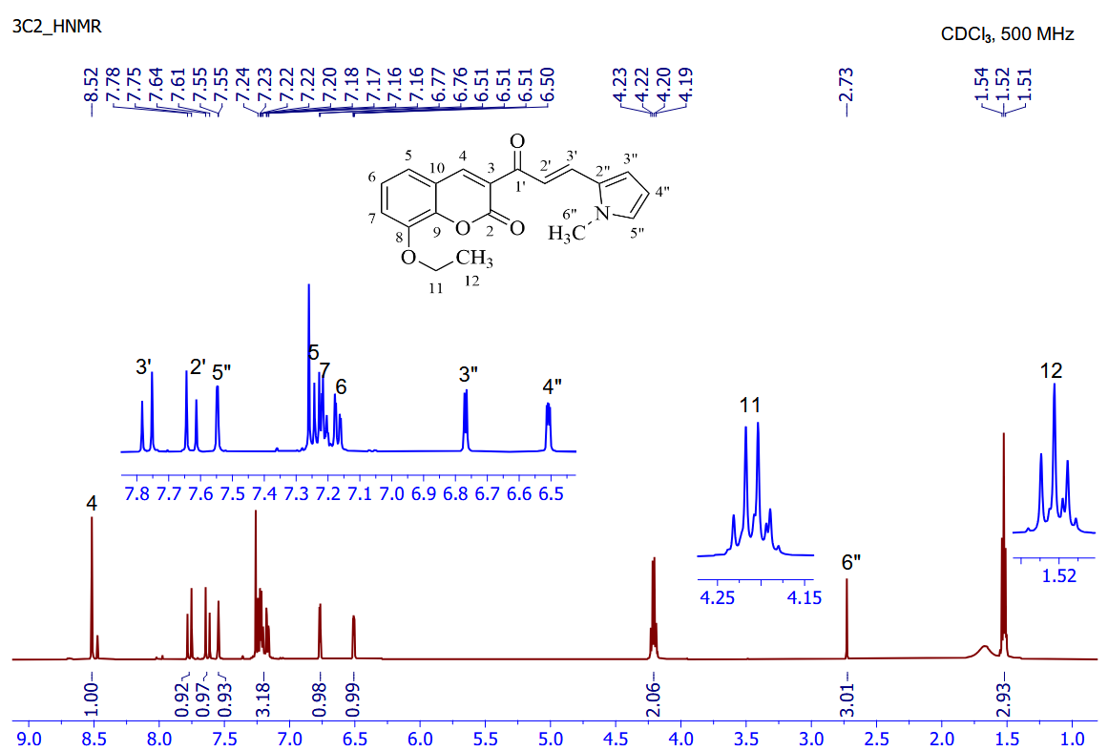
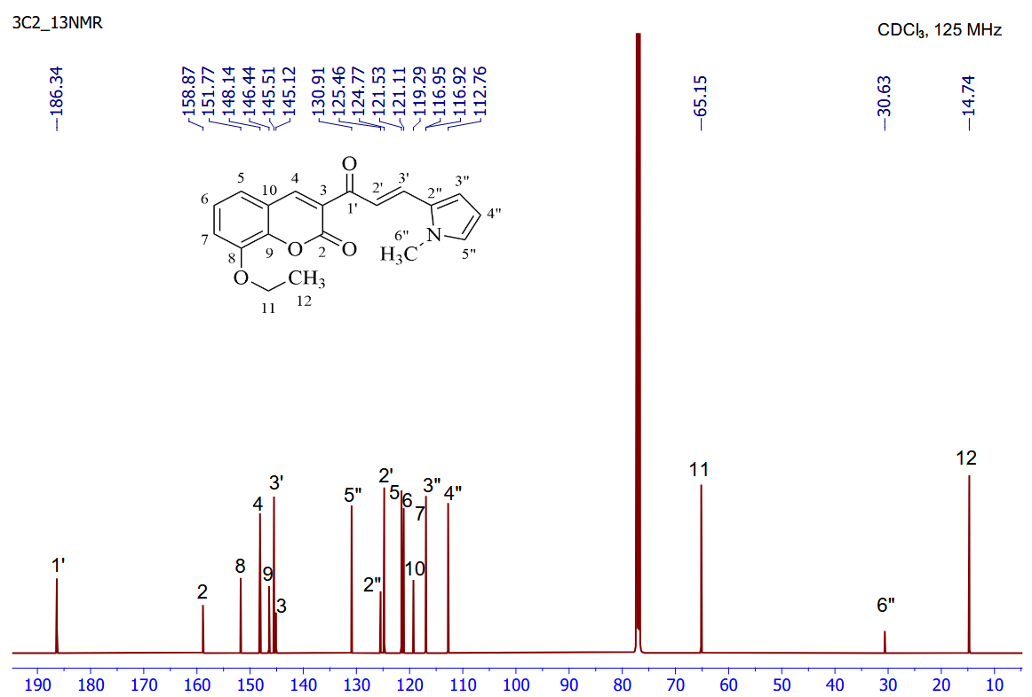

Figure S11. FT-IR, ¹H-NMR and ¹³C-NMR spectra of compound 3a. (500 MHz, CDCl₃).
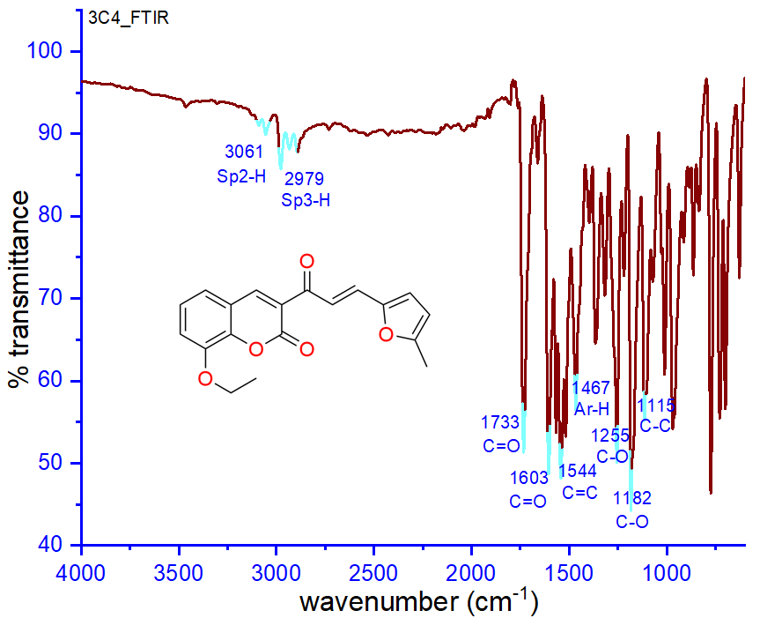
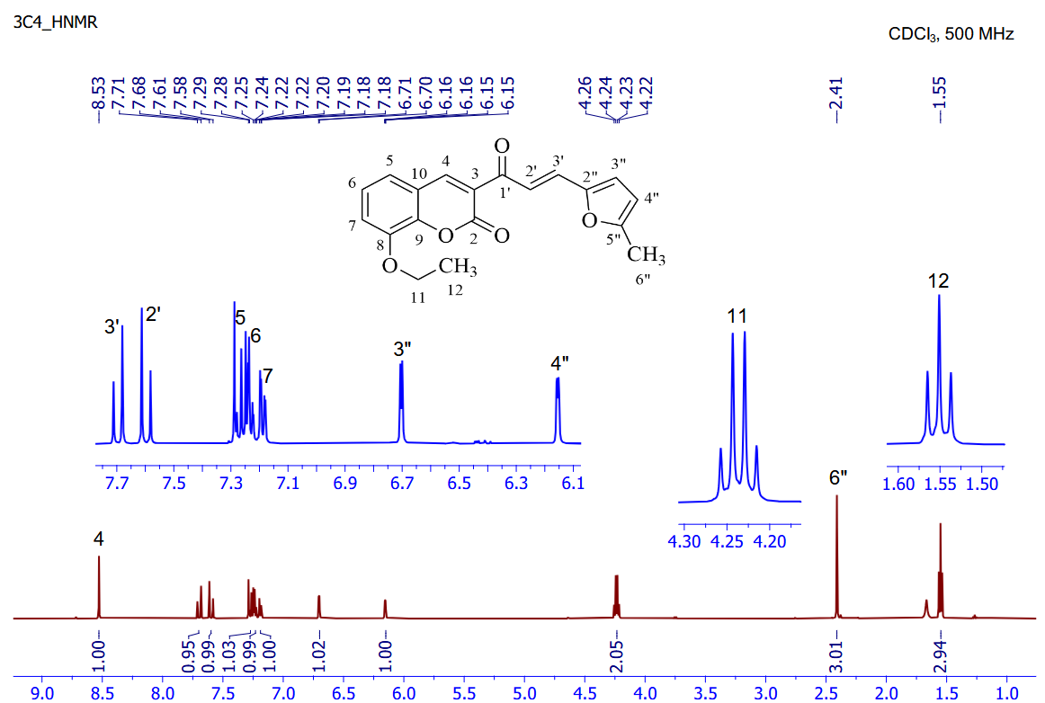
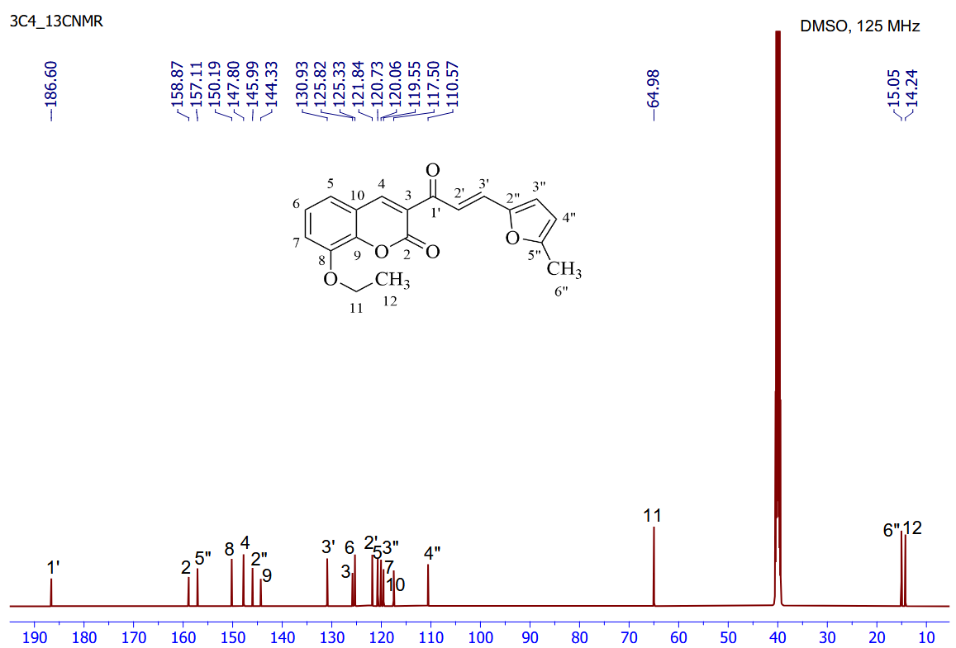

Figure S12. FT-IR, ¹H-NMR and ¹³C-NMR spectra of compound 3b. (500 MHz, CDCl₃, DMSO).
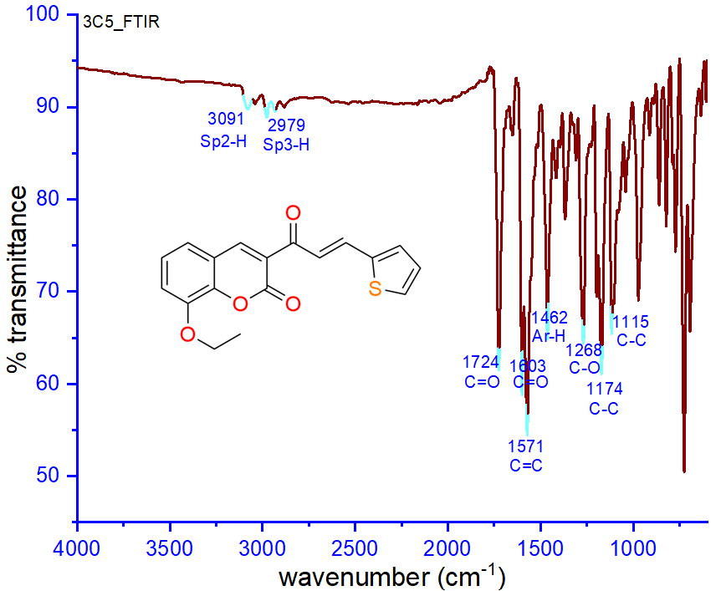
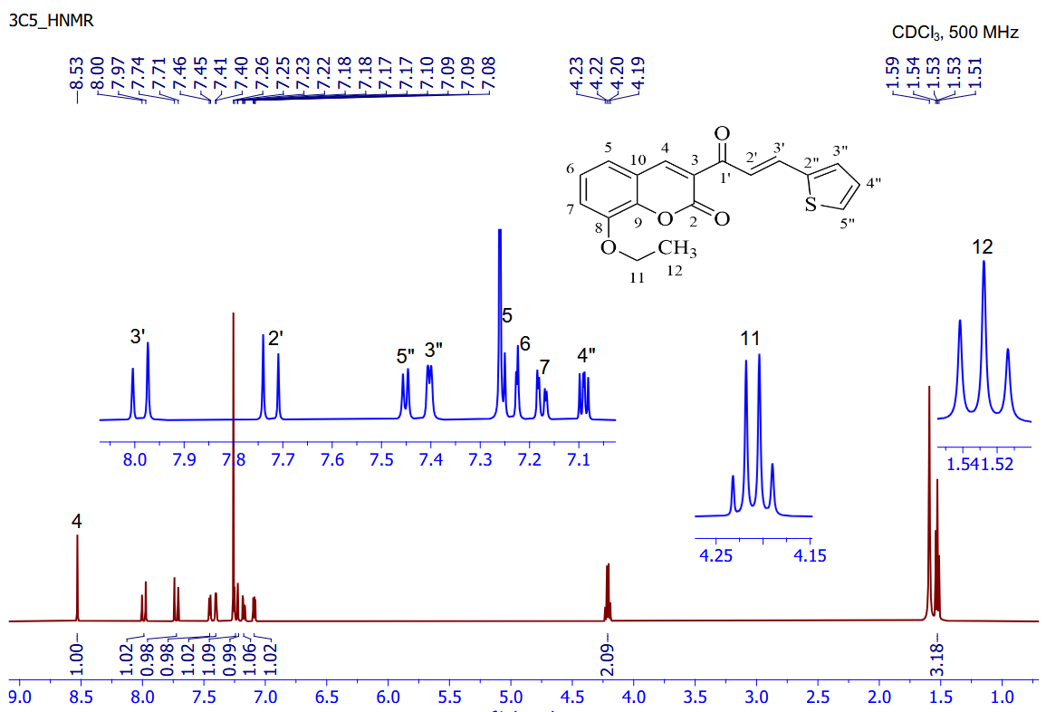
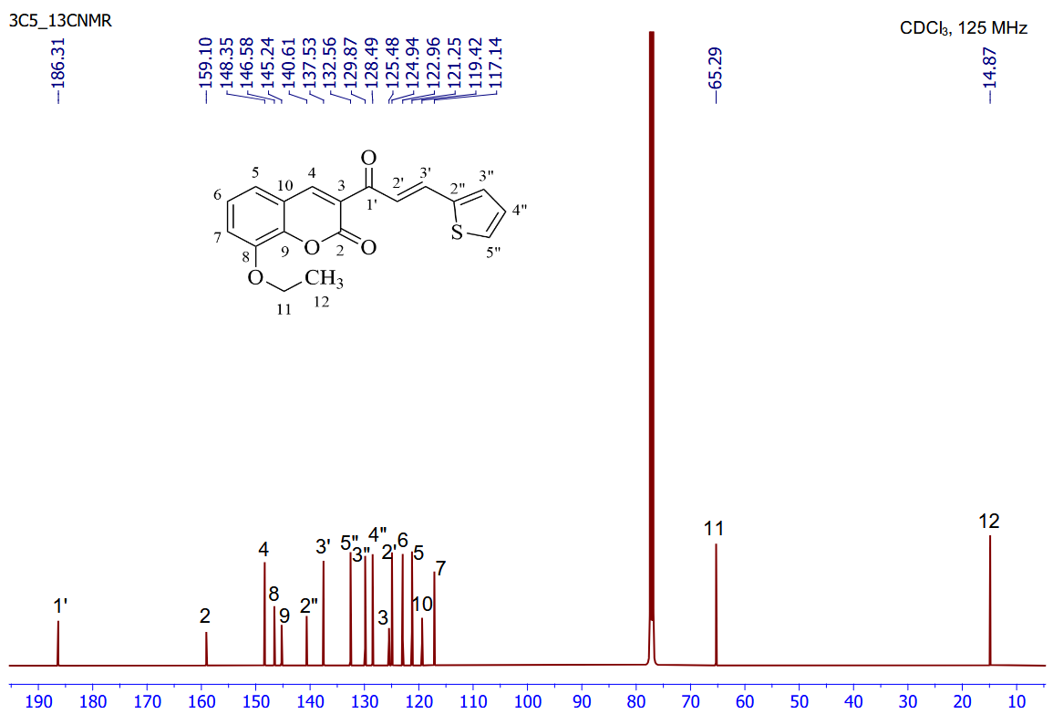

Figure S13. FT-IR, ¹H-NMR and ¹³C-NMR spectra of compound 3c. (500 MHz, CDCl₃).
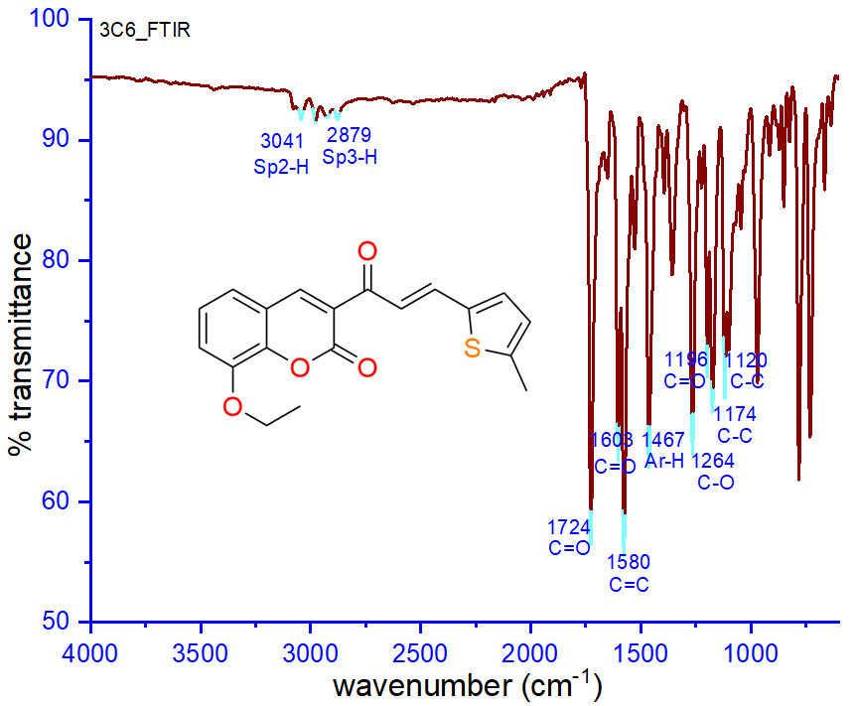
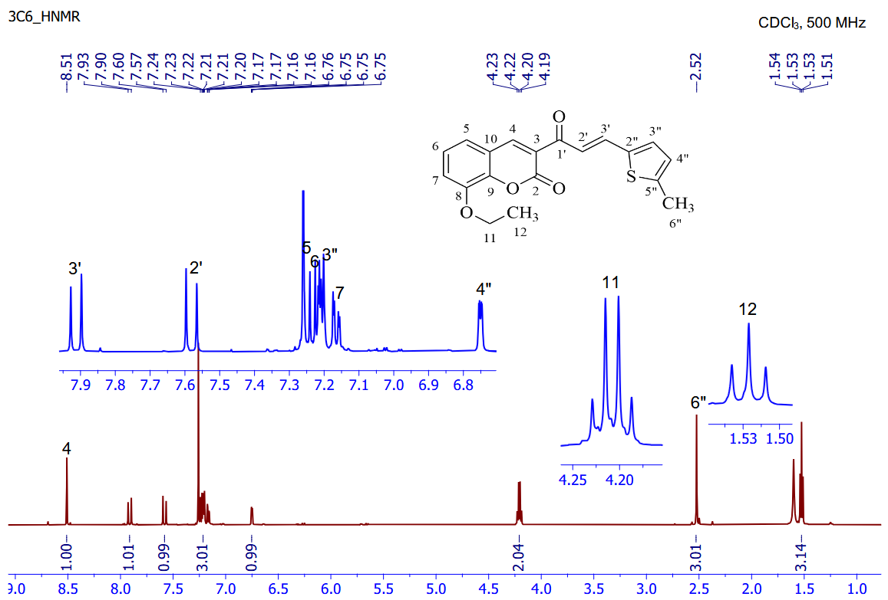
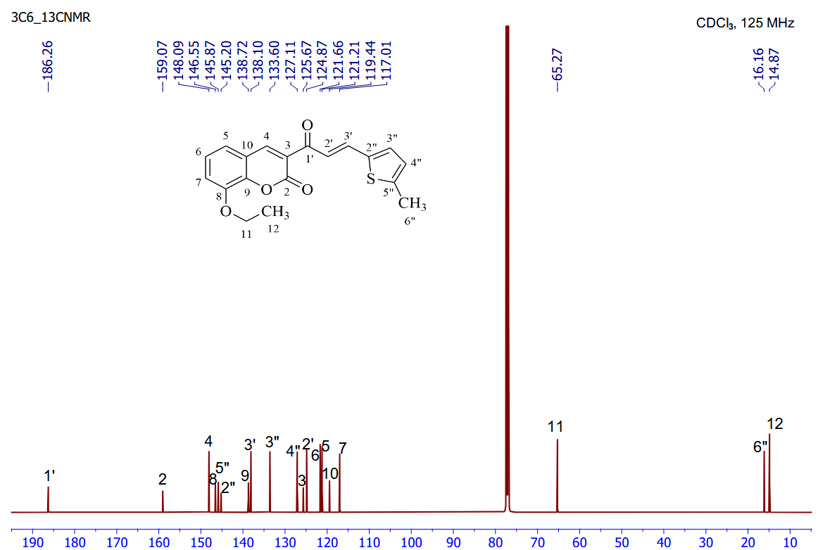

Figure S14. FT-IR, ¹H-NMR and ¹³C-NMR spectra of compound 3d. (500 MHz, CDCl₃).

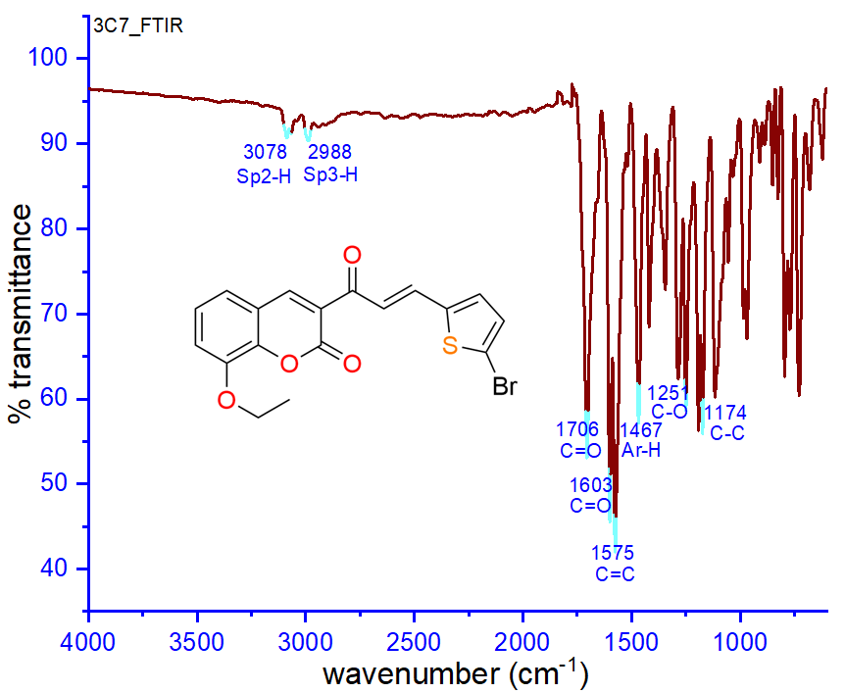
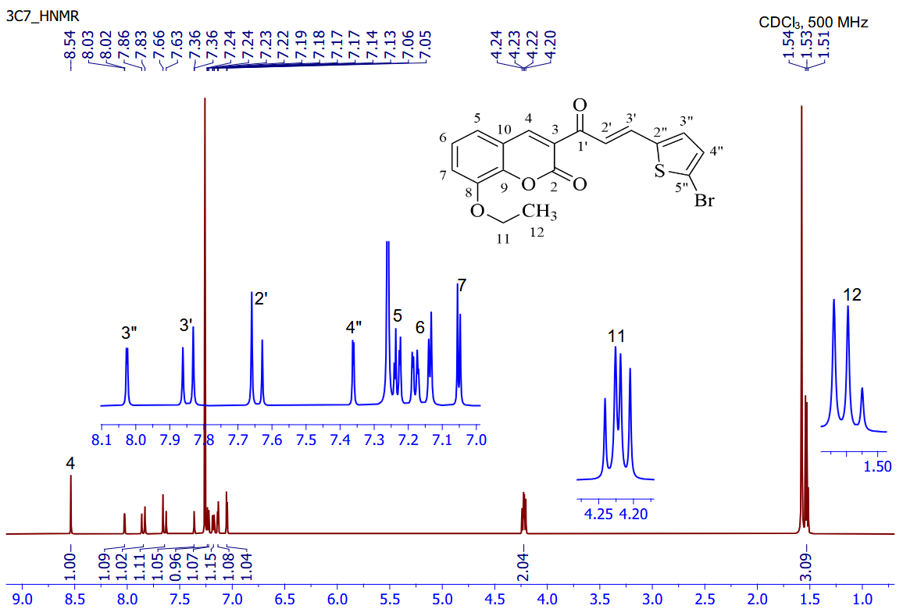
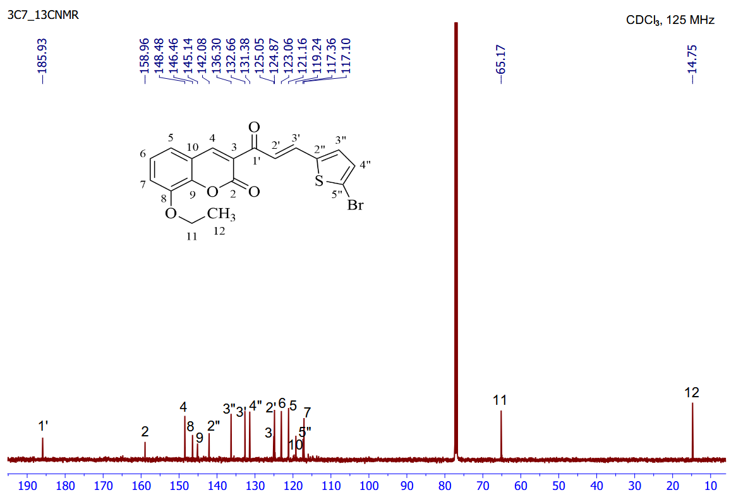

Figure S15. FT-IR, ¹H-NMR and ¹³C-NMR spectra of compound 3e. (500 MHz, CDCl₃).

