SUPPLEMENTARY INFORMATION
Astronomical calibration of the Jurassic–Cretaceous transition links cooling, calcification events, and Boreal–Tethyan carbon-cycle decoupling

Jihede Haj Messaoudª, Nicolas Thibault^{b}, Nicholas Boehmª, Thomas Finkbeinerª, Frans van Buchemª

Supplementary Note 1. Geological settings
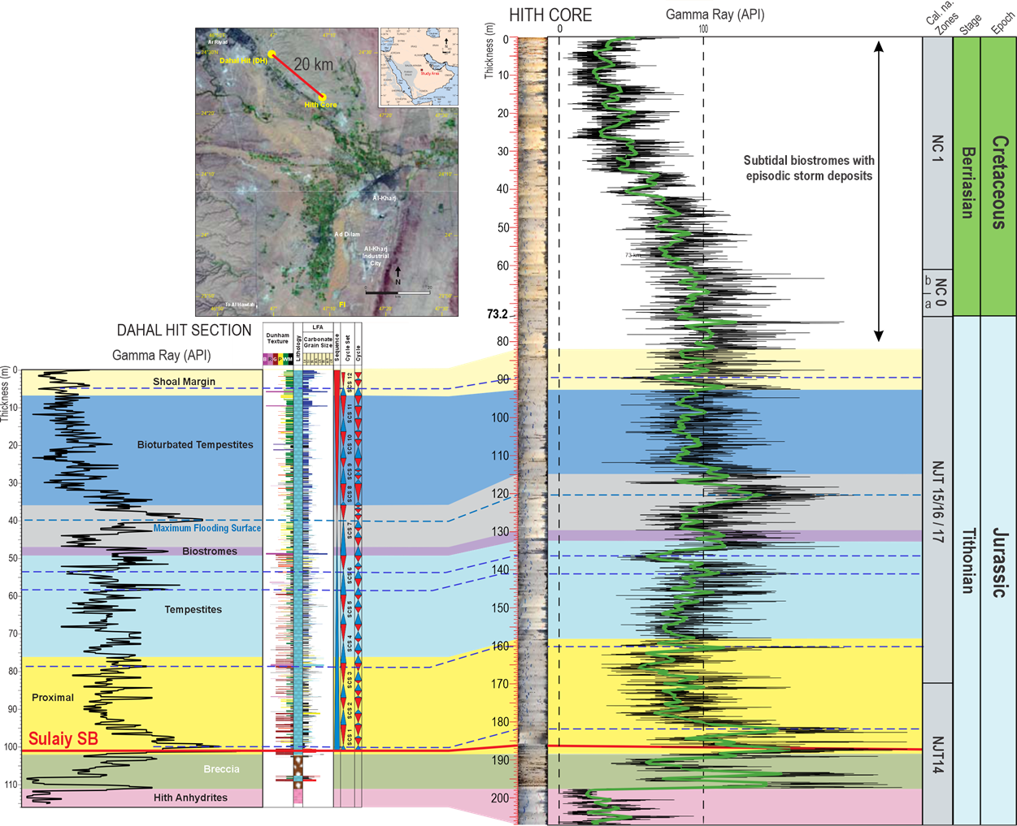
Figure S1. Geological setting, lithostratigraphy, and sequence-stratigraphic framework of the BH-02 core and Dahal Hit outcrop. (a) Satellite image showing the location of the BH-02 (Hith) core relative to the Dahal Hit outcrop (~20 km apart) in central Saudi Arabia. (b) Composite stratigraphic correlation between the Dahal Hit outcrop and the BH-02 core showing gamma-ray (GR) logs, lithology, facies associations, sequence boundaries (SB), maximum flooding surfaces (MFS), calcareous nannofossil biozones, and chronostratigraphic subdivisions.
BH-02 core and sampling strategy
The studied material comprises the continuously cored BH-02 (Hith) borehole, which penetrates the Upper Jurassic–Lower Cretaceous succession of the Sulaiy Formation in central Saudi Arabia. The core provides an exceptionally continuous record across the Tithonian–Berriasian interval, with a core recovery of approximately 100% and no evidence of major stratigraphic hiatuses. Sampling resolution was adjusted according to lithological variability and the distribution of key biostratigraphic events, with higher sampling density across the Jurassic–Cretaceous transition and other intervals of particular stratigraphic significance. For stable carbon and oxygen isotope analyses, sampling was restricted to the least-altered carbonate intervals. Prior to sampling, the core was systematically screened to identify intervals exhibiting the lowest degree of diagenetic alteration, avoiding stylolitized, recrystallized, fractured, or dolomitized horizons whenever possible. Fine-grained, homogeneous micritic limestones showing minimal evidence of secondary alteration were preferentially selected to maximize preservation of the primary marine isotopic signal. Calcareous nannofossil biostratigraphy is based on 96 samples collected throughout the studied interval. Following an initial screening to establish the preservation and distribution of nannofossil assemblages, sampling resolution was increased across intervals characterized by significant biostratigraphic turnover, particularly around the Jurassic–Cretaceous boundary. This variable-resolution sampling strategy provided a robust biostratigraphic framework while maximizing the temporal resolution of key bioevents
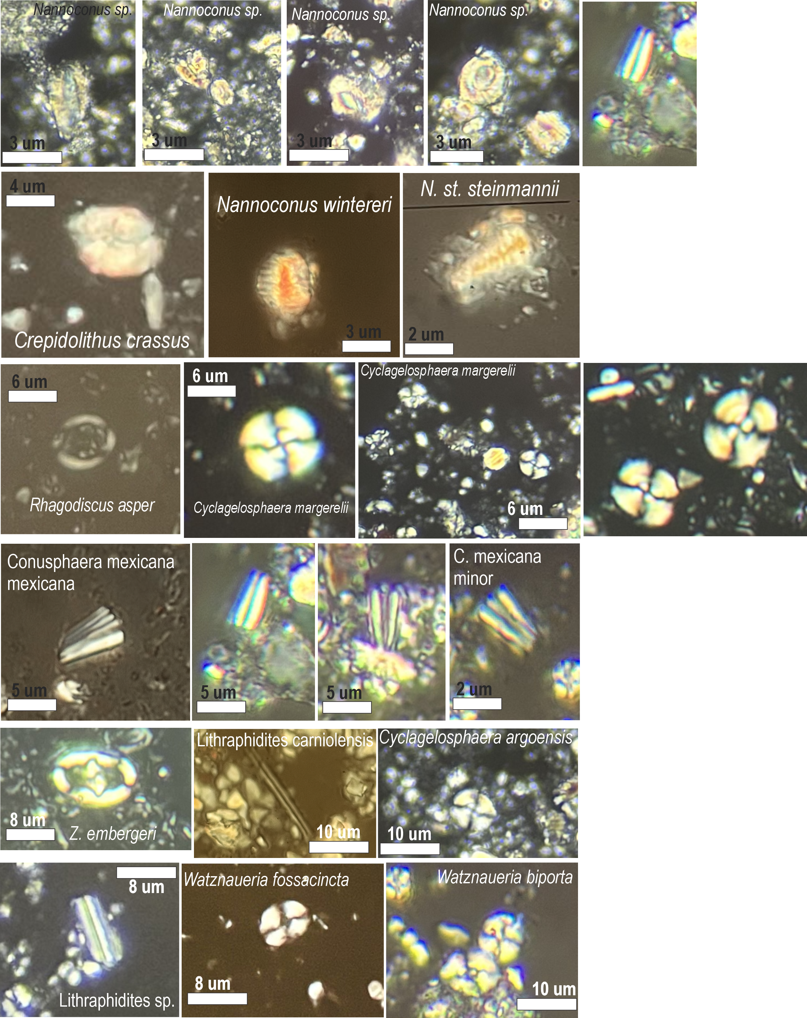
Figure S2. Representative photomicrographs of the principal calcareous nannofossil taxa identified in the Tithonian–Berriasian succession of the BH-02 core (Sulaiy Formation, central Saudi Arabia). for the calcareous nannofossil biostratigraphic framework presented in this study.
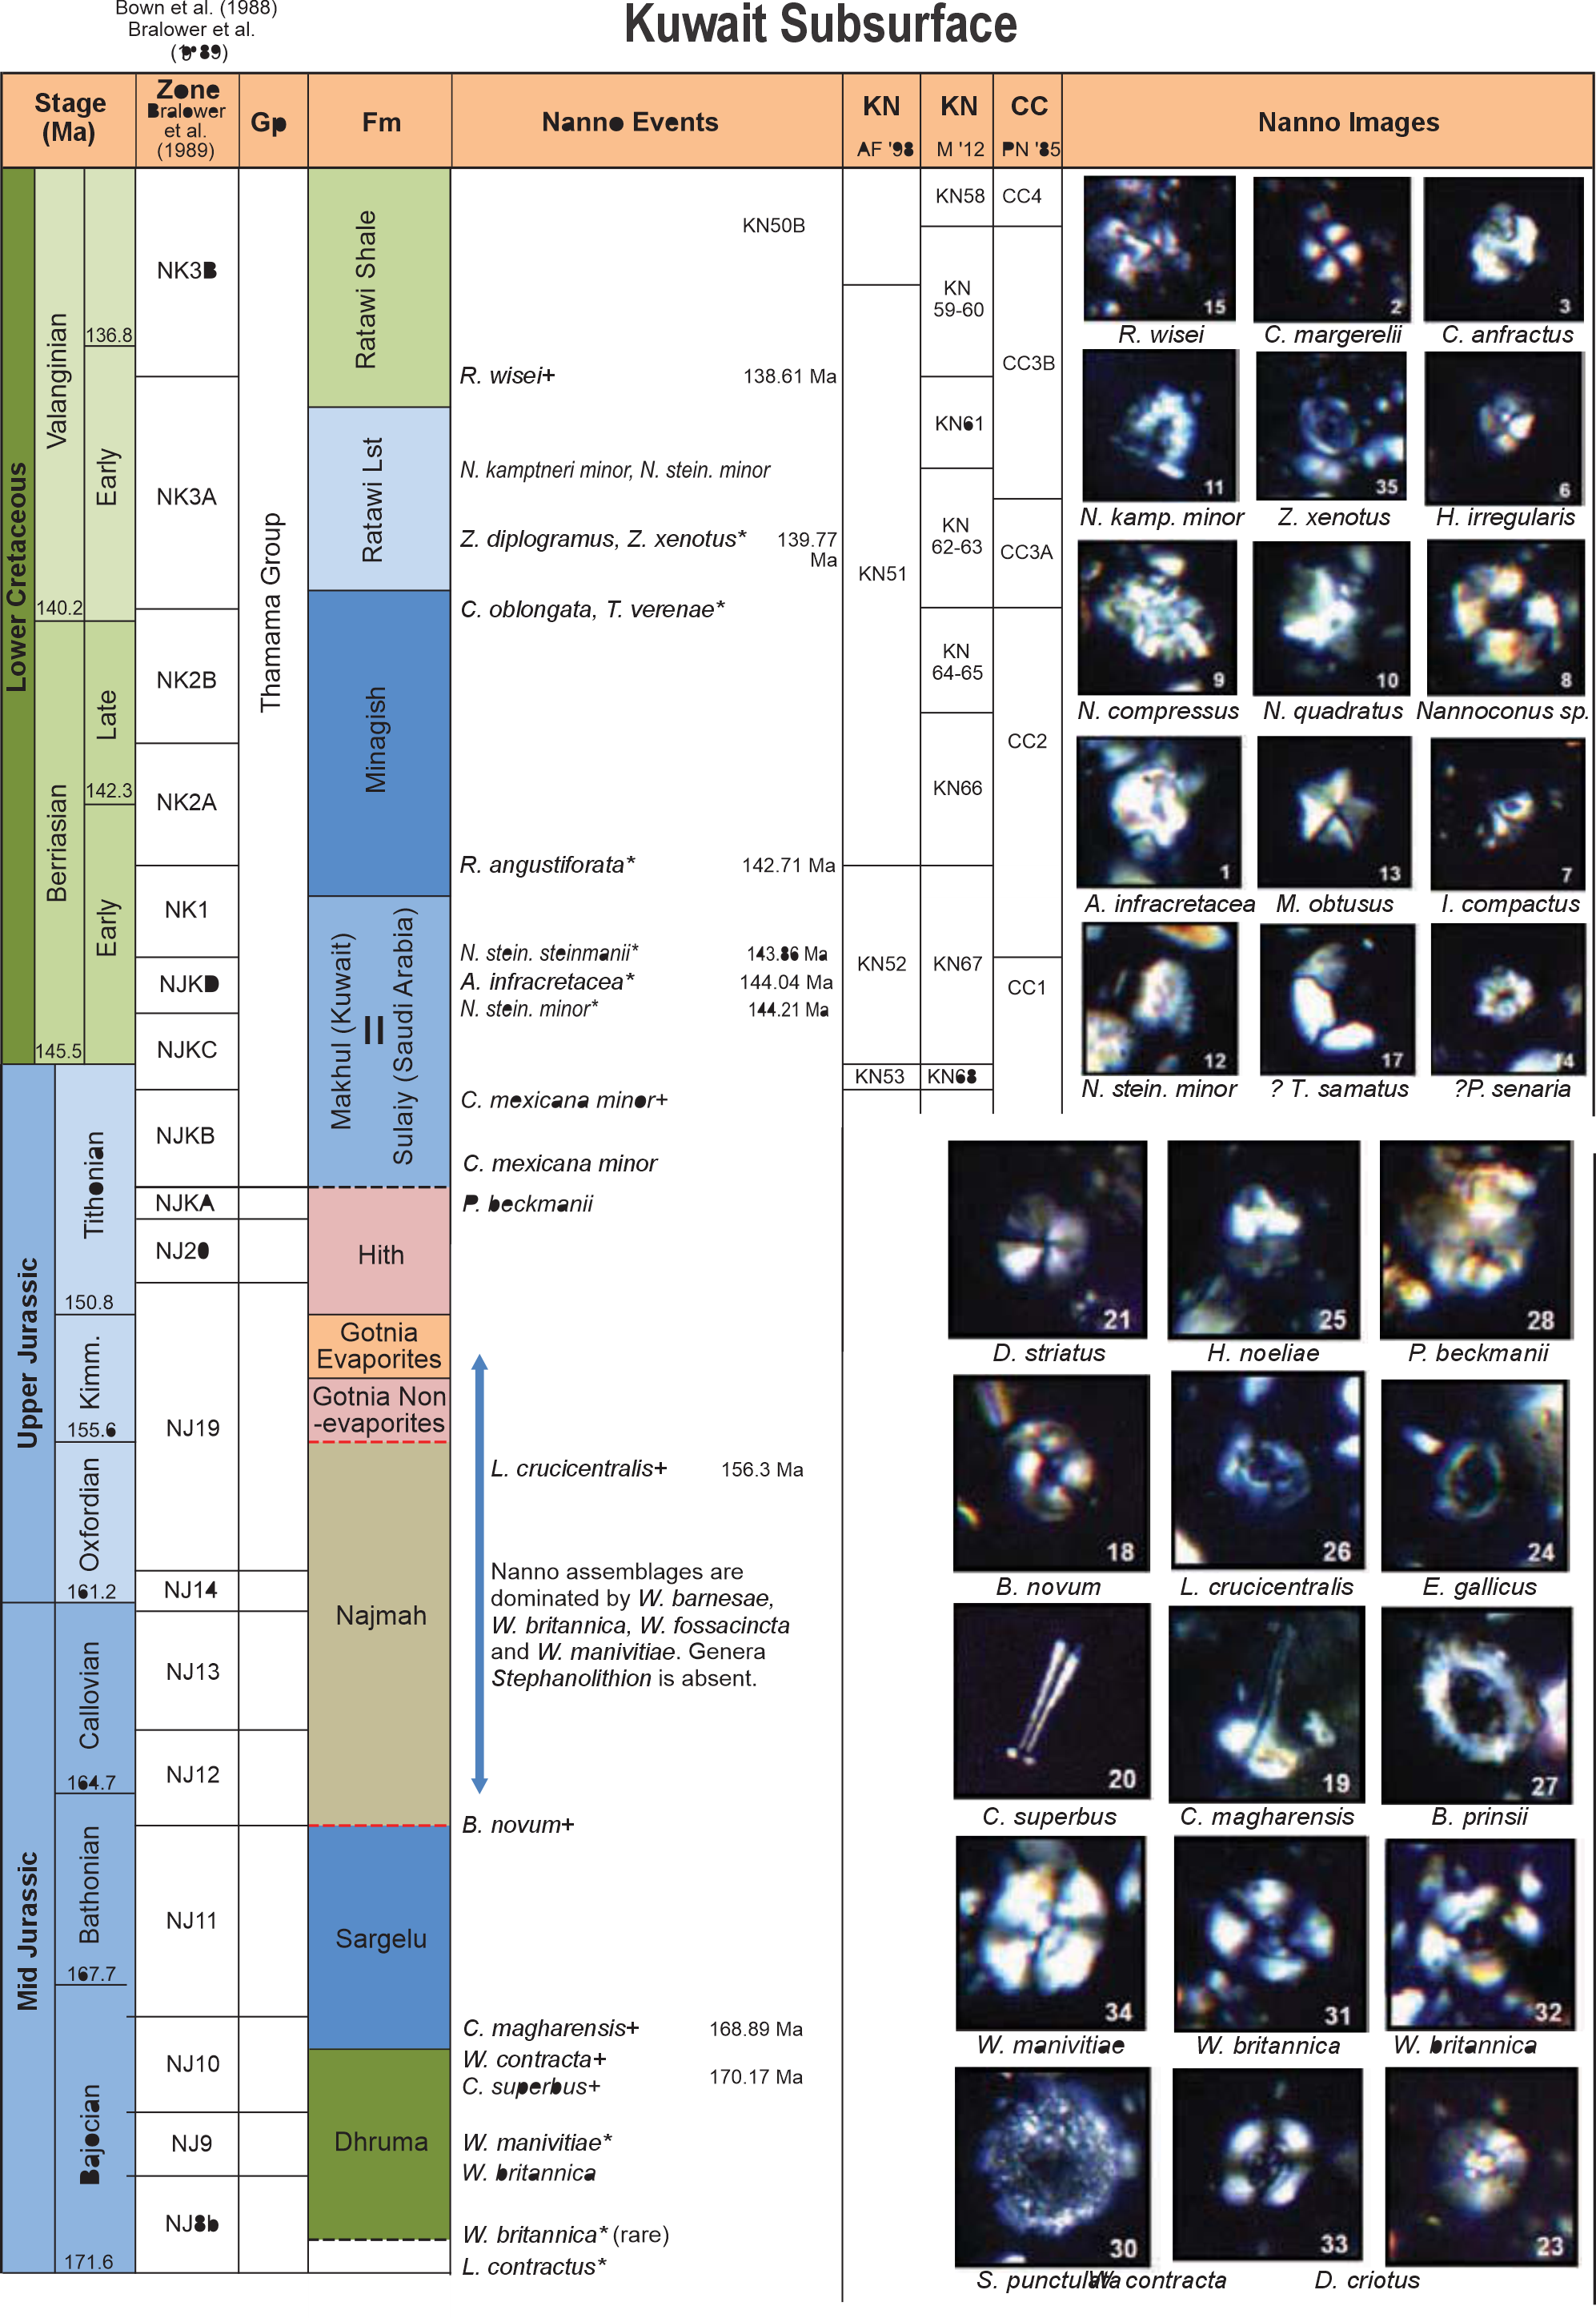
Figure S3. Regional calcareous nannofossil biostratigraphic framework for the Jurassic–Cretaceous transition in the northeastern Arabian Plate. The Kuwait subsurface succession, located immediately northeast of the Saudi Arabian study area, provides the best-constrained regional reference section for the Jurassic–Cretaceous transition. Owing to its highly comparable lithostratigraphy and nannofossil assemblages, it is used here as a regional biostratigraphic framework for the Sulaiy Formation. The Jurassic–Cretaceous boundary in the Kuwait succession is independently constrained using integrated calcareous nannofossil and calpionellid biostratigraphy, allowing robust regional correlation of the Saudi Arabian record. Representative nannofossil taxa and the principal bioevents defining the Upper Jurassic–Lower Cretaceous zonation are shown.
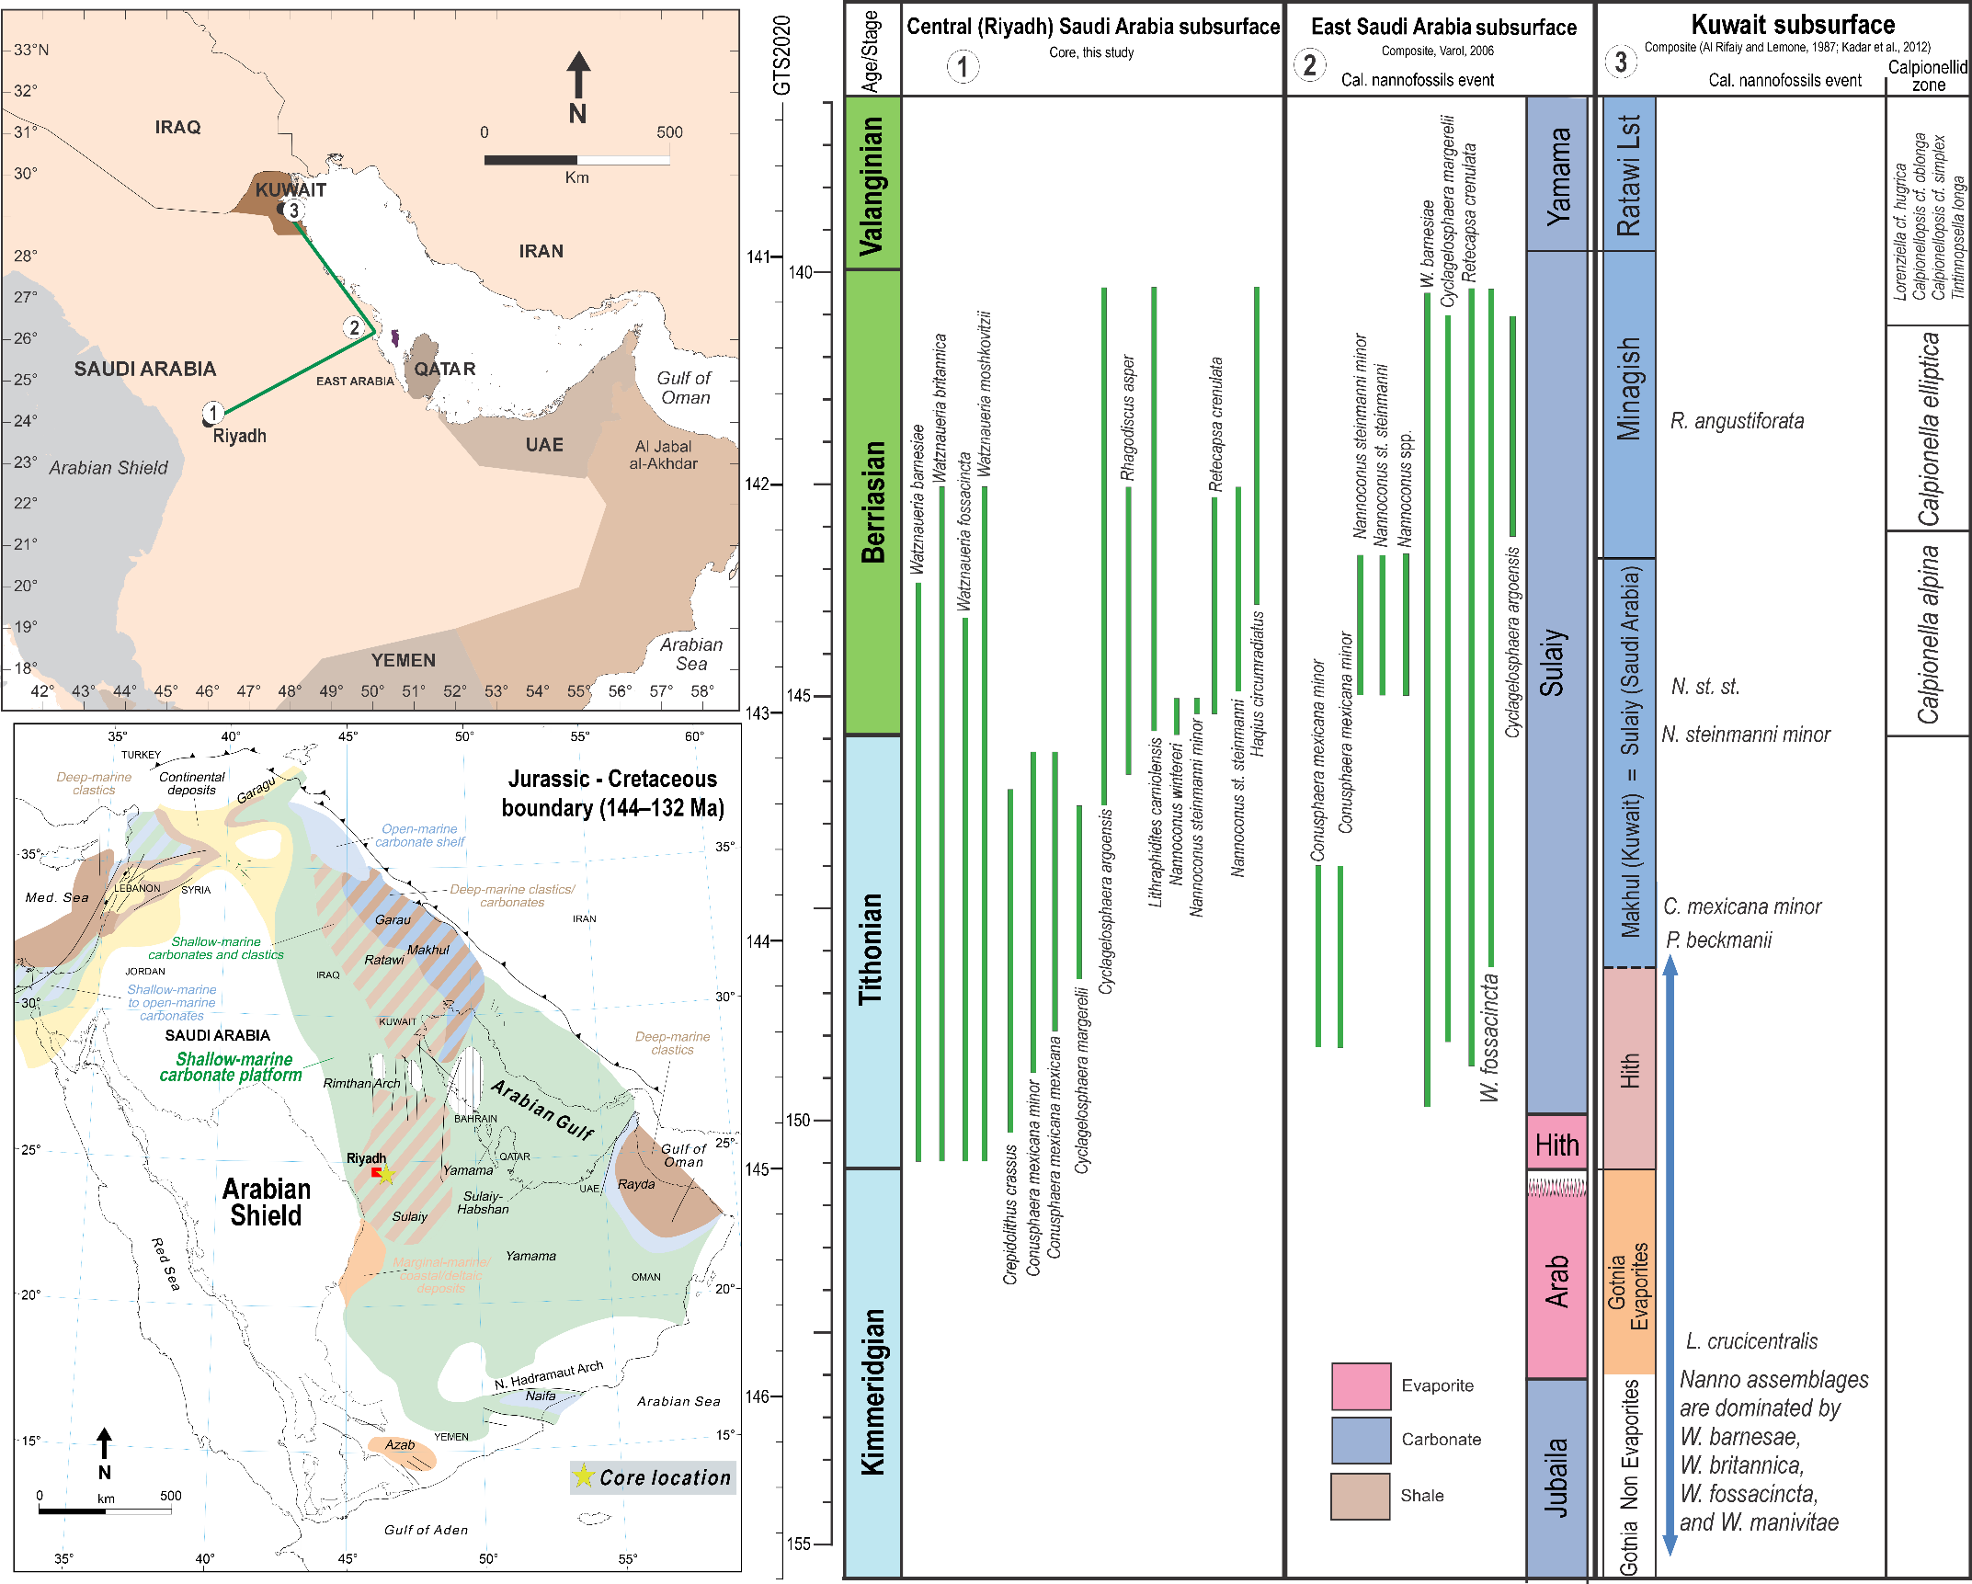
Figure S4. Regional stratigraphic and biostratigraphic correlation of the Tithonian–Berriasian succession across eastern Arabia. (a) Location of the studied BH-02 core in central Saudi Arabia and the reference sections used for regional correlation across eastern Arabia, including Kuwait. (b) Simplified paleogeographic map showing the distribution of Upper Jurassic–Lower Cretaceous formations across the Arabian Plate and the location of the studied core. (c) Regional correlation of lithostratigraphic units, calcareous nannofossil bioevents, and carbonate facies between the Saudi Arabian and Kuwait successions. The Sulaiy Formation of central Saudi Arabia is laterally equivalent to the Makhul and Sulaiy formations in Kuwait and can be correlated confidently using characteristic calcareous nannofossil bioevents. This regional framework demonstrates the continuity of the Tithonian–Berriasian carbonate platform across eastern Arabia and provides the basis for transferring the well-constrained Jurassic–Cretaceous boundary from the Kuwait reference succession, where it is independently calibrated using integrated calcareous nannofossil and calpionellid biostratigraphy, to the Saudi Arabian succession.

Supplementary Note 2.Definition of the Jurassic-Cretaceous boundary
The numerical age of the base of the Cretaceous remains uncertain because no Global Boundary Stratotype Section and Point (GSSP) has yet been formally ratified, and radiometric constraints across the Jurassic–Cretaceous (J–K) transition are limited. Although the Geologic Time Scale 2020 (GTS2020) places the boundary near the midpoint of magnetosubchron M19n.2n, its precise stratigraphic position is still under evaluation. In this study, the J–K boundary in the BH-02 core is placed using an integrated framework combining calcareous nannofossil biostratigraphy, astrochronology, and stratigraphic trends (Fig. 3). We adopt Option 2 of the Berriasian Working Group (Grabowski et al., 2026), which approximates the base of the Cretaceous by the first appearance datum (FAD) of Nannoconus wintereri (Casellato and Erba, 2021). This event occurs within magnetosubchron M19n.2n and closely coincides with the base of the Calpionella alpina Subzone, the traditional marker for the base of the Berriasian (Remane, 1986; Channell et al., 1987, 1995, 2010; Bralower et al., 1989; Gradstein et al., 2012; Gale et al., 2020; Wimbledon et al., 2020a,b).
Option 2 constrains the boundary to the interval between the base of M19n and the base of M18r, where multiple independent stratigraphic markers converge. This interval includes the C. alpina acme, the FAD of N. wintereri (base of the NC0a Subzone), and the subsequent appearances of Nannoconus steinmannii minor and N. kamptneri minor (base of the NC0b Subzone). Additional constraints are provided by ammonite zonal boundaries (including the former Berriasella jacobi Zone), the base of Radiolarian UAZ 14 near the base of M18r, and the well-defined magnetostratigraphic succession of M19n.2n, M19n.1r, and M18r.
Option 2 was selected because it integrates the most densely documented interval of the J–K transition, combining calpionellid, calcareous nannofossil, ammonite, radiolarian, and magnetostratigraphic data within a single correlation framework. In particular, the FAD of Nannoconus wintereri provides a highly reproducible nannofossil event that can be recognized even in successions lacking calpionellids, making it especially suitable for carbonate-platform and pelagic successions such as the BH-02 core.

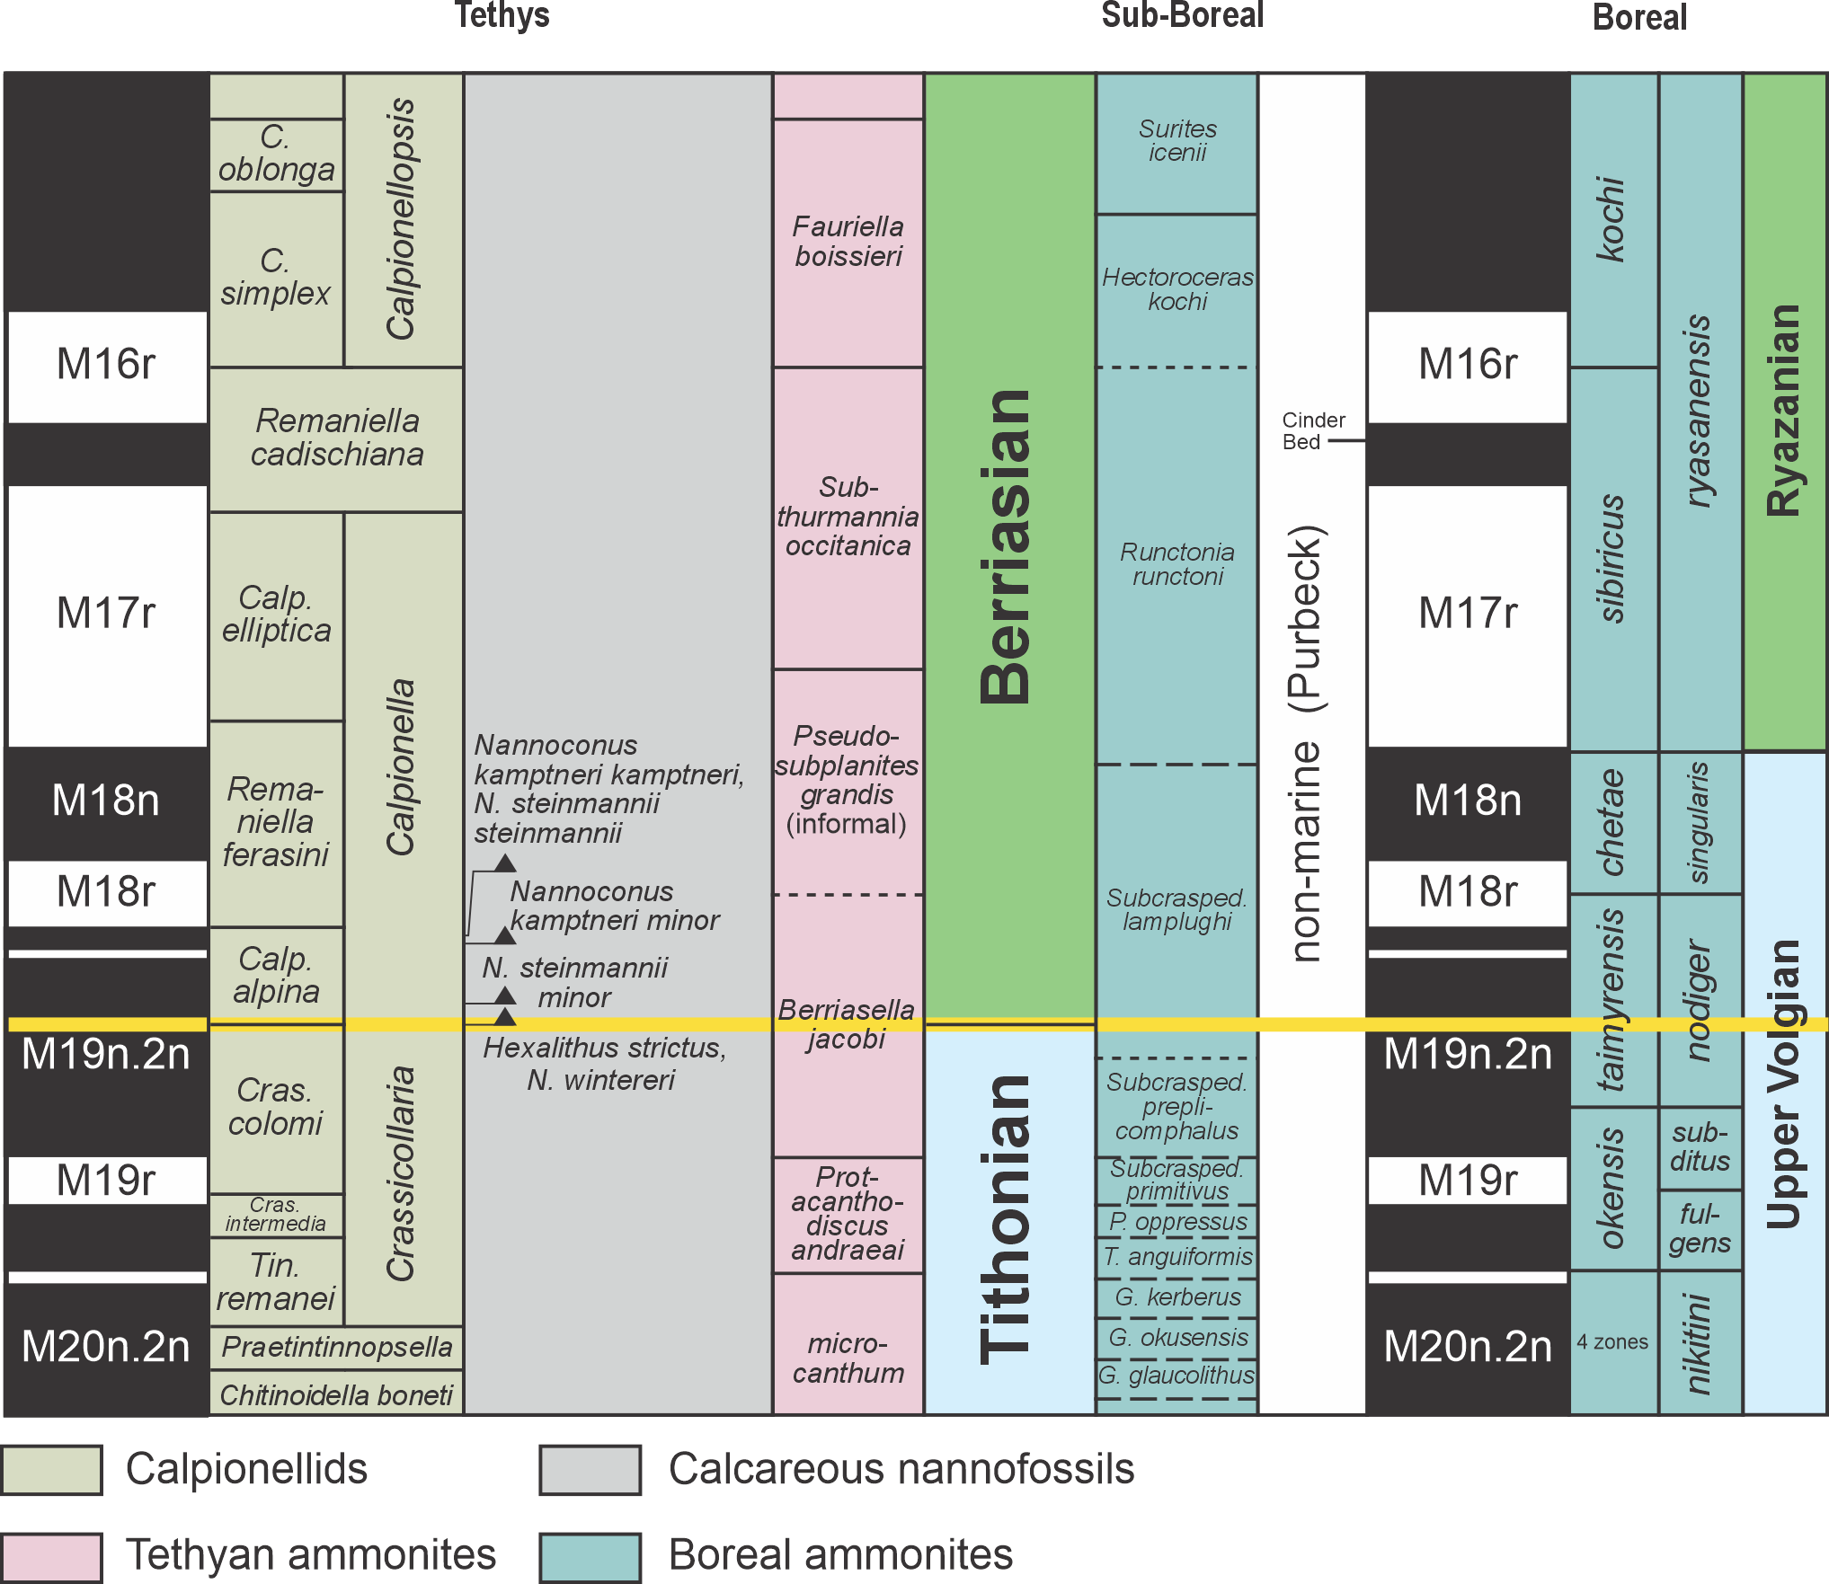
Figure S5. Integrated biostratigraphic framework for the Jurassic–Cretaceous transition showing the correlation of Tethyan, Sub-Boreal, and Boreal biostratigraphic zonations across the Tithonian–Berriasian interval. The figure integrates calpionellid, calcareous nannofossil, ammonite, and dinoflagellate cyst biozonations with the geomagnetic polarity timescale (M20n.2n–M16r). The yellow horizontal line marks the Jurassic–Cretaceous boundary, placed at the base of the Nannoconus wintereri Zone (equivalent to the base of the Berriasella jacobi Zone and the base of magnetic chron M19n.2n), illustrating the correlation between low-latitude Tethyan and higher-latitude Boreal successions. The framework highlights the principal biostratigraphic markers used for global correlation of the Tithonian–Berriasian transition.

Interregional Depth–Age Conversion
To facilitate direct comparison of carbon isotope records from Boreal, Tethyan, and Southern Hemisphere successions, all sections were converted from stratigraphic depth to numerical age within a unified and internally consistent chronostratigraphic framework. Only records characterized by adequate sampling density, robust stratigraphic architecture, and independent age constraints were included. This screening ensured that temporal correlations were based on reliable biostratigraphic, radioisotopic, and sequence stratigraphic control, thereby limiting uncertainties associated with poorly constrained successions.
Age models were developed by integrating ammonite and other biostratigraphic zonations with published radioisotopic ages and regionally established sequence stratigraphic frameworks. For Southern Hemisphere sections, ammonite zones were aligned with the Andean zonation scheme and correlated to the Sub-Mediterranean (Tethyan) standard zonation following the conventions of Leanza et al. (2020) and Vennari (2016). Numerical ages assigned to biozones were adopted from recent geochronological syntheses (Gale et al., 2020; Hesselbo et al., 2020; Ogg, 2020). Stratigraphic depths were transformed to numerical ages by linear interpolation between calibrated biozone or stage boundaries, assuming approximately constant sedimentation rates within each constrained interval. Sequence stratigraphic surfaces were employed as supplementary tie-points where biostratigraphic resolution alone was insufficient. All external datasets used for interregional comparison were recalibrated using the same protocol. Published stratigraphic frameworks were converted to numerical ages by extracting reported biozone or stage boundaries, calibrating them to the updated timescale, and linearly interpolating within constrained intervals. The application of this uniform depth–age conversion methodology across Boreal, Tethyan, and Southern Hemisphere records establishes a coherent temporal framework for evaluating the timing, synchronicity, and spatial extent of Jurassic–Cretaceous carbon cycle perturbations.
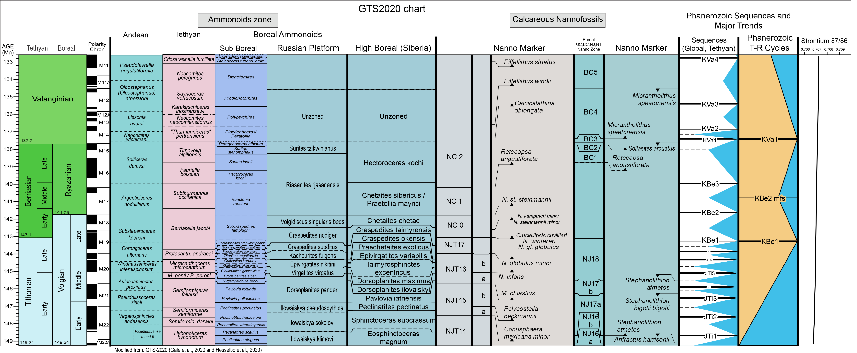
Figure S6. Integrated Late Jurassic–Early Cretaceous timescale (modified after Gale et al., 2020; Hesselbo et al., 2020) showing numerical ages of epoch/series and stage boundaries together with selected ammonite zones from the Tethyan and Sub-Boreal realms. Magnetostratigraphic correlations to the marine M-anomaly sequence and to Tethyan and Boreal ammonite zonations follow Gale et al. (2020) and Hesselbo et al. (2020). Andean ammonite biozones are correlated to their Tethyan counterparts after Leanza et al. (2020) and Vennari and Pujana (2017), with Valanginian Andean zonation after Aguirre-Urreta et al. (2008).

Gale, A., Mutterlose, J., Batenburg, S., Gradstein, F., Agterberg, F., Ogg, J., and Petrizzo, M., 2020, The Cretaceous Period, in Gradstein, F.M., Ogg, J.G., Schmitz, M.D., and Ogg, G.M., eds., Geologic Time Scale 2020: Amsterdam, Netherlands, Elsevier, p. 1023–1086, https://doi.org/10.1016/B978-0-12-824360-2.00027-9.
Hesselbo, S., Ogg, J., Ruhl, M., Hinnov, L., and Huang, C., 2020, The Jurassic Period, in Gradstein, F.M., Ogg, J.G., Schmitz, M.D., and Ogg, G.M., eds., Geologic Time Scale 2020: Amsterdam, Netherlands, Elsevier, p. 955–1021, https://doi.org/10.1016/B978-0-12- 824360-2.00026-7
Ogg, J., 2020, Geomagnetic polarity time scale, in Gradstein, F.M., Ogg, J.G., Schmitz, M.D., and Ogg, G.M., eds., Geologic Time Scale 2020: Amsterdam, Netherlands, Elsevier, p. 159–192, https://doi.org/10.1016/B978-0- 12-824360-2.00005-

Supplementary Note 3. Cyclostratigraphy and time series analysis
Downhole gamma-ray (GR) and potassium (K) logs from the BH-02 core were acquired at high vertical resolution, providing continuous records of lithological and paleoenvironmental variability. The GR signal in the Tithonian–Berriasian carbonate succession is primarily controlled by the abundance of clay minerals and K-bearing aluminosilicates associated with terrigenous input. Consequently, higher GR values reflect increased clay-rich siliciclastic influx, whereas lower values correspond to cleaner carbonate and evaporitic intervals.
Variations in GR are interpreted to record orbitally driven changes in continental weathering, runoff, sediment supply, and relative sea level. During relatively humid phases, enhanced weathering and fluvial transport increased the delivery of clay minerals to the basin, producing elevated GR values. In contrast, more arid conditions favoured carbonate production, reduced siliciclastic input, and lower GR values. The climatic signal is further amplified by facies-dependent dilution effects, whereby carbonate-rich shoal deposits exhibit consistently low GR values, while quieter offshore and transitional settings preferentially accumulate clay-rich sediments with higher natural radioactivity. As a result, the GR record provides a robust proxy for astronomically forced fluctuations in climate, sediment supply, and accommodation.
Although the cyclostratigraphic analyses presented here primarily use the GR record because of its continuous acquisition and high signal-to-noise ratio, the potassium (K) log exhibits nearly identical cyclic behaviour. Since K is predominantly hosted in clay minerals and relatively immobile during early diagenesis, it provides an independent and equally reliable proxy for cyclostratigraphic analysis, supporting the orbital interpretation of the GR record.
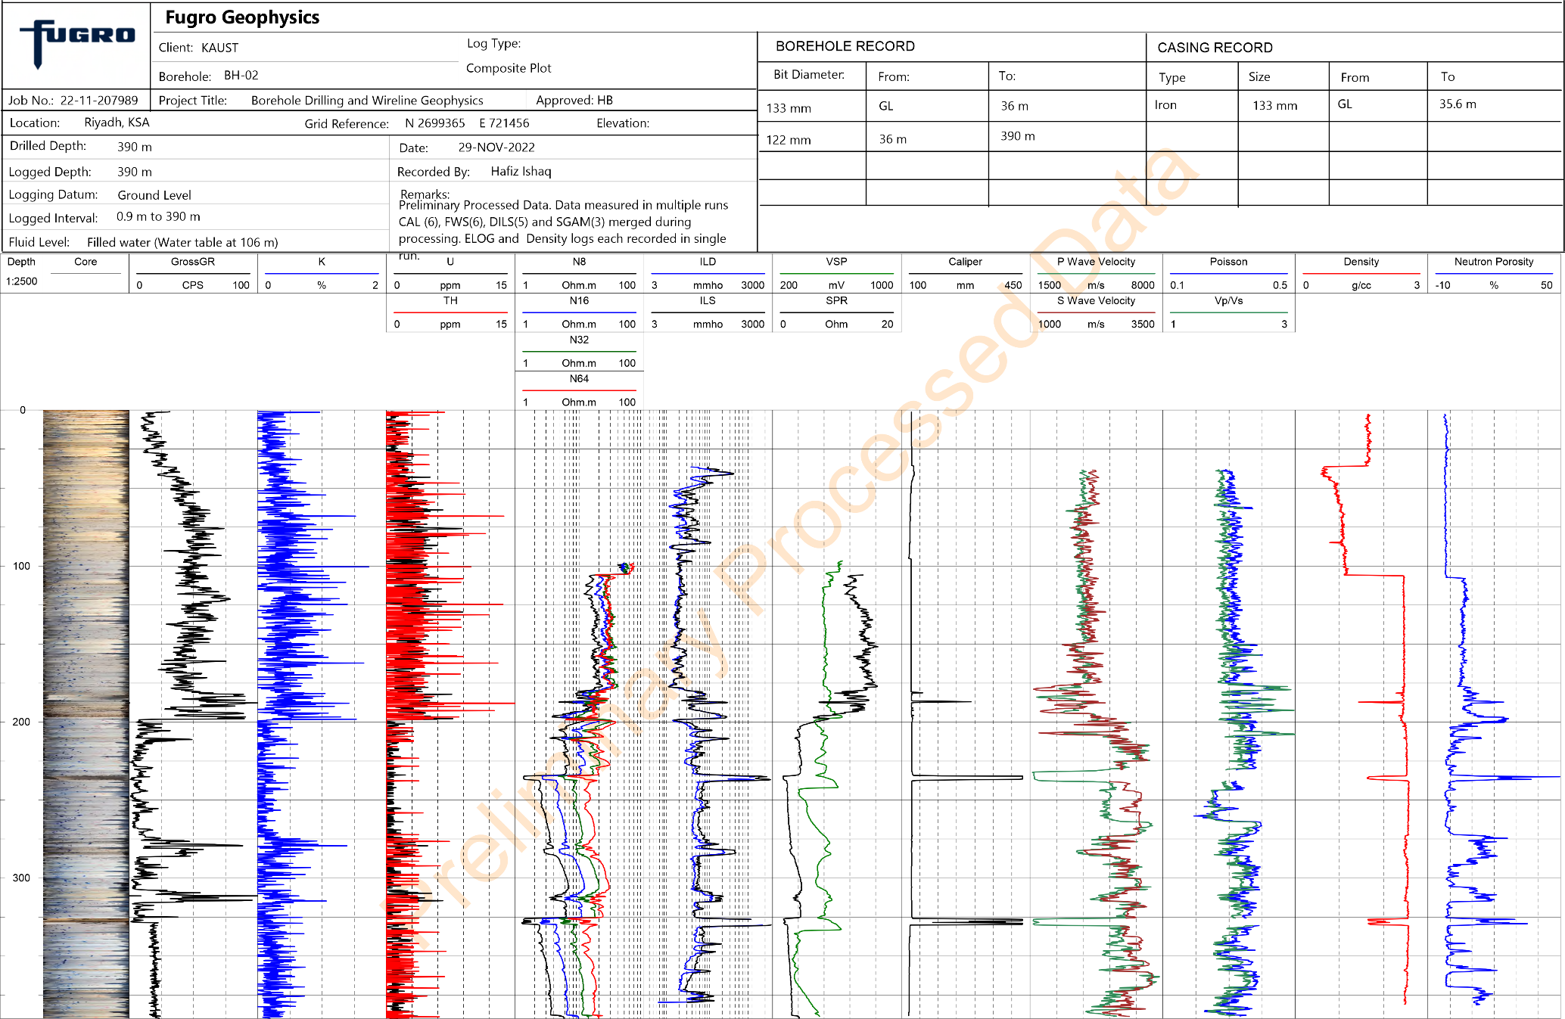
Figure S7. Composite wireline log of the BH-02 borehole (central Saudi Arabia) acquired by Fugro Geophysics. The log includes the optical borehole image, total gamma-ray (GR), potassium (K), thorium (Th), electrical resistivity (16-, 32-, and 64-inch normal resistivity), induction conductivity, spontaneous potential (SP), caliper, P-wave velocity, Poisson’s ratio, bulk density, and neutron porosity. The continuous high-resolution GR and K records were used as the primary datasets for cyclostratigraphic analysis because they provide sensitive proxies for variations in terrigenous input, clay mineral abundance, and carbonate dilution. These records form the basis for the astronomical tuning and spectral analyses presented in this study.

Spectral gamma-ray interpretation
The spectral gamma-ray logs (U, K and Th) exhibit relatively stable background concentrations throughout the Sulaiy Formation, with no major long-term increase or decrease and no discernible change across the Jurassic–Cretaceous boundary. Uranium and potassium remain remarkably uniform over the studied interval despite short-wavelength fluctuations, indicating that the succession was deposited under relatively stable environmental conditions without significant changes in the influx of radioactive elements or clay-bearing detritus.
Thorium concentrations are consistently low throughout the section but display numerous recurring narrow peaks. Because thorium is generally associated with the detrital fraction and is relatively immobile during diagenesis, these repetitive excursions most likely record periodic pulses of siliciclastic input. The absence of any sustained increase in Th suggests that continental weathering intensity and terrigenous sediment supply remained generally low during deposition of the Sulaiy Formation. Instead, the preserved cyclic pattern indicates repeated, low-amplitude fluctuations in detrital delivery, consistent with orbitally paced variations in weathering, runoff, or sediment transport rather than major climatic or tectonic reorganizations.
Overall, the spectral gamma-ray data indicate a remarkably stable depositional system characterized by limited long-term changes in continental weathering and terrigenous influx. The well-preserved cyclicity, particularly in the thorium record, demonstrates that although detrital input remained low, it varied systematically through time, supporting the interpretation of orbitally modulated environmental variability superimposed on an otherwise stable carbonate depositional setting.
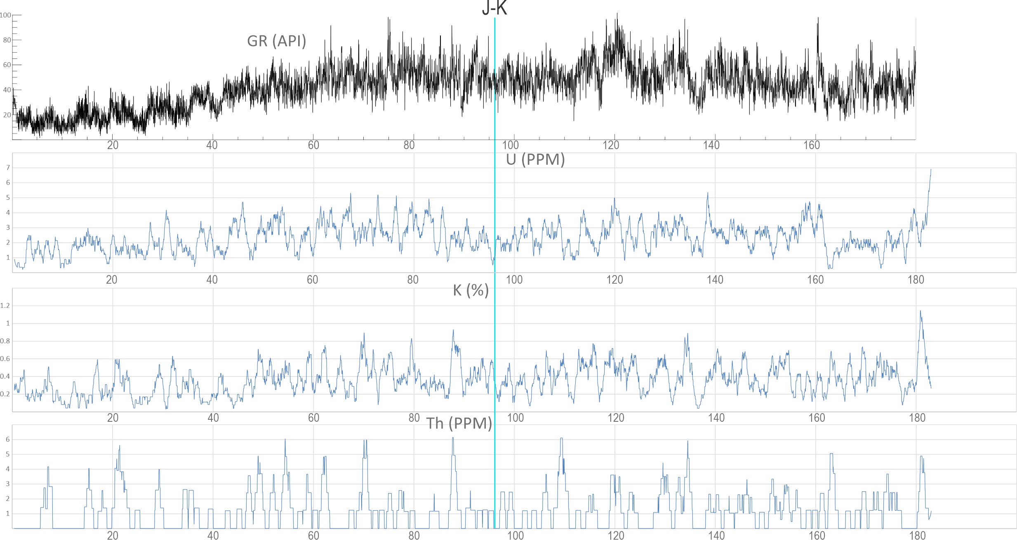
Figure S8. Continuous downhole gamma-ray (GR) and spectral gamma-ray logs (U, K, and Th) through the Tithonian–Berriasian Sulaiy Formation (BH-02 core, central Saudi Arabia). The cyan vertical line marks the position of the Jurassic–Cretaceous (J–K) boundary, placed at the first occurrence of Nannoconus wintereri. Total gamma-ray (GR) values show moderate variability throughout the succession, whereas the spectral components (U, K, and Th) display no significant long-term trends or abrupt shifts across the J–K boundary, indicating relatively stable depositional conditions and limited long-term variations in terrigenous input during Sulaiy deposition. Thorium concentrations remain consistently low but exhibit repetitive, narrow peaks that reflect cyclic, low-amplitude pulses of detrital input, consistent with orbitally paced fluctuations in continental weathering and sediment supply rather than major changes in provenance or weathering intensity. Overall, the spectral gamma-ray data support deposition under persistently low siliciclastic influx within a stable carbonate platform setting.
Statistical Cyclostratigraphic Analysis Methodology
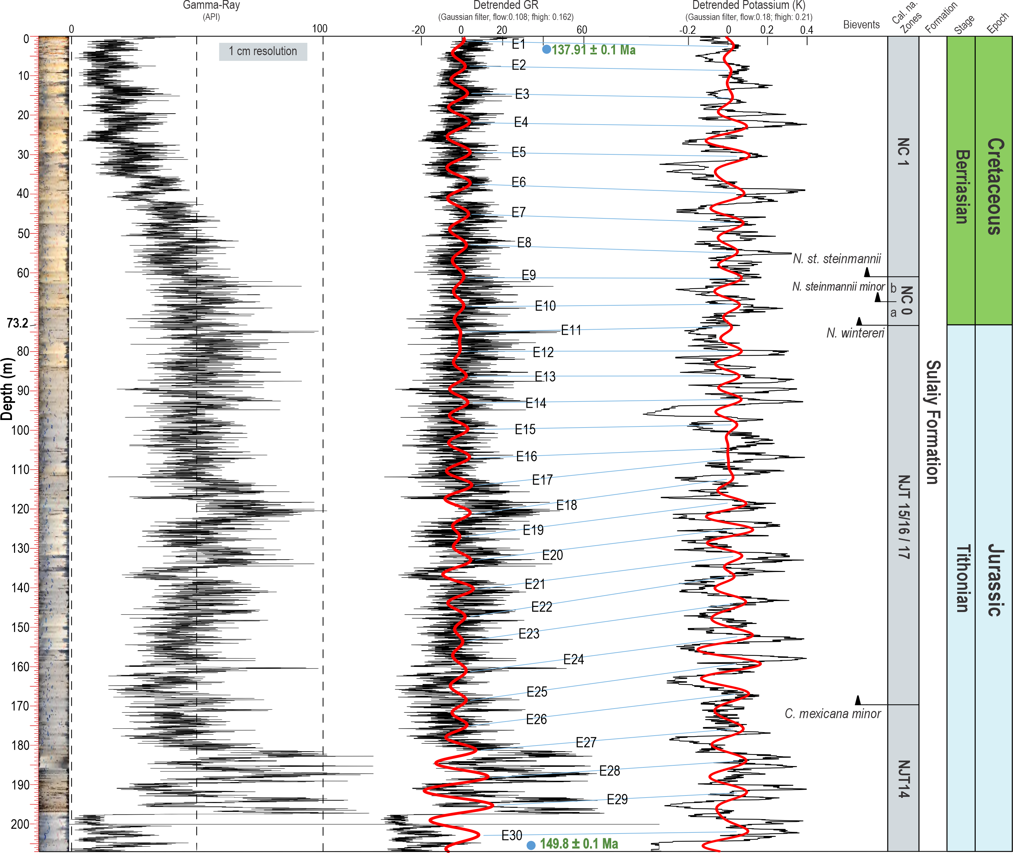
Figure S9. High-resolution gamma-ray (GR) record and cyclostratigraphic interpretation of the Tithonian–Berriasian interval in the BH-02 core, central Saudi Arabia. From left to right: optical borehole image, raw gamma-ray (GR) log acquired at 1-cm resolution, detrended GR record with the interpreted long-eccentricity (405-kyr) cycles (E1–E30; red curve), and high-pass filtered GR record highlighting short-eccentricity variability. Blue tie lines correlate successive 405-kyr cycle boundaries between the two filtered records. Calcareous nannofossil bioevents, including the first occurrences of Conusphaera mexicana minor, Nannoconus wintereri, N. steinmannii minor, and N. steinmannii steinmannii, provide independent biostratigraphic constraints on the astronomical interpretation. The integrated framework places the studied interval between 149.8 ± 0.1 Ma and 137.9 ± 0.1 Ma, spanning the Tithonian–Berriasian succession of the Sulaiy Formation. The first appearance of Nannoconus wintereri marks the position adopted for the Jurassic–Cretaceous boundary in this study, following Option 2 of the Berriasian Working Group.
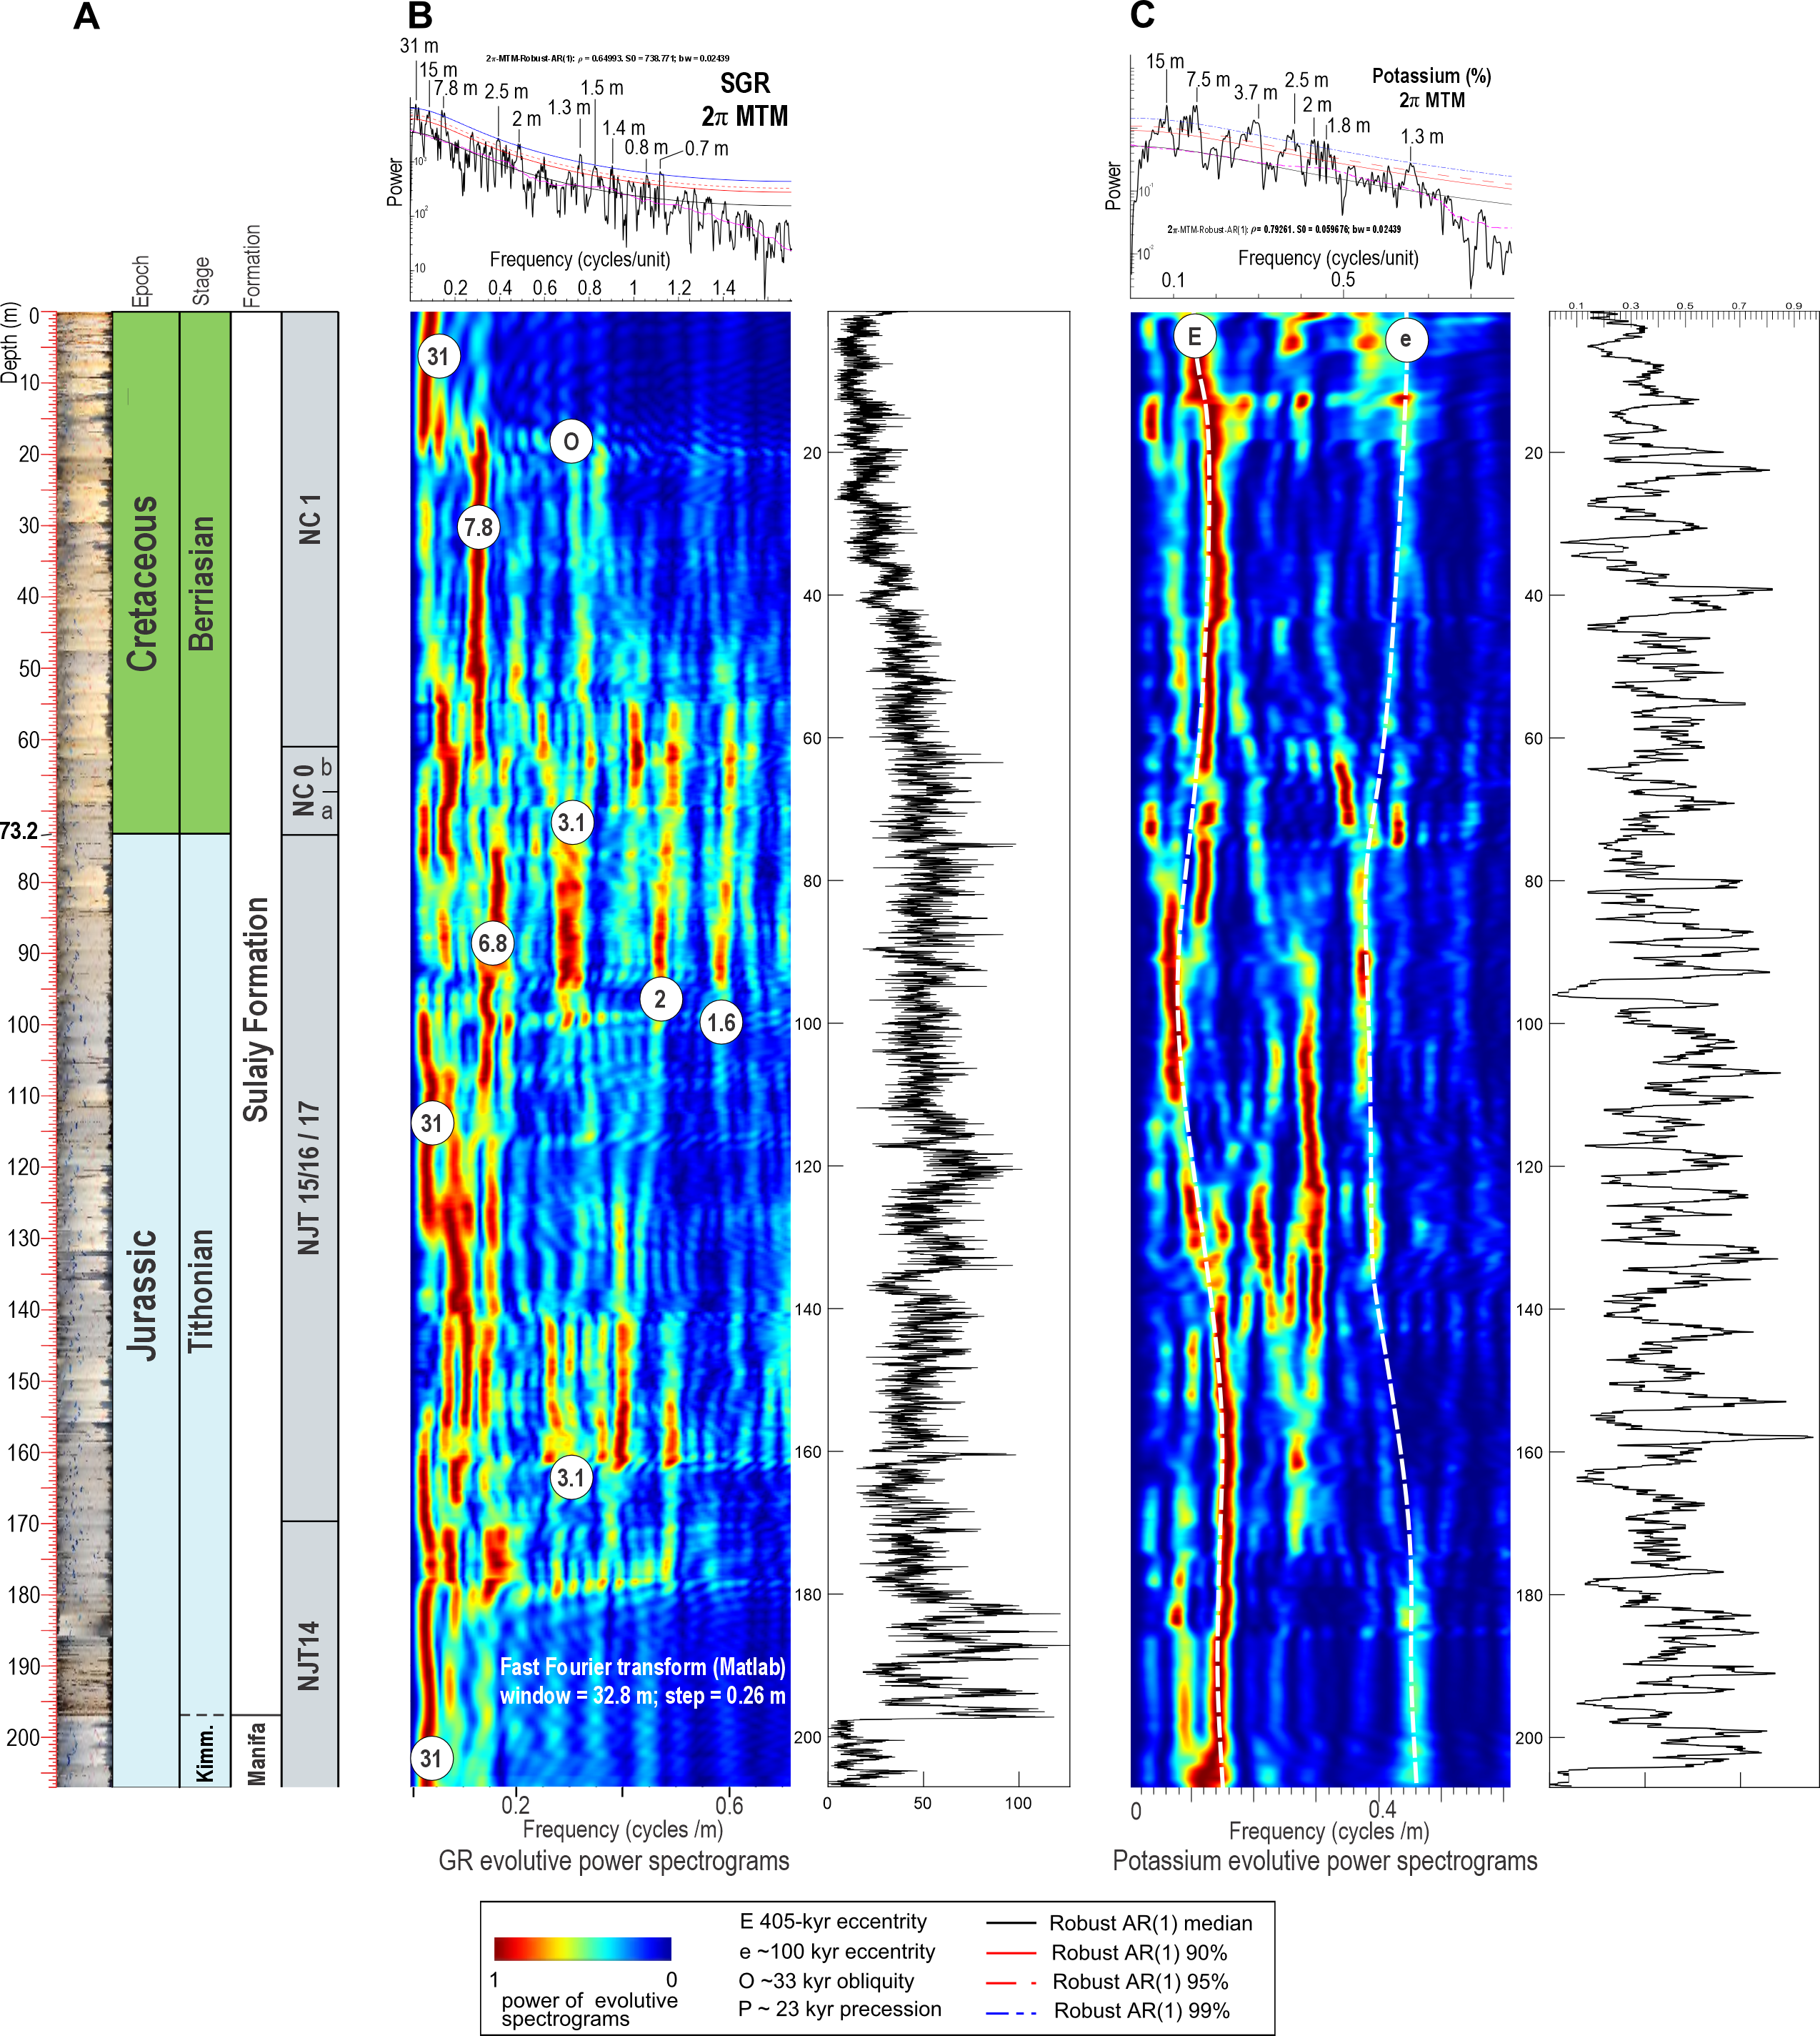
Figure S10. Spectral characteristics of the BH-02 gamma-ray (GR) and potassium (K) records across the Tithonian–Berriasian succession. (A) Composite stratigraphic framework showing the optical borehole image, depth, lithostratigraphy, chronostratigraphy, and calcareous nannofossil biozonation. (B) Evolutive harmonic analysis (EHA) of the gamma-ray (GR) record. The upper panel shows the multitaper method (MTM) power spectrum with significant spectral peaks and their corresponding wavelengths, while the lower panel presents the EHA spectrogram highlighting the vertical evolution of orbital cyclicity. Significant spectral bands corresponding to long eccentricity (~405 kyr; E), short eccentricity (~100 kyr; e), obliquity (~33 kyr; O), and precession (~23 kyr; P) are indicated. Dashed and solid lines represent the expected orbital frequencies based on the tuned sedimentation-rate model and the 90%, 95%, and 99% robust AR(1) confidence levels. (C) Equivalent MTM spectrum and EHA spectrogram for the potassium (K) record, showing a spectral structure closely matching that of the GR record. The strong agreement between the GR and K datasets demonstrates that both proxies preserve the same astronomically forced cyclicity, supporting the use of the GR record as the primary cyclostratigraphic proxy and confirming the robustness of the orbital interpretation.
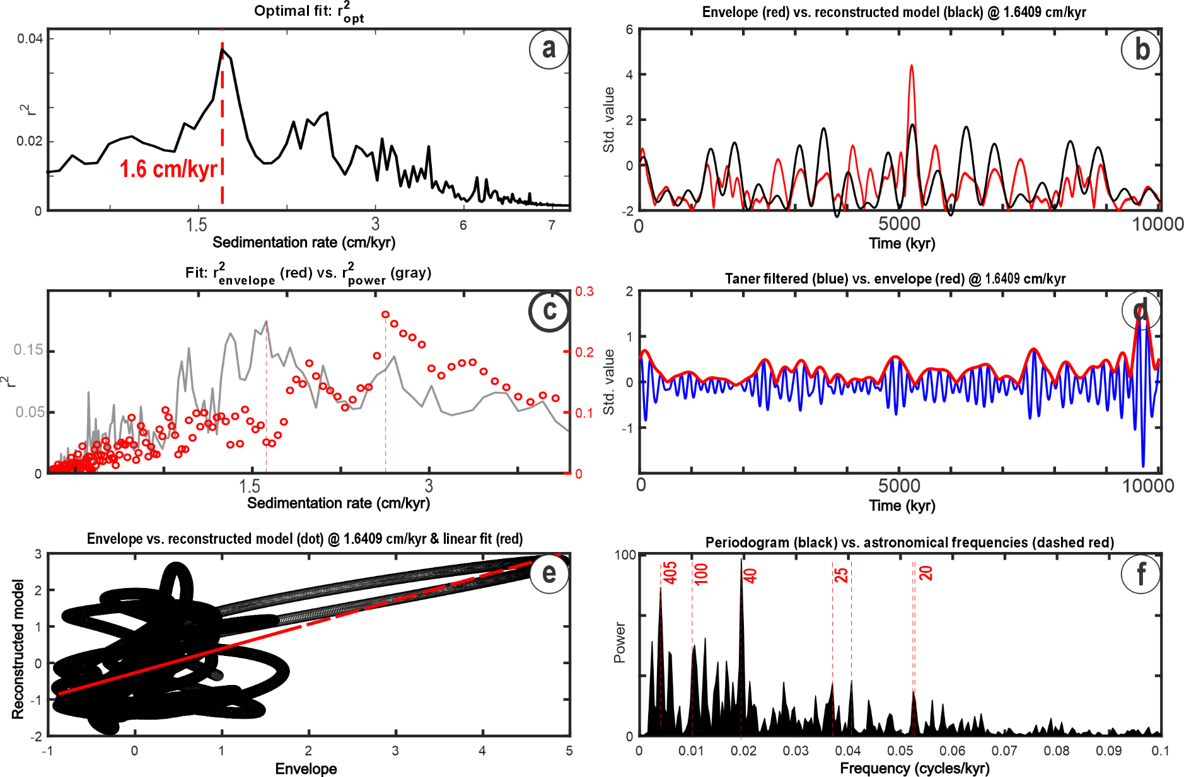Figure S11. Statistical evaluation and spectral characterization of the tuned gamma-ray (GR) record used for astronomical calibration. (a) Correlation coefficient (R²) as a function of tested sedimentation rates, identifying an optimal mean sedimentation rate of 1.6 cm kyr⁻¹ for tuning to the 405-kyr eccentricity cycle. (b) Comparison between the band-pass filtered GR signal (black) and the target 405-kyr eccentricity solution (red), illustrating the close agreement between the sedimentary record and the astronomical target. (c) Evolution of the correlation coefficient (R²; grey line) and statistical significance (red circles) across the range of tested sedimentation rates, with the vertical dashed line indicating the optimum solution adopted for the astrochronological framework. (d) Residual analysis comparing the astronomical target (red) and the tuned GR signal (blue), demonstrating generally low residuals and a robust fit throughout the record. (e) Phase-space (attractor) plot of the tuned signal showing the regularity and continuity of the extracted orbital cyclicity. (f) Multitaper Method (MTM) power spectrum of the astronomically tuned GR record, showing significant spectral peaks corresponding to the 405-kyr long eccentricity cycle and the ~100-, ~40-, ~23-, and ~20-kyr Milankovitch periodicities, confirming preservation of the complete hierarchy of orbital forcing in the BH-02 succession.
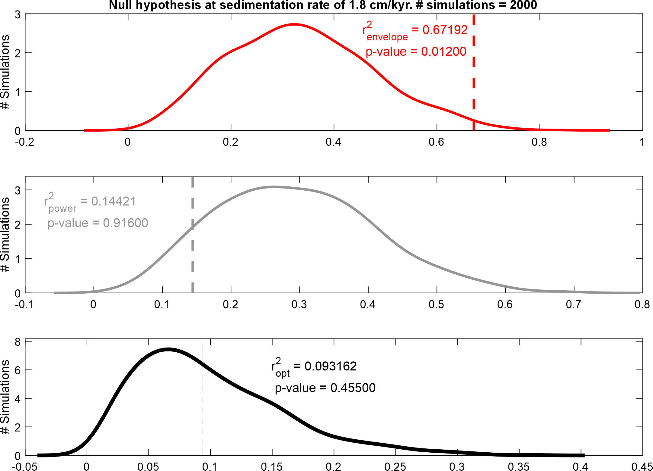
Figure S12. Average Spectral Misfit (ASM) analysis used to evaluate the astronomical tuning of the BH-02 gamma-ray record. The three panels show the statistical significance of the tuning based on different ASM metrics. (Top) Envelope ASM test (red), comparing the modulation of the sedimentary record with the expected astronomical eccentricity envelope. The relatively high coefficient of determination (R² = 0.672) and significant p-value = 0.012 indicate that the amplitude modulation of the tuned record is consistent with orbital forcing. (Middle) Power ASM test (grey), evaluating the agreement between the observed and expected spectral power distribution. The low coefficient of determination (R² = 0.144) and non-significant p-value = 0.916 indicate that spectral power alone provides little discriminatory support for the tuning solution. (Bottom) Optimal ASM test (black), assessing the overall tuning performance using the combined optimal metric. The low R² = 0.093 and non-significant p-value = 0.455 suggest that, despite weaker support from the power-based metrics, the statistically significant envelope test provides the primary evidence supporting the astronomical calibration of the BH-02 record. Vertical dashed lines indicate the values obtained for the preferred tuning solution relative to the Monte Carlo distributions generated by the ASM analysis.
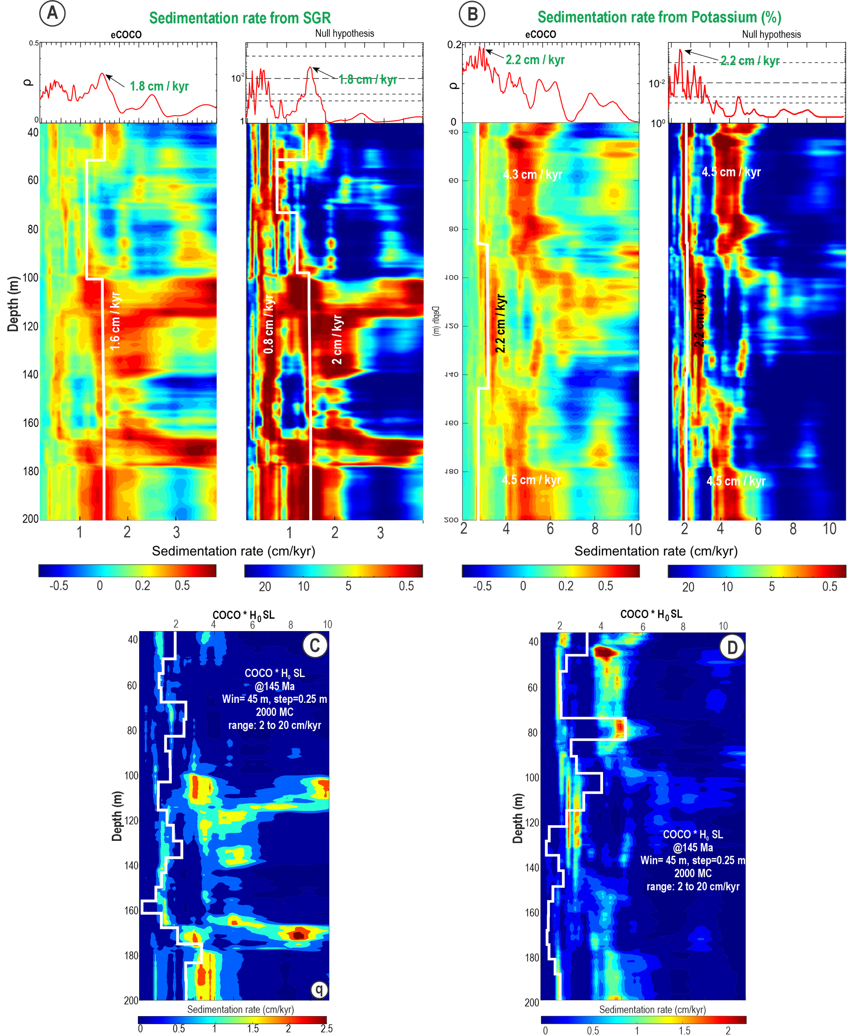Figure S13. Sedimentation-rate estimates derived from spectral analyses of the BH-02 gamma-ray (GR) and potassium (K) records. (A) Evolutive Average Spectral Misfit (eASM) analysis of the gamma-ray (GR) record. The upper panels show the mean sedimentation-rate estimates obtained from the spectral optimization, while the lower panels illustrate the corresponding depth-dependent sedimentation-rate evolution. The white stepped curve represents the optimal sedimentation-rate model, indicating relatively stable accumulation rates averaging ~1.8 cm kyr⁻¹ throughout most of the Tithonian–Berriasian succession, with localized intervals of higher and lower sedimentation rates. (B) Equivalent eASM results obtained from the potassium (K) record. The K-derived model yields a mean sedimentation rate of ~2.2 cm kyr⁻¹, displaying a stratigraphic pattern comparable to that derived from the GR record and confirming the consistency of both proxies for astrochronological analysis. (C–D) Correlation Coefficient (COCO) analyses performed at 145 Ma using the Hilbert-transform sedimentation-length (HSL) method for the GR (C) and K (D) records. Both analyses identify sedimentation rates predominantly between ~1.5 and 2.5 cm kyr⁻¹, with similar down-core trends, providing independent support for the sedimentation-rate model adopted for the astronomical tuning. The convergence of eASM and COCO results from both GR and K records demonstrates the robustness of the inferred accumulation history and the cyclostratigraphic interpretation of the BH-02 succession.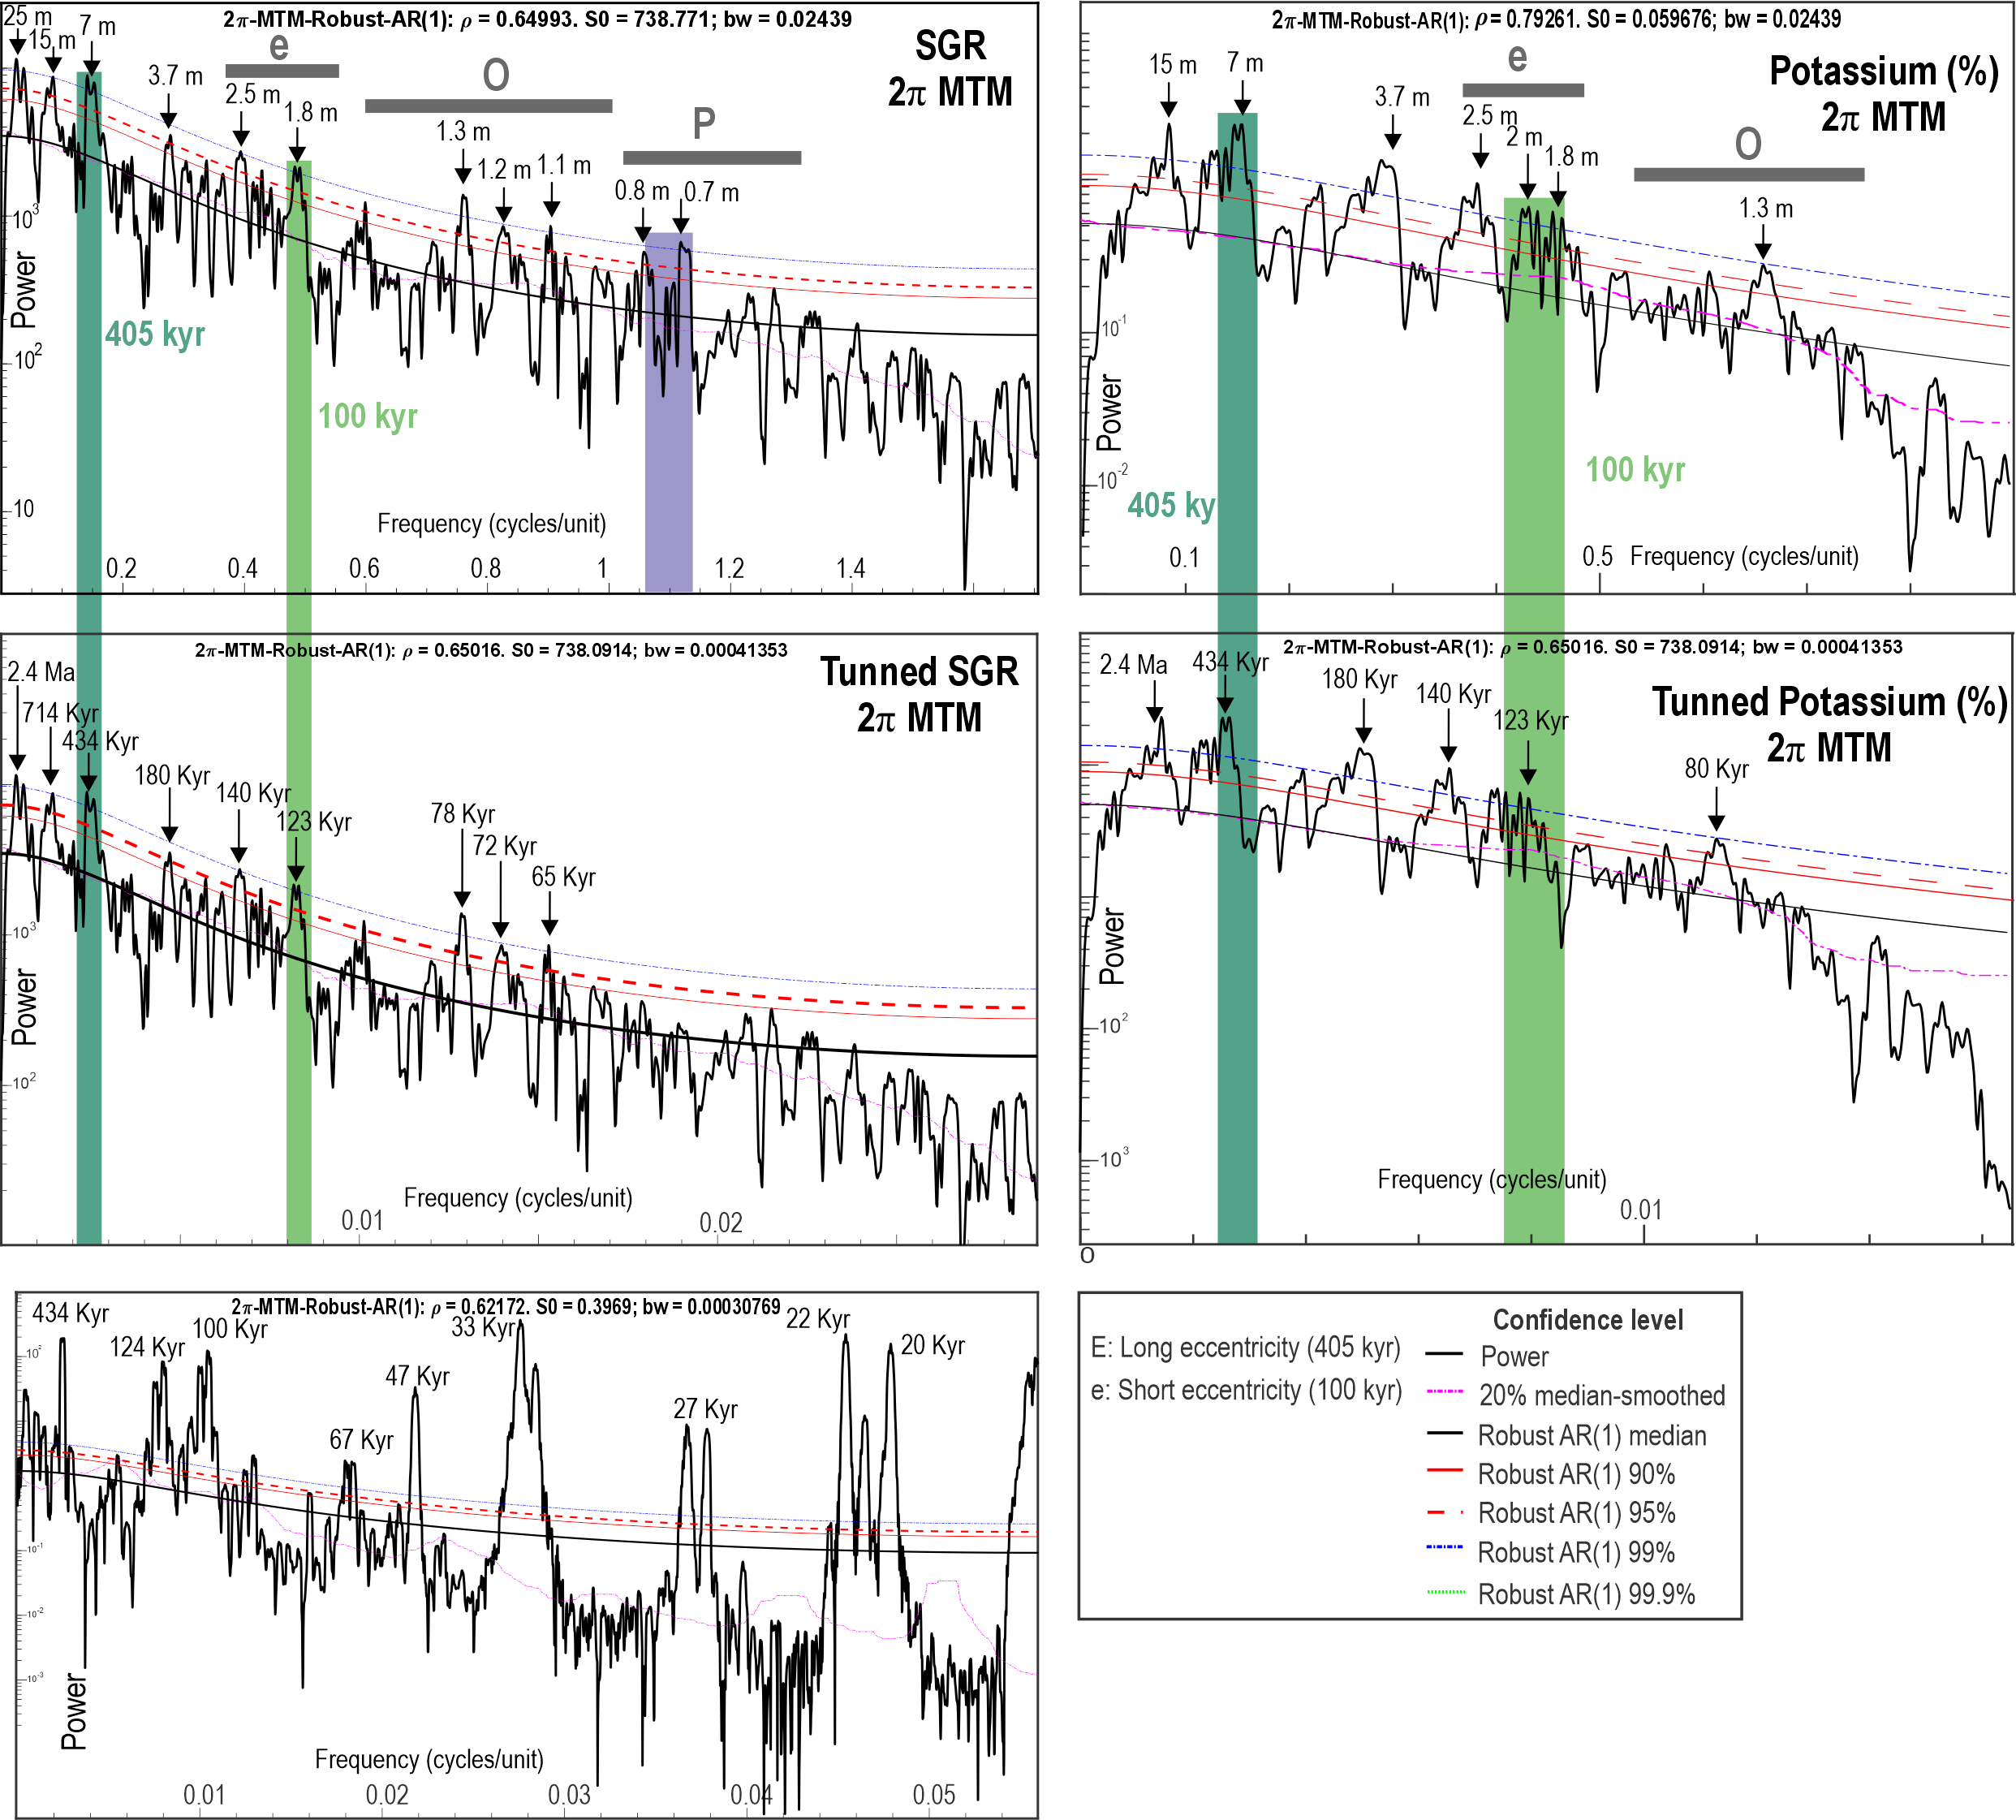
Figure S14. Multitaper Method (MTM) spectral analyses of the BH-02 gamma-ray (GR) and potassium (K) records before and after astronomical tuning. Black curves represent the power spectra of the analyzed records, whereas the coloured lines denote the robust AR(1) confidence levels (90%, 95%, 99%, and 99.9%). Grey bars indicate the expected frequency ranges of the principal Milankovitch cycles: long eccentricity (E; ~405 kyr), short eccentricity (e; ~100 kyr), obliquity (O; ~40 kyr), and precession (P; ~23–20 kyr). Shaded vertical bands highlight the statistically significant orbital frequencies identified in each analysis. The untuned depth-domain spectra display dominant wavelengths corresponding to the 405-kyr and ~100-kyr eccentricity cycles, with weaker expressions of obliquity and precession. Following astronomical calibration, the time-domain spectra exhibit significant peaks at the expected orbital periods (~405, ~100, ~40, ~23, and ~20 kyr), confirming that the tuning accurately recovers the complete hierarchy of Milankovitch forcing. Comparable spectral signatures obtained from both the GR and K records further demonstrate that the orbital signal is robust and reproducible across independent downhole proxies.
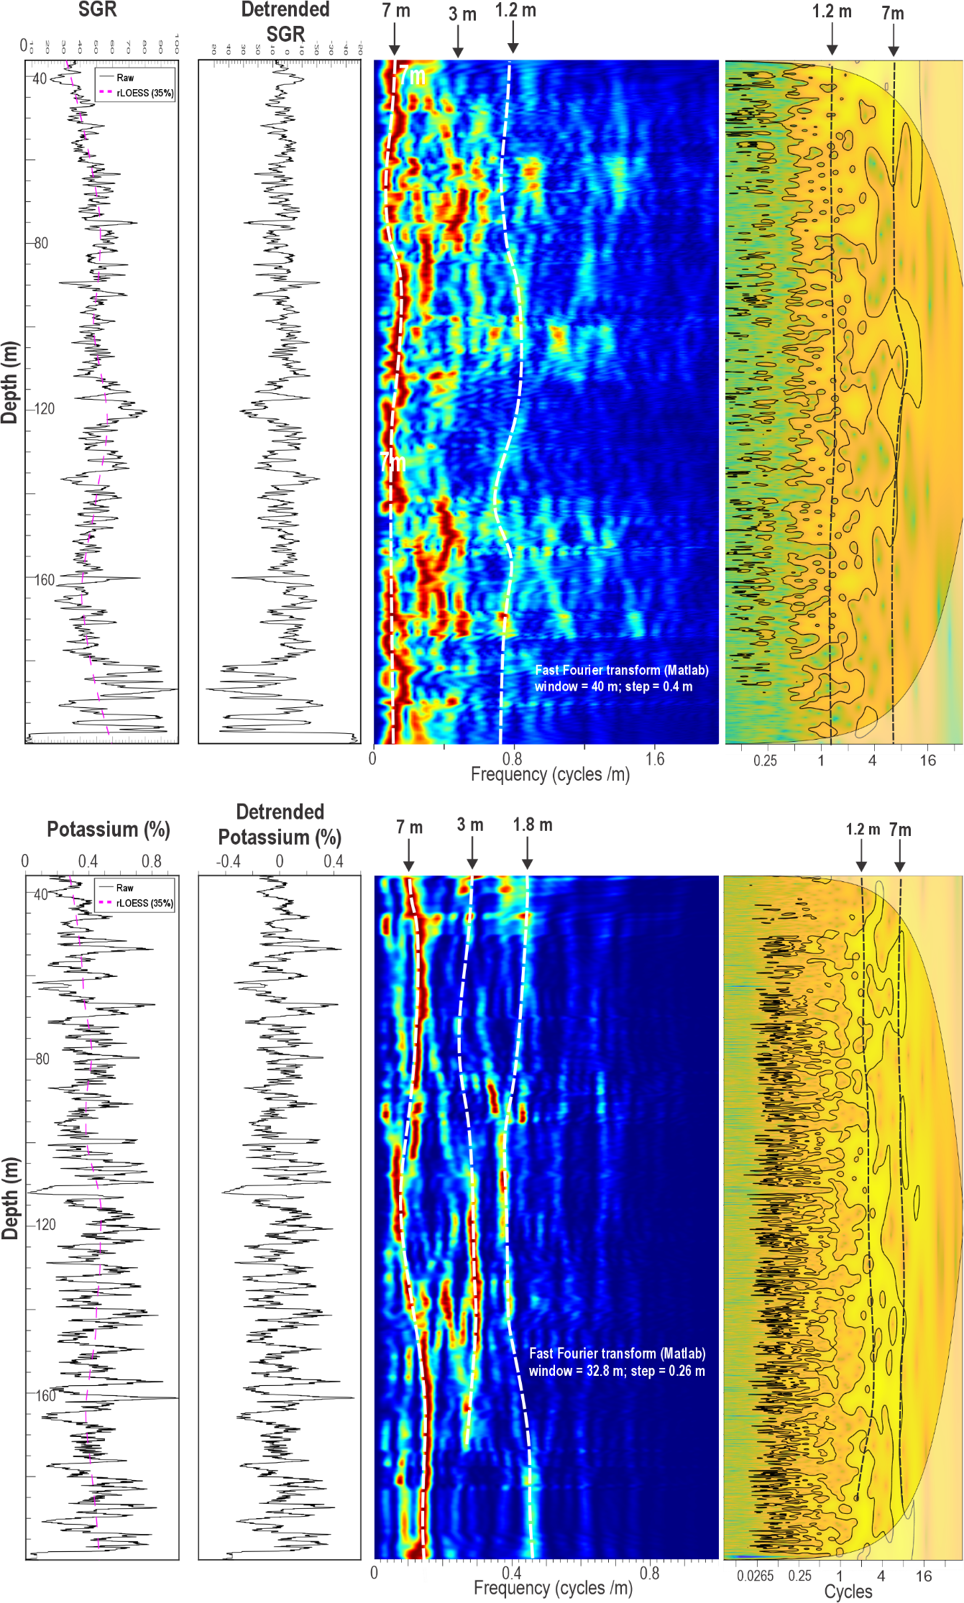
Figure S15. Wavelet and Fast Fourier Transform (FFT) analyses of the BH-02 gamma-ray (GR) and potassium (K) records in the depth domain. The upper row presents results for the gamma-ray (GR) record, whereas the lower row shows the corresponding analyses for the potassium (K) record. For each proxy, panels from left to right show the original record, the detrended signal used for spectral analysis, the evolutive Fast Fourier Transform (FFT) spectrogram, and the continuous wavelet transform (CWT) power spectrum. The FFT spectrograms reveal persistent cyclicities with dominant wavelengths of approximately 7 m, 3 m, and 1.2–1.8 m, interpreted respectively as expressions of the 405-kyr long eccentricity, ~100-kyr short eccentricity, and precession-scale orbital forcing under the preferred sedimentation-rate model. The wavelet spectra confirm that these cyclicities are maintained throughout most of the studied interval, with the strongest and most continuous power concentrated in the long- and short-eccentricity bands. The close correspondence between the GR and K spectral patterns demonstrates that both proxies preserve the same hierarchy of orbital cycles, providing independent support for the cyclostratigraphic interpretation and the astronomical calibration of the BH-02 succession.

Table S1. Summary of age model and main event for the Tithonian –Berriasian Sulaiy Formation

Events | Depth (m) | Depth error (m) | Age (Ma)  GTS 2020 | Error (myr)  GTS2020 and Casellato and Erba, 2021 | Magnetic polarity | This study | Error
Middle Berriasian CIE
FO N. steinmannii | 84.6 | 0.3 | 141.4 | 1.1 | CM18n–CM17r | 140-140.3 | ++
FO N. steinmannii minor | 89.5 | 0.3 | 141.75-142.31 | 2.4 | CM19n-1n–CM17r |  | ++
Carbon isotope negative shift 3 |  |  |  |  |  | 142.2-141.65
Carbon isotope negative shift 2 |  |  |  |  |  | 142.84
Jurassic Cretaceous boundary | 96 | 0.1 | 141.17 | 0.6
FO N. wintereri | 96 | 0.1 | 141.4-143.6 | 1.8 | CM19n-1n–CM18r |  | ++
FO C. mexicana mexicana | 158 | 0.9 | 147.7 | 1.5 | CM22n–CM21r |  | ++
Early Tithonian CIE
FO C. mexicana minor | 169.7 | 0.5 | 148.2 | 1.6 | CM22n–CM21r |  | ++
FO Z. embergeri | 173 | 1.6 | 148.7 | 5.5 | CM22r–CM20n-2n |  | +
Base Tithonian |  |  | 149.2

Table S2. Astronomical calibration tie points
Age model | Cycle number | depth | Time (kyr) | La2010b target | SR
Max405 | 1 | 0.8 | 415 | 138176
3.1 m = 137.91 +- 0.1 Ma
Max405 | 2 | 7.58 | 815 | 138601
Max405 | 3 | 14.4 | 1215 | 139003
21.1 m = 138.64 +- 0.03 Ma
Max405 | 4 | 21.7 | 1617 | 139417
Max405 | 5 | 29.3 | 2024 | 139816
Max405 | 6 | 37.13 | 2430 | 140223
Max405 | 7 | 44.99 | 2827 | 140630 | 2.72
Max405 | 8 | 52.95 | 3230 | 141033 | 3.41
57.1 m = 141.19 +- 0.3 ma
Max405 | 9 | 60.87 | 3654 | 141435 | 2.2
Max405 | 10 | 68.37 | 4051 | 141835 | 3.19
Max405 | 11 | 75.44 | 4415 | 142251 | 3.3
Max405 | 12 | 79.37 | 4916 | 142662 | 2.75
Max405 | 13 | 86.12 | 5280 | 143071 | 2.8
87.1m = 142.5 +- 0.3 Ma
Max405 | 14 | 92.86 | 5669 | 143477
Max405 | 15 | 99.56 | 6068 | 143870
Max405 | 16 | 106.71 | 6489 | 144272
Max405 | 17 | 113.9 | 6889 | 144662
Max405 | 18 | 120.96 | 7276 | 145083
Max405 | 19 | 126.99 | 7693 | 145498
129.1 m = 145.94 +- 0.2 Ma
Max405 | 20 | 132.84 | 8114 | 145905
Max405 | 21 | 140.19 | 8497 | 146300
Max405 | 22 | 147.26 | 8890 | 146695
Max405 | 23 | 153.64 | 9307 | 147091
159.1 m = 147+-0.1 Ma
Max405 | 24 | 161.01 | 9725 | 147498
165.1 m = 147.38 +- 0.1 Ma
Max405 | 25 | 168.52 | 10139 | 147907
171.1 m = 147.5 +- 0.1 Ma
Max405 | 26 | 174.69 | 10552 | 148318
Max405 | 27 | 181.05 | 10950 | 148723
184.08 m = 148.45 +- 0.1 Ma
Max405 | 28 | 187.82 | 11338 | 149128
Max405 | 29 | 195.18 | 11736 | 149520
Max405 | 30 | 202.7 | 12137 | 149915
205.13 m = 149.86 -+ 0.1 Ma

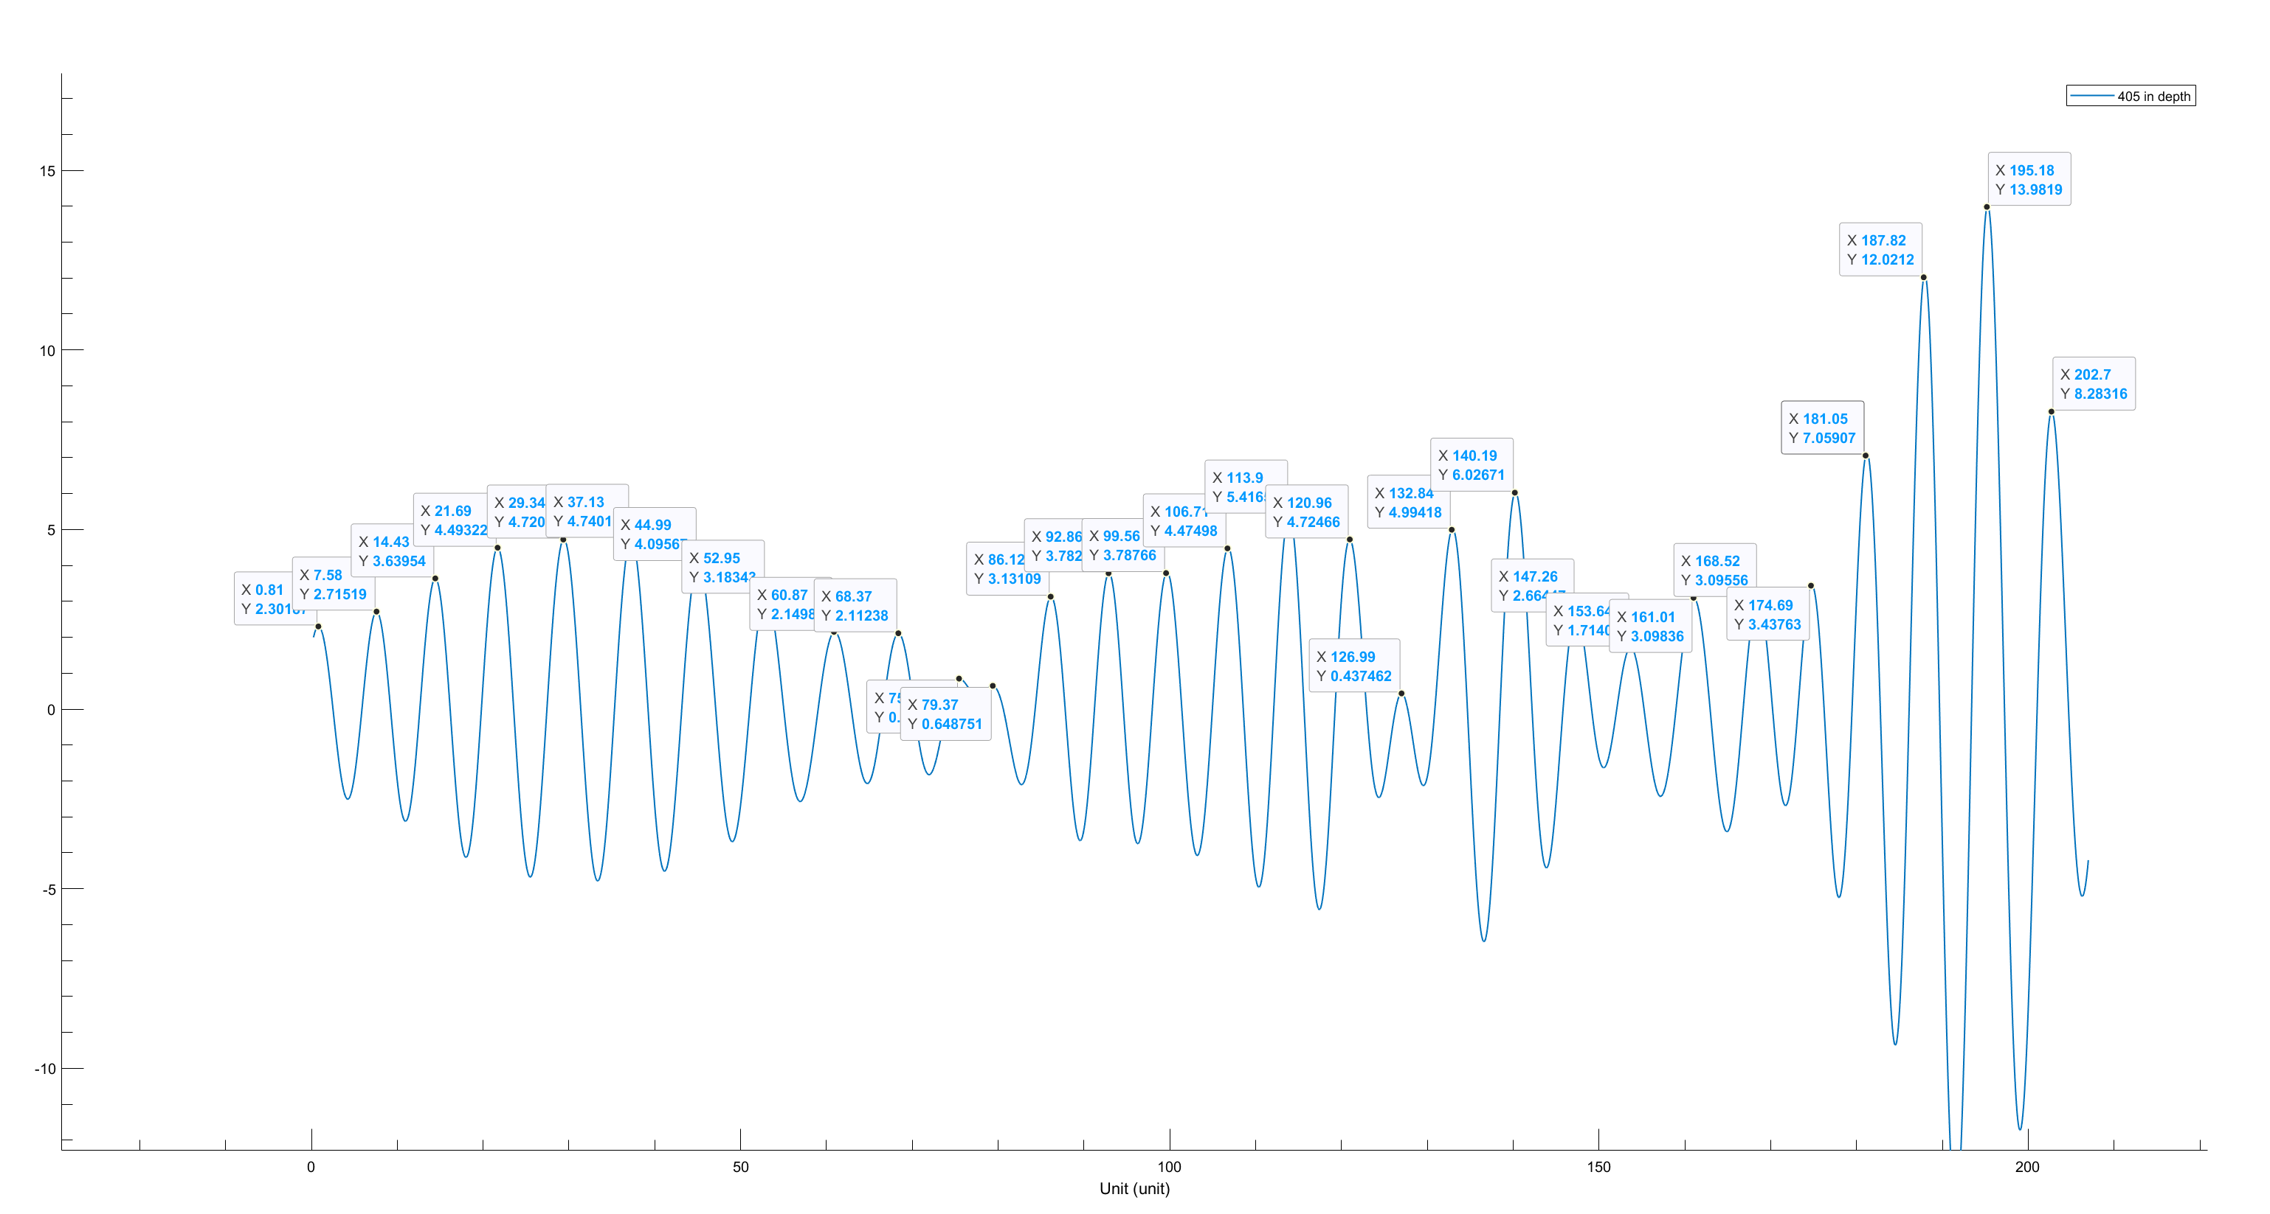
Figure S16. 7m filter output from the GR records. We did a maxima-to-maxima correlation to perform the astronomical calibration. (X and Y) points highlight the position of the used points for calibration.
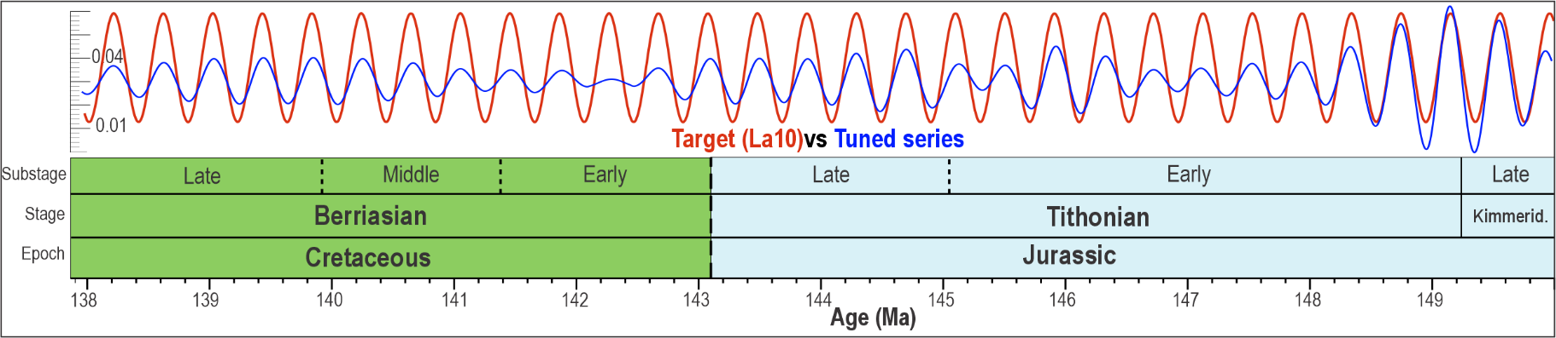
Figure S17. Comparison between the astronomically tuned BH-02 gamma-ray (GR) record (blue) and the target La2004 405-kyr eccentricity solution (red) plotted against the tuned age model. The close correspondence in phase and amplitude between the two series demonstrates the robustness of the astronomical calibration throughout the studied interval. The tuned chronology spans the late Kimmeridgian, Tithonian, and Berriasian (149.8–137.9 Ma), providing a continuous astronomical timescale for the Jurassic–Cretaceous transition. Differences in amplitude between the target and tuned series mainly reflect variations in sedimentation rate, depositional processes, and the filtering applied during astronomical tuning, whereas the overall phase agreement confirms the reliability of the adopted age mode

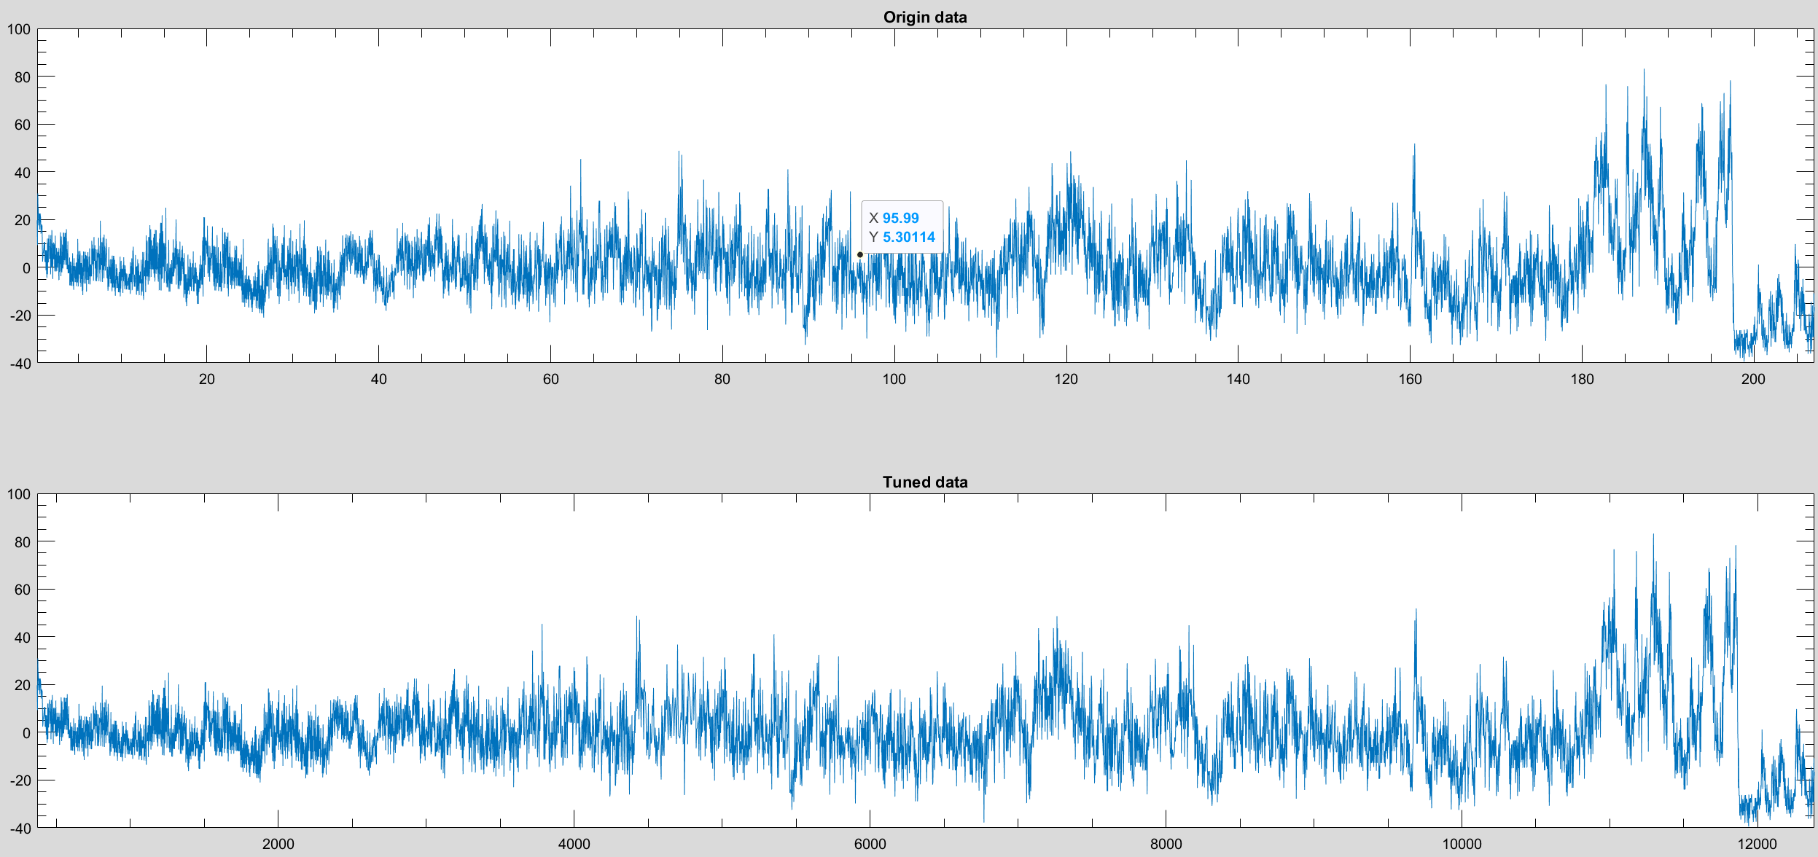
Figure S18. Comparison of the original and astronomically tuned gamma-ray (GR) records from the BH-02 core. Upper panel: original detrended GR record plotted in the depth domain (0–205 m). Lower panel: the same record after astronomical tuning, resampled to uniform time increments using the final age model (149.8–137.9 Ma). The tuning preserves the overall character and amplitude of the original signal while correcting for variations in sedimentation rate, resulting in a continuous time-domain record suitable for spectral, wavelet, and orbital analyses. The similarity between the two series indicates that the tuning process introduces minimal distortion and faithfully preserves the primary climatic signal recorded in the succession.
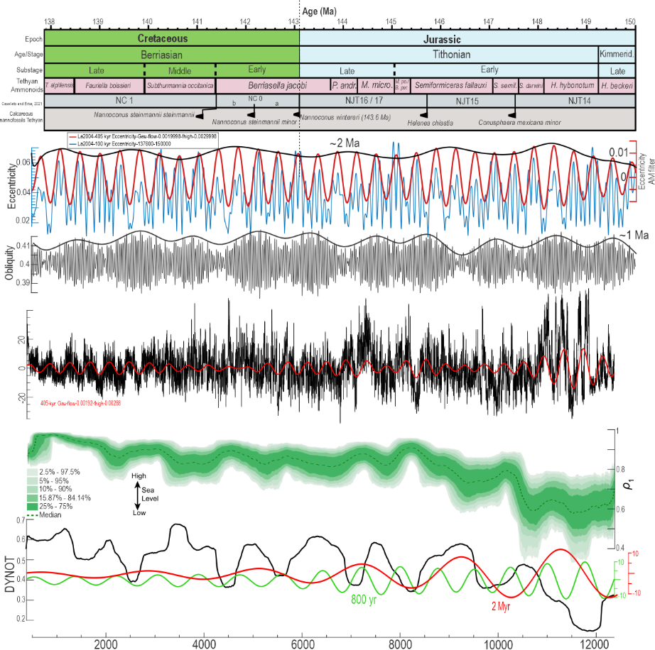
Figure S19. Integrated astronomical framework and orbital interpretation of the Tithonian–Berriasian interval. From top to bottom: (1) Chronostratigraphic framework showing stages, substages, Tethyan ammonite zones, and calcareous nannofossil biozonation calibrated to the astronomically tuned age model. Key bioevents, including the first occurrences of Conusphaera mexicana minor, Helenea chiastia, Nannoconus wintereri, N. steinmannii minor, and N. steinmannii steinmannii, are shown within the nannofossil zonation. (2) La2004 astronomical solution illustrating the 405-kyr long eccentricity cycle (red), the ~100-kyr short eccentricity cycle (blue), and the ~2.4-Myr eccentricity modulation (black envelope). (3) Obliquity solution (grey) together with its ~1.2-Myr amplitude modulation (black envelope). (4) Astronomically tuned gamma-ray (GR) record (black) with the extracted 405-kyr eccentricity component (red), demonstrating the close correspondence between the sedimentary signal and the astronomical target. (5) Dynamic noise after orbital tuning (DYNOT; black), shown together with the probabilistic global eustatic sea-level reconstruction (green; median and confidence envelopes) and the extracted long-period ~800-kyr (green) and ~2-Myr (red) components. The integrated framework highlights the relationship between orbital forcing, long-period eccentricity modulation, sea-level variability, and changes in sedimentary dynamics across the Jurassic–Cretaceous transition.
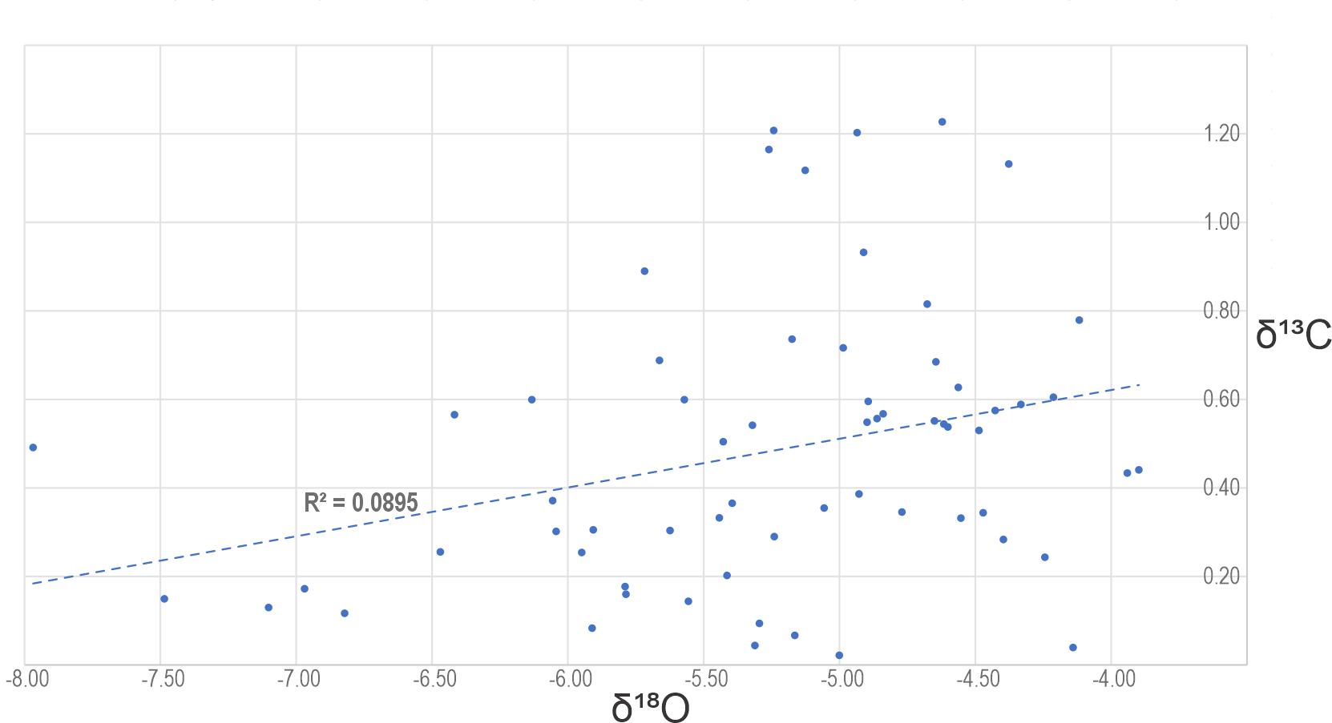
Figure S20. Cross-plot of bulk-carbonate δ¹³C versus δ¹⁸O values from the BH-02 Tithonian–Berriasian succession. The weak positive correlation (R² = 0.0895) indicates that the two isotope systems are largely decoupled, suggesting that the carbon-isotope record was not substantially modified by pervasive meteoric or burial diagenesis. Instead, δ¹³C and δ¹⁸O primarily record independent variations in the global carbon cycle and paleoenvironmental conditions, supporting the use of the stable-isotope dataset for paleoceanographic and astrochronological interpretation.

Supplementary Note 5. Supporting discussion
Preservation of cyclostratigraphic signals during the Tithonian differed markedly between the northern and southern Tethys. In the northern Tethys, widespread arid conditions reduced continental weathering and terrigenous sediment supply, limiting the preservation of orbitally forced environmental variability and weakening the expression of eccentricity-scale cycles (Hallam et al., 1991; Deconinck and Baudin, 2008; Hesselbo et al., 2009; Schneider et al., 2018; Lodowski et al., 2026). In contrast, the BH-02 succession from Saudi Arabia preserves a clear hierarchy of Milankovitch cycles, indicating that southern Tethyan environmental conditions were more favourable for recording orbital forcing (Fig. 5). The progressive increase in ^87Sr/^86Sr values through the Berriasian further suggests enhanced continental weathering and runoff, consistent with a transition toward more humid climatic conditions and increased sediment supply from the Arabian Shield (Wolpert et al., 2015). Similar evidence for intensified weathering and terrigenous input during the Late Berriasian has been documented throughout the northern Tethys, including the Vocontian Basin, Northern Calcareous Alps, Central Western Carpathians, Transdanubian Range, and Slovenian Basin (Grabowski et al., 2013; Price et al., 2016; Lodowski et al., 2024a,b, 2025), marking a regional strengthening of the hydrological cycle.
Calcareous nannofossil records from DSDP Holes 105 and 534 display evolutionary trends comparable to those observed in the Arabian Plate. Early Tithonian assemblages are dominated by Watznaueria, Cyclagelosphaera, and Zeugrhabdotus, whereas the middle Tithonian is characterized by an expansion of heavily calcified nannoliths, including Conusphaera mexicana, Polycostella beckmannii, and Nannoconus. During the early Berriasian, nannolith abundance declines and more diverse coccolith assemblages become established. Morphometric analyses reveal a reduction in Watznaueria size accompanied by enlargement of nannolith taxa, suggesting a regional environmental response, potentially linked to declining atmospheric pCO₂ and changes in carbonate chemistry.
A pronounced middle Tithonian nannofossil calcification event (NCE) is recorded at Hole 105, where heavily calcified taxa account for a substantial proportion of carbonate production under oligotrophic, arid, and relative sea-level lowstand conditions. Following this interval, the decline of Conusphaera and Polycostella, together with increasing coccolith diversity and carbonate accumulation rates during the Berriasian, coincides with major paleoceanographic reorganization, including the opening of the proto-Panama Gateway and the development of equatorial circulation. These observations indicate that the latest Jurassic–earliest Cretaceous marked a transition toward more efficient pelagic carbonate production and an increasingly important role of the deep ocean as a sink for biogenic CaCO₃.

Records from western Tethys DSDP 105 and 534

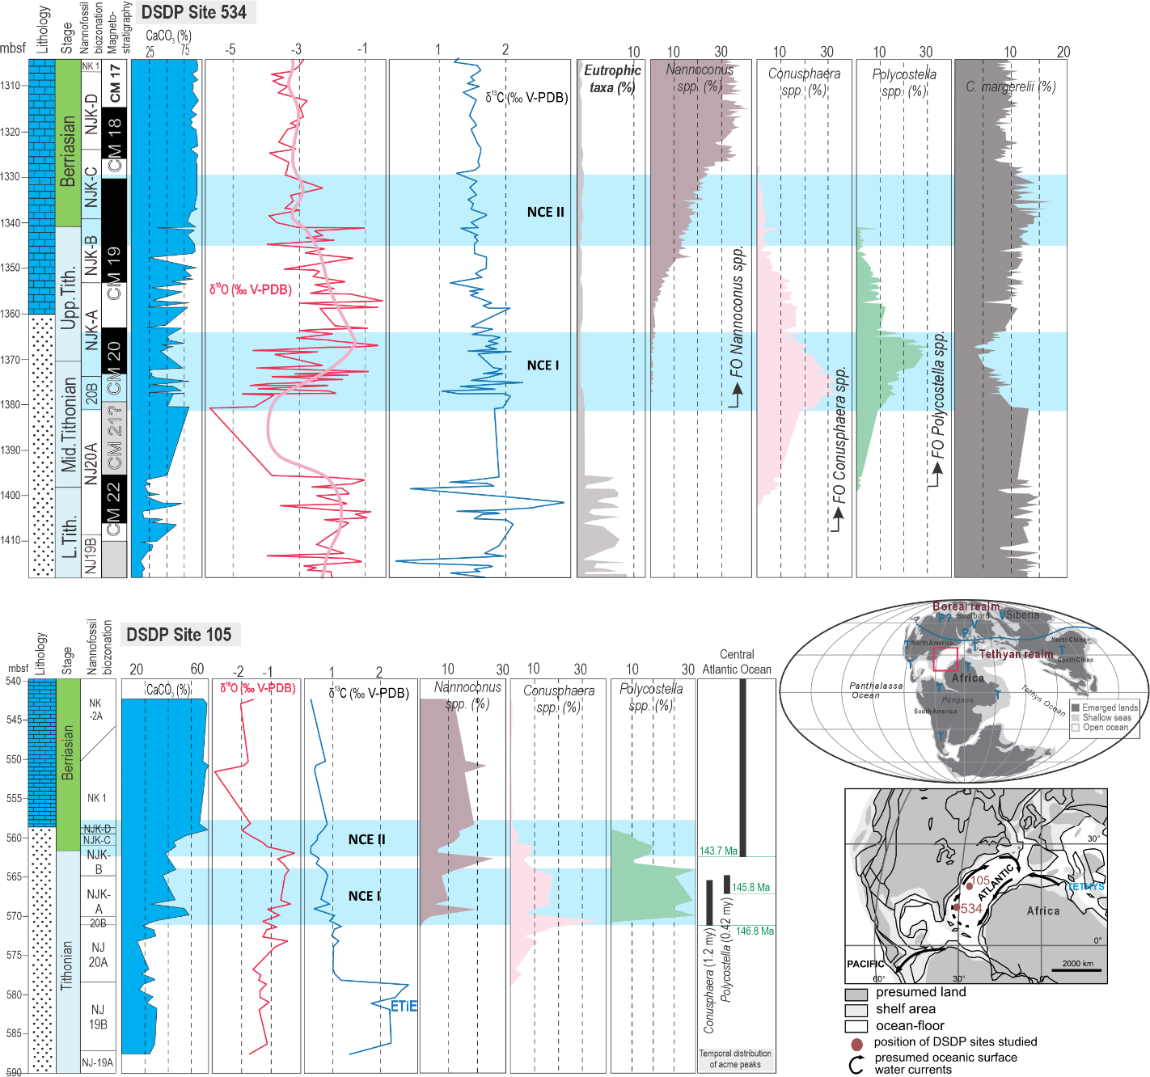
Figure S21. Comparison of calcareous nannofossil abundance patterns, carbon- and oxygen-isotope records, and carbonate content across the Jurassic–Cretaceous transition at DSDP Site 534 (Blake Plateau, western North Atlantic) and DSDP Site 105 (western Atlantic–Tethyan gateway). Shown are lithology, calcareous nannofossil biozonation, CaCO₃ content, bulk-rock δ¹³C and δ¹⁸O records, and relative abundances of selected nannofossil groups (Nannoconus spp., Conusphaera spp., Polycostella spp., Cyclagelosphaera margerelii, and eutrophic taxa). The light-blue bands indicate the two negative carbon-isotope excursions (NCE I and NCE II), while arrows mark the first occurrences (FOs) of key biostratigraphic taxa.
The two records demonstrate that the negative carbon-isotope excursions are diachronous across the western Tethyan–Atlantic region. At DSDP Site 534, NCE I occurs within the upper Tithonian (NJ20B) and NCE II within the lower Berriasian (NJK-C), whereas at DSDP Site 105 both excursions occur stratigraphically higher and are shifted toward younger intervals relative to the nannofossil biozonation. The timing of the abundance peaks of Nannoconus, Conusphaera, and Polycostella also differs between the two sites, indicating that the associated calcification events were not synchronous throughout the basin. These diachronous relationships support a progressive development of the Boreal–Tethyan carbon-isotope decoupling during the latest Jurassic–earliest Cretaceous rather than a single globally synchronous event. The inset maps show the paleogeographic position of the studied DSDP sites within the western Tethyan–Atlantic realm during the Late Jurassic–Early Cretaceous, illustrating their location along the evolving Boreal–Tethyan oceanic gateway. The observed temporal offsets between the isotope excursions and nannofossil events likely reflect regional differences in water-mass exchange, carbon cycling, and ocean circulation as gateway restriction intensified during the late Tithonian–early Berriasian cooling interval.

Records from Hungary
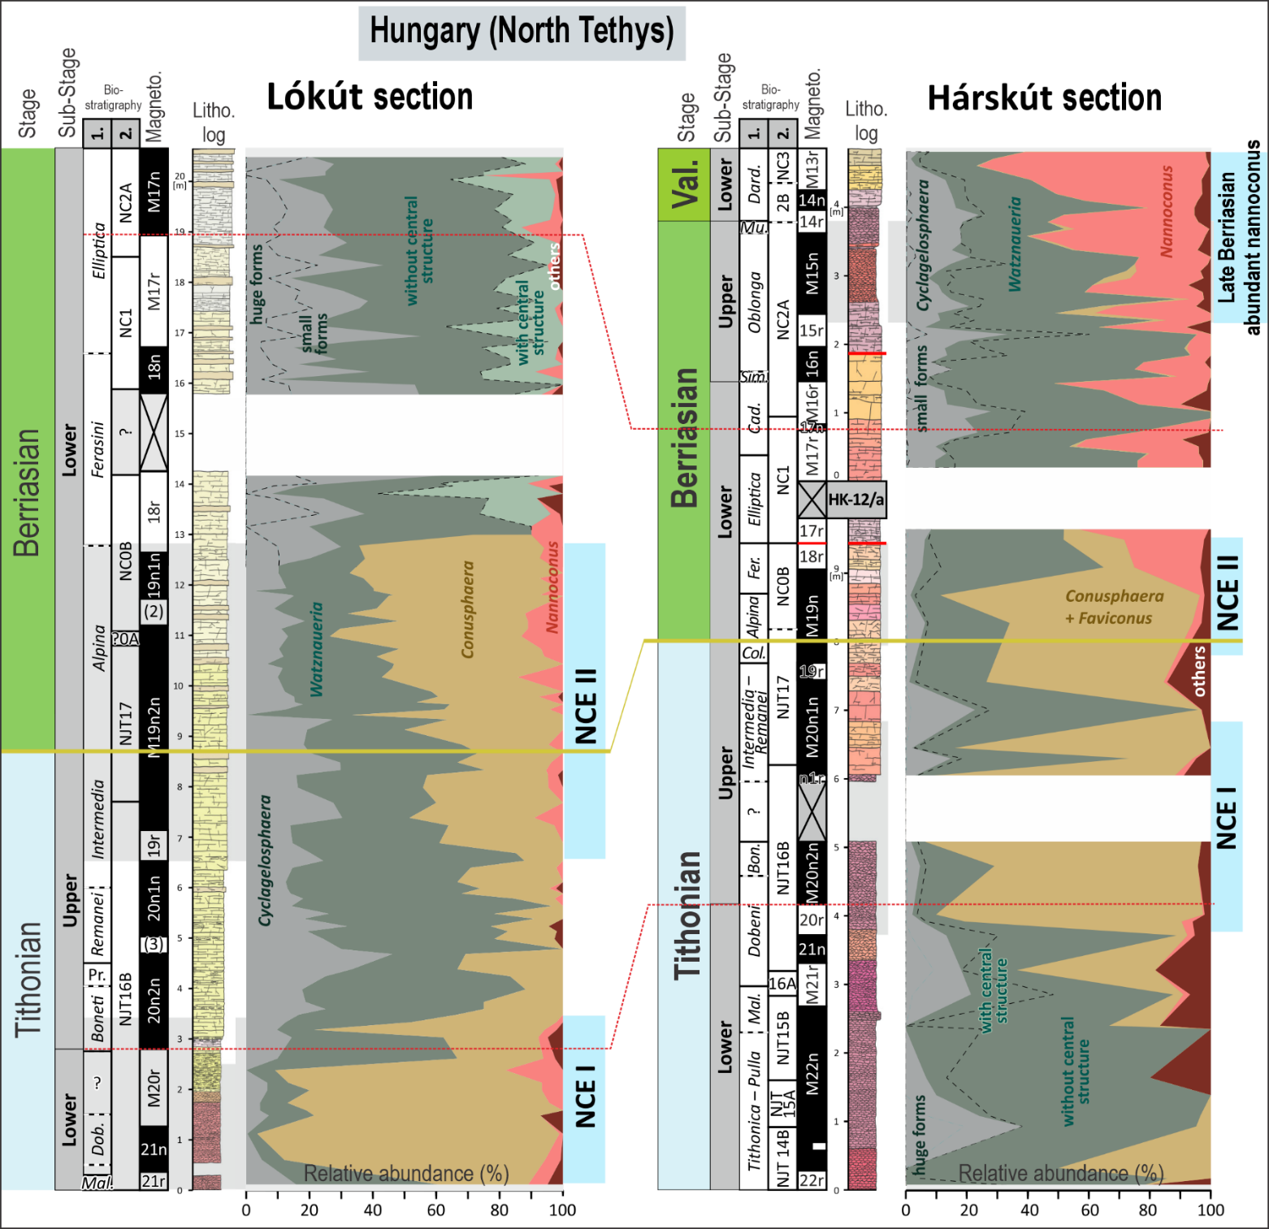
Figure S22. Comparison of calcareous nannofossil assemblage changes across the Jurassic–Cretaceous transition in the Lókút and Hárskút sections (Hungary, North Tethys). Shown are lithology, biostratigraphy, magnetostratigraphy, and the relative abundances of the principal calcifying nannofossil groups (Cyclagelosphaera, Watznaueria, Conusphaera, Nannoconus, and other taxa). The light-blue bands indicate the positions of the two negative carbon-isotope excursions (NCE I and NCE II), and enlarged panels highlight the intervals of increased Nannoconus abundance during the late Berriasian. Although the Lókút and Hárskút sections are located within the same North Tethyan region, the stratigraphic positions of NCE I and NCE II differ between the two successions, demonstrating that these negative carbon-isotope excursions are diachronous even at a regional scale. Likewise, changes in the abundance of heavily calcified nannofossils are not synchronous between the sections, indicating progressive rather than instantaneous environmental and biotic responses during the latest Jurassic–earliest Cretaceous. The observed regional offsets support the interpretation that the Boreal–Tethyan carbon-cycle perturbation and associated calcification events evolved over several million years instead of representing globally synchronous marker horizons.

Records from Italy

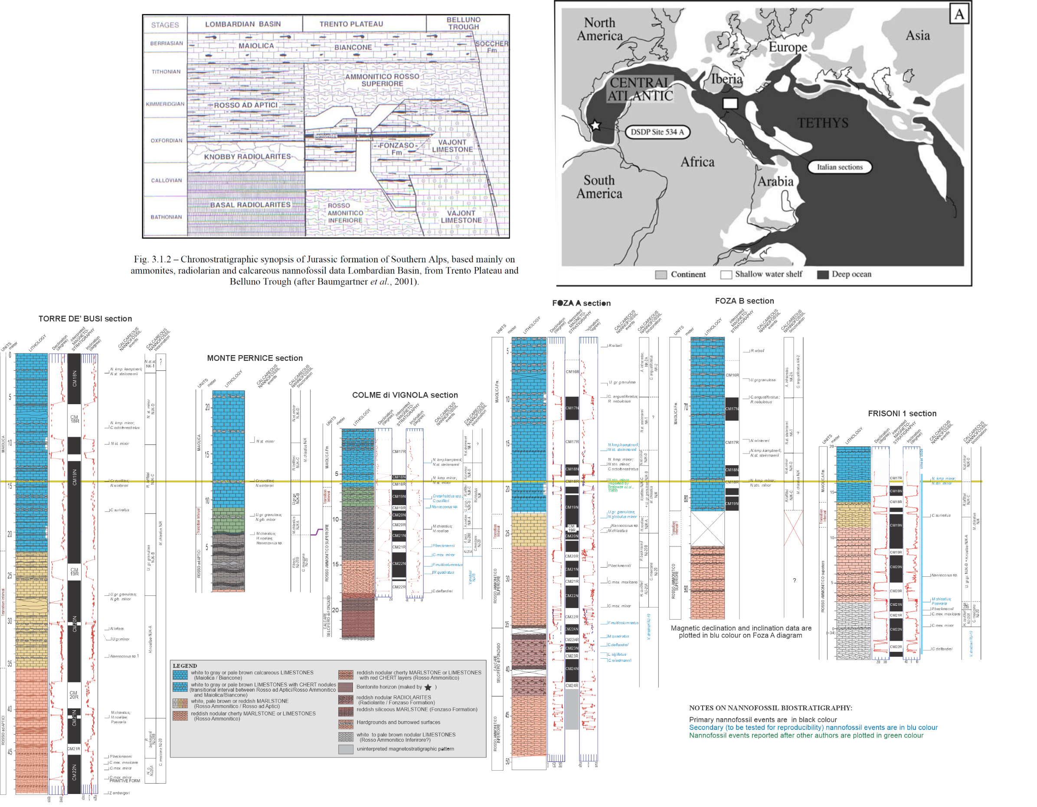

Figure S23. Correlation of the Jurassic–Cretaceous boundary interval among key Tethyan pelagic sections from northern Italy used by the Berriasian Working Group for evaluation of candidate Global Boundary Stratotype Section and Point (GSSP) sections. Upper panels: (left) Chronostratigraphic framework of the Lombardian Basin, Trento Plateau, and Belluno Trough, illustrating the principal lithostratigraphic units spanning the Callovian–Berriasian; (right) Late Jurassic paleogeographic reconstruction showing the location of the Italian sections within the western Tethys. Lower panels: Integrated lithostratigraphic, magnetostratigraphic, calcareous nannofossil, calpionellid, and carbon-isotope records from the Torre de' Busi, Monte Pernice, Colme di Vignola, Foza (A and B), and Frisoni 1 sections. The yellow horizontal line marks the position of the Jurassic–Cretaceous boundary adopted by the Berriasian Working Group (Option 2), placed close to the base of the Calpionella alpina Subzone and within magnetosubchron M19n.2n. These reference successions provide the principal biostratigraphic and magnetostratigraphic framework used to calibrate the first appearance of Nannoconus wintereri and correlate the boundary to the BH-02 astrochronological framework developed in this study.

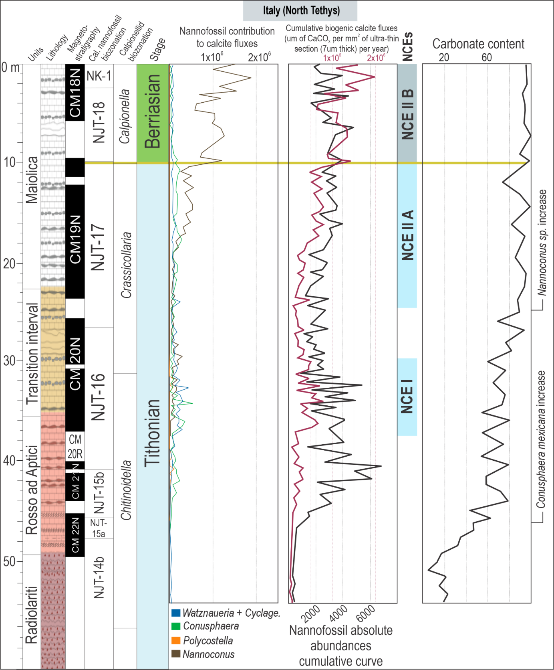
Figure S24. Carbonate production and calcareous nannofossil evolution across the Jurassic–Cretaceous transition in the Brodno section, Italy (North Tethys). Shown are lithology, magnetostratigraphy, calpionellid and calcareous nannofossil biostratigraphy, relative contributions of the principal nannofossil groups to calcite production (Watznaueria + Cyclagelosphaera, Conusphaera, Polycostella, and Nannoconus), cumulative biogenic calcite fluxes, positions of the negative carbon-isotope excursions (NCE I, NCE IIA and NCE IIB), and carbonate content. The first occurrence (FO) of Conusphaera mexicana mexicana coincides closely with NCE I, where carbonate content increases abruptly from <20% to >60%, marking the onset of widespread carbonate deposition in the Tethyan realm. This lithological shift is accompanied by a sharp increase in biogenic calcite production and the appearance of heavily calcified nannofossil taxa, indicating that the onset of the calcification events was closely linked to the regional transition from mixed siliciclastic–carbonate sedimentation to carbonate-dominated deposition during the latest Tithonian. The subsequent expansion of Nannoconus in the early Berriasian further reflects the continued development of oligotrophic, carbonate-producing conditions across the Tethys.

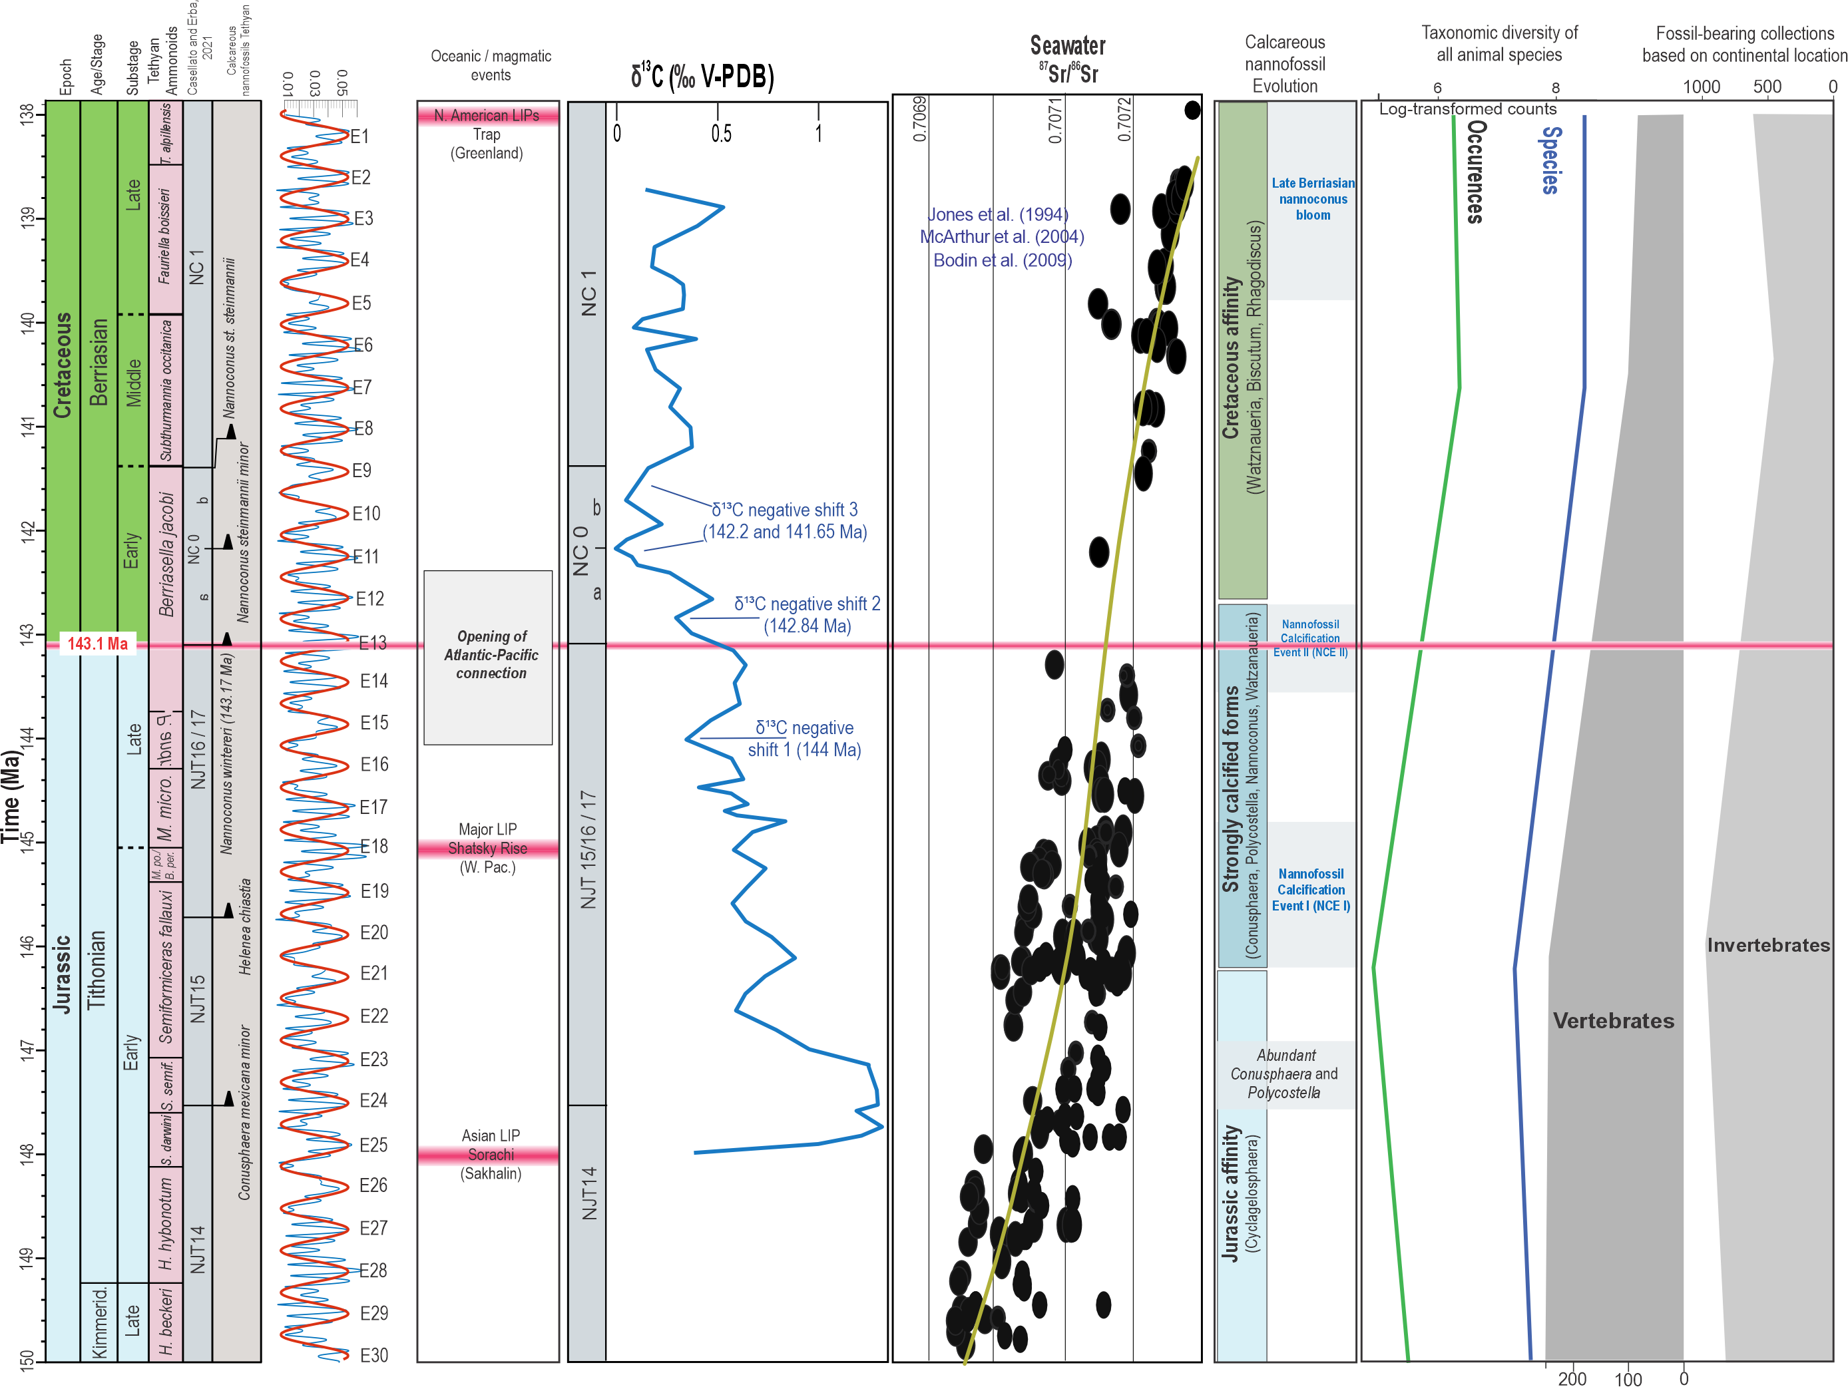
Figure 25. Integrated overview of major paleoenvironmental, geochemical, and biotic changes across the Tithonian–Berriasian interval. Shown are the astronomically calibrated age model, calcareous nannofossil biozonation, long-eccentricity cycles, major magmatic events, bulk-rock δ¹³C record, marine ^87Sr/^86Sr ratios, evolutionary trends of calcareous nannofossils, and marine animal diversity. The carbon-isotope record is characterized by a gradual recovery following the Early Tithonian carbon-isotope excursion (CIE), followed by two negative carbon-isotope excursions (NCE I and NCE II) during the latest Tithonian–earliest Berriasian. The Jurassic–Cretaceous boundary (143.1 Ma) is positioned approximately midway through NCE II, emphasizing that the carbon-cycle perturbation represents a prolonged interval of environmental change rather than a discrete boundary event. The two major nannofossil calcification events closely coincide with NCE I and NCE II, indicating a close temporal relationship between carbon-cycle perturbations and enhanced carbonate production.
The marine ^87Sr/^86Sr curve shows relatively low values throughout the Tithonian, consistent with reduced continental weathering and runoff under predominantly arid climatic conditions. A progressive increase in ^87Sr/^86Sr through the Berriasian reflects intensified continental weathering and greater fluvial input associated with increasingly humid conditions.
Marine biodiversity records indicate a gradual decline in both taxonomic diversity and fossil occurrences across the Jurassic–Cretaceous transition, without an abrupt extinction or major turnover at the boundary itself. Together, these records support the interpretation that the Jurassic–Cretaceous transition represents a prolonged Earth-system reorganization involving progressive climatic cooling, changes in continental weathering, carbon-cycle perturbations, and enhanced carbonate production rather than a single catastrophic event.
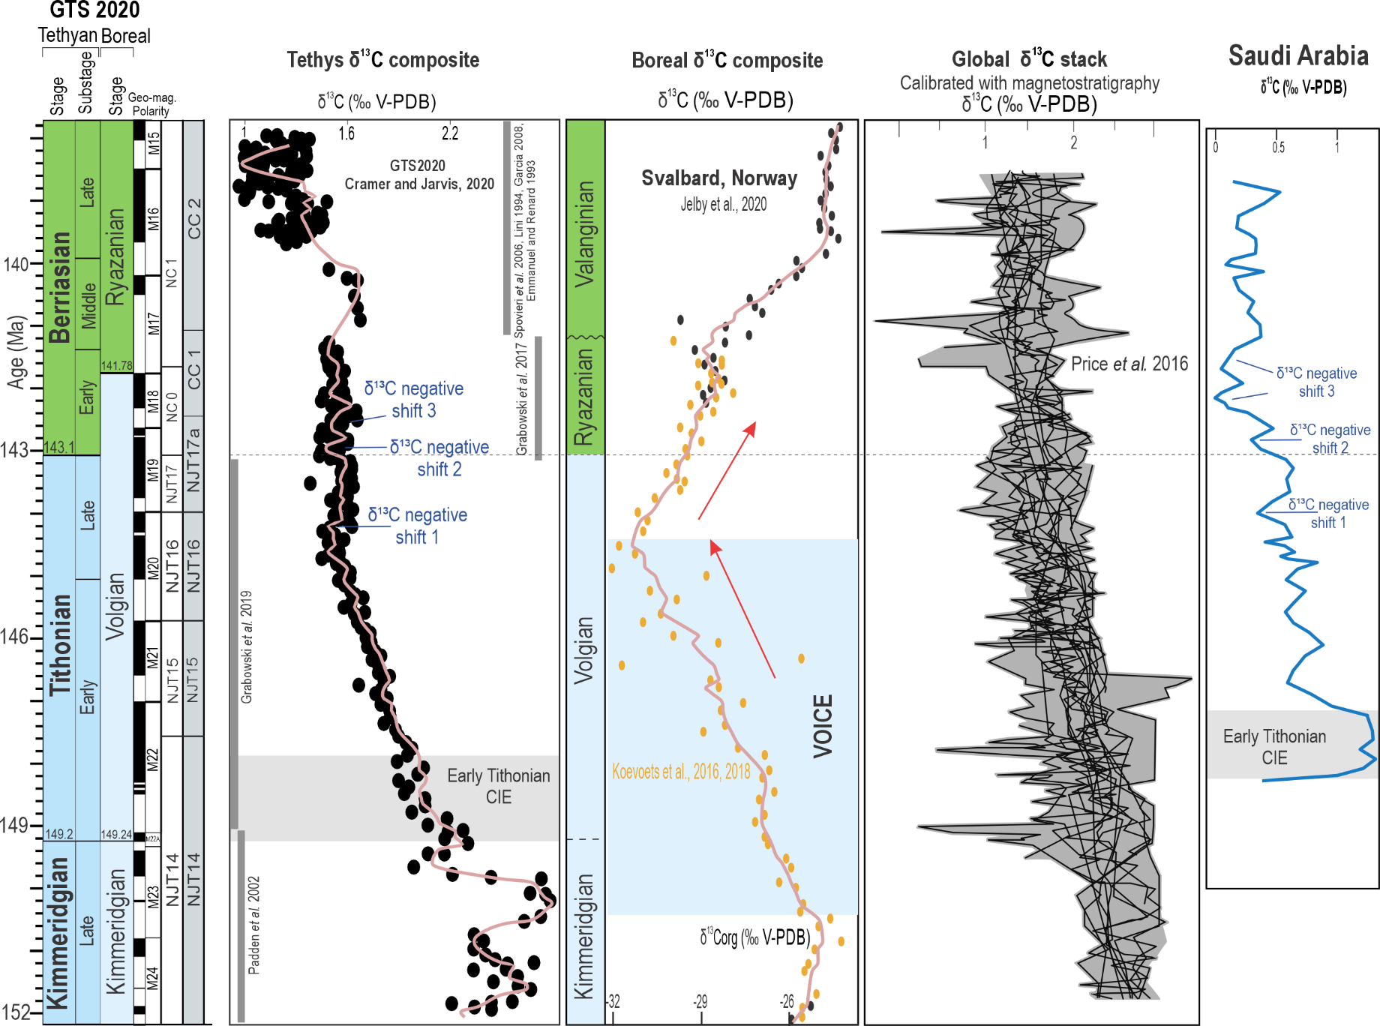
Figure S26. Comparison of carbon-isotope records across the Jurassic–Cretaceous transition from the Tethyan and Boreal realms, the global δ¹³C compilation, and the astronomically calibrated δ¹³C record from the BH-02 core (Saudi Arabia). Shown are the Tethyan composite δ¹³C curve, the Boreal composite from Svalbard, the global marine δ¹³C stack, and the Saudi Arabian bulk-rock δ¹³C record, all plotted against the Geologic Time Scale 2020. The Saudi Arabian δ¹³C record closely resembles the composite Tethyan curve, reproducing the major long-term carbon-isotope evolution from the Early Tithonian to the Berriasian. In particular, it records the Early Tithonian carbon-isotope excursion (CIE), followed by three successive negative carbon-isotope shifts during the latest Tithonian–earliest Berriasian, with the second shift (NCE II) spanning the Jurassic–Cretaceous boundary (143.1 Ma). These characteristic negative excursions provide a robust framework for correlation throughout the Tethyan realm. In contrast to Boreal records, the Saudi Arabian succession shows no evidence for the Volgian Isotopic Carbon Excursion (VOICE), supporting previous interpretations that the VOICE represents a regional Boreal carbon-cycle perturbation rather than a global event. The close correspondence between the Saudi Arabian and Tethyan composite curves confirms that the BH-02 core faithfully records the evolution of the low-latitude Tethyan carbon cycle and provides an excellent reference section for correlation across the Jurassic–Cretaceous transition.

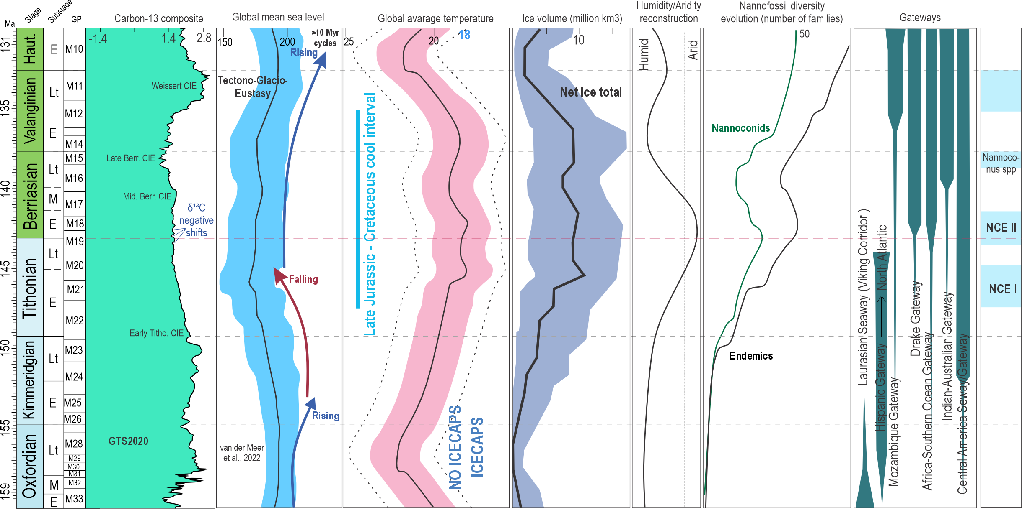

Figure S27. Integrated climatic, eustatic, biotic, and paleoceanographic evolution across the Jurassic–Cretaceous transition. The panel summarizes changes in global mean sea level, average surface temperature, and estimated ice volume through the Late Jurassic to Early Cretaceous, highlighting the Tithonian–Berriasian interval as the phase of maximum inferred ice volume and a general long-term sea-level fall during the Tithonian. It also shows the humidity–aridity reconstruction from the northern Tethyan margin, with maximum aridity occurring near the Jurassic/Cretaceous boundary, alongside carbon-isotope records δ¹³C_{carb} and δ¹³C_{org} from DSDP Atlantic sites (the Blake Plateau, Katz et al., 2005; Falkowski et al., 2005). Note that the δ¹³C_{org} patterns from these sites differ markedly from those observed in the Boreal realm where a large VOICE negative excursion is recorded in the Tithonian. Nannofossil diversity evolution indicates a peak in endemic species and nannoconids at the Jurassic/Cretaceous boundary, followed by a decline to a minimum in the middle Berriasian and a renewed increase during the Late Berriasian. The figure further illustrates the progressive opening of major ocean gateways after the boundary, including the Drake, Central American Seaway, Indian–Australian, Mozambique, and South Atlantic gateways, contrasted with the closure of the Laurasian Seaway (Viking Corridor) near the base of the Tithonian. Together, these changes suggest that the onset of the westward-flowing circumglobal equatorial current system in the Late Jurassic promoted connections among Tethyan ocean basins, while NCE events coincided with peak Tethyan aridity, maximum northern polar ice volume, the first peak in endemic nannofossils and nannoconids. The carbon-cycle response to these changes was highly heterogeneous. In Tethyan settings, carbonate production remained relatively stable (δ¹³Ccarb ~ +1 to +1.5‰), whereas Boreal basins record large negative δ¹³Corg excursions (up to ~6‰), reflecting enhanced organic carbon burial and restricted circulation. This decoupling highlights the dominance of regional oceanography during eustatic lowstands and the limited connectivity of carbon reservoirs during the J–K transition.

