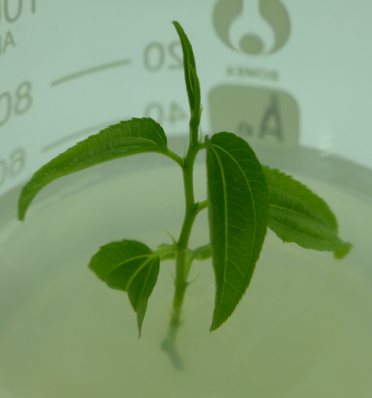
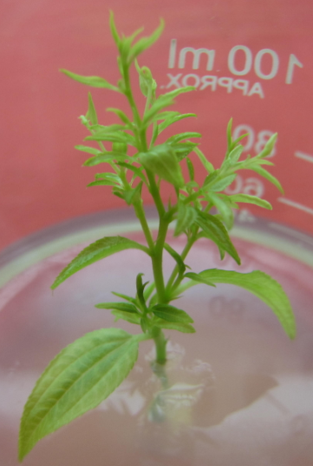
A
B

Additional file 3: Fig. S2 The healthy and diseased plantlets. A: Healthy plantlets; B: Diseased plantlets.

