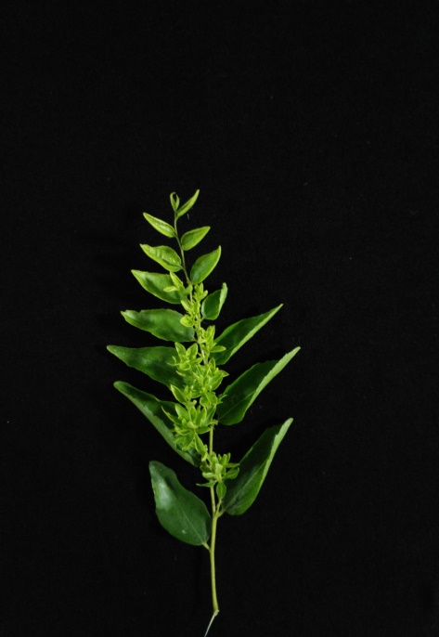
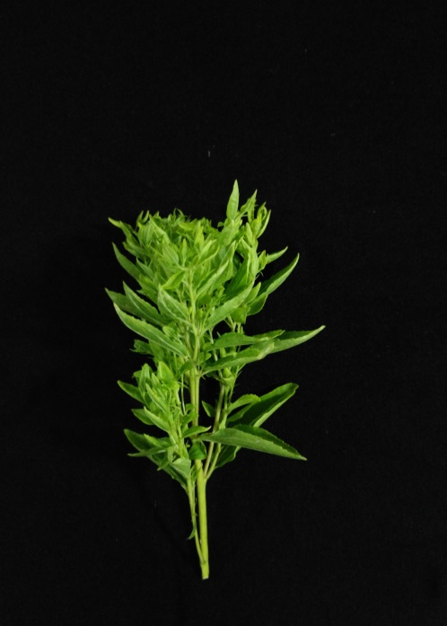
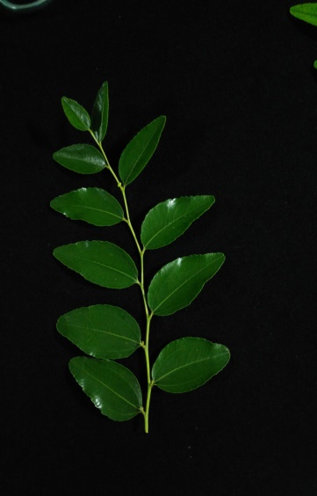
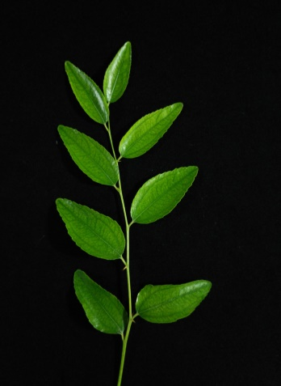
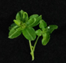
A

B

C

D

Additional file 4: Fig. S3 The tissues showing different JWB disease symptoms. A: Witches’ broom leave; B: Phyllody leaves; C: Apparent normal leaves; D: Healthy leaves. A, B and C were used as test group which collected from the diseased trees. D was used as control which collected from the healthy trees.

