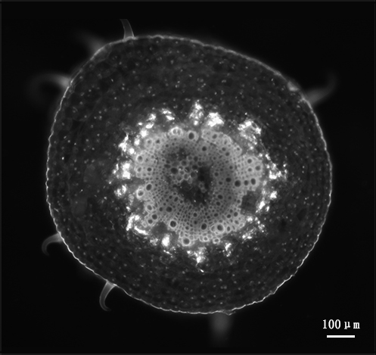
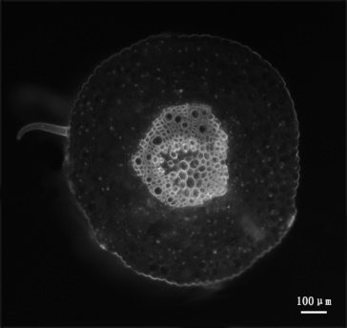
B
A

B
A

Additional file 5: Fig. S4: Phytoplasma determination in jujube petiole phloem by using 4’,6-diamidino-2-phenylindole (DAPI). A, No fluorescent spots in the sieve element (SE) of healthy plantlets. B, The fluorescent spots formed a large bright circle in the sieve element (SE) of the diseased plantlets. The number and size of fluorescent spots represent the number of phytoplasma. Bar = 100 µm.

