Diffusion and Operation Strategies of Residential Batteries in Europe
Áron Dénes Hartvig

Appendix A
The analysis builds on a previous version of the CLEARS model focusing on the Central and Eastern European region [1]. The inputs of the model are summarised in Table A.1.
Table A.1 Rooftop PV and residential battery storage system specifications
Parameter | Value | Sources
Battery cost (EUR/kWh) | 459 | [2]ª
Battery power cost (EUR/kW) | 388 | [2]ª
Battery cost relative std. (%) | 20 | based on [3]^{b}
Depth of discharge (%) | 90 | [4]
Battery efficiency (%) | 90 | [4]
Battery lifetime (year) | 15 | [4]
Discount rate (%) | 5 | [4]
Annual electricity price growth (%) | 2 | [5]
Labour cost of battery installation (EUR/kWh) | 240 | based on [6]^{c}
Notes:
ª Medium battery cost scenario.
^{b} The standard deviation of battery installation is derived from the 5th percentile value and mean of PV costs in 2022 presented by [3].
^{c} Battery installation labour cost reference the total battery cost from [6], assuming a 70–30 split between battery cost and labour cost.
The analysis focuses on a single battery technology, namely lithium-ion batteries of varying sizes. Average battery sizes and historical installation data were provided by SolarPower Europe upon request. Three types of household load profiles (normal, cooling, and heating) estimated by Schlemminger et al. [7] are used. The annual load of the normal profile is lower than that of the other two. The heating and cooling profiles have similar annual consumption levels, although the heating profile shows higher winter demand due to electric heating, while the cooling profile peaks in summer.
The proportion of household profiles within each region is estimated from national household final energy use by end use (for example, space heating or cooling). The annual consumption of the profiles is then adjusted to match the average household electricity consumption of each country.
The model distinguishes three consumption levels: small, medium, and large. Medium consumers correspond to the regional average consumption, while small and large consumers use 75% and 150% of this value, respectively. Half of the population are assumed to be medium consumers, while the remaining half are evenly divided between small and large consumers. Average rooftop PV sizes are exogenously defined at the country level and adjusted according to annual consumption. Battery storage capacity is set to the maximum energy that the rooftop PV system can produce within two hours.
Projections of future battery price developments are based on Cole and Karmakar’s [8] literature-based projection approach. The method compiles recent cost data for 4-hour lithium-ion batteries, converts everything to 2022 real dollars, and normalizes each projection to its 2022 value to create consistent trends. Low, mid, and high cost trajectories are defined as the min, median, and max normalized values at key future years, then rescaled using NREL’s 2022 benchmark to get absolute $/kWh capital costs. The electricity prices faced by households are defined by their consumption level and the country’s electricity price band as defined by Eurostat.
The innovation (p) and imitation (q) parameters of the Bass diffusion model are estimated through a bounded iterative procedure in which diffusion curves are fitted to historical residential battery adoption data for each country, and the parameter values that minimize the mean squared error are selected. The start year for residential battery diffusion is defined as the first year in which solar photovoltaic capacity is recorded in a given country. Hourly solar PV output data by region were obtained from the Photovoltaic Geographical Information System [9]. The data were collected for national capitals with zero-degree azimuths, assuming that solar generation profiles are uniform across each country.
References
[1] Á. D. Hartvig, ‘Trade-offs in feed-in tariff scenarios for incentivizing clean technologies in Central and Eastern Europe’, Solar Energy, vol. 294, p. 113499, Jul. 2025, doi: 10.1016/j.solener.2025.113499.
[2] X. Han, J. Garrison, and G. Hug, ‘Techno-economic analysis of PV-battery systems in Switzerland’, Renewable and Sustainable Energy Reviews, vol. 158, p. 112028, Apr. 2022, doi: 10.1016/j.rser.2021.112028.
[3] IRENA, ‘Renewable power generation costs in 2022’, International Renewable Energy Agency, Abu Dhabi, 2023. [Online]. Available: https://www.irena.org/Publications/2023/Aug/Renewable-Power-Generation-Costs-in-2022
[4] N. S. Rayit, J. I. Chowdhury, and N. Balta-Ozkan, ‘Techno-economic optimisation of battery storage for grid-level energy services using curtailed energy from wind’, Journal of Energy Storage, vol. 39, p. 102641, Jul. 2021, doi: 10.1016/j.est.2021.102641.
[5] D. Fett, D. Keles, T. Kaschub, and W. Fichtner, ‘Impacts of self-generation and self-consumption on German household electricity prices’, J Bus Econ, vol. 89, no. 7, pp. 867–891, Sep. 2019, doi: 10.1007/s11573-019-00936-3.
[6] J. Somogyiné Molnár, ‘Szigetüzemű háztartási méretű kiserőmű (HMKE) megtérülési idejének elemzése’, JTGF, vol. 18, no. Különszám, pp. 445–465, Jun. 2023, doi: 10.14232/jtgf.2023.kulonszam.445-465.
[7] M. Schlemminger, R. Niepelt, and R. Brendel, ‘A Cross-Country Model for End-Use Specific Aggregated Household Load Profiles’, Energies, vol. 14, no. 8, p. 2167, Apr. 2021, doi: 10.3390/en14082167.
[8] W. Cole and A. Karmakar, ‘Cost Projections for Utility-Scale Battery Storage: 2023 Update’, NREL, 2023. [Online]. Available: https://docs.nrel.gov/docs/fy23osti/85332.pdf
[9] Joint Research Centre, ‘Photovoltaic Geographical Information System (PVGIS)’. 2025. [Online]. Available: https://joint-research-centre.ec.europa.eu/photovoltaic-geographical-information-system-pvgis_en

Appendix B

B.1 Sensitivity Analysis
The modelling exercise relies on simplifying assumptions needed to construct the diffusion model, so the sensitivity analysis tests how the results respond to regulatory, economic, and behavioural uncertainties. It covers four sets of assumptions: future electricity price growth, feed-in tariff levels, battery cost reduction trajectories, and the innovation and imitation parameters of the Bass diffusion model.
Given the considerable uncertainty surrounding future electricity prices and feed-in tariffs [1], two key factors are examined: the evolution of residential electricity prices, reflecting the extent to which regulators shield households from price fluctuations, and FiTs, which, while promoting rooftop PV adoption, may discourage residential battery installations. Two additional electricity price growth pathways are considered: a low increase (0%) and a high increase (4%). Similarly, two alternative FiT scenarios are tested: a low FiT (2 cents below the baseline) and a high FiT (2 cents above the baseline). The results are presented in Figure B.1.
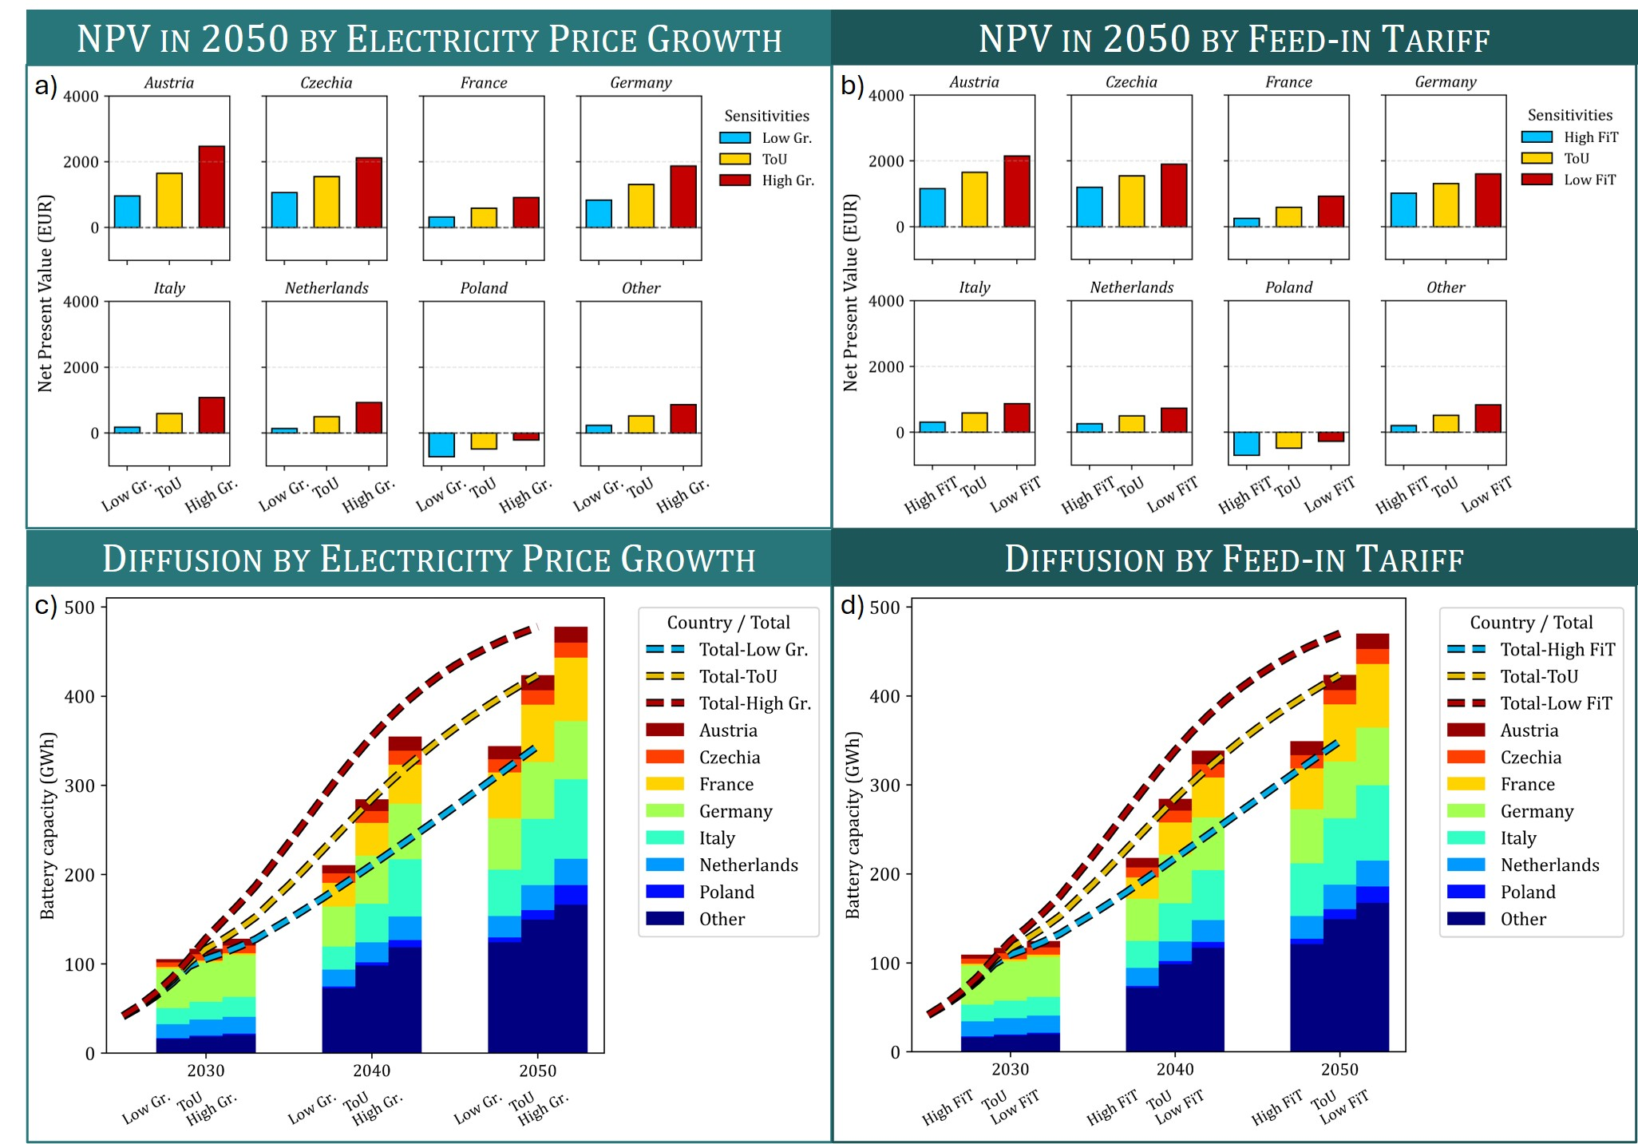
Figure B.1 Sensitivity to electricity price growth and feed-in tariff levels in the ToU scenario. a) NPV in 2050 by country under electricity price growth rates of 0% (Low Gr.), 2% (ToU), and 4% (High Gr.); b) NPV in 2050 by country under ToU scenario feed-in tariffs and tariffs that are 2 cents lower (Low FiT) or higher (High FiT); c) Diffusion of residential battery energy storage capacity in Europe by country under electricity price growth rates of 0% (Low Gr.), 2% (ToU), and 4% (High Gr.); d) Diffusion of residential battery energy storage capacity in Europe by country under ToU scenario feed-in tariffs and tariffs that are 2 cents lower (Low FiT) or higher (High FiT).
The analysis confirms that electricity price growth affects the NPV of residential battery installations in the expected manner. Higher electricity price growth increases NPV, as greater self-consumption and reduced reliance on grid electricity become more economically advantageous. Conversely, when electricity price growth is reduced to zero (Low Gr. scenario), NPV declines and approaches zero in several countries even by 2050, including France, Italy, and the Netherlands, thereby reducing the number of households for which battery installation is financially attractive. However, adoption levels are not sensitive to the magnitude of electricity price growth. Consequently, total residential battery energy storage capacity in 2050 is projected to range between 344.2 GWh and 477.7 GWh across the electricity price growth scenarios.
Feed-in tariffs exhibit a similar influence on the results. Under a high FiT scenario, total residential battery storage capacity declines to around 350 GWh by 2050, as exporting electricity to the grid becomes relatively more attractive than storing it. In contrast, reducing FiT levels leads to a modest increase in battery deployment.
To assess the robustness of the results and the influence of key economic assumptions on residential battery adoption two additional critical drivers are examined: the rate of battery cost reduction and the innovation and imitation parameters of the Bass diffusion model. While the baseline scenario assumes a low trajectory of battery cost decline based on [1], and Bass parameters calibrated for each country on historical data, alternative assumptions are introduced to capture potential deviations from these trends.
Furthermore, two additional battery cost trajectories are tested, low reduction, and medium reduction as defined by [1] Additionally, scenarios characterized by slow innovation and slow imitation are considered. In the Low p scenario, the minimum innovation parameter (p) observed among the countries is applied uniformly across all countries. Analogously, in the Low q scenario, the minimum imitation parameter (q) observed is applied consistently to all countries. These variants allow the analysis to evaluate how slower or faster technological cost declines and differing diffusion dynamics may affect the financial viability, adoption rate, and aggregate storage capacity of residential batteries across Europe.
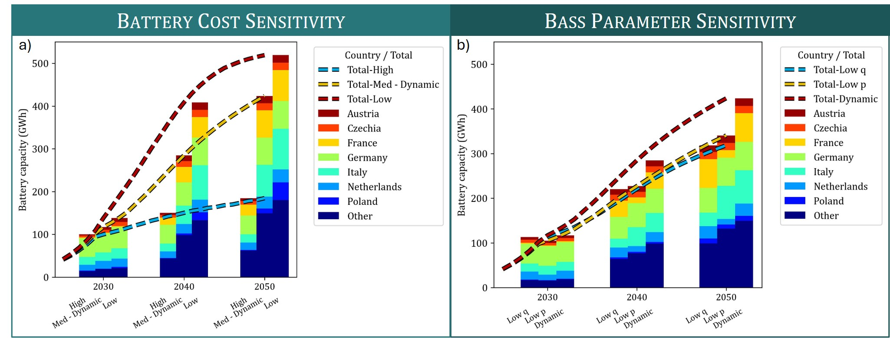
Figure B.2 Sensitivity analysis of residential battery storage capacity diffusion. a) Sensitivity to battery cost reduction pathways; b) Sensitivity to Bass innovation and imitation parameters.
The sensitivity analysis, shown in Figure B.2, reveals that the rate of battery cost reduction plays a decisive role in shaping future diffusion patterns. A slower decline in battery prices substantially lowers the projected number of installations and total storage capacity by 2050, particularly in France, Italy, and the group of Other countries, where investment profitability is more sensitive to upfront costs.
Variation in the innovation and imitation parameters of the Bass diffusion model has more limited impact on residential battery diffusion. A lower innovation parameter primarily delays early uptake, leading to a reduction of over 105 GWh in total capacity by 2050. In contrast, a lower imitation parameter mainly affects long-term diffusion, resulting in a decrease of 83 GWh in total capacity by 2050.
References
[1] X. Han, J. Garrison, and G. Hug, ‘Techno-economic analysis of PV-battery systems in Switzerland’, Renew. Sustain. Energy Rev., vol. 158, p. 112028, Apr. 2022, doi: 10.1016/j.rser.2021.112028.
[2] W. Cole and A. Karmakar, ‘Cost Projections for Utility-Scale Battery Storage: 2023 Update’, NREL, 2023. [Online]. Available: https://docs.nrel.gov/docs/fy23osti/85332.pdf

Appendix C

C.1 Comparison with relevant literature
Table C.1 Summary of most relevant studies
Reference | Geography | Main focus | Modelling approach | Key relevant outputs
Castaneda et al. [1] | United Kingdom (national) | Long‑term rooftop PV adoption (with/without batteries) under FiT reductions | System‑dynamics model combined with Bass diffusion. Financial factors (prices, FiTs, costs) shape pool of potential adopters | Installed rooftop PV and PV‑battery capacity to 2038, effects of FiT degression
Fett et al. [2] | Germany (national) | Diffusion and system impact of residential batteries under different regulations | Bass diffusion combined with prosumer simulation, and agent‑based electricity market model. Financial returns do not change adopter numbers; affect system operation and sizing | Installed residential storage capacity to 2050, impacts on utilities’ capacity expansion planning
Hartvig [3] | 8 CEE countries (multi‑country) | Trade‑offs between FiT levels for rooftop PV and residential batteries | CLEARS model combining NPV and Bass diffusion. NPV influences potential adopters | Installed rooftop PV and residential battery capacity to 2050 across various FiT levels, trade‑offs between technologies
Hartvig and Szabó [4] | Hungary (NUTS3 regional) | Regional residential battery diffusion under various support schemes | CLEARS model combining NPV and Bass diffusion. NPV influences potential adopters | Installed residential battery capacity to 2050 across various levels of support, spatial distribution
Klingler [5] | Germany (national) | Rooftop PV–battery self‑consumption and market diffusion | Market diffusion model combined with individual consumption data, user preferences, and techno-economic analysis. Total cost of ownership influences potential adopters | Installed rooftop PV-battery capacity to 2040 across adopter groups
Klingler et al. [6] | EU‑28 + NO, CH (multi‑country) | Residential battery deployment and system benefits | Country-level diffusion with logistic curves combined with power system assessment. Economic feasibility shifts diffusion start year; does not affect curve shape. Fixed S‑shaped logistic diffusion | Installed residential battery capacity to 2050, aggregate system benefits
Schwarz et al. [7] | California (state) | Rooftop PV-battery adoption under policy designs | Agent‑based model with three‑step household decision process. Households evaluate options using NPV; adopt most profitable positive‑NPV option | Installed rooftop PV-battery capacity to 2030, emission reductions and integration effects

C.2 Support schemes and compensation mechanisms to promote household self-consumption of solar energy in selected 10 countries
Table C.2 Overview of the compensation mechanisms for household self-consumption in ten countries, T and D indicate whether the tariff applies to the use of transmission or distribution system, source: [8]
 | Metering and billing arrangement | Sell rate | Retail rate (excl. taxes, levies and other charges)
 | Metering and billing arrangement | Sell rate | Energy fee | System charges
AT | Separate metering and billing & buy all, sell all | Weighted average monthly market price with minimum and maximum limits or market premium (>10 kWp) | Fixed, variable, dynamic, depending on the supply contract | T-tariff: static  D-tariff: static/ToU
DK | Separate metering and billing | Market price (hourly) + charge for service to buyer, fee for metering /balancing to TSO, and injection charge to DSO | Fixed, variable, dynamic, depending on the supply contract | T-tariff: static  D-tariff: static/ToU system balance tariff paid to TSO
DE | Separate metering and billing  & buy all, sell all | FIT for 20 years | Fixed, variable, dynamic, depending on the supply contract | T-tariff and D-tariff: static, with large regional differences
EL | Net metering (25 years) for some consumer categories, net billing to be introduced | No option for selling surplus after the 3-years crediting period expires. | Fixed, variable, dynamic, depending on the supply contract | Static/ToU at both transmission and distribution level
HU | Separate metering and billing | Static, fixed | Static | T-tariff and  D-tariff: static
IT | Separate metering and billing | Dynamic: hourly zonal price with minimum | Fixed, variable, dynamic, depending on the supply contract,  reduced VAT | T-tariff and  D-tariff: static
NL | Net metering, without initially set eligibility period (planned to be phased out) | Non-regulated price set by the supplier, ~ 80% of electricity price | Mostly static but can also be variable or dynamic, depending on the supply contract | T-tariff: static  D-tariff: static
PL | Net billing | Monthly average price until 2024 July, then dynamic hourly market price, VAT levied also on credited amount | Static, variable, ToU, dynamic, depending on the supply contract | T-tariff: static  D-tariff: static/ToU
PT | Separate metering and billing, 15-minute net metering | Depends on contract with buyer (aggregator) | Static, variable, dynamic, ToU, depending on the supply contract, reduced VAT | Static/ToU at both transmission and distribution levels
SK | No specific scheme, market contracts | Depends on the supply contract, mostly virtual storage service. No compensation for surplus | Static | T-tariff: static  D-tariff: static/ToU

C.3 Time-of-use tariffs in Europe
Time-of-use (ToU) network tariffs are widely used in Europe to encourage consumers to shift electricity consumption away from peak demand periods through differentiated network charges. Higher tariffs are applied during periods of high network utilisation, while lower tariffs apply during off-peak periods, helping reduce congestion and postpone costly grid investments. Static ToU tariffs, with predefined peak and off-peak periods, are the dominant approach, particularly at the distribution level, where they are implemented in 21 out of 28 European countries, and 18 out of the 25 countries analysed in the current study, as shown in Table C.3. In contrast, dynamic ToU tariffs, which adjust prices closer to real time, remain less common [9].
Recent developments show a gradual transition toward more granular and flexible tariff structures in several European countries, including Belgium, Germany, the Netherlands, and Slovenia. ToU tariffs typically vary by time of day, weekday or weekend, and season, with winter months often associated with higher charges due to seasonal peaks in electricity demand. However, the effectiveness of ToU tariffs remains uncertain in many countries, as limited impact assessments and metering constraints continue to restrict their broader implementation and evaluation [9].
Table C.3 Tariff basis embedding the time-of-use signal for distributional level, source: [9]
 | Austria | Belgium | Bulgaria | Croatia | Czechia | Denmark | Estonia | Finland | France | Germany | Greece | Hungary | Ireland | Italy | Latvia | Lithuania | Luxembourg | Netherlands | Poland | Portugal | Romania | Slovakia | Slovenia | Spain | Sweden
Energy (€/MWh) | X | X |  | X | X | X | X | X | X |  | X |  | X |  |  | X |  | X | X | X |  | X | X | X | X
Power (€/MW) |  |  |  | X | X |  | X | X | X |  | X |  |  |  |  |  |  |  |  | X |  | X | X | X | X

References
[1] M. Castaneda, S. Zapata, J. Cherni, A. J. Aristizabal, and I. Dyner, ‘The long-term effects of cautious feed-in tariff reductions on photovoltaic generation in the UK residential sector’, Renew. Energy, vol. 155, pp. 1432–1443, Aug. 2020, doi: 10.1016/j.renene.2020.04.051.
[2] D. Fett, C. Fraunholz, and D. Keles, ‘Diffusion and system impact of residential battery storage under different regulatory settings’, Energy Policy, vol. 158, p. 112543, Nov. 2021, doi: 10.1016/j.enpol.2021.112543.
[3] Á. D. Hartvig, ‘Trade-offs in feed-in tariff scenarios for incentivizing clean technologies in Central and Eastern Europe’, Sol. Energy, vol. 294, p. 113499, Jul. 2025, doi: 10.1016/j.solener.2025.113499.
[4] Á. D. Hartvig and L. Szabó, ‘Regional residential battery storage diffusion pathways in Hungary’, Reg. Stat., vol. 15, no. 2, pp. 234–257, 2025, doi: 10.15196/RS150203.
[5] A.-L. Klingler, ‘Self-consumption with PV + Battery systems: A market diffusion model considering individual consumer behaviour and preferences’, Appl. Energy, vol. 205, pp. 1560–1570, Nov. 2017, doi: 10.1016/j.apenergy.2017.08.159.
[6] A.-L. Klingler, S. Schreiber, and A. Louwen, ‘Stationary batteries in the EU countries, Norway and Switzerland: Market shares and system benefits in a decentralized world’, in 2019 16th International Conference on the European Energy Market (EEM), Ljubljana, Slovenia: IEEE, Sep. 2019, pp. 1–5. doi: 10.1109/EEM.2019.8916537.
[7] M. Schwarz, J. Ossenbrink, C. Knoeri, and V. H. Hoffmann, ‘Addressing integration challenges of high shares of residential solar photovoltaics with battery storage and smart policy designs’, Environ. Res. Lett., vol. 14, no. 7, p. 074002, Jul. 2019, doi: 10.1088/1748-9326/aaf934.
[8] Varga, M. Bartek-Lesi, A. Diallo, and B. Dzsi, ‘The changing regulatory landscape of household self-consumption’, REKK, Budapest, 2024. [Online]. Available: https://rekk.hu/downloads/events/ECF%20Self-consumption%20study%20REKK_final.pdf
[9] ACER, ‘Getting the signals right: Electricity network tariff methodologies in Europe’, ACER, Ljubjana, 2025 March. [Online]. Available: https://www.acer.europa.eu/sites/default/files/documents/Publications/2025-ACER-Electricity-Network-Tariff-Practices.pdf

Corvinus University of Budapest, Department of Decision Sciences, Fővám square 8., Budapest, 1093, Hungary; Cambridge Econometrics; International Institute for Applied System Analysis (IIASA); aron.hartvig@stud.uni-corvinus.hu; ORCID: 0000-0001-5827-7174

