Appendix:
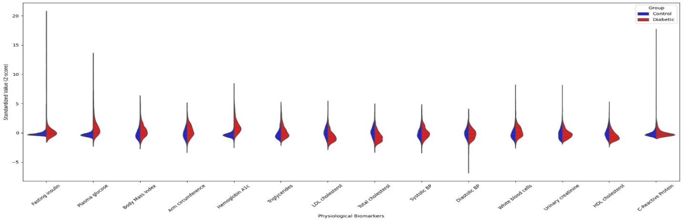
Violine plot: combined data set
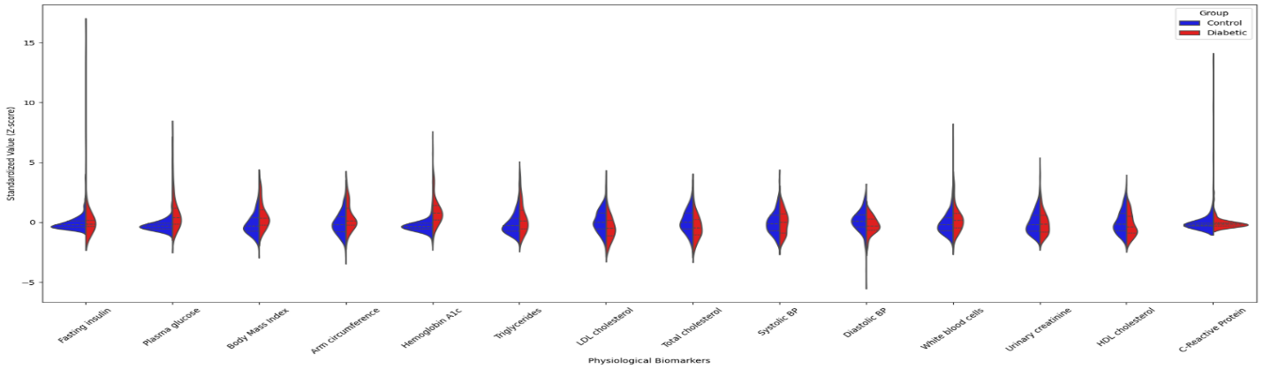
Violine plot: 2009-2010

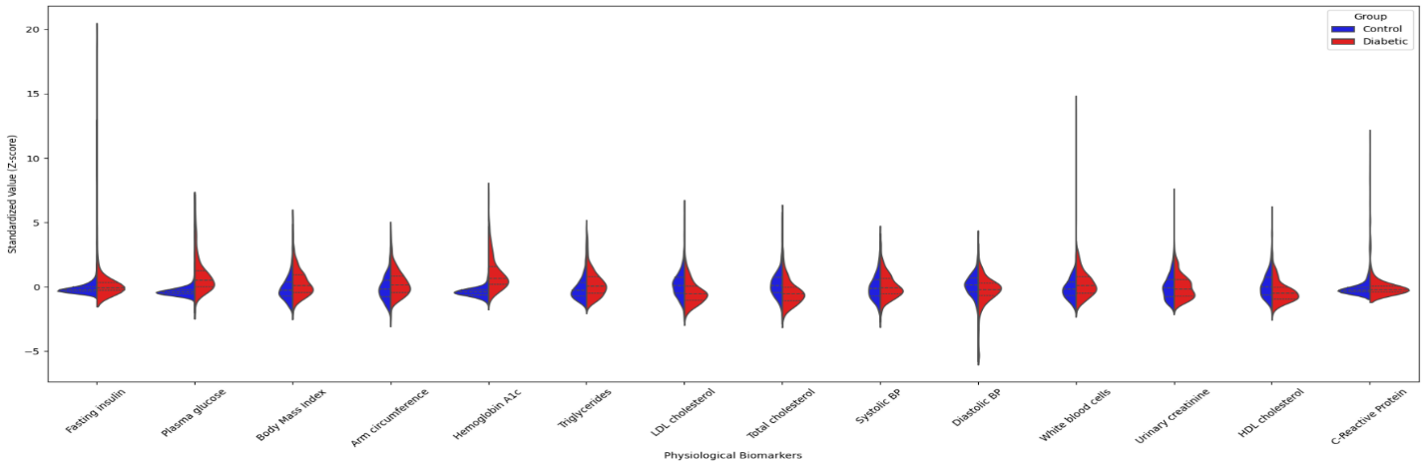
Violin plot: 2017-2018
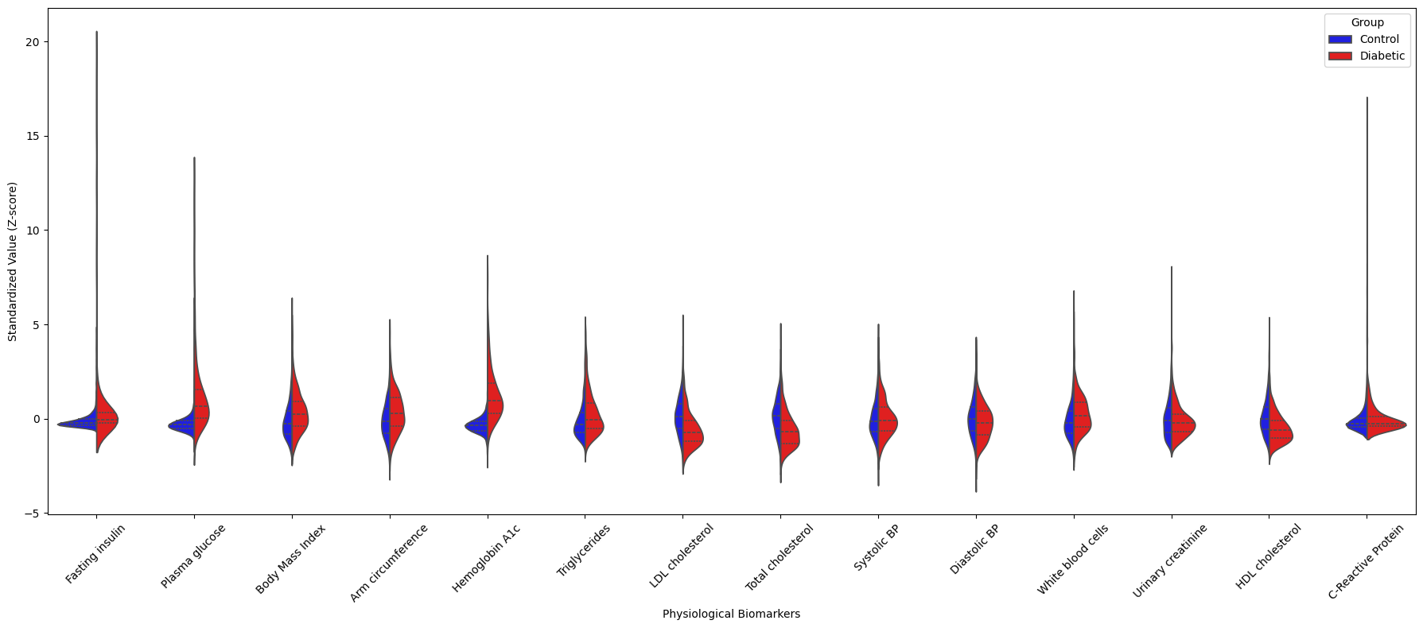
Violin plot: 2021- 2023

Figure A1: Standardized physiological biomarker distributions in diabetic vs control groups from NHANES dataset.

