Supplementary information
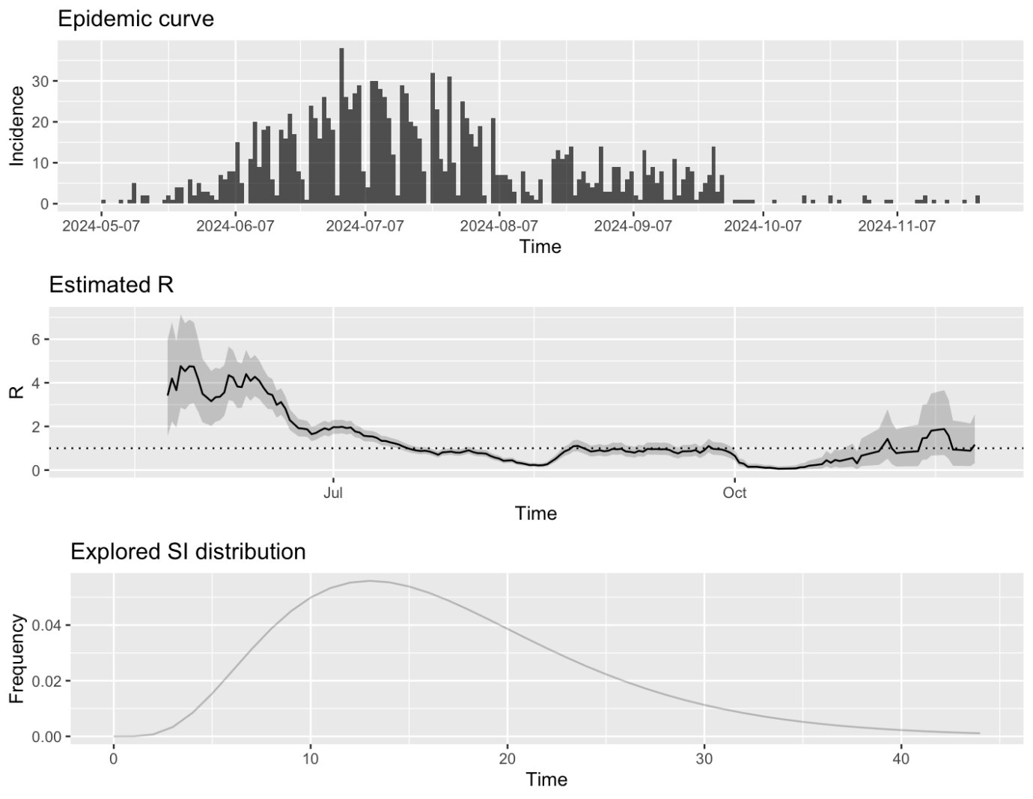
Figure S1 - R(t) estimate for Togo. The first plot shows the epidemic curve, i.e. recorded cases. The second plot shows the posterior mean and 95% credible interval of the reproduction number (estimates are not shown from the very beginning because precise estimation is not possible in this period). The third plot shows the discrete distribution(s) of the serial interval.
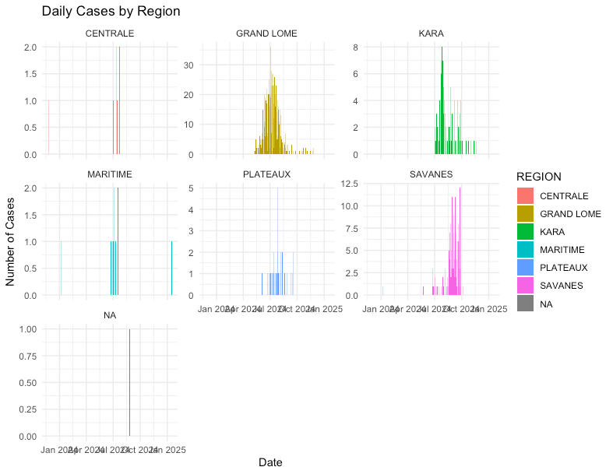
Figure S2 - Daily cases by region. Breakdown of the number of daily cases by region over the period spanning Jan 2024 to Jan 2025.

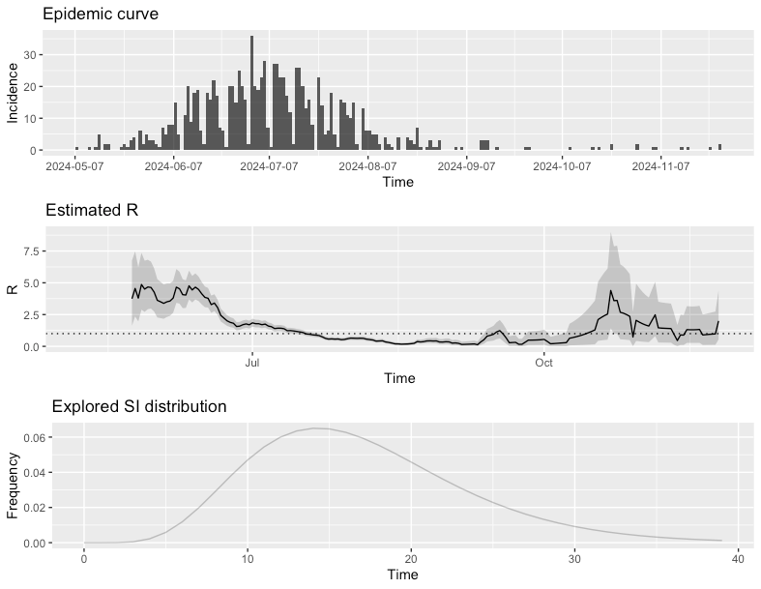
Figure S3 - R(t) estimate for Grand Lome region. The first plot shows the epidemic curve, i.e. recorded cases. The second plot shows the posterior mean and 95% credible interval of the reproduction number (estimates are not shown from the very beginning because precise estimation is not possible in this period). The third plot shows the discrete distribution(s) of the serial interval.

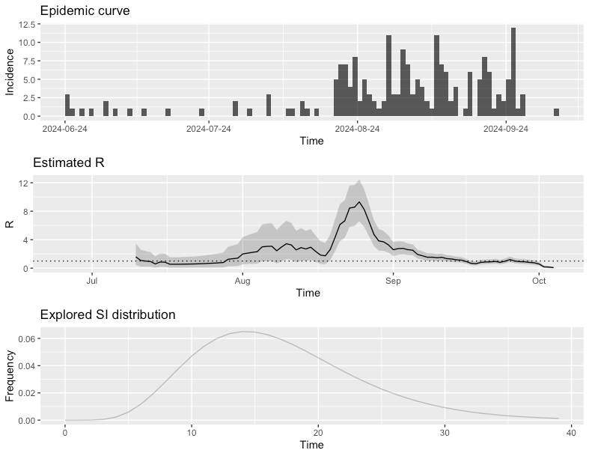
Figure S4 - R(t) estimate for Savanes region. The first plot shows the epidemic curve, i.e. recorded cases. The second plot shows the posterior mean and 95% credible interval of the reproduction number (estimates are not shown from the very beginning because precise estimation is not possible in this period). The third plot shows the discrete distribution(s) of the serial interval.

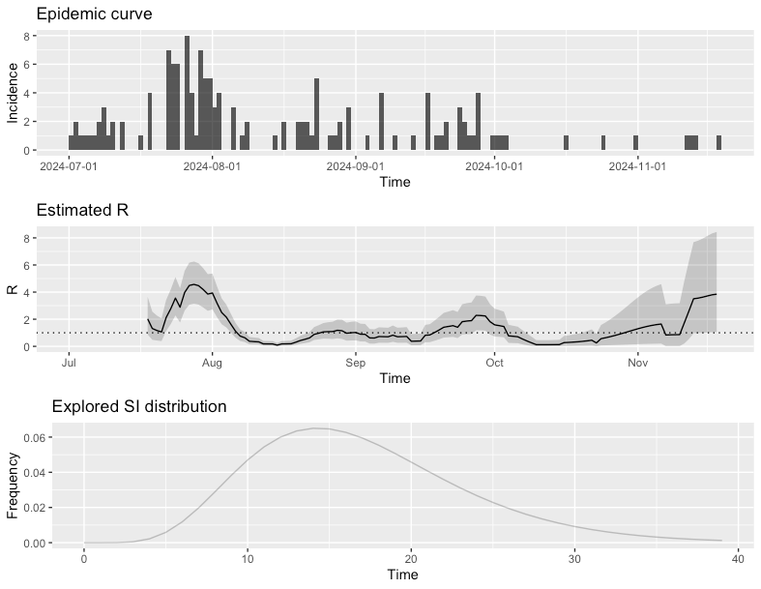
Figure S5 - R(t) estimate for Kara region. The first plot shows the epidemic curve, i.e. recorded cases. The second plot shows the posterior mean and 95% credible interval of the reproduction number (estimates are not shown from the very beginning because precise estimation is not possible in this period). The third plot shows the discrete distribution(s) of the serial interval.

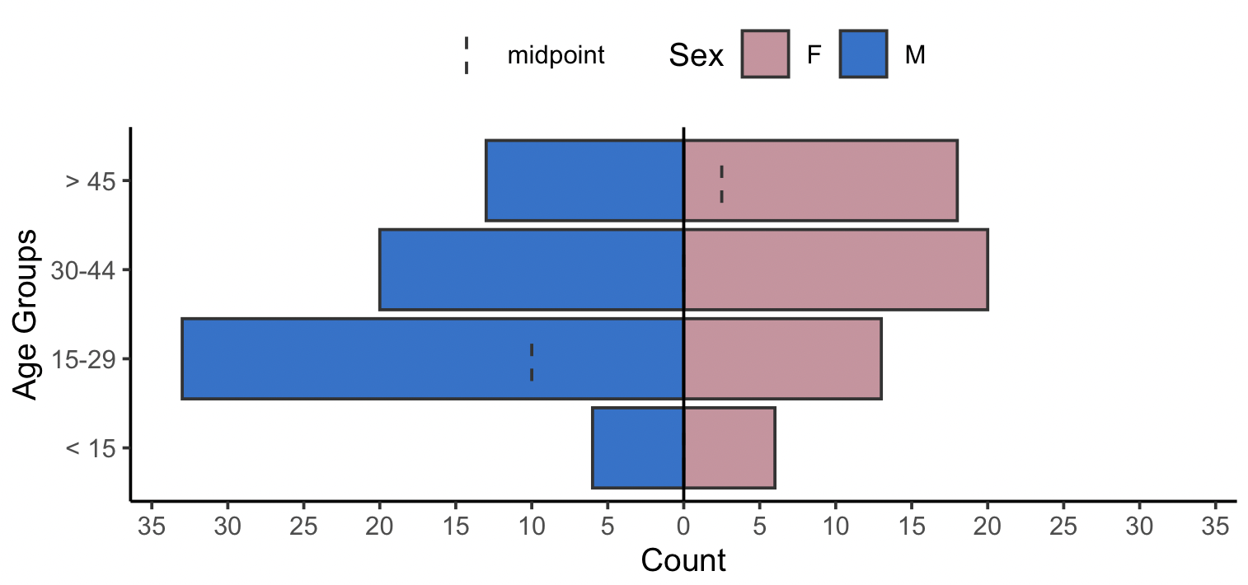
Figure S6. Demographic distribution of patients with dengue virus infections in study of genomic characterization of circulating dengue virus, Togo, 2024.

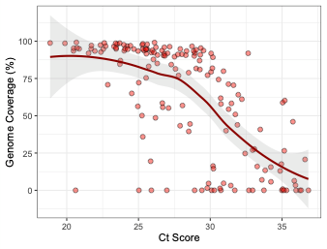
Figure S7. Relationship between Ct score and genome coverage. Scatter plot showing genome coverage (%) as a function of cycle threshold (Ct) score for sequenced samples. Each red dot represents an individual sample, and the solid line indicates the fitted regression with 95% confidence intervals (shaded area). Genome coverage remains high (>80%) for Ct scores below ~28, but progressively declines with increasing Ct, reflecting the reduced sequencing efficiency associated with lower viral loads.

Figure S8. Root-to-tip regression plot showing molecular clock of lineage A.2 subclade used for Bayesian phylogenetic reconstruction. Sequences are coloured by country of origin.

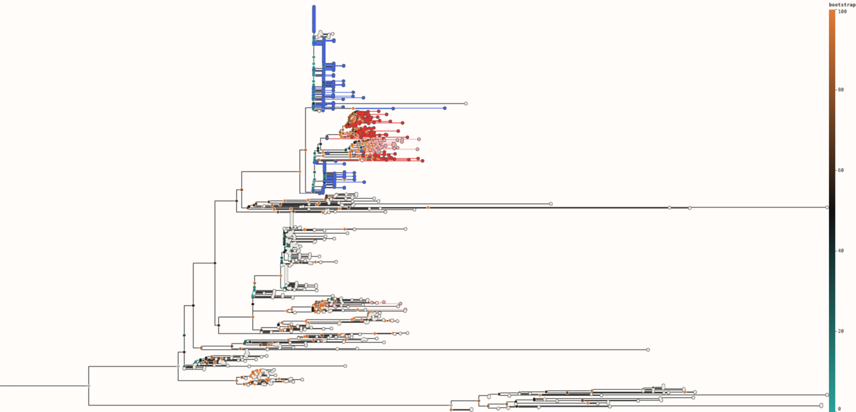
Figure S9. Maximum likelihood phylogeny of DENV-1 lineage A with node coloured by bootstrap support, from teal being lowest bootstrap to orange being highest bootstrap. Sequences from Tanzania are coloured in blue, from Togo in red, and from Côte d’Ivoire in pink.

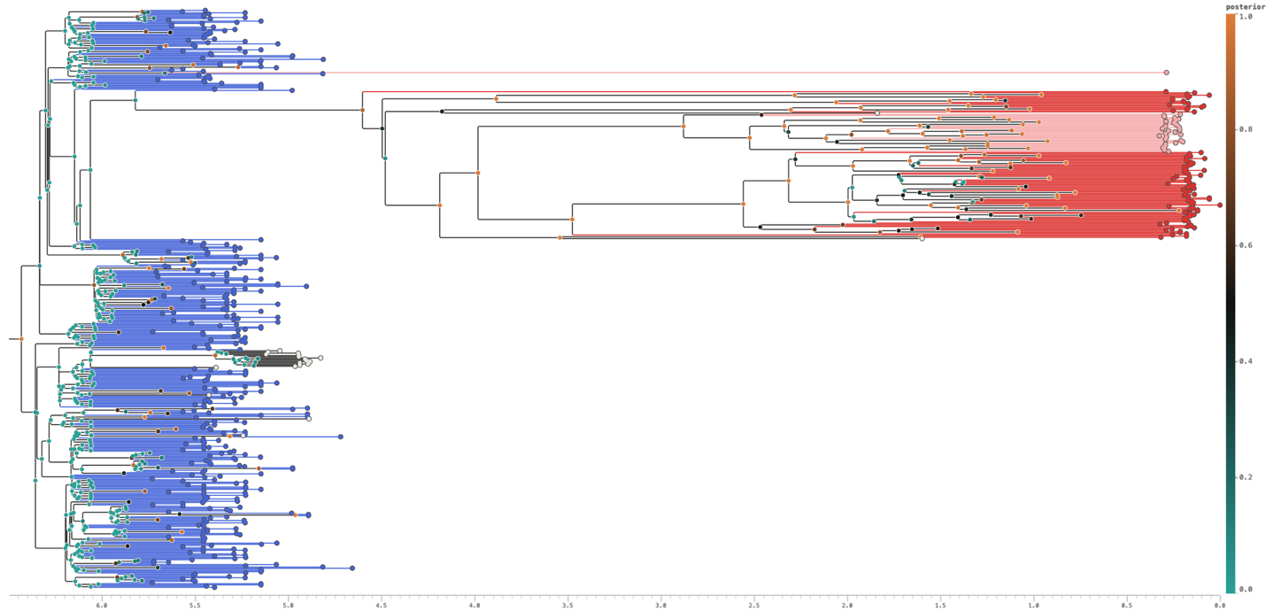
Figure S10. Maximum clade credibility tree of the A.2 lineage with node coloured by posterior probability support, from teal being lowest posterior to orange being highest posterior. Sequences from Tanzania are coloured in blue, from Togo in red, and from Côte d’Ivoire in pink.

