Supplementary Information
Three Weapons, Three Regimes of Order: Per-Touch Skill Transmission and the Structural Predictability of Fencing Tournaments
This document contains supplementary tables and a figure supporting the robustness checks referenced in the main text (§3.1 and §5). The pool-size normalization of the cyclic-triad rate is reported as Table 1a in the main text (§2.2) and is not repeated here. All analyses were performed on the full corpus of 158,652 pool bouts across 474 FIE Junior World Cup competitions (2015–2026), using the raw CSV files and replication scripts deposited in the accompanying OSF repository.

Table S1
Transitivity-gap robustness across null specifications
We tested whether the cyclic-triad rate exceeds chance once heterogeneous skill is accounted for (main text, §3.1), using four independent null specifications: a seed-gap logistic reference fitted globally, the same reference fitted per competition, and a ridge-regularized per-fencer Bradley–Terry model at two penalty strengths. The observed rate exceeded all four nulls in every weapon (p < 0.01 to p < 0.001 for the foil-versus-other-weapons gap).
Null specification | Épée gap | Sabre gap | Foil gap | Épée vs Sabre
Seed-gap logistic, global scale | +0.047 | +0.048 | +0.038 | Not distinguishable (p = 0.74)
Seed-gap logistic, per-competition scale | +0.070 | +0.063 | +0.056 | Épée > Sabre
Per-fencer Bradley–Terry (ridge λ = 0.05) | +0.043 | +0.033 | +0.022 | Épée > Sabre (p < 0.001)
Per-fencer Bradley–Terry (ridge λ = 0.20) | ~0.001 | ~0.007 | ~0.013* | Not interpreted (see note)
Note. The foil-versus-other-weapons gap is significant under all four specifications. The épée-versus-sabre ordering is not stable across specifications: it is indistinguishable under the global seed-gap scale, but épée is significantly higher under the per-competition scale and under the per-fencer Bradley–Terry model. We therefore do not claim an épée-versus-sabre ordering as a finding; the robust result is that both weapons carry more true intransitivity than foil.
*At λ = 0.20, absolute null levels are sensitive to over-regularization (pools are small, 6–7 fencers, limiting per-fencer identifiability); this row is included for transparency but not used to support the ranking, which relies on the λ = 0.05 and seed-gap specifications.

Table S2
Direct-elimination bracket sensitivity (Pillar III)
The structural out-of-sample prediction in the main text (§2.4, §5) assumes the FIE's standard single-elimination seeding bracket (top seeds in opposite halves, byes to the highest seeds). We re-ran the prediction under two alternative bracket rules — a fully random draw and adjacent (1–2, 3–4) seeding — to test whether the épée under-prediction reported in the main text depends on this assumption.
Weapon | Observed τb | Standard bracket | Random draw | Adjacent seeding | Gap (standard)
Foil | 0.684 | 0.673 | 0.355 | −0.013 | +0.011
Sabre | 0.650 | 0.663 | 0.350 | −0.012 | −0.013
Épée | 0.638 | 0.574 | 0.277 | −0.015 | +0.064
Note. The standard bracket reproduces the main-text values almost exactly (0.673/0.663/0.574 vs. 0.672/0.664/0.573). The épée under-prediction (+0.064) is specific to the standard, FIE-documented seeding procedure; predicted concordance collapses under both alternative rules, confirming the gap reflects skill transmission through the seeded tableau rather than an artifact of an arbitrary bracket choice.

Table S3
Field depth and ability-spread descriptives (Pillar II)
To address the concern that cross-weapon differences might reflect differences in competitive depth or ability spread rather than the rules of play (main text, §5), we report mean field size, mean pool size, and a proxy for within-field ability spread by weapon.
Weapon | Mean field size | Mean pool size | Indicator SD (ability-spread proxy)
Épée | 120.1 | 6.84 | 8.90
Foil | 115.4 | 6.81 | 11.64
Sabre | 107.4 | 6.79 | 10.63
Note. Field sizes and pool sizes are closely matched across weapons (mean pool size 6.79–6.84), reducing concern that weapon differences reflect tournament-depth confounds. The spread of the ability-spread proxy is smallest in épée (SD 8.9) and largest in foil (11.6) — the opposite of what a “wider épée field” explanation of its high cyclicity would require.

Table S4
Sensitivity to the time-limited-bout exclusion
Bouts that did not reach five touches within the time limit (ws ≠ 5) were excluded from the per-touch model in the main text (§3.2, §5). This exclusion is asymmetric across weapons. We refit the marginal per-touch slope β including these bouts, using their realized winning score, to test whether the exclusion drives the reported épée–foil ordering.
Weapon | Exclusion rate (ws ≠ 5) | β (strict race-to-5) | β (all bouts included) | Δ
Épée | 6.7% | 0.481 | 0.473 | −0.008
Foil | 1.9% | 0.830 | 0.826 | −0.004
Sabre | 0.01% | 0.801 | 0.801 | ~0
Note. Although the exclusion rate is markedly higher in épée (6.7%) than foil (1.9%) or sabre (0.01%), including these bouts changes the épée estimate by only −0.008 (0.481→0.473) and leaves the épée–foil ordering intact. The result reported in the main text is therefore not an artifact of this exclusion.

Table S5
Weapon ordering within each gender.
The three headline measures re-estimated separately for men's and women's events. Columns report the pillar-I disorder measure (percentage of intransitive [cyclic] triads within pools), the pillar-II marginal per-touch slope (β, race-to-five maximum-likelihood estimate), and the pillar-III seed-to-outcome concordance on the artifact-free earned-tier outcome (Kendall τ_b). Within each gender the disorder measure orders the weapons épée > sabre > foil, while both skill-transmission measures order them foil > sabre > épée; the ordering reported in the main analysis therefore holds in men's and women's events alike and is not an artifact of pooling across gender. Per-touch slopes are systematically higher in women's events, but the cross-weapon ordering is unchanged. Estimates use the same specifications as Tables 2–4; see the replication package (script 09) at https://osf.io/jtb8h.
Group | Cyclic-triad % | Marginal β | Earned-tier τb
Men — Foil | 10.4 | 0.745 | 0.680
Men — Sabre | 12.6 | 0.727 | 0.648
Men — Épée | 15.0 | 0.453 | 0.632
Women — Foil | 10.2 | 0.978 | 0.687
Women — Sabre | 12.2 | 0.925 | 0.652
Women — Épée | 13.9 | 0.530 | 0.644

Figure S1. Observed cyclicity against a seed-based skill-model null
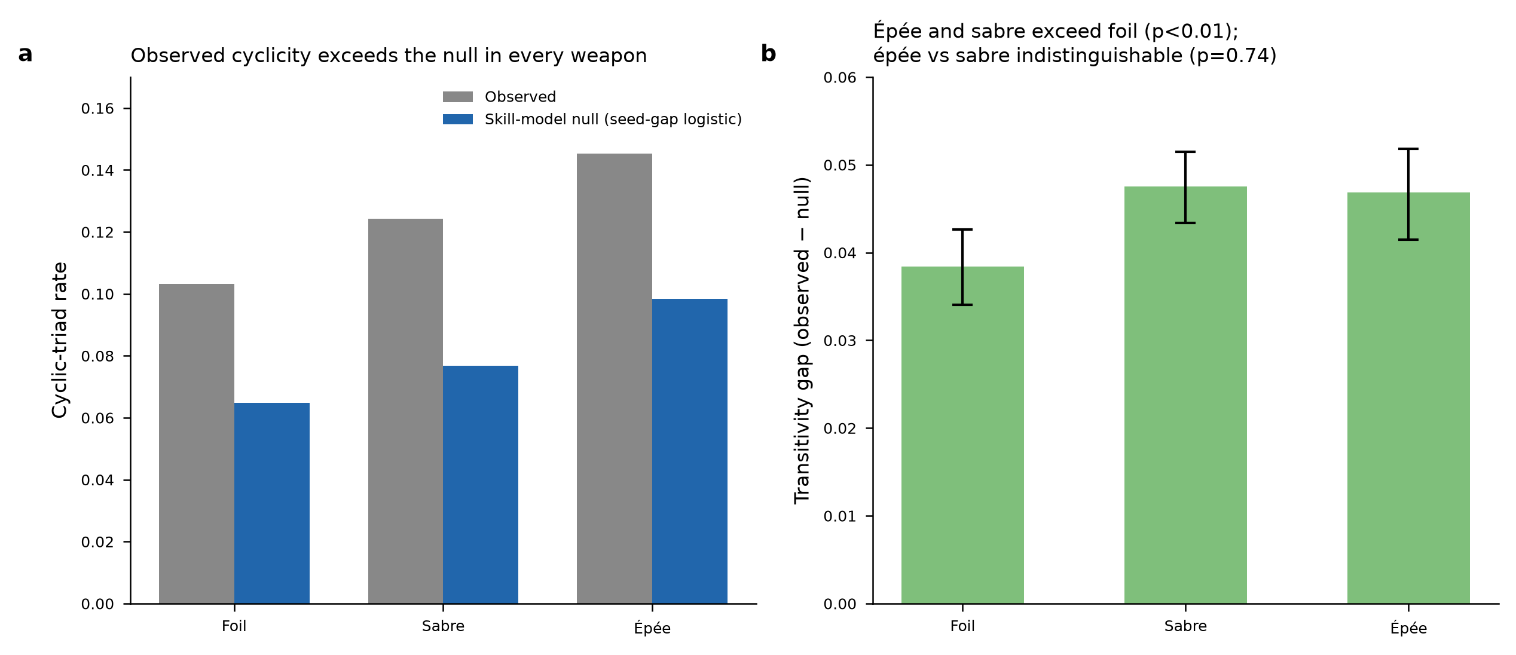
Figure S1. (a) Observed cyclic-triad rate against the seed-gap logistic null (global scale), by weapon. (b) Transitivity gap (observed − null) with cluster-bootstrap 95% confidence intervals (400 repetitions, resampled at the competition level); épée and sabre exceed foil (p < 0.01), while épée and sabre are not distinguishable from one another (p = 0.74). See Table S1 for results under three additional null specifications.

Reference
Kendall, M. G., & Babington Smith, B. (1940). On the method of paired comparisons. Biometrika, 31(3/4), 324–345. https://doi.org/10.2307/2332226

