Supplementary Materials
Supplementary figure S1. Breastfeeding positions distribution after implementation of documentation in EHR
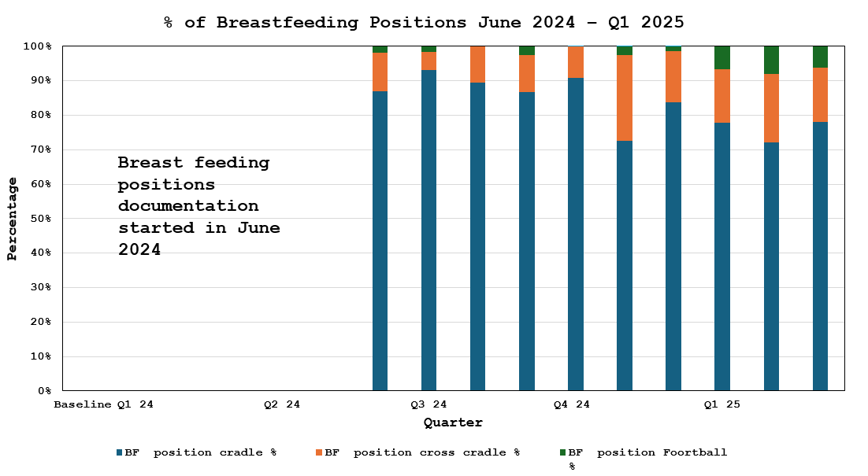

Supplementary figure S2. Latch score distribution after implementation of standardized breastfeeding assessment
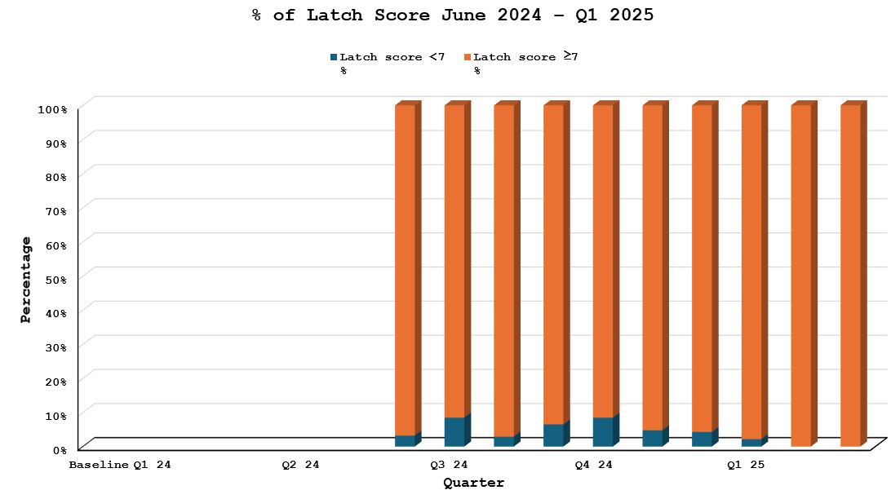

Supplementary figure S3. Parental knowledge and self-efficacy scores in hospital across PDSA cycles
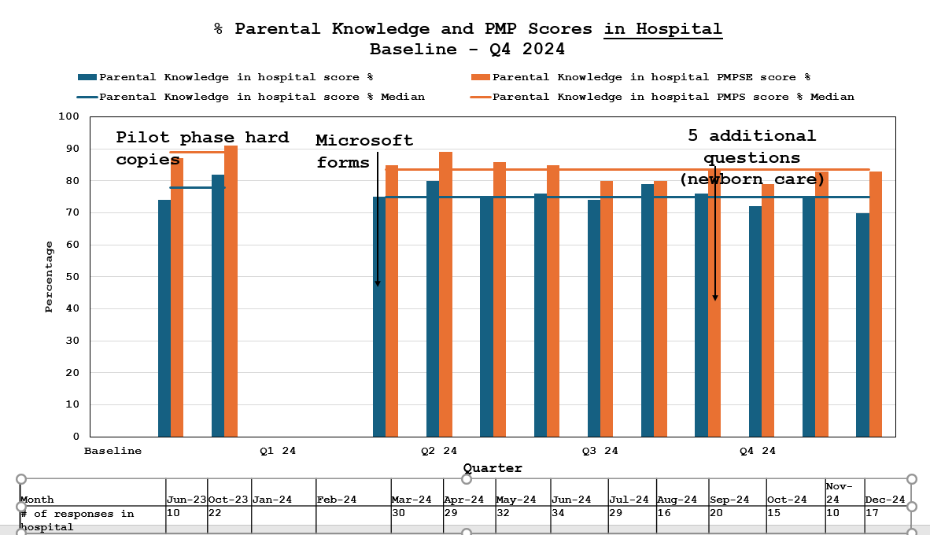

Supplementary figure S4. Parental knowledge and self-efficacy scores at 1 month post-discharge across PDSA cycles
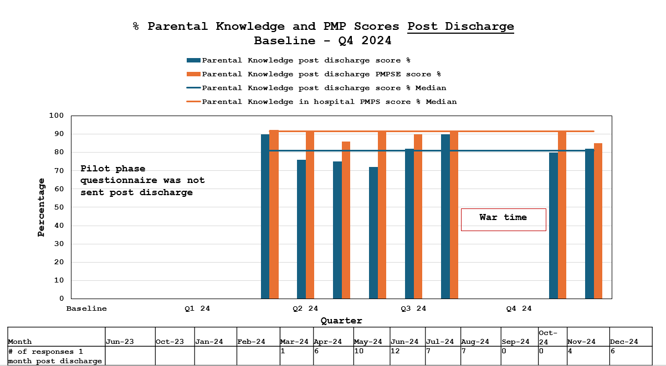

Supplementary figure S5. Response rates to parental knowledge questionnaires in hospital and at 1 month post-discharge across PDSA cycles
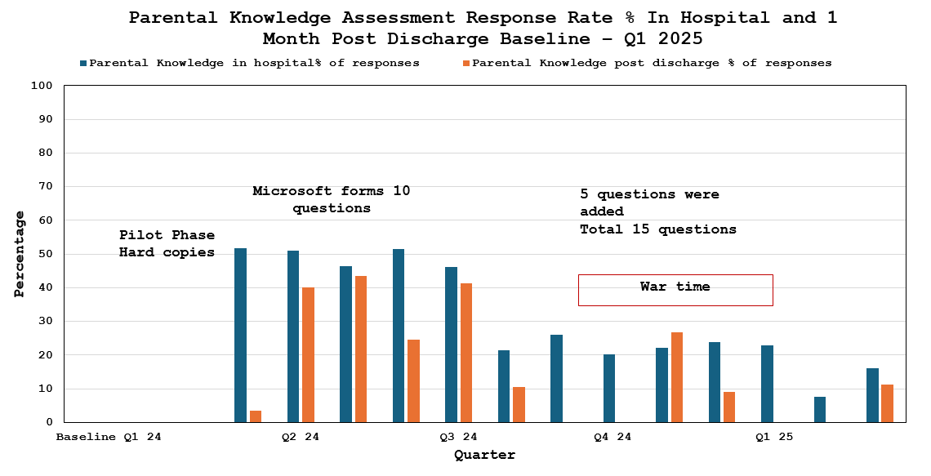

Supplementary figure S6. Comparison of exclusive breastfeeding rates between primigravida and multigravida mothers across PDSA cycles

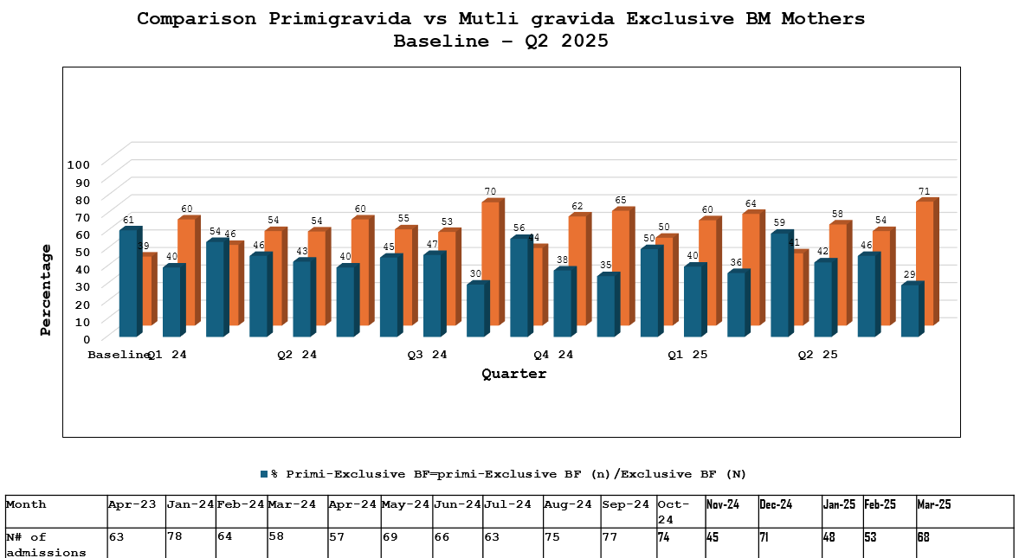
Supplementary figure S7. Parent-reported breastfeeding experience at one week post-discharge based on follow-up phone calls (N=1,028)

Supplementary figure S8. Parent-reported newborn-care concerns at one week post-discharge based on follow-up phone calls (N=1,028)

