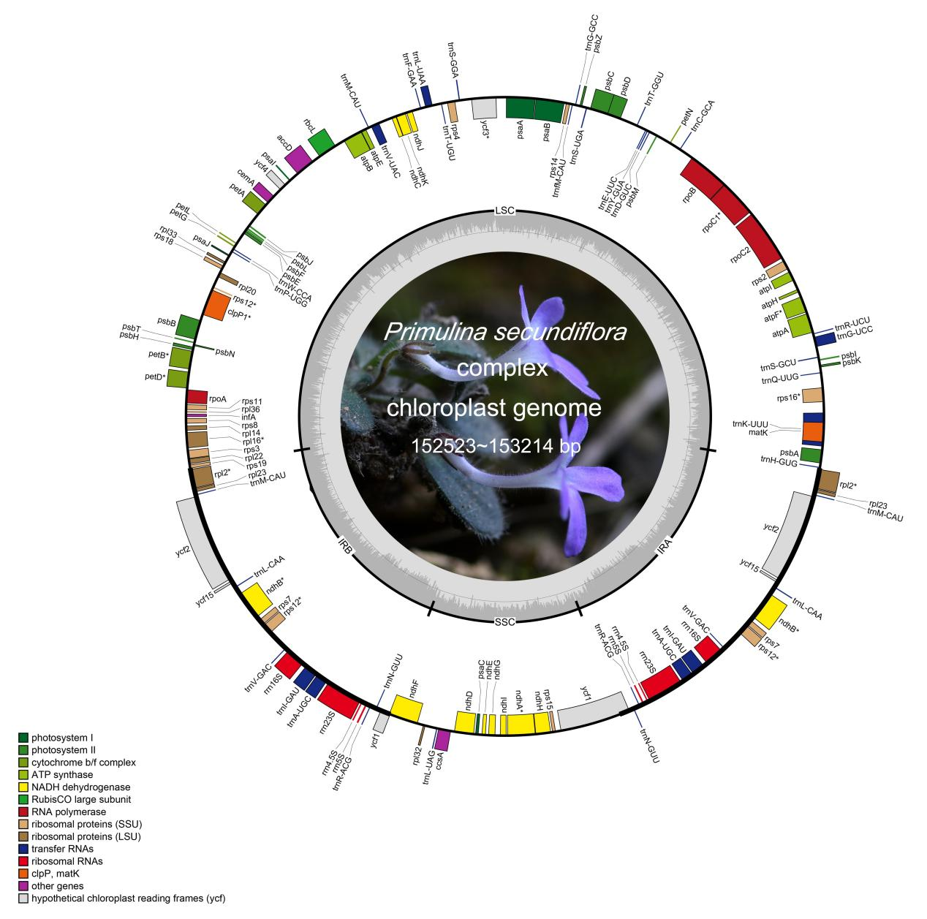Fig. 5 Structural map of the chloroplast genome of the Primulina secundiflora complex, using a photograph and the map of Pri. secundiflora as a background and template; maps of the other species in this complex are shown in Additional file 2.

