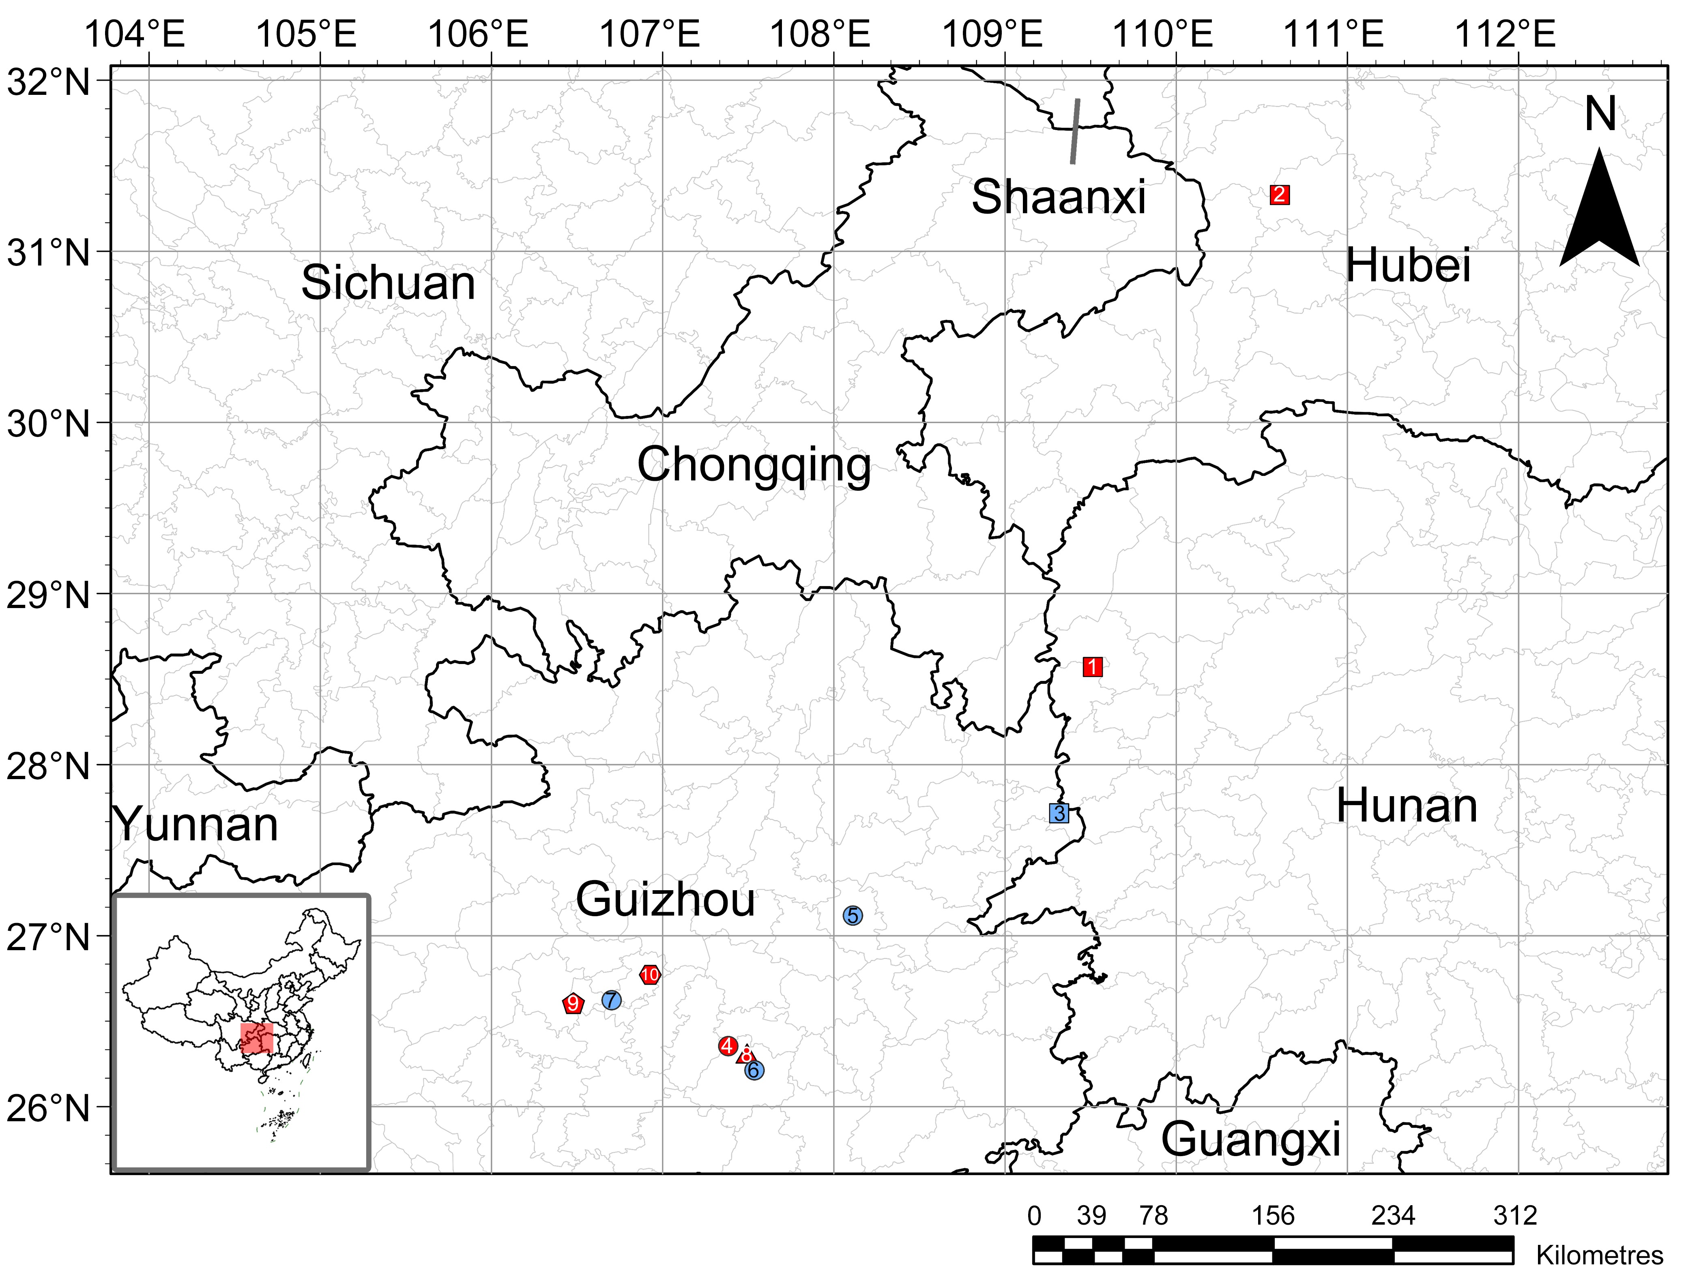
Fig. 2 Survey points for the Primulina secundiflora complex: 1 Pri. tenuitubum HYGMH; 2 Pri. tenuitubum SNJLQ; 3 Pri. tenuitubum TRJLD; 4 Pri. vestita DPS; 5 Pri. vestita SBYTS; 6 Pri. vestita YLDT; 7 Pri. vestita LCG; 8 Pri. flexusa DYHLZ; 9 Pri. secundiflora QZHQ; 10 Pri. huahaii XZG. The red graph indicates that this population is located in the type locality. Base map sourced from the Natural Geomatics Center of China (https://cloudcenter.tianditu.gov.cn/administrativeDivision; map No. GS(2024)0650).

