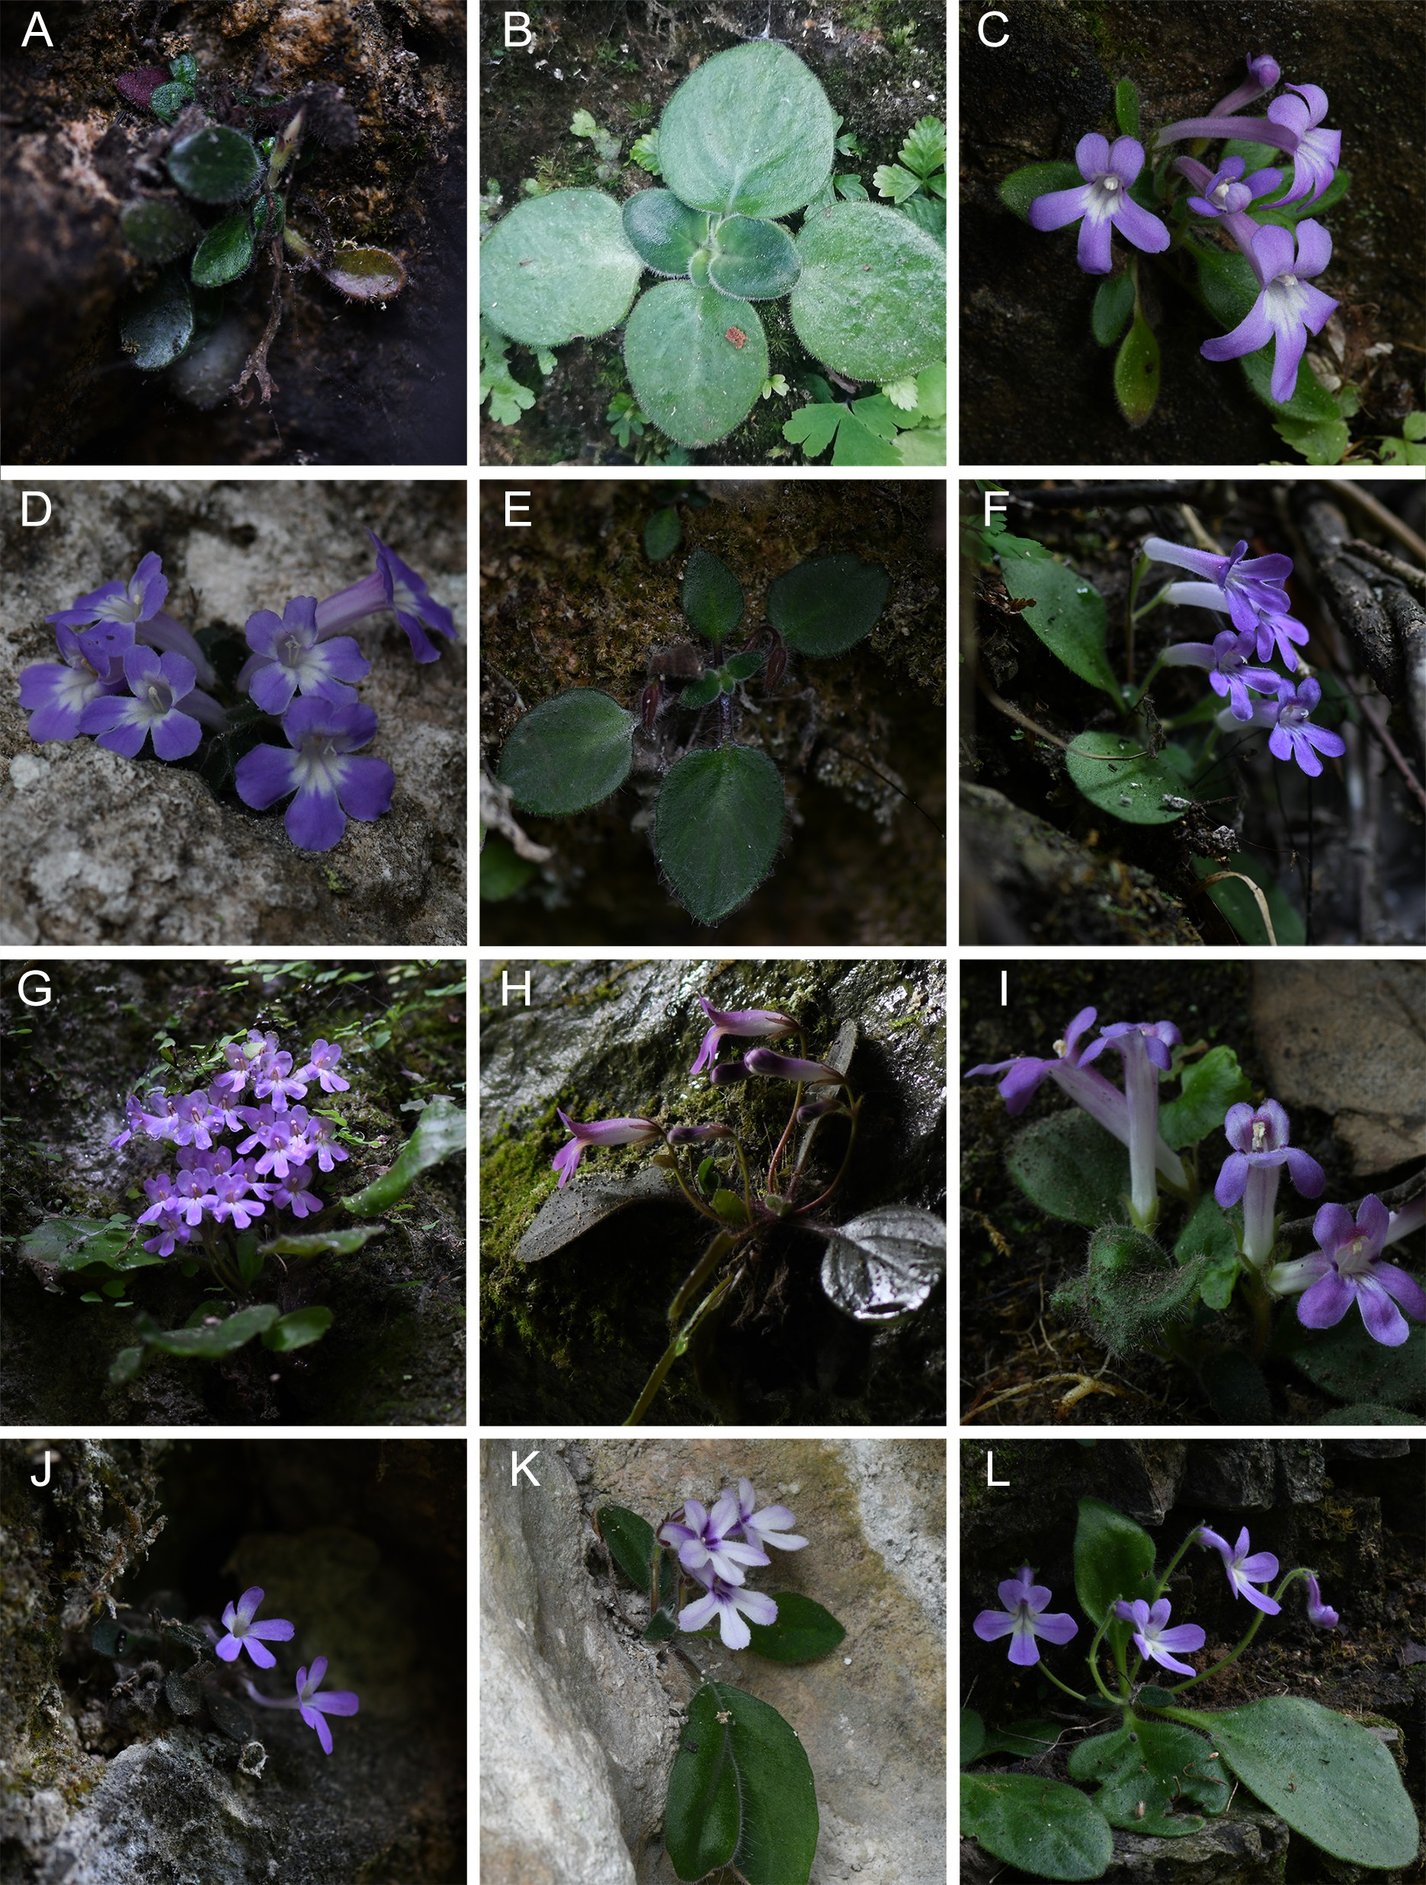
Fig. 1 Field populations and codes of the Primulina secundiflora complex. A Pri. tenuitubum (type locality of Deltocheilos tenuitubum, HYGMH); B Pri. tenuitubum (type locality of Chirita shennungjiaensis, SNJLQ); C, D Pri. tenuitubum (Jiulongdong, Bijiang District, Guizhou Province, TRJLD); E Pri. vestita (type locality, DPS); F Pri. vestita (Yuntai Mountain, Shibing County, Guizhou Province, SBYTS); G, H Pri. vestita (Yaolindongtian, Duyun City, Guizhou Province, YLDT); I Pri. vestita (Luchongguan, Yunyan District, Guizhou Province, LCG); J Pri. flexusa (type locality, DYHLZ); K Pri. secundiflora (type locality, QZHQ); L Pri. huahaii (type locality, XZG).

