Supplement of
Methane transport from the world's densest fossil source region systematically biases satellite-based emission estimates
Zheng et al.
Correspondence to: Jason B. Cohen and Kai Qin (jasonbc@alum.mit.edu; jasonbc@cumt.edu.cn; qinkai@cumt.edu.cn)

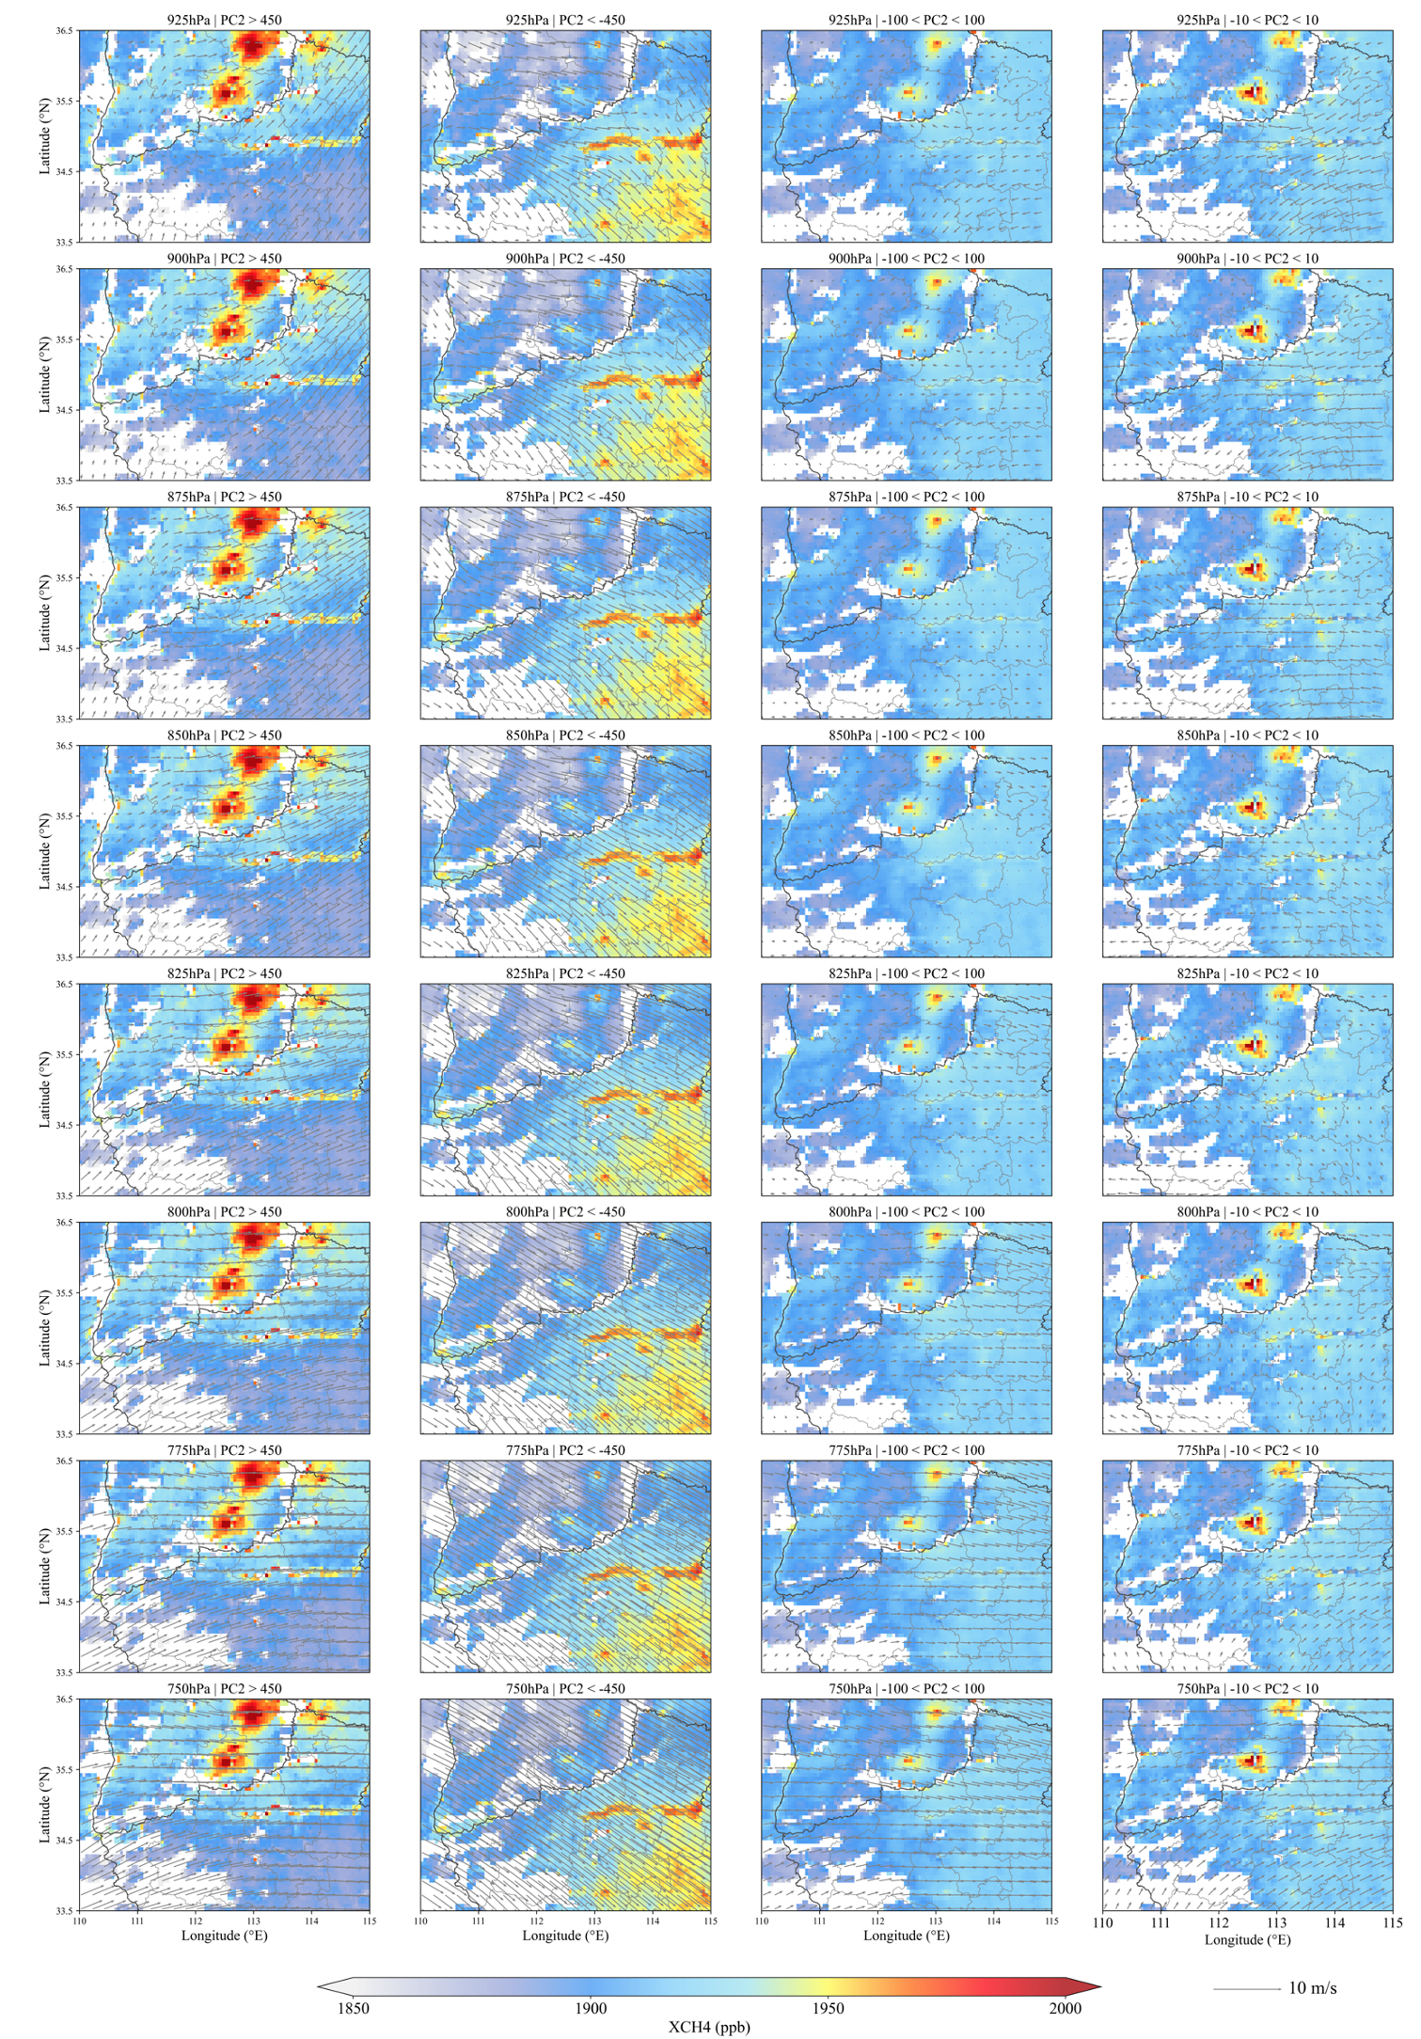
Figure S1. The four columns of subplots (from left to right) represent the mean XCH4 concentrations and mean wind fields corresponding to PC2 >450, PC2 < -450, -100 < PC2 < 100, and -10 < PC2 < 10 conditions, respectively. The eight rows of subplots (from top to bottom) display the wind fields at different pressure levels ranging from 925hPa to 750hPa.
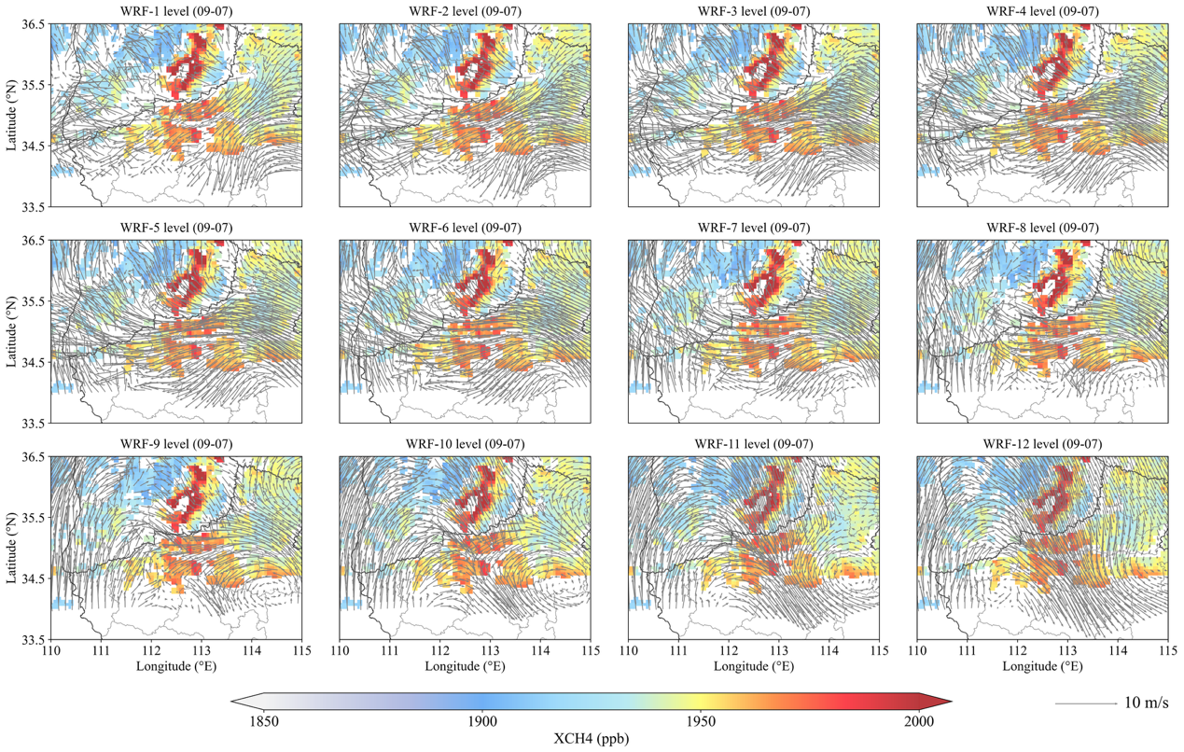
Figure S2. The spatial distribution of XCH₄ concentration on September 7, 2022, and the wind field at WRF from the first layer to the 12th layer (from the ground to 700hpa) height matched the time when PC2>450.
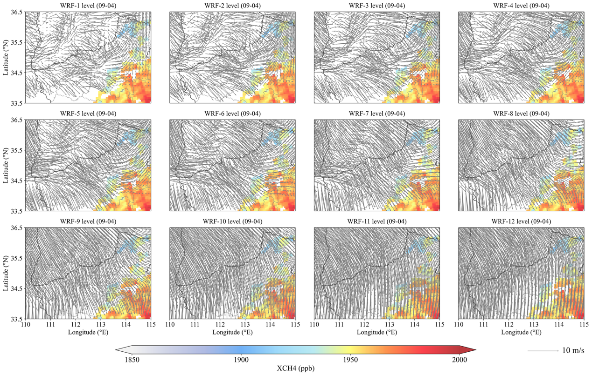
Figure S3. The spatial distribution of XCH₄ concentration on September 4, 2022, and the wind field at WRF from the first layer to the 12th layer (from the ground to 700hpa) height matched the time when PC2<-450.
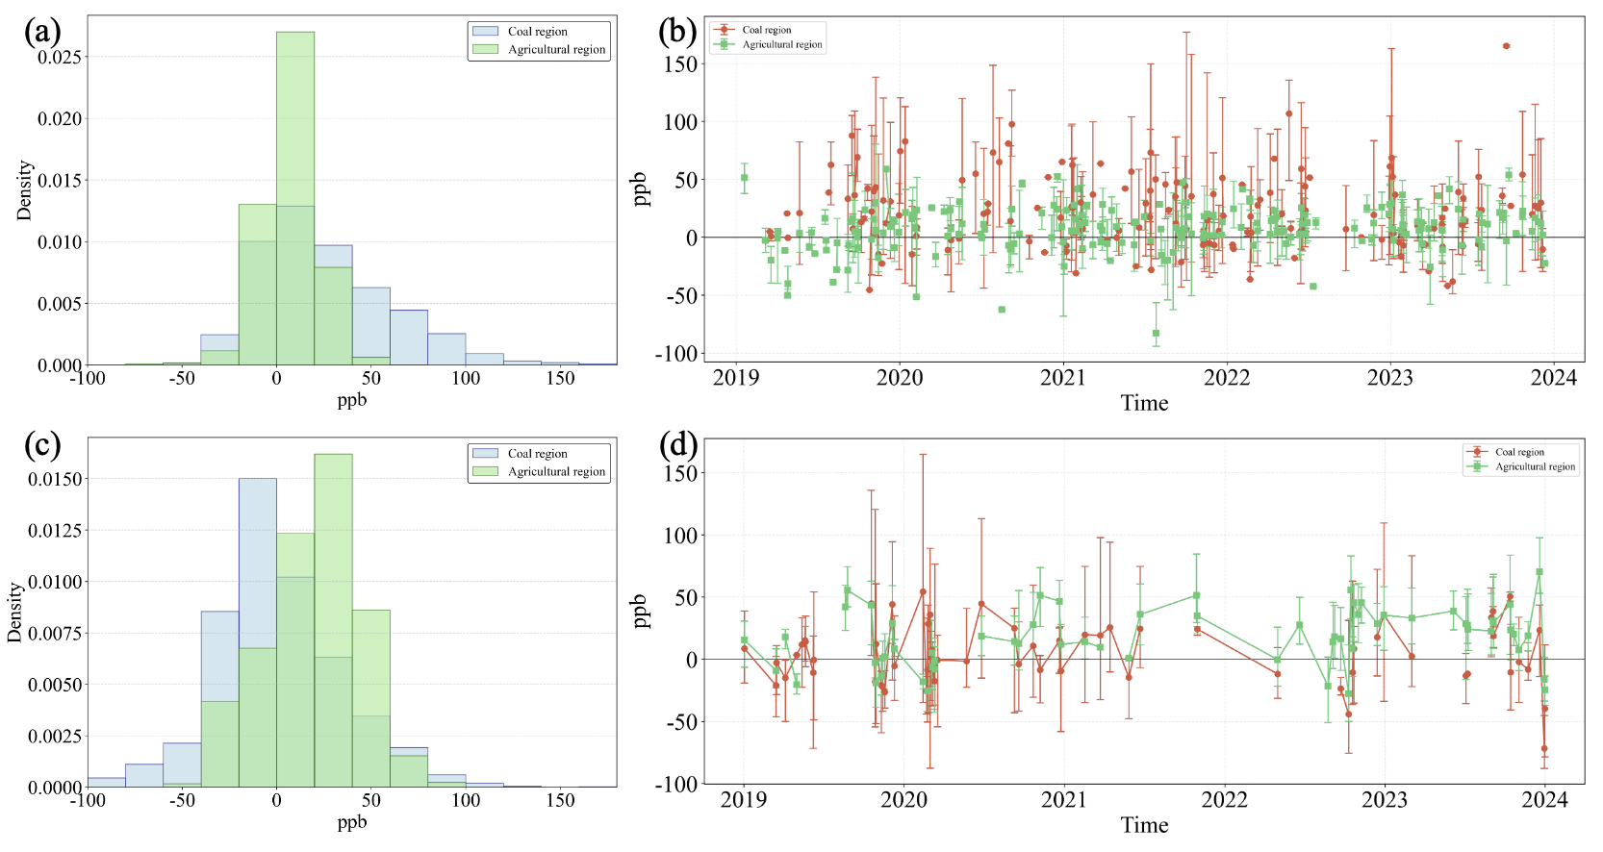
Figure S4. (a) and (c) are respectively the distribution of methane concentration enhancement values in the coal mining area and the agricultural area during the normal period and the period when methane transport occurs. (b) and (d) are the time series of methane concentration enhancement values corresponding to (a) and (c), where the scattered points represent the average value of daily methane concentration enhancement values, and the error line is the fluctuation range of daily methane concentration enhancement values.

