Table1.Characteristics of included patients.

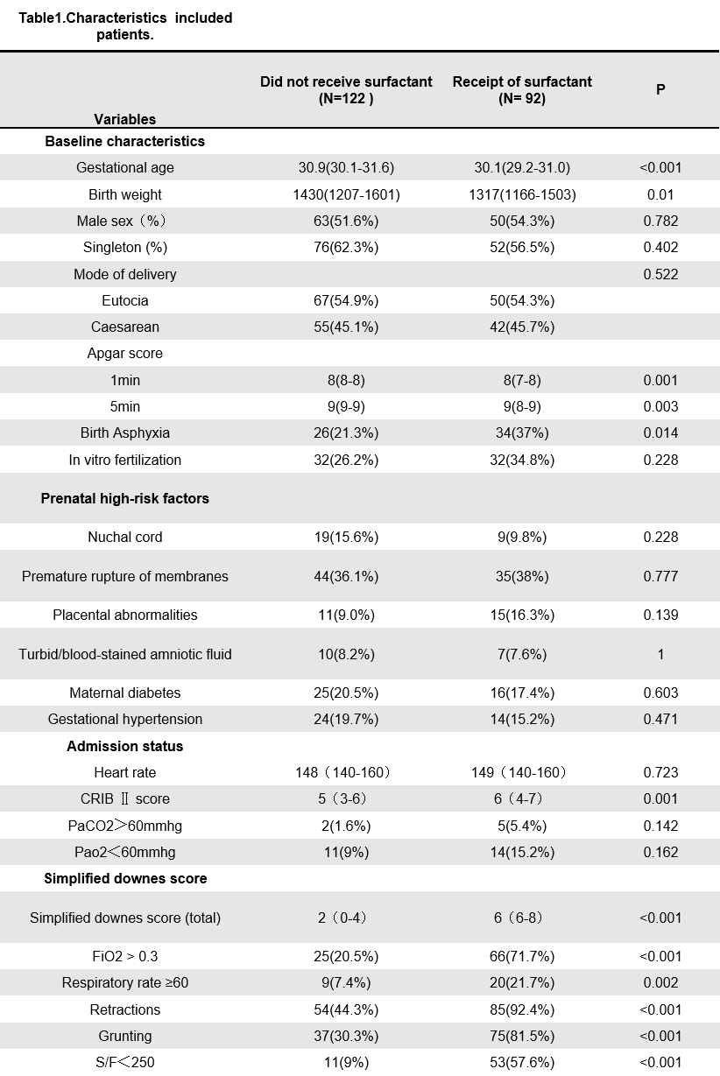
Table 2.Results of Multivariable Logistic Regression Analysis for Factors Associated with Surfactant Requirement
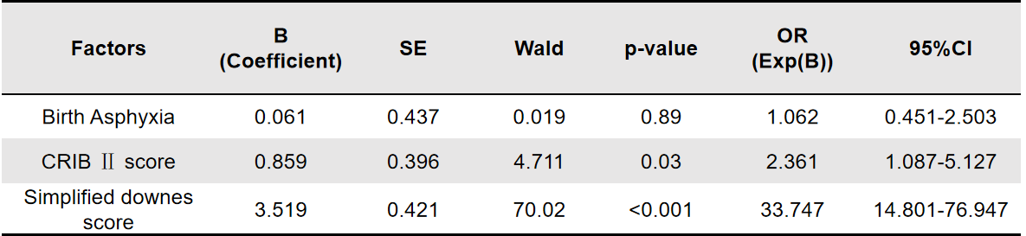

Table 3. Predictive value of the total score and individual components of the simplified Downes score for receipt of surfactant (FiO2: Fraction of inspired oxygen).
