Supplementary Figures 1-8: Interaction effects of temperature, CO2, ozone and water availability on mineral and nutrient content of three spring wheat varieties.

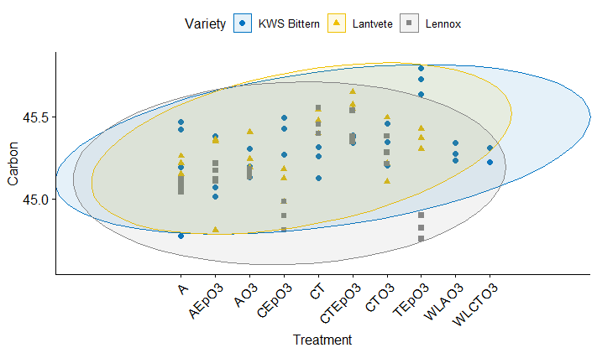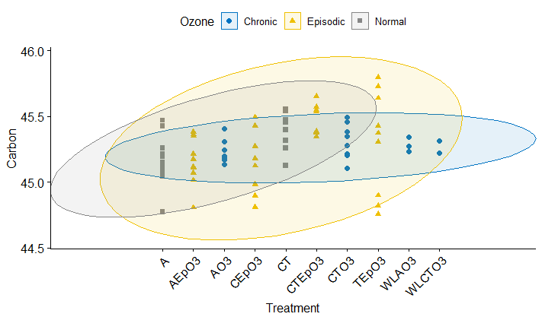
B
A
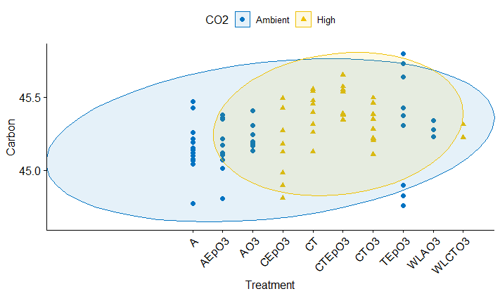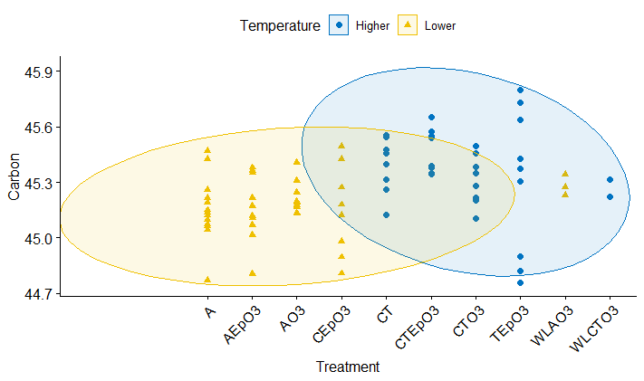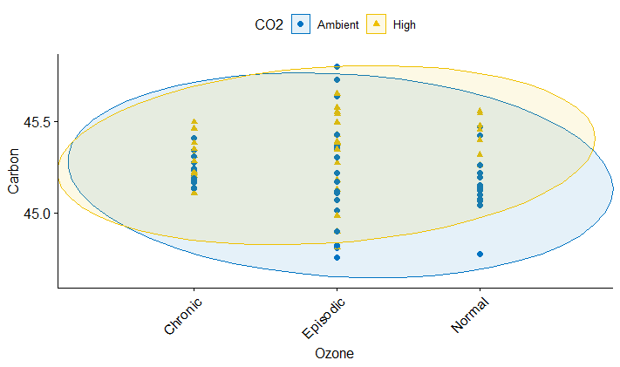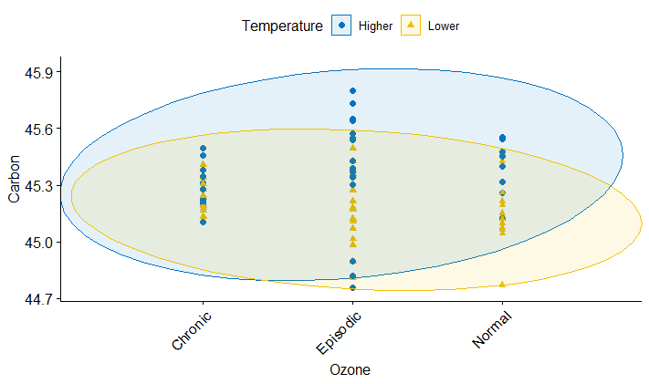
F
D
C
E
D
C
Supplementary Material Figure 1. Effect of temperature, CO2, ozone and water availability on carbon content of wheat.
A = Ambient CO2, lower temperature settings and no O3 addition (control). A.EpO3 = Ambient CO2, lower temperature settings and episodic O3 addition. A.O3 = Ambient CO2, lower temperature settings and chronic O3 addition. C.EpO3 = High CO2, lower temperature settings and episodic O3 addition. CT = High CO2, higher temperature settings, and no O3 addition. CT.EpO3 = High CO2, higher temperature settings and episodic O3 addition. CT.O3 = High CO2, higher temperature settings and chronic O3 addition. T.EpO3 = Ambient CO2, higher temperature and episodic O3 addition. WLA.O3: Ambient CO2, lower temperature settings and chronic O3 addition (i.e., A.O3), in water-limited condition. WLCT.O3 = High CO2, higher temperature settings and chronic O3 addition (i.e., CT.O3), in water-limited condition.

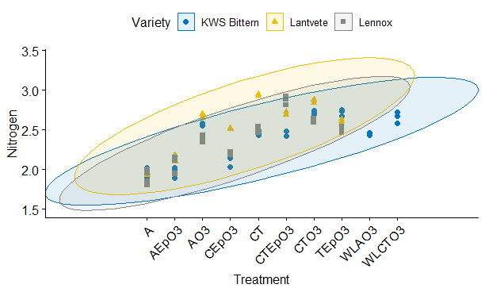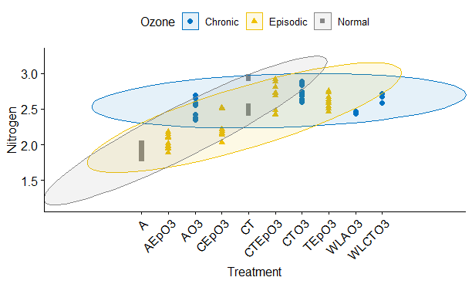
B
A
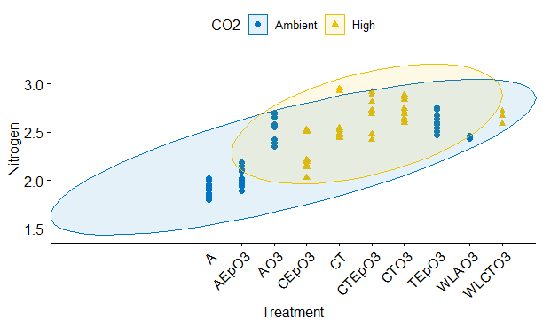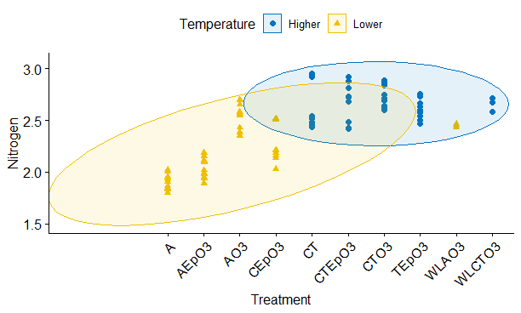
D
C
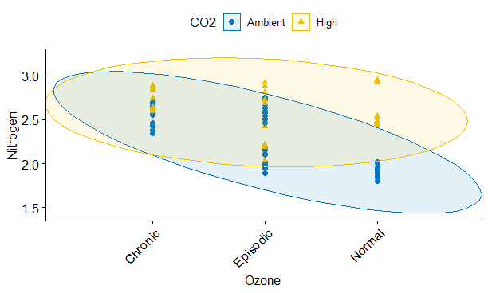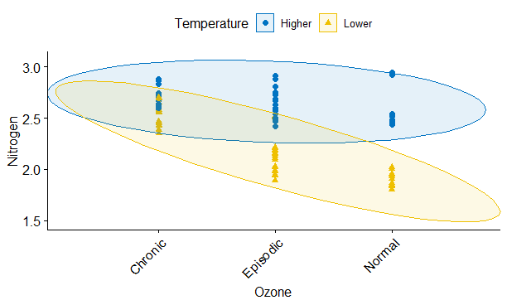
F
E
Supplementary Material Figure 2. Effect of temperature, CO2, ozone and water availability on nitrogen content of wheat.
A = Ambient CO2, lower temperature settings and no O3 addition (control). A.EpO3 = Ambient CO2, lower temperature settings and episodic O3 addition. A.O3 = Ambient CO2, lower temperature settings and chronic O3 addition. C.EpO3 = High CO2, lower temperature settings and episodic O3 addition. CT = High CO2, higher temperature settings, and no O3 addition. CT.EpO3 = High CO2, higher temperature settings and episodic O3 addition. CT.O3 = High CO2, higher temperature settings and chronic O3 addition. T.EpO3 = Ambient CO2, higher temperature and episodic O3 addition. WLA.O3: Ambient CO2, lower temperature settings and chronic O3 addition (i.e., A.O3), in water-limited condition. WLCT.O3 = High CO2, higher temperature settings and chronic O3 addition (i.e., CT.O3), in water-limited condition.

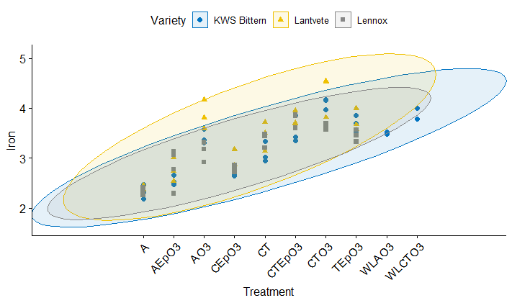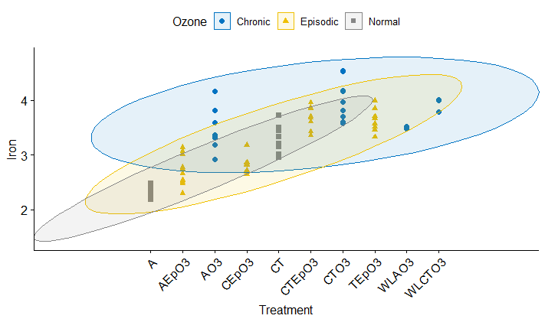

B
A
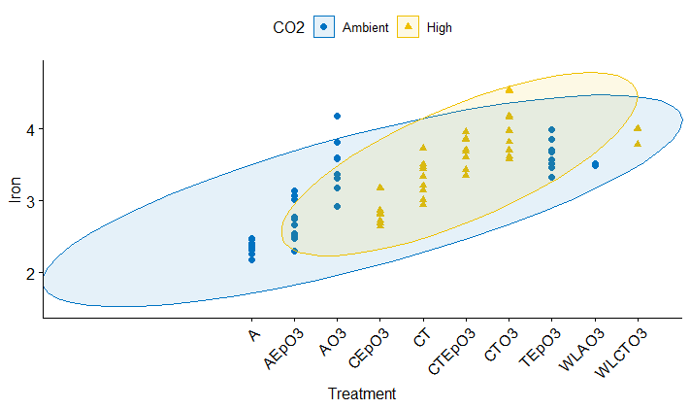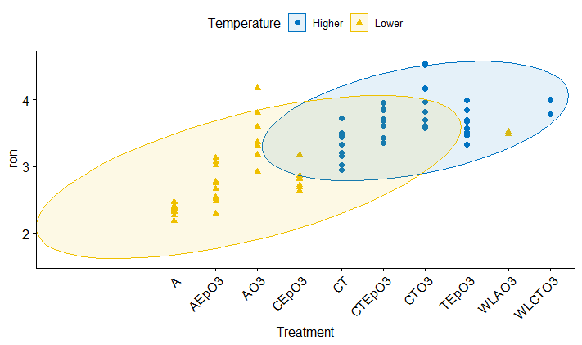
D
C
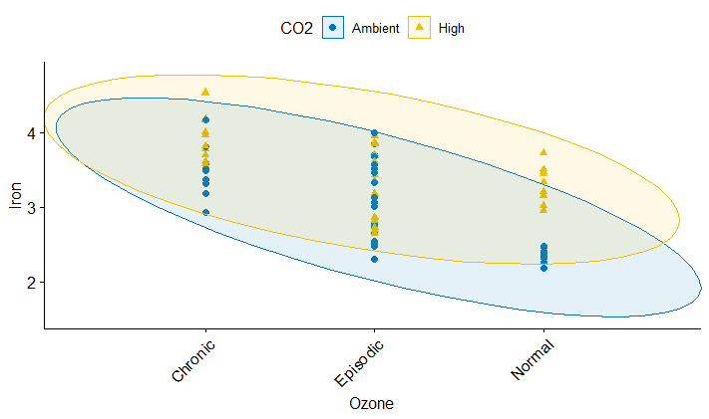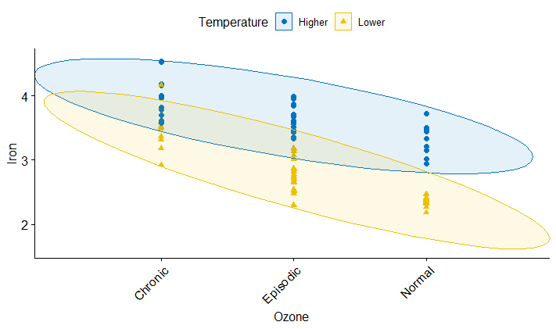
F
E
Supplementary Material Figure 3. Effect of temperature, CO2, ozone and water availability on iron content of wheat.
A = Ambient CO2, lower temperature settings and no O3 addition (control). A.EpO3 = Ambient CO2, lower temperature settings and episodic O3 addition. A.O3 = Ambient CO2, lower temperature settings and chronic O3 addition. C.EpO3 = High CO2, lower temperature settings and episodic O3 addition. CT = High CO2, higher temperature settings, and no O3 addition. CT.EpO3 = High CO2, higher temperature settings and episodic O3 addition. CT.O3 = High CO2, higher temperature settings and chronic O3 addition. T.EpO3 = Ambient CO2, higher temperature and episodic O3 addition. WLA.O3: Ambient CO2, lower temperature settings and chronic O3 addition (i.e., A.O3), in water-limited condition. WLCT.O3 = High CO2, higher temperature settings and chronic O3 addition (i.e., CT.O3), in water-limited condition.

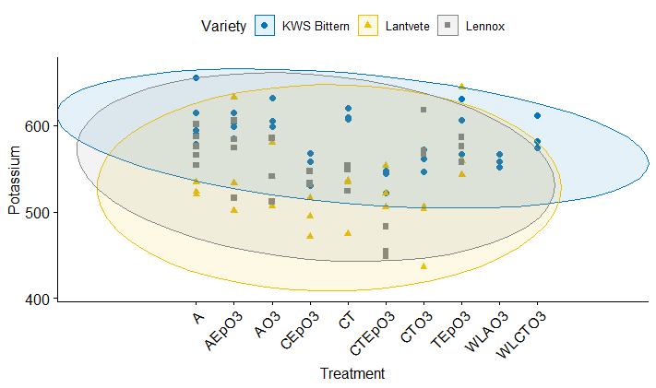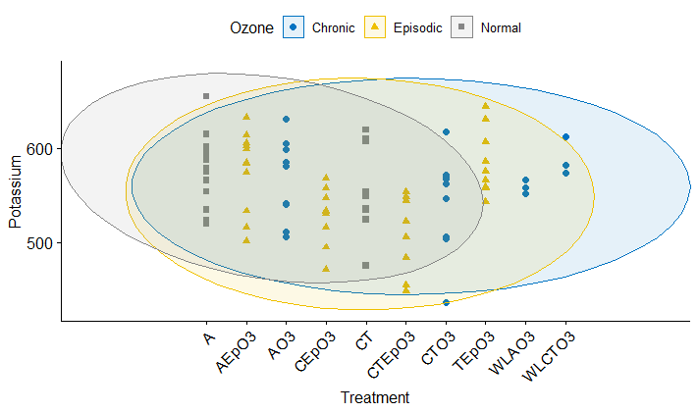
A
B
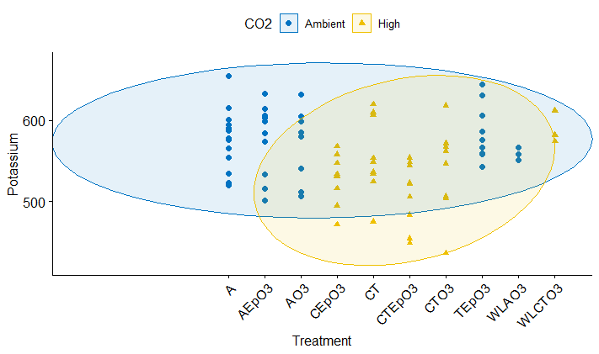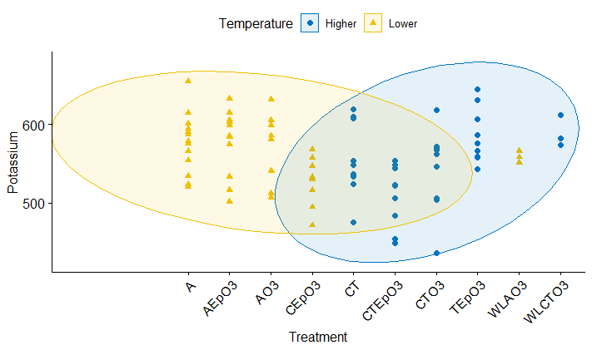
D
C
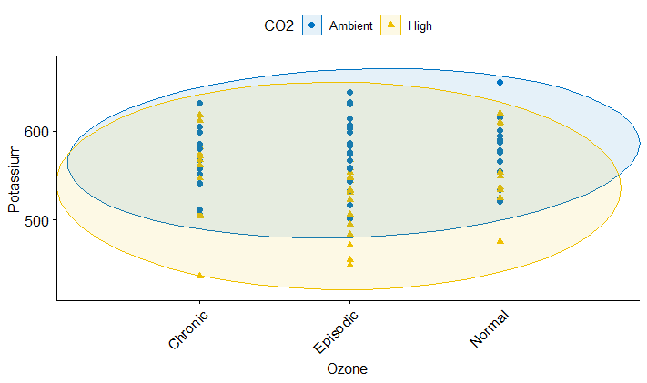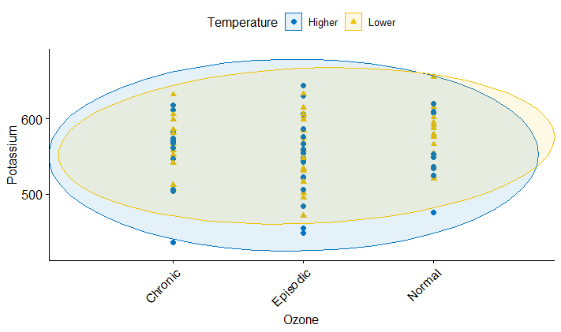
F
E
Supplementary Material Figure 4. Effect of temperature, CO2, ozone and water availability on potassium content of wheat.
A = Ambient CO2, lower temperature settings and no O3 addition (control). A.EpO3 = Ambient CO2, lower temperature settings and episodic O3 addition. A.O3 = Ambient CO2, lower temperature settings and chronic O3 addition. C.EpO3 = High CO2, lower temperature settings and episodic O3 addition. CT = High CO2, higher temperature settings, and no O3 addition. CT.EpO3 = High CO2, higher temperature settings and episodic O3 addition. CT.O3 = High CO2, higher temperature settings and chronic O3 addition. T.EpO3 = Ambient CO2, higher temperature and episodic O3 addition. WLA.O3: Ambient CO2, lower temperature settings and chronic O3 addition (i.e., A.O3), in water-limited condition. WLCT.O3 = High CO2, higher temperature settings and chronic O3 addition (i.e., CT.O3), in water-limited condition.

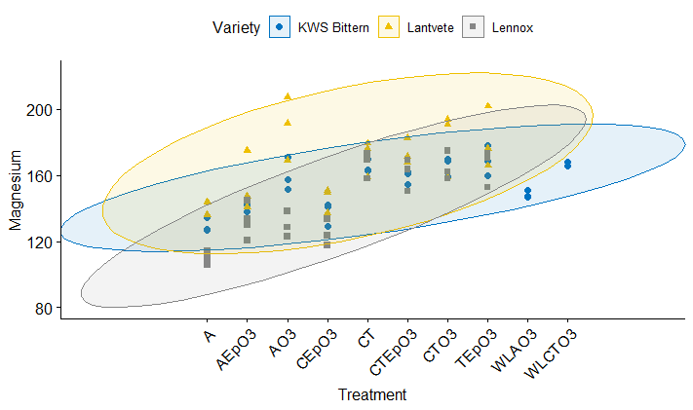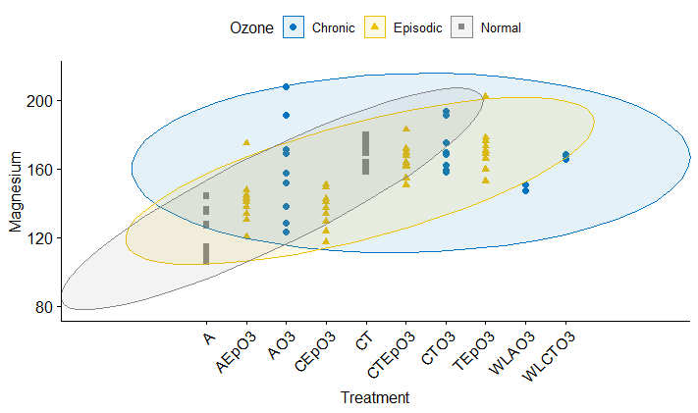
B
A
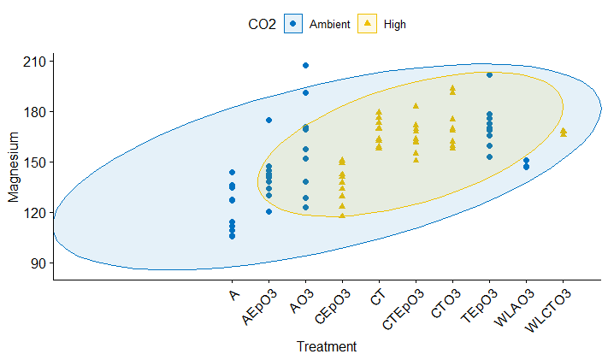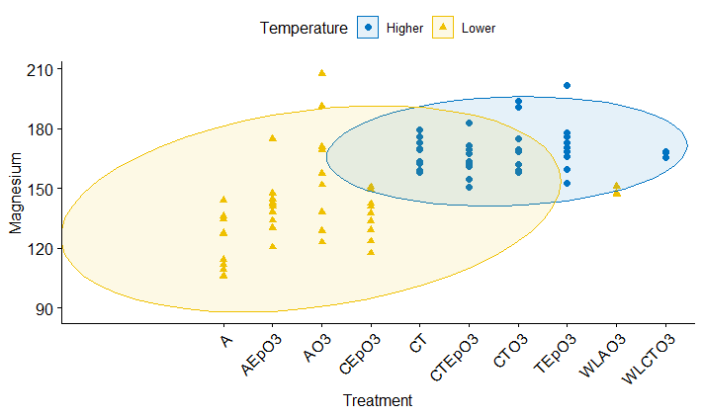
C
D
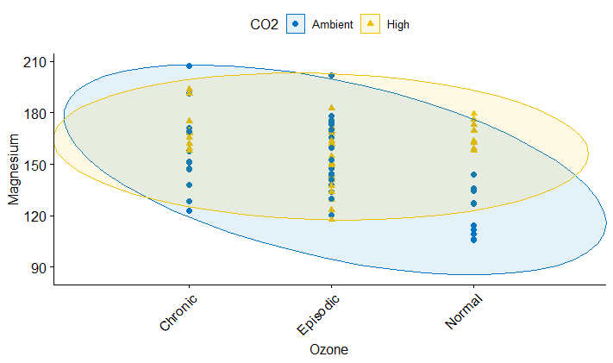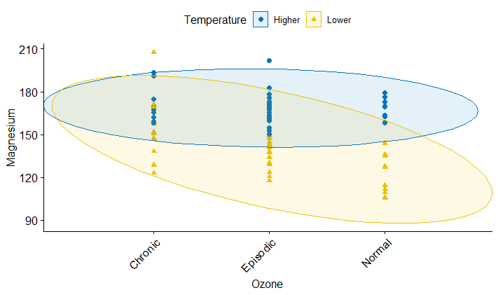
F
E
Supplementary Material Figure 5. Effect of temperature, CO2, ozone and water availability on magnesium content of wheat.
A = Ambient CO2, lower temperature settings and no O3 addition (control). A.EpO3 = Ambient CO2, lower temperature settings and episodic O3 addition. A.O3 = Ambient CO2, lower temperature settings and chronic O3 addition. C.EpO3 = High CO2, lower temperature settings and episodic O3 addition. CT = High CO2, higher temperature settings, and no O3 addition. CT.EpO3 = High CO2, higher temperature settings and episodic O3 addition. CT.O3 = High CO2, higher temperature settings and chronic O3 addition. T.EpO3 = Ambient CO2, higher temperature and episodic O3 addition. WLA.O3: Ambient CO2, lower temperature settings and chronic O3 addition (i.e., A.O3), in water-limited condition. WLCT.O3 = High CO2, higher temperature settings and chronic O3 addition (i.e., CT.O3), in water-limited condition.

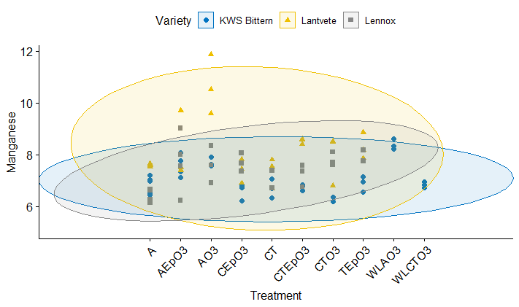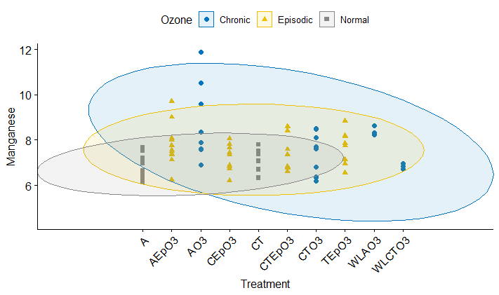
B
A
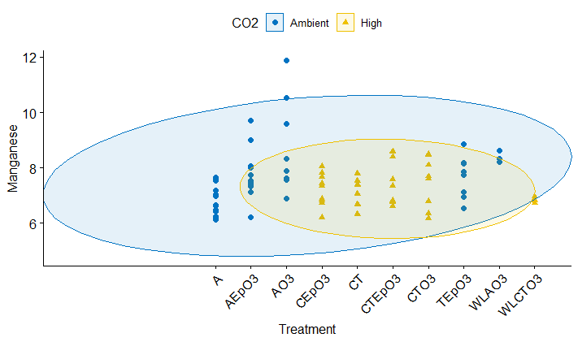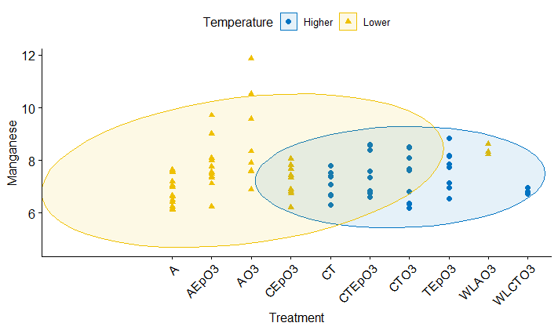
D
C
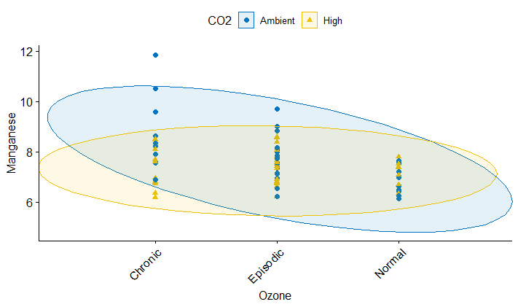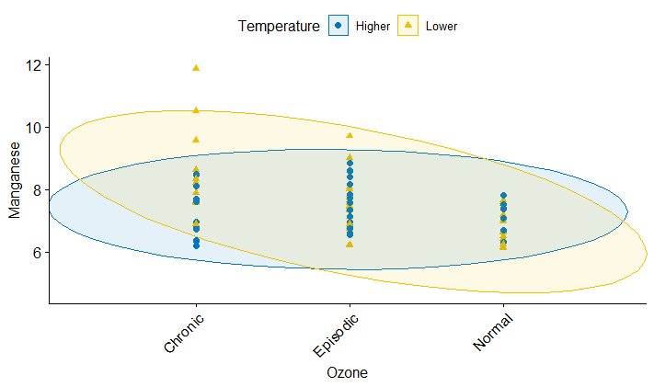
F
E
Supplementary Material Figure 6. Effect of temperature, CO2, ozone and water availability on manganese content of wheat.
A = Ambient CO2, lower temperature settings and no O3 addition (control). A.EpO3 = Ambient CO2, lower temperature settings and episodic O3 addition. A.O3 = Ambient CO2, lower temperature settings and chronic O3 addition. C.EpO3 = High CO2, lower temperature settings and episodic O3 addition. CT = High CO2, higher temperature settings, and no O3 addition. CT.EpO3 = High CO2, higher temperature settings and episodic O3 addition. CT.O3 = High CO2, higher temperature settings and chronic O3 addition. T.EpO3 = Ambient CO2, higher temperature and episodic O3 addition. WLA.O3: Ambient CO2, lower temperature settings and chronic O3 addition (i.e., A.O3), in water-limited condition. WLCT.O3 = High CO2, higher temperature settings and chronic O3 addition (i.e., CT.O3), in water-limited condition.

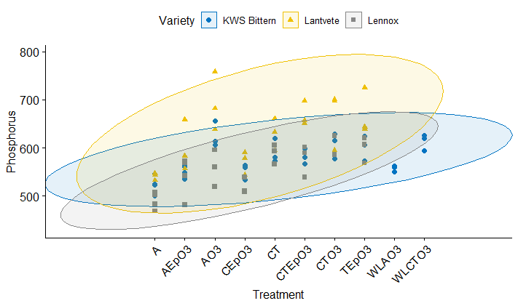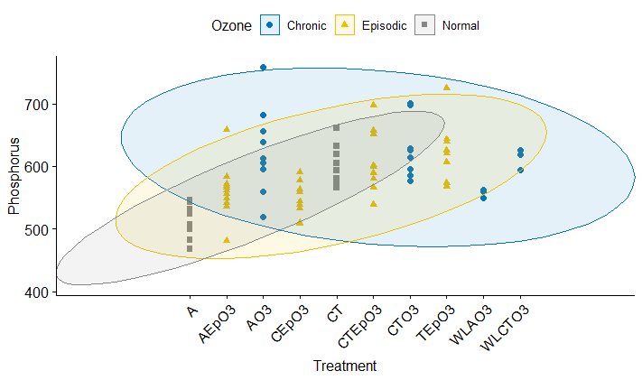
F
E
D
C
B
A
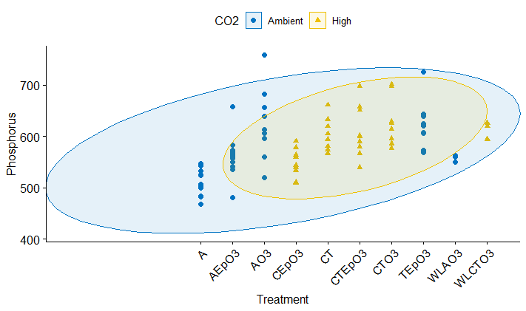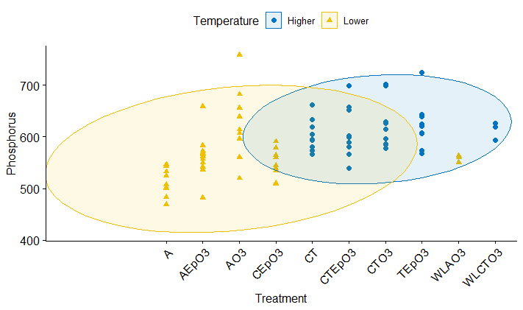
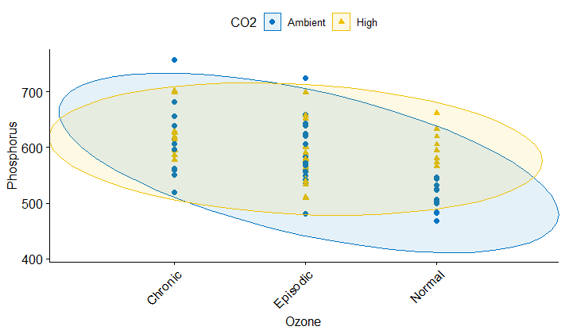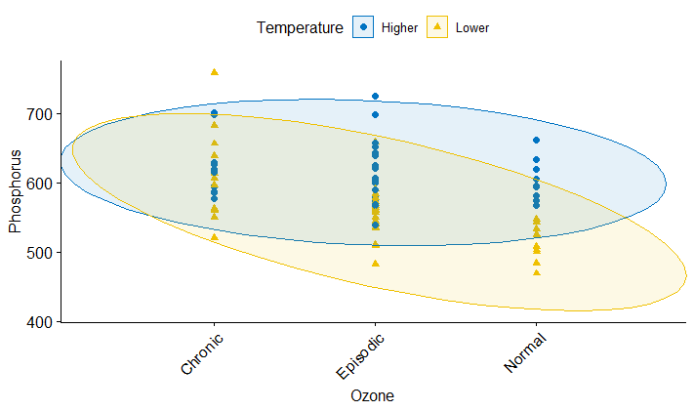
Supplementary Material Figure 7. Effect of temperature, CO2, ozone and water availability on phosphorus content of wheat.
A = Ambient CO2, lower temperature settings and no O3 addition (control). A.EpO3 = Ambient CO2, lower temperature settings and episodic O3 addition. A.O3 = Ambient CO2, lower temperature settings and chronic O3 addition. C.EpO3 = High CO2, lower temperature settings and episodic O3 addition. CT = High CO2, higher temperature settings, and no O3 addition. CT.EpO3 = High CO2, higher temperature settings and episodic O3 addition. CT.O3 = High CO2, higher temperature settings and chronic O3 addition. T.EpO3 = Ambient CO2, higher temperature and episodic O3 addition. WLA.O3: Ambient CO2, lower temperature settings and chronic O3 addition (i.e., A.O3), in water-limited condition. WLCT.O3 = High CO2, higher temperature settings and chronic O3 addition (i.e., CT.O3), in water-limited condition.

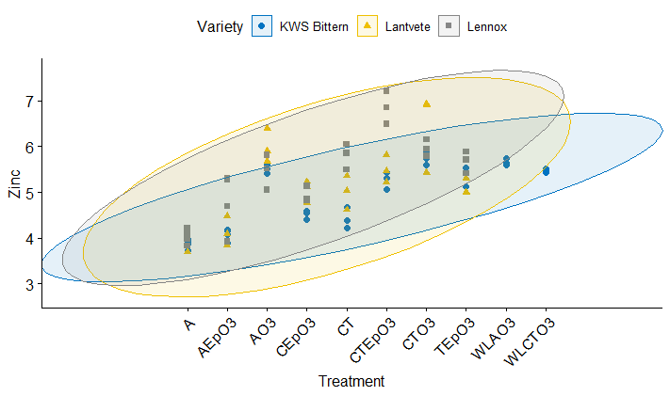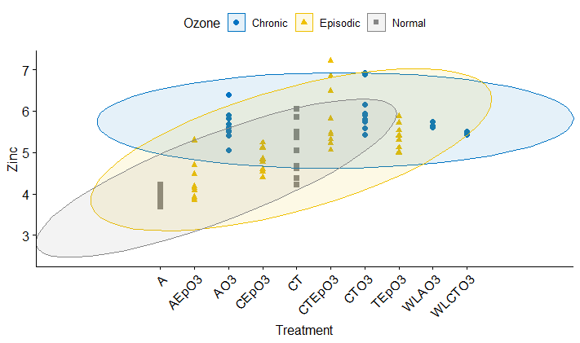
F
E
D
C
B
A
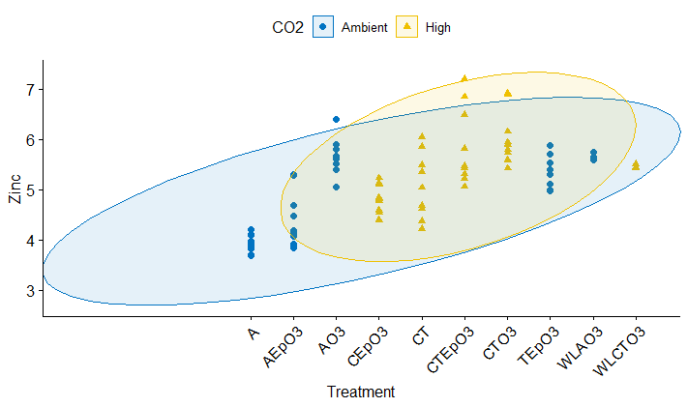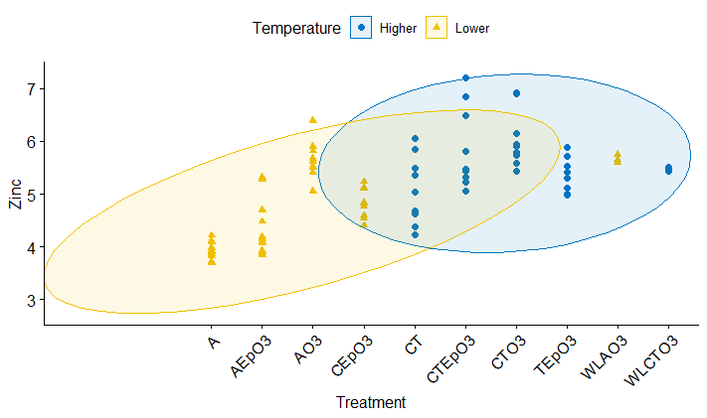
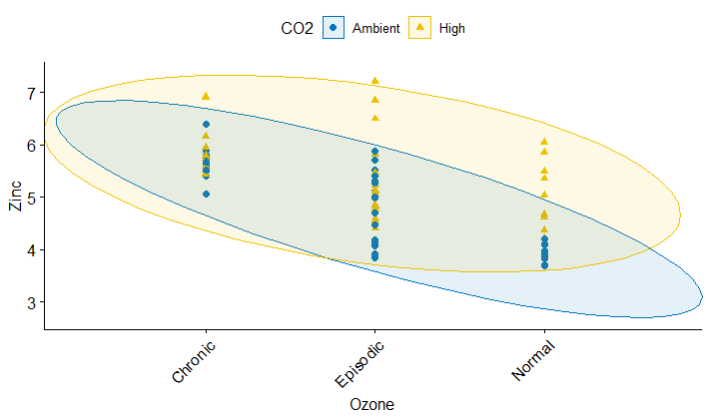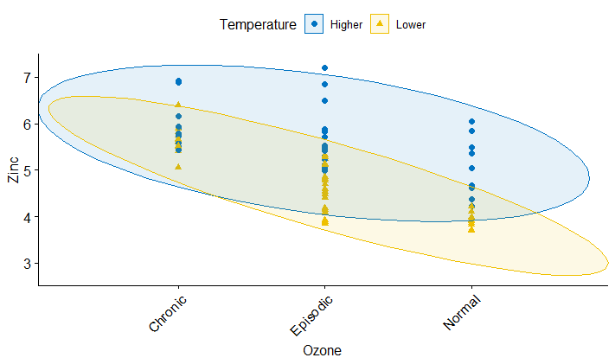
Supplementary Material Figure 8. Effect of temperature, CO2, ozone and water availability on zinc content of wheat.
A = Ambient CO2, lower temperature settings and no O3 addition (control). A.EpO3 = Ambient CO2, lower temperature settings and episodic O3 addition. A.O3 = Ambient CO2, lower temperature settings and chronic O3 addition. C.EpO3 = High CO2, lower temperature settings and episodic O3 addition. CT = High CO2, higher temperature settings, and no O3 addition. CT.EpO3 = High CO2, higher temperature settings and episodic O3 addition. CT.O3 = High CO2, higher temperature settings and chronic O3 addition. T.EpO3 = Ambient CO2, higher temperature and episodic O3 addition. WLA.O3: Ambient CO2, lower temperature settings and chronic O3 addition (i.e., A.O3), in water-limited condition. WLCT.O3 = High CO2, higher temperature settings and chronic O3 addition (i.e., CT.O3), in water-limited condition.

Supplementary Material Table 1. Results of effect of temperature, CO2, ozone and water availability on grain nutrient content of wheat. (See Excel sheet)

