Supplementary information
Supplementary Figures (9 in total)

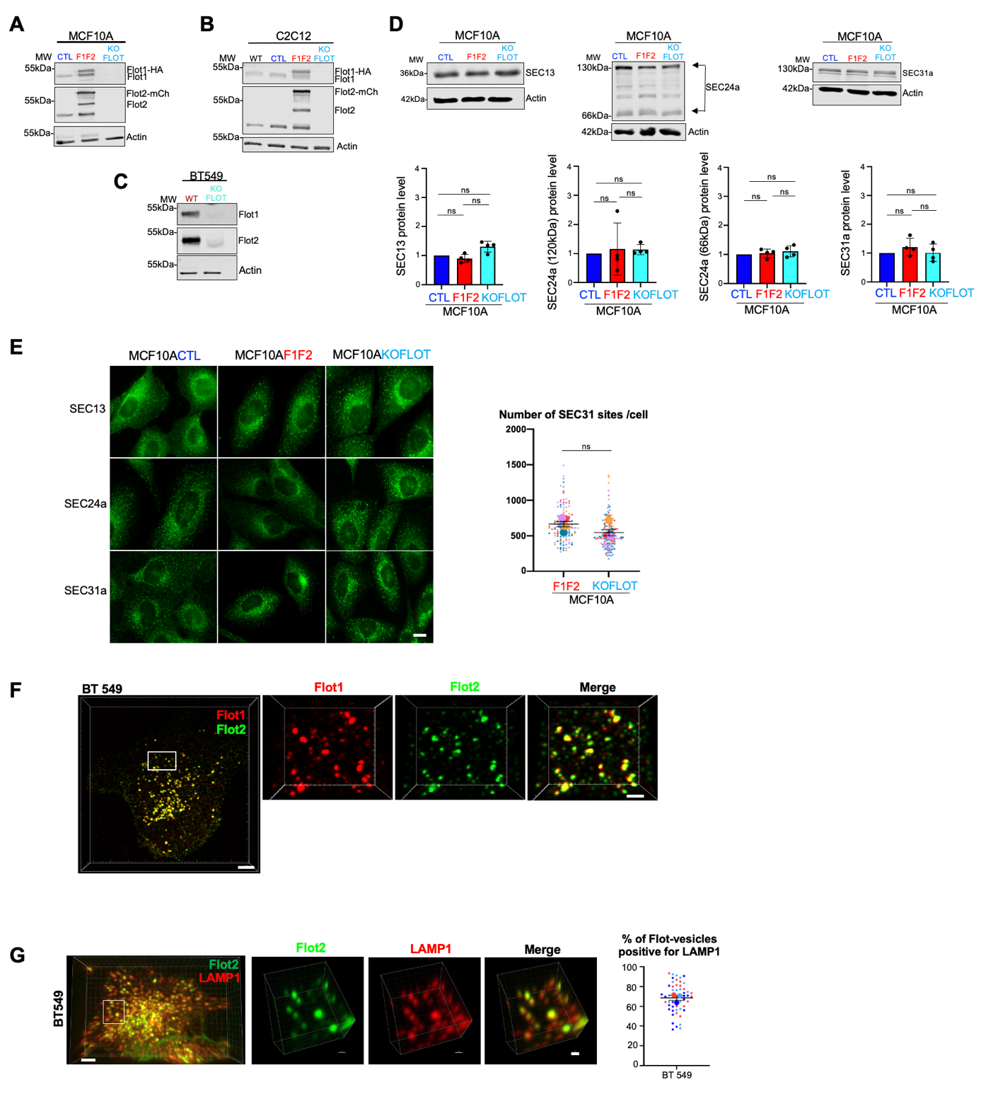Supplementary Figure S1
A, B, C. The non-invasive epithelial (MCF10A) (A) and mesenchymal (C2C12) (B) cell lines were transfected with flotillin 1 and 2 (F1F2) or engineered using CRISPR/Cas9 to knock out flotillin 1 and 2 (KOFLOT). As control, cells that express only mCherry (CTL, empty vector) were also generated. The invasive triple negative breast carcinoma (BT549) cell line (C) shows higher flotillin 1 and 2 expression level compared with non-malignant cells. In BT549 cells, flotillins were knocked out using CRISPR/Cas9 (KOFLOT). Western blot analysis (20µg) confirmed flotillins overexpression and the efficiency of flotillins knock out in the indicated cell lines. Actin was used as loading control (bottom panel).
D. Western blot (20µg) analysis to measure SEC13, 24a and 31a expression level in MCF10ACTL, MCF10AF1F2 and MCF10AKOFLOT cells. Actin was used as loading control (bottom panel). The histograms show the expression level of the indicated proteins. Results are expressed as fold-increase compared with CTL cells and are the mean ± SEM of 4 independent experiments. *P <0.05, ns: non-significant (Wilcoxon test, paired t-test).
E. Micrographs of MCF10ACTL, F1F2 and KOFLOT cells incubated with anti-SEC13, SEC24a and SEC31a antibodies. Scale bar: 10µm. Graph shows the number of SEC31a-positive ER sites per cell segmented in 3D and quantified in the total cell volume. Each small dot represents the number of SEC31a objects measured in a single cell and the large dots the mean value from each experiment. Quantification was performed using 128 MCF10AF1F2 cells and 146 MCF10AKOFLOT cells respectively from 5 independent experiments. (one color/experiment). ns: non-significant (ratio paired t-test performed using the mean values of each experiment, two-tailed P value).
F. Immunofluorescence analysis of flotillin 1 and flotillin 2 expression in BT549 cells. Images were acquired with a spinning disk confocal microscope. Micrograph of a 3D reconstruction of a representative stack (scale bar: 3 µm). The boxed area corresponds to the magnified images for flotillin 1, flotillin 2 and the merge image (scale bar of magnified area: 1 µm).
G. 3D reconstruction of a stack of spinning disk confocal images of a representative BT549 cell after immunofluorescence analysis of LAMP1 and flotillin 2 expression. A 3D segmentation of the vesicular LAMP1 and flotillin 2 signals was performed in the total cell volume and used as a mask to generate images such as those shown in the magnified images from the boxed area. The yellow signal shows the segmented volumes of LAMP1 vesicles containing flotillin signal. The graph shows the proportion (mean ± SEM), among all LAMP1-positive vesicles, of vesicles with a flotillin 2 signal (quantification in 55 cells from 3 independent experiments).
Scale bars: 5 µm and 1 µm in magnified images in panels F and G.

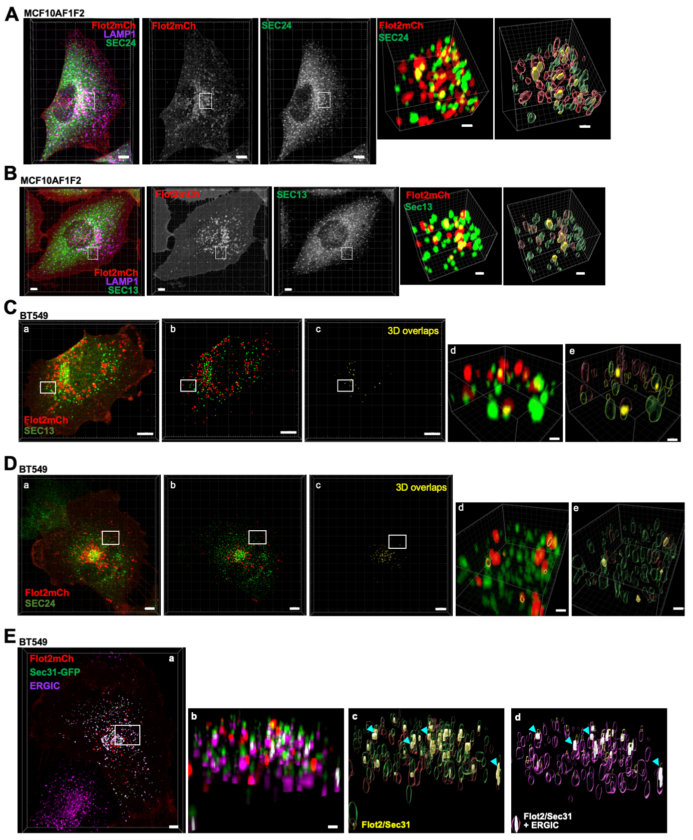
Supplementary Figure S2
A, B. MCF10AF1F2 cells were stained for SEC13 or SEC24a and imaged acquired using a spinning disk confocal microscope. n=75 cells from 3 independent experiments for each condition. See legend to Fig. 1C. Scale bars: 5µm and 1µm (zoomed-in section).
C, D. (a) 3D reconstruction of a stack of spinning disk confocal images of a representative BT549 cell that expresses flotillin 2-mCherry (Flot2mCh) and incubated with anti-SEC13 or -SEC24 antibodies (cells were imaged from bottom to top with a z-step of 0.27 nm). Flot2mCh-positive vesicles and SEC-ER-sites were separately segmented in 3D. The 3D images in b and d correspond to the image obtained using the 3D segmentations as masks on the raw signals. The images in c show in yellow the volumes of overlaps between the Flot2mCh and SEC signals after segmentation. d and e correspond to the magnification of the boxed area. The image in e illustrates the segmentation for both signals and for the volumes of overlaps (yellow). Scale bars: 5µm (a), 0.5µm and 0.7 µm for C (d,e) and D (d,e) respectively.
E. (a) 3D reconstruction of a representative spinning disk confocal image stack of a BT549 cell that expresses Flot2-mCh, SEC31-GFP and stained by immunofluorescence for ERGIC-53. Scale bar: 5µm. (b) 3D segmentation of the SEC31, flotillin 2, and ERGIC-53 signals performed in the total cell volume and used as a mask to generate the 3D object representations (in c and d). Scale bar: 0.5µm. (c) 3D object representation of flotillin 2 (red), SEC31 (green), and their overlap (yellow). (d) 3D object representation of flotillin 2/SEC31 overlap objects (yellow), ERGIC-53 (purple) and flotillin2/SEC31 objects that are positive for ERGIC-53 (white). The blue arrows show flotillin 2/SEC31 objects that are negative for ERGIC-53.

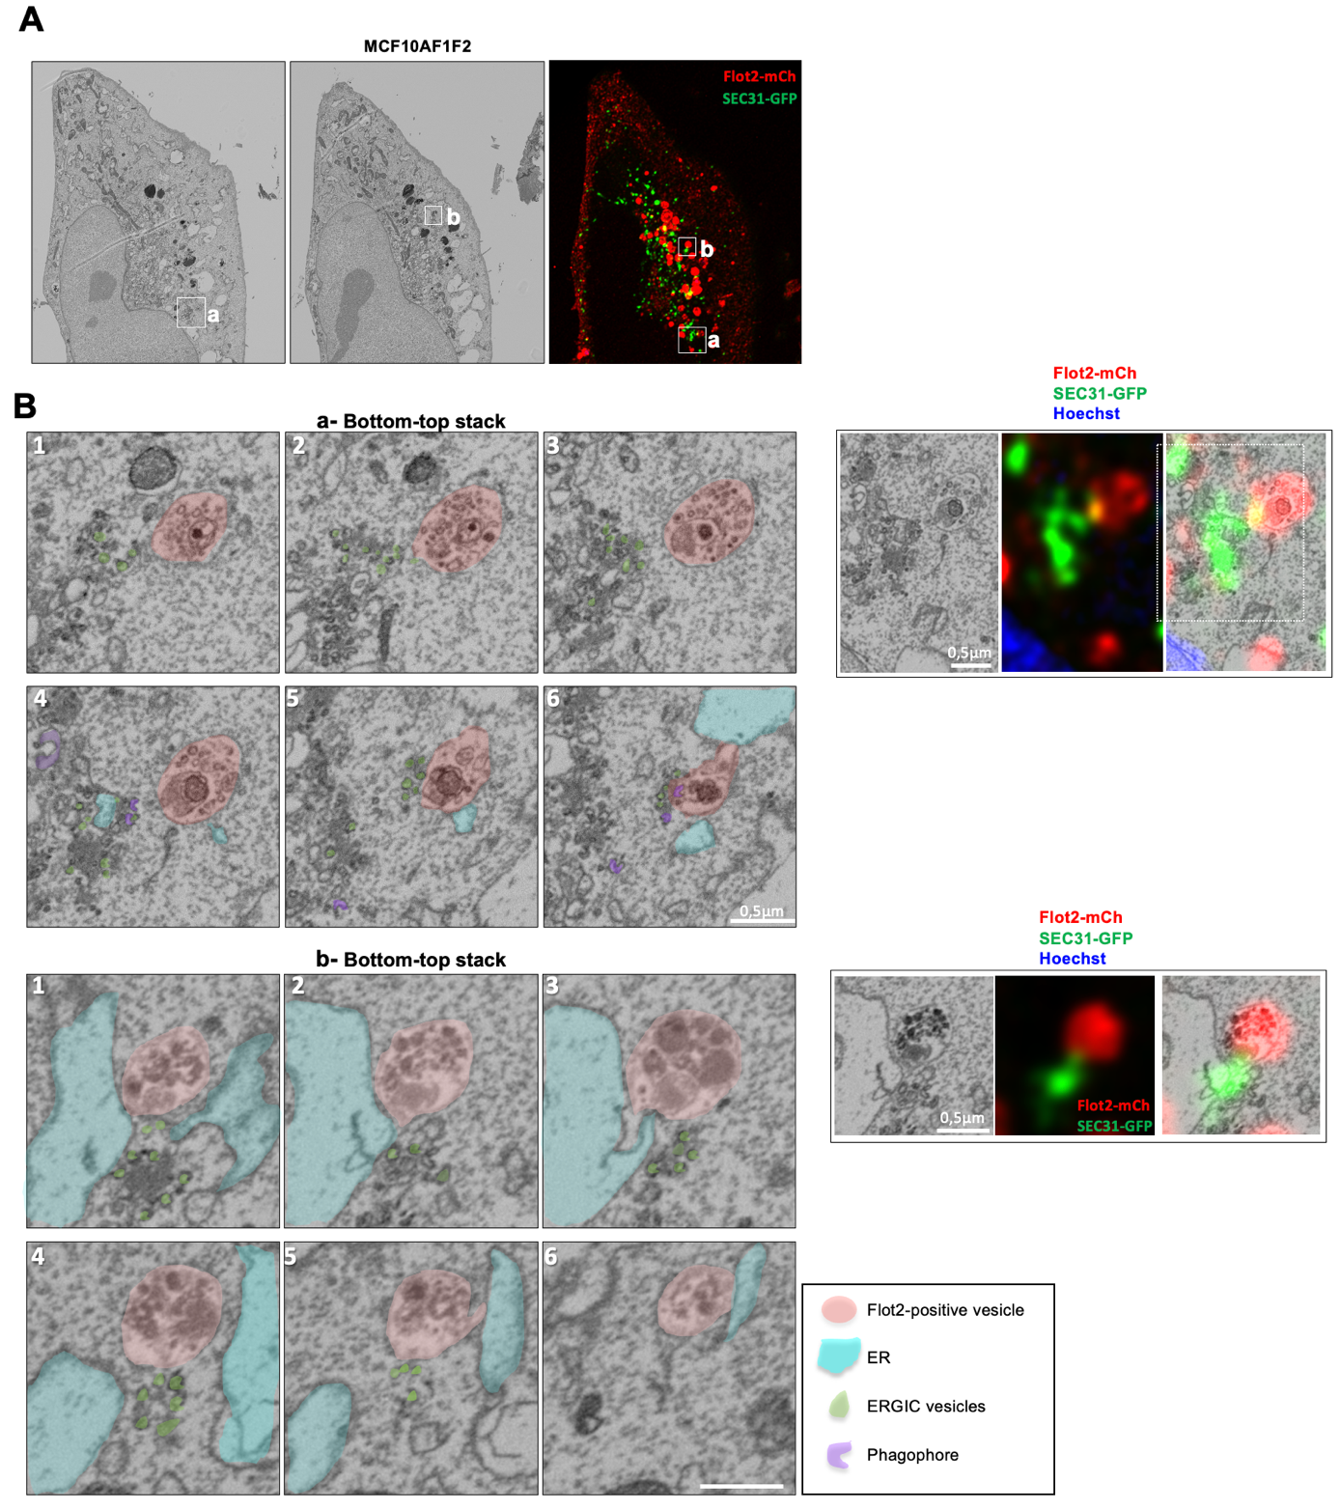
Supplementary Figure S3
CLEM to describe Flot2mCh-positive vesicles in MCF10AF1F2 cells that express SEC31-GFP.
A. Z-stack images of a MCF10AF1F2 cell that express SEC31-GFP were acquired by SEM and spinning disk confocal microscopy (Z-step 0.2µm). The panel shows two planes from the SEM Z-stack and the corresponding fluorescent maximum intensity projection image obtained from 10 planes. The two boxed-areas (a) and (b) on distinct EM planes highlight two flotillin2-mCherry-positive vesicles in contact with SEC31-GFP-positive ERES vesicles.
B. The left panels from the a (top) or b area (bottom) show enlarged serial EM images (from the bottom to the top of the cell) of the Z stack from the boxed areas shown in Aa and Ab. Flot2-mCherry-positive vesicles, ER, COPII-positive (ERGIC) vesicles and phagophores are colored according to the legend. Right panels show one EM plane, an average Z-projection image of 7 (a) and 9 (b) planes acquired by confocal fluorescent microscopy and the corresponding CLEM image (see Movie 1 corresponding to panel Ba).
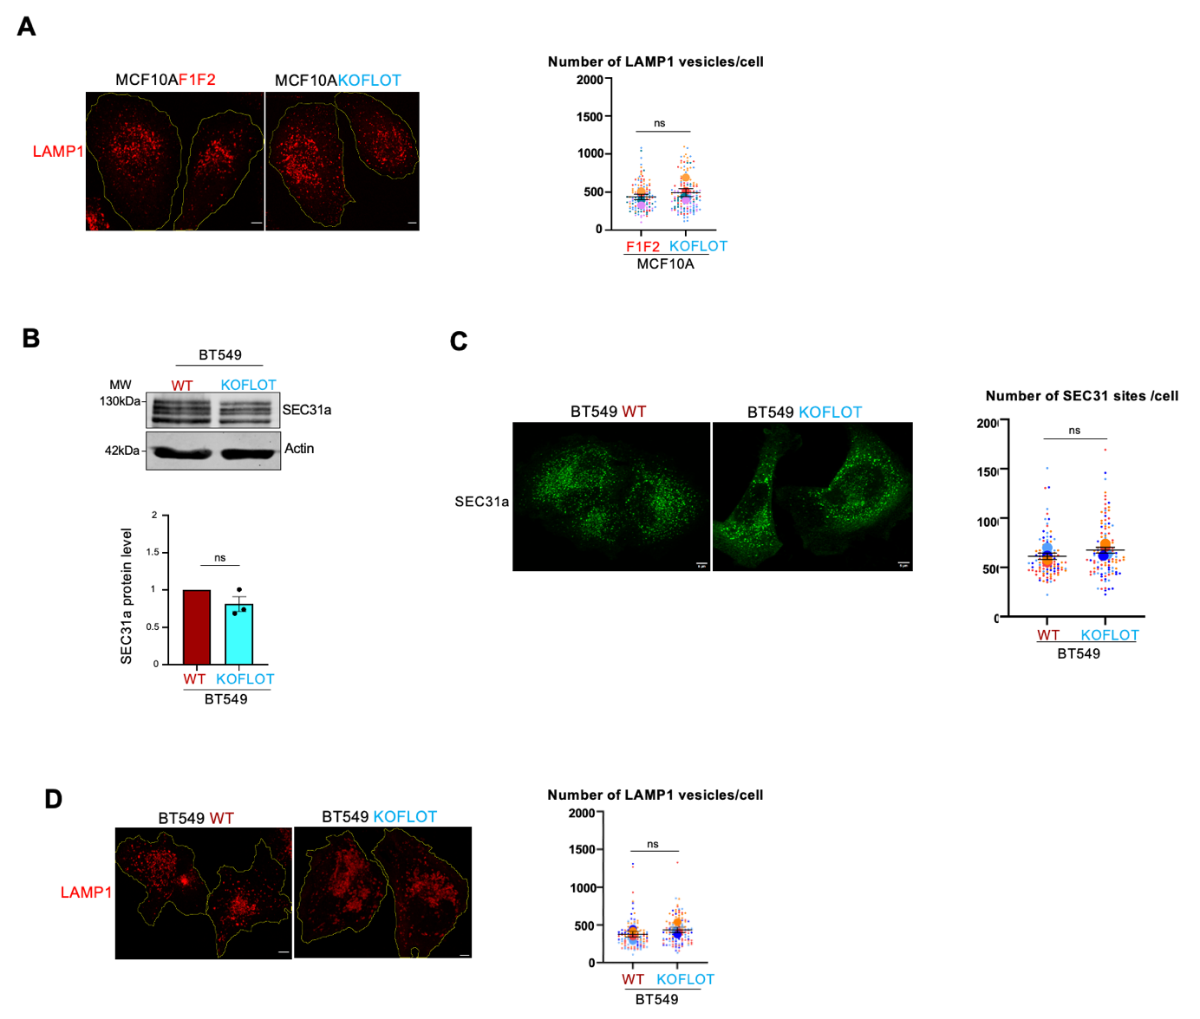
Supplementary Figure S4
A. Representative Z-stack images of LAMP1 immunofluorescence staining in MCF10AF1F2 and MCF10AKOFLOT cells. The white dotted lines indicate the outline of the cells. Scale bar: 5µm. Graph shows the number of LAMP1-positive vesicles per cell segmented in 3D and quantified in the total cell volume. Each small dot represents the number of LAMP1 objects measured in a single cell and the large dots the mean value from each experiment (quantification was performed on 128 MCF10AF1F2 cells and 146 MCF10AKOFLOT cells from 5 independent experiments (one color/experiment). ns: non-significant (ratio paired t-test performed using the mean values of each experiment, two-tailed P value).
B. Western blot (20µg) analysis to measure SEC31a expression level in BT549 WT and BT549KOFLOT cells. Actin was used as loading control (bottom panel). The histogram shows the expression level of SEC31a. Results are expressed as fold-increase compared with BT549 cells and are the mean ± SEM of 3 independent experiments. ns: non-significant (Wilcoxon test, paired t-test).
C. Micrographs of BT549 and BT549KOFLOT cells stained for SEC31a. Scale bar: 10µm. Graph shows the number of SEC31-ER sites per cell segmented in 3D and quantified in the total cell volume of BT549 WT and BT549KOFLOT cells. Each small dot represents the number of SEC31 objects measured in a single cell and the large dots the mean value from each experiment. Quantification was performed using 105 BT549 WT cells and 119 BT549KPFLOT cells from 4 independent experiments (one color/experiment). ns: non-significant (ratio paired t-test performed using the mean values of each experiment, two-tailed P value).
D. Representative Z-stack images of LAMP1 staining in BT549 WT and BT549KOFLOT cells. The white dotted lines indicate the outline of the cells. Scale bar: 5µm. Graph shows the number of LAMP1-positive vesicles per cell segmented in 3D and quantified in the total cell volume. Each small dot represents the number of LAMP1 objects measured in a single cell and the large dots the mean value from each experiment. Quantification was performed in 105 BT549 WT cells and 119 BT549KPFLOT cells from 4 independent experiments (one color/experiment). ns, non-significant (ratio paired t-test performed using the mean values of each experiment, two-tailed P value).

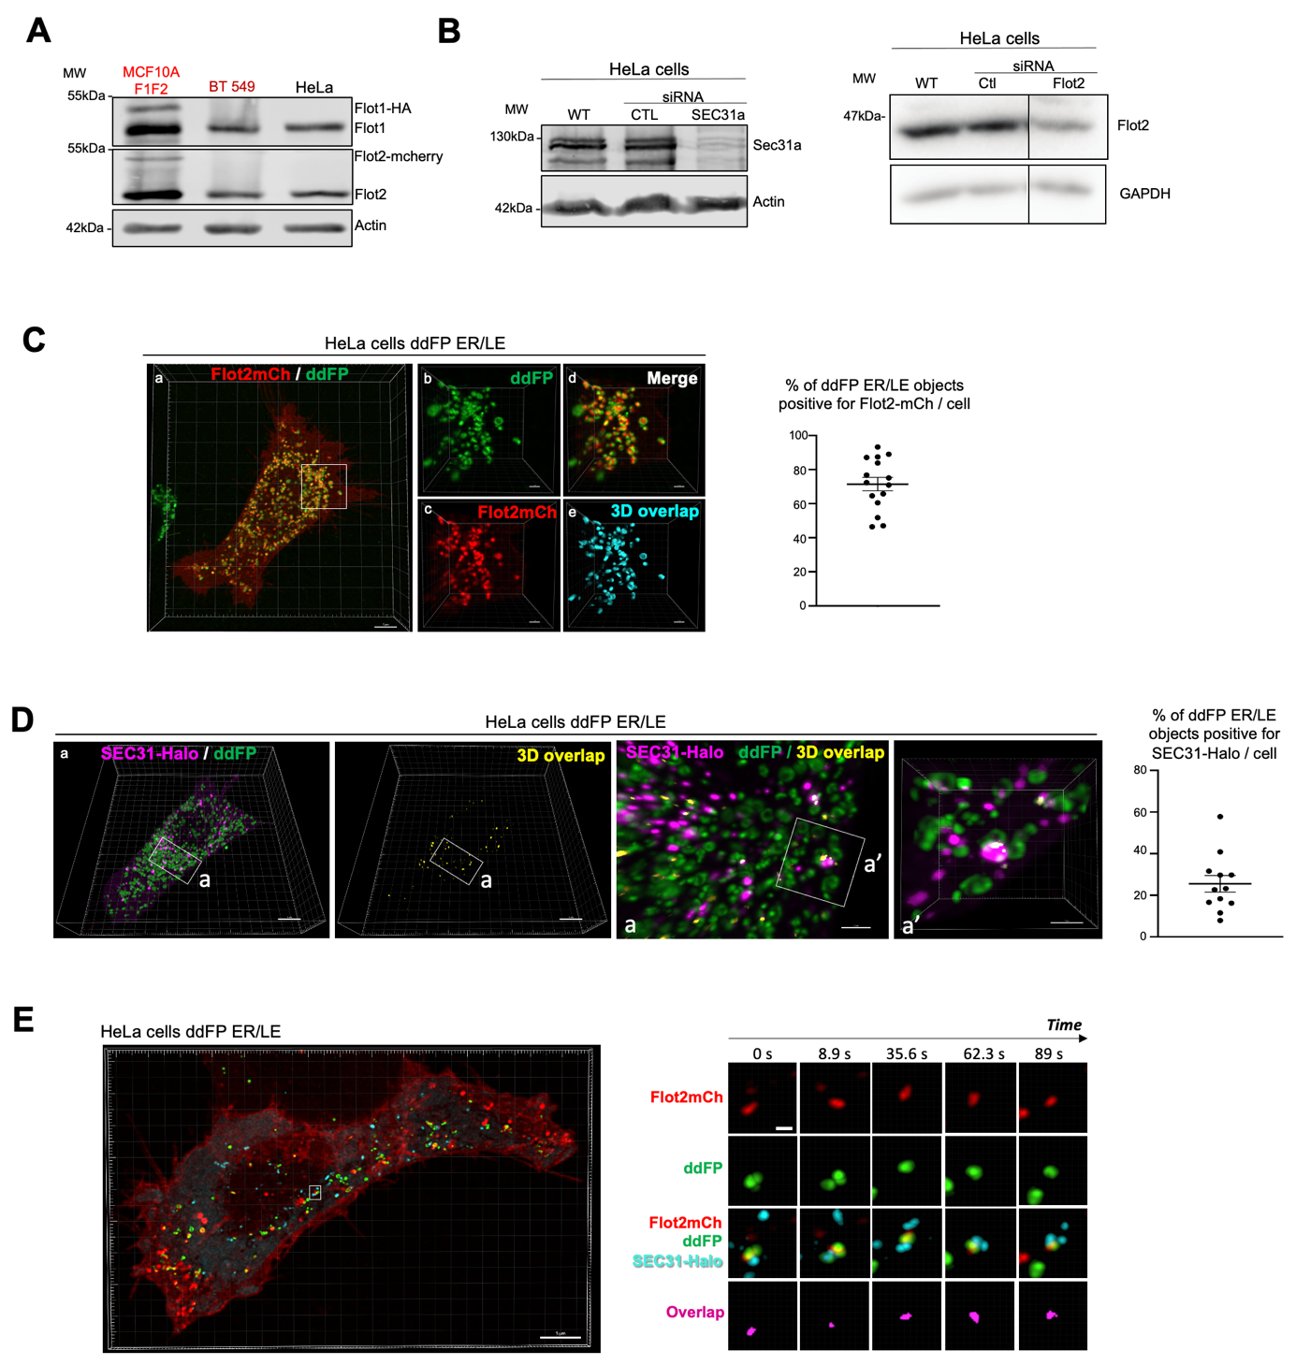
Supplementary Figure S5
A. Western blot (20µg) analysis to measure flotillin 1 and 2 expression in MCF10AF1F2, BT549 and HeLa cells. Actin was used as loading control.
B. Western blot (20µg) analysis to assess SEC31 and flotillin 2 levels in HeLa cells. Actin and GAPDH were used as loading controls.
C. D. HeLa cells that express the ddFP ER/EL reporter system and Flot2mCh (D) or SEC31-Halo (labeled with the Halo-Tag ligand Janelia 646) (D). Live cells were imaged by spinning disk confocal microscopy with a z-step of 0.27µm from bottom to top. The images shown are the 3D-reconstructions of confocal image stacks. The ddFP signal was segmented using Imaris. In (C), panels b to e are enlargements of the boxed area in panel a. The 3D overlap images shown in C (cyan) and in D (yellow) represent the Flot2mCh signal or SEC31-Halo signal included in the ddFP segmented objects. Graphs in (C) and (D) indicate the % (mean ± SEM) of ddFP segmented objects per cell containing Flot2mCh signal or SEC31-Halo-Janelia646 signal, respectively. Each dot represents the value measured in a single cell (analyses were performed in 15 cells in C and 12 cells in D). Scale bar: 5 µm for the main images and 1 µm for the magnified images from the boxed areas.
E. HeLa cell that expresses the ddFP ER/EL reporter system and Flot2mCh and SEC31-Halo (labeled with Halo-Tag ligand Janelia 646). The cell was imaged by spinning disk confocal microscopy on 4 planes with a z-step of 0.2 µm every 8.9 sec for 2min 49sec. The left panel shows a 3D image of a whole cell acquired at 1min46sec in Movie 2. The right panels correspond to still images from the time-lapse series of the boxed area (see Movie 3) at Time 0. The 0s time in the figure correspond to 1min20sec in Movie 2. “Overlap” panels correspond to the overlap between the Flot2mCh, ddFP and SEC31-Halo-Janelia 646 signals. Scale bars: 5 µm in the main images and 0.5 µm in the magnified images from the boxed area.

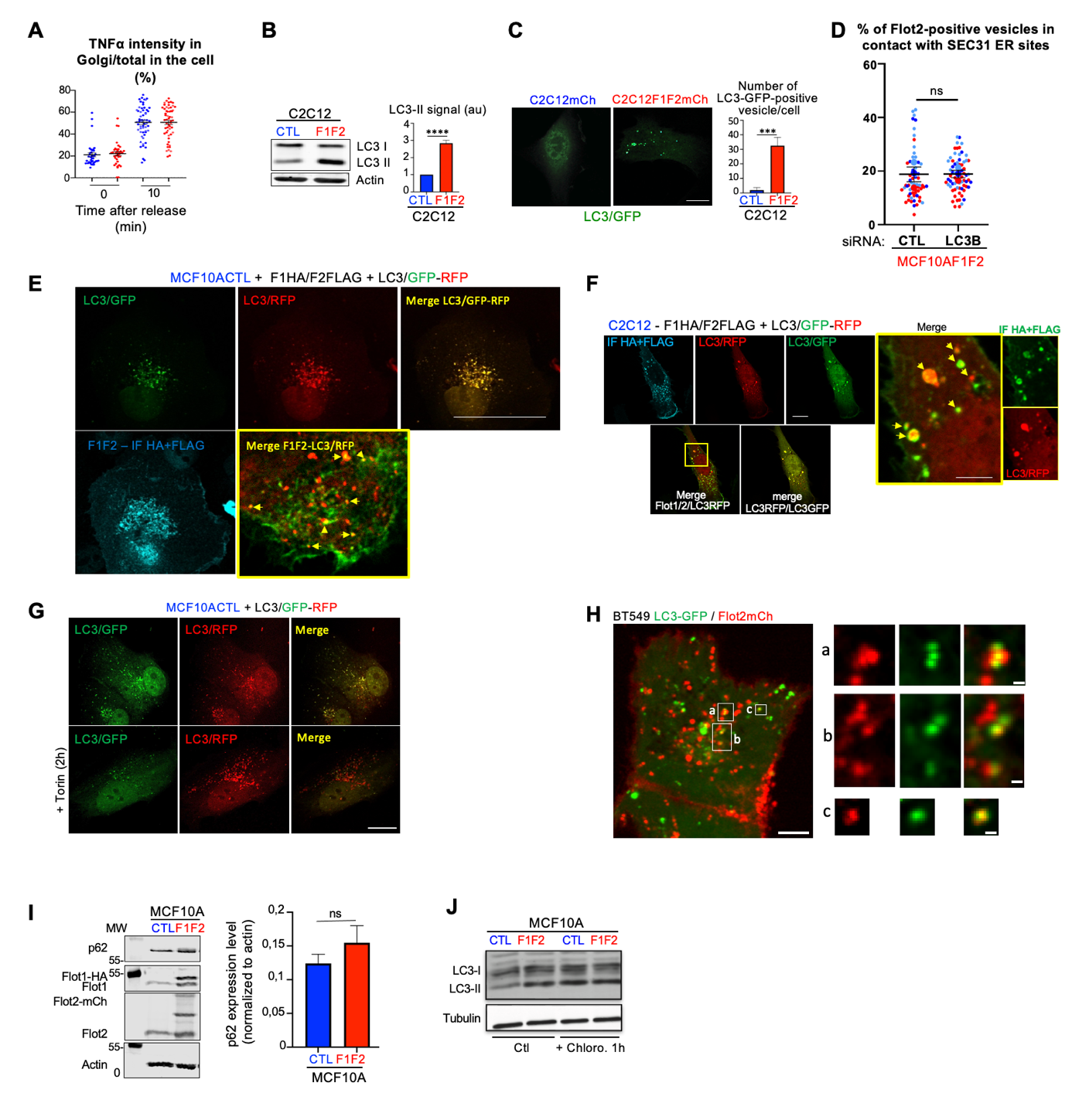
Supplementary Figure S6
A. Graph showing the kinetics of TNFα release from the ER to the Golgi apparatus before (T0) and at 10 mins after biotin addition (T10). Each dot represents the percentage of TNFα-GFP fluorescence signal intensity in the Golgi apparatus relative to the whole cell. At T0, 38 MCF10ACTL and 36 MCF10AF1F2 cells were analyzed and at T10, 58 MCF10ACTL and 56 MCF10AF1F2 cells from 2 independent experiments. Data are the mean ± SEM of individual cells pooled from the 2 experiments.
B. LC3 expression was analyzed by immunoblotting in C2C12CTL and C2C12F1F2 cell lysates. Actin was used as loading control. Results are expressed as fold-increase compared with CTL cells and are the mean ± SEM of 4 independent experiments.
C. Cells were transfected with LC3-GFP and the number of puncta/cell were measured after 20 h. Results are the mean ± SEM of 4 independent experiments. Scale bar: 10µm.
D. SEC31 expression was assessed by immunofluorescence analysis in MCF10AF1F2 cells transfected with siRNA CTL or against LC3B. Flot2mCh-positive vesicles and SEC31-positive ER sites were segmented from a 3D-reconstruction of a Z-stack of spinning disk confocal images. Histogram shows the percentage of overlaps between Flot2mCh-positive vesicles and SEC31-positive ER sites relative to all Flot2mCh-positive vesicles per cell from 3 independent experiments. ns: non-significant (Mann Whitney test, two-tailed P value).
E, F. MCF10ACTL (E) and C2C12 (F) cells co-transfected with Flot1-HA, Flot2-FLAG and LC3/GFP-RFP reporter were stained for flotillin 1 and 2 using anti-HA and anti-FLAG antibodies followed by an Alexa305 anti-mouse antibody. Confocal images for each channel are shown, and the merge for flotillins/LC3-RFP and LC3GFP/LC3-RFP. The higher magnification image of the boxed region shows the vesicular co-localization of flotillins and LC3-RFP. Scale bar: 10µm.
G. Validation of the LC3/GFP-RFP reporter transfected in MCF10A cells upon torin addition. Bar: 10µm.
H. Live BT549 cell that co-expresses LC3-GFP and Flot2-mCherry imaged by spinning disk confocal microscopy. The image corresponds to the maximal intensity projection of a stack of three planes acquired with a z-step of 0.27µm. Boxed areas show examples of Flot2mCherry-positive vesicles where LC3-GFP is present. Scale bars: 5 µm for the main image and 0.5 µm for the magnified images from the boxed areas
I. The expression p62 was analyzed by immunoblotting in MCF10ACTL and MCF10AF1F2 cell lysates. Actin was used as loading control. Results are the mean ± SEM of 4 independent experiments. ns: non-significant (Mann Whitney test, two-tailed P value).
J. MCF10ACTL and MCF10AF1F2 cells were incubated or not (Ctl) with chloroquine for 1h. LC3B and tubulin were analyzed by western blotting.

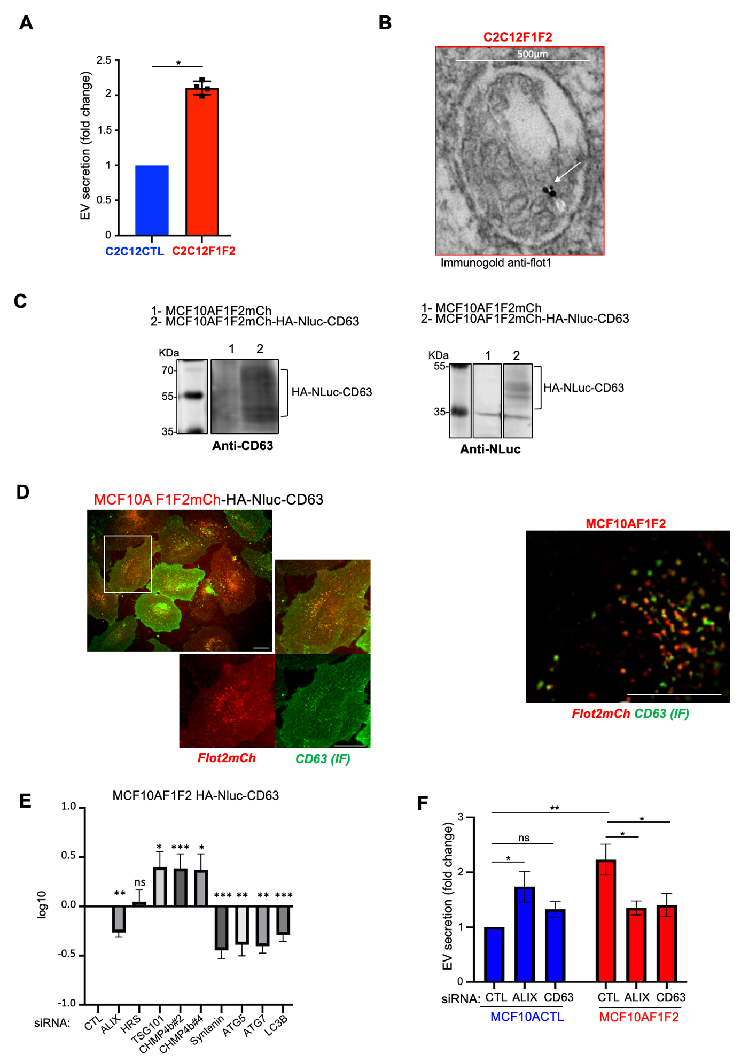
Supplementary Figure S7
A. Number of EVs isolated from C2C12CTL (expressing mCherry) and C2C12F1F2 cells calculated using the ZetaView analyzer. Data are the mean ± SEM of four independent experiments.
B. C2C12F1F2 cells were processed to detect flotillin1-HA by immunogold labeling. TEM image showing flotillin 1 (arrow) in an EL containing one engulfed endosome and ILVs.
C. Western blot analysis (20µg) of HA-NLuc-CD63 expression in the indicated cell lines.
D. Representative immunofluorescence image of MCF10AF1F2-HA-NLuc-CD63 (left) and MCF10AF1F2 (right) cells stained for CD63 and revealing the vesicular co-localization of CD63 and flotillin 2. Scale bar: 10µm.
E. Effects of the indicated siRNAs on EV secretion in MCF10AF1F-HA-NLuc-CD63 cells measured as the ratio of the NanoLuc signal in the supernatant to the one in the cell lysate. Data are the mean ± SEM of 4 independent experiments.
F. Number of EVs isolated from MCF10ACTL and MCF10AF1F2 cells in which ALIX or CD63 were silenced by siRNA or not (siRNA CTL) (ZetaView analysis). Data are the mean ± SEM of 5 independent experiments. *P <0.05, **P <0.005, ***P <0.0005. ns: non-significant (ratio paired t-test for E and F).

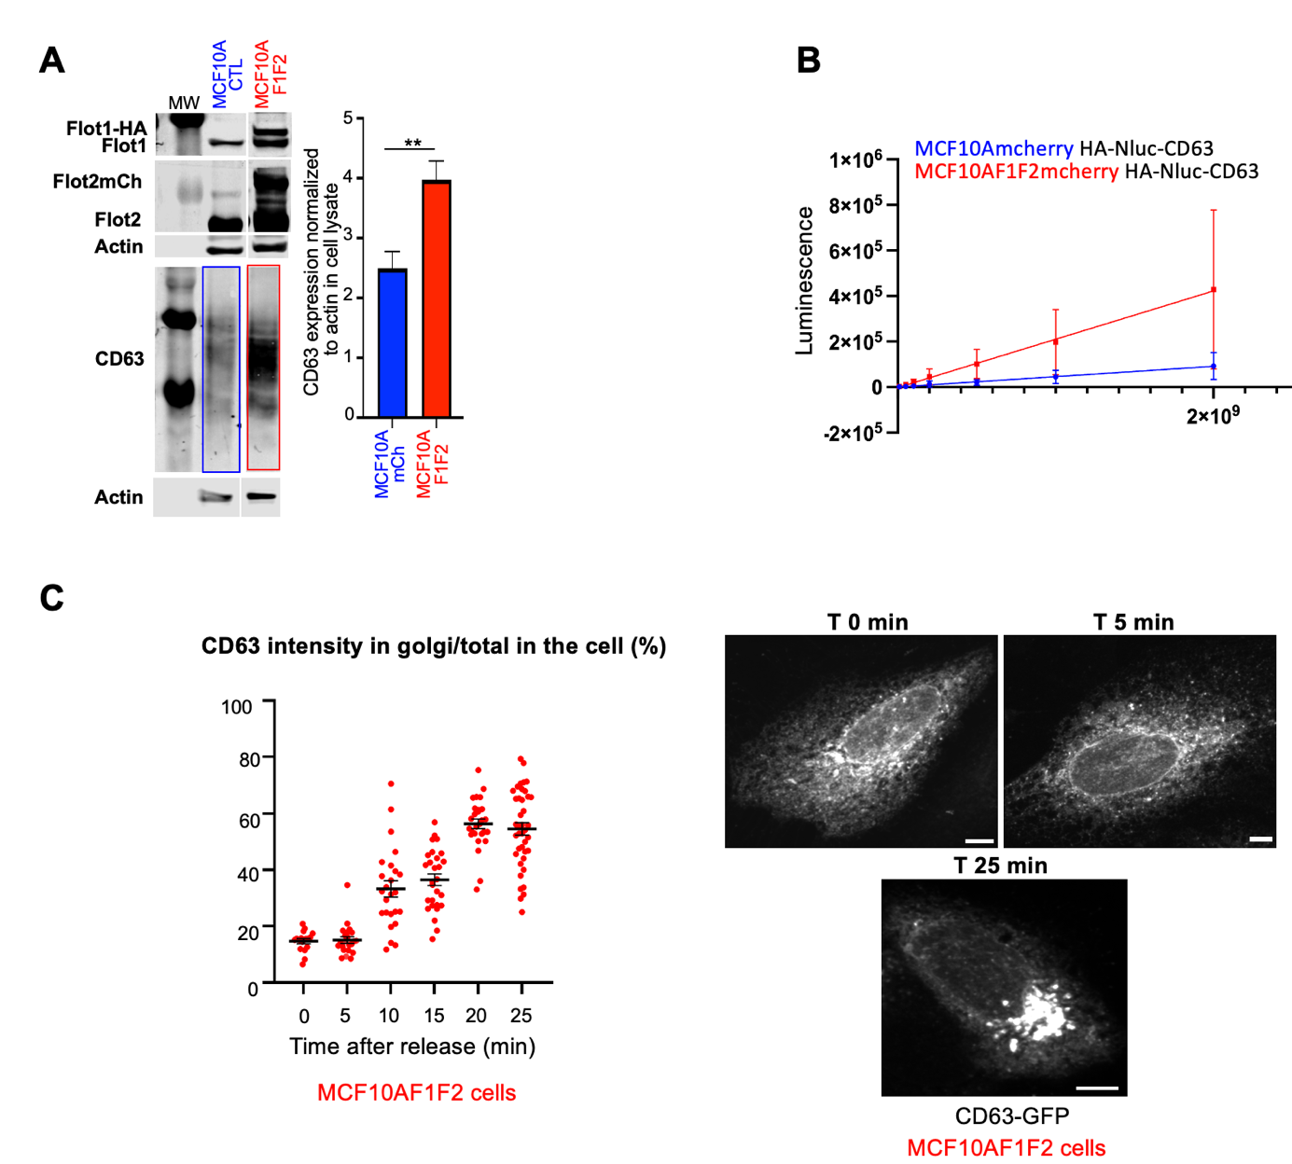
Supplementary Figure S8
A. Western blot analysis of whole cell lysates (20µg). Blue and red rectangles highlight CD63 levels in the MCF10ACTL and MCF10AF1F2 cell lysates. Histogram shows the quantification of CD63 in the cell lysates from 3 independent experiments. Data are the mean ± SEM. **P <0.005 (unpaired t-test).
B. Luminescence measured in the same number of EVs from MCF10ACTL and MCF10AF1F cells that stably express CD63-Nluc.
C. Graph shows the kinetics of streptavidin-KDEL-CD63-SBP-GFP release from the ER to the Golgi apparatus upon addition of biotin (from 0 min to 25 min after biotin addition). Each dot represents the percentage of CD63-GFP fluorescent intensity in the Golgi apparatus relative that in the whole cell from one experiment.
Micrographs show MCF10AF1F2 cells that express streptavidin-KDEL-CD63-SBP-GFP at T0 and at 5 min and 25 min after release upon biotin addition. Scale bar: 5µm.

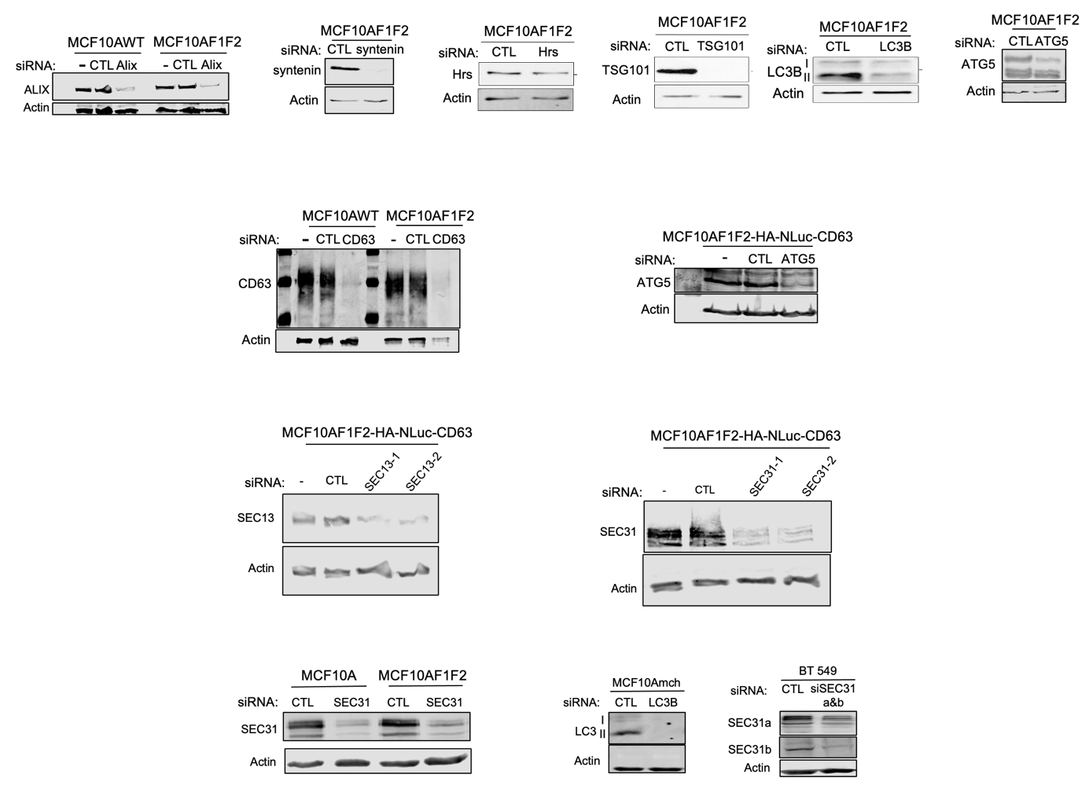
Supplementary Figure S9
Western blot analysis (20µg) of MCF10ACTL, MCF10AF1F2, MCF10AF1F2-HA-NLuc-CD63 and BT549 cell lines transfected or not with the indicated siRNAs.

Supplementary tables
Supplementary Table 1: List of the siRNAs and their sequences used for the screen (Fig. 5) and and for the other experiments mentioned in the article.
Supplementary Table 2: Proteomic data (Fig.1A). The two FLOTs are shown in red; the proteins indicated in Fig. 1A are shown in blue.
Supplementary Table 3: CLEM sample preparation, details related to the program used.

Movies
Movie 1: This movie shows the CLEM analysis of the Flotillin2mCherry-positive vesicles in contact with SEC31-GFP-positive ERES vesicles shown in Figure 1E (top panel) and in Figure S3Ba. The first part of the movie shows the merge of the consecutive planes of the EM-Z-stack and of the corresponding confocal-Z-stack and the 3D reconstruction. On each plane of the EM-stack, the Flot2-positive EL and its intraluminal vesicles, the ERES vesicles, the Endoplasmic reticulum and the phagophores were manually segmented using Fiji. The second part of the movie shows the 3D reconstruction of these segmented membrane compartments merged with the EM. This movie was made using NAPARI.

Movies 2 & 3: A live HeLa cell that expresses the ddFP ER/EL reporter system, Flot2mCherry and SEC31-Halo (labeled with the Halo-Tag ligand Janelia 646) was imaged by spinning disk confocal microscopy with a z-step of 0.27µm from bottom to top. Movie 2 shows a view from the top of the cell through a 3D reconstruction (Imaris) of the Z-stacks. In movie 2, the indicated boxed area corresponds to the region shown in movie 3. In movie 3, the overlap between Flot2mCherry, SEC31-Halo and ddFP is shown in purple. Movies 2 and 3 last 2min 49s (time interval between frames: 8.9s). Scale bars: 5 µm in movie 2 and 0.5 µm in movie 3.

Movie 4: A MCF10AF1F2 cell that expresses Flot2mCherry (red), SEC31-Halo (labeled with the Halo-Tag ligand Janelia 646) (cyan) and LC3-GFP (green) was imaged by spinning disk confocal microscopy. The movie corresponds to time lapse imaging (1 frame/1.49 s) of one single plane of the boxed area in Figure 4A. On the merge image, the arrow indicates the contact between the Flot2-mCherry-positive vesicle and the SEC31 site. Scale bar: 0.5 µm.

Movie 5: A BT549 cell that expresses Flot2mCherry (red), SEC31-Halo (labeled with the Halo-Tag ligand Janelia 646) (cyan) and LC3-GFP (green) was imaged by spinning disk confocal microscopy. The movie corresponds to time lapse imaging (3 frame/7 s) of the boxed area in Figure 4B. Each frame of the movie is a MIP image of three planes acquired with a z-step of 0.27 µm. On the merge image, the arrow indicates the contact between the Flot2-mCherry- positive vesicle and the SEC31 site. Scale bar: 0.5 µm.

