Supporting information

Astragalus-Angelica sinensis-Derived Extracellular Vesicles Attenuate Knee Osteoarthritis with Periarticular Muscle Atrophy via PPARγ-Mediated Regulation of Skeletal Muscle Fatty Acid Metabolism

Supporting Figures
Fig S 1. (A) Statistical graph of forelimb grip strength assessment in mice (n=5). (B) Statistical graph of thermal pain latency assessment in mice (n=5). (C) Statistical graph of exhaustive swimming time assessment in mice (n=5). (D) Schematic diagram of gait analysis in mice. (E) Statistical graph of stride length, stance time, and footprint area assessment in mice (n=5). (F) Open field test in mice. (G) Statistical graph of total distance traveled and mean speed in mice (n=5). Between-group differences were assessed using one-way ANOVA followed by Tukey’s post hoc test. Asterisks denote significance levels as follows: ns, no significant; *P < 0.05; **P < 0.01; ***P < 0.001.
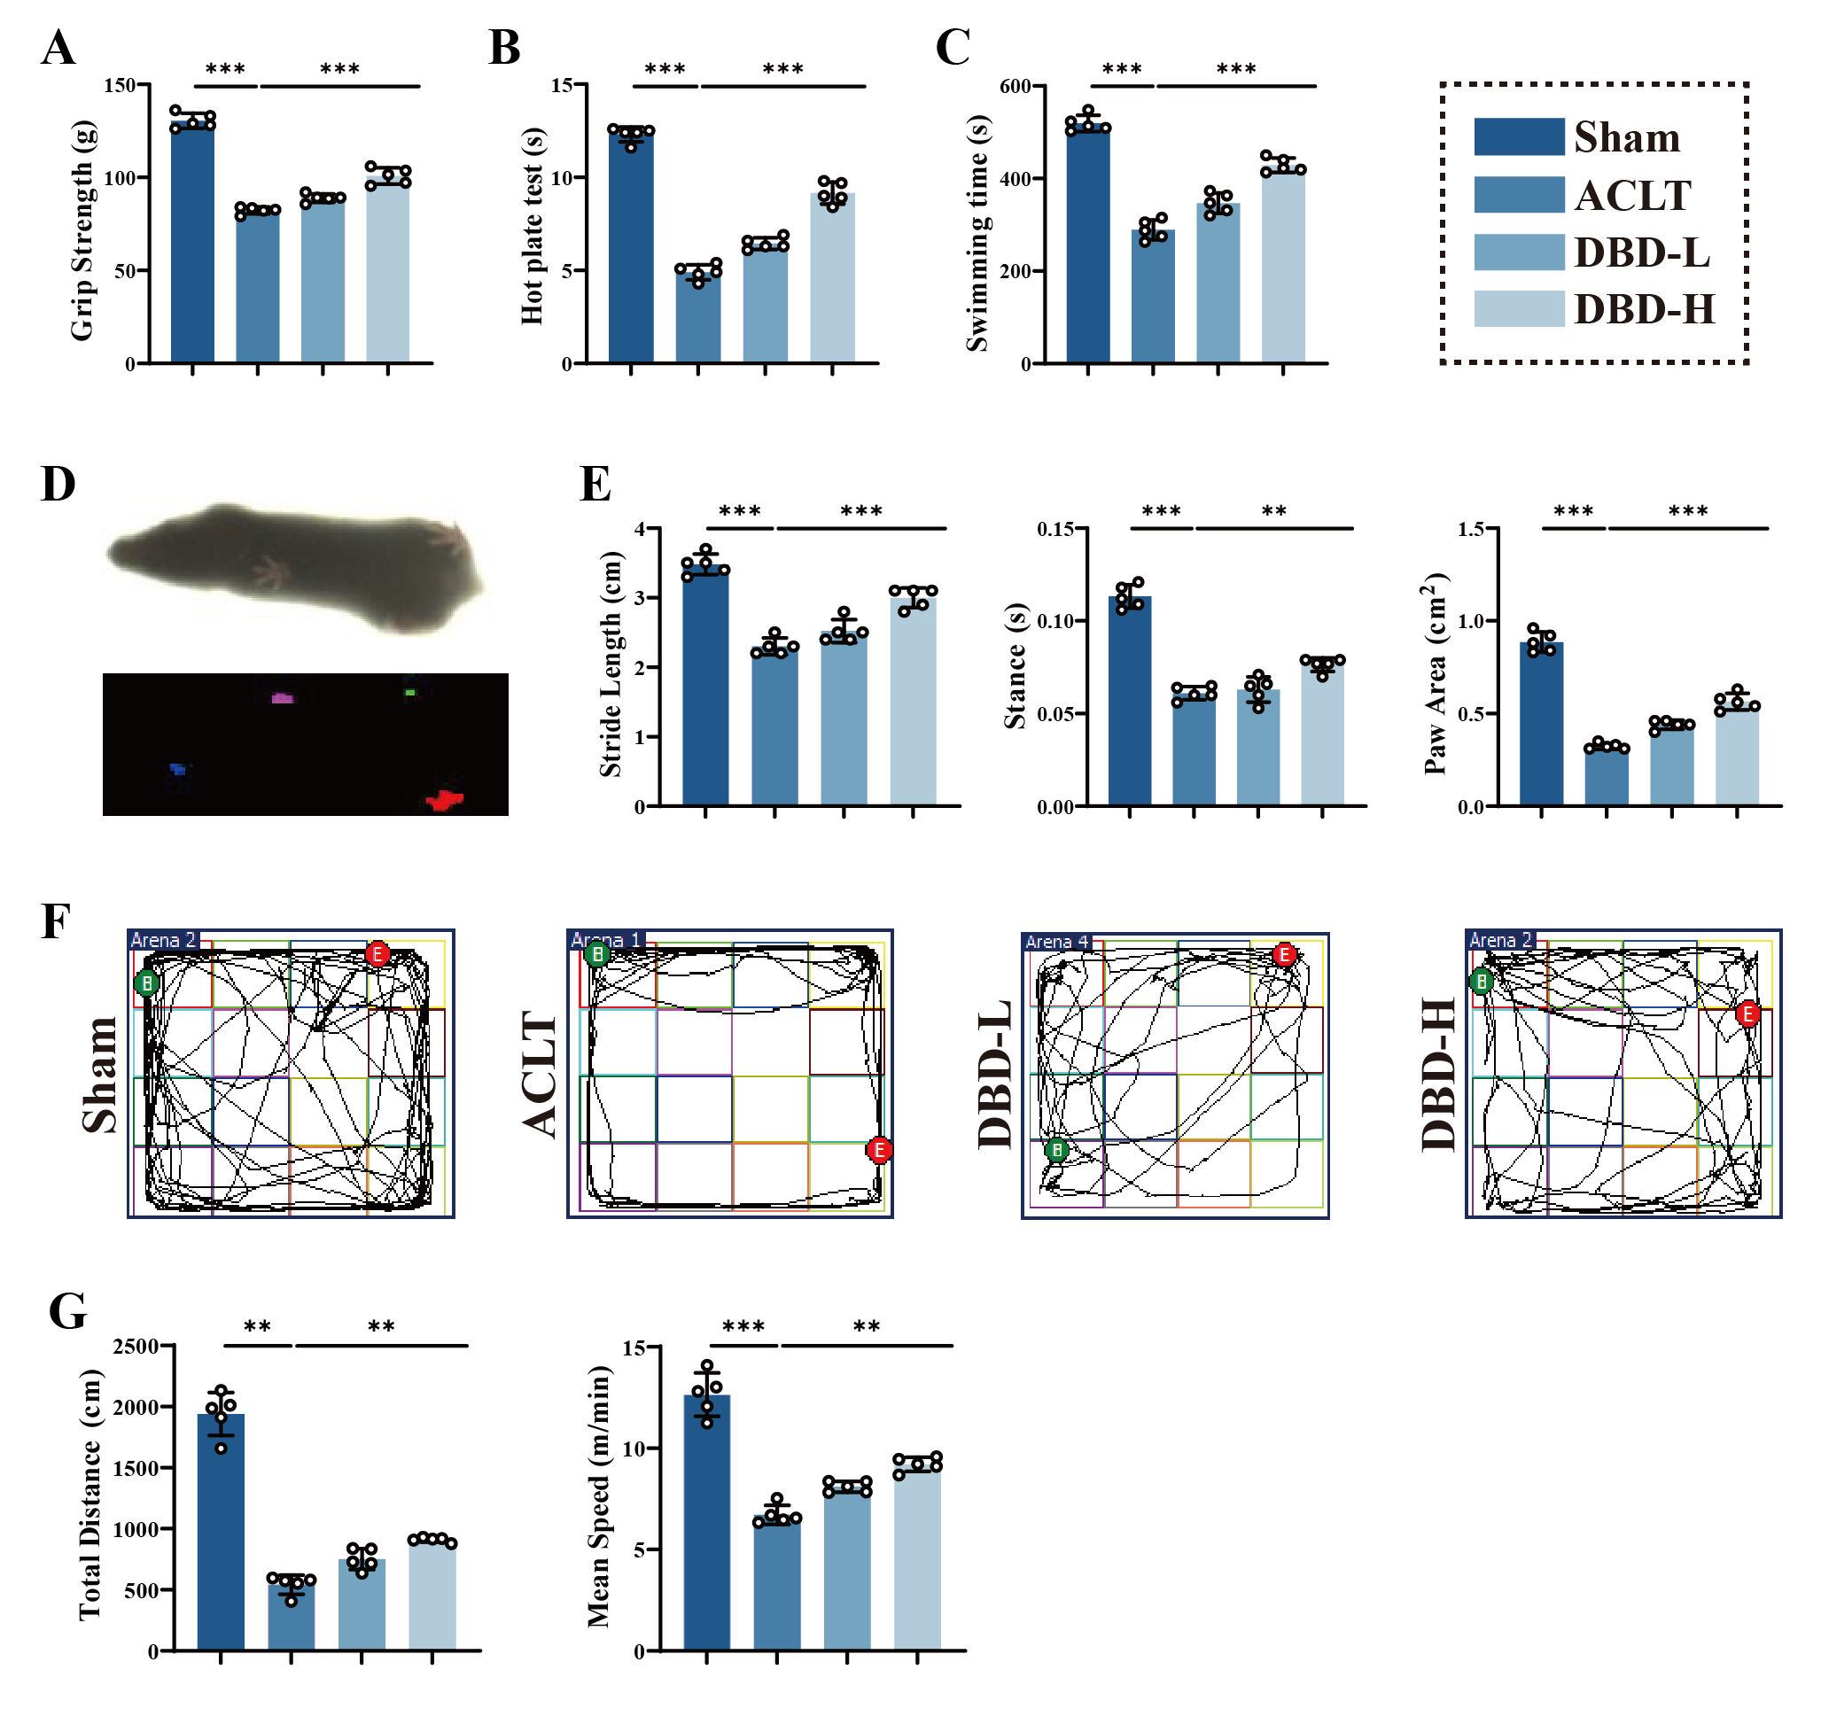

Fig S 2. Histological sections of major organs, including the heart, liver, spleen, lung, and kidney, were stained with hematoxylin and eosin (H&E). Scale bar, 100 μm.
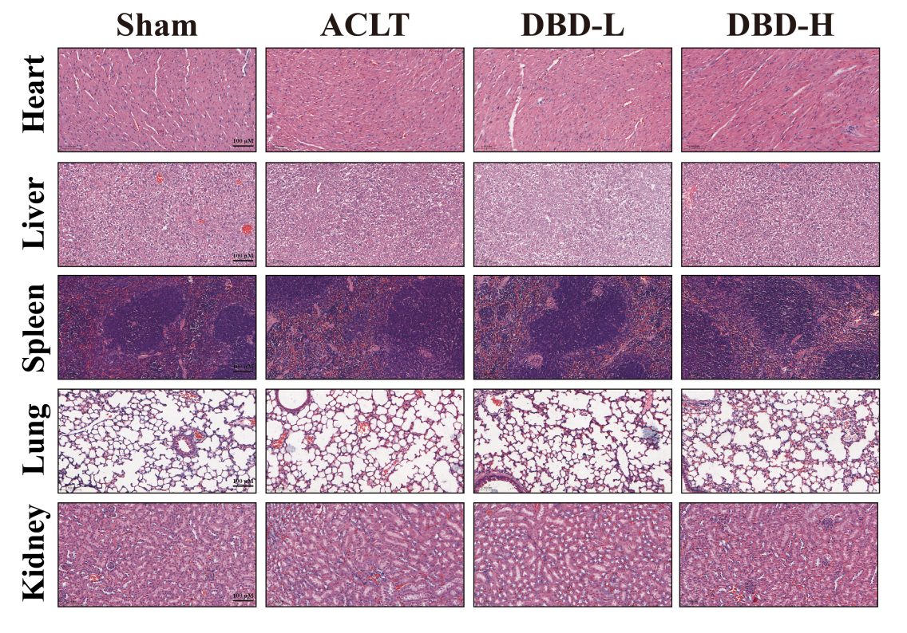

Fig S 3. Representative Western blot expression images of HSP 70 proteins in As-EVs and An-EVs.
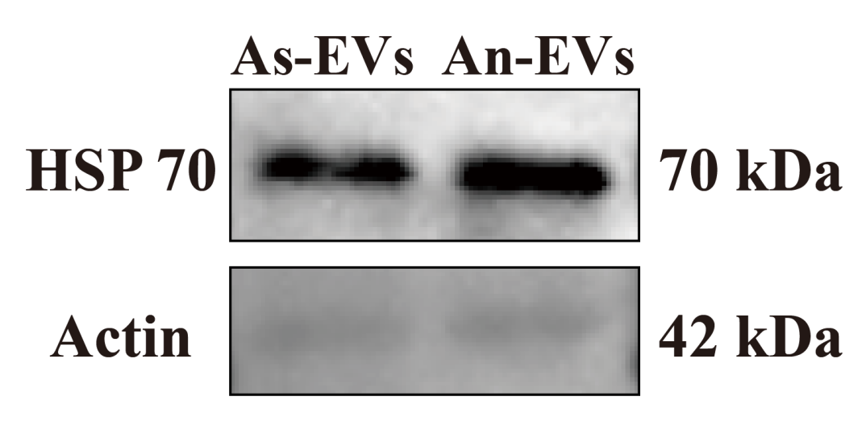

Fig S 4. Compounds in As-EVs identified by LC/MS analyses in negative and positive modes.
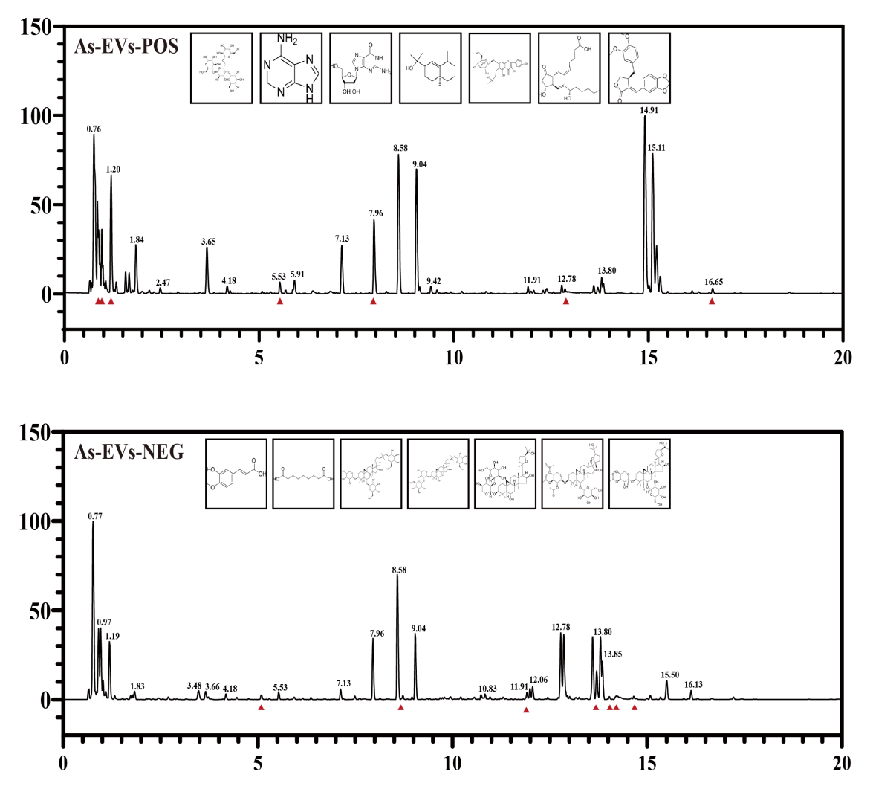

Fig S 5. Compounds in An-EVs identified by LC/MS analyses in negative and positive modes.
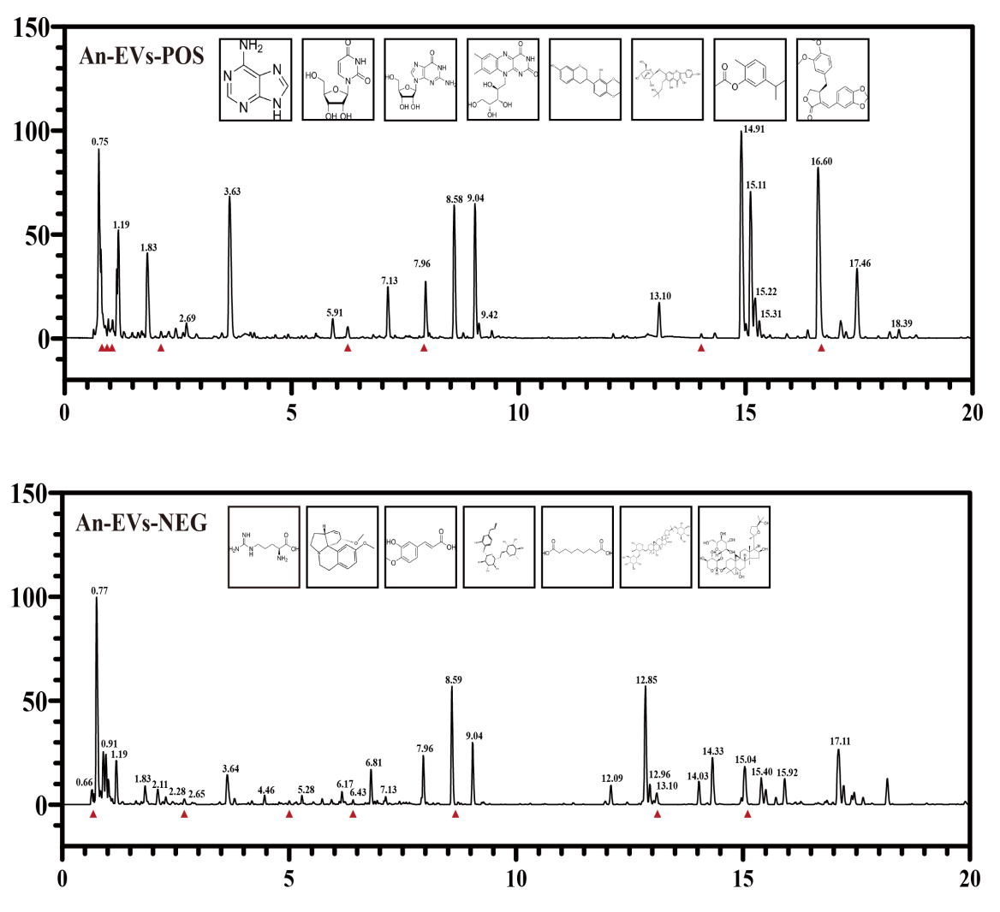

Fig S 6. (A)Effect of AA-EVs intervention concentrations on C2C12 cell viability. (B) Effects of TNF-α alone and TNF-α combined with AA-EVs intervention on C2C12 cell viability (n=6). Between-group differences were assessed using one-way ANOVA followed by Tukey’s post hoc test. Asterisks denote significance levels as follows: ns, no significant; *P < 0.05; **P < 0.01; ***P < 0.001.
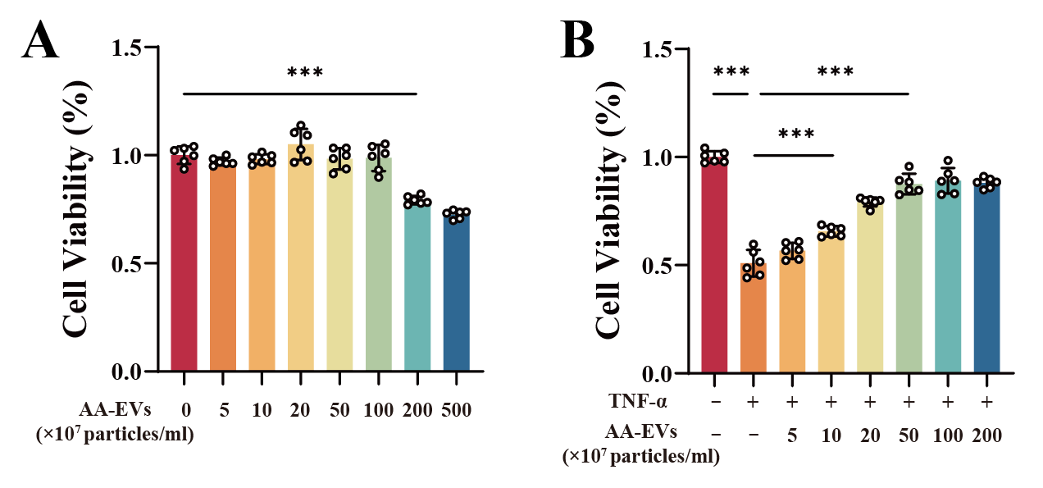

Fig S 7. (A) Statistical chart of dynamic body weight changes of mice over 4 weeks. (B) Statistical graph of forelimb grip strength assessment in mice (n=5). (C) Statistical graph of thermal pain latency assessment in mice (n=5). (D) Statistical graph of exhaustive swimming time assessment in mice (n=5). (E) Schematic diagram of gait analysis in mice. (F) Statistical graph of stride length, stance time, and footprint area assessment in mice (n=5). (G) Open field test in mice. (H) Statistical graph of total distance traveled and mean speed in mice (n=5). Between-group differences were assessed using one-way ANOVA followed by Tukey’s post hoc test. Asterisks denote significance levels as follows: ns, no significant; *P < 0.05; **P < 0.01; ***P < 0.001.
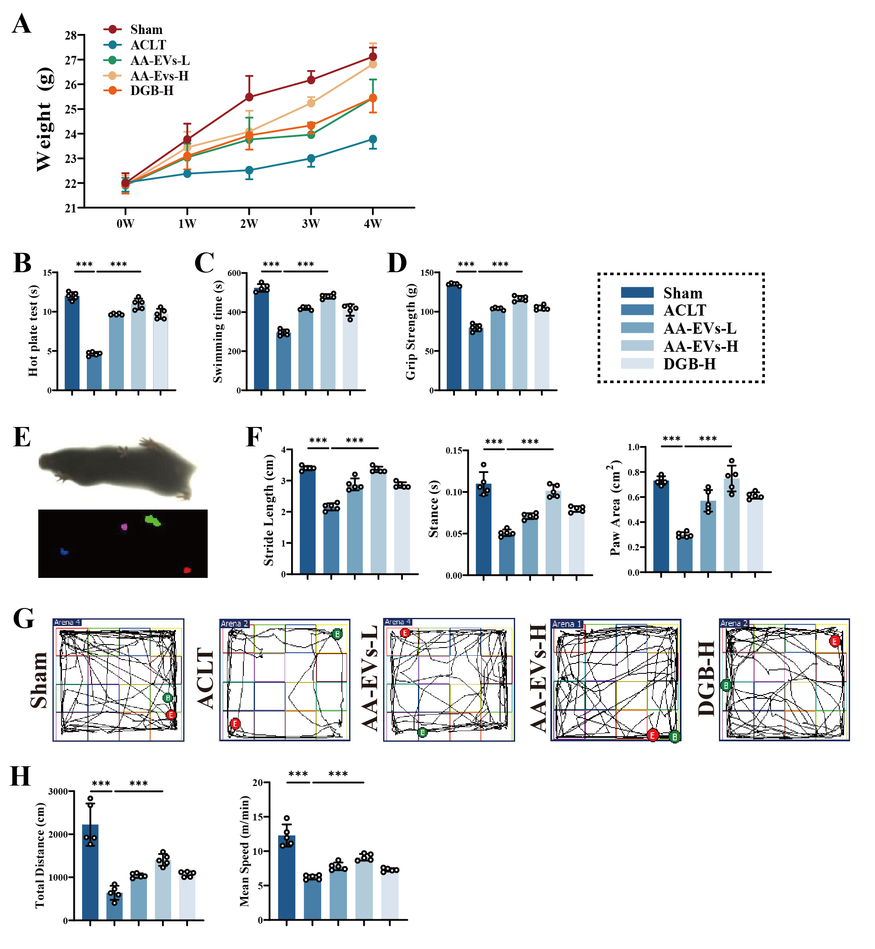

Fig S 8. Histological sections of major organs, including the heart, liver, spleen, lung, and kidney, were stained with hematoxylin and eosin (H&E). Scale bar, 100 μm.
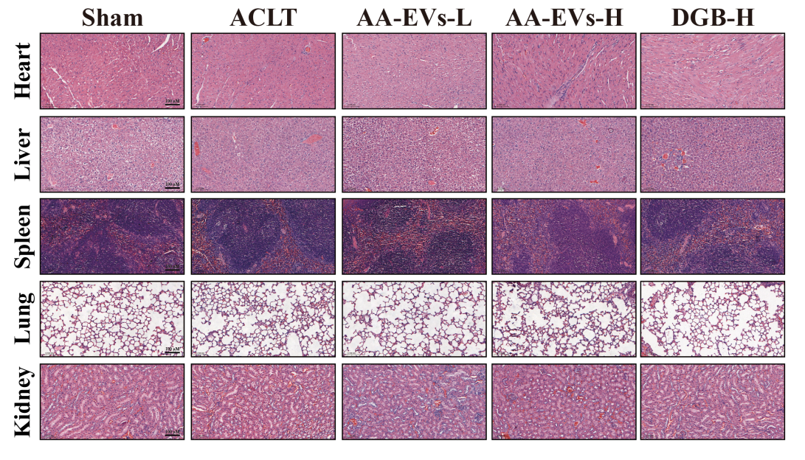

Fig S 9. H&E staining of the cross-sectional area of the tibialis anterior, quadriceps, and gastrocnemius muscles. Scale bar, 100 μm.
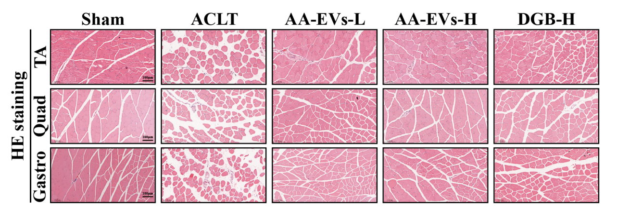

Fig S 10. (A) Statistical graph of MyoG fluorescence intensity in quadriceps muscle cross sections (n=3). (B) Statistical graph of Murf-1 fluorescence intensity in quadriceps muscle cross sections (n=3). Between-group differences were assessed using one-way ANOVA followed by Tukey’s post hoc test. Asterisks denote significance levels as follows: ns, no significant; *P < 0.05; **P < 0.01; ***P < 0.001.
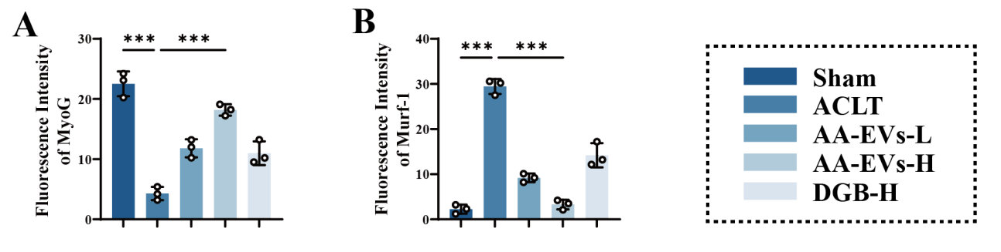

Fig S 11. Hierarchical clustering heatmap of DEGs in the ACLT vs. Sham and AA-EVs vs. ACLT comparison.
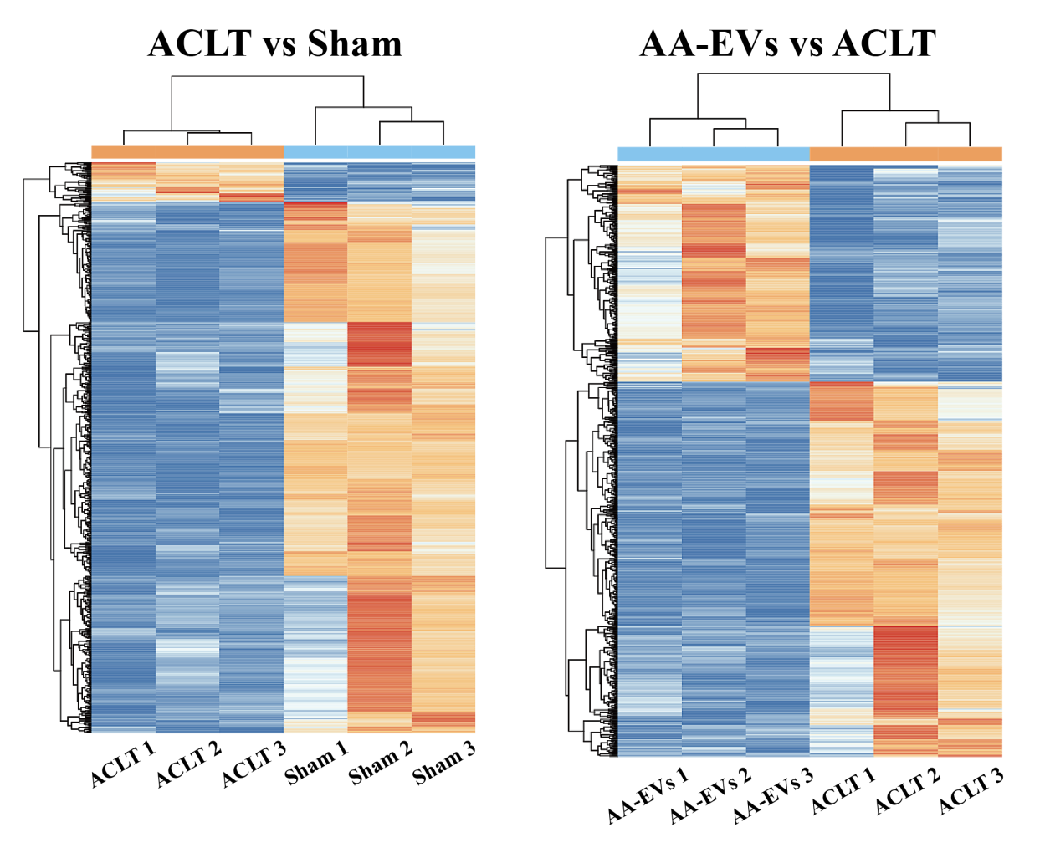

Fig S 12. Metabolomic profiling and bioinformatics analysis of quadriceps femoris muscles from ACLT-induced and AA-EVs-treated mice. (A) Volcano plots of differentially abundant metabolites in the ACLT vs Sham and AA-EVs vs. ACLT comparisons. (B) Overview of regulatory metabolites reversed by AA-EVs treatment in ACLT-induced muscle atrophy. (C) KEGG pathway enrichment analysis for the ACLT vs. Sham and AA-EVs vs. ACLT comparisons. (D) Hierarchical clustering heatmap of 61 pathway-associated metabolites between the ACLT and AA-EVs groups.
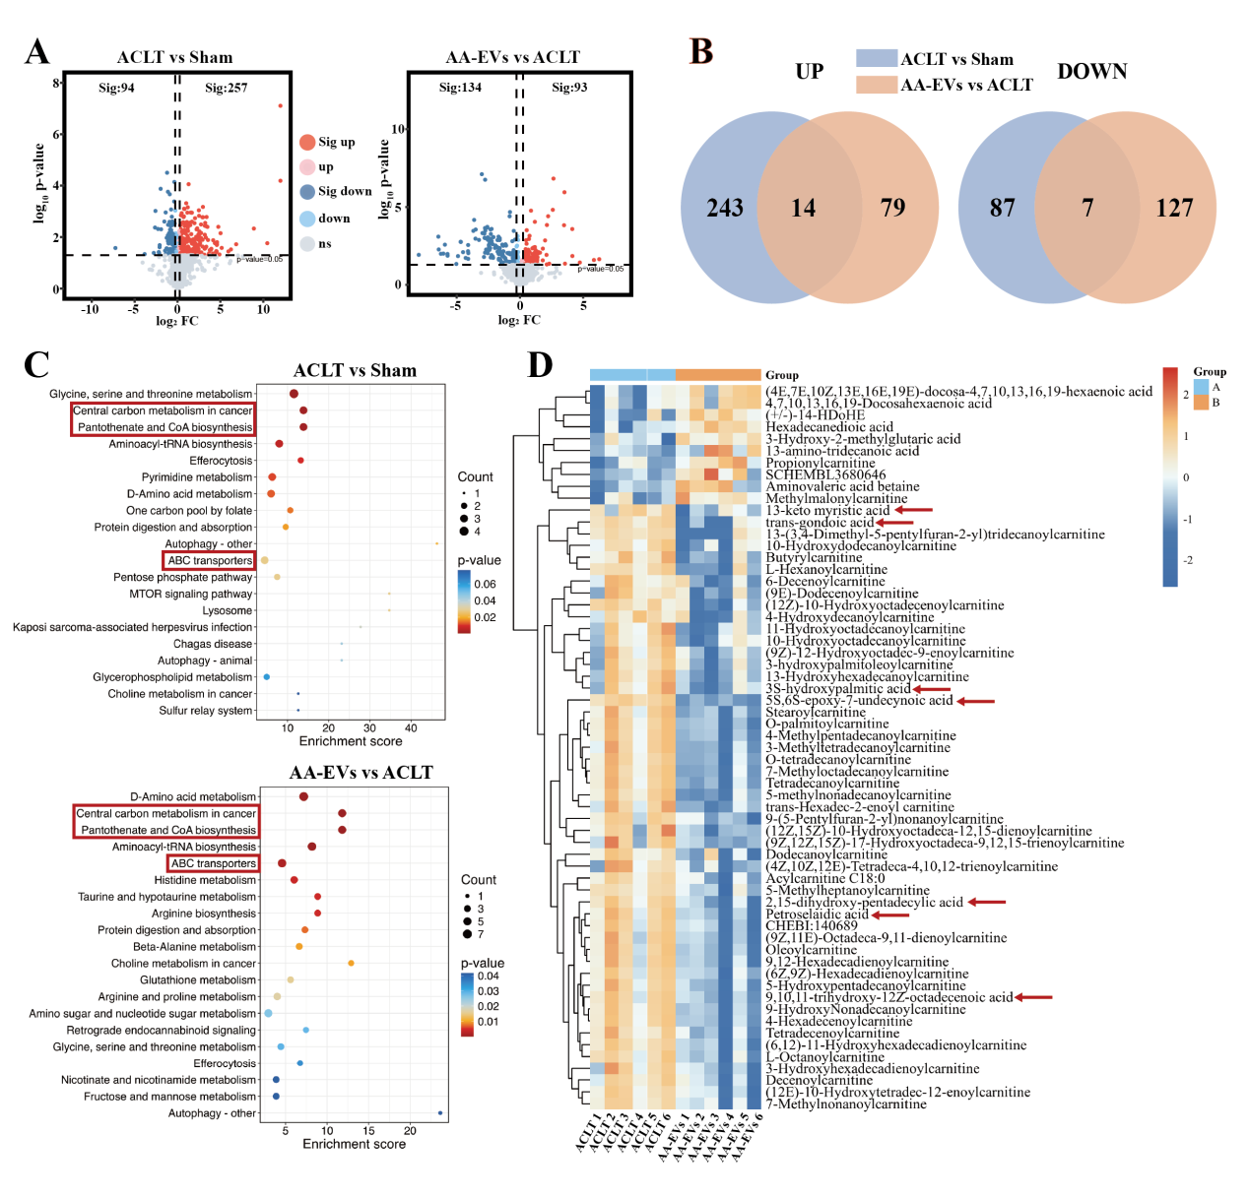

Fig S 13. qPCR analysis of PPARα and PPARβ gene (n=6). Between-group differences were assessed using one-way ANOVA followed by Tukey’s post hoc test. Asterisks denote significance levels as follows: ns, no significant; *P < 0.05; **P < 0.01; ***P < 0.001.
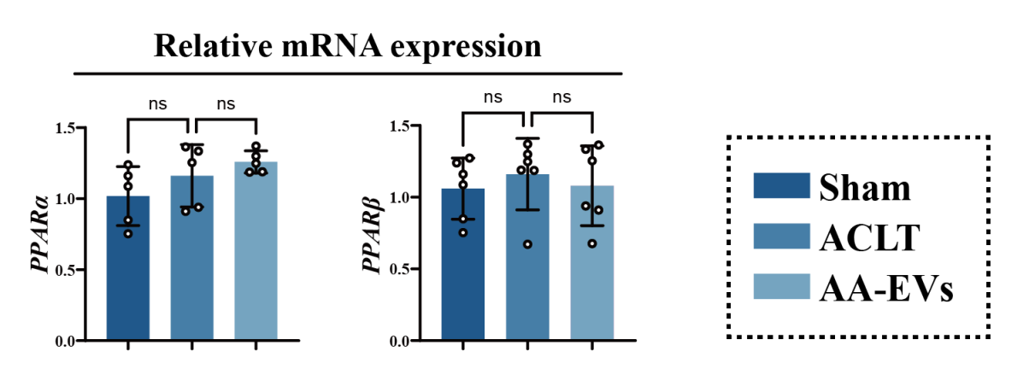

Fig S 14. qPCR analysis of PPARγ gene (n=6). Between-group differences were assessed using one-way ANOVA followed by Tukey’s post hoc test. Asterisks denote significance levels as follows: ns, no significant; *P < 0.05; **P < 0.01; ***P < 0.001.
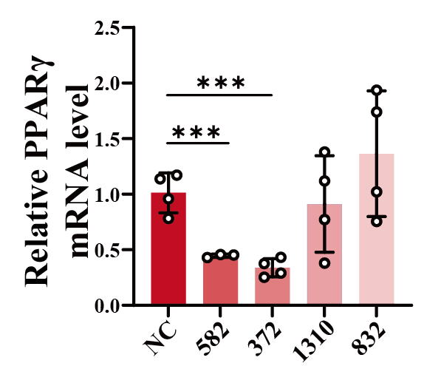

Fig S 15. (A)Western blot analysis of PPARγ. (B) Quantitative analysis of PPARγ protein expression (n=3). Between-group differences were assessed using one-way ANOVA followed by Tukey’s post hoc test. Asterisks denote significance levels as follows: ns, no significant; *P < 0.05; **P < 0.01; ***P < 0.001.
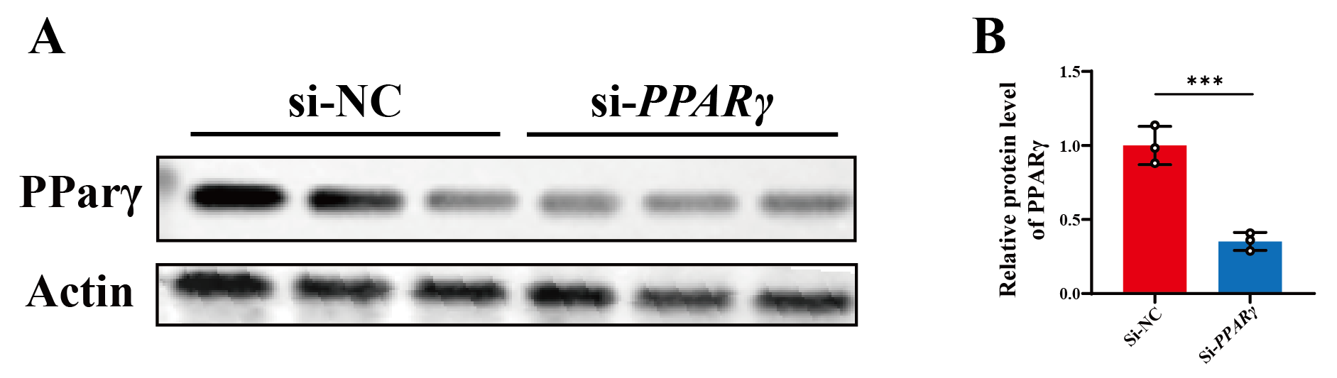

Table S1. LC/MS analytical data characterizing As-EVs components, detailing retention times, ionization modes, adduct formations, molecular formulas, and precise m/z values.
NO | Component name | Retention time  (min) | Mode | Adducts | Molecular formula | m/z
1 | L-Arginine | 173.1039 | 0.72 | -H | C6H14N4O2 | NEG
2 | Glycogen | 689.2112 | 0.8 | +Na, +H, +K | C24H42O21 | POS
3 | Adenine | 136.0613 | 0.86 | +H | C5H5N5 | POS
4 | Guanosine | 284.0994 | 1.02 | +H | C10H13N5O5 | POS
5 | Riboflavin | 377.1425 | 2.28 | +H | C17H20N4O6 | POS
6 | Isococculidine | 330.1686 | 2.65 | +HCOO | C18H23NO2 | NEG
7 | 4-Hydroxy-3-methoxycinnamic acid | 193.0501 | 5.12 | -H | C10H10O4 | NEG
8 | 7,2’-Dihydroxy-3’,4’,6’-trimethoxyisoflavan | 355.1179 | 6.17 | +Na | C18H20O6 | POS
9 | 2-Hydroxy-4-allylphenyl 6-O-alpha-L-rhamnopyranosyl-beta-D-glucopyranoside | 503.1772 | 6.43 | +HCOO | C21H30O11 | NEG
10 | Phellatin | 533.1667 | 7.94 | -H | C26H30O12 | POS
11 | Azelaic acid | 187.0971 | 8.73 | -H | C9H16O4 | NEG
12 | Senkyunolide D | 221.0829 | 13.2 | -H | C12H14O4 | NEG
13 | Carvacryl acetate | 193.1222 | 14.03 | +H | C12H16O2 | POS
14 | Acetylastragaloside | 955.4949 | 15.18 | +HCOO | C47H74O17 | NEG
15 | Suchilactone | 369.1335 | 16.67 | +H | C21H20O6 | POS

Table S2. LC/MS analytical data characterizing An-EVs components, detailing retention times, ionization modes, adduct formations, molecular formulas, and precise m/z values.
NO | Component name | Retention time  (min) | Mode | Adducts | Molecular formula | m/z
1 | Glycogen | 689.2103 | 0.81 | +Na | C24H42O21 | POS
2 | Adenine | 136.0613 | 0.86 | +H | C5H5N5 | POS
3 | Guanosine | 284.0994 | 1.2 | +H, +Na | C10H13N5O5 | POS
4 | 4-Hydroxy-3-methoxycinnamic acid | 193.0501 | 5.09 | +HCOO | C10H10O4 | NEG
5 | Rosifoliol | 245.1861 | 5.54 | +Na | C15H26O | POS
6 | Phellatin | 557.1638 | 7.94 | +Na | C26H30O12 | POS
7 | Azelaic acid | 187.0972 | 8.73 | -H | C9H16O4 | NEG
8 | Astragaloside VII | 945.5108 | 11.89 | -H | C47H78O19 | NEG
9 | Prostaglandin E2 | 353.2303 | 12.87 | +H | C20H32O5 | POS
10 | Senkyunolide D | 221.0826 | 13.2 | -H | C12H14O4 | NEG
11 | Astragaloside III | 829.4571 | 13.61 | +HCOO, -H | C41H68O14 | NEG
12 | Acetylastragaloside | 955.4985 | 14.5 | +HCOO | C47H74O17 | NEG
13 | Isoastragaloside II | 871.4688 | 14.66 | +HCOO | C43H70O15 | NEG
14 | Suchilactone | 369.1337 | 16.66 | +H, +Na | C21H20O6 | POS

Table S3. LC/MS analytical data characterizing AA-EVs components, detailing retention times, ionization modes, adduct formations, molecular formulas, and precise m/z values.
NO | Component name | Retention time  (min) | Mode | Adducts | Molecular formula | m/z
1 | L-Arginine | 173.1039 | 0.72 | -H | C6H14N4O2 | NEG
2 | Glycogen | 689.2103 | 0.81 | +Na | C24H42O21 | POS
3 | Adenine | 136.0613 | 0.86 | +H | C5H5N5 | POS
4 | Guanosine | 284.0994 | 1.2 | +H, +Na | C10H13N5O5 | POS
5 | Riboflavin | 377.1425 | 2.28 | +H | C17H20N4O6 | POS
6 | Isococculidine | 330.1686 | 2.65 | +HCOO | C18H23NO2 | NEG
7 | 4-Hydroxy-3-methoxycinnamic acid | 239.0564 | 5.09 | +HCOO | C10H10O4 | NEG
8 | Rosifoliol | 245.1861 | 5.54 | +Na | C15H26O | POS
9 | 7,2’-Dihydroxy-3’,4’,6’-trimethoxyisoflavan | 355.1179 | 6.17 | +Na | C18H20O6 | POS
10 | 2-Hydroxy-4-allylphenyl 6-O-alpha-L-rhamnopyranosyl-beta-D-glucopyranoside | 503.1772 | 6.43 | +HCOO | C21H30O11 | NEG
11 | Phellatin | 557.1638 | 7.94 | +Na | C26H30O12 | POS
12 | Azelaic acid | 187.0972 | 8.73 | -H | C9H16O4 | NEG
13 | Astragaloside VII | 945.5108 | 11.89 | -H | C47H78O19 | NEG
14 | Prostaglandin E2 | 353.2303 | 12.87 | +H | C20H32O5 | POS
15 | Senkyunolide D | 221.0826 | 13.2 | -H | C12H14O4 | NEG
16 | Astragaloside III | 829.4571 | 13.61 | +HCOO, -H | C41H68O14 | NEG
17 | Carvacryl acetate | 193.1222 | 14.03 | +H | C12H16O2 | POS
18 | Acetylastragaloside | 955.4985 | 14.5 | +HCOO | C47H74O17 | NEG
19 | Isoastragaloside II | 871.4688 | 14.66 | +HCOO | C43H70O15 | NEG
20 | Suchilactone | 369.1337 | 16.66 | +H, +Na | C21H20O6 | POS

Table S4. The primer sequence of target genes
Genes | Forward primer sequence | Reverse primer sequence
Actin | CATCACTGCCACCCAGAAGACTG | ATGCCAGTGAGCTTCCCGTTCAG
MyoG | CCATCCAGTACATTGAGCGCCT | CTGTGGGAGTTGCATTCACTGG
MyoD | GCACTACAGTGGCGACTCAGAT | TAGTAGGCGGTGTCGTAGCCAT
MuRF1 | TACCAAGCCTGTGGTCATCCTG | ACGGAAACGACCTCCAGACATG
Atrogin-1 | CTTCTCGACTGCCATCCTGGAT | TCTTTTGGGCGATGCCACTCAG
FABP4 | TGAAATCACCGCAGACGACAGG | GCTTGTCACCATCTCGTTTTCTC
CD36 | GGACATTGAGATTCTTTTCCTCTG | GCAAAGGCATTGGCTGGAAGAAC
CPT1b | ATGTATCGCCGCAAACTGGACC | CTCTGAGAGGTGCTGTAGCAAG
Acaa1b | GGAGAATGTGGCTGAGCGGTTT | AGGACAGTGGTTGTCACAGGCA
PPARα | ACCACTACGGAGTTCACGCATG | GAATCTTGCAGCTCCGATCACAC
PPARβ | GGACCAGAACACACGCTTCCTT | CCGACATTCCATGTTGAGGCTG
PPARγ | GTACTGTCGGTTTCAGAAGTGCC | ATCTCCGCCAACAGCTTCTCCT
Col2 | GCTGGTGAAGAAGGCAAACGAG | CCATCTTGACCTGGGAATCCAC
MMP13 | GATGACCTGTCTGAGGAAGACC | GCATTTCTCGGAGCCTGTCAAC

