Sub-county Heterogeneity in the Impact of Improved RTS,S Fourth-Dose Coverage with Enhanced Vector Control in Kenya’s Lake-Endemic Region: A Transmission Modelling Study
Stephanie Kamunya¹, Geoffrey Githinji²
¹Mount Kenya University, Thika, Kenya
²Swiss Tropical and Public Health Institute, Basel, Switzerland

Overview
This supplementary file provides the mathematical formulation, assumptions, intervention representation, calibration approach, and additional methodological details underlying the transmission model used to assess the impact of increasing fourth-dose RTS,S coverage in the lake-endemic region of Kenya. The analysis was conducted for all 65 sub-counties across the eight lake-endemic counties of Kenya. The model was fitted at the sub-county level to capture spatial heterogeneity in malaria transmission and intervention effects. The principal objective was to evaluate the epidemiological impact of incrementally increasing fourth-dose RTS,S coverage under two main scenarios:
- Increasing fourth-dose coverage while maintaining existing net interventions; and
- Increasing fourth-dose coverage alongside deployment of dual active-ingredient (AI) insecticide-treated nets.

Study Setting
The study focused on the lake-endemic malaria region of Kenya, comprising eight counties: Busia, Bungoma, Homa Bay, Kakamega, Kisumu, Migori, Siaya, and Vihiga. Analysis was performed at the sub-county level, with all 65 sub-counties included in the modelling framework (Table S1). This region experiences sustained malaria transmission, although the level of transmission varies spatially across sub-counties. Such heterogeneity makes sub-county-level modelling particularly important for evaluating the localised impact of interventions.
Table S1: Administrative sub-counties included in the lake-endemic region malaria transmission model.
County | Sub-county
Bungoma | Bumula, Cheptais, Kabuchai, Kanduyi, Kimilili, Mt. Elgon, Sirisia, Tongaren, Webuye East, Webuye West
Busia | Bunyala, Butula, Matayos, Nambale, Samia, Teso Central, Teso North, Teso South
Homa Bay | Ndhiwa, Homa Bay Town, Rachuonyo East, Rachuonyo North, Rachuonyo South, Rangwe, Suba South, Suba North, Suba West
Kakamega | Butere, Ikolomani, Khwisero, Likuyani, Lugari, Lurambi, Matungu, Malava, Mumias East, Mumias West, Navakholo, Shinyalu
Kisumu | Kisumu Central, Kisumu East, Kisumu West, Muhoroni, Nyakach, Nyando, Seme
Migori | Awendo, Kuria East, Kuria West, Rongo, Suna East, Suna West, Nyatike, Uriri
Siaya | Alego Usonga, Bondo, Gem, Rarieda, Ugenya, Ugunja
Vihiga | Hamisi, Emuhaya, Sabatia, Vihiga, Luanda

Model Structure
A deterministic, age-structured compartmental transmission model was developed to represent malaria dynamics in the human population. The human population is divided into different epidemiological compartments that represent various states related to malaria: susceptible, exposed, asymptomatic infected, symptomatic infected, treated, recovered, and severe malaria cases (Table S2).
Table S2: Definitions of epidemiological compartments included in the age-structured malaria transmission model. Subscripts denote age groups: a (>5 years), b (<1 year), and c (1–5 years).
Compartment | Definition
S_{i} | Susceptible
E_{i} | Exposed
V_{b,c} | Vaccinated population in both the under 1 and under 5 population
E_{vb,c} | Exposed and vaccinated in both the under 1 and under 5 population
I_{ai} | Infected and asymptomatic
I_{uni} | Infected and symptomatic
I_{sevi} | Infected and severely symptomatic
T_{i} | Treated
R_{i} | Recovered
The model explicitly captures infection, disease progression, treatment, recovery, waning immunity, and vaccination in children under five years of age, with the parameters described in Tables S3.
Table S3: Model parameters, baseline values, uncertainty ranges, and data sources used in calibration and simulation analyses.
Parameter | Definition | Value | Range | Source
a | Human feeding rate per mosquito (per day) | 0.2-0.3 | 0.2-0.3 | Fitted
b | Transmission efficiency from mosquito to human (per day) | 0.69 | 0.51-0.74 | Fitted
c | Transmission efficiency human to mosquito (per day) | 0.30 | 0.3-0.46 | Fitted
γ_{m} | Rate of onset of infectiousness in mosquitoes (Incubation rate; per day) | 0.05 | 0.05-0.07 | ¹
µ_{m} | Mosquito mortality rate (per day) | 0.21 | 0.205 | ²
m | Average number of mosquitoes per human per day | 10 | 10-12 | Fitted
p_{a} | Proportion of individuals expected to develop asymptomatic malaria | 0.0087 | 0.007-0.11 | Fitted
p_{u} | Proportion of individuals expected to develop clinical uncomplicated malaria | 0.98 | 0.6-0.98 | Fitted
γ_{h} | Rate of onset of infectiousness in humans (Incubation rate; per day) | 0.08 | 0.06-0.09 | Fitted
δ | Natural recovery rate (per day) | 0.0029 | 0.0014-0.017 | ³
r | Recovery rate after antimalarial treatment (AL; per day) | 0.062 | 0.06-0.18 | ⁴
r_{s} | Recovery rate after antimalarial treatment from severe malaria (per day) | 0.3 | 0.2-0.35 | ⁵
ρ | Loss of immunity (per day) | 0.007 | 0.000055-0.011 | ⁶
ζ_{a} | Relative infectiousness of asymptomatic infection compared to clinical infections | 0.04 | 0.035-0.05 | ⁷
ζ_{t} | Relative infectiousness of outpatient-treated individuals compared to clinical infection | 0.08 | 0.07-0.21 | Fitted
ω | Transition rate from uncomplicated malaria to the asymptomatic class | 0.02 | 0.01-0.03 | Fitted
τ | Admission rate to hospital for uncomplicated malaria | 0.19 | 0.16-0.24 | Fitted
τ_{c} | Admission rate to hospital for the under-5 population with uncomplicated malaria | 0.34 | 0.2-0.4 | Fitted
α | Amplitude of seasonal variation | 0.6 | 0 - 1 | Fitted
φ | Month of peak transmission per month | 0.25 | 0 - 1 | Fitted
ε | Vaccine efficacy (proportionate reduction in the risk of infection for vaccinated individuals compared to unvaccinated ones). | 0.3 | 0.29-0.36 | ⁸
µ_{h} | Human birth/mortality rate (per day) | 1/(62*365) | 1/((62-64)*365) | ⁹
ν_{u1} | Probability that the exposed but vaccinated under-1 population will develop symptomatic uncomplicated malaria | 0.45 | 0.4-0.55 | ¹⁰
ν_{s1} | Probability that the exposed but vaccinated under-1 population will develop symptomatic severe malaria | 0.39 | 0.35-0.5 | ¹⁰
ν_{u2} | Probability that the exposed but vaccinated under-5 population will develop symptomatic uncomplicated malaria | 0.29 | 0.25-0.4 | ¹⁰
ν_{s2} | Probability that the exposed but vaccinated under-5 population will develop symptomatic severe malaria | 0.065 | 0.05-0.3 | ¹⁰
θ₁ | Ageing rate of the under-1 population | 1/(1*365) | 0.00274
θ₂ | Ageing rate of the under-5 population | 1/(4*365) | 0.000685
p_{treat_c} | Proportion of the under-5 population who receive treatment | 0.9 | 0.8 -1 | Expert opinion
vacc_{p} | Rate of vaccination | 1/(0.5*365) | 0.00548 | ¹¹
cv₁ | Vaccine coverage of the under-1 population | 0.8-1 | 0.8-1 | Data informed for each sub-county
cv₂ | Vaccine coverage of the under-5 population | 0.1-0.5 | 0.1-0.5 | Data informed for each sub-county
p_{treat} | p_{t} * p_{s} (proportion of population that receive treatment * proportion of population that seek treatment) | 0.6-0.8 | 0.6-0.8 | Data informed from indicator surveys

Since the vaccine targets young children, the model incorporates an age structure that distinguishes the vaccine-eligible population from older age groups. Vaccinated children are categorised separately due to their reduced susceptibility and/or lower progression rates to clinical disease after receiving the RTS,S vaccine. Furthermore, the under-5 age group is split into two categories: under 1 year old and over 1 year old, to accurately reflect the coverage for the fourth dose. Transitions between age groups occur at age-specific rates. The model equations are provided below.

Under 1 Population (Under 1)
$$\frac{dS_{b}}{dt}=μ_{h}P+ρR_{b}-\left(cv_{1}vacc_{p}+λ+μ_{h}+θ_{1}\right)S_{b}$$
$$\frac{dV_{b}}{dt}=cv_{1}vacc_{p}S_{b}-\left(\left(1-ϵ\right) λ +μ_{h} + θ_{1}\right)V_{b}$$
$$\frac{dE_{vb}}{dt}=(\left(1-ϵ\right)λ V_{b}-\left(γ_{h}+μ_{h}+θ_{1}\right)E_{vb}$$
$$\frac{dE_{b}}{dt}=λ S_{b}-\left(γ_{h}+μ_{h}+θ_{1}\right)E_{b}$$
$$\frac{dI_{ab}}{dt}=pa γ_{h} E_{b}+pa γ_{h} E_{vb}+\left(1-p_{treat_{c}}\right) ω I_{unb}-\left(δ+μ_{h}+θ_{1}\right) I_{ab}+\left(\left(1-ν_{u1}\right) pu \left(1-pa\right) γ_{h}\right)) E_{vb}+\left(1-ν_{s1}\right) \left(1-pu\right) \left(1-pa\right) γ_{h})E_{vb}$$
$$\frac{dI_{unb}}{dt}=p_{u}\left(1-p_{a}\right)γ_{h}E_{b}+ν_{u1}p_{u}\left(1-p_{a}\right)γ_{h}E_{vb}-p_{treat_{c}}τ_{c}I_{unb}-\left(1-p_{treat_{c}}\right)ωI_{unb}-\left(μ_{h}+θ_{1}\right)I_{unb}$$
$$\frac{dT_{b}}{dt}=p_{treat_{c}} τ_{c} I_{unb}-\left(r+μ_{h}+θ_{1}\right) T_{b}$$
$$\frac{dI_{sevb}}{dt}=\left(\left(1-pu\right) \left(1-pa\right) γ_{h}\right) E_{b}+\left(ν_{s1} \left(1-pu\right) \left(1-pa\right) γ_{h}\right) E_{vb}-\left(rs+μ_{h}+θ_{1}\right) I_{sevb}$$
$$\frac{dR_{b}}{dt}=δ I_{ab}+r T_{b}+r_{s} I_{sevb}-\left(ρ+μ_{h}+θ_{1}\right) R_{b}$$

Under 5 Population (Under 5)
$$\frac{dS_{c}}{dt}=ρ R_{c}-λ S_{c}-\left(μ_{h} +θ_{2}\right)S_{c} +θ_{1} S_{b} +\left(1-cv_{2}\right) θ_{1} V_{b}$$
$$\frac{dV_{c}}{dt}=cv_{2} θ_{1} V_{b}-\left(1-ϵ\right) λ V_{c}-\left(μ_{h}+θ_{2}\right)Vc$$
$$\frac{dE_{vc}}{dt}=\left(1-ϵ\right) λ V_{c}-\left(γ_{h}+μ_{h}+θ_{2}\right) E_{vc}+θ_{1} E_{vb}$$
$$\frac{dE_{c}}{dt}=λSc-\left(γ_{h}+μ_{h}+θ_{2}\right) E_{c}+θ_{1}E_{b}$$
$$\frac{dI_{ac}}{dt}=p_{a} γ_{h} E_{c}+p_{a} γ_{h} E_{vc}+\left(1-p_{treat_{c}}\right) ω I_{unc}-\left(δ+μ_{h}+θ_{2}\right) I_{ac}+θ_{1} I_{ab}+\left(1-ν_{u2}\right) \left(1-p_{a}\right) p_{u}γ_{h} E_{vc}+\left(1-ν_{s2}\right) \left(1-p_{u}\right) \left(1-p_{a}\right) γ_{h} E_{vc}$$
$$\frac{dI_{unc}}{dt}=\left(p_{u} \left(1-p_{a}\right) γ_{h}\right) E_{c}+\left(ν_{u2} p_{u} \left(1-p_{a}\right) γ_{h}\right) E_{vc}-p_{treat_{c}} τ_{c} I_{unc}-\left(1-p_{treat_{c}}\right) ω I_{unc}-\left(μ_{h}+θ_{2}\right) Iunc+θ_{1} I_{unb}$$
$$\frac{dT_{c}}{dt}=p_{treat_{c}} τ_{c} I_{unc}-\left(r+μ_{h}+θ_{2}\right) T_{c}+θ_{1} T_{b}$$
$$\frac{dI_{sevc}}{dt}=\left(\left(1-p_{u}\right) \left(1-p_{a}\right) γ_{h}\right) E_{c}+\left(ν_{s2} \left(1-p_{u}\right) \left(1-p_{a}\right) γ_{h}\right) E_{vc}-\left(r_{s}+μ_{h}+θ_{2}\right) I_{sevc}+θ_{1} I_{sevb}$$
$$\frac{dR_{c}}{dt}=δ I_{ac}+r T_{c}+r_{s} I_{sevc}-\left(ρ+μ_{h}+θ_{2}\right) Rc+θ_{1} R_{b}$$

Rest of the Population (Over 5)
$$\frac{dS_{a}}{dt}=ρ R_{a}-\left(λ+μ_{h}\right) S_{a}+θ_{2} S_{c}+θ_{2} V_{c}$$
$$\frac{dE_{a}}{dt}=λ S_{a}-\left(γ_{h}+μ_{h}\right) E_{a}+θ_{2} E_{c}+θ_{2} E_{vc}$$
$$\frac{dI_{aa}}{dt}=p_{a} γ_{h} E_{a}+\left(1-p_{treat}\right) ω I_{una}-\left(δ+μ_{h}\right) I_{aa}+θ_{2} I_{ac}$$
$$\frac{dI_{una}}{dt}=p_{u} \left(1-p_{a}\right) γ_{h} E_{a}-p_{treat} τ I_{una}-\left(1-p_{treat}\right) ω I_{una}-μ_{h} I_{una}+θ_{2} I_{unc}$$
$$\frac{dT_{a}}{dt}=p_{treat} τ I_{una}-\left(r+μ_{h}\right) T_{a}+θ_{2} T_{c}$$
$$\frac{dI_{seva}}{dt}=\left(1-p_{u}\right) \left(1-p_{a}\right) γ_{h} E_{a}-\left(r_{s}+μ_{h}\right) I_{seva}+θ_{2} I_{sevc}$$
$$\frac{dR_{a}}{dt}=δ I_{aa}+r T_{a}+r_{s} I_{seva}-\left(ρ+μ_{h}\right) R_{a}+θ_{2} R_{c}$$

Vector Dynamics and Force of Infection
Vector dynamics were not modelled explicitly as a full dynamic system. Instead, the model assumes that mosquito populations have relatively short generation times and respond rapidly to changes in infection prevalence in the human population. Under this assumption, mosquito dynamics can be treated as being at quasi-equilibrium with respect to changes in the human population, allowing transmission to be represented through a single force of infection term rather than a full host-vector system. This simplification reduces model complexity while retaining the ability to represent variation in transmission intensity across sub-counties and over time. The resulting formulation makes it possible to evaluate changes in malaria burden under different intervention scenarios by modifying the force of infection directly. The force of infection, denoted by λ, determines the rate at which susceptible individuals acquire infection. The baseline force of infection was formulated to reflect local transmission intensity in each sub-county and was modified to account for intervention effects.¹² In the model, the force of infection is influenced by:
- Baseline transmission intensity in each sub-county,
- Seasonality,
- Effective coverage of insecticide-treated nets,
- Indoor residual spraying where applicable,
- Vaccination effects in vaccine-eligible children.
The complete derivation of the force of infection may be presented here as:
$$λ=\frac{a^{2} b c m \text{Infectious Compartments} }{μ_{m} + a c \text{Infectious Compartments} }⋅\frac{γ_{m}}{γ_{m}+μ_{m}}$$

Incorporation of Seasonality
Seasonality was incorporated by applying a seasonal forcing function to the force of infection. This allowed transmission to vary over time in line with rainfall-driven malaria patterns. A seasonal function based on rainfall data was used to mimic temporal fluctuations in malaria transmission across the study region. Rainfall data from the Climate Hazards Group InfraRed Precipitation with Station (CHIRPS) dataset were used to inform the seasonal component of the model, consistent with your earlier methods text.¹² The seasonality function was denoted as:
$$sea\left(t\right)=1+rain⋅a⋅cos\left(2π\left(t-ϕ\right)\right)$$

Model Fitting
The model was fitted at the sub-county level to reflect local variation in malaria transmission across the lake-endemic region. For each of the 65 sub-counties, transmission parameters were calibrated to ensure that model outputs reproduced the observed malaria burden as closely as possible. This calibration process allowed each sub-county to retain the same overarching model structure while differing in local transmission intensity and intervention exposure. The fitting procedure was designed to minimise discrepancies between model predictions and observed data using the least squares method. To assess parameter uncertainty, a global sensitivity analysis was conducted across all model parameters over their plausible ranges. Model projections remained robust, with vaccine efficacy, treatment coverage, and transmission intensity identified as the strongest determinants of intervention impact.
Fitting at the sub-county level enabled the model to capture substantial heterogeneity that would have been obscured in county-level or region-wide analyses. After calibration, simulated cumulative malaria incidence closely matched observed surveillance data across all 65 sub-counties, with model predictions reproducing both the magnitude and temporal patterns of malaria incidence. Figure 1 shows Khwisero sub-county fitting figures that were selected to represent the 65 sub-counties.
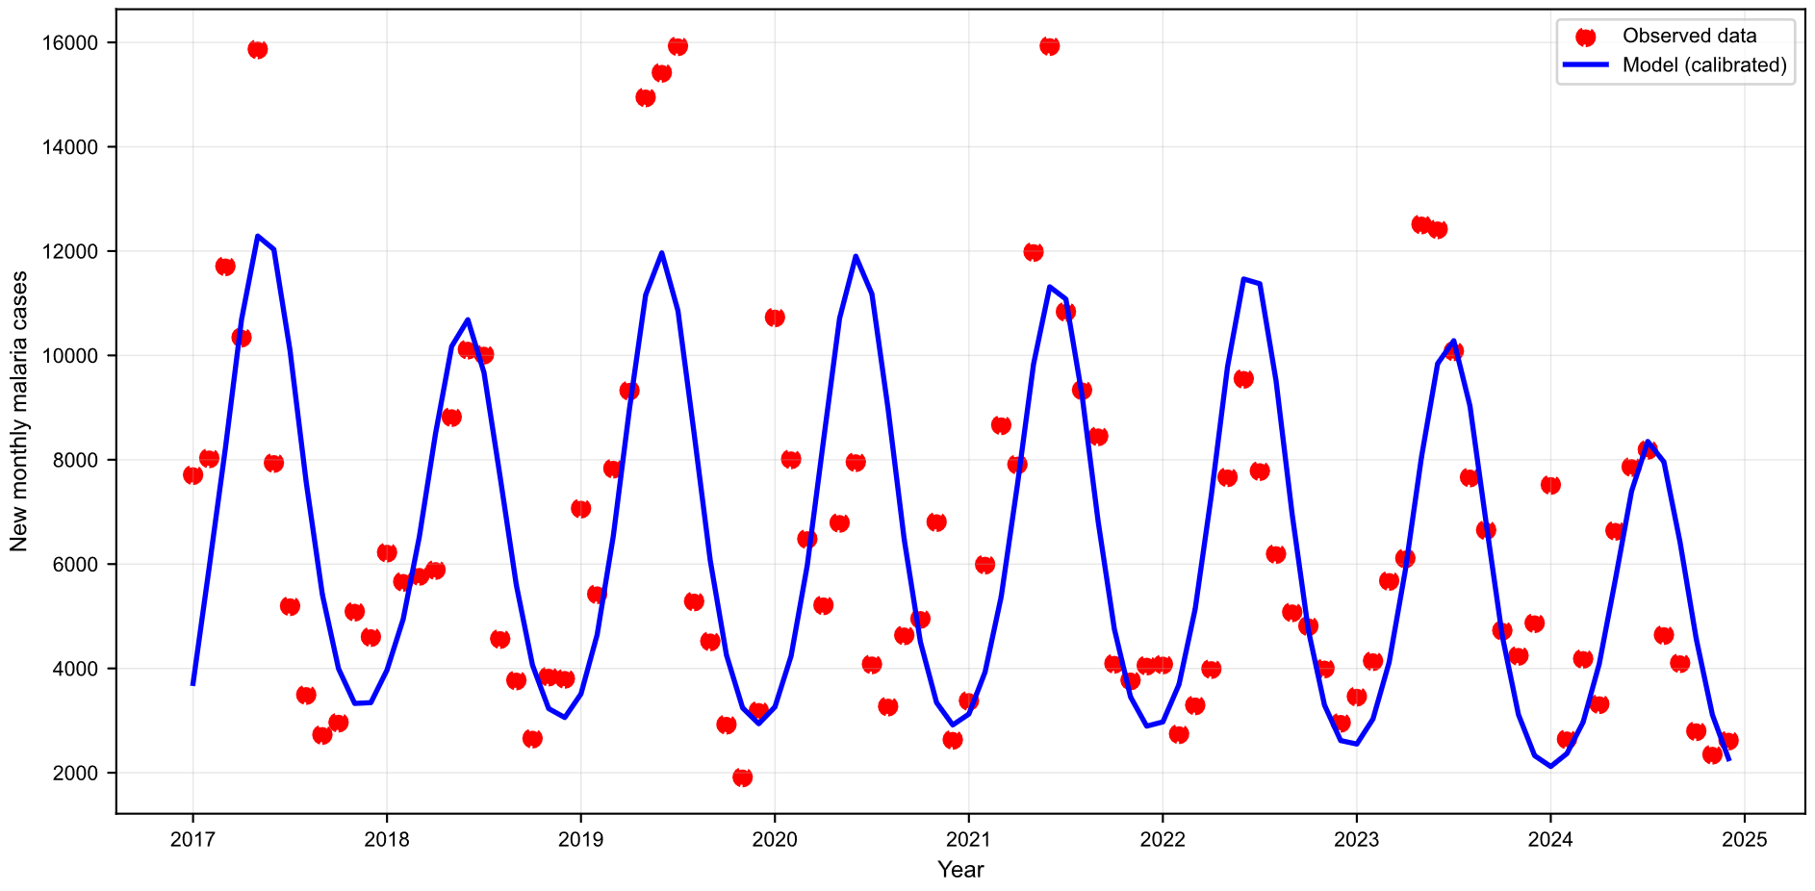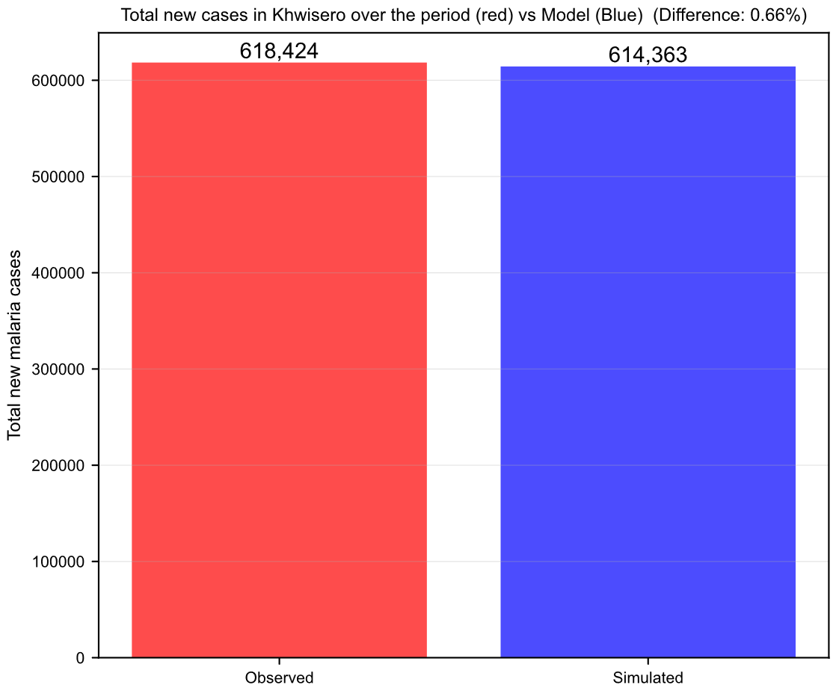
B.
A.
Figure S1. Representative model fit for Khwisero sub-county. (A) Observed monthly malaria incidence and fitted model output from 2017–2024. (B) Observed and simulated cumulative malaria cases over the fitting period. Khwisero is presented as an illustrative example; equivalent fitting procedures were applied to all sub-counties.
References
(1) Chamchod, F.; Beier, J. C. Modeling Plasmodium Vivax: Relapses, Treatment, Seasonality, and G6PD Deficiency. J. Theor. Biol. 2013, 316, 25–34. https://doi.org/10.1016/j.jtbi.2012.08.024.
(2) Silal, S. P.; Little, F.; Barnes, K. I.; White, L. J. Sensitivity to Model Structure: A Comparison of Compartmental Models in Epidemiology. Health Systems 2016, 5 (3), 178–191. https://doi.org/10.1057/hs.2015.2.
(3) Koella, J. C.; Antia, R. Malaria Journal Epidemiological Models for the Spread of Anti-Malarial Resistance; 2003. http://www.malariajournal.com/content/2/1/3.
(4) Makanga, M.; Krudsood, S. The Clinical Efficacy of Artemether/Lumefantrine (Coartem®). Malar. J. 2009, 8 (SUPPL. 1). https://doi.org/10.1186/1475-2875-8-S1-S5.
(5) Lubell, Y.; Staedke, S. G.; Greenwood, B. M.; Kamya, M. R.; Molyneux, M.; Newton, P. N.; Reyburn, H.; Snow, R. W.; D’Alessandro, U.; English, M.; Day, N.; Kremsner, P.; Dondorp, A.; Mbacham, W.; Dorsey, G.; Owusu-Agyei, S.; Maitland, K.; Krishna, S.; Newton, C.; Pasvol, G.; Taylor, T.; von Seidlein, L.; White, N. J.; Binka, F.; Mills, A.; Whitty, C. J. M. Likely Health Outcomes for Untreated Acute Febrile Illness in the Tropics in Decision and Economic Models; a Delphi Survey. PLoS One 2011, 6 (2). https://doi.org/10.1371/journal.pone.0017439.
(6) Silal, S. P.; Little, F.; Barnes, K. I.; White, L. J. Hitting a Moving Target: A Model for Malaria Elimination in the Presence of Population Movement. PLoS One 2015, 10 (12). https://doi.org/10.1371/journal.pone.0144990.
(7) Lindblade, K. A.; Steinhardt, L.; Samuels, A.; Kachur, S. P.; Slutsker, L. The Silent Threat: Asymptomatic Parasitemia and Malaria Transmission. Expert Review of Anti-Infective Therapy. June 2013, pp 623–639. https://doi.org/10.1586/eri.13.45.
(8) White, M. T.; Verity, R.; Griffin, J. T.; Asante, K. P.; Owusu-Agyei, S.; Greenwood, B.; Drakeley, C.; Gesase, S.; Lusingu, J.; Ansong, D.; Adjei, S.; Agbenyega, T.; Ogutu, B.; Otieno, L.; Otieno, W.; Agnandji, S. T.; Lell, B.; Kremsner, P.; Hoffman, I.; Martinson, F.; Kamthunzu, P.; Tinto, H.; Valea, I.; Sorgho, H.; Oneko, M.; Otieno, K.; Hamel, M. J.; Salim, N.; Mtoro, A.; Abdulla, S.; Aide, P.; Sacarlal, J.; Aponte, J. J.; Njuguna, P.; Marsh, K.; Bejon, P.; Riley, E. M.; Ghani, A. C. Immunogenicity of the RTS,S/AS01 Malaria Vaccine and Implications for Duration of Vaccine Efficacy: Secondary Analysis of Data from a Phase 3 Randomised Controlled Trial. Lancet Infect. Dis. 2015, 15 (12), 1450–1458. https://doi.org/10.1016/S1473-3099(15)00239-X.
(9) Kenya National Bureau of Statistics. 2019 KENYA POPULATION AND HOUSING CENSUS. 2019.
(10) RTS, S. C. T. P. Efficacy and Safety of RTS,S/AS01 Malaria Vaccine with or without a Booster Dose in Infants and Children in Africa: Final Results of a Phase 3, Individually Randomised, Controlled Trial. The Lancet 2015, 386 (9988), 31–45. https://doi.org/10.1016/S0140-6736(15)60721-8.
(11) World Health Organisation. World Malaria Report 2025; World Health Organization, 2025.
(12) Chiziba, C.; Chiwaula, J.; Hamainza, B.; Silal, S. Advancing Malaria Reactive Case Detection in a Zambia-like Setting: A Modeling Study. PLOS Global Public Health 2025, 5 (2). https://doi.org/10.1371/journal.pgph.0004288.

