Supplementary Material - Additional Figures
Supporting figures for: Mapping the Sustainability Transition in Liquid and Water-Soluble Fertilizer Research: A Scopus-Based Bibliometric Analysis (2021-2026)

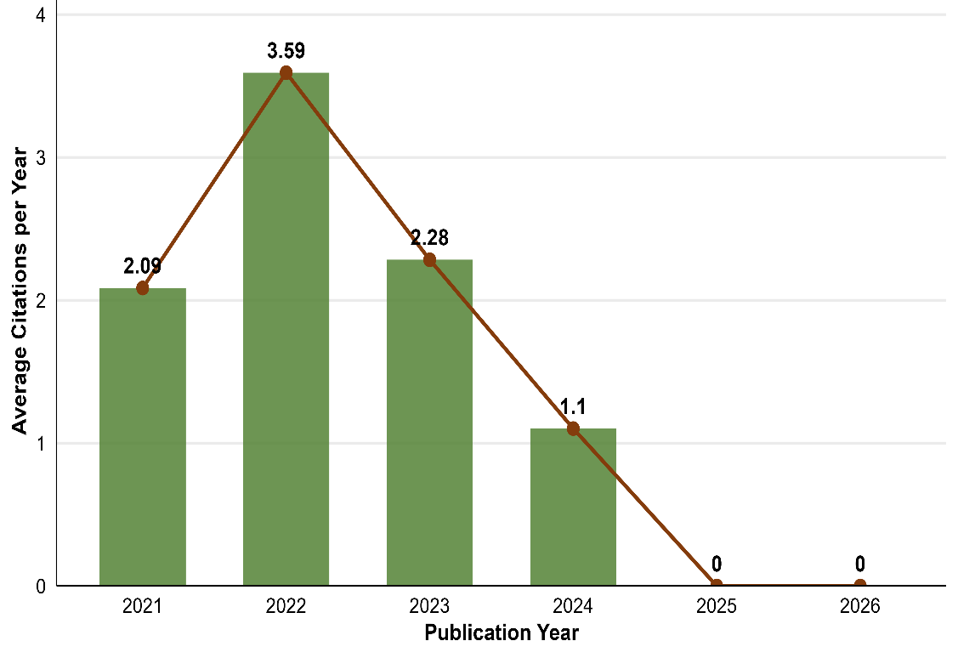
Fig. S1 Average citations per year, normalized by document age, for each annual publication cohort (2021–2026).

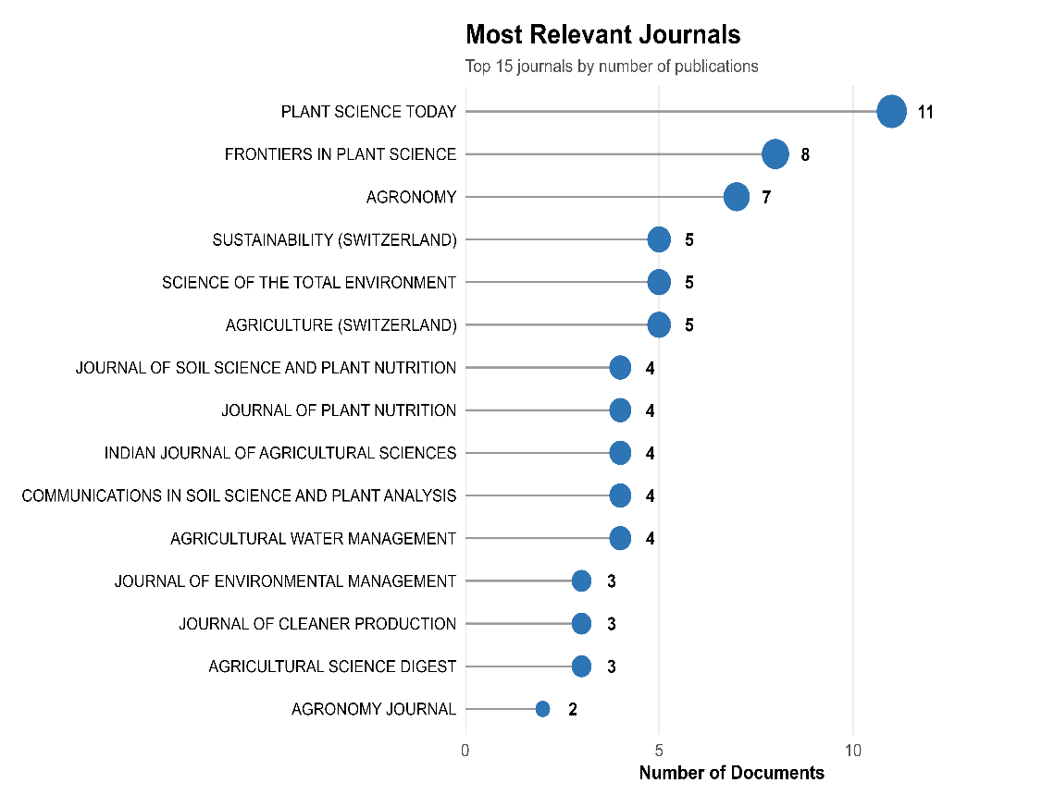
Fig. S2 Most relevant journals by number of published documents.

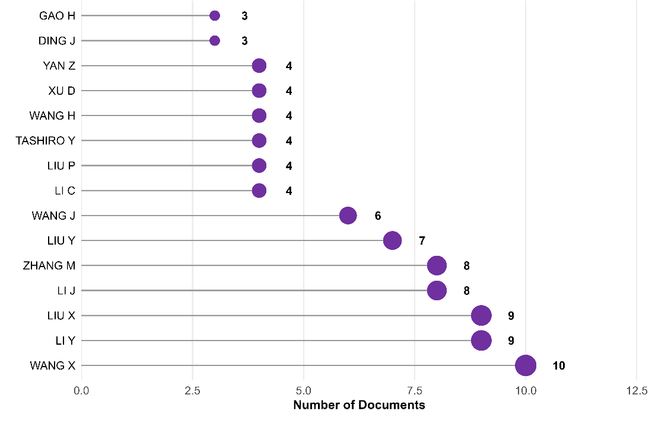
Fig. S3 Most productive authors by number of documents.

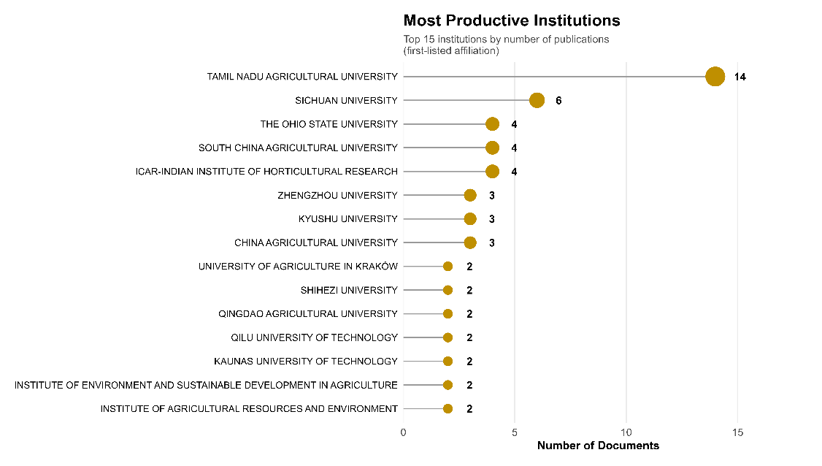
Fig. S4 Most productive institutions by number of documents (first-listed affiliation).

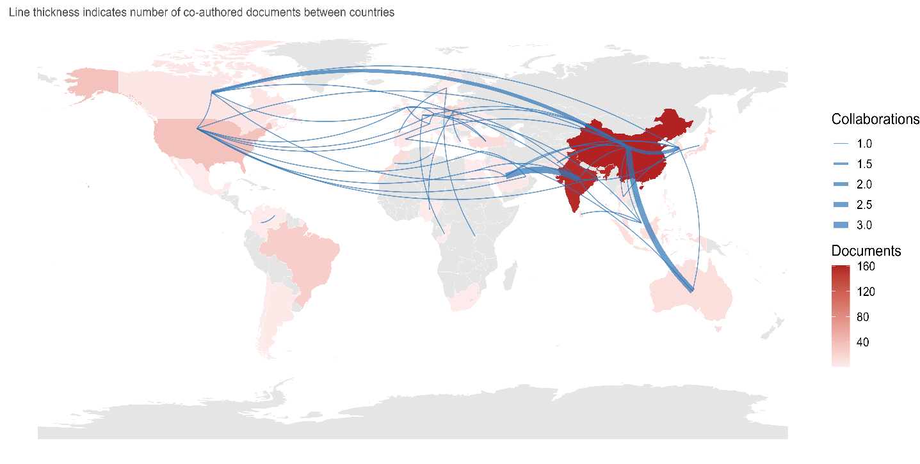
Fig. S5 Country collaboration network overlaid on a world map; line thickness indicates the number of co-authored documents between country pairs.

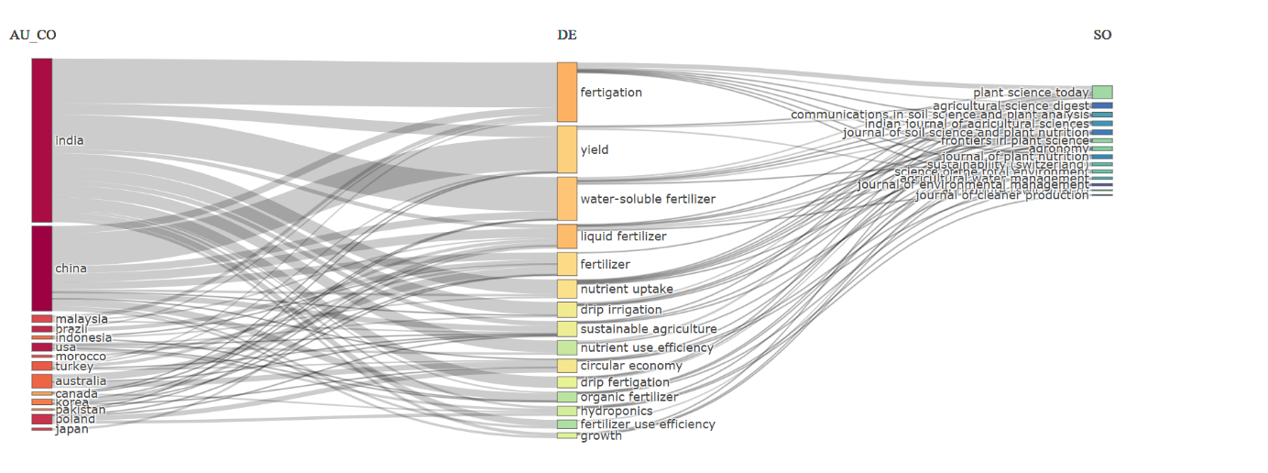
Fig. S6 Three-field plot linking author countries (left), author keywords (middle), and source journals (right).

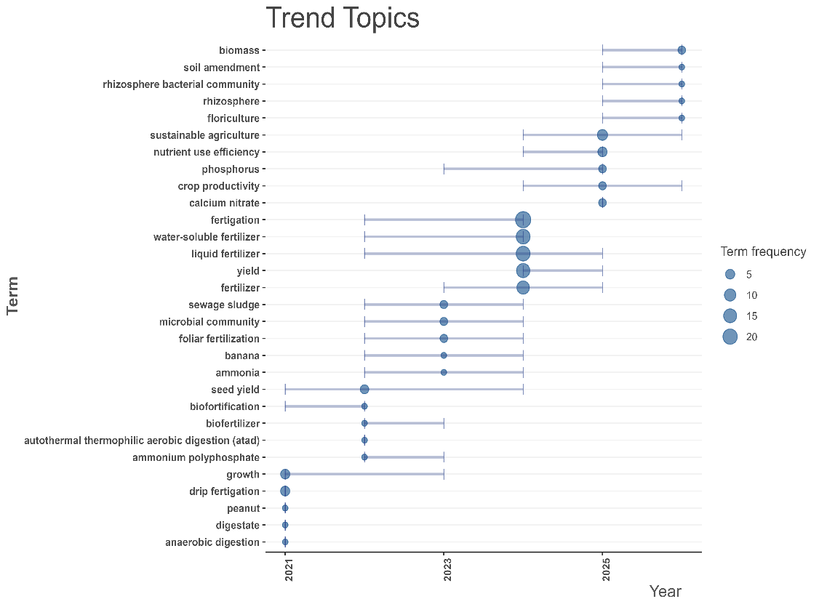
Fig. S7 Trend topics showing the temporal distribution of author-keyword usage (2021–2026); bubble size indicates term frequency.

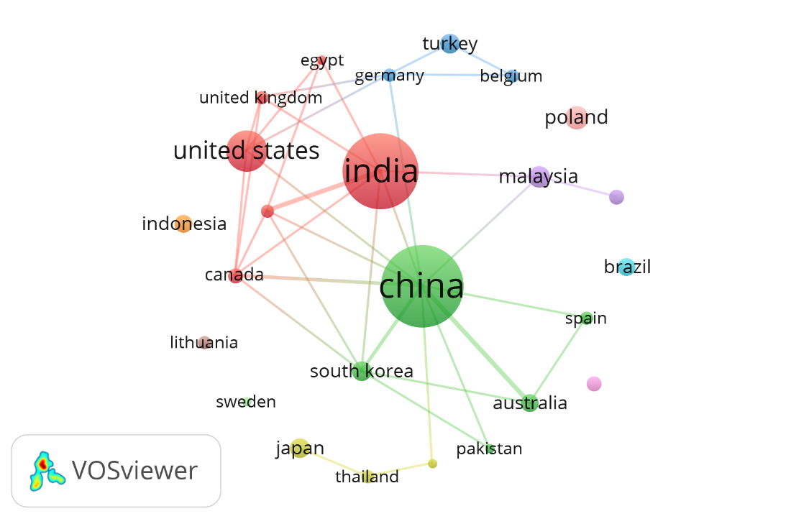
Fig. S8 Country collaboration network (VOSviewer; co-authorship, minimum 2 documents/country).

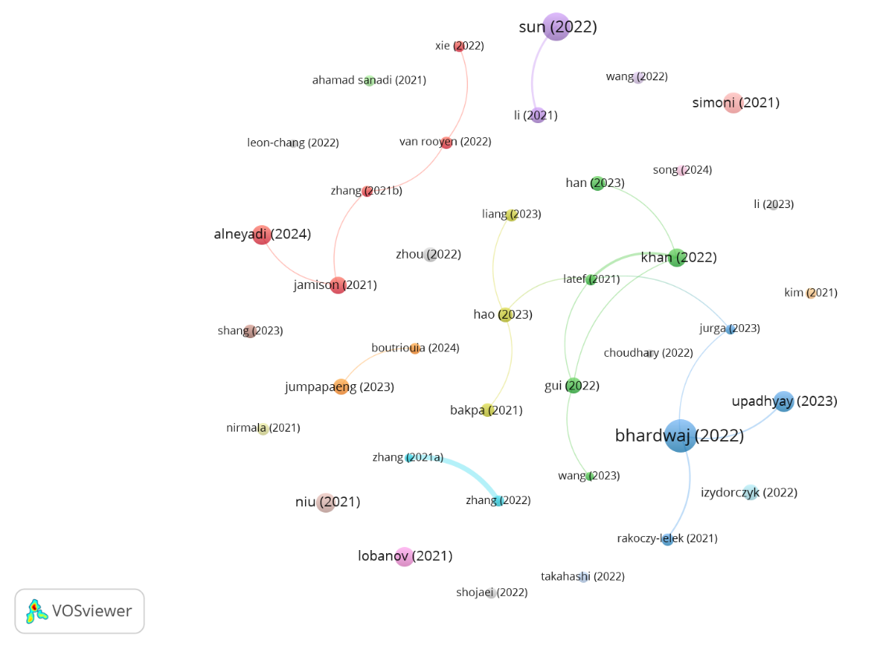
Fig. S9 Bibliographic coupling network at the document level (VOSviewer; minimum 10 citations/document; 39 items, 23 clusters, 19 links).

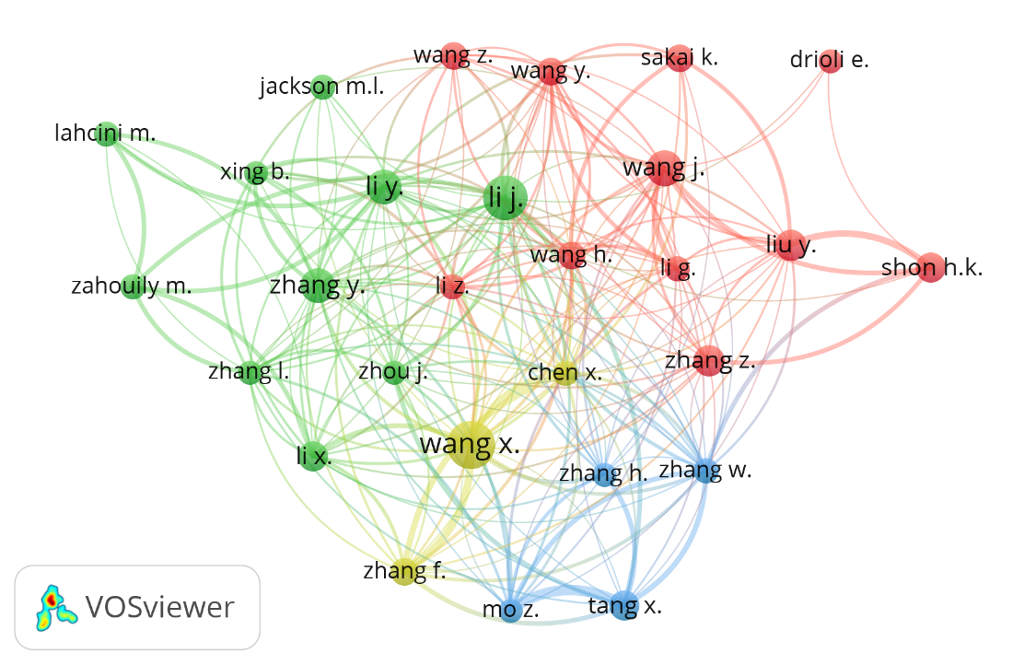
Fig. S10 Co-citation network of cited authors (VOSviewer; minimum 10 citations/author; 28 items, 4 clusters, 214 links).

