Supplementary information
Molecular confirmation of host root identity
Table 1. Molecular confirmation of the host plant identity
Forest reserve | Voucher number | Taxon | % Identity Genbank | Accession number
WM | TSC 24-112 | Isoberlinia doka | 100% | MN885536
KB | TSC 25-176 | Isoberlinia doka | 100% | MN885536
KT | TSC 24-133 | Isoberlinia doka | 100% | MN885536
BS | TSC 24-71 | Isoberlinia doka | 99.8% | KX119305
OK | TSC 24-20 | Isoberlinia doka | 100% | MN885536
OS | M25-0294 | Isoberlinia doka | 100% | MN885536
TR | TSC 24-178 | Isoberlinia doka | 100% | KX119305
PD | TSC 24-208 | Isoberlinia doka | 100% | MN885536
GN | TSC 24-223 | Isoberlinia doka | 100% | MN885536
LL | TSC 24-230 | Isoberlinia doka | 100% | MN885536
ST | TSC 24-188 | Isoberlinia doka | 100% | MN885536
PS | TSC 24-90 | Isoberlinia doka | 100% | MN885536
This table shows the BLAST results used to confirm the identity of Isoberlinia doka root collected. 12 samples are shown, including one from a forest reserve.
PD: Pendjari, GN: Goungoun, KT: Kota, LL: Lolo, ST: Sota, TR: Trois rivière, PS: Penessoulou, BS: Bassila, WM: Wari-Maro, OK: Okpara, KB: Kilibo, OS: Ouémé supérieur
Mycorrhizal system length:
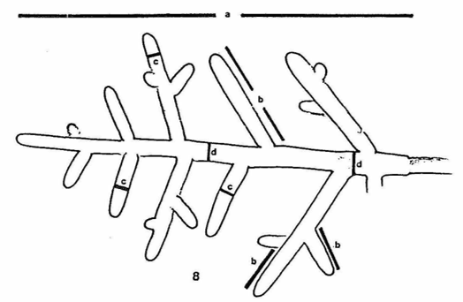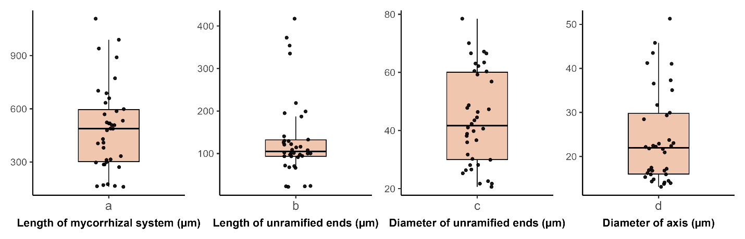
Fig 4: Length of mycorrhizal system a: Length; b: Length of unramified; c: Diameter of unramified ends; d: Diameter of axis

