Supplementary materials

Environmental drivers and anthropogenic impacts influencing the presence probability and health status of Isidella elongata in the Ionian Sea.
Filippo Pandolfi^{1*}, Lucia Concilio², Lucia Ventura^{1,3}, Davide Di Bari^{1,3}, Stefano Moro⁴, Benedetta Zoe Donelli^{4,5}, Francesco Stenico^{1,3}, Ludovica De Vincenzis^{6,7}, Pietro Battaglia^{9,10}, Eva Salvati^{4,9}, Teresa Romeo^{7,8,9}, Silvestro Greco¹¹, Simonepietro Canese^{1,9}
1. Department of Research Infrastructures for Marine Biological Resources, Stazione Zoologica Anton Dohrn, Rome, Italy
2. Department of Biology, University of Naples Federico II, Naples, Italy
3. Department of Research Infrastructures for Marine Biological Resources, Calabria Marine Centre (CRIMAC), Amendolara, CS, Italy
4. Department of Integrative Marine Ecology, Stazione Zoologica Anton Dohrn, Rome, Italy
5. Department of Life and Environmental Science, Polytechnic University of Marche, Ancona, Italy
6. Department of Life and Environmental Sciences, University of Cagliari, Cagliari, Italy
7. Department of Biology and Evolution of Marine Organisms, Stazione Zoologica Anton Dohrn, Sicily Marine Centre, Messina, Italy
8. National Institute for Environmental Protection and Research, Milazzo, Italy.
9. National Biodiversity Future Center, Palermo, Italy
10. Department of Integrative Marine Ecology, Stazione Zoologica Anton Dohrn, Sicily Marine Centre, Messina, Italy
11. University of Gastronomic Sciences, Pollenzo, Italy
* filippo.pandolfi@szn.it
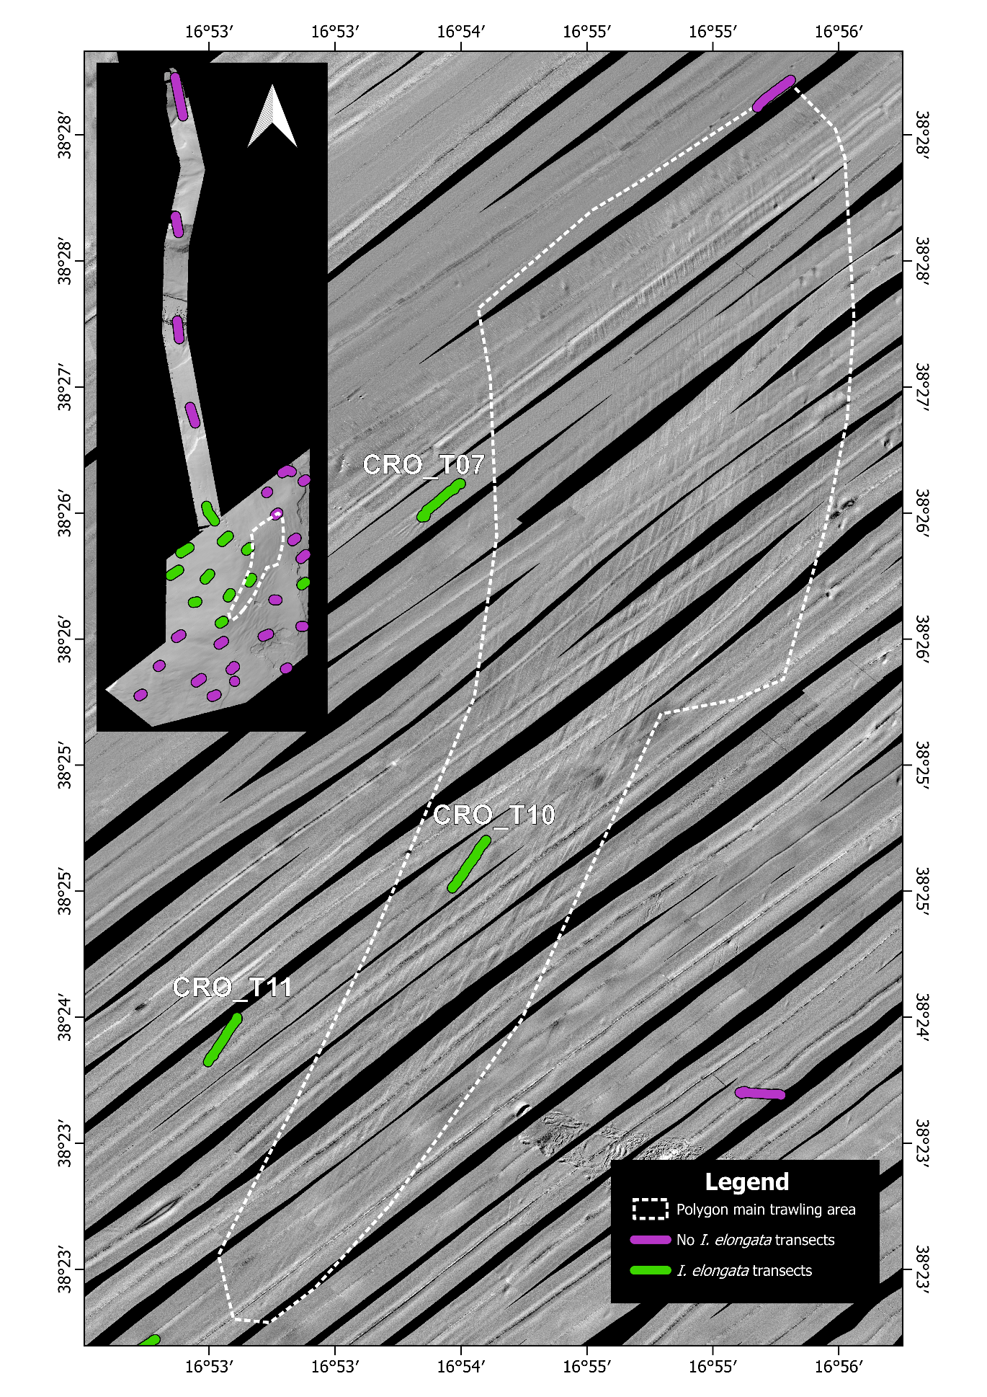
Figure S1 Side-scan sonar (SSS) imagery and ROV survey transects in the Ionian Sea. Main panel shows the acoustic mosaic detailing seafloor micro-topography. Linear furrows across the mosaic correspond to seabed trawling scars; the white dashed polygon delineates an extensive zone characterized by high trawling scar density. Colored paths indicate ROV video transects classified by bamboo coral occurrence (green: Isidella elongata present; violet: I. elongata absent). Specifically, transect CRO_T10 intersected the intensive trawling zone identified by side-scan sonar, whereas transects CRO_T07 and CRO_T11 were situated beyond the main scar footprints. Inset map illustrates the regional arrangement of transects across the broader survey area with the withe dashed polygon.

