Additional file 1
Supplementary Tables S1–S4 and Figures S1–S2

Table S1. Scores for the main scales and domains (n = 1158)
Scale/domain | n | Mean (SD) | Median (IQR) | Range | Internal consistency coefficient
Total successful aging score | 1158 | 46.83 (13.07) | 47.00 (38.00–56.00) | 4–80 | 0.899
Intrapsychic factors and existential meaning | 1158 | 20.57 (6.42) | 21.00 (16.00–25.00) | 1–32 | —
Functional coping mechanisms | 1158 | 13.20 (4.18) | 14.00 (10.00–16.00) | 0–20 | —
Gerotranscendence | 1158 | 7.50 (3.37) | 7.00 (5.00–10.00) | 0–16 | —
Sense of legacy | 1158 | 2.90 (1.14) | 3.00 (2.00–4.00) | 0–4 | —
Spirituality | 1158 | 2.66 (2.36) | 2.00 (0.00–4.00) | 0–8 | —
WHO-5 psychological well-being | 1158 | 13.68 (5.26) | 13.00 (10.00–17.00) | 0–25 | 0.917
Total digital literacy score | 1158 | 42.93 (17.37) | 44.00 (28.00–54.00) | 18–90 | 0.969
Digital information literacy | 1158 | 7.32 (3.16) | 7.00 (5.00–9.00) | 3–15 | —
Digital social literacy | 1158 | 10.24 (4.38) | 10.00 (7.00–13.00) | 4–20 | —
Digital innovation literacy | 1158 | 6.48 (3.14) | 6.00 (3.00–9.00) | 3–15 | —
Digital safety literacy | 1158 | 9.84 (4.36) | 10.00 (6.00–12.00) | 4–20 | —
Digital problem-solving literacy | 1158 | 9.05 (4.11) | 9.00 (5.00–12.00) | 4–20 | —
Total social participation score | 1158 | 57.36 (15.67) | 57.00 (46.00–67.00) | 22–110 | 0.922
Household activities | 1158 | 16.80 (4.08) | 17.00 (14.00–20.00) | 5–25 | —
Leisure activities | 1158 | 7.11 (2.90) | 7.00 (5.00–9.00) | 3–15 | —
Visits with relatives and friends | 1158 | 7.84 (2.65) | 8.00 (6.00–9.00) | 3–15 | —
Group recreational activities | 1158 | 4.74 (2.18) | 5.00 (3.00–6.00) | 2–10 | —
Volunteering and public-interest activities | 1158 | 8.97 (3.71) | 9.00 (6.00–12.00) | 4–20 | —
Online participation | 1158 | 11.89 (5.04) | 12.00 (7.00–15.00) | 5–25 | —
Total frailty score | 1158 | 0.81 (1.17) | 0.00 (0.00–1.00) | 0–5 | 0.639
Note: Cronbach’s α is reported for the Successful Aging Inventory, Digital Literacy Scale, Social Participation Scale, and WHO-5; the Kuder–Richardson 20 coefficient is reported for the dichotomous FRAIL scale. Internal consistency coefficients are reported only for the total scales.

Table S2. Raw WHO-5 psychological well-being categories and frailty classification (n = 1158)
Indicator | Category | n(%)
Raw WHO-5 psychological well-being category | Raw total score ≥13 | 657 (56.74%)
Raw WHO-5 psychological well-being category | Raw total score <13 (indicates need for further assessment; not diagnostic) | 501 (43.26%)
Frailty classification | Robust | 652 (56.30%)
Frailty classification | Prefrail | 387 (33.42%)
Frailty classification | Frail | 119 (10.28%)
Note: A raw WHO-5 total score <13 indicates a need for further assessment only and is not a clinical diagnosis.

Table S3. Comparisons of the main variables by sex and age group (n = 1158)
Variable | Sex test | Sex statistic | Sex P value | Age-group statistic | Age P value
Total successful aging score | Wilcoxon rank-sum test | 163945.5 | 0.740 | 67.237 | <0.001
WHO-5 psychological well-being | Wilcoxon rank-sum test | 164521.0 | 0.818 | 40.286 | <0.001
Total digital literacy score | Wilcoxon rank-sum test | 172263.0 | 0.255 | 125.981 | <0.001
Total social participation score | Wilcoxon rank-sum test | 166249.5 | 0.940 | 51.111 | <0.001
Total frailty score | Wilcoxon rank-sum test | 159308.5 | 0.201 | 28.447 | <0.001
Note: Sex comparisons used Wilcoxon rank-sum tests between men and women. Age-group comparisons used Kruskal–Wallis tests among participants aged 60–69 years, 70–79 years, and 80 years or older.

Table S4. Conditional serial indirect associations and between-group differences across frailty levels (n = 1158)
Association | B | SE | Bootstrap 95% CI | P value
Conditional serial indirect association: robust group (n = 652) | 0.096 | 0.013 | [0.071, 0.123] | <0.001
Conditional serial indirect association: prefrail group (n = 387) | 0.084 | 0.011 | [0.064, 0.106] | <0.001
Conditional serial indirect association: frail group (n = 119) | 0.071 | 0.016 | [0.042, 0.104] | <0.001
Difference in serial indirect association: prefrail vs robust | −0.013 | 0.010 | [−0.033, 0.007] | 0.209
Difference in serial indirect association: frail vs robust | −0.025 | 0.020 | [−0.066, 0.013] | 0.209
Note: B, unstandardized association estimate; CI, confidence interval; SE, standard error. Confidence intervals were obtained using 5000 bias-corrected bootstrap samples. The robust group was the reference for between-group comparisons. The between-group differences were not statistically significant.
Fig. S1. Heatmap of Spearman correlations among the main study variables (n = 1158)
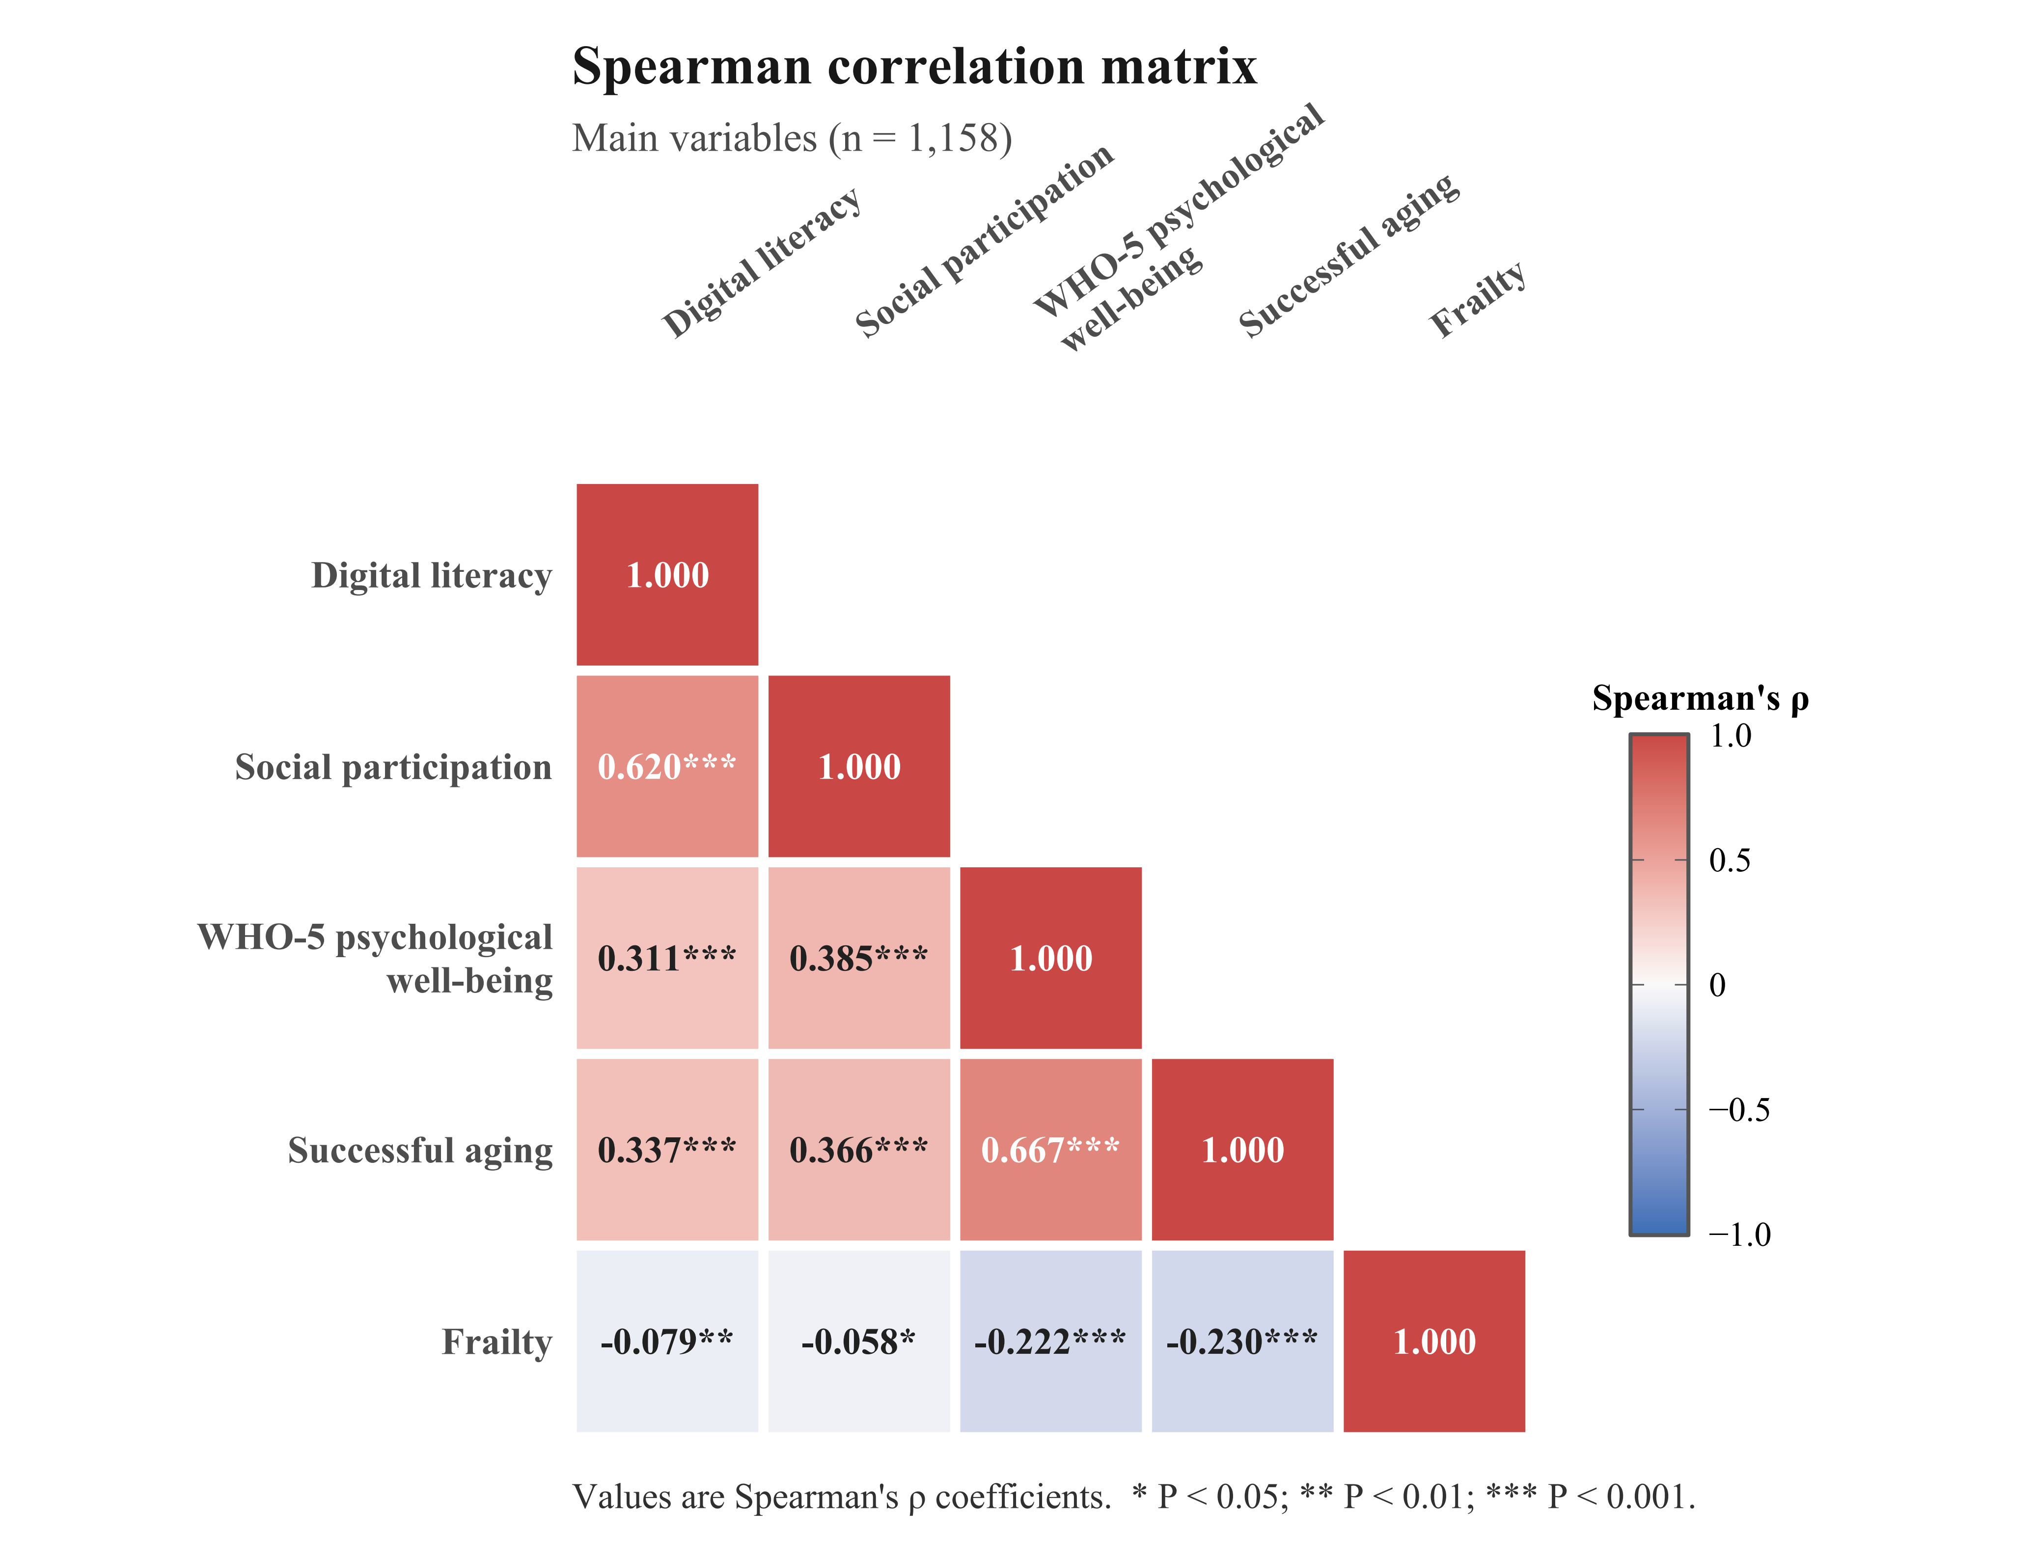
Note: Values are Spearman's ρ coefficients. * P < 0.05, ** P < 0.01, *** P < 0.001.

Fig. S2. Exploratory frailty moderation analysis
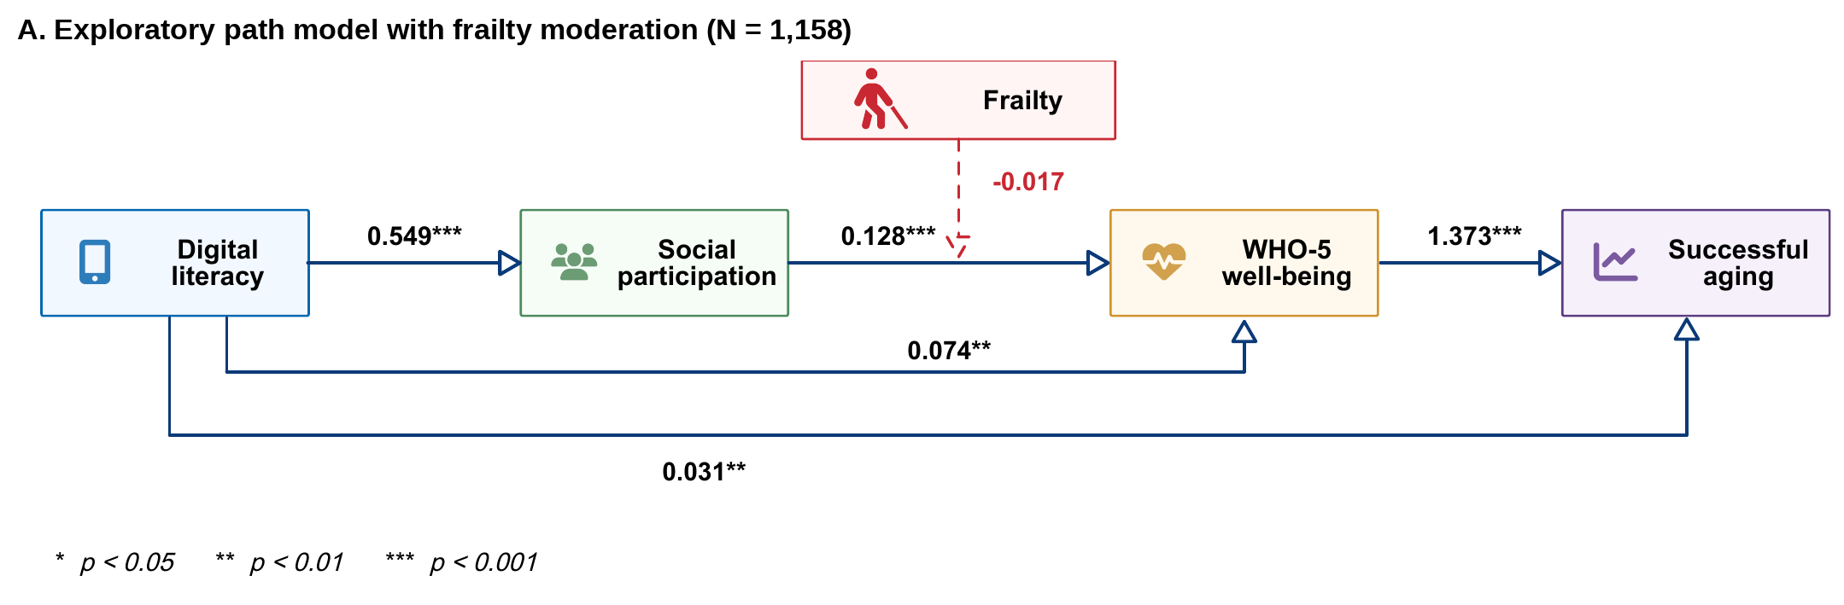
Panel A. Exploratory path model with frailty moderation. Coefficients shown in the panel are unstandardized estimates.

Fig. S2. Exploratory frailty moderation analysis (continued)
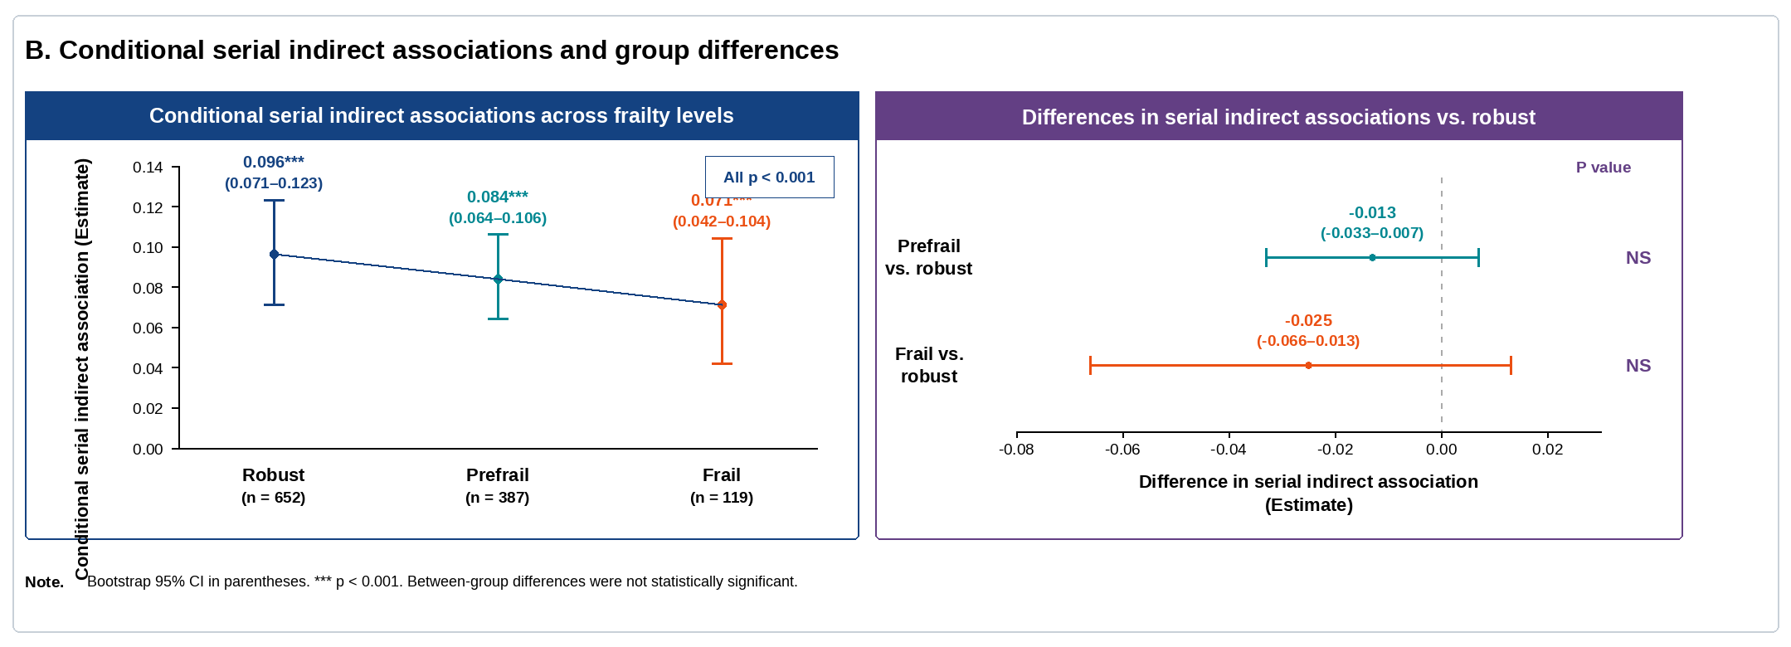
Panel B. Conditional serial indirect association estimates across frailty groups and differences relative to the robust group.
Note: The interaction between social participation and frailty and the between-group differences were not statistically significant. Overall fit of the exploratory moderation model was poor; therefore, the figure is provided for descriptive transparency only and should not be interpreted as evidence of moderation or a dose-response trend. Bootstrap 95% confidence intervals are shown. WHO-5, World Health Organization-Five Well-Being Index; NS, not significant.

