Supplementary Materials for
All-hydrocarbon Stapling Modification and Optimization of Scorpion Toxin-Derived Peptide TtAP-2 Against Multidrug-Resistant Bacterial Infections

Wei Wang^{1,} †, Danyu Chen^{1, †}, Shushan Liu¹, Shanping Ji¹, Xumei Zhao¹, Jinghan Zhang¹, Xianwen Zhang¹, Chunhui Dou ^{2,} *, Yulei Li ¹

¹ School of Pharmaceutical Sciences & Institute of Materia Medica, Shandong First Medical University & Shandong Academy of Medical Sciences, Jinan 250117, Shandong, P. R. China.
² Central Hospital Affiliated to Shandong First Medical University, Jinan 250013, Shandong, China.
*Corresponding authors. 15662690191@163.com (Chunhui Dou);
†W.W., and DYC. contributed equally to this work.
Supplementary Information
Table S1. Electrospray MS data for peptides (positive mode) 4
Figure S1. (A) Amino acid sequence of TtAP-2-0 ; (B) Analytical HPLC of TtAP-2-0. Column: Welch C18. Gradient: 10%-90% CH₃CN (0.1% TFA) in H₂O (0.1% TFA) over 15 min (λ=214 nm). The yield of TtAP-2-0 is 14.50 %; (C) ESI-MS of peptide TtAP-2-0. 4
Figure S2. (A）Amino acid sequence of TtAP-2-1 (B) Analytical HPLC of TtAP-2-1. Column: Welch C18. Gradient: 10%-90% CH3CN (0.1% TFA) in H2O (0.1% TFA) over 15 min (λ=214 nm). The yield of TtAP-2-1 is 1.91 %. (C) ESI-MS of peptide TtAP-2-1. 5
Figure S3. (A) Amino acid sequence of TtAP-2-2. (B) Analytical HPLC of TtAP-2-2. Column: Welch C18. Gradient:10%-90% CH₃CN (0.1% TFA) in H₂O (0.1% TFA) over 15 min (λ=214 nm). The yield of TtAP-2-2 is 7.38 %. (C) ESI-MS of peptide TtAP-2-2. 5
Figure S4. (A) Amino acid sequence of TtAP-2-3. (B) Analytical HPLC of TtAP-2-3. Column: Welch C18. Gradient:10%-90% CH₃CN (0.1% TFA) in H₂O (0.1% TFA) over 15 min (λ=214 nm). The yield of TtAP-2-3 is 4.59 %. (C) ESI-MS of peptide TtAP-2-3. 6
Figure S5. (A) Amino acid sequence of TtAP-2-4. (B) Analytical HPLC of TtAP-2-4. Column: Welch C18. Gradient:10%-90% CH₃CN (0.1% TFA) in H₂O (0.1% TFA) over 15 min (λ=214 nm). The yield of TtAP-2-4 is 6.45%. (C) ESI-MS of peptide TtAP-2-4. 6
Figure S6. (A) Amino acid sequence of TtAP-2-5. (B) Analytical HPLC of TtAP-2-5. Column: Welch C18. Gradient:10%-90% CH₃CN (0.1% TFA) in H₂O (0.1% TFA) over 15 min (λ=214 nm). The yield of TtAP-2-5 is 5.53%. (C) ESI-MS of peptide TtAP-2-5. 7
Figure S7. (A) Amino acid sequence of TtAP-2-6. (B) Analytical HPLC of TtAP-2-6. Column: Welch C18. Gradient:10%-90% CH₃CN (0.1% TFA) in H₂O (0.1% TFA) over 15 min (λ=214 nm). The yield of TtAP-2-6 is 2.85%. (C) ESI-MS of peptide TtAP-2-6. 7
Figure S8. (A) Amino acid sequence of TtAP-2-7. (B) Analytical HPLC of TtAP-2-7. Column: Welch C18. Gradient:10%-90% CH₃CN (0.1% TFA) in H₂O (0.1% TFA) over 15 min (λ=214 nm). The yield of TtAP-2-7 is 1.16%. (C) ESI-MS of peptide TtAP-2-7. 8
Figure S9. (A) Amino acid sequence of TtAP-2-8. (B) Analytical HPLC of TtAP-2-8. Column: Welch C18. Gradient:10%-90% CH₃CN (0.1% TFA) in H₂O (0.1% TFA) over 15 min (λ=214 nm). The yield of TtAP-2-8 is 1.18%. (C) ESI-MS of peptide TtAP-2-8. 8
Figure S10. (A) Amino acid sequence of TtAP-2-9. (B) Analytical HPLC of TtAP-2-9. Column: Welch C18. Gradient:10%-90% CH₃CN (0.1% TFA) in H₂O (0.1% TFA) over 15 min (λ=214 nm). The yield of TtAP-2-9 is 2.00%. (C) ESI-MS of peptide TtAP-2-9. 9
Figure S11. (A) Amino acid sequence of TtAP-2-10. (B) Analytical HPLC of TtAP-2-10. Column: Welch C18. Gradient:10%-90% CH₃CN (0.1% TFA) in H₂O (0.1% TFA) over 15 min (λ=214 nm). The yield of TtAP-2-10 is 0.61%. (C) ESI-MS of peptide TtAP-2-10. 9
Figure S12. (A) Amino acid sequence of TtAP-2-11. (B) Analytical HPLC of Ttap-2-11. Column: Welch C18. Gradient:10%-90% CH₃CN (0.1% TFA) in H₂O (0.1% TFA) over 15 min (λ=214 nm). The yield of TtAP-2-11 is 1.43%. (C) ESI-MS of peptide TtAP-2-11. 10
Figure S13. (A) Amino acid sequence of TtAP-2-12. (B) Analytical HPLC of TtAP-2-12. Column: Welch C18. Gradient:10%-90% CH₃CN (0.1% TFA) in H₂O (0.1% TFA) over 15 min (λ=214 nm). The yield of TtAP-2-12 is 4.29%. (C) ESI-MS of peptide TtAP-2-12. 10
Figure S15. (A) Amino acid sequence of TtAP-2-14. (B) Analytical HPLC of TtAP-2-14. Column: Welch C18. Gradient:10%-90% CH₃CN (0.1% TFA) in H₂O (0.1% TFA) over 15 min (λ=214 nm). The yield of TtAP-2-14 is 2.30%. (C) ESI-MS of peptide TtAP-2-14. 11
Figure S16. (A) Amino acid sequence of TtAP-2-15. (B) Analytical HPLC of TtAP-2-15. Column: Welch C18. Gradient:10%-90% CH₃CN (0.1% TFA) in H₂O (0.1% TFA) over 15 min (λ=214 nm). The yield of TtAP-2-15 is 11.01 %. (C) ESI-MS of peptide TtAP-2-15. 12

Table S1. Electrospray MS data for peptides (positive mode)
Peptide | Cal (g/mol) | Found Mass
TtAP-2-0 | 1774.0215 | [M+2H]²⁺=888.3050 | [M+3H]³⁺=592.5581
TtAP-2-1 | 1798.0215 | [M+2H]²⁺=900.3107 | [M+3H]³⁺=600.5574
TtAP-2-2 | 1780.0685 | [M+2H]²⁺=891.3863 | [M+3H]³⁺=594.6055
TtAP-2-3 | 1911.1501 | [M+2H]²⁺=956.8459 | [M+3H]³⁺=637.9198
TtAP-2-4 | 1799.2540 | [M+2H]²⁺=900.8652 | [M+3H]³⁺=600.5904
TtAP-2-5 | 1871.1188 | [M+2H]²⁺=936.3832 | [M+3H]³⁺=624.6039
TtAP-2-6 | 1911.4700 | [M+2H]²⁺=956.9114 | [M+3H]³⁺=637.9547
TtAP-2-7 | 1799.0249 | [M+2H]²⁺=900.3923 | [M+3H]³⁺=600.6109
TtAP-2-8 | 1881.1395 | [M+2H]²⁺=941.4350 | [M+3H]³⁺=627.9755
TtAP-2-9 | 1897.0981 | [M+2H]²⁺=949.4550 | [M+3H]³⁺=633.3187
TtAP-2-10 | 1807.0875 | [M+2H]²⁺=904.8594 | [M+3H]³⁺=603.2517
TtAP-2-11 | 1953.1970 | [M+2H]²⁺=977.3903 | [M+3H]³⁺=651.9423
TtAP-2-12 | 1879.1780 | [M+2H]²⁺=940.3835 | [M+3H]³⁺=627.2677
TtAP-2-13 | 1856.0998 | [M+2H]²⁺=929.3530 | [M+3H]³⁺=619.9163
TtAP-2-14 | 1923.1865 | [M+2H]²⁺=962.8538 | [M+3H]³⁺=641.9182
TtAP-2-15 | 1807.0875 | [M+2H]²⁺=904.8568 | [M+3H]³⁺=603.2505

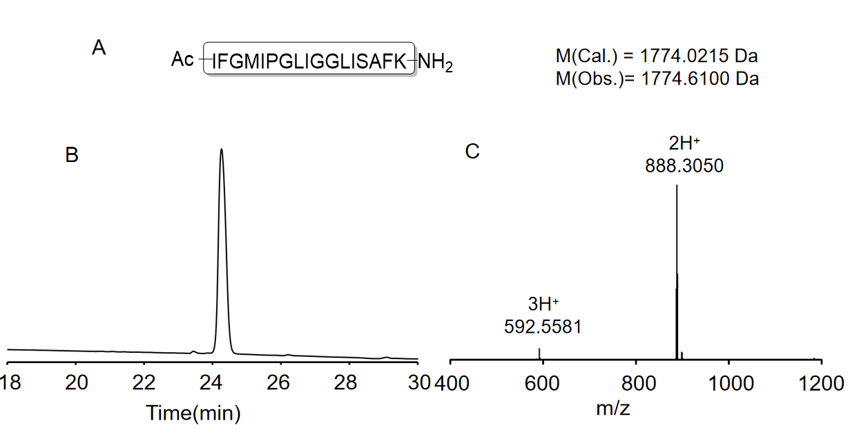

Figure S1. (A) Amino acid sequence of TtAP-2-0; (B) Analytical HPLC of TtAP-2-0. Column: Welch C18. Gradient: 10%-90% CH₃CN (0.1% TFA) in H₂O (0.1% TFA) over 15 min (λ=214 nm). The yield of TtAP-2-0 is 14.50 %; (C) ESI-MS of peptide TtAP-2-0.

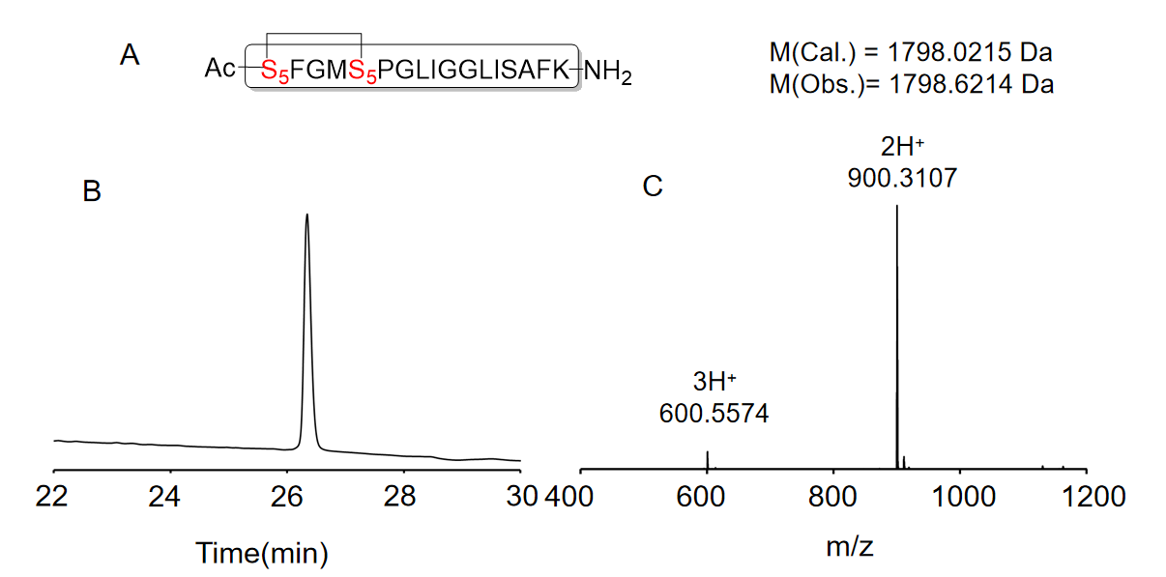

Figure S2. (A) Amino acid sequence of TtAP-2-1 (B) Analytical HPLC of TtAP-2-1. Column: Welch C18. Gradient: 10%-90% CH3CN (0.1% TFA) in H2O (0.1% TFA) over 15 min (λ=214 nm). The yield of TtAP-2-1 is 1.91 %. (C) ESI-MS of peptide TtAP-2-1.

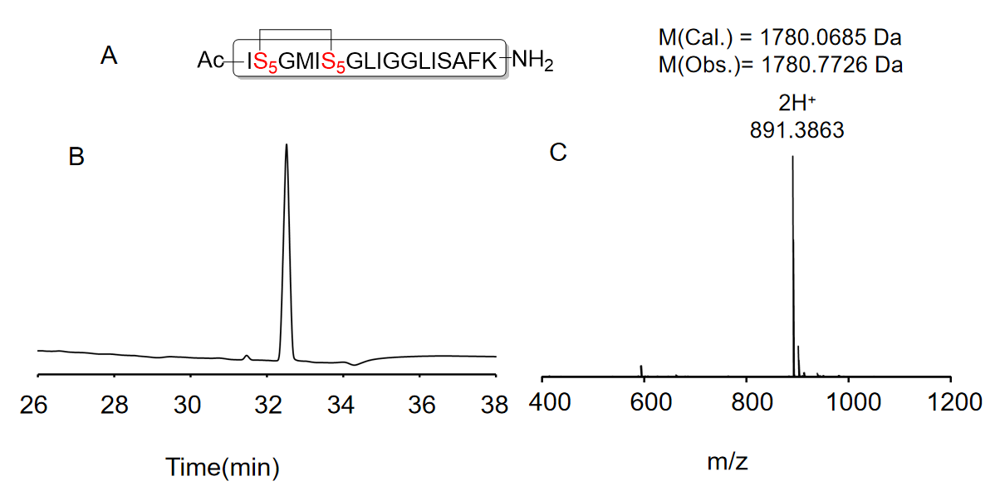

Figure S3. (A) Amino acid sequence of TtAP-2-2. (B) Analytical HPLC of TtAP-2-2. Column: Welch C18. Gradient:10%-90% CH₃CN (0.1% TFA) in H₂O (0.1% TFA) over 15 min (λ=214 nm). The yield of TtAP-2-2 is 7.38 %. (C) ESI-MS of peptide TtAP-2-2.

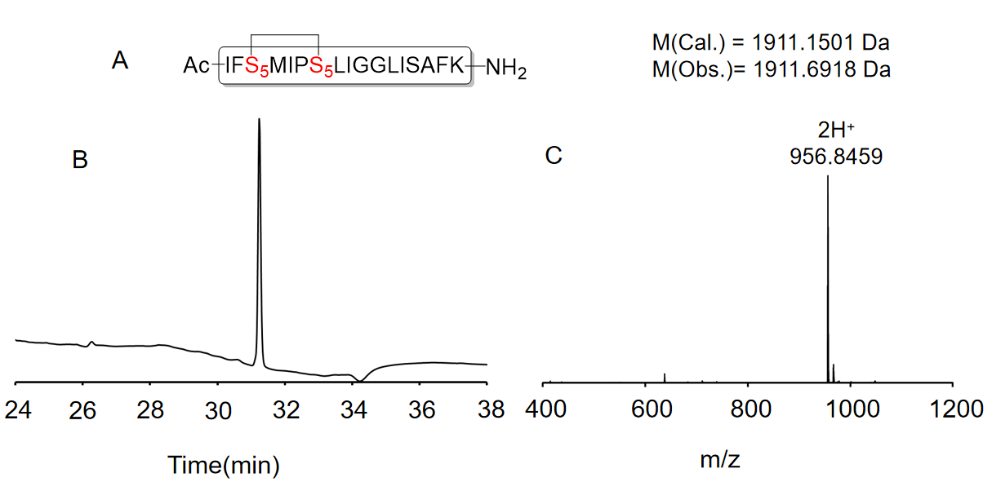

Figure S4. (A) Amino acid sequence of TtAP-2-3. (B) Analytical HPLC of TtAP-2-3. Column: Welch C18. Gradient:10%-90% CH₃CN (0.1% TFA) in H₂O (0.1% TFA) over 15 min (λ=214 nm). The yield of TtAP-2-3 is 4.59 %. (C) ESI-MS of peptide TtAP-2-3.

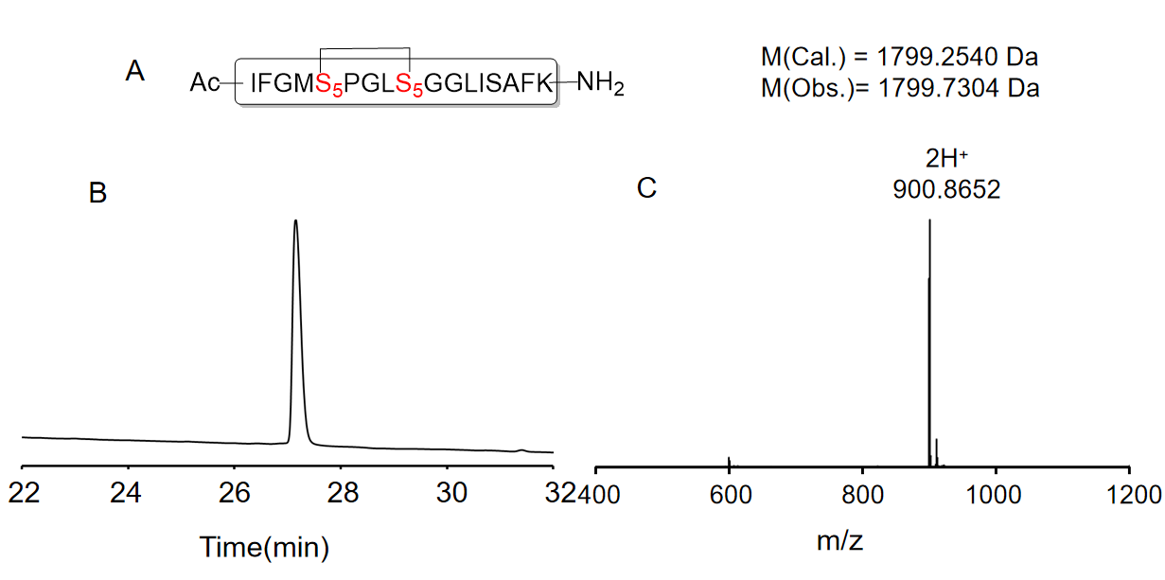

Figure S5. (A) Amino acid sequence of TtAP-2-4. (B) Analytical HPLC of TtAP-2-4. Column: Welch C18. Gradient:10%-90% CH₃CN (0.1% TFA) in H₂O (0.1% TFA) over 15 min (λ=214 nm). The yield of TtAP-2-4 is 6.45%. (C) ESI-MS of peptide TtAP-2-4.

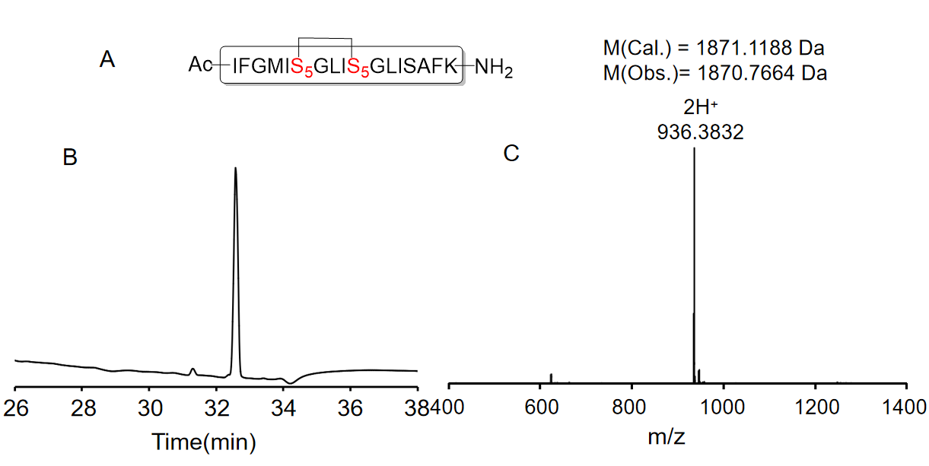

Figure S6. (A) Amino acid sequence of TtAP-2-5. (B) Analytical HPLC of TtAP-2-5. Column: Welch C18. Gradient:10%-90% CH₃CN (0.1% TFA) in H₂O (0.1% TFA) over 15 min (λ=214 nm). The yield of TtAP-2-5 is 5.53%. (C) ESI-MS of peptide TtAP-2-5.

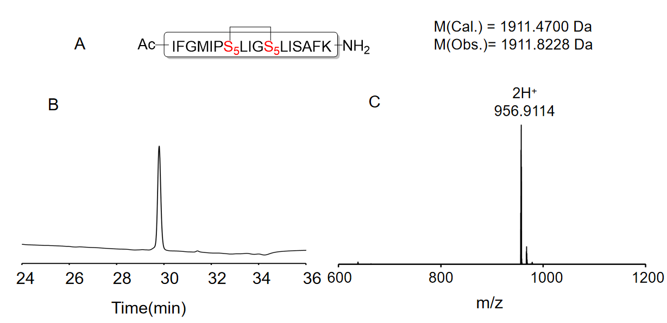

Figure S7. (A) Amino acid sequence of TtAP-2-6. (B) Analytical HPLC of TtAP-2-6. Column: Welch C18. Gradient:10%-90% CH₃CN (0.1% TFA) in H₂O (0.1% TFA) over 15 min (λ=214 nm). The yield of TtAP-2-6 is 2.85%. (C) ESI-MS of peptide TtAP-2-6.

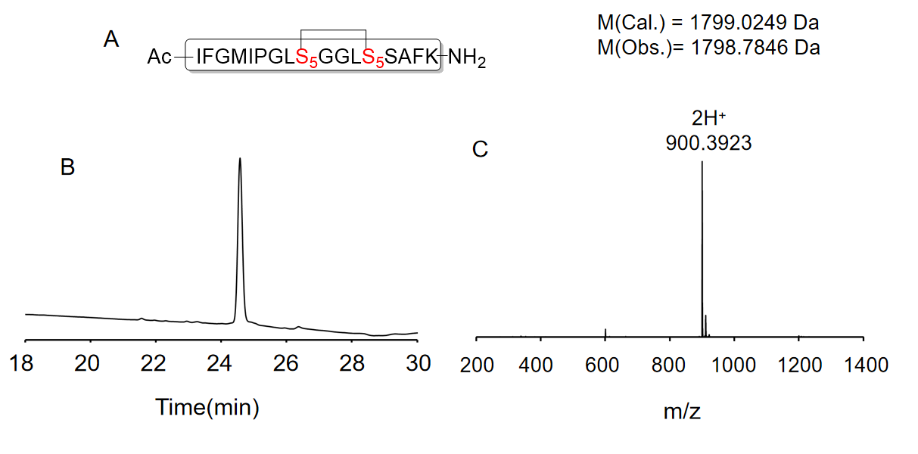

Figure S8. (A) Amino acid sequence of TtAP-2-7. (B) Analytical HPLC of TtAP-2-7. Column: Welch C18. Gradient:10%-90% CH₃CN (0.1% TFA) in H₂O (0.1% TFA) over 15 min (λ=214 nm). The yield of TtAP-2-7 is 1.16%. (C) ESI-MS of peptide TtAP-2-7.

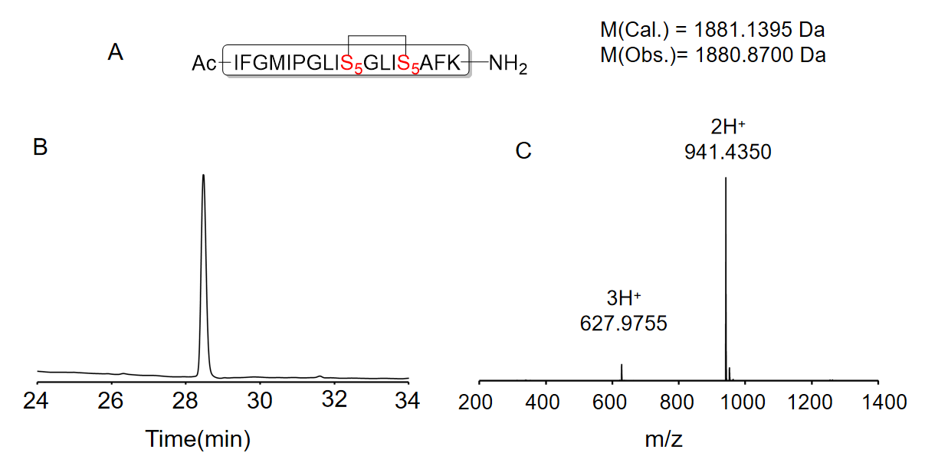

Figure S9. (A) Amino acid sequence of TtAP-2-8. (B) Analytical HPLC of TtAP-2-8. Column: Welch C18. Gradient:10%-90% CH₃CN (0.1% TFA) in H₂O (0.1% TFA) over 15 min (λ=214 nm). The yield of TtAP-2-8 is 1.18%. (C) ESI-MS of peptide TtAP-2-8.

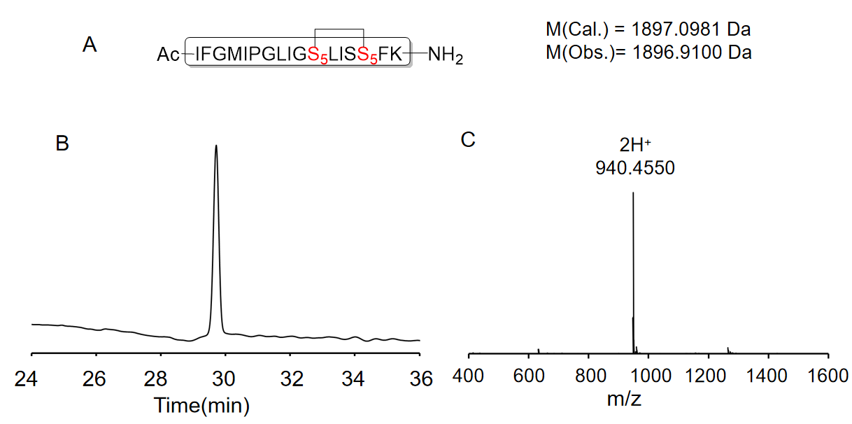

Figure S10. (A) Amino acid sequence of TtAP-2-9. (B) Analytical HPLC of TtAP-2-9. Column: Welch C18. Gradient:10%-90% CH₃CN (0.1% TFA) in H₂O (0.1% TFA) over 15 min (λ=214 nm). The yield of TtAP-2-9 is 2.00%. (C) ESI-MS of peptide TtAP-2-9.

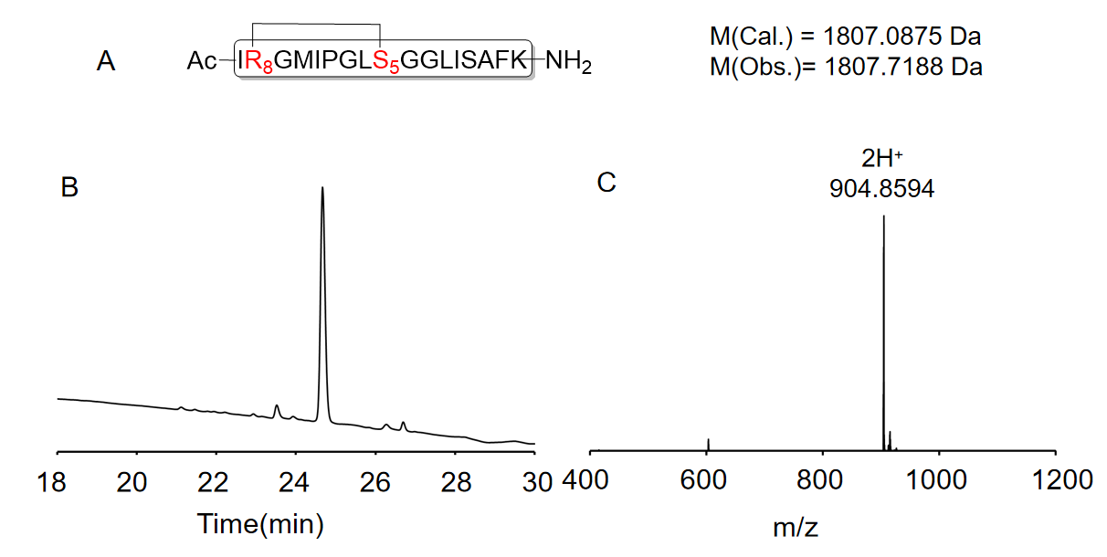

Figure S11. (A) Amino acid sequence of TtAP-2-10. (B) Analytical HPLC of TtAP-2-10. Column: Welch C18. Gradient:10%-90% CH₃CN (0.1% TFA) in H₂O (0.1% TFA) over 15 min (λ=214 nm). The yield of TtAP-2-10 is 0.61%. (C) ESI-MS of peptide TtAP-2-10.

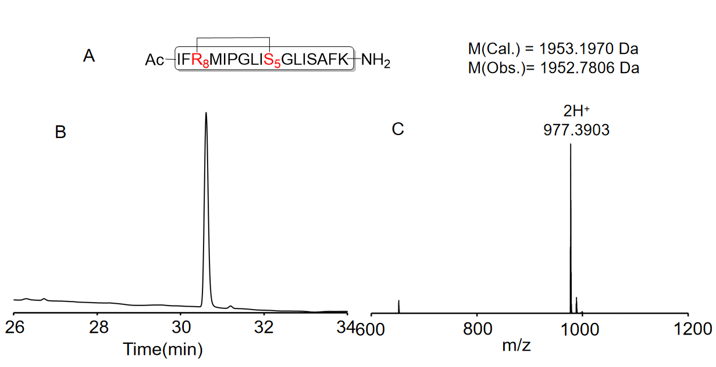

Figure S12. (A) Amino acid sequence of TtAP-2-11. (B) Analytical HPLC of Ttap-2-11. Column: Welch C18. Gradient:10%-90% CH₃CN (0.1% TFA) in H₂O (0.1% TFA) over 15 min (λ=214 nm). The yield of TtAP-2-11 is 1.43%. (C) ESI-MS of peptide TtAP-2-11.
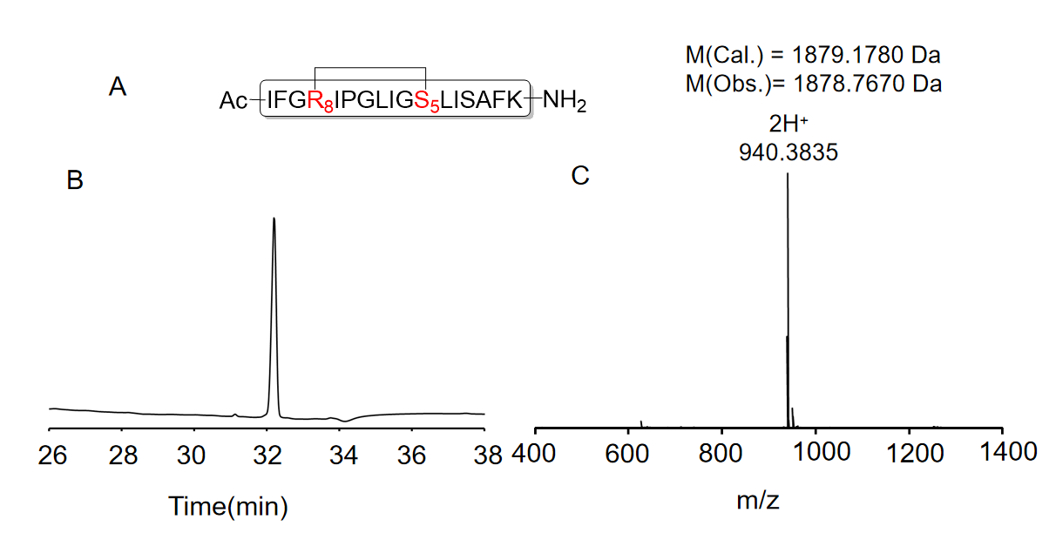

Figure S13. (A) Amino acid sequence of TtAP-2-12. (B) Analytical HPLC of TtAP-2-12. Column: Welch C18. Gradient:10%-90% CH₃CN (0.1% TFA) in H₂O (0.1% TFA) over 15 min (λ=214 nm). The yield of TtAP-2-12 is 4.29%. (C) ESI-MS of peptide TtAP-2-12.

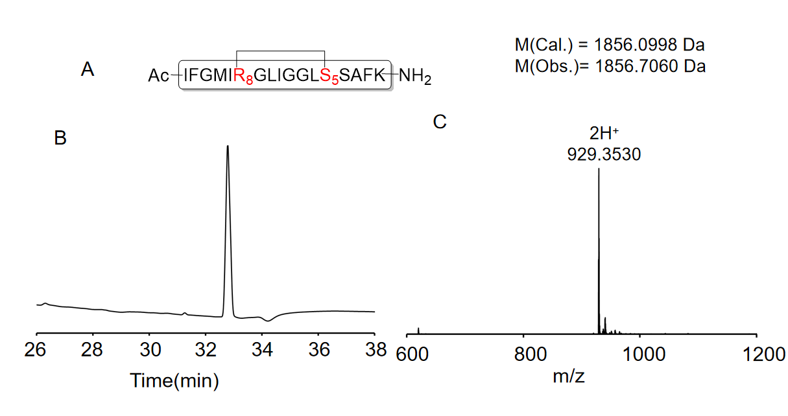Figure S14. (A) Amino acid sequence of TtAP-2-13. (B) Analytical HPLC of TtAP-2-13. Column: Welch C18. Gradient:10%-90% CH₃CN (0.1% TFA) in H₂O (0.1% TFA) over 15 min (λ=214 nm). The yield of TtAP-2-13 is 6.52%. (C) ESI-MS of peptide TtAP-2-13.

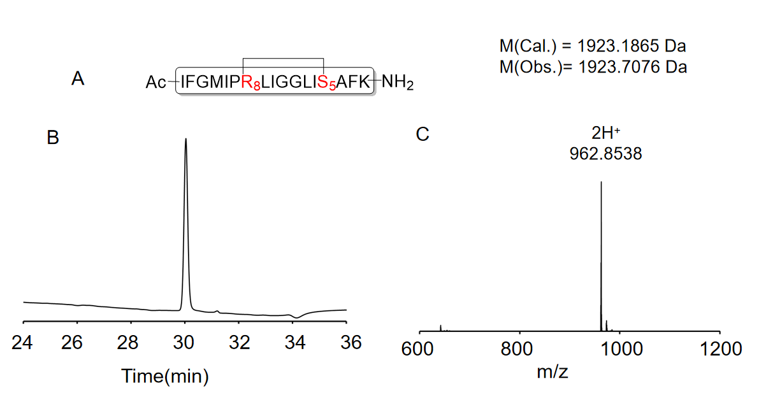

Figure S15. (A) Amino acid sequence of TtAP-2-14. (B) Analytical HPLC of TtAP-2-14. Column: Welch C18. Gradient:10%-90% CH₃CN (0.1% TFA) in H₂O (0.1% TFA) over 15 min (λ=214 nm). The yield of TtAP-2-14 is 2.30%. (C) ESI-MS of peptide TtAP-2-14.
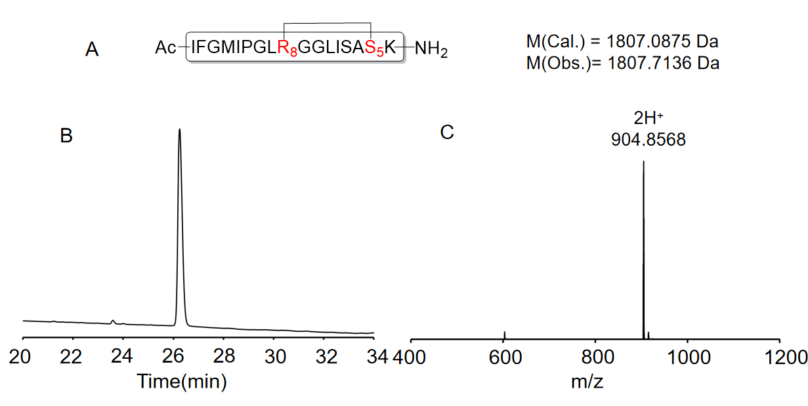

Figure S16. (A) Amino acid sequence of TtAP-2-15. (B) Analytical HPLC of TtAP-2-15. Column: Welch C18. Gradient:10%-90% CH₃CN (0.1% TFA) in H₂O (0.1% TFA) over 15 min (λ=214 nm). The yield of TtAP-2-15 is 11.01 %. (C) ESI-MS of peptide TtAP-2-15.

