Supplementary Information
Thermodynamic gating reconciles molecular and device rankings in solid-state DSSCs: a DFT-informed multiscale study of D-π-A dyes and polythiophene hole-transport polymers for solid-state DSSCs
Esin Mutluª, Gülbin Kurtayª*
ªDepartment of Chemistry, Hacettepe University, 06800 Beytepe, Ankara, Türkiye
*Corresponding author. E-mail: gulbinkurtay@hacettepe.edu.tr
ORCID: Esin Mutlu https://orcid.org/0009-0005-0636-6040; Gülbin Kurtay https://orcid.org/0000-0003-0920-8409
Contents
1 Computational validation
2 Photoanode dyes: ground-state electronic structure
3 Photoanode dyes: excited states and charge transfer
4 Dye adsorption on TiO₂ and the cluster-size effect
4a Electrostatic potential maps
5 Hole-transport polymers: oligomer series and polymer limit
5a Backbone conformation of the hexamer models
6 Regeneration feasibility
7 Device simulation: parameters and sweep packages
8 Indoor photovoltaic performance
9 Data provided in the accompanying workbook

1 Computational validation
A single electronic-structure level, ωB97X-D/def2-SVP with the SMD continuum model for acetonitrile, was retained across every scale of the study, so that the molecular, polymer and device descriptors are mutually comparable. The software used at each stage is listed in Table S39.
The functional and basis-set combination was benchmarked on the reference dye D-model. Six combinations were compared at the TD-DFT level in SMD acetonitrile, the reported quantity being the wavelength and oscillator strength of the most intense transition among the first thirty singlet states. The range-separated functionals cluster between 401 and 422 nm whereas B3LYP and PBE0 place the band at 544 and 512 nm respectively, consistent with the known underestimation of intramolecular charge-transfer excitation energies by global hybrids. Extension of the basis set from def2-SVP to def2-TZVP shifts the reference value by 11.3 nm, which establishes def2-SVP as adequate for this system.
Table S39 Software used in the workflow
Software | Version | Role in the workflow
Gaussian | 16 Rev. C.01 | Geometry optimization, harmonic frequencies, TD-DFT, CPHF polarizabilities, ΔSCF single points
GFN2-xTB | 6.x | Semiempirical prescreening of regiochemical isomers
Multiwfn | 2026.4.10 | Hole-electron analysis, charge-transfer indices, electrostatic potential maps
SCAPS-1D | 3.3.12 | One-dimensional drift-diffusion device simulation
Python | 3.13 | Workflow automation and data analysis
scikit-learn | 1.8.0 | Random-forest regression, cross-validation and permutation importance
SHAP | current | Feature attribution
A single electronic-structure level, ωB97X-D/def2-SVP with the SMD continuum model for acetonitrile, was retained across every scale of the study.
Table S1 Functional and basis-set benchmark on D-model
Functional / basis set | Character | λ_{max} / nm | E_{max} / eV | f_{max} | Δ λ_{max} vs reference / nm
ωB97X-D/def2-SVP | Range-separated hybrid; reference level of this work | 401.300 | 3.090 | 1.471 | 0.000
ωB97X-D/def2-TZVP | Basis-set sufficiency check | 412.600 | 3.005 | 1.459 | 11.300
CAM-B3LYP/def2-SVP | Range-separated alternative | 415.500 | 2.984 | 1.385 | 14.200
M06-2X/def2-SVP | Minnesota meta-hybrid | 421.300 | 2.943 | 1.324 | 20.000
PBE0/def2-SVP | Global hybrid | 512.300 | 2.420 | 0.908 | 111.000
B3LYP/def2-SVP | Global hybrid, classical standard | 543.700 | 2.280 | 0.816 | 142.400
All values from TD-DFT in SMD acetonitrile over the first thirty singlet states. Reference: ωB97X-D/def2-SVP.
2 Photoanode dyes: ground-state electronic structure
All fifteen dyes were optimized without symmetry constraints and characterized by harmonic frequency analysis. No imaginary frequency was obtained for any structure, and the lowest real frequencies fall between 6.8 and 11.9 cm⁻¹, corresponding to soft torsional motions of the conjugated backbone and of the triphenylamine propeller.
Table S2 Frontier-orbital energies, dipole moments, bond-length alternation and lowest real vibrational frequencies
Dye | HOMO / eV | LUMO / eV | Gap / eV | Dipole / D | BLA | Lowest frequency / cm⁻¹
D-1a | -7.123 | -1.038 | 6.085 | 8.926 | 0.076 | 11.900
D-1b | -7.057 | -1.155 | 5.902 | 9.224 | 0.069 | 6.800
D-2a | -7.114 | -1.063 | 6.051 | 12.398 | 0.063 | 7.600
D-2b | -7.055 | -1.245 | 5.810 | 8.221 | 0.060 | 10.800
D-3a | -7.119 | -1.063 | 6.056 | 13.007 | 0.071 | 8.400
D-3b | -7.055 | -1.243 | 5.812 | 6.638 | 0.067 | 11.900
D-4a | -7.145 | -1.073 | 6.072 | 10.758 | 0.062 | 8.400
D-4b | -7.062 | -1.262 | 5.801 | 9.655 | 0.059 | 11.700
D-5a | -7.177 | -1.107 | 6.070 | 14.224 | 0.055 | 7.800
D-5b | -7.079 | -1.456 | 5.623 | 9.707 | 0.059 | 8.200
D-6a | -7.170 | -1.106 | 6.064 | 14.062 | 0.063 | 9.700
D-6b | -7.076 | -1.448 | 5.628 | 9.069 | 0.066 | 10.200
D-7a | -7.168 | -1.091 | 6.076 | 17.629 | 0.061 | 8.600
D-7b | -7.078 | -1.466 | 5.612 | 11.406 | 0.063 | 9.400
D-model | -7.039 | -1.099 | 5.939 | 10.231 | 0.059 | 10.800
ωB97X-D/def2-SVP, SMD acetonitrile. No imaginary frequencies were obtained.
Table S3 ΔSCF ionization potentials, electron affinities, reactivity descriptors and oxidation potentials
HOMO / eV | IP (ΔSCF) / eV | Koopmans error / eV | Eox vs SCE / V | Dye | IP adiabatic / eV | EA adiabatic / eV | ΔSCF gap / eV | η (ΔSCF) / eV | ω (ΔSCF) / eV
-7.123 | 5.529 | 1.593 | 0.846 | D-1a | 5.529 | 3.123 | 2.407 | 1.204 | 7.775
-7.057 | 5.465 | 1.592 | 0.781 | D-1b | 5.465 | 3.268 | 2.196 | 1.098 | 8.681
-7.114 | 5.354 | 1.760 | 0.670 | D-2a | 5.354 | 3.142 | 2.212 | 1.106 | 8.159
-7.055 | 5.373 | 1.683 | 0.689 | D-2b | 5.373 | 3.349 | 2.024 | 1.012 | 9.395
-7.119 | 5.405 | 1.714 | 0.721 | D-3a | 5.405 | 3.141 | 2.264 | 1.132 | 8.067
-7.055 | 5.833 | 1.222 | 1.149 | D-3b | 5.833 | 3.341 | 2.491 | 1.246 | 8.445
-7.145 | 5.253 | 1.891 | 0.570 | D-4a | 5.253 | 3.153 | 2.101 | 1.050 | 8.409
-7.062 | 5.204 | 1.858 | 0.520 | D-4b | 5.204 | 3.372 | 1.832 | 0.916 | 10.035
-7.177 | 5.273 | 1.904 | 0.589 | D-5a | 5.273 | 3.191 | 2.082 | 1.041 | 8.603
-7.079 | 5.208 | 1.871 | 0.524 | D-5b | 5.208 | 3.573 | 1.635 | 0.818 | 11.786
-7.170 | 5.271 | 1.898 | 0.588 | D-6a | 5.271 | 3.188 | 2.083 | 1.042 | 8.589
-7.076 | 5.203 | 1.873 | 0.519 | D-6b | 5.203 | 3.561 | 1.642 | 0.821 | 11.696
-7.168 | 5.273 | 1.895 | 0.589 | D-7a | 5.273 | 3.174 | 2.099 | 1.049 | 8.500
-7.078 | 5.211 | 1.867 | 0.527 | D-7b | 5.211 | 3.563 | 1.647 | 0.824 | 11.683
-7.039 | 5.197 | 1.842 | 0.513 | D-model | 5.197 | 3.128 | 2.070 | 1.035 | 8.371
Koopmans error is -E(HOMO) - IP(ΔSCF) and ranges from 1.22 to 1.90 eV, which is why all reported ionization potentials derive from ΔSCF. Eox(SCE) = IP - 4.684 V, combining the Trasatti absolute NHE potential (4.44 V) with the NHE-to-SCE conversion (0.244 V); the same constant is used for the polymers, so ΔE_{ox} is independent of the reference offset.
Table S4 Koopmans-type global reactivity descriptors
μ / eV | η / eV | ω / eV | Dye
-4.080 | 3.042 | 2.736 | D-1a
-4.106 | 2.951 | 2.856 | D-1b
-4.088 | 3.026 | 2.762 | D-2a
-4.150 | 2.905 | 2.965 | D-2b
-4.091 | 3.028 | 2.763 | D-3a
-4.149 | 2.906 | 2.961 | D-3b
-4.109 | 3.036 | 2.780 | D-4a
-4.162 | 2.900 | 2.986 | D-4b
-4.142 | 3.035 | 2.826 | D-5a
-4.267 | 2.812 | 3.239 | D-5b
-4.138 | 3.032 | 2.824 | D-6a
-4.262 | 2.814 | 3.227 | D-6b
-4.129 | 3.038 | 2.806 | D-7a
-4.272 | 2.806 | 3.251 | D-7b
-4.069 | 2.970 | 2.788 | D-model
From frontier-orbital energies; ΔSCF counterparts in Table S3.
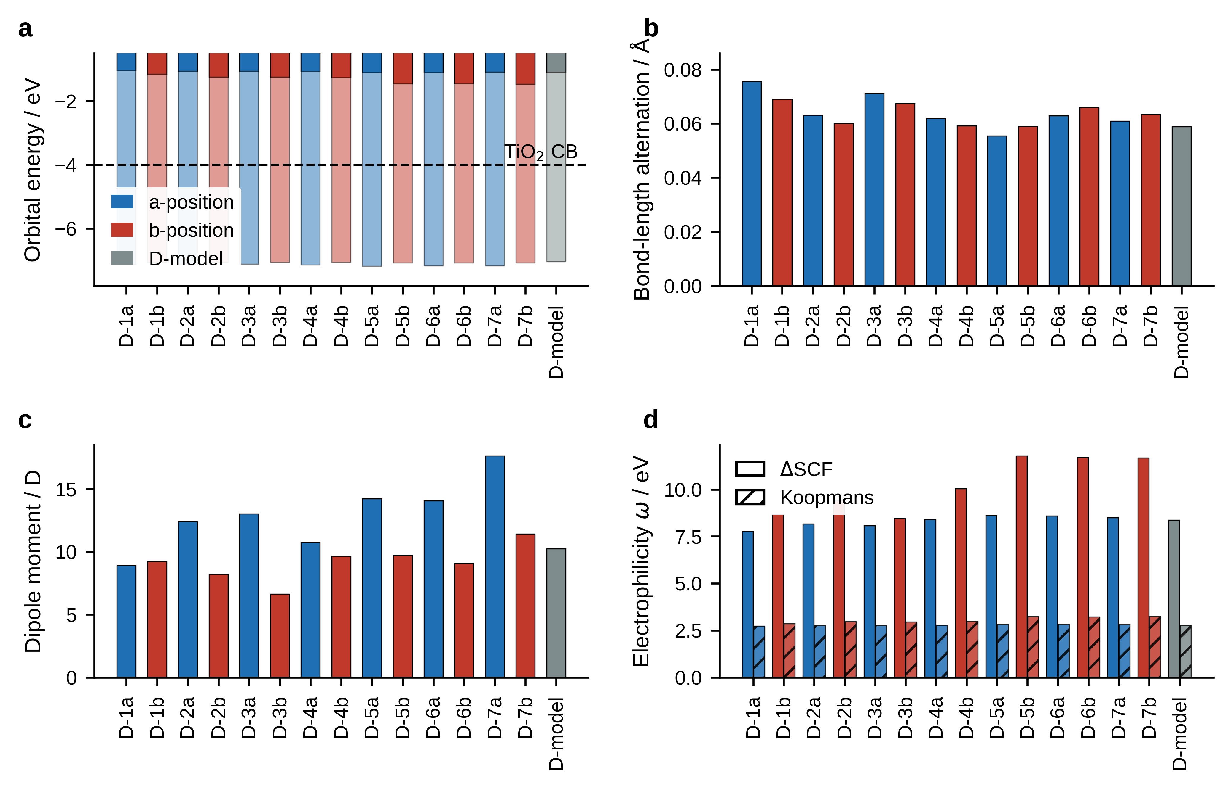
Fig. S1 Ground-state descriptors of the fifteen dyes. a Frontier-orbital energies, with the TiO₂ conduction-band edge marked. b Bond-length alternation. c Ground-state dipole moment. d Electrophilicity index on the ΔSCF and Koopmans scales. Blue, a-position isomers; red, b-position isomers; grey, D-model
3 Photoanode dyes: excited states and charge transfer
Vertical excitation energies were obtained from linear-response TD-DFT at the same level. The lowest singlet is dominated by the HOMO to LUMO configuration in every dye, with leading coefficients between 0.71 and 0.84. The light-harvesting efficiency follows from the oscillator strength of that transition.
Table S5 TD-DFT absorption properties of the free dyes
λ_{max} / nm | f_{max} | S₁ λ / nm | S₁ f | S₁ E / eV | LHE | τ_{S1} / ns | S₁ leading coefficient | Dye
361.200 | 1.231 | 361.200 | 1.231 | 3.433 | 0.941 | 0.103 | 0.714 | D-1a
392.600 | 1.079 | 392.600 | 1.079 | 3.158 | 0.917 | 0.139 | 0.787 | D-1b
372.400 | 1.216 | 372.400 | 1.216 | 3.330 | 0.939 | 0.111 | 0.779 | D-2a
400.800 | 0.772 | 400.800 | 0.772 | 3.094 | 0.831 | 0.203 | 0.754 | D-2b
372.400 | 1.220 | 372.400 | 1.220 | 3.329 | 0.940 | 0.111 | 0.777 | D-3a
400.700 | 0.790 | 400.700 | 0.790 | 3.094 | 0.838 | 0.198 | 0.757 | D-3b
370.700 | 1.234 | 370.700 | 1.234 | 3.345 | 0.942 | 0.109 | 0.759 | D-4a
398.500 | 0.890 | 398.500 | 0.890 | 3.111 | 0.871 | 0.174 | 0.775 | D-4b
373.800 | 1.118 | 373.800 | 1.118 | 3.317 | 0.924 | 0.122 | 0.707 | D-5a
336.200 | 1.177 | 405.300 | 0.690 | 3.059 | 0.796 | 0.232 | 0.770 | D-5b
374.200 | 1.124 | 374.200 | 1.124 | 3.313 | 0.925 | 0.122 | 0.711 | D-6a
342.000 | 1.250 | 405.200 | 0.626 | 3.060 | 0.764 | 0.256 | 0.765 | D-6b
371.100 | 1.209 | 371.100 | 1.209 | 3.341 | 0.938 | 0.111 | 0.751 | D-7a
413.500 | 0.813 | 413.500 | 0.813 | 2.999 | 0.846 | 0.205 | 0.784 | D-7b
401.300 | 1.471 | 401.300 | 1.471 | 3.090 | 0.966 | 0.107 | 0.838 | D-model
LHE = 1 - 10^{-f}. τ_{S1} is the radiative lifetime.
Table S6 Charge-transfer diagnostics of the S₁ excitation
Dye | E(S₁) / eV | λ(S₁) / nm | D index / Å | t index / Å | Sr index | H index / Å
D-1a | 3.433 | 361.150 | 2.649 | -0.973 | 0.719 | 3.931
D-1b | 3.158 | 392.600 | 2.660 | -0.476 | 0.730 | 3.900
D-2a | 3.330 | 372.320 | 2.578 | -0.852 | 0.717 | 4.006
D-2b | 3.094 | 400.720 | 2.259 | -0.843 | 0.740 | 3.995
D-3a | 3.329 | 372.440 | 2.601 | -0.866 | 0.717 | 4.009
D-3b | 3.094 | 400.720 | 2.286 | -0.805 | 0.742 | 3.984
D-4a | 3.345 | 370.650 | 2.638 | -0.906 | 0.724 | 4.029
D-4b | 3.111 | 398.530 | 2.680 | -0.448 | 0.728 | 3.898
D-5a | 3.317 | 373.780 | 2.540 | -0.906 | 0.714 | 4.068
D-5b | 3.059 | 405.310 | 2.980 | -0.165 | 0.707 | 3.878
D-6a | 3.313 | 374.230 | 2.512 | -0.876 | 0.716 | 4.088
D-6b | 3.060 | 405.180 | 2.968 | -0.054 | 0.703 | 3.837
D-7a | 3.341 | 371.100 | 2.627 | -0.885 | 0.725 | 4.059
D-7b | 2.999 | 413.420 | 2.944 | -0.214 | 0.708 | 3.841
D-model | 3.090 | 401.240 | 2.358 | -1.338 | 0.743 | 3.967
Hole-electron analysis in Multiwfn.
Table S7 Injection driving force, regeneration level offset and level-alignment photovoltage bound
ΔG_{inj} / eV | ΔG_{reg} / eV | LUMO-CB offset / eV | Dye
0.310 | 2.273 | 2.962 | D-1a
0.101 | 2.207 | 2.845 | D-1b
0.216 | 2.264 | 2.937 | D-2a
0.038 | 2.205 | 2.755 | D-2b
0.210 | 2.268 | 2.937 | D-3a
0.039 | 2.205 | 2.757 | D-3b
0.200 | 2.295 | 2.927 | D-4a
0.049 | 2.212 | 2.738 | D-4b
0.140 | 2.327 | 2.893 | D-5a
-0.020 | 2.229 | 2.544 | D-5b
0.143 | 2.320 | 2.894 | D-6a
-0.016 | 2.226 | 2.552 | D-6b
0.174 | 2.317 | 2.909 | D-7a
-0.079 | 2.228 | 2.534 | D-7b
0.051 | 2.189 | 2.901 | D-model
E_{CB}(TiO₂) = -4.00 eV; I⁻/I₃⁻ at -4.85 eV. Level offsets, not reaction free energies.
Table S8 Four-point reorganization energies and relative Marcus transfer rates
Dye | IP vertical / eV | IP adiabatic / eV | EA vertical / eV | EA adiabatic / eV | λ_{h} / eV | λ_{e} / eV | k_{h} / k_{e} | Transport character
D-1a | 5.839 | 5.529 | 2.911 | 3.123 | 0.549 | 0.417 | 0.277 | Electron-transport favoured (n-type)
D-1b | 5.806 | 5.465 | 2.975 | 3.268 | 0.579 | 0.571 | 0.926 | Electron-transport favoured (n-type)
D-2a | 5.637 | 5.354 | 2.933 | 3.142 | 0.602 | 0.415 | 0.163 | Electron-transport favoured (n-type)
D-2b | 5.660 | 5.373 | 3.045 | 3.349 | 0.610 | 0.582 | 0.759 | Electron-transport favoured (n-type)
D-3a | 5.686 | 5.405 | 2.932 | 3.141 | 0.602 | 0.415 | 0.162 | Electron-transport favoured (n-type)
D-3b | 6.010 | 5.833 | 3.043 | 3.341 | 0.363 | 0.576 | 7.923 | Hole-transport favoured (p-type)
D-4a | 5.331 | 5.253 | 2.942 | 3.153 | 0.143 | 0.416 | 14.219 | Hole-transport favoured (p-type)
D-4b | 5.271 | 5.204 | 3.066 | 3.372 | 0.134 | 0.592 | 86.456 | Hole-transport favoured (p-type)
D-5a | 5.358 | 5.273 | 2.978 | 3.191 | 0.154 | 0.419 | 13.192 | Hole-transport favoured (p-type)
D-5b | 5.279 | 5.208 | 3.214 | 3.573 | 0.137 | 0.664 | 169.856 | Hole-transport favoured (p-type)
D-6a | 5.355 | 5.271 | 2.977 | 3.188 | 0.152 | 0.418 | 13.347 | Hole-transport favoured (p-type)
D-6b | 5.277 | 5.203 | 3.209 | 3.561 | 0.139 | 0.656 | 152.614 | Hole-transport favoured (p-type)
D-7a | 5.356 | 5.273 | 2.962 | 3.174 | 0.152 | 0.419 | 13.360 | Hole-transport favoured (p-type)
D-7b | 5.279 | 5.211 | 3.258 | 3.563 | 0.133 | 0.568 | 68.449 | Hole-transport favoured (p-type)
D-model | 5.271 | 5.197 | 2.917 | 3.128 | 0.129 | 0.411 | 15.520 | Hole-transport favoured (p-type)
Four-point scheme; rate ratios are relative Marcus estimates at constant electronic coupling and driving force. The transport character follows from the sign of λ_{h} - λ_{e}: a smaller hole reorganization energy favours hole transport and hence p-type character.
Table S9 Static polarizability and first hyperpolarizability
α_{iso} / a.u. | α_{iso} / Å³ | Dye | β_{total} / a.u. | β_{total} / 10⁻³⁰ esu | β_{HRS} / a.u.
639.140 | 94.711 | D-1a | 18403.87 | 158.995 | 8230.46
654.070 | 96.923 | D-1b | 26871.57 | 232.149 | 12017.33
652.840 | 96.741 | D-2a | 21288.78 | 183.918 | 9520.63
661.230 | 97.984 | D-2b | 25631.49 | 221.436 | 11462.75
669.090 | 99.149 | D-3a | 21537.22 | 186.064 | 9631.74
678.290 | 100.513 | D-3b | 29030.34 | 250.799 | 12982.76
671.820 | 99.554 | D-4a | 22706.13 | 196.163 | 10154.49
678.860 | 100.597 | D-4b | 29909.12 | 258.391 | 13375.77
691.250 | 102.433 | D-5a | 22876.11 | 197.631 | 10230.51
693.140 | 102.714 | D-5b | 25478.5 | 220.114 | 11394.33
713.020 | 105.658 | D-6a | 21235.88 | 183.461 | 9496.97
712.910 | 105.643 | D-6b | 22627.67 | 195.485 | 10119.4
674.620 | 99.968 | D-7a | 20910.13 | 180.647 | 9351.3
681.640 | 101.009 | D-7b | 28394.88 | 245.309 | 12698.58
522.820 | 77.474 | D-model | 34422.79 | 297.385 | 15394.34
CPHF, static limit.
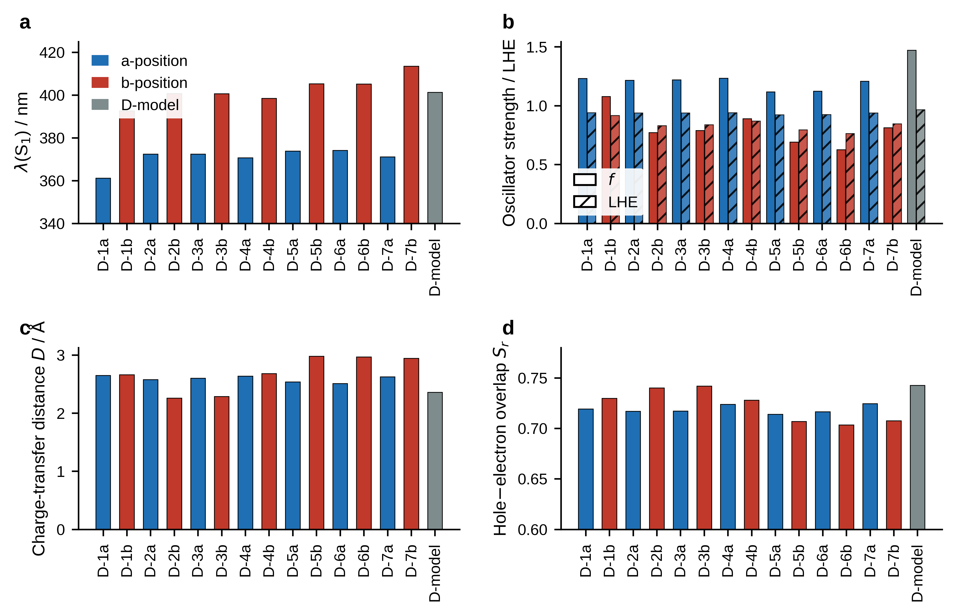
Fig. S2 Excited-state properties. a Wavelength of the lowest singlet. b Oscillator strength and light-harvesting efficiency. c Charge-transfer distance. d Hole–electron overlap
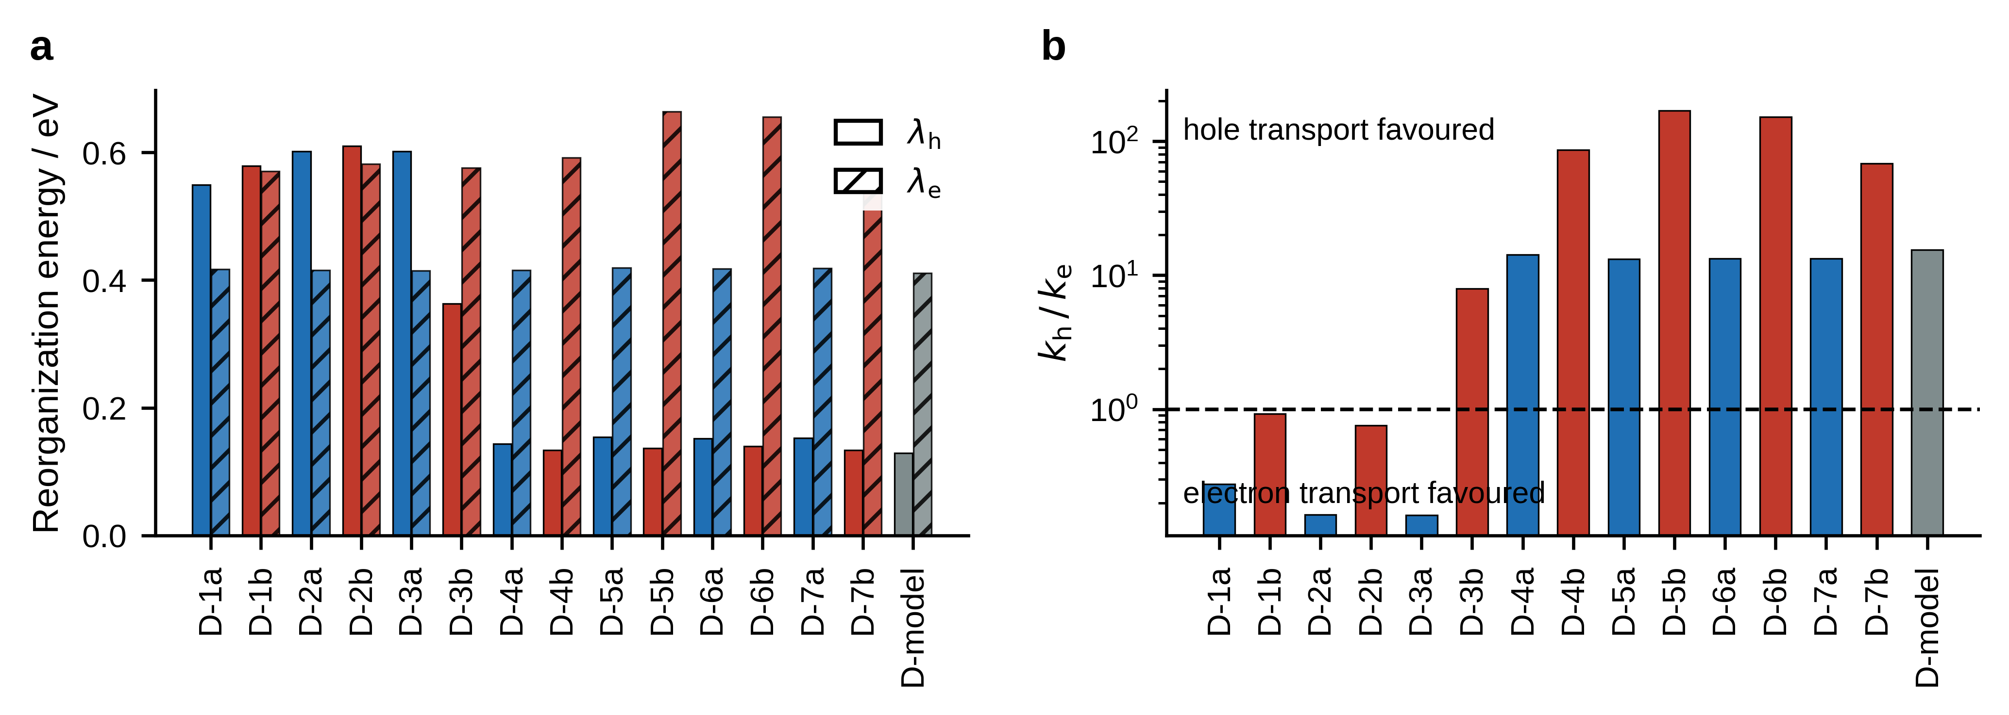
Fig. S3 Charge transport. a Hole and electron reorganization energies from the four-point scheme. b Ratio of the relative Marcus rates on a logarithmic scale; the dashed line marks equal hole and electron transport
4 Dye adsorption on TiO₂ and the cluster-size effect
Adsorption was modeled on two hydrogen-free neutral clusters derived from the anatase (101) surface. The free dye is taken in its neutral carboxylic-acid form and the carboxyl proton migrates to a bridging surface oxygen on bidentate binding, so that the adsorption energy is computed between charge-neutral fragments.
The optical consequence is systematic. Every dye red-shifts on (TiO₂)₅ and blue-shifts on (TiO₂)₁₅, the mean shifts being +17.6 and -8.0 nm, and the reversal holds for all fifteen dyes without exception. The injection driving force reverses with it: eight dyes become unfavorable on the small cluster while all but D-7b are restored to favorable values on the large one.
The extent of that transfer was quantified directly. Fragment-based analysis of the (TiO₂)₁₅ complexes divides the system into a dye fragment and a cluster fragment and returns the percentage of electron density moved between them on excitation (Table S43). The lowest singlet transfers only 6 to 23 per cent, so S1 remains largely localized on the dye; the S₃ channel, by contrast, reaches essentially complete transfer for thirteen of the fifteen dyes. Efficient injection therefore proceeds through the higher-lying full charge-transfer channel rather than through S1 itself. Two dyes break the pattern: D-5b and D-6b reach only 40.7 and 30.9 per cent on S3. The same two dyes carry the split oscillator strength noted in Section 3.4 and the formally negative free-molecule injection driving force of Section 3.3, so three independent observations identify them as the weakest photoanodes of the set.
Table S10 Adsorption energies on the (TiO₂)₅ and (TiO₂)₁₅ clusters
ΔE (TiO₂)₅ / kcal mol⁻¹ | ΔE (TiO₂)₁₅ / kcal mol⁻¹ | E_{ads} (TiO₂)₅ / kcal mol⁻¹ | E_{ads} (TiO₂)₁₅ / kcal mol⁻¹ | Dipole (TiO₂)₅ / D | Dipole (TiO₂)₁₅ / D | Dye
-3137077.22 | -9411370.98 | -41.870 | -28.960 | 7.960 | 6.154 | D-1a
-3137078.4 | -9411372.26 | -43.040 | -30.240 | 9.339 | 8.324 | D-1b
-3137079.17 | -9411371.05 | -43.810 | -29.030 | 11.763 | 9.131 | D-2a
-3137076.36 | -9411371.65 | -41.010 | -29.630 | 11.971 | 10.981 | D-2b
-3137077.87 | -9411371.04 | -42.520 | -29.020 | 12.684 | 13.081 | D-3a
-3137076.71 | -9411372.29 | -41.360 | -30.270 | 10.712 | 8.395 | D-3b
-3137079.26 | -9411371.07 | -43.900 | -29.050 | 10.343 | 11.020 | D-4a
-3137076.07 | -9411371.98 | -40.710 | -29.960 | 13.526 | 10.212 | D-4b
-3137078.56 | -9411371.09 | -43.200 | -29.070 | 13.106 | 16.824 | D-5a
-3137076.35 | -9411372.2 | -41.000 | -30.180 | 5.877 | 12.056 | D-5b
-3137077.97 | -9411371.22 | -42.610 | -29.200 | 12.776 | 14.346 | D-6a
-3137076.45 | -9411372.65 | -41.090 | -30.630 | 10.354 | 10.687 | D-6b
-3137077.55 | -9411370.95 | -42.190 | -28.930 | 11.397 | 18.369 | D-7a
-3137077.33 | -9411372.29 | -41.980 | -30.270 | 9.105 | 13.535 | D-7b
-3137078.62 | -9411371.04 | -43.260 | -29.020 | 11.438 | 9.787 | D-model
E_{ads} between charge-neutral fragments; cluster hydrogen-free.
Table S11 Cluster-size dependence of the S₁ absorption maximum
S₁ free / nm | Dye | S₁ (TiO₂)₅ / nm | S₁ (TiO₂)₁₅ / nm | Δ (TiO₂)₅ / nm | Δ (TiO₂)₁₅ / nm
361.200 | D-1a | 372.200 | 352.600 | 11.000 | -8.600
392.600 | D-1b | 409.200 | 384.100 | 16.600 | -8.500
372.400 | D-2a | 384.400 | 365.500 | 12.000 | -6.900
400.800 | D-2b | 424.700 | 392.400 | 23.900 | -8.400
372.400 | D-3a | 384.800 | 364.200 | 12.400 | -8.200
400.700 | D-3b | 424.200 | 388.000 | 23.500 | -12.700
370.700 | D-4a | 381.900 | 365.400 | 11.200 | -5.300
398.500 | D-4b | 418.500 | 384.800 | 20.000 | -13.700
373.800 | D-5a | 382.000 | 371.600 | 8.200 | -2.200
405.300 | D-5b | 430.000 | 397.800 | 24.700 | -7.500
374.200 | D-6a | 386.700 | 370.700 | 12.500 | -3.500
405.200 | D-6b | 433.800 | 396.200 | 28.600 | -9.000
371.100 | D-7a | 383.600 | 366.300 | 12.500 | -4.800
413.500 | D-7b | 439.500 | 404.000 | 26.000 | -9.500
401.300 | D-model | 422.200 | 389.800 | 20.900 | -11.500
Means +17.6 nm on (TiO₂)₅ and -8.0 nm on (TiO₂)₁₅; the reversal holds for all fifteen dyes.
Table S12 Injection driving force of the free dye and of the adsorbed complexes
ΔG_{inj} / eV | ΔG_{reg} / eV | LUMO-CB offset / eV | Dye | S₁ E (TiO₂)₅ / eV | S₁ E (TiO₂)₁₅ / eV
0.310 | 2.273 | 2.962 | D-1a | 3.332 | 3.516
0.101 | 2.207 | 2.845 | D-1b | 3.030 | 3.228
0.216 | 2.264 | 2.937 | D-2a | 3.226 | 3.392
0.038 | 2.205 | 2.755 | D-2b | 2.919 | 3.160
0.210 | 2.268 | 2.937 | D-3a | 3.222 | 3.404
0.039 | 2.205 | 2.757 | D-3b | 2.923 | 3.195
0.200 | 2.295 | 2.927 | D-4a | 3.247 | 3.393
0.049 | 2.212 | 2.738 | D-4b | 2.963 | 3.222
0.140 | 2.327 | 2.893 | D-5a | 3.246 | 3.337
-0.020 | 2.229 | 2.544 | D-5b | 2.883 | 3.116
0.143 | 2.320 | 2.894 | D-6a | 3.206 | 3.345
-0.016 | 2.226 | 2.552 | D-6b | 2.858 | 3.129
0.174 | 2.317 | 2.909 | D-7a | 3.232 | 3.385
-0.079 | 2.228 | 2.534 | D-7b | 2.821 | 3.069
0.051 | 2.189 | 2.901 | D-model | 2.937 | 3.180
Eight dyes become unfavourable on the small cluster and all but D-7b are restored on the large one.
Table S43 Fragment-based charge transfer to TiO₂ in the adsorbed complexes
Dye | S₁ / % | S₂ / % | S₃ / %
D-1a | 8.400 | 100.100 | 100.100
D-1b | 9.200 | 100.200 | 100.000
D-2a | 7.000 | 56.700 | 100.000
D-2b | 16.400 | 38.300 | 100.000
D-3a | 5.800 | 54.400 | 100.200
D-3b | 15.100 | 37.800 | 100.100
D-4a | 6.800 | 43.700 | 100.000
D-4b | 13.600 | 40.500 | 100.000
D-5a | 18.000 | 49.500 | 100.200
D-5b | 22.700 | 47.300 | 40.700
D-6a | 18.400 | 50.800 | 100.000
D-6b | 23.300 | 52.700 | 30.900
D-7a | 10.000 | 52.400 | 100.000
D-7b | 17.400 | 46.200 | 99.900
D-model | 6.300 | 99.800 | 100.100
Percentage of electron density transferred from the dye fragment to the cluster fragment on excitation, from Mulliken fragment transition-charge analysis of the (TiO₂)₁₅ complexes. The S₃ channel reaches essentially complete transfer for thirteen of the fifteen dyes; D-5b and D-6b are the exceptions.
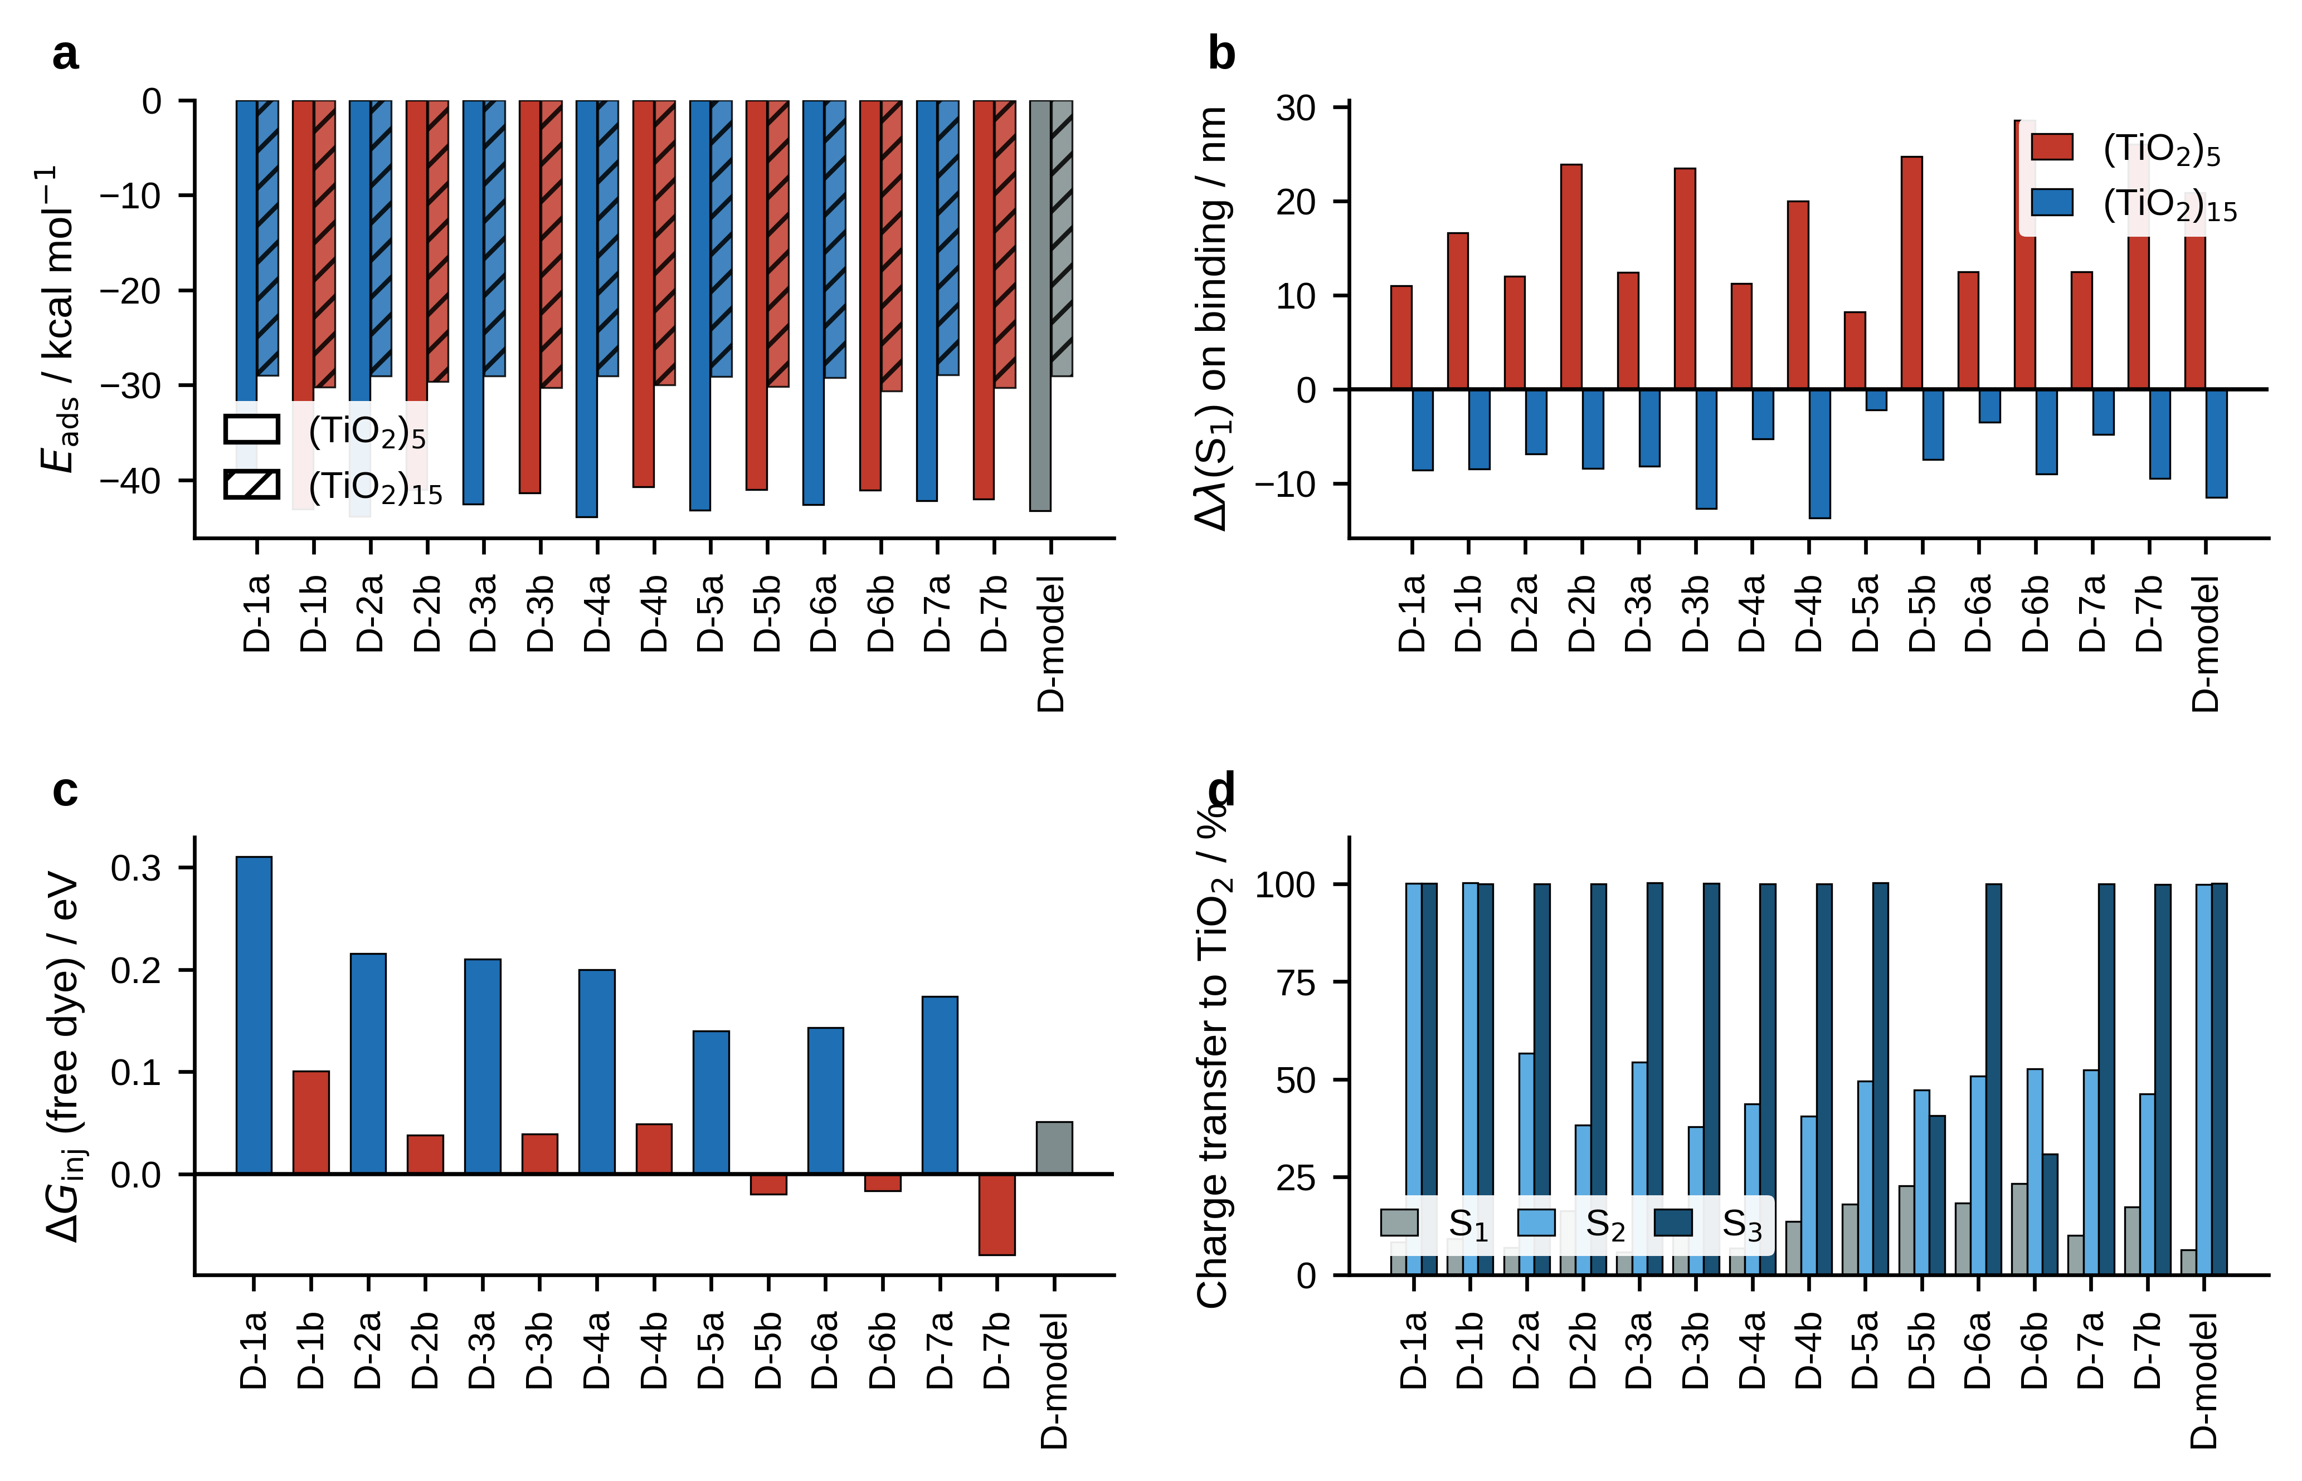
Fig. S4 Interaction with the titania surface. a Adsorption energies on the two clusters. b Shift of the lowest singlet on binding, positive to the red. c Injection driving force of the free dye. d Percentage of electron density transferred to the cluster in each of the three lowest excitations
4a Electrostatic potential maps
Molecular electrostatic potential maps were computed from the ωB97X-D/def2-SVP densities and projected onto the 0.001 a.u. total electron-density isosurface over the range -0.04 to +0.04 a.u., with red denoting electron-rich and blue electron-poor regions. A common colour scale is used throughout so that panels may be compared directly across dyes and across the three binding states.
In the free dyes (Fig. S5) the negative potential is localized on the cyanoacrylic anchoring group and on the imine nitrogen of the Schiff-base linkage, while the triphenylamine donor carries the positive region, which is the electrostatic signature of the donor-acceptor architecture. On complexation with the (TiO₂)₅ and (TiO₂)₁₅ clusters (Figs. S6 and S7) the negative potential at the anchor is transferred to the cluster, consistent with electron donation into the surface upon bidentate binding and with the adsorption energies of Table S10.
All structures are shown in a common orientation with the donor at the left and the anchoring group, or the cluster where present, at the right.
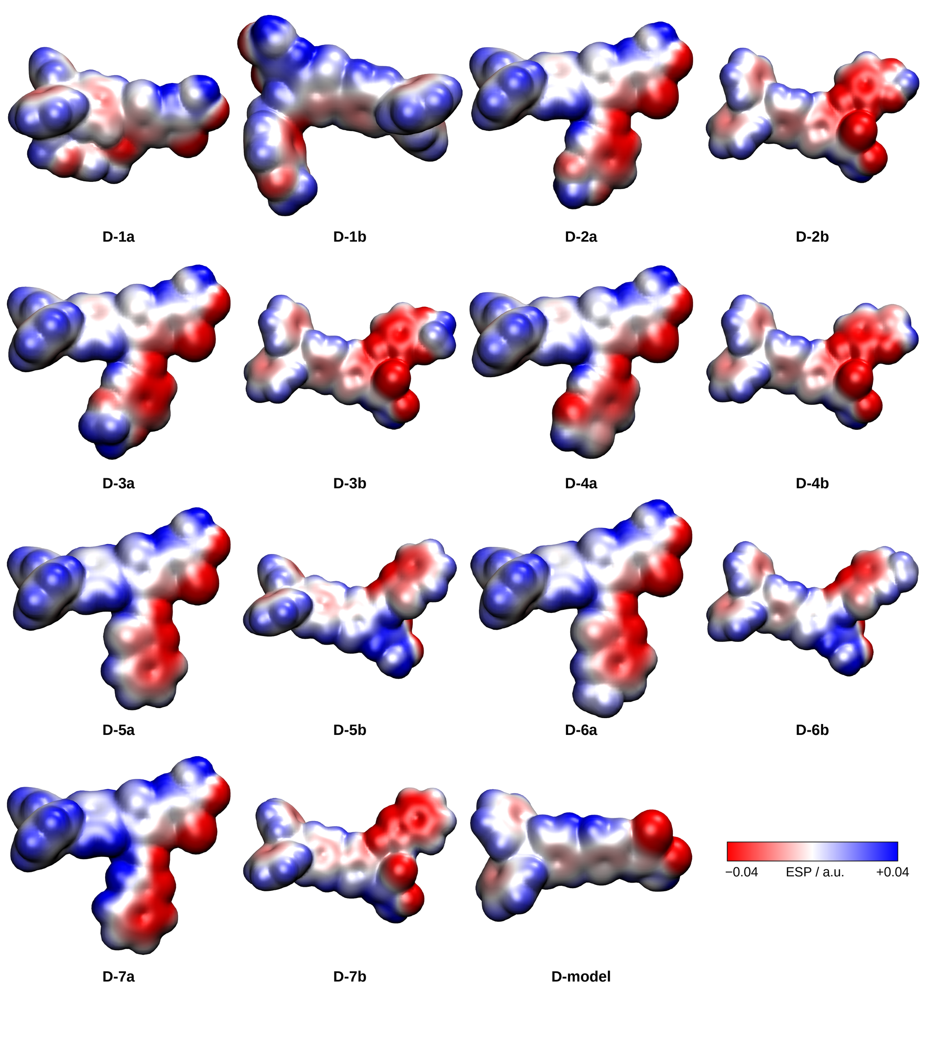
Fig. S5 Molecular electrostatic potential maps of the fifteen free dyes, projected onto the 0.001 a.u. electron-density isosurface over the range −0.04 to +0.04 a.u. Red denotes electron-rich and blue electron-poor regions
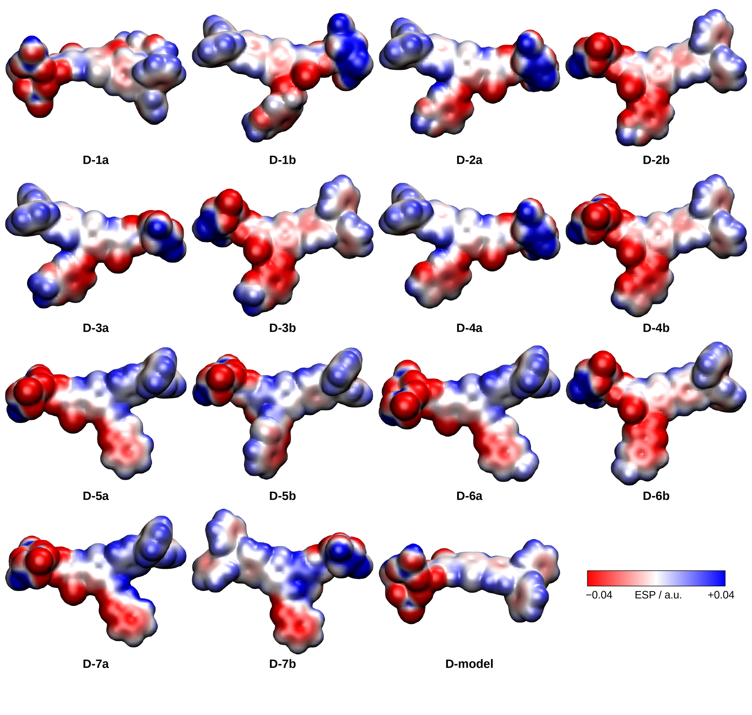
Fig. S6 Electrostatic potential maps of the fifteen dye–(TiO₂)₅ complexes, on the scale of Fig. S5
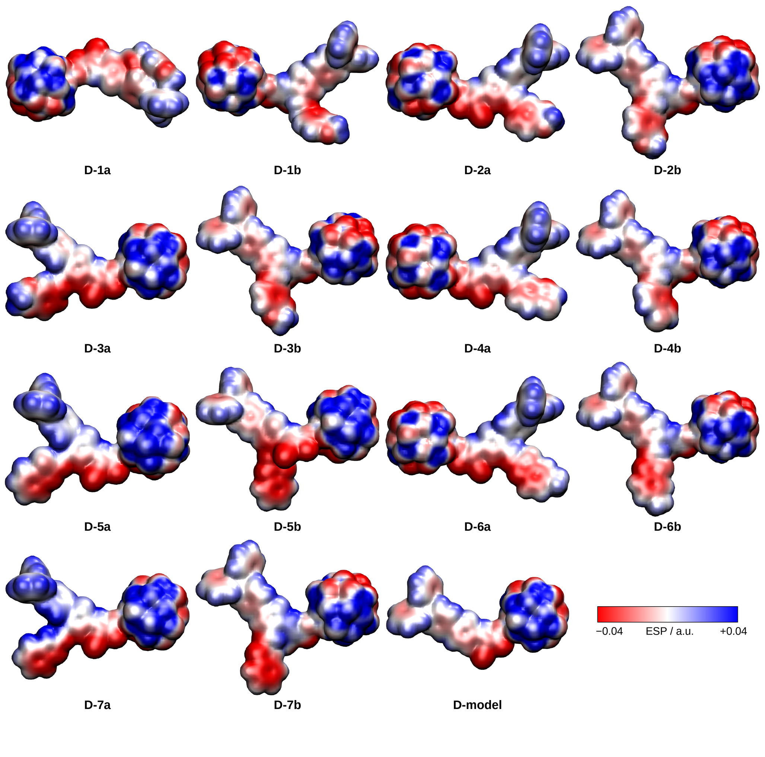
Fig. S7 Electrostatic potential maps of the fifteen dye–(TiO₂)₁₅ complexes, on the scale of Fig. S5
5 Hole-transport polymers: oligomer series and polymer limit
Each family was treated as a length-resolved oligomer series. Vertical ionization potentials were computed at the neutral optimized geometry, with HTM-1 to HTM-4 extended to the decamer and HTM-5 to HTM-7 to the hexamer. Two distinct convergence metrics are reported and must not be conflated: the Tanaka 1/n fit to the ionization potential, computed over the family-specific series length, and the Meier-Stalmach fit to the S₁ excitation energy, computed over n = 1 to 6 for every family so that the optical criterion is defined on an identical range throughout.
Table S13 ΔSCF vertical ionization potentials of the oligomer series
n | HTM-1 | HTM-2 | HTM-3 | HTM-4 | HTM-5 | HTM-6 | HTM-7
1.000 | 5.724 | 5.618 | 5.663 | 6.230 | 6.681 | 6.237 | 6.044
2.000 | 5.741 | 5.627 | 5.676 | 6.250 | 6.446 | 6.215 | 6.043
3.000 | 5.739 | 5.664 | 5.660 | 5.872 | 6.809 | 6.272 | 5.896
4.000 | 5.708 | 5.626 | 5.630 | 5.717 | 6.181 | 6.211 | 5.870
5.000 | 5.766 | 5.576 | 5.551 | 5.631 | 6.226 | 6.176 | 5.954
6.000 | 5.713 | 5.529 | 5.530 | 5.605 | 6.075 | 6.139 | 6.193
7.000 | 5.784 | 5.500 | 5.487 | 5.565
8.000 | 5.752 | 5.509 | 5.474 | 5.590
9.000 | 5.781 | 5.468 | 5.457 | 5.588
10.000 | 5.769 | 5.521 | 5.467 | 5.573
Vertical IP at the neutral optimized geometry.
Table S14 Tanaka 1/n polymer-limit fits and calibrated oxidation potentials
HTM | IP_{inf} / eV | A | R2 (1/n fit) | Data points | n range | IP polymer limit / eV | Eox vs SCE / V | Eox in MeCN / V | Method
HTM-1 | 5.857 | -0.143 | 0.375 | 10 | 1-10 | 5.857 | 1.173 | 1.223 | 1/n fit
HTM-2 | 5.178 | 0.503 | 0.762 | 10 | 1-10 | 5.178 | 0.494 | 0.544 | 1/n fit
HTM-3 | 4.990 | 0.742 | 0.926 | 10 | 1-10 | 4.990 | 0.306 | 0.356 | 1/n fit
HTM-4 | 5.513 | 1.172 | 0.917 | 10 | 1-10 | 5.513 | 0.829 | 0.879 | 1/n fit
HTM-5 | 4.000 | 2.858 | 0.607 | 6 | 1-6 | 6.075 | 1.391 | 1.441 | Hexamer value
HTM-6 | 5.836 | 0.442 | 0.564 | 6 | 1-6 | 6.139 | 1.455 | 1.505 | Hexamer value
HTM-7 | 5.988 | 0.337 | 0.040 | 6 | 1-6 | 6.193 | 1.509 | 1.559 | Hexamer value
For HTM-5 to HTM-7 the 1/n fit is unreliable (R2 = 0.607, 0.564, 0.040) and the hexamer value is adopted directly.
Table S15 Meier-Stalmach optical convergence fits
HTM | Oligomer lengths | E_{inf} / eV | a parameter | R2 (optical) | λ_{inf} / nm
HTM-1 | 6 | 3.106 | 1.689 | 0.864 | 399.234
HTM-2 | 6 | 3.011 | 1.031 | 0.828 | 411.781
HTM-3 | 6 | 3.157 | 0.903 | 0.749 | 392.705
HTM-4 | 6 | 2.946 | 1.315 | 0.796 | 420.810
HTM-5 | 6 | 2.898 | 1.010 | 0.987 | 427.811
HTM-6 | 6 | 2.790 | 1.029 | 0.954 | 444.323
HTM-7 | 6 | 3.004 | 0.995 | 0.967 | 412.749
Computed over n = 1-6 for every family.
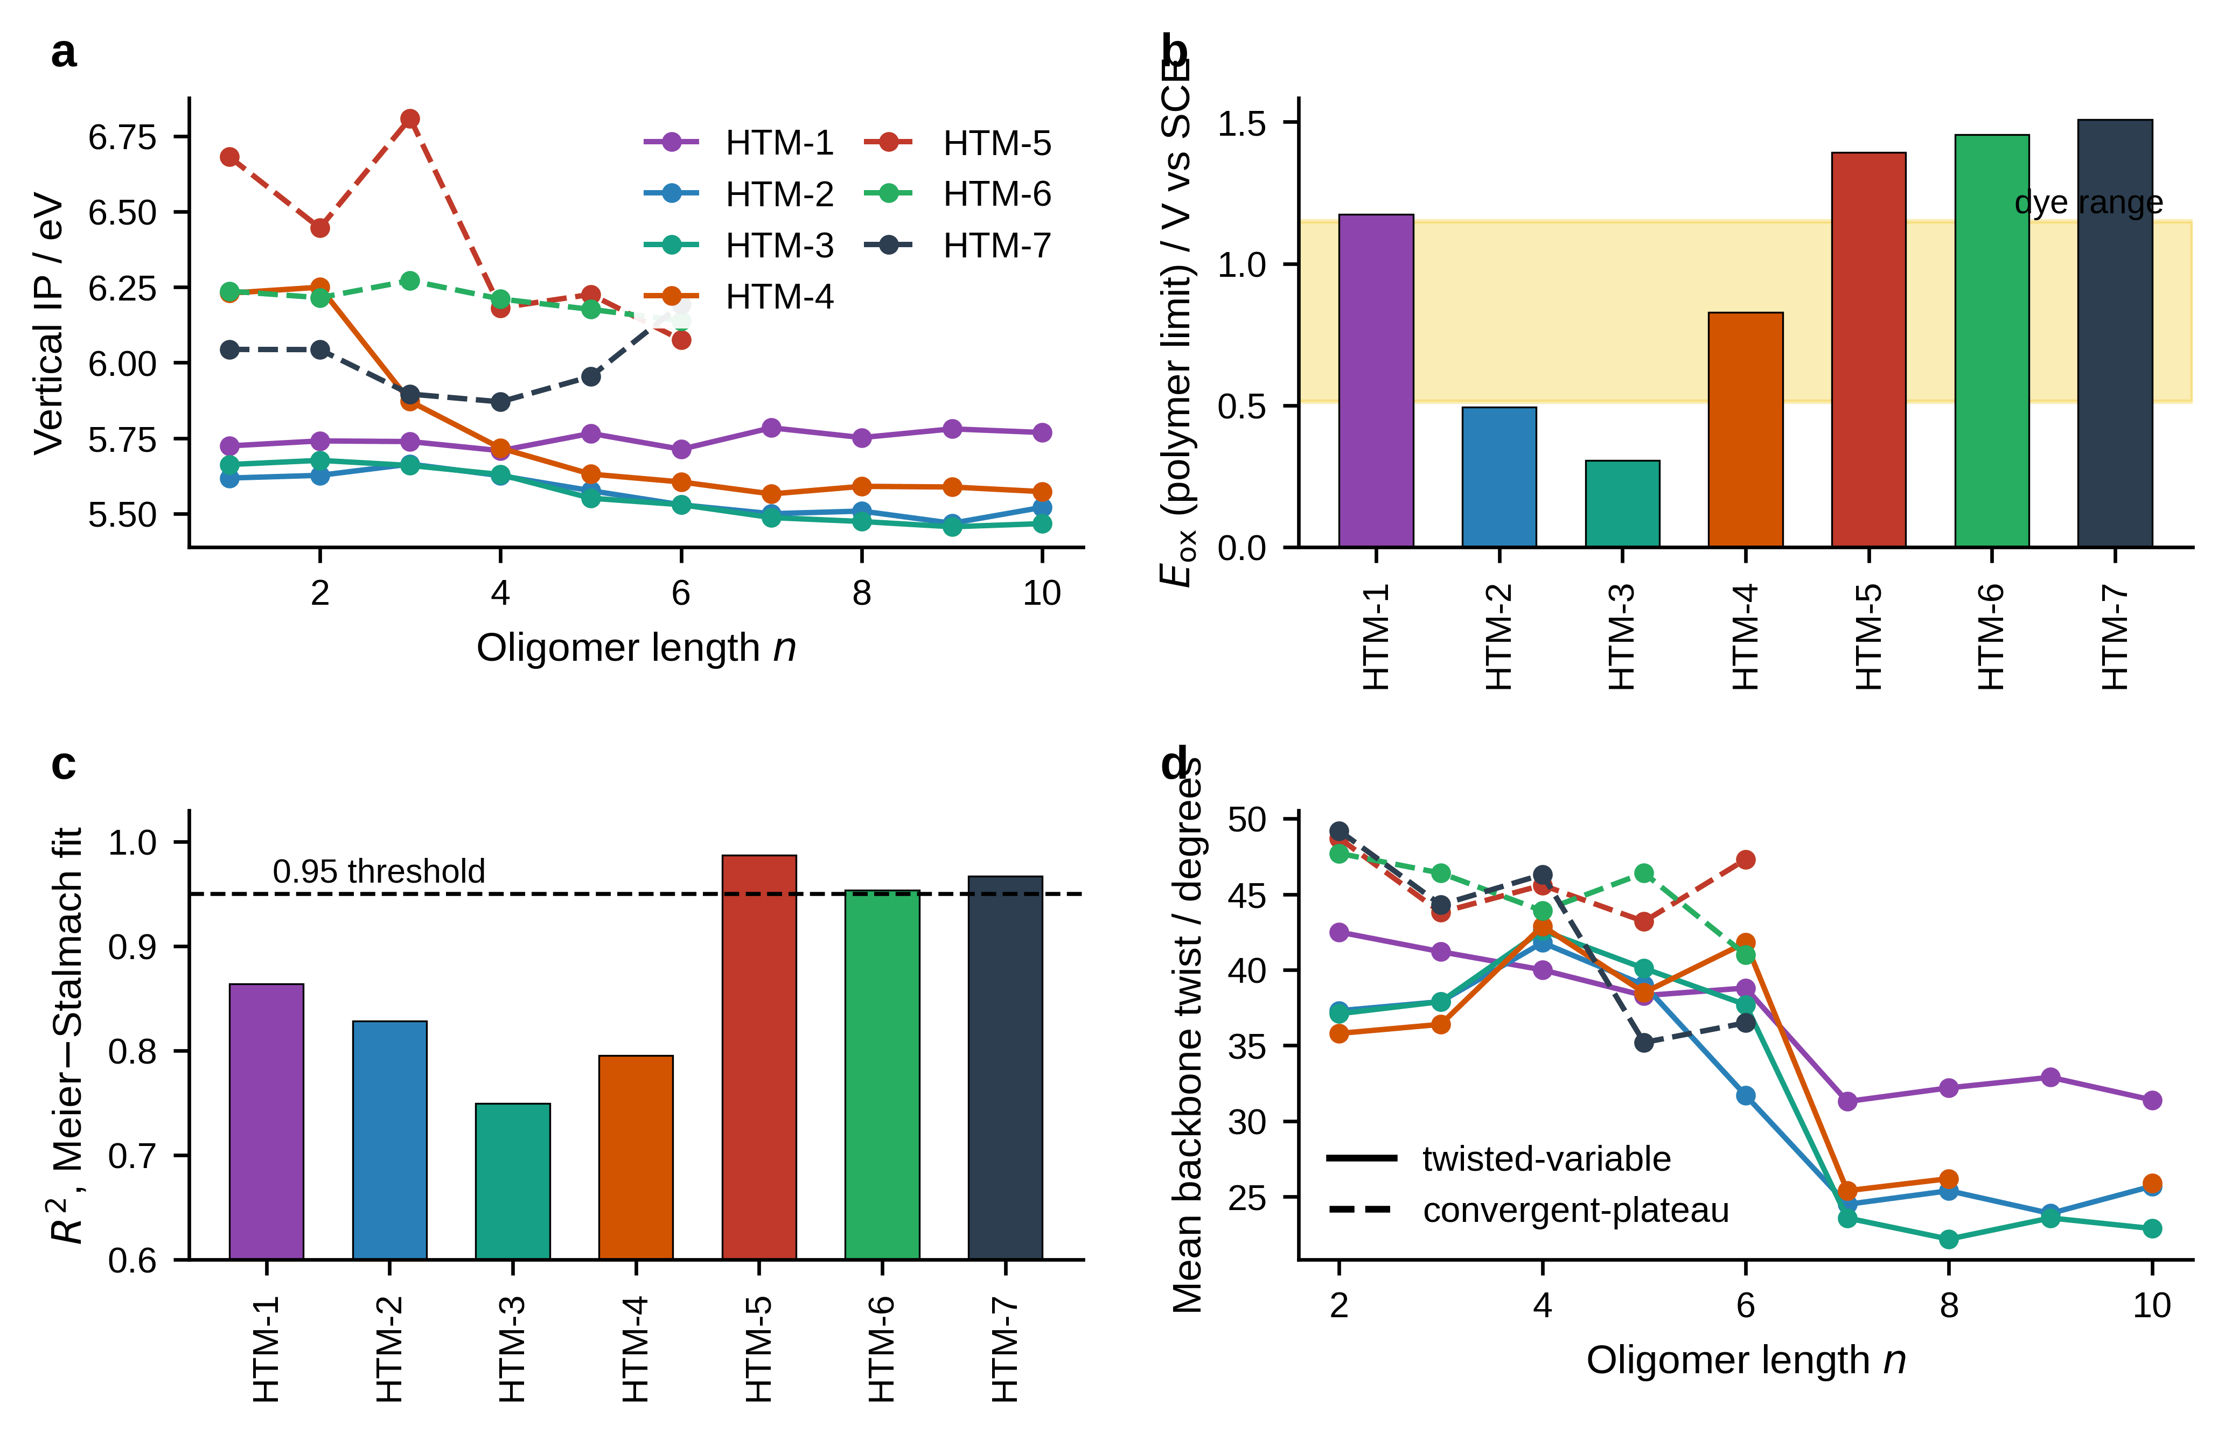
Fig. S8 Convergence behaviour of the seven polymer families. a Vertical ionization potential against oligomer length. b Polymer-limit oxidation potential; the shaded band spans the dye potentials. c Coefficient of determination of the Meier–Stalmach fit, with the 0.95 threshold. d Mean backbone twist against oligomer length. Solid lines, twisted-variable families; dashed lines, convergent-plateau families
5a Backbone conformation of the hexamer models
The convergence classification rests on two independent axes. The optical axis is the quality of the Meier-Stalmach fit (Table S15); the structural axis is the backbone conformation, evaluated at the hexamer for all seven families. The hexamer was chosen because the dihedral profile of polythiophene derivatives converges near n = 5-6, because the convergent-plateau families use the hexamer directly as their polymer-limit estimate, and because it permits a consistent comparison matrix at tractable cost.
Five inter-ring torsions were measured for each hexamer, each defined as the S-C2-C5-S angle between consecutive thiophene rings. The deviation from planarity of each torsion was taken as its angular distance to the nearer ideal plane, min(|φ|, |φ - 180|), so that the metric runs from 0 degrees for a planar backbone to 90 degrees for a perpendicular one. Mean, maximum, root-mean-square and standard deviation were derived from the five values.
The outcome does not follow the magnitude of the twist. At the hexamer the convergent-plateau families average 41.6 degrees against 37.5 degrees for the twisted-variable families, so a criterion based on planarity alone would assign the classes in the opposite sense. What separates them is the stability of the twist along the series: the convergent-plateau families hold a high plateau between 35.2 and 49.2 degrees at every chain length examined, whereas the twisted-variable families evolve and fall sharply beyond n = 6.
The full length dependence is given in Table S45. The twisted-variable families rise to a maximum near n = 4, between 40.0 and 42.9 degrees, and then fall abruptly beyond n = 6 to between 23.1 and 32.0 degrees, a drop of roughly fifteen degrees that marks a conformational rearrangement rather than a gradual relaxation. The convergent-plateau families show no such transition over the lengths computed, remaining between 35.2 and 49.2 degrees throughout. The irregular optical convergence of the twisted-variable families has its structural origin here: a backbone whose geometry changes qualitatively with chain length cannot produce a smooth exponential approach to the polymer limit.
Table S42 Backbone twist of the hexamer models
HTM | Convergence class | Mean backbone twist at the hexamer / degrees
HTM-1 | Twisted-variable | 38.800
HTM-2 | Twisted-variable | 31.700
HTM-3 | Twisted-variable | 37.700
HTM-4 | Twisted-variable | 41.800
HTM-5 | Convergent-plateau | 47.300
HTM-6 | Convergent-plateau | 41.000
HTM-7 | Convergent-plateau | 36.500
Backbone twist is the mean deviation of the five inter-ring dihedral angles from the nearest planar configuration, each angle defined as the S-C2-C5-S torsion between consecutive thiophene rings. The convergent-plateau families are the more twisted of the two at this chain length, so the classification does not follow the magnitude of the twist.
Table S45 Backbone twist as a function of oligomer length
HTM | Convergence class | n = 2 | n = 3 | n = 4 | n = 5 | n = 6 | n = 7 | n = 8 | n = 9 | n = 10
HTM-1 | Twisted-variable | 42.500 | 41.200 | 40.000 | 38.300 | 38.800 | 31.300 | 32.200 | 32.900 | 31.400
HTM-2 | Twisted-variable | 37.300 | 37.900 | 41.800 | 39.000 | 31.700 | 24.500 | 25.400 | 23.900 | 25.700
HTM-3 | Twisted-variable | 37.100 | 37.900 | 42.600 | 40.100 | 37.700 | 23.600 | 22.200 | 23.600 | 22.900
HTM-4 | Twisted-variable | 35.800 | 36.400 | 42.900 | 38.500 | 41.800 | 25.400 | 26.200 |  | 25.900
HTM-5 | Convergent-plateau | 48.700 | 43.800 | 45.600 | 43.200 | 47.300
HTM-6 | Convergent-plateau | 47.700 | 46.400 | 43.900 | 46.400 | 41.000
HTM-7 | Convergent-plateau | 49.200 | 44.300 | 46.300 | 35.200 | 36.500
Mean deviation of the inter-ring torsions from the nearer planar configuration, in degrees. The twisted-variable families peak near n = 4 and fall abruptly beyond n = 6, from about 40 to about 25 degrees; the convergent-plateau families hold a high plateau throughout. Empty cells indicate chain lengths not computed for that family; the nonamer of HTM-4 did not converge geometrically.
6 Regeneration feasibility
The regeneration criterion requires the hole-transport material to be more easily oxidized than the dye, that is ΔE_{ox} = Eox(dye) - Eox(HTM) > 0. Both sides of the comparison derive from ΔSCF ionization potentials converted to the SCE scale with the same calibration constant, so the difference is independent of the reference offset. Thirty-two of the 105 nominal pairs satisfy the criterion. HTM-2 and HTM-3 are compatible with all fifteen dyes, HTM-4 with D-1a and D-3b only, and HTM-1 together with HTM-5 to HTM-7 with none.
The pair D-2b and D-3b merits particular attention. The two have effectively identical frontier-orbital energies and therefore identical device inputs, yet their ΔSCF oxidation potentials differ by 0.46 V because they respond differently to orbital relaxation upon ionization. Against HTM-4 the pair is resolved into one feasible and one infeasible combination at identical simulated efficiency.
Table S17 Regeneration driving force ΔE_{ox} for all 105 dye-HTM pairs
Dye | Eox(dye) / V | HTM-1 | HTM-2 | HTM-3 | HTM-4 | HTM-5 | HTM-6 | HTM-7
D-1a | 0.845 | -0.328 | 0.352 | 0.539 | 0.016 | -0.546 | -0.609 | -0.664
D-1b | 0.781 | -0.393 | 0.287 | 0.475 | -0.048 | -0.610 | -0.674 | -0.728
D-2a | 0.670 | -0.503 | 0.177 | 0.364 | -0.159 | -0.721 | -0.784 | -0.839
D-2b | 0.689 | -0.485 | 0.195 | 0.383 | -0.140 | -0.703 | -0.766 | -0.820
D-3a | 0.721 | -0.453 | 0.227 | 0.415 | -0.108 | -0.670 | -0.734 | -0.788
D-3b | 1.149 | -0.025 | 0.655 | 0.843 | 0.320 | -0.243 | -0.306 | -0.360
D-4a | 0.569 | -0.604 | 0.076 | 0.263 | -0.260 | -0.822 | -0.885 | -0.940
D-4b | 0.520 | -0.653 | 0.027 | 0.214 | -0.309 | -0.871 | -0.934 | -0.989
D-5a | 0.589 | -0.584 | 0.096 | 0.283 | -0.240 | -0.802 | -0.865 | -0.920
D-5b | 0.524 | -0.649 | 0.031 | 0.218 | -0.305 | -0.867 | -0.931 | -0.985
D-6a | 0.587 | -0.586 | 0.094 | 0.281 | -0.242 | -0.804 | -0.867 | -0.922
D-6b | 0.519 | -0.655 | 0.025 | 0.213 | -0.310 | -0.872 | -0.936 | -0.990
D-7a | 0.589 | -0.585 | 0.095 | 0.283 | -0.240 | -0.802 | -0.866 | -0.920
D-7b | 0.527 | -0.647 | 0.033 | 0.221 | -0.302 | -0.865 | -0.928 | -0.982
D-model | 0.513 | -0.660 | 0.019 | 0.207 | -0.316 | -0.878 | -0.942 | -0.996
ΔE_{ox} = Eox(dye) - Eox(HTM); 32 of 105 pairs are admissible.
7 Device simulation: parameters and sweep packages
The device stack is FTO / compact TiO₂ / dye-sensitized absorber / HTM / metal contact, with illumination entering from the FTO side. Layer parameters are collected in Table S24 and the contact and simulation settings in Table S25. Quantities accessible from the molecular calculations were propagated directly: the HTM HOMO from the polymer-limit ionization potential, the dye electron affinity and gap from the corresponding molecular values. Transport, doping, dielectric and defect parameters were assigned from calibrated literature values for analogous polythiophene and mesoporous TiO₂ systems.
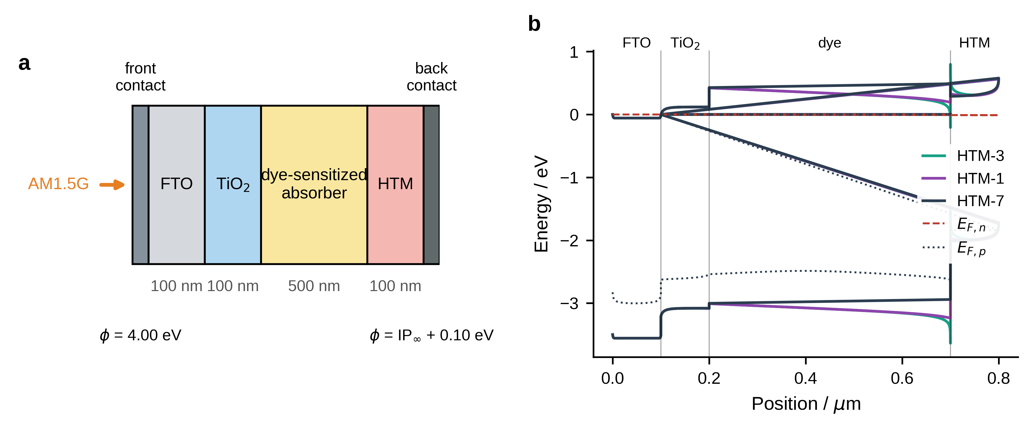
Fig. S9 Simulated device. a Layer stack, with the thickness of each layer marked; box widths are drawn for legibility and are not to scale. The electron-collecting contact is fixed at 4.00 eV and the hole-collecting contact tracks the polymer ionization potential. b Energy band diagram at open circuit for D-1a with three polymers spanning the range of contact alignment, with the quasi-Fermi levels of HTM-3 shown
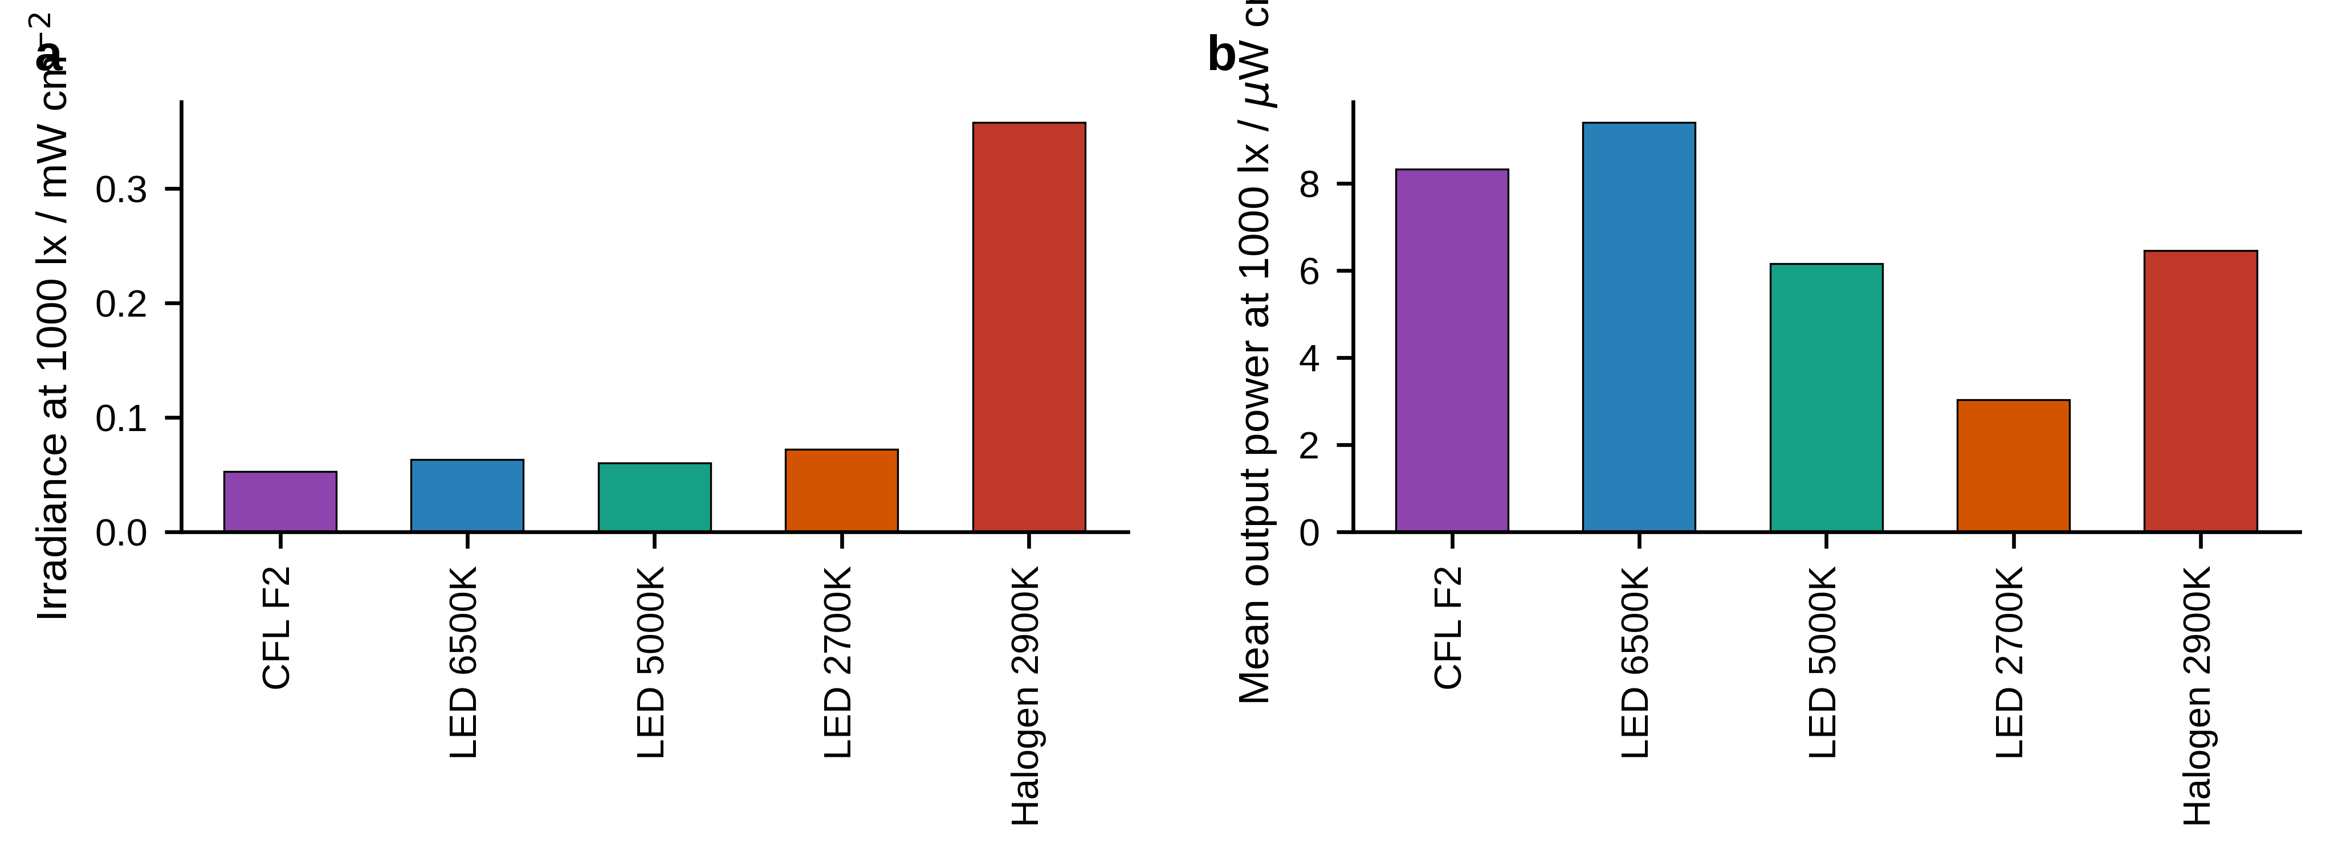
Fig. S10 Indoor sources at 1000 lx. a Irradiance required to reach that illuminance, which differs by a factor of seven between the coolest and warmest sources. b Mean output power density over the 105 pairs
The twelve highest simulated efficiencies are listed in Table S46. Every one of them fails the regeneration criterion, so the entire top of the unfiltered ranking is populated by devices that cannot operate. Table S47 carries the same point to the dye level: averaging each dye over all seven polymers gives one ordering, and averaging only over the pairs it can actually form gives another, and the two are not significantly correlated (Spearman ρ = 0.43, p = 0.11). D-1a moves from last of fifteen to first, because its unfiltered mean is depressed by the fill-factor collapse it suffers with HTM-6 and HTM-7, pairings that are infeasible in any case.
Two aspects of the parameterization govern the reported ordering and are stated explicitly. The electron-collecting contact is held at 4.00 eV throughout, while the hole-collecting metal contact is aligned 0.10 eV below the HTM HOMO, so the built-in potential varies from 1.09 V for HTM-3 to 2.29 V for HTM-7. The simulated open-circuit voltage follows that quantity at r = 0.99 across the matrix and at r = 1.00 across the four polymers below the saturation threshold. The dominance of the normalized HOMO offset in the SHAP attribution is therefore the recovery of a relation built into the model inputs rather than an independent finding.
The simulation campaign comprises 4361 device configurations distributed over six sweep packages (Table S26). Beyond the 105-pair matrix reported in the main text, these establish the sensitivity of the ranking to bulk trap density, absorber thickness, carrier mobility and illumination spectrum. Two results bear on the interpretation of the main text. Efficiency falls monotonically with absorber thickness across the whole matrix, from a mean of 7.40 % at 200 nm to 6.88 % at 1000 nm, the lengthening recombination path outweighing the additional absorption. Substituting polymer-specific Marcus-derived hole mobilities (0.061-0.504 cm² V⁻¹ s⁻¹) for a uniform reference value changes the efficiency by at most 0.07 percentage points, so the ordering is insensitive to the mobility assumption and is governed by the level alignment alone.
The descriptor matrix comprises 105 rows, one per dye-HTM pair, and 51 columns grouped into eight physicochemical categories (Table S40). Eight of the descriptors are derived combinations built by hand rather than generated automatically, encoding the band-alignment quantities and the convergence-class indicator that the preceding sections identify as relevant. Five independent validation protocols were applied (Table S41); their outcomes bound what the model may be used for.
Table S46 Highest simulated efficiencies in the unfiltered matrix
Dye | HTM | η / % | Voc / V | Jsc / mA cm⁻² | FF / % | ΔE_{ox} / V
D-3a | HTM-1 | 9.452 | 1.818 | 5.837 | 89.063 | -0.452
D-2a | HTM-1 | 9.452 | 1.818 | 5.837 | 89.064 | -0.503
D-4a | HTM-1 | 9.448 | 1.818 | 5.836 | 89.020 | -0.604
D-7a | HTM-1 | 9.428 | 1.818 | 5.836 | 88.852 | -0.584
D-6a | HTM-5 | 9.407 | 1.806 | 5.868 | 88.769 | -0.804
D-5a | HTM-5 | 9.404 | 1.806 | 5.868 | 88.755 | -0.802
D-5a | HTM-1 | 9.379 | 1.817 | 5.835 | 88.447 | -0.584
D-6a | HTM-1 | 9.373 | 1.817 | 5.835 | 88.393 | -0.586
D-7a | HTM-5 | 9.366 | 1.803 | 5.868 | 88.506 | -0.802
D-6a | HTM-6 | 9.321 | 1.802 | 5.877 | 87.998 | -0.868
D-5a | HTM-6 | 9.311 | 1.802 | 5.877 | 87.913 | -0.866
D-4a | HTM-5 | 9.302 | 1.802 | 5.869 | 87.970 | -0.822
Reference configuration: uniform hole mobility, 500 nm absorber, lowest trap density. ΔE_{ox} is given for reference; every device in this list fails the regeneration criterion, so none is realizable.
Table S47 Dye-level mean efficiency before and after the feasibility filter
Dye | Mean η, all seven HTMs / % | Mean η, feasible pairs only / % | Rank (all) | Rank (feasible)
D-1a | 6.220 | 6.830 | 15 | 1
D-2a | 7.550 | 5.710 | 7 | 2
D-3a | 7.600 | 5.680 | 6 | 3
D-4a | 7.720 | 5.600 | 4 | 4
D-7a | 7.840 | 5.480 | 3 | 5
D-5a | 7.890 | 5.320 | 1 | 6
D-6a | 7.890 | 5.310 | 1 | 7
D-3b | 7.200 | 5.140 | 10 | 8
D-1b | 7.640 | 4.970 | 5 | 9
D-4b | 7.510 | 4.690 | 8 | 10
D-model | 7.250 | 4.530 | 9 | 11
D-2b | 7.200 | 4.450 | 10 | 12
D-6b | 7.060 | 4.190 | 12 | 13
D-5b | 7.050 | 4.180 | 13 | 14
D-7b | 6.570 | 3.710 | 14 | 15
Reference configuration. The unfiltered mean covers all seven polymers; the filtered mean covers only the pairs satisfying ΔE_{ox} > 0, which is HTM-2 and HTM-3 for every dye and additionally HTM-4 for D-1a and D-3b. The two orderings are not significantly correlated (Spearman ρ = 0.43, p = 0.11).
Table S24 SCAPS-1D layer parameters
Parameter | FTO | compact TiO₂ | dye-sensitized layer | HTM
Thickness d / nm | 100 | 100 | 500 | 100
Dielectric permittivity | 9.0 | 10.0 | 10.0 | 10.0
Electron affinity χ / eV | 4.00 | 4.00 | 3.69 (dye-specific) | IP(HTM) - 2.30
Band gap Eg / eV | 3.50 | 3.20 | 3.43 (dye-specific) | 2.30 (fixed)
N_{C} / cm⁻³ | 2.2e18 | 1.0e19 | 1.0e20 | 1.0e19
N_{V} / cm⁻³ | 1.8e19 | 1.0e19 | 1.0e20 | 1.0e19
μ_{n} / cm² V⁻¹ s⁻¹ | 33 | 20 | 1.0 | 1.0
μ_{p} / cm² V⁻¹ s⁻¹ | 8.0 | 10 | 1.0 | 0.061-0.504 (Marcus)
Uniform trap density Nt / cm⁻³ | 1.0e15 | 1.0e15 | 1.0e16 | 1.0e15
Capture cross-section / cm² | 1.0e-14 | 1.0e-14 | 1.0e-14 | 1.0e-14
Trap level Et above E_{V} / eV | 0.60 | 0.60 | 0.60 | 0.60
Values shown for the reference device; the electron affinity and band gap of the dye layer are dye-specific and the HTM electron affinity follows from χ = IP - Eg with Eg fixed at 2.30 eV.
Table S25 SCAPS-1D contact and simulation settings
Setting | Value
Front contact (electron-collecting) work function / eV | 4.00 (fixed for all 105 devices)
Back contact (hole-collecting) work function / eV | IP(HTM) + 0.10; 5.09 (HTM-3) to 6.29 (HTM-7)
Surface recombination velocity Sn, Sp / cm s⁻¹ | 1.0e7
Interface defect density (dye/HTM) / cm⁻² | 1.0e11 reference; swept 1e10-1e13
Interface capture cross-section / cm² | 1.0e-19
Operating temperature / K | 300
Voltage scan | 0 V to Voc, 0.005 V steps, forward bias
Series / shunt resistance | not applied
Illumination | AM1.5G, 100 mW cm⁻², from the FTO side
The hole-collecting contact is aligned 0.10 eV below the HTM HOMO, so the built-in potential varies with the polymer from 1.09 to 2.29 V.
Table S26 Inventory of the SCAPS-1D sweep packages
Package | Swept parameter | Range | Configurations
P1 low Nt | Bulk trap density | 6 levels, 1e10-1e13 cm⁻³ | 630
P1 high Nt | Bulk trap density | 4 levels, 1e20-1e23 cm⁻³ | 420
P2 thickness | Absorber thickness | 5 levels, 200-1000 nm | 346 of 525
P3 Marcus | HTM hole mobility from Marcus scaling | 105 pairs | 105
P4 AM1.5G | Uniform reference mobility 0.400 cm² V⁻¹ s⁻¹ | 105 pairs | 105
Indoor sweep | 5 light sources x 5 illuminance levels | 50-1000 lx | 2625
Total 4361 configurations. Of the 525 thickness targets, 346 converged; the remainder reached the Newton-Raphson convergence limit and are reported as such.
Table S32 Effect of the Marcus-derived hole mobility on the simulated efficiency
Dye | HTM | η_{pct} (Marcus μ) | η_{pct} (uniform μ) | Difference
D-1a | HTM-1 | 9.264 | 9.285 | -0.021
D-1a | HTM-2 | 6.583 | 6.595 | -0.013
D-1a | HTM-3 | 5.577 | 5.577 | 0.000
D-1a | HTM-4 | 8.317 | 8.318 | -0.001
D-1a | HTM-5 | 7.099 | 7.100 | -0.001
D-1a | HTM-6 | 4.420 | 4.421 | -0.000
D-1a | HTM-7 | 2.263 | 2.263 | 0.000
D-1b | HTM-1 | 8.958 | 9.019 | -0.060
D-1b | HTM-2 | 5.455 | 5.466 | -0.011
D-1b | HTM-3 | 4.481 | 4.481 | 0.000
D-1b | HTM-4 | 7.136 | 7.137 | -0.001
D-1b | HTM-5 | 9.190 | 9.188 | 0.001
Substituting polymer-specific Marcus mobilities for a uniform reference value changes the efficiency by at most 0.07 percentage points, so the device ranking is insensitive to the mobility assumption.
Table S40 Taxonomy of the 51-descriptor matrix
Category | Features | Representative descriptors
(i) Dye electronic baseline | 12 | HOMO, LUMO, gap, dipole moment, BLA, IP(vertical), λ_{max}, E(S₁), LHE
(ii) Charge-transfer metrics | 11 | D index, t index, Sr, Sm, HDI, EDI, CT(S₁), τ_{S1}
(iii) Marcus reorganization | 5 | λ_{h}, λ_{e}, their ratio and component terms
(iv) Nonlinear optics and adsorption | 5 | α_{iso}, β_{total}, E_{ads} on (TiO₂)₅ and (TiO₂)₁₅, dye dipole
(v) Polymer parameters | 6 | IP_{inf}, Eox(SCE), R2 (convergence), oligomer count, plateau indicator
(vi) Thermodynamic composites | 3 | level-alignment photovoltage bound, ΔG_{reg}, ΔG_{inj}
(vii) Derived combinations | 8 | ΔE_{ox}(pair), ΔHOMO, λ_{h}/λ_{e}, LHE x f_{max}, IP_{inf}/R2
(viii) Multi-criteria composite | 1 | composite ranking score
Descriptor matrix of 105 rows and 51 columns, one row per dye-HTM pair. The derived combinations of category (vii) encode domain knowledge rather than being generated automatically.
Table S41 Cross-validation protocols and generalization scenarios
Protocol | Generalization scenario | R2 (efficiency) | R2 (robustness) | Outcome
Random five-fold | In-domain prediction | 0.991 | 0.903 | Reproduces the data structure
Leave-one-dye-out | Extrapolation to a new dye | 0.782 | 0.872 | Usable
Leave-one-HTM-out | Extrapolation to a new polymer | -1.013 | 0.337 | Fails for efficiency; weak for robustness
Bootstrap top-five (B = 1000) | Ranking stability | - | - | Interpretive
Permutation importance | Feature contribution | - | - | Interpretive
Both targets from the same 51-descriptor random-forest model, so the two columns are directly comparable. The failure under leave-one-HTM-out establishes that the model is interpretive rather than predictive outside the sampled polymer families.
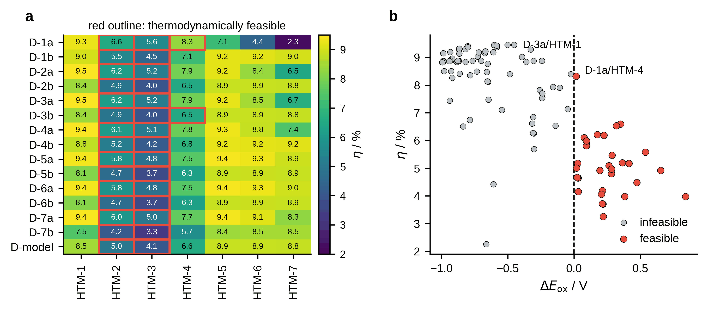
Fig. S11 Simulated device matrix. a Power-conversion efficiency for all 105 pairs, with the thirty-two thermodynamically feasible combinations outlined in red. b Efficiency against regeneration driving force; the dashed line is the feasibility threshold
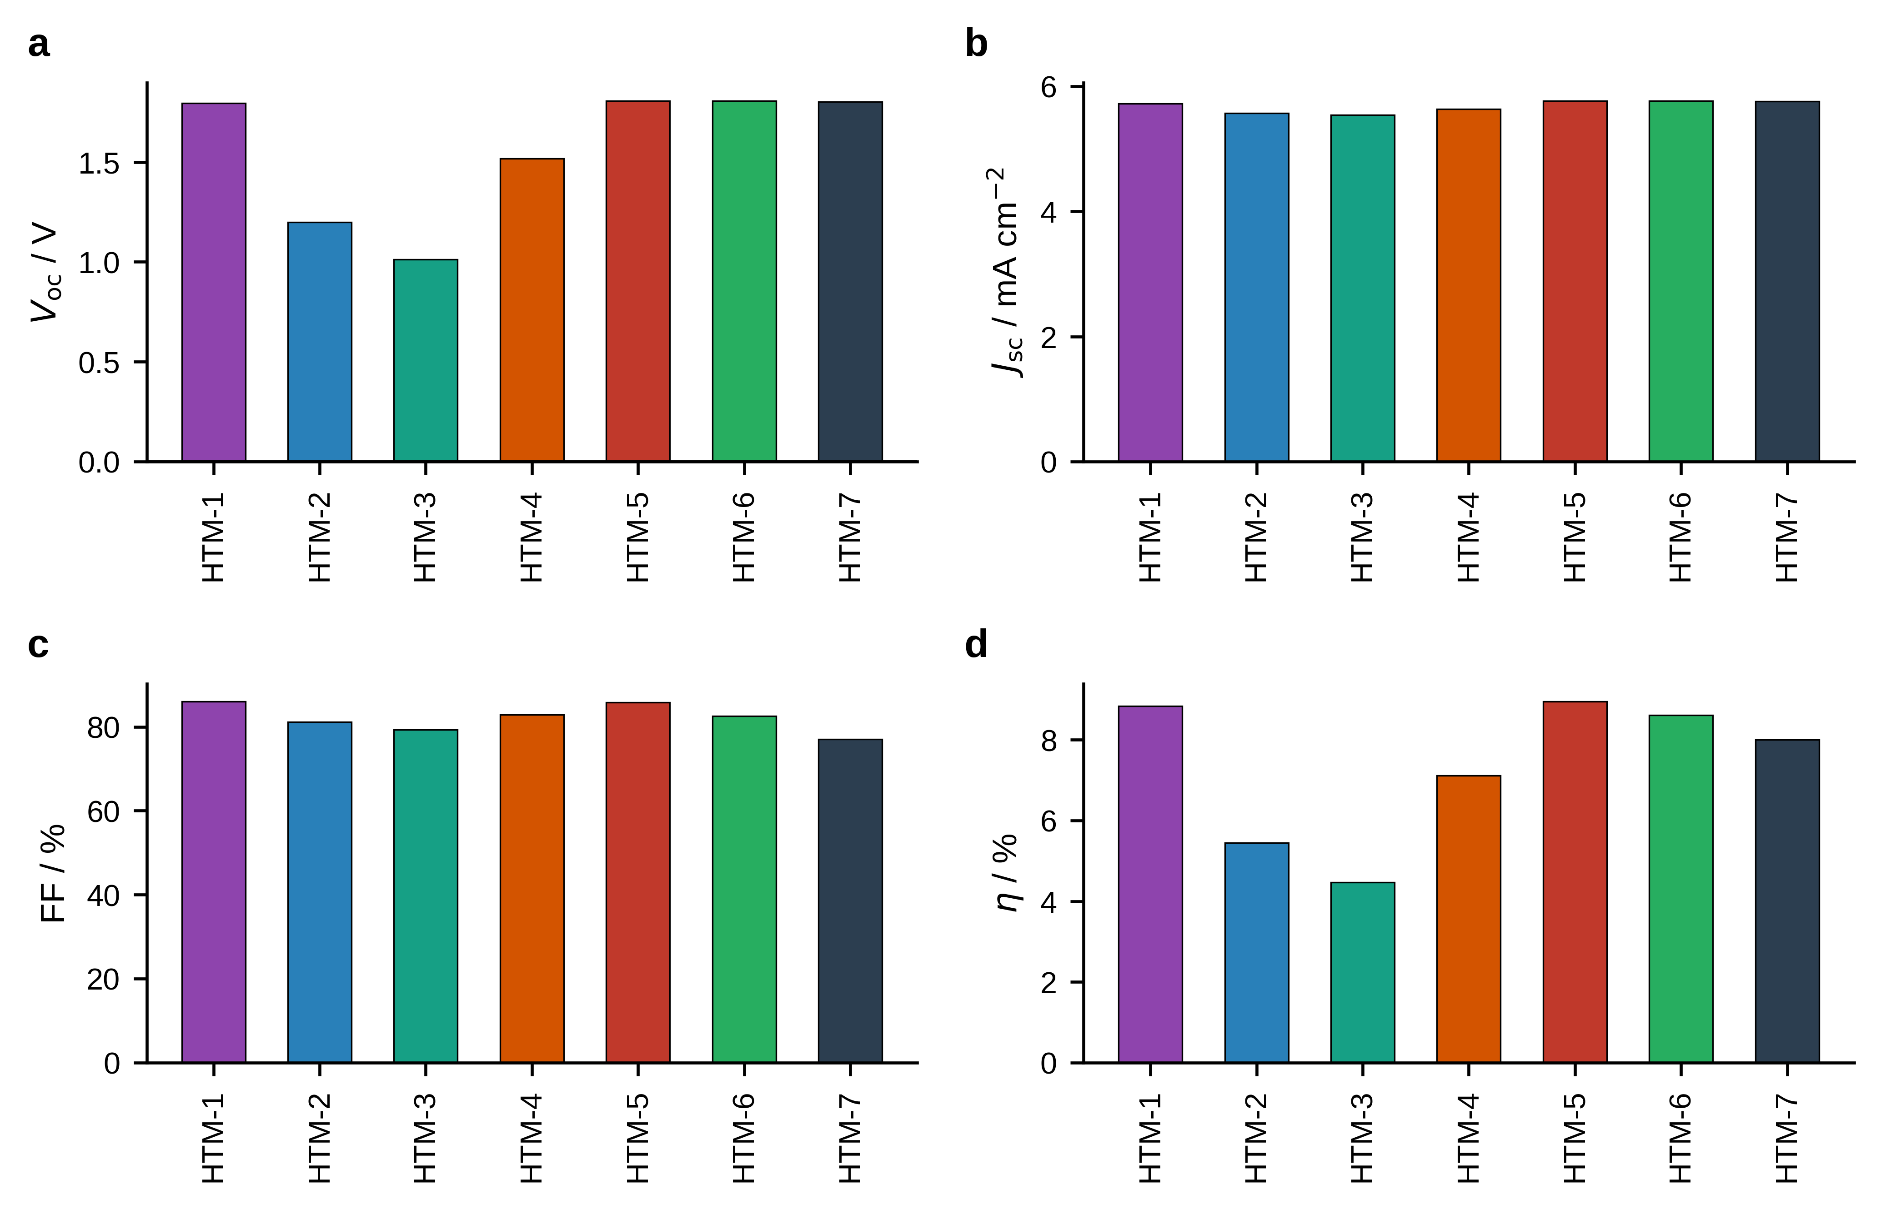
Fig. S12 Photovoltaic parameters averaged over the fifteen dyes for each polymer. a Open-circuit voltage. b Short-circuit current density. c Fill factor. d Power-conversion efficiency
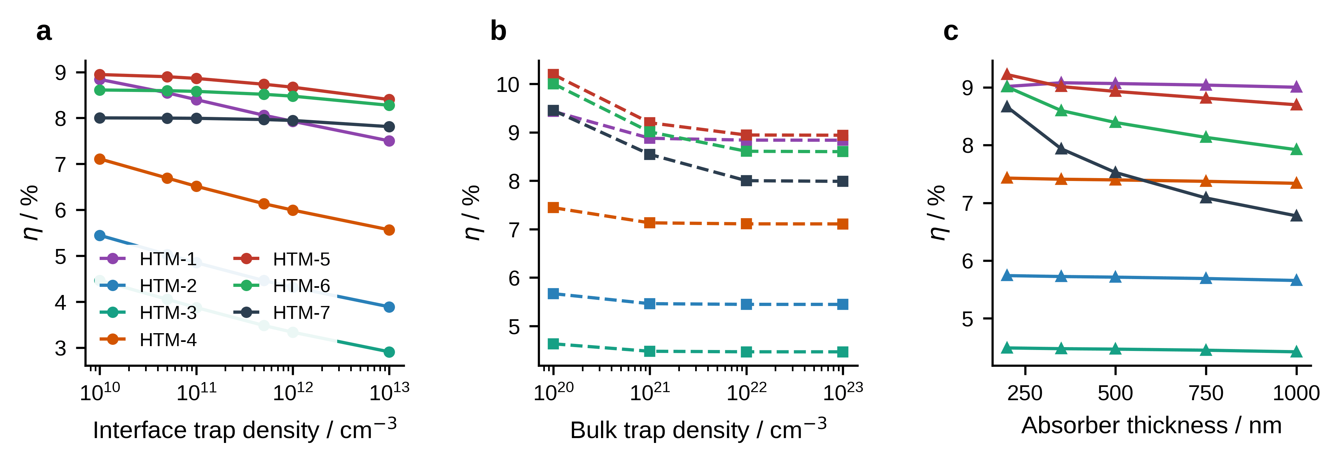
Fig. S13 Sensitivity of the simulated efficiency, averaged over the fifteen dyes. a Interface trap density. b Bulk trap density in the degenerate limit. c Absorber thickness
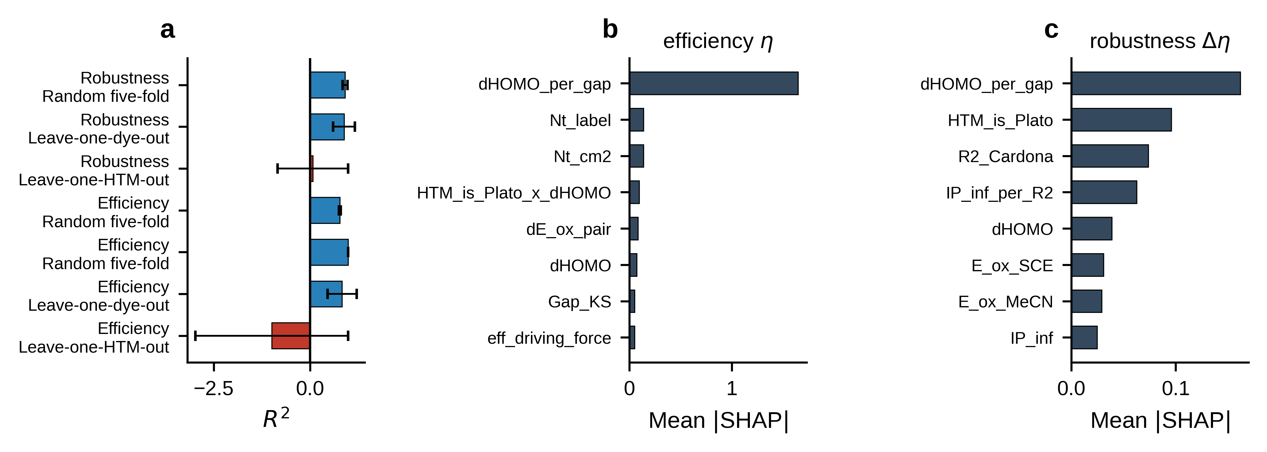
Fig. S14 Data-driven analysis. a Cross-validation performance under the five protocols, with standard deviations; red marks the protocols the model fails. b Mean absolute SHAP attributions for the efficiency model. c The same for the robustness model
8 Indoor photovoltaic performance
Dye-sensitized cells are of particular interest for ambient-light energy harvesting, where the emission spectrum is narrow and the irradiance is several orders of magnitude below one sun. The full matrix was therefore simulated under five artificial sources (CFL F2, halogen 2900 K, and LED at 2700, 5000 and 6500 K) at five illuminance levels between 50 and 1000 lx, giving 2625 configurations. Spectra were derived from ASTM E927-19 reference templates and calibrated to the photopic response.
Performance is governed by spectral match rather than by illuminance. At 1000 lx the matrix mean efficiency is 15.78 % under CFL F2 and 14.86 % under the 6500 K LED, falling to 4.19 % under the 2700 K LED and 1.80 % under halogen, an eightfold range across sources at identical illuminance. Across the 50 to 1000 lx range the mean efficiency of any given source varies by roughly one percentage point. The origin is the overlap between the emission of the cool sources in the blue and near-ultraviolet and the absorption of these dyes, which lies between 361 and 414 nm; the warm sources and the halogen lamp emit predominantly in the red and near-infrared, where these sensitizers do not absorb.
The efficiencies obtained under indoor illumination exceed those under AM1.5G for every device, the leading pair reaching 21.00 % under CFL F2 at 1000 lx against 9.28 % under one sun. Two effects contribute: the narrow indoor spectrum overlaps the dye absorption window far more completely than the broad solar spectrum, and the low photon flux reduces the thermalization losses associated with high-energy solar photons. The absolute output power density is nevertheless of the order of 10 μW cm⁻², which is the quantity relevant to device operation and is reported in Table S29.
One consistency point requires emphasis. The pair leading the indoor ranking under every source is D-1a/HTM-1, and HTM-1 regenerates none of the fifteen dyes. The indoor ranking therefore carries the same caveat as the AM1.5G ranking of Section 3.9: it is a map of how the level alignment acts within the device model and not a ranking of realizable cells. Applying the regeneration filter to the indoor matrix leaves the same 32 admissible pairs.
Table S27 Mean simulated efficiency under the five indoor sources across the illuminance range
Source | 50 | 100 | 200 | 500 | 1000
CFL F2 | 14.690 | 14.940 | 15.190 | 15.520 | 15.780
Halogen 2900K | 1.680 | 1.710 | 1.740 | 1.770 | 1.800
LED 2700K | 3.890 | 3.960 | 4.030 | 4.120 | 4.190
LED 5000K | 9.480 | 9.640 | 9.810 | 10.020 | 10.190
LED 6500K | 13.830 | 14.070 | 14.300 | 14.620 | 14.860
Efficiencies rise weakly with illuminance and are governed almost entirely by the spectral match between source emission and dye absorption.
Table S28 Best-performing device under each indoor source at 1000 lx
Source | Dye | HTM | Voc / V | Jsc / mA cm⁻² | FF / % | η / % | P_{out} / μW cm⁻² | Matrix mean η / %
CFL F2 | D-1a | HTM-1 | 1.629 | 0.007 | 91.491 | 20.995 | 11.086 | 15.780
LED 6500K | D-1a | HTM-1 | 1.632 | 0.008 | 91.495 | 19.681 | 12.458 | 14.860
LED 5000K | D-1a | HTM-1 | 1.621 | 0.006 | 91.375 | 13.527 | 8.170 | 10.190
LED 2700K | D-1a | HTM-1 | 1.603 | 0.003 | 90.946 | 5.583 | 4.036 | 4.190
Halogen 2900K | D-1a | HTM-1 | 1.623 | 0.006 | 89.012 | 2.417 | 8.657 | 1.800
The same dye-HTM pair leads under every source. Note that this pair fails the regeneration criterion (ΔE_{ox} < 0), so the indoor ranking carries the same caveat as the AM1.5G ranking.
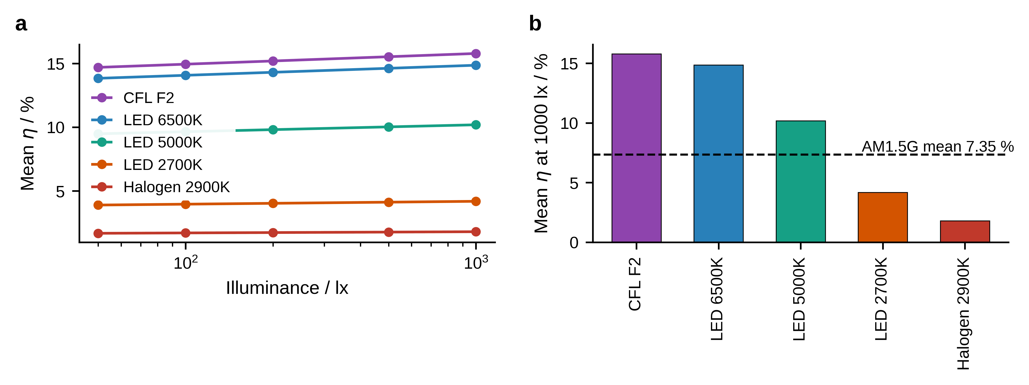
Fig. S15 Indoor photovoltaic response. a Mean efficiency against illuminance for the five artificial sources. b Mean efficiency at 1000 lx; the dashed line is the AM1.5G mean over the same matrix
8a Frontier orbitals
Frontier orbitals are plotted at an isovalue of 0.02 a.u. For the dyes the HOMO is confined to the triphenylamine donor and the bridge in every case, while the LUMO occupies the acceptor end; on the larger cluster the LUMO moves onto the titania, which is the orbital counterpart of the fragment charge-transfer percentages of Table S43. For the polymers the frontier orbitals delocalize along the backbone with consistent π and π* character at every chain length, and the electrostatic potential tracks the heteroatoms of the pendant donor.
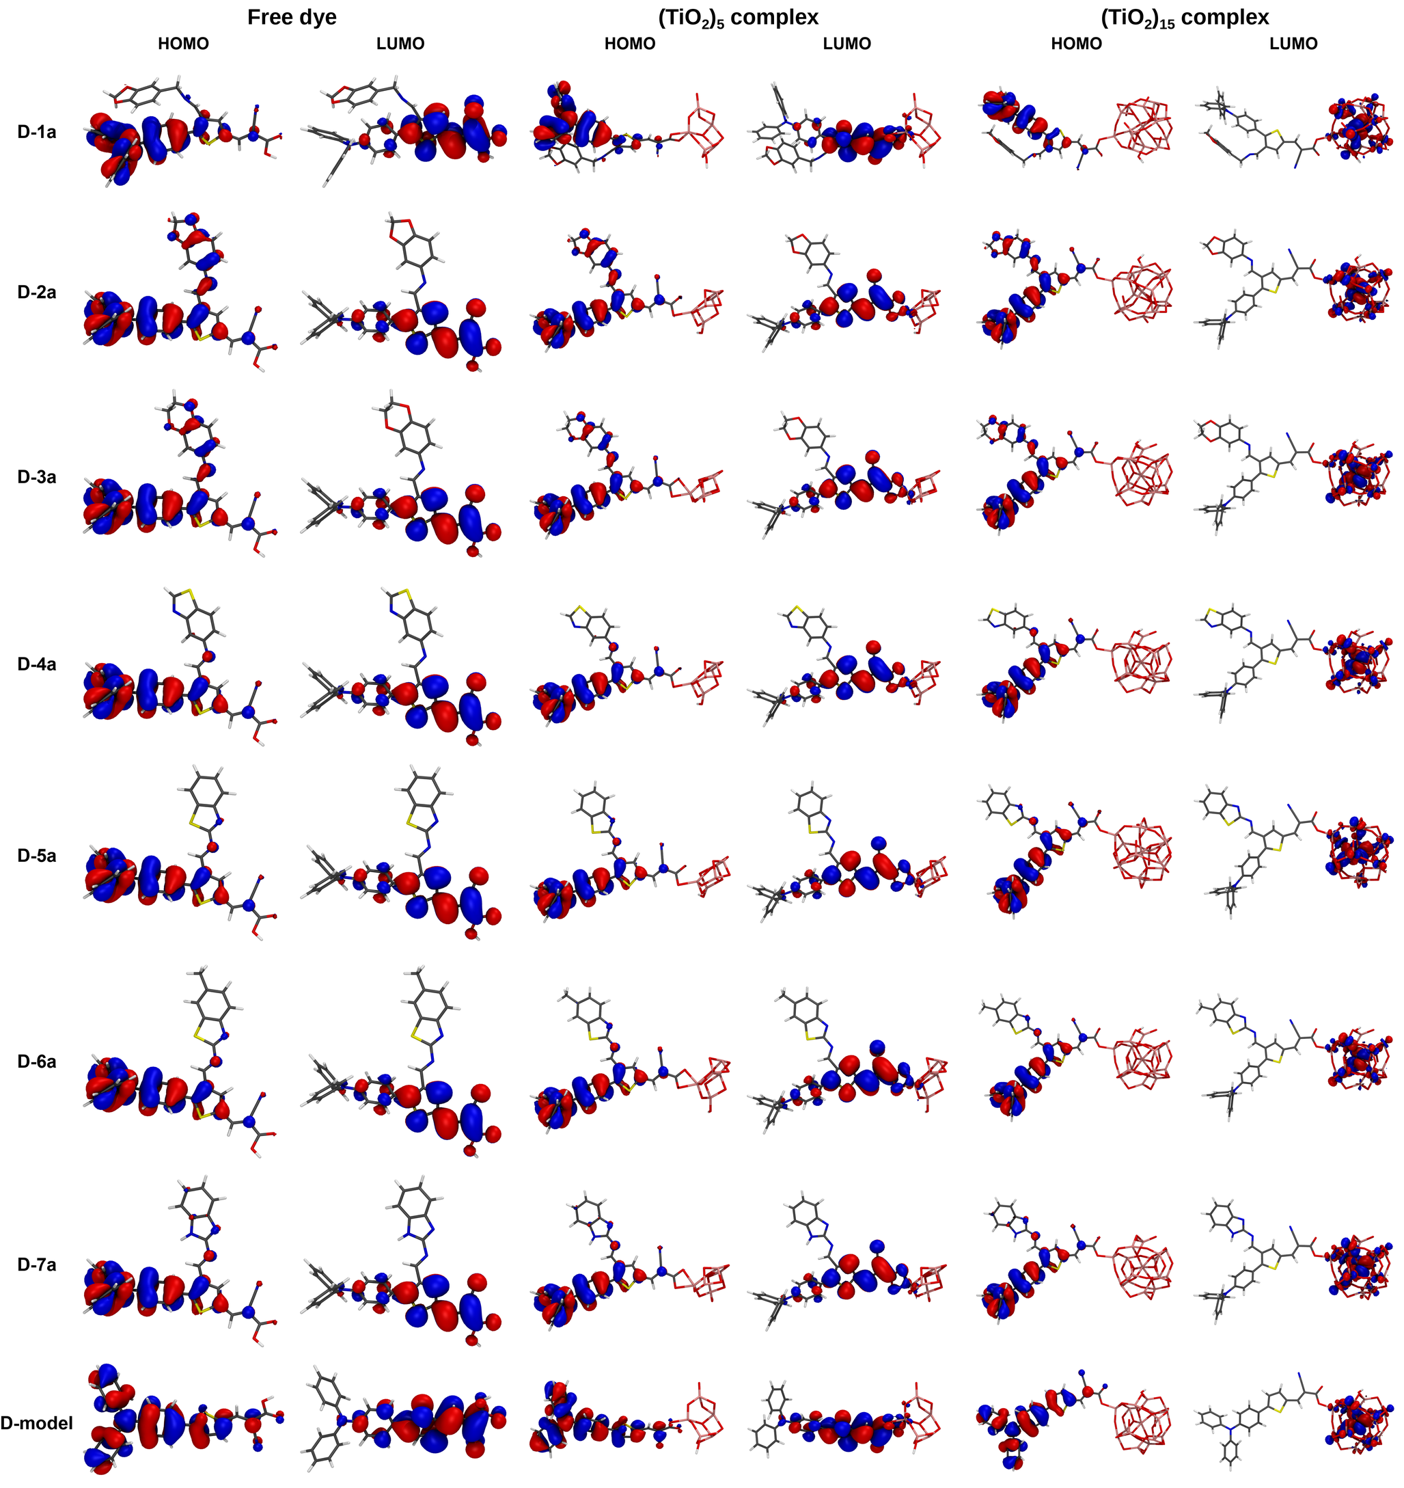
Fig. S16 Frontier orbitals of the a-position isomers as the free dye and on the two clusters, at an isovalue of 0.02 a.u.
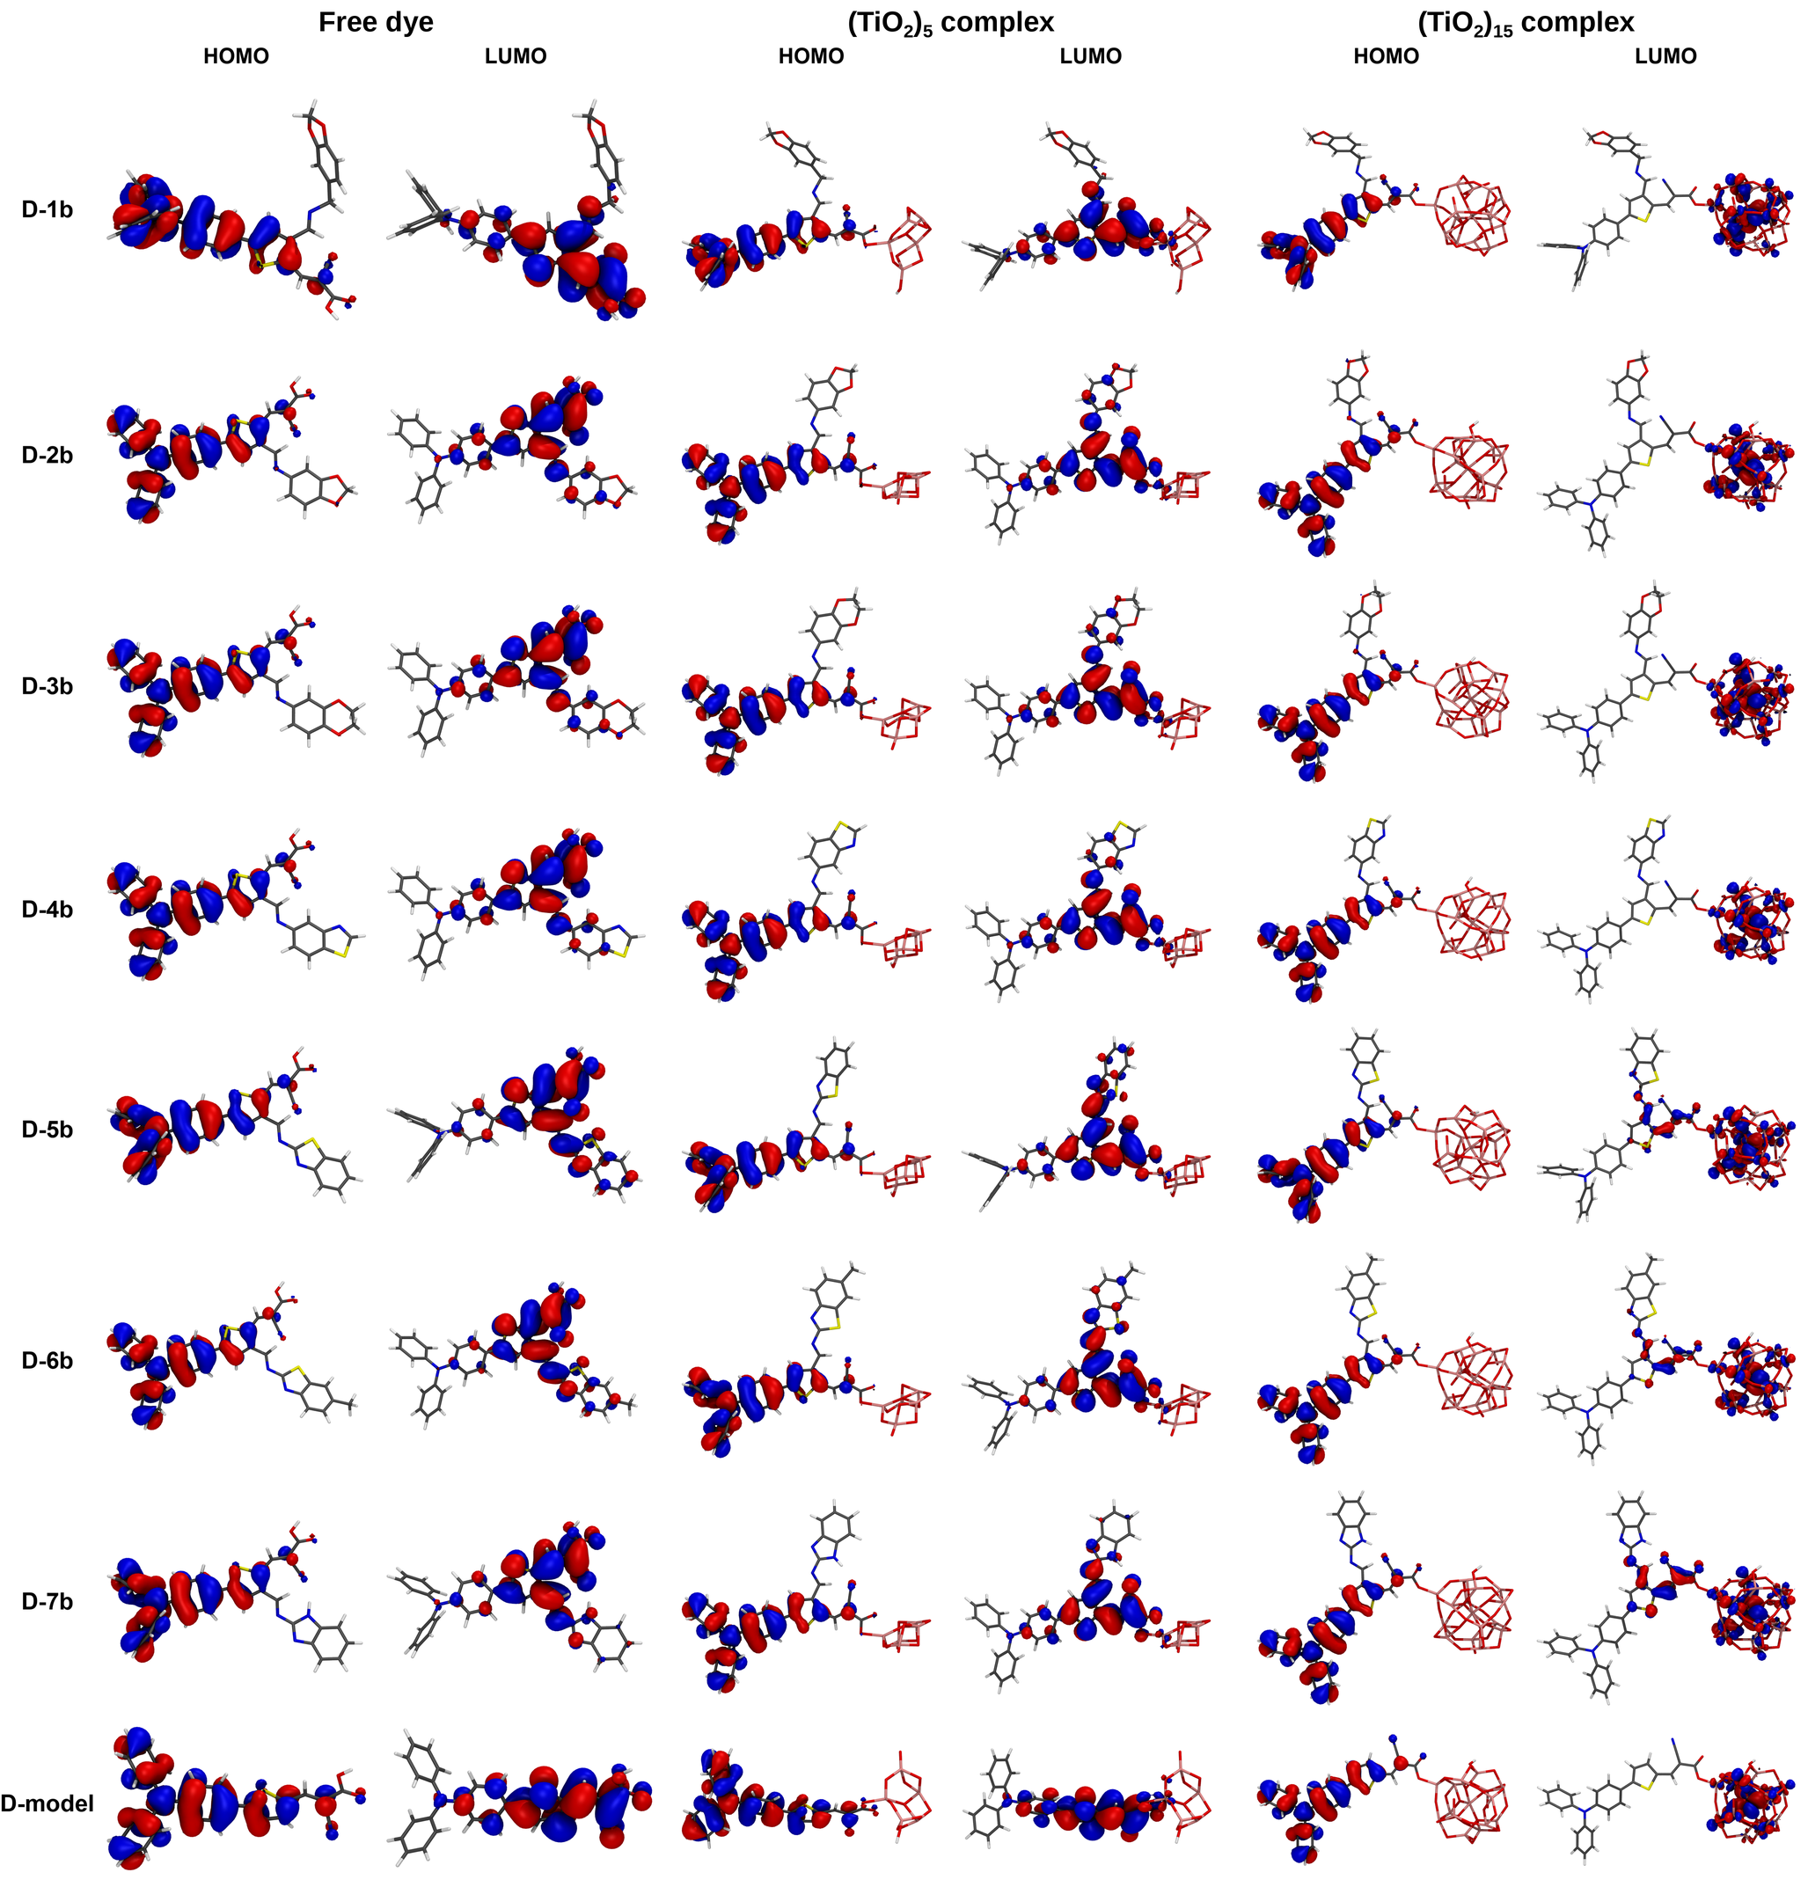
Fig. S17 Frontier orbitals of the b-position isomers, on the scale of Fig. S14
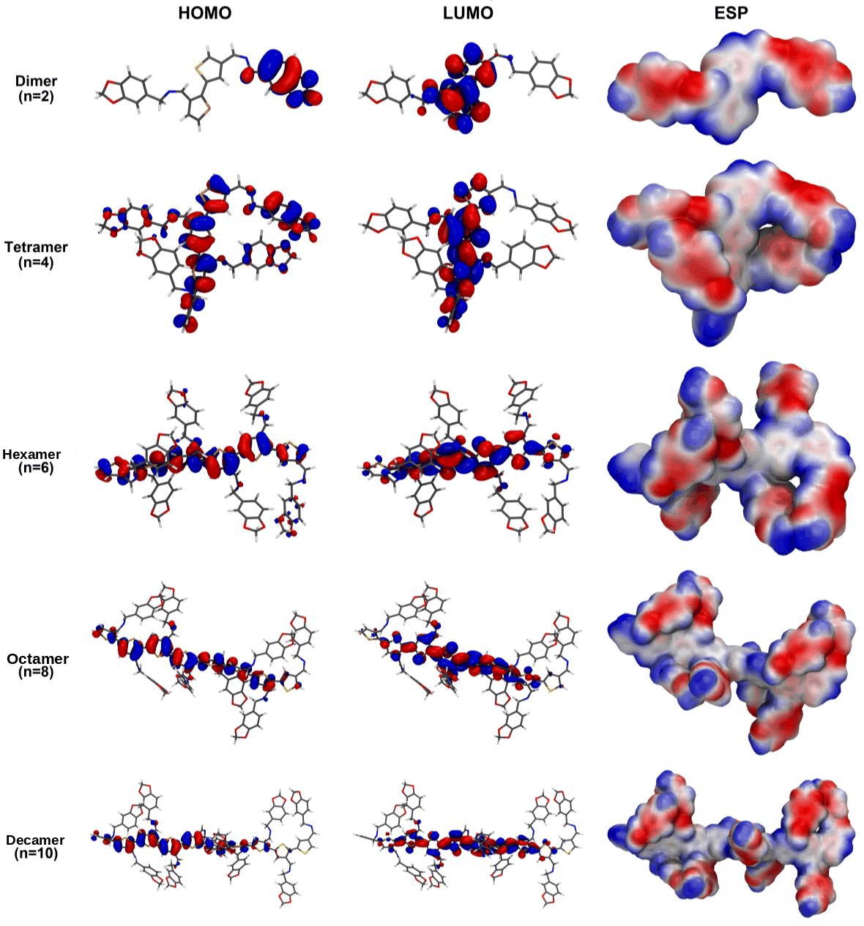
Fig. S18 Frontier orbitals and electrostatic potential of the HTM-1 oligomers along the series
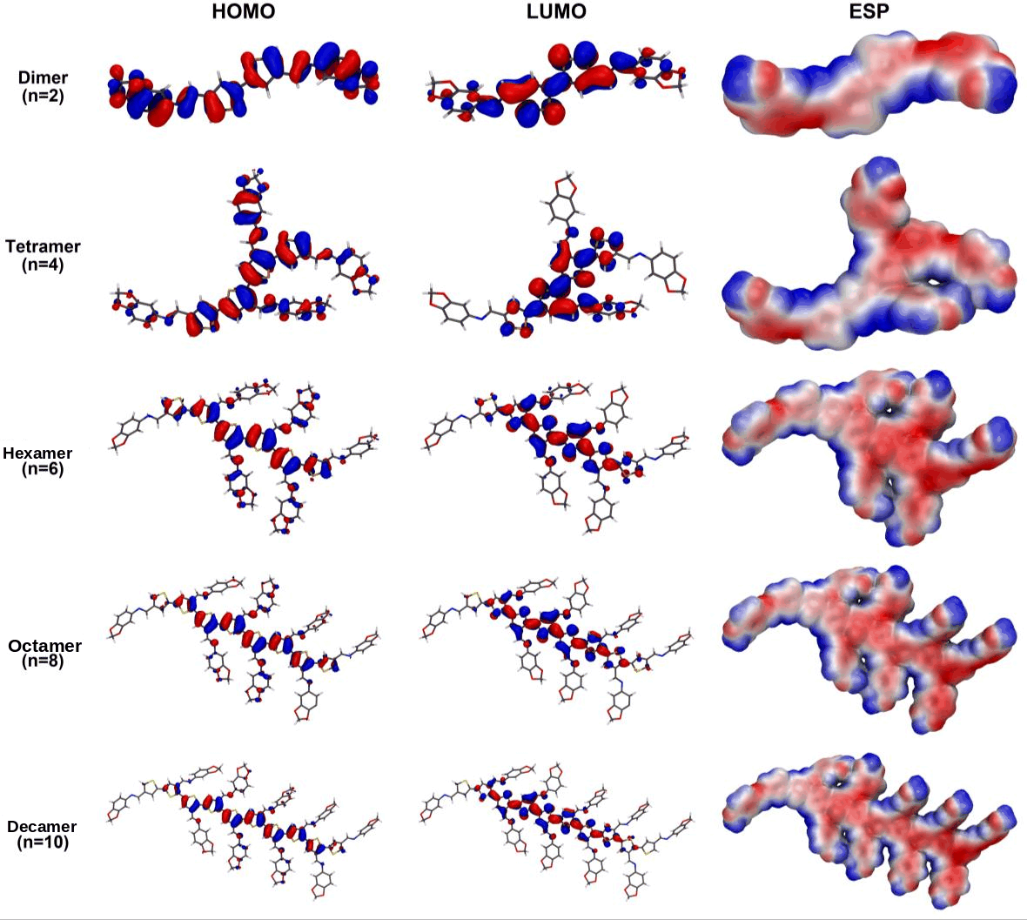
Fig. S19 Frontier orbitals and electrostatic potential of the HTM-2 oligomers along the series
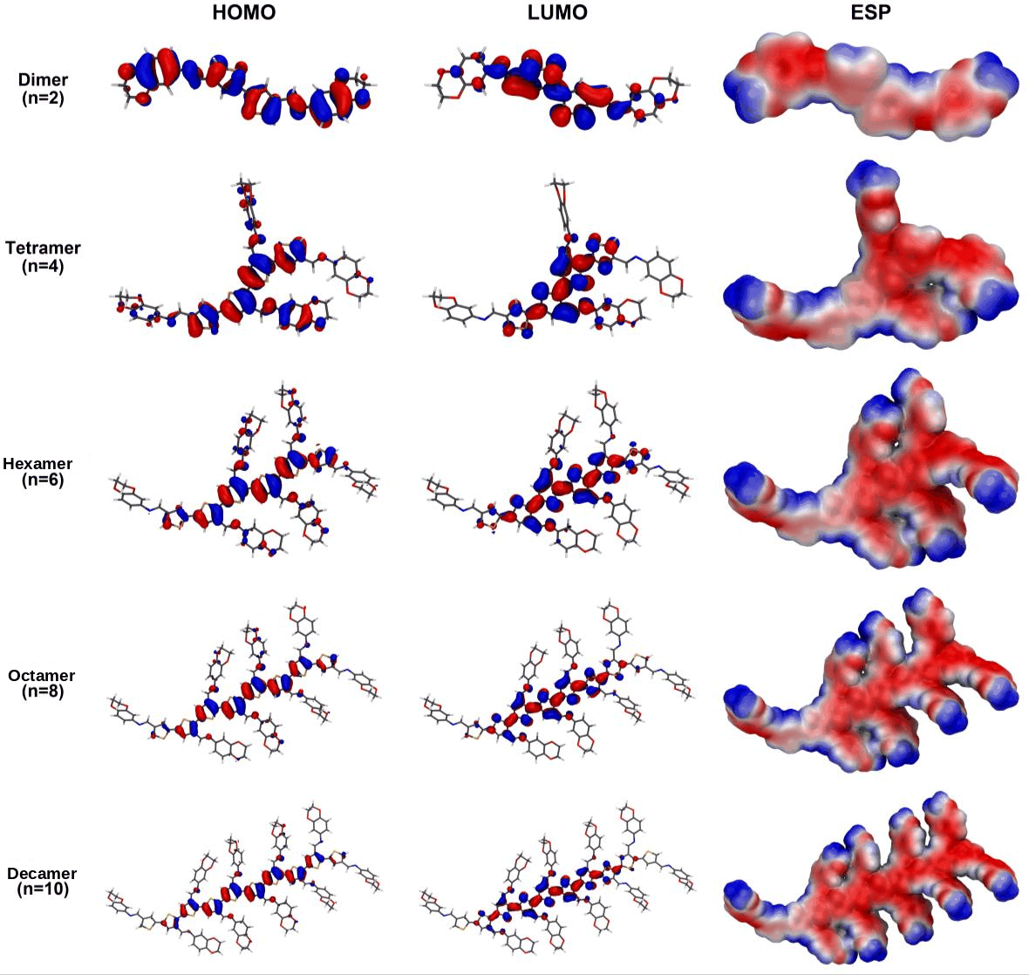
Fig. S20 Frontier orbitals and electrostatic potential of the HTM-3 oligomers along the series
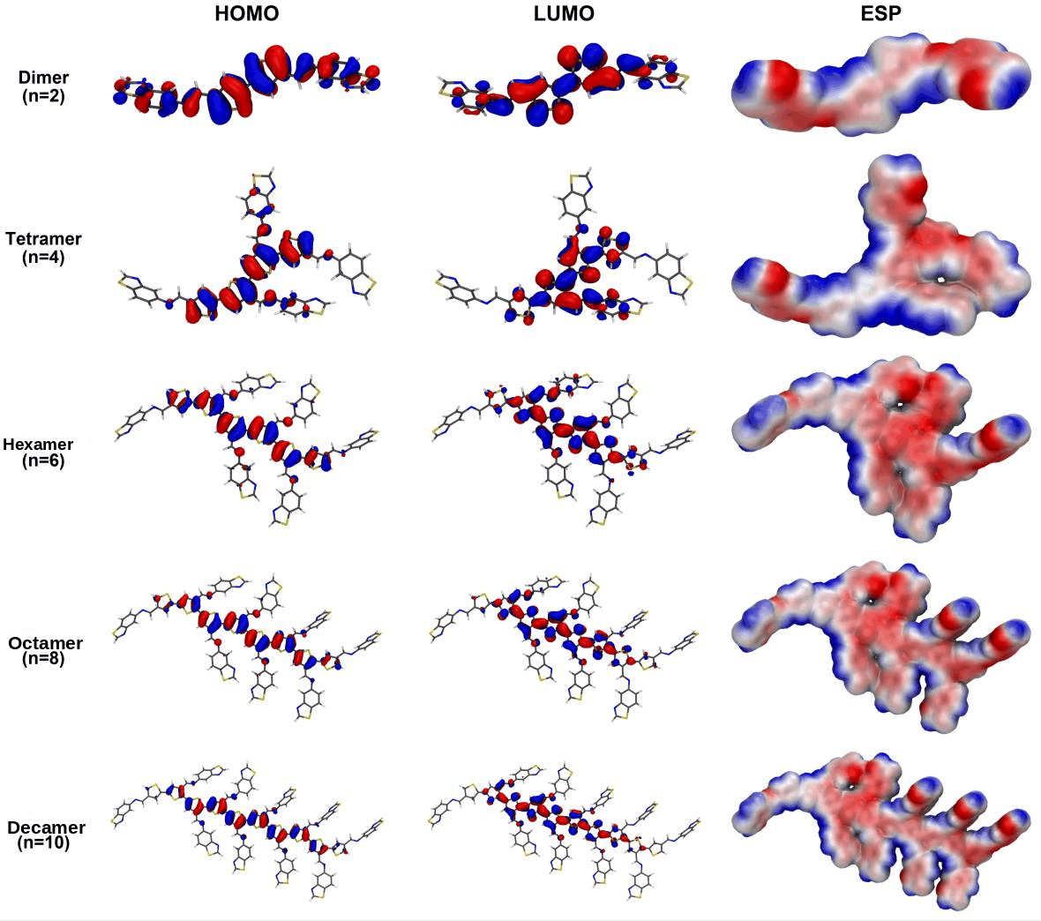
Fig. S21 Frontier orbitals and electrostatic potential of the HTM-4 oligomers along the series
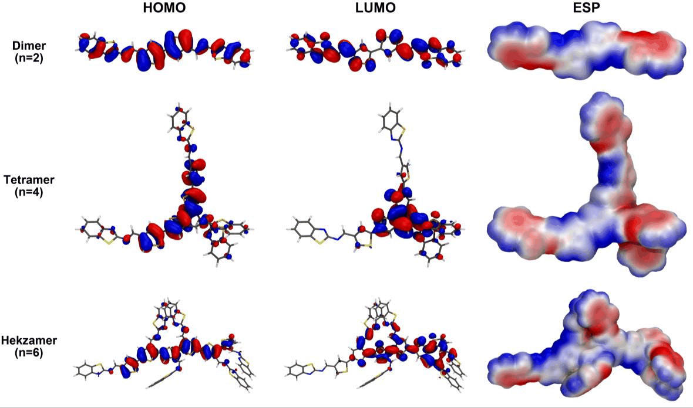
Fig. S22 Frontier orbitals and electrostatic potential of the HTM-5 oligomers along the series
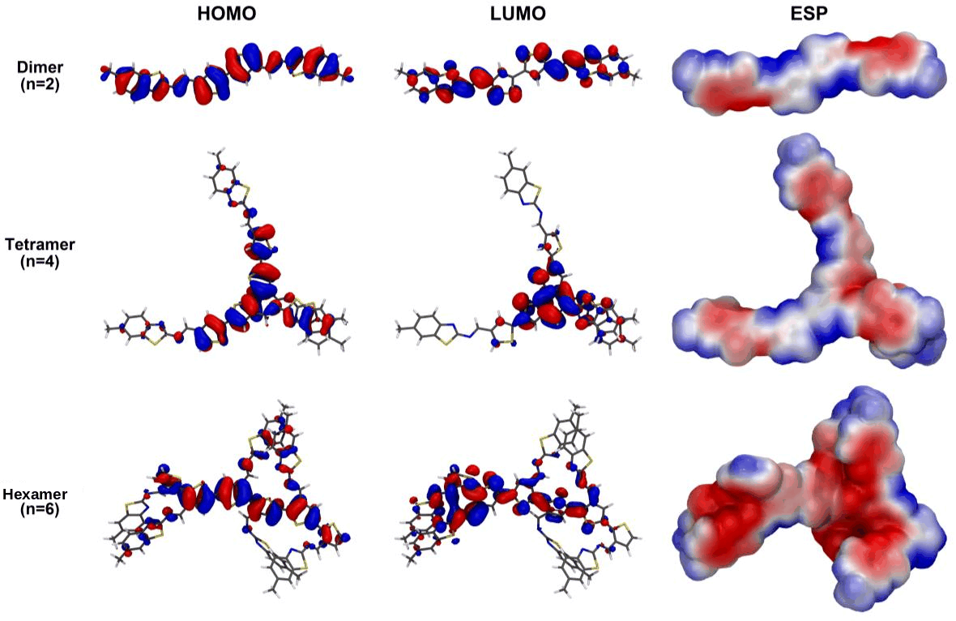
Fig. S23 Frontier orbitals and electrostatic potential of the HTM-6 oligomers along the series
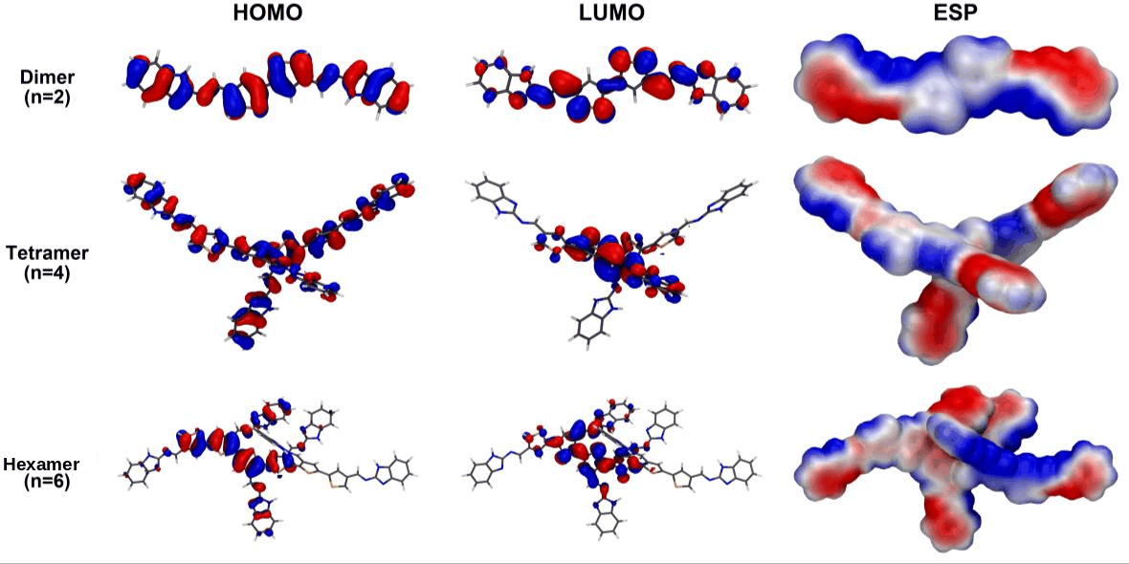
Fig. S24 Frontier orbitals and electrostatic potential of the HTM-7 oligomers along the series
9 Data provided in the accompanying workbook
The file Resource_2_Supplementary_Tables_S1-S47.xlsx contains all forty-seven tables in machine-readable form, including those too large to reproduce here: Table S16 (TD-DFT data for all 160 regiochemical isomers), Table S18 (630-row trap-density matrix), Table S29 (complete 2625-configuration indoor sweep), Table S30 (346-row thickness sweep), Table S31 (420-row high-trap-density sweep), Table S33 (dye descriptor matrix) and Table S35 (bootstrap prediction intervals).

