Table S1. The primers of genes used in the article.
Gene | Primer sequence (5' to 3')
NOS2-F | GTTCTCAGCCCAACAATACAAGA
NOS2-R | GTGGACGGGTCGATGTCAC
CD86-F | TCAATGGGACTGCATATCTGCC
CD86-R | GCCAAAATACTACCAGCTCACT
IL-1β-F | GAAATGCCACCTTTTGACAGTG
IL-1β-R | TGGATGCTCTCATCAGGACAG
TNF-α-F | CAGGCGGTGCCTATGTCTC
TNF-α-R | CGATCACCCCGAAGTTCAGTAG
Arg-1-F | CTCCAAGCCAAAGTCCTTAGAG
Arg-1-R | GGAGCTGTCATTAGGGACATCA
CD206-F | CTCTGTTCAGCTATTGGACGC
CD206-R | TGGCACTCCCAAACATAATTTGA
IL-4-F | GGTCTCAACCCCCAGCTAGT
IL-4-R | GCCGATGATCTCTCTCAAGTGAT
IL-10-F | CTTACTGACTGGCATGAGGATCA
IL-10-R | GCAGCTCTAGGAGCATGTGG
IL-18-F | ACCTGAAGAAAATGGAGACCTGG
IL-18-R | AGTCATATCCTCGAACACAGGC
GPX4-F | AATCAAGGAGTTTGCAGCCG
GPX4-R | CCACGCAGCCGTTCTTATCA
NOX3-F | CTTCACTCTCACCTCCGCTC
NOX3-R | CGCTCACGGGGTAGTGAAAT
RANKL-F | AAGTCACTCTGTCCTCTTGGTA
RANKL-R | AGATAGTCTGTAGGTACGCTTCC
Ctsk-F | CTCGGCGTTTAATTTGGGAGA
Ctsk-R | TCGAGAGGGAGGTATTCTGAGT
Acp5-F | CACTCCCACCCTGAGATTTGT
Acp5-R | CCCCAGAGACATGATGAAGTCA

Table S2. EXAFS fitting parameters at the Ni K –edge for various samples.
Sample | Path | CNª | R(Å)^{b} | σ² (Å²)^{c} | ΔE₀(eV)^{d} | K-range/Å⁻¹ | R-range/Å⁻¹ | R factor
Fe foil | Fe-Fe₁ | 8* | 2.45±0.01 | 0.0030±0.0015 | 4.92±2.14 | 3.0-12.0 | 1.0-2.9 | 0.0057
Fe foil | Fe-Fe₂ | 6* | 2.85±0.01 | 0.0032±0.0024
Fe₂O₃ | Fe-O | 6* | 1.98±0.01 | 0.012±3.0031 | -0.39±1.87 | 2.6-11.1 | 1.0-2.0 | 0.0067
FePc | Fe-N | 4* | 1.96±0.01 | 0.0083±0.0027 | 1.45±2.00 | 2.6-11.2 | 1.0-2.1 | 0.015
Fe₂-N₆/DAN | Fe-N | 3.1±0.3 | 1.95±0.04 | 0.002 | -5.47±5.01 | 2.4-9.2 | 1.1-2.0 | 0.02
Fe₂-N₆/DAN | Fe-Fe | 0.9±0.2 | 1.97±0.05 | 0.0023 | -5.12±5.01 | 2.4-9.2 | 1.2-2.0 | 0.018
Fe-N₄/SAN | Fe-N | 4.0±0.2 | 1.98±0.01 | 0.0025 | -4.2±1.67 | 2.4-9.2 | 1.0-2.0 | 0.0063
CN, coordination number; ^{b}R, the distance between absorber and backscatter atoms; ^{c}σ², the Debye Waller factor value; ^{d}ΔE₀, inner potential correction to account for the difference in the inner potential between the sample and the reference compound; R factor indicates the goodness of the fit. Ѕ₀² was fixed to 0.85, according to the experimental EXAFS fit of Fe foil by fixing CN as the known crystallographic value. * This value was fixed during EXAFS fitting, based on the known structure of Fe. Fitting conditions: fitting space: R space; k-weight = 3. A reasonable range of EXAFS fitting parameters: 0.700 < Ѕ₀² < 1.000; CN > 0; σ2 > 0 Å²; |ΔE₀| < 10 eV; R factor < 0.02.

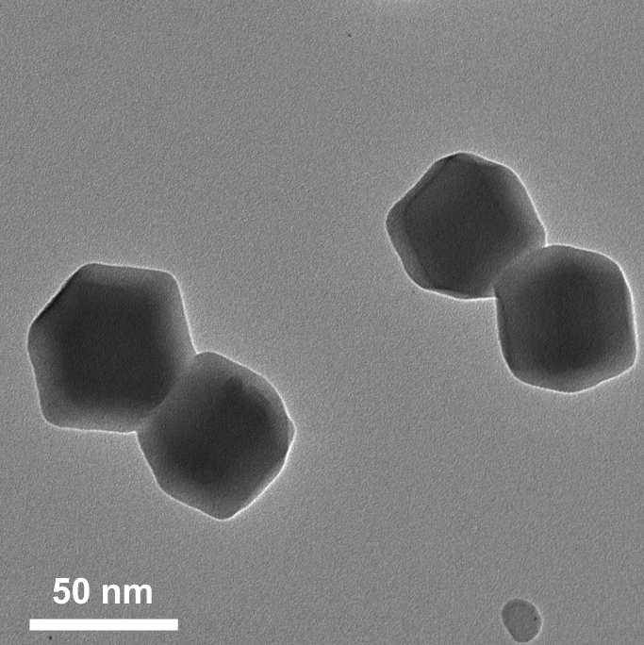
Figure S1. TEM image of ZIF@Fe₂(CO)₉. Scale bar =50 nm.
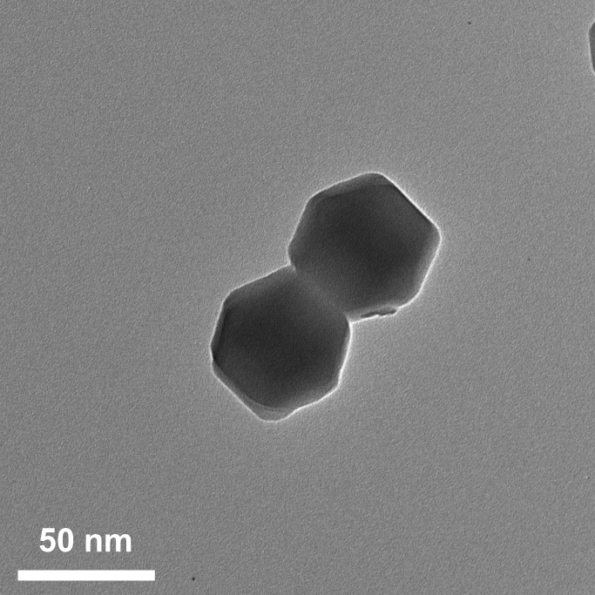
Figure S2. TEM image of ZIF@Fe(acac)₃. Scale bar =50 nm.
Figure S3. HR-TEM image of LS Fe-N₄/DAN. Scale bar = 5 nm.

Figure S4. SAED image of LS Fe-N₄/SAN. Scale bar = 5 1/ nm.
Figure S5. Raman spectra of LS Fe-N₄/SAN and HS Fe₂-N₆/DAN.
Figure S6. High resolution of C 1s XPS spectrum in HS Fe₂-N₆/DAN.

Figure S7. High resolution of N 1s XPS spectrum in HS Fe₂-N₆/DAN.
Figure S8. EXAFS fitting curve of Fe₂O₃ at the R space.
Figure S9. EXAFS fitting curve of Fe foil, and Fe₂O₃ at the k space.

Figure S10. Projected crystal orbital Hamiltonian population (pCOHP) analysis of the interaction between Fe centers and H₂O₂ in both LS Fe-N₄/SAN and HS Fe₂-N₆/DAN.
Figure S11. Density of states (DOS) analysis of the Fe d-band center in both LS Fe-N₄/SAN and HS Fe₂-N₆/DAN.

Figure S12. Gibbs free-energy diagrams for the decomposition of the conversion of H₂O₂ into O₂ on HS Fe₂-N₆/DAN and LS Fe-N₄/SAN.
Figure S13. Gibbs free-energy diagrams for the decomposition of the conversion of H₂O₂ into O₂ on HS Fe₂-N₆/DAN and LS Fe-N₄/SAN.
Figure S14. Gibbs free-energy diagrams for the decomposition of •OH into H₂O on HS Fe₂-N₆/DAN and LS Fe-N₄/SAN.

Figure S15. (a-b) BMDM viability was measured by CCK-8 assay after incubation with Fe-N₄/SAN, nMgO/Gel@Fe-N₄/SAN, Fe₂-N₆/DAN and nMgO/Gel@Fe₂-N₆/DAN for 12 h or 24 h. n = 3 per group. All data represent Mean ± SD.

Figure S16. (a-b) Representative fluorescence images and quantification of different doses of nMgO/Gel@Fe-N₄/SAN treatments on BMDMs stained with Calcein-AM/PI. Scale bar: 100 μm. n = 3 per group. (c-d) Representative fluorescence images and quantification of different doses of nMgO/Gel@Fe₂-N₆/DAN treatments on BMDMs stained with Calcein-AM/PI. Scale bar: 100 μm. n = 3 per group. Green and red represent live and dead cells, respectively. All data represent Mean ± SD. NS = not significant. *P < 0.01,**P < 0.01, ***P < 0.001.

Figure S17. (a-b) Flow cytometry analyses and corresponding quantifications of DCFH-DA⁺ cells after different treatments on BMDMs. n = 3 per group. All data represent Mean ± SD. *P < 0.05; ***P < 0.001.

Figure S18. (a-b) qRT-PCR analysis of M1 markers (CD86, NOS2, IL-1β and TNF-α) and M2 markers (CD206, Arg-1, IL-4, and IL-10) relative mRNA expression in BMDMs with different treatments. n = 5 per group. All data represent Mean ± SD. NS = not significant. *P < 0.05, **P < 0.01, ***P < 0.001.

Figure S19. (a-b) Chondrocyte viability was measured by CCK-8 assay after incubation with Fe-N₄/SAN, nMgO/Gel@Fe-N₄/SAN, Fe₂-N₆/DAN and nMgO/Gel@Fe₂-N₆/DAN for 12 h or 24 h. n = 3 per group. All data represent Mean ± SD.

Figure S20. (a-b) Representative fluorescence images and quantification of different doses of nMgO/Gel@Fe-N₄/SAN treatments on chondrocytes stained with Calcein-AM/PI. Scale bar: 100 μm. n = 3 per group. (c-d) Representative fluorescence images and quantification of different doses of nMgO/Gel@Fe₂-N₆/DAN treatments on chondrocytes stained with Calcein-AM/PI. Scale bar: 100 μm. n = 3 per group. Green and red represent live and dead cells, respectively. All data represent Mean ± SD. NS = not significant. **P < 0.01, ***P < 0.001.

Figure S21. (a-b) Flow cytometry analyses and corresponding quantifications of DCFH-DA⁺ cells after different treatments on chondrocytes. n = 3 per group. All data represent Mean ± SD. *P < 0.05; ***P < 0.001.
Figure S22. (a-b) qRT-PCR analysis of IL-1β and IL-18 relative mRNA expression in chondrocytes with different treatments. n = 5 per group. All data represent Mean ± SD. NS = not significant. *P < 0.05, **P < 0.01, ***P < 0.001.

Figure S23. (a-d) Quantitative analysis of coimmunostaining of F4/80 with CD86 or CD206 in the knee and ankle joints of CIA mice with different treatment. n = 8 per group. All data represent Mean ± SD. NS = not significant. *P < 0.05, **P < 0.01, ***P < 0.001.

Figure S24. (a-d) Representative immunofluorescence staining of GSDMD (red) and quantitative analysis of coimmunostaining of GSDMD⁺ cells in the cartilage of the knee and ankle joints from CIA mice with different treatment. Scale bar: 50 μm. n = 8 per group. All data represent Mean ± SD. NS = not significant. *P < 0.05, **P < 0.01, ***P < 0.001.

Figure S25. (a) The assessment of hepatotoxicity and nephrotoxicity of various treatment through the analysis of serum levels of ALT, AST, BUN, and Cre. n = 5 per group. (b) Histological safety evaluation by H&E staining of main organs collected from treated RA mice model. Scale bar: 50 μm. n = 3 per group. All data represent Mean ± SD. NS = not significant.
Figure S26. (a) Heatmap of identified genes based on hierarchical cluster analysis in the BMDMs from nMgO/Gel@Fe₂-N₆/DAN vs. PBS. (b-c) Volcano plot and number of DEGs of all genes identified in the BMDMs from nMgO/Gel@Fe₂-N₆/DAN vs. PBS. Red and blue dots indicate up- or down-regulated genes significantly, respectively (|log2FC|≥ 1 and Q-value of <0.05).

Figure S27. (a) Representative GO analysis (molecular function) of DEGs in the BMDMs from nMgO/Gel@Fe₂-N₆/DAN vs. PBS (|log2FC| ≥ 1). (b) Representative KEGG pathways of DEGs in the BMDMs from nMgO/Gel@Fe₂-N₆/DAN vs. PBS (|log2FC| ≥ 1).

Figure S28. (a-b) qRT-PCR analysis of GPX4 (A) and NOX3 (B) relative mRNA expression in BMDMs from nMgO/Gel@Fe₂-N₆/DAN vs. PBS. n = 6 per group. All data represent Mean ± SD. *P < 0.05.

Figure S29. (a-b) Representative images and quantification of TRAP staining in osteoclasts treated with the cell supernantant obtained from the nMgO/Gel@Fe₂-N₆/DAN vs. PBS group. n = 3 per group. Scale bar: 100 µm. (c-e) qRT-PCR analysis of Acp5 (C), Ctsk (D) and RANKL (E) in osteoclasts treated with the cell supernantant obtained from the nMgO/Gel@Fe₂-N₆/DAN vs. PBS group. n = 6 per group. All data represent Mean ± SD. *P < 0.05, **P < 0.01.

Figure S30. (a-b) Western blot analysis and quantifications of NF-κB, pNF-κB and GAPDH in BMDMs from nMgO/Gel@Fe₂-N₆/DAN vs. PBS. n = 3 per group. All data represent Mean ± SD. NS = not significant. *P < 0.05.

Figure S31. (a-b) GSEA plots of Rheumatoid arthritis (a) and NF-κB signaling pathway (b) in the BMDMs from nMgO/Gel@Fe₂-N₆/DAN vs. PBS.

Figure S32. (a) Heatmap of identified genes based on hierarchical cluster analysis in the chondrocytes from nMgO/Gel@Fe₂-N₆/DAN vs. PBS. (b-c) Volcano plot and number of DEGs of all genes identified in the chondrocytes from nMgO/Gel@Fe₂-N₆/DAN vs. PBS. Red and blue dots indicate up- or down-regulated genes significantly, respectively (|log2FC|≥ 1 and Q-value of <0.05).

Figure S33. (a) Representative KEGG pathways of DEGs in the chondrocytes from nMgO/Gel@Fe₂-N₆/DAN vs. PBS (|log2FC| ≥ 1).

Figure S34. (a-b) GSEA plots of Rheumatoid arthritis (a) and NF-κB signaling pathway (b) in the chondrocytes from nMgO/Gel@Fe₂-N₆/DAN vs. PBS.

Figure S35. (a-b) Western blot analysis and quantifications of NF-κB, pNF-κB and GAPDH in chondrocytes from nMgO/Gel@Fe₂-N₆/DAN vs. PBS. n = 3 per group. All data represent Mean ± SD. NS = not significant. *P < 0.05, **P < 0.01.

