Supplementary material
Expansion and provincial inequality in physician home-visit activity in China, 2018–2023: a national ecological panel study of community health service capacity
Qiufeng Liu, Yuling Zhang, and Liping Xia

Supplementary Table S1 Segmented national growth and the 2020–2021 change
Measure | Period | Start | End | CAGR, %
Total physician home-visit occasions | 2018-2023 | 47135017 | 163691154 | 28.27
Total physician home-visit occasions | 2018-2020 | 47135017 | 65126595 | 17.55
Total physician home-visit occasions | 2021-2023 | 118784375 | 163691154 | 17.39
Community-institution occasions | 2018-2023 | 21016898 | 57561391 | 22.32
Community-institution occasions | 2018-2020 | 21016898 | 26271888 | 11.81
Community-institution occasions | 2021-2023 | 39486959 | 57561391 | 20.74
Community registered nurses | 2018-2023 | 189207 | 277658 | 7.97
Community registered nurses | 2018-2020 | 189207 | 219574 | 7.73
Community registered nurses | 2021-2023 | 237441 | 277658 | 8.14
Community centres and stations | 2018-2023 | 34997 | 37177 | 1.22
Community centres and stations | 2018-2020 | 34997 | 35365 | 0.52
Community centres and stations | 2021-2023 | 36160 | 37177 | 1.40
Community-institution occasions increased by 50.30% and total occasions by 82.39% from 2020 to 2021.

Supplementary Table S2 Year-specific Spearman correlations with community-institution activity rate
Year | Predictor | Spearman rho | P value
2018 | Registered-nurse density | 0.697 | <0.001
2018 | Community facility density | 0.600 | <0.001
2018 | Population aged ≥65 years | 0.246 | 0.183
2019 | Registered-nurse density | 0.672 | <0.001
2019 | Community facility density | 0.615 | <0.001
2019 | Population aged ≥65 years | 0.244 | 0.186
2020 | Registered-nurse density | 0.489 | 0.005
2020 | Community facility density | 0.455 | 0.010
2020 | Population aged ≥65 years | 0.138 | 0.460
2021 | Registered-nurse density | 0.474 | 0.007
2021 | Community facility density | 0.392 | 0.029
2021 | Population aged ≥65 years | 0.263 | 0.153
2022 | Registered-nurse density | 0.529 | 0.002
2022 | Community facility density | 0.406 | 0.023
2022 | Population aged ≥65 years | 0.262 | 0.154

Supplementary Table S3 Sensitivity analyses for the structural-capacity coefficients
Model | Predictor | Relative difference, % | 95% CI | P value | Province-years | Regions
Primary: exchangeable GEE, Mancl-DeRouen covariance | Nurse density | 4.75 | -3.79 to 14.05 | 0.285 | 155 | 31
Primary: exchangeable GEE, Mancl-DeRouen covariance | Facility density | 1.59 | -3.40 to 6.84 | 0.540 | 155 | 31
Primary: exchangeable GEE, Mancl-DeRouen covariance | Age ≥65 | -4.44 | -11.35 to 3.01 | 0.236 | 155 | 31
Conventional robust covariance | Nurse density | 4.75 | -0.99 to 10.83 | 0.107 | 155 | 31
Conventional robust covariance | Facility density | 1.59 | -2.50 to 5.85 | 0.452 | 155 | 31
Conventional robust covariance | Age ≥65 | -4.44 | -10.24 to 1.74 | 0.156 | 155 | 31
Independent working correlation | Nurse density | 1.16 | -8.39 to 11.70 | 0.819 | 155 | 31
Independent working correlation | Facility density | 3.39 | -2.10 to 9.18 | 0.231 | 155 | 31
Independent working correlation | Age ≥65 | 0.07 | -10.30 to 11.65 | 0.990 | 155 | 31
Poisson GEE with population offset | Nurse density | 5.45 | -2.03 to 13.50 | 0.157 | 155 | 31
Poisson GEE with population offset | Facility density | 0.57 | -3.85 to 5.20 | 0.804 | 155 | 31
Poisson GEE with population offset | Age ≥65 | -0.71 | -8.71 to 7.99 | 0.869 | 155 | 31
Province and year fixed-effects GEE | Nurse density | 12.18 | -3.98 to 31.07 | 0.148 | 155 | 31
Province and year fixed-effects GEE | Facility density | 4.21 | -11.66 to 22.93 | 0.625 | 155 | 31
Province and year fixed-effects GEE | Age ≥65 | -7.49 | -16.26 to 2.20 | 0.126 | 155 | 31
One-year-lagged covariates | Lagged nurse density | 2.99 | -5.47 to 12.21 | 0.500 | 124 | 31
One-year-lagged covariates | Lagged facility density | 2.07 | -3.49 to 7.95 | 0.473 | 124 | 31
One-year-lagged covariates | Lagged age ≥65 | -2.16 | -10.22 to 6.62 | 0.618 | 124 | 31
2018-2023 supply-only GEE | Nurse density | 3.53 | -5.62 to 13.57 | 0.462 | 186 | 31
2018-2023 supply-only GEE | Facility density | 2.48 | -2.42 to 7.63 | 0.328 | 186 | 31
Excluding Tibet after influence diagnostic | Nurse density | 8.09 | 1.50 to 15.11 | 0.015 | 150 | 30
Excluding Tibet after influence diagnostic | Facility density | 1.65 | -3.24 to 6.78 | 0.516 | 150 | 30
Excluding Tibet after influence diagnostic | Age ≥65 | -3.09 | -10.72 to 5.18 | 0.453 | 150 | 30
For log-density predictors, relative differences correspond to a 10% higher density; for the age predictor, they correspond to a one-percentage-point higher proportion aged 65 years or older.
Supplementary Table S4 Influence diagnostics for the nurse-density coefficient
Province | DFBETAS | Absolute DFBETAS | Nurse effect after deletion, % | Screening threshold | Flagged
Tibet | -0.723 | 0.723 | 8.09 | 0.359 | Yes
Zhejiang | 0.334 | 0.334 | 3.24 | 0.359 | No
Shanghai | 0.233 | 0.233 | 3.70 | 0.359 | No
Hainan | -0.188 | 0.188 | 5.61 | 0.359 | No
Anhui | -0.183 | 0.183 | 5.59 | 0.359 | No
Hebei | 0.171 | 0.171 | 3.98 | 0.359 | No
Ningxia | 0.171 | 0.171 | 3.98 | 0.359 | No
Fujian | -0.145 | 0.145 | 5.41 | 0.359 | No
Xinjiang | -0.127 | 0.127 | 5.33 | 0.359 | No
Jiangxi | 0.122 | 0.122 | 4.20 | 0.359 | No
Liaoning | 0.113 | 0.113 | 4.24 | 0.359 | No
Chongqing | 0.086 | 0.086 | 4.36 | 0.359 | No
Beijing | -0.077 | 0.077 | 5.10 | 0.359 | No
Shandong | 0.077 | 0.077 | 4.40 | 0.359 | No
Jilin | 0.072 | 0.072 | 4.42 | 0.359 | No
Guangdong | 0.056 | 0.056 | 4.50 | 0.359 | No
Shaanxi | -0.050 | 0.050 | 4.98 | 0.359 | No
Guangxi | -0.043 | 0.043 | 4.95 | 0.359 | No
Heilongjiang | -0.043 | 0.043 | 4.95 | 0.359 | No
Jiangsu | 0.037 | 0.037 | 4.58 | 0.359 | No
Guizhou | -0.031 | 0.031 | 4.89 | 0.359 | No
Tianjin | -0.024 | 0.024 | 4.86 | 0.359 | No
Hubei | 0.023 | 0.023 | 4.65 | 0.359 | No
Hunan | 0.022 | 0.022 | 4.65 | 0.359 | No
Qinghai | -0.022 | 0.022 | 4.85 | 0.359 | No
Sichuan | 0.020 | 0.020 | 4.66 | 0.359 | No
Yunnan | 0.012 | 0.012 | 4.70 | 0.359 | No
Henan | -0.005 | 0.005 | 4.78 | 0.359 | No
Shanxi | -0.004 | 0.004 | 4.77 | 0.359 | No
Inner Mongolia | 0.003 | 0.003 | 4.74 | 0.359 | No
Gansu | -0.001 | 0.001 | 4.76 | 0.359 | No
A province was flagged when |DFBETAS| exceeded 2/sqrt(31)=0.359. Flagging triggered parallel reporting and was not an automatic exclusion criterion.

Supplementary Table S5 Largest provincial contributions to the 2020–2021 increase
Measure | Province | Absolute increase | Share of national increase, %
Community-institution | Shandong | 2496375 | 18.89
Community-institution | Zhejiang | 2495720 | 18.89
Community-institution | Hubei | 828729 | 6.27
Community-institution | Jiangsu | 641503 | 4.85
Community-institution | Hunan | 616112 | 4.66
Total | Shandong | 11248766 | 20.96
Total | Henan | 5753710 | 10.72
Total | Zhejiang | 4856699 | 9.05
Total | Hubei | 3744755 | 6.98
Total | Hunan | 3446967 | 6.42
For community-institution activity, 30 of 31 regions increased and Yunnan declined. For total activity, 30 regions increased and Tibet declined.

Supplementary Figure S1
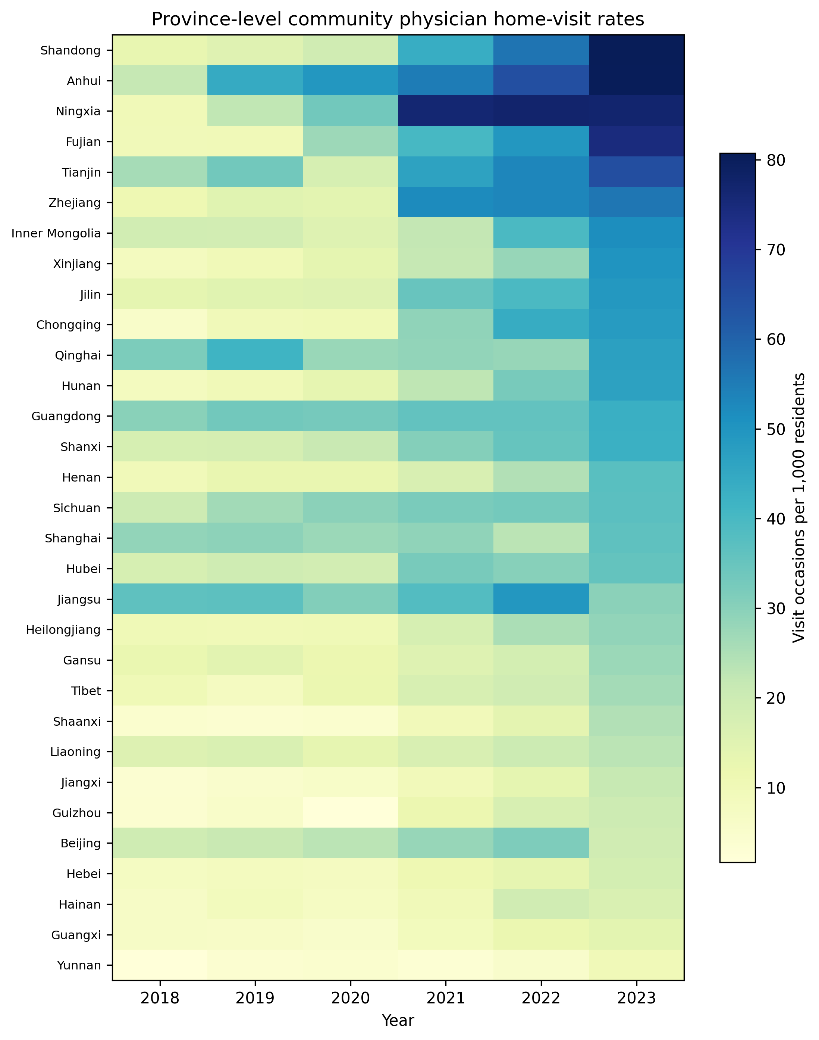
Province-year heatmap of community-institution physician home-visit rates, 2018–2023. Values are occasions per 1,000 residents.

