Supporting files for:
Remotely sensing for restoration: A scalable framework for tracking conservation outcomes and ecosystem resilience on islands
Christy N. Wails*, Bradley J. Cosentino, Lara J. Brenner, Min Feng, Katie Franklin, James P. Gibbs, Nick Holmes, Miroslav Honzák, Annie Little, Annie E. Meeder, Joseph O. Sexton, Justine D. Shaw, Panshi Wang, Alex Wegmann, Cameron B. Williams, Elke Windschitl, and
David J. Will
* Corresponding author: christy.wails@sdstate.edu
Contents
Supplemental Methods …………………………………………………………………………... 2
Study islands & vegetation change ……………………………………...…………….…. 2
Spatially explicit interventions …………………………………………………………... 6
Model structure & fitting procedures…………………………………………………….. 8
Model selection procedures……………………………………………………….…….. 11
In-situ model validation ……………………………………………………………..….. 11
Model output derivation procedures ………………………………………………….… 12
Supplemental Results …………………………………………………………………………... 13
In-situ validation ………………………………………………………………………... 13
Supplemental Tables ……………………………………………………………………...…...... 15
Supplemental Figures …………………………………………………………………………... 44
References ………………………………………………………………….…………………... 73

Supplemental Methods

Study islands & vegetation change

Palmyra Atoll
Palmyra (5°53’N, 162°04’W; c. 3 km²) is a sandy atoll in the central Pacific with a warm, wet tropical climate and little to no seasonality (Wolf et al. 2018). Vegetative communities include monodominant stands of Cocos nucifera, native-dominant forests, forest-shrubland, and some coastal grasses (Struckhoff 2019; Wolf et al. 2018). C. nucifera is thought to have been introduced and cultivated at Palmyra (Young et al. 2017; Wolf et al. 2018; Franklin et al. 2024, but see Young et al. 2010 for a discussion on natural dispersal), where it competes with endemic forest communities (Krauss et al. 2015). During WWII, black rats (Rattus rattus) were inadvertently introduced to Palmyra (Wegmann et al. 2012) and reduced native plant recruitment in this system (Wolf et al. 2018). The atoll is currently managed by the U.S. Fish and Wildlife Service and The Nature Conservancy. Rats were removed from Palmyra in 2011 (Wegmann et al. 2012; Wolf et al. 2018) and reforestation efforts to remove C. nucifera and replant native vegetation have been ongoing since 2019 (Franklin et al. 2024).
Prior to intervention, Cocos-dominated stands were associated with reduced plant diversity, atypical forest structure for the atoll, and changes in soil nutrient dynamics (Young et al. 2010), and competitive effects from Cocos reduced water use in native Pisonia grandis (Krauss et al. 2015). Following the removal of rats, seedling recruitment and juvenile plant biomass increased, particularly for Cocos (Miller-ter Kuile et al. 2021; Wolf et al. 2018). As of 2016 – 2017, remote sensing analyses indicated that Cocos and native forests occupied roughly equal areas of the atoll (Burnett et al. 2019). Evidence suggests that the continued transitions from Cocos-dominated stands to native Pisonia/Heliotropium forest will increase soil carbon storage and reduce dissolved organic carbon export (Longley-Wood et al. 2022).

US Channel Islands: Santa Rosa and Santa Cruz
Santa Rosa (33°58’N, 120°06’W; c. 215 km²) and Santa Cruz (34°00’N, 119°43’W; c. 250 km²) are off the coast of California, US in the Pacific Ocean and have a warm summer Mediterranean climate with wet, cool winters (Junak et al. 2007). Vegetative communities on these two islands include grasslands, coastal sage scrub, chaparral, woodland and pine forests, and riparian areas (Anderson et al. 2010; Junak et al. 2007; Minnich 1980). On Santa Cruz, the nadir of the central valley, an historic center point of human activity on the island, is characterized by its grassland system with no woody vegetation. The Chumash peoples previously resided across the northern Channel Islands for thousands of years but were displaced by the mid-1800s when Santa Rosa and Santa Cruz were used for livestock ranching (Livingston 2016). The extensive browsing and grazing from the introduced herbivores damaged native forest and denuded segments of the island (Beltran et al. 2014; Klinger et al. 1994; Pesendorfer et al. 2018; Summers et al. 2018; Thomson et al. 2022; Woolsey et al. 2018). The islands are now owned and managed by the U.S. National Park Service (NPS) and The Nature Conservancy (TNC); in the 1990s, TNC owned the western 90% of Santa Cruz. When ownership changed to NPS and TNC, pigs (Sus scrofa) were removed from Santa Rosa in 1993 (Lombardo and Faulkner 2000), domestic cattle (Bos taurus) in 1998, elk (Cervus elaphus nelsoni) in 2011, and mule deer (Odocoileus hemionus) in 2015 (Livingston 2016). At Santa Cruz, domestic cattle were removed in 1989, sheep (Ovis aries) were removed from the western 90% of the island in 1990 and the remaining sheep on the eastern 10% in 2000, and pigs were later removed in 2007 (Klinger et al. 2002). In 2000, TNC donated 8,500 acres to NPS, which increased NPS ownership to 24% of Santa Cruz and shifted the modern property boundary westward.
Broadscale change in vegetation cover has been reported and measured with remote sensing tools (e.g., Beltran et al. 2014; Meeder et al. 2025), and the subsequent increased reporting of listed plants has led to delisting (USFWS 2022). Numerous studies quantified vegetation change, particularly in response to the removal of herbivores (Table S1). On Santa Rosa, the impact of elk and deer also led to substantial soil loss that mediated vegetation recovery, requiring consideration into habitat restoration planning, which facilitated the increase in shrub cover (Clark 2015; Lane 2015; Starcevich et al. 2025; Summers et al. 2018), and increases to areas of island oak (Quercus tomentella) groves (Woolsey et al. 2018). At Santa Cruz, woody overstory increased as systems transitioned from grasslands to native woody communities (Beltran et al. 2014; Meeder et al. 2025). However, not all vegetation communities have responded positively, with invasive grasses in the central valley of Santa Cruz persisting (TNC and NPS pers. obs.) and bishop pines (Pinus muricata) undergoing periodic mortality events (Taylor et al. 2020). Climatic conditions – particularly via fog and low cloud extent, and the frequency of drought events – are expected to greatly mediate any vegetation response to conservation interventions, including past herbivore removals (Fischer 2007; McEachern et al. 2016).

Isla Pinzón
Pinzón (00°36’S, 90°39’W; c. 18 km²) is a small island in the center of the Galápagos archipelago in the Pacific and has a tropical savanna climate. Vegetative communities consist of xerophytic and semi-desert grasslands, shrublands, and forest (Hamann 1981; van der Werff 1978). Black rats were introduced to the island sometime in the early to mid-1800s by whalers (Patton et al. 1975). The Galápagos National Park was established in 1959 and the archipelago is managed by the Galápagos National Park Directorate. Since 1970, head-started juvenile Pinzón giant tortoises (Chelonoidis duncanensis) have been repatriated to the island on a near-annual basis (Cayot 2021). Black rats were removed from Pinzón in 2012 (Rueda et al. 2019) and tortoise vital rates are recovering (Cayot 2021).
Relative to other islands in this study, long-term vegetation change at Pinzón is less well documented. Early studies provided general characterization of the vegetation community (Hamann 1981; van der Werff 1978), though observations do not coincide with the remote sensing dataset. From other studies of rat impacts (Russell 2011), rats could have altered seedling recruitment (particularly of Croton seeds and in Scalesia forests; Clark 1981), although rats are not believed to have caused substantial direct changes in vegetation composition or structure (Hamann 1981; van der Werff 1978). However, rats heavily depredated hatchling tortoises, effectively halting tortoise recruitment on Pinzón (Cayot 2021; Clark 1981; MacFarland et al. 1974), suggesting the potential for indirect effects on plant communities mediated through changes in tortoise herbivory.

Macquarie Island
Macquarie (54°37’S, 158°51’E; c. 130 km²) is a subantarctic island in the South Ocean (Southern Pacific biogeographic zone) with a tundra climate that experiences frequent precipitation. There is no woody vegetation at Macquarie, and communities include alpine tundra dominated by bryophytes, tussock and grasslands, and herbfields (Kitchner and Harris 2013). Sealers first arrived at Macquarie in 1810 (Anderson et al. 2021; Hindell and Burton 1988), and introduced multiple vertebrates, purposefully and accidentally, during subsequent visits to the island. These invasive vertebrates caused severe damage to native vegetation, reducing the quality of seabird nesting habitat and impacting seabird breeding populations (Raymond et al. 2011; Springer 2018). Goats (Capra hircus) were removed in 1957, domestic cats (Felis catus) in 2000, and black rats, house mice (Mus musculus), and European rabbits (Oryctolagus cuniculus) in 2011, and the interventions were declared a success in 2014 (DIISE 2019).
Vegetation dynamics at Macquarie are driven by rabbit grazing, climate variability, and disease. Rabbits have had the greatest impact, causing widespread changes in vegetation composition, cover, and NDVI, and reductions in rabbit abundance were associated with the recovery of tussock grasses (Bergstrom et al. 2009; Copson and Whinam 1998; Scott and Kirkpatrick 2008, 2013). Ground-based studies have shown signs of vegetation changes following removal of rabbits (Fitzgerald et al. 2021; Shaw et al. 2011; Williams et al. 2016). Coastal tussock grasslands and herbfields were the vegetation communities most impacted by rabbits (Copson and Whinam 1998).
The endemic cushion plant Azorella macquariensis is restricted to the island’s high-altitude plateau (Bricher et al. 2013). Seventeen years of changing climatic conditions created atypical periods of drying, which, coupled with a pathogenic infection, led to landscape-level declines of Azorella macquariensis (Bergstrom et al. 2015, 2021; Dickson et al. 2021). More recent work has suggested a regime shift to grasslands in the high-altitude fjaeldmark community historically dominated by Azorella macquariensis (Bergstrom et al. 2021; Fitzgerald et al. 2021).

Data processing
To balance computational feasibility with ecological relevance, we conducted analyses at the finest spatial resolution that was practical for land management decisions. Processing annual raster time-series spanning c. 40 years at c. 30 × 30 m native resolution was computationally prohibitive for large islands due to the number of unique pixels. Thus, raster datasets for islands < 4,000 unique pixels (typically, ≤ 5 km²) were analyzed at the native resolution, while islands ≥ 4,000 unique pixels (typically, > 5 km²) were aggregated using a scaling function that increased the aggregation factor with raster size, generally up to a maximum aggregation factor of 10× (approximating 300 m × 300 m on-ground dimensions, dependent upon latitude; equation 1):
$$a=\left\{\begin{aligned}1, &n_{I}<4,000 \\ min⁡(round(e^{(5.11×{10}^{-6}n_{I}+1.20494042)}), 10), &n_{I}≥4,000\end{aligned}\right.$$ | (1)
where a was the aggregation factor (an integer) and $n_{I}$ was the number of unique pixels in the raster. We performed aggregation using a custom function that we developed, which modified the aggregate() function from the ‘terra’ package (Hijmans et al. 2026) to apply median aggregation to each annual raster layer while preserving the spatiotemporal structure of the dataset. Median aggregation reduced the influence of outliers while preserving central tendencies in vegetation indices.

Spatially explicit interventions
For two islands, we accounted for spatiotemporal differences in the application of conservation interventions. At Santa Cruz, sheep removal occurred at different times (Klinger et al. 2002). We obtained shapefiles for treatment areas and dates of interventions, reflecting ownership at the time of interventions, which we used to calculate time since intervention based on pixel locations. We note that the boundary used in analysis for Santa Cruz does not reflect the current land ownership. At Pinzón, the giant tortoise repatriation program began 14 years prior to the start of the remote sensing time-series, and while their movement is not restricted by land managers, tortoises are not distributed evenly across the island (Cayot 2021). To account for spatially explicit effects of grazing by this megaherbivore, we obtained a shapefile of all adult tortoise encounters across the island (J. P. Gibbs, unpubl. data), which we expressed as the proportion of encounters in c. 74 ha cells. We used the ‘sf’ package (Pebesma 2018) in the statistical computing environment R, ver. 4.4.2 (R Core Team 2024) to identify pixels within shapefile boundaries and apply spatially explicit effects.

Model structure & fitting procedures
We fit models using Bayesian inference via the ‘brms’ package (Bürkner 2017) implemented with Stan (Carpenter et al. 2017; Gabry et al. 2024). Islands with documented eradication events (DIISE 2019) and sufficient data (i.e. ≥ 5 annual observations both pre- and post-intervention; Honzák et al. 2024) were modelled using an interrupted time-series (Wauchope et al. 2021) designed to quantify trends before and after interventions. Islands without an intervention were modeled as a simple time-series (equation 2; Figure S1a), islands with one intervention were modeled with a one-intervention interrupted time-series (equation 3; Figure S1b), and islands with two interventions were modeled with a two-intervention interrupted time-series (equation 4; Figure S1c):
$$Y_{t}= α+ β_{1}time+ β_{0}lag+ ε_{t}$$ | (2)
$$Y_{t}= α+ β_{1}time+ β_{2}time.post+ β_{0}lag+ ε_{t}$$ | (3)
$$Y_{t}= α+ β_{1}time+ β_{2}time.post1+β_{3}time.post2 + β_{0}lag+ ε_{t}$$ | (4)
where $α$ was the island-level intercept, $β_{1}$ represented the overall temporal trend, and $β_{2}$ and $β_{3}$represented the post-intervention temporal trends (where included). For islands with multiple interventions, the intervention year was defined as the final year in which the island was cleared.
To account for both temporal vegetation dynamics (Wu et al. 2015) and temporal dependence among repeated observations per pixel, we included a lagged vegetation response ($β_{0}$) that consisted of the index value from the previous year. $ε_{t}$ represented an error term. We included a random intercept for time to allow for variation in initial vegetation conditions, and we included pixel-specific random slopes for time and time post-intervention(s) (where included) to allow vegetation trajectories to spatially vary.
For all indices except NDMI, we bounded index ranges to (0, 1) to fit the limits of a beta error distribution. NDMI ranges from -1 to 1, where negative values capture meaningful information on vegetation moisture (Gao 1996; Wilson and Sader 2002), so we bounded NDMI to fit a truncated Gaussian error distribution (-1, 1). For NDMI, temporal dependence could not be included as a lagged vegetation predictor ($β_{3}$); instead, we addressed residual temporal autocorrelation by using a first-order autoregressive process (equation 5):
$$ε_{i,t}={ρε}_{i,t-1}+ξ_{i,t}$$ | (5)
where $ε_{i,t}$ was the observation at time t for pixel i, $ρ$ was the correlation parameter set to 1, and $ξ_{i,t}$ was the independent Gaussian error at time t for pixel i.
We assessed how vegetation change varied with environmental conditions, specifically elevation, landcover classifications, and tortoise density (Pinzón only). We first mean-centered and standardized continuous environmental covariates. We fit candidate environmental models as a modification of the time-series model (equation 6):
$$Y_{t}= α+ β_{1}time+ β_{2}time.post+β_{4}env+ β_{5}(time×env)+ β_{6}(time.post×env)+β_{0}lag+ ε_{t}$$ | (6)
where env could represent elevation, landcover, or tortoise density. For models with two interventions, we included the interaction between time.post2 and the environmental variable (and the additive constituent terms).
For all models, we used normally distributed regularizing priors for estimated parameters. Intercept priors were set as (equation 7):
$$α \sim Normal(μ_{α}, σ_{α})$$ | (7)
where $μ_{α}$ was the observed mean vegetation index and$σ_{α}$ represented standard deviation (Bürkner 2017). The prior mean for the intercept was determined from the observed island-wide mean vegetation index grouped into pre-defined intervals rather than directly using the empirical mean (Table S6). For vegetation indices bounded between (0, 1), $μ_{α}$ values were assigned on the logit scale (Table 6a) and $σ_{α}$ was set to 0.5, whereas vegetation indices bounded between (-1, 1) were assigned on the response scale (Table 6b) with $σ_{α}$ set to 0.1. Levels for $μ_{α}$ and $σ_{α}$ were selected to represent broad, biologically plausible ranges of mean vegetation conditions while providing sufficient regularization to ensure posterior estimates were within the bounds of the vegetation index. Priors for covariates were set as (equations 8, 9):
$$β_{x} \sim Normal(0, 0.1)$$ | (8)
$$β_{0}lag \sim Normal(0, 1)$$ | (9)
where $β_{x}$ represented expectations for gradual temporal change in response to time ($β_{1}$) and time post-intervention(s) ($β_{2}$ and $β_{3}$; where included), and $β_{0}$ was included for beta distributions with a relatively large standard deviation to allow for uncertainty in the magnitude of temporal dependence. Priors for continuous environmental variables and all interactions followed equation 8, while priors for categorical levels in the landcover constituent term followed equation 9.
Student’s t priors for random effects, and a gamma prior for phi (beta distribution; equation 10) or a Student’s t prior for sigma (truncated Gaussian distribution; equation 11).
$$τ_{i} \sim Student^{'}s t(3, 0, 0.25)$$  $$τ_{x} \sim Student^{'}s t(3, 0, 0.75)$$  $$ϕ \sim Gamma(3, 0.01)$$ | (10)
$$τ_{i} \sim Student^{'}s t(3, 0, 2.5)$$  $$τ_{x} \sim Student^{'}s t(3, 0, 2.5)$$  $$σ \sim Student^{'}s t(3, 0, 2.5)$$ | (11)
where $τ_{i}$ denoted standard deviation of the pixel-level random intercept, $τ_{x}$ represented standard deviation for time and time post-intervention(s), where included. $ϕ$ represented the precision parameter to allow flexibility in the dispersion of the response distribution and $σ$ represented residual standard deviation. The autoregressive parameter in the truncated Gaussian model retained the default prior specified by ‘brms’ (Bürkner 2017).
For each model, we implemented 4 Markov chains with 4,000 iterations each, a warm-up period of 2,000 iterations, and a thinning rate of 2, resulting in posterior samples of 4,000. We assessed model diagnostics by visually inspecting chains (Gabry et al. 2019) and checking for convergence ($\hat{R}$ ≤ 1.05; Gelman and Rubin 1992). When poor sampling and convergence were detected (i.e. $\hat{R}$ > 1.05), we re-fitted models with adapt_delta = 0.99 to reduce the Hamiltonian Monte Carlo step size, which improves sampling efficiency of posterior geometries for complex hierarchical models (Bürkner 2017). If sampling and convergence remained unsatisfactory, we removed correlations among pixel-level random effects (while retaining random intercepts and slopes) to reduce the number of estimated covariance parameters, which improves chain mixing without altering the structure of the hierarchical models.

Model selection procedures
We compared candidate models for each vegetation index per island using approximate leave-one-out cross validation (Gelfand 1996; Gelfand et al. 1992). We used leave-one-out information criterion (LOOIC) to evaluate model performance, where the model with the lowest LOOIC value in the candidate model list has the best predictive performance, and we used expected log predictive density (ELPD) to evaluate model support, where ΔELPD > 4 indicates strong model support (Bürkner 2017; Vehtari et al. 2017). We report estimates using the mean of the posterior distribution and the corresponding 85% highest continuous posterior distribution interval (HPDIs).

In-situ model validation
To assess the predictive accuracy of models, we compared model-predicted woody cover estimates to field-based measurements observed from in-situ monitoring plots using on Santa Cruz Island. Rather than evaluating the raw, remotely sensed values, we focused on the predictions generated by the top-ranked model and assessed how well predictions align with ground-based observations. We selected all 30-m pixels that were within 425 m of in-situ monitoring plots (approximating the hypotenuse of the c. 300-m pixels used for spatially explicit time-series analysis) using the R package ‘sf’ (Pebesma 2018). For these pixels, we constructed three candidate models following the same structure used in our main time-series analysis. We then used the top-ranked model to generate predicted values of woody cover for both the remote sensing dataset (training data) and the in-situ monitoring plots (test data). We considered predictions to be accurate when the median woody cover value (remote sensing/training data) or the observed proportion of woody cover (in-situ/test data) fell within the 100% HPDI of the predicted posterior.

Model output derivation procedures
We generated posterior expected values for each pixel in every year of the time-series. Prediction datasets were constructed for all pixel-year combinations while holding the lagged vegetation covariate constant at the mean value for pixel i, which allowed us to isolate long-term temporal trends. We generated expected values in two ways: (1) by including pixel-level random intercepts and temporal slopes but excluding the year-level random intercept, which produced smoothed trajectories that reflected the expected long-term vegetation trend, and (2) by including the year-level random intercept, which produced predictions that reflected the expected long-term vegetation trend with interannual variability.
We estimated pixel-specific temporal trends for each time period. For pixel i in period k, where k denotes either the pre- or post-intervention period, the estimated temporal trend was calculated as the sum of the fixed effect of time and the pixel-specific random effect (equation 12):
$$T_{i,k}= β_{k}+u_{i,k}$$ | (12)
where $T_{i,k}$ was the estimated temporal trend, $β_{k}$ was the island-wide time effect for period k, and$u_{i,k}$ was the pixel-specific random effect for period k. We then calculated Δ as the difference between the post- and pre-intervention trends (equation 13).
$$Δ= T_{i,post}- T_{i,pre}$$ | (13)
We derived the cumulative and annualized vegetation change that occurred in each pixel using posterior model predictions. For islands without an intervention, we derived change across the full time-series. For islands with one intervention, we derived change across three intervals: (1) the pre-intervention period, (2) the post-intervention period, and (3) the full time-series. For islands with two interventions, we derived change across four intervals: (1) the pre-intervention period, (2) the post1/pre2-intervention period, (3) the post2-intervention period, and (4) the full time-series. For each interval, cumulative change was calculated as the difference between posterior predicted vegetation conditions at the end and beginning of the interval (equation 14):
$$C_{i,k}={\hat{Y}}_{i,k_{2}}-{\hat{Y}}_{i,k_{1}}$$ | (14)
where $C_{i,k}$was the cumulative change for pixel i in interval k, and ${\hat{Y}}_{i,k_{1}}$and ${\hat{Y}}_{i,k_{2}}$were the posterior predicted vegetation index values for pixel i at the beginning and end of interval k, respectively. Annualized change was then calculated (equation 15):
$$A_{i,k}= \frac{C_{i,k}}{n_{i,k}}$$ | (15)
where $A_{i,k}$ was the annual rate of change for pixel i in interval k, and $n_{i,k}$ was the number of years in interval k for pixel i. We performed these calculations using posterior predictions that included pixel-level random effects to incorporate spatial variation. We summarized posterior distributions of cumulative and annualized change as means and the corresponding 75%, 85%, and 95% HPDIs.

Supplemental Results

In-situ validation
Woody vegetation cover in in-situ monitoring plots on Santa Cruz was relatively stable in the early 1990s. In 1992, average woody cover was 0.46 (SE: ± 0.05; range: 0.01 – 0.99) and remained stable across four years, averaging 0.47 (SE: ± 0.04; range: 0.01 – 0.99) in 1995. Of the models we tested, the elevation model performed best (Table S8), explaining c. 13% of the variation in woody cover (Bayes R² 85% CRI: 0.11 – 0.16). When applied to the remotely sensed data used for model training, this model correctly predicted 99.4% of observations with high accuracy, marginally underestimating few observations by < -0.001 (range: -0.21 – 0.12). When we tested this model on the in-situ data, it correctly predicted woody cover for 79.7% of observations (243 out of 305 annual observations from 91 plots). On average, the model underestimated woody cover in these plots by -0.16 (range: -0.70 – 0.22), and when predictions were inaccurate (62 inaccurate predictions out of 305), 80.6% (50 of 62) of the in-situ monitoring plots had woody cover ≥ 95%.

Supplemental Tables
Table S1. Previous vegetation monitoring studies conducted at the five study islands and a succinct description of results. Monitoring type was considered ‘in-situ’ when author(s) primarily led fieldwork to collect data and ‘remote sensing’ when author(s) used aerial or satellite imagery. Table continues onto the following six pages.
Island | Year(s) of study | Monitoring type | Monitored response(s) | Results | Reference
Palmyra | Unspecified | In-situ | Abundance, diversity, stem density, stand basal area, macronutrients, macro/trace elements/energy of soil organic matter | Reduced vegetation diversity, higher stem density and stand basal area, reduced macronutrients, varying responses of macro/trace elements/energy in Cocos stands | Young et al. (2010)
Palmyra | 2010-2012 | In-situ | Sap flow, tree water use, diameter growth | Sap flow in Pisonia was 53% reduced when growing in Cocos stands, Pisonia tree water use was reduced when growing near Cocos, and competition with Cocos led to increased diameter growth in Pisonia | Krauss et al. (2015)
Palmyra | 2004, 2007, 2011, 2012, 2014, 2016 | In-situ | Seedling recruitment | Removal of invasive rats increased seedling recruitment of Pisonia and Cocos | Wolf et al. (2018)
Palmyra | 2016-2017 | Remote-sensing,  in-situ validation | Tree cover (Cocos) | Cocos estimated to cover 1.00 km² of the atoll, native forest at 0.98 km² of the atoll | Burnett et al. (2019)

Table S1. Continued.
Island | Year(s) of study | Monitoring type | Monitored response(s) | Results | Reference
Palmyra | 2007-2010, 2014-2017 | In-situ | Seedling predation/recruitment, aboveground biomass, tree community composition | 95% reduction in seed predation of Cocos after rat removal, juvenile tree biomass of all trees increased with Cocos increasing the most, rat removal led to 10% increase in Cocos population growth rate | Miller-ter Kuile et al. (2021)
Palmyra | 2016, 2019 | Remote-sensing,  in-situ validation | Soil carbon, aboveground carbon, dissolved organic carbon | Transition from Cocos to Pisonia/Heliotropium reduces aboveground biomass, increases soil carbon, and reduces organic carbon exported from forest to nearshore marine environment | Longley-Wood et al. (2022)
Santa Rosa | 1993, 1994, 1996, 1999, 2013, 2014 | In-situ | Percent cover | Shrub cover approximately quadrupled (3% to 11%) in photo points | Clark (2015)
Santa Rosa | 1939, 1942, 1944, 1951, 1953, 1983, 1990, 1993, 1994, 1995, 2014, 2015 | In-situ | Percent cover | Two-fold increase in shrub vegetation post-grazer removal in photo points | Lane (2015)
Santa Rosa | 2005 | In-situ, simulations | Island scrub oak demography | Oak habitat on Santa Rosa greatly reduced from historical extent; simulations over 200 years predict scrub-jays increase extent of oak population by 544% | Pesendorfer et al. (2018)

Table S1. Continued.
Island | Year(s) of study | Monitoring type | Monitored response(s) | Results | Reference
Santa Rosa | 2012 | Remote sensing,  in-situ validation | Landcover classifications | Increase in scrub, chaparral, woodland, and decrease in grassland and bare ground cover; extent of recovery greater on gentle and moderating slopes | Summers et al. (2018)
Santa Rosa | 2012 | Remote sensing,  in-situ validation | Landcover classifications | Creation of vegetation map and characterization of vegetation communities | Rodriguez and Williams (2025)
Santa Rosa | 1989, 1994, 2015 | Remote sensing,  in-situ validation | Island oak regeneration: DBH, number of trunks, height class, % crown mortality, nurse plant species, reproductive status | Island oak grove size expanded by an average of 36.9% on Black Mountain | Woolsey et al. (2018)
Santa Rosa | 1990-2018 | In-situ | Diversity, shrub and tree density, vegetation cover | Diversity decreased, shrub density increased, no change in tree density, shrub and tree cover increased, forb and grass cover decreased | Starcevich et al. (2025)
Santa Rosa | 1994-1996, 2010-2012 | In-situ | Species occurrence, area and abundance, richness and diversity | Occurrence increased for 35% of species, 36/39 species increased in area, 38/39 species increased in abundance, diversity increased | Thomson et al. (2022)

Table S1. Continued.
Island | Year(s) of study | Monitoring type | Monitored response(s) | Results | Reference
Santa Cruz | 1970 | In-situ | Percent cover | Creation of vegetation map | Minnich (1980)
Santa Cruz | 1985 | Remote sensing | Percent cover | Grass was dominant cover (52.5% of island), chaparral covered 1/5th of island, and 1/10th of island was barren | Jones et al. (1993)
Santa Cruz | 1984-1993 | In-situ | Diversity, abundance/frequency, percent cover, distribution | No change in diversity, herbaceous cover increased after invasive mammal removal, frequency of nonnative plants unchanged | Klinger et al. (1994)
Santa Cruz | 1984-1998 | In-situ | Diversity, abundance/frequency, percent cover, distribution | Diversity briefly increased then declined, abundance of native herbaceous taxa inversely related to herbaceous cover and abundance of alien plants, 33/43 endemic species increased in distribution and/or abundance after invasive mammal removal, new populations of 2/5 rarest plant species | Klinger et al. (2002)
Santa Cruz | 1985, 2005, 2006 | Remote sensing,  in-situ validation | Percent cover | Creation of vegetation database | Cohen et al. (2009)

Table S1. Continued.
Island | Year(s) of study | Monitoring type | Monitored response(s) | Results | Reference
Santa Cruz | 2000-2018 | In-situ | Sites with well developed vegetation communities (non-randomly selected, 2000-2018) versus probabilistic sites (randomly selected, 2013-2018): diversity, shrub and tree density, cover | Non-random sites: diversity decreased, shrub density increased, no change in tree density, shrub cover increased, tree cover decreased, nonnative forb and grass covers decreased, no trend in native forb or grass covers. Random sites: no change in diversity, shrub or tree density, shrub or tree cover, native or nonnative forb cover, nonnative grass cover; decrease in native grass cover. | Starcevich et al. (2025)
Santa Cruz | 2003-2006 | In-situ | Presence/absence | c. 80% of populations exist in fragmented/invaded landscape | McEachern et al. (2010)
Santa Cruz | 2012 | Remote sensing,  in-situ validation | Landcover classifications | Creation of vegetation map and characterization of vegetation communities | Rodriguez and Williams (2025)
Santa Cruz | 1980, 2012 | In-situ, remote sensing | Percent cover (transects, photos, maps), stored carbon and nitrogen | 23% increase in woody overstory (transects), 26% increase in woody vegetation (photographs), transition from grass/bare ground (74.3% cover) to woody plants (77.2% cover), 70% increase in stored carbon, 17% increase in nitrogen | Beltran et al. (2014)
Santa Cruz | 1991-1995, 1998, 2022 | In-situ | Convergence/divergence of plant communities | Community convergence in woody communities, divergence in grasslands and fennel-dominant systems, owing to invasive plants | Meeder et al. (2025)
Table S1. Continued.
Island | Year(s) of study | Monitoring type | Monitored response(s) | Results | Reference
Pinzón |  | In-situ | Characterized vegetation |  | van der Werff (1978)
Pinzón |  | In-situ | Characterized vegetation |  | Hamann (1981)
Macquarie | 1981, 1982, 1984, 1986, 1989, 1992 | In-situ | Abundance (classification), percent cover, grazing damage, rabbit activity | 11/32 species formed major portion of rabbit diet and 4/32 species moderately grazed; 17/25 species benefited from the introduction of rabbits | Copson and Whinam (1998)
Macquarie | 1980-1981, 1994-1995 | In-situ | Percent cover, height | Dense Poa opened up and increased diversity, elsewhere vegetation became thicker | Kirkpatrick and Scott (2002)
Macquarie | 1980-2007 | In-situ | Percent cover | Increase cover of tussock grass when rabbits reduced | Scott and Kirkpatrick (2008)
Macquarie | 2000-2007 | In-situ, remote sensing | Difference in pixel intensity, NDVI, percent cover | 36.4% of island changed (17.5% with moderate to severe change) when rabbits present, NDVI declined in coastal areas (22.4% of island and 25.2% of coastal slopes lost chlorophyll) | Bergstrom et al. (2009)
Macquarie | 2008/2009, 2009/2010 | Remote sensing,  in-situ validation | Percent cover, NDVI | Mapped presence/absence and cover of cushion plants | Bricher et al. (2013)
Macquarie | 1980/1981, 1995, 2003, 2009 | In-situ | Percent cover, height | 2/3rd of species had significant temporal changes attributed to rabbit grazing | Scott and Kirkpatrick (2013)

Table S1. Continued.
Island | Year(s) of study | Monitoring type | Monitored response(s) | Results | Reference
Macquarie | 2008-2012 | Remote sensing, in-situ validation | Percent cover, NDVI | Tracked decline in cushion plants due to disease and climate change; interrupted water supply and drying associated with dieback | Bergstrom et al. (2015)
Macquarie | 1980, 2009, 2014 | In-situ, remote sensing | Percent cover, NDVI, MTVI2, SGI | Herbfield stable, increased megaherbs, increase short grassland; NDVI increases associated with slope, MTVI2 stable, SGI indicated overall increase in vegetation reflectance | Fitzgerald et al. (2021)

Table S2. Descriptions of remote sensing indices used to track changes in vegetation structure and function across the five study islands.
Index | Definition | Natural range | Range edits* | Island(s)
Woody cover (WC) | Percentage of woody vegetation crowns (Sexton et al. 2013) | 0 – 100% coverage of area | Expressed as proportion  (0 – 1) | Palmyra,  Santa Rosa, Santa Cruz, Pinzón
Normalized difference moisture index (NDMI) | Vegetation moisture; correlates with canopy water content (Gao 1996; Wilson and Sader 2002) | -1.0 – 1.0 | N/A | Palmyra,  Santa Rosa, Santa Cruz, Pinzón, Macquarie
Normalized difference vegetation index (NDVI) | Vegetation ‘greenness,’ correlates with aboveground net primary productivity (Petterolli et al. 2005) | -1.0 – 1.0  Values < 0 indicate clouds and water, c. 0 indicates no vegetation, > 0 indicates vegetation | 0 – 1 | Macquarie
Enhanced vegetation index (EVI) | An ‘optimized’ vegetation index with sensitivity in high biomass regions (Petterolli et al. 2005); corrects for some atmospheric conditions and canopy background, making it more sensitive in areas with dense vegetation (less prone to saturation in temperate and tropical forests; Jiang et al. 2008) | -1.0 – 1.0  Values < 0 indicate water, c. 0 indicates exposed substrate, > 0 indicates vegetation | 0 – 1 | Palmyra
Modified soil-adjusted vegetation index (MSAVI2) | Corrects for soil reflectance in NDVI when vegetative cover is low; MSAVI minimizes the effect of bare soil on SAVI (Qi et al. 1994a) and MSAVI2 eliminates the need to specify the soil brightness correction factor (Qi et al. 1994b) | -1.0 – 1.0  Values < 0 indicate water, c. 0 indicates exposed substrate, > 0 indicates vegetation | 0 – 1 | Santa Rosa, Santa Cruz,  Pinzón
*WC, NDVI, EVI, and MSAVI2 were analyzed with a beta error distribution (0, 1), and NDMI was analyzed with a truncated Gaussian distribution (-1, 1). To ensure remote sensing indices fell within the bounds of the error distributions, we subtracted a negligible value (0.0001) when annual measures were equal to 1 and added when measures were equal to 0 (for beta) or -1 (for truncated Gaussian).
Table S3. Decision criteria used to determine the productivity index for analysis using the FAO (2012) Global Ecological Zones.
EZ Level 1: Domain |  | EZ Level 2: Global Ecological Zone |  |  | Index | Example  island
Climate | Criteria¹ | Climate² | Code | Criteria³ | Index | Example  island
Tropical | All months without frost: in marine areas over 18°C | Tropical rain forest | TAr | Wet: 0 – 3 months dry, during winter | EVI | Palmyra Atoll,  Northern Line Islands
Tropical | All months without frost: in marine areas over 18°C | Tropical moist deciduous forest | TAwa | Wet/dry: 3 – 5 months dry, during winter | EVI | Grande Terre, Seychelles
Tropical | All months without frost: in marine areas over 18°C | Tropical dry forest | TAwb | Dry/wet: 5 – 8 months dry, during winter | MSAVI2 | Socorro, Islas Revillagigedo
Tropical | All months without frost: in marine areas over 18°C | Tropical shrubland | TBSh | Semi-arid: Evaporation > precipitation | MSAVI2 | Pinzón, Islas Galápagos
Tropical | All months without frost: in marine areas over 18°C | Tropical desert | TBWh | Arid: All months dry | MSAVI2 | Chañaral, Atacama region
Tropical | All months without frost: in marine areas over 18°C | Tropical mountain | TM | Approximate > 1,000 m altitude | EVI or MSAVI2 | Lehua, Hawai’i
Subtropical | ≥ 8 months over 10°C | Subtropical humid forest | SCf | Humid: No dry season | EVI | Ahuahu (Great Mercury),  Mercury Islands
Subtropical | ≥ 8 months over 10°C | Subtropical dry forest | SCs | Seasonally dry: Winter rains, dry summer | MSAVI2 | Deserta Grande, Ilhas Desertas
Subtropical | ≥ 8 months over 10°C | Subtropical steppe | SBSh | Semi-arid: Evaporation > precipitation | NDVI or MSAVI2 | Fuerteventura, Canarias
Subtropical | ≥ 8 months over 10°C | Subtropical desert | SBWh | Arid: All months dry | MSAVI2 | Hermite, Montebello Islands
Subtropical | ≥ 8 months over 10°C | Subtropical mountain | SM | Approximate > 800 – 1,000 m altitude | NDVI or MSAVI2 | Santa Cruz, Channel Islands⁴
Temperate | 4 – 8 months over 10°C | Temperate oceanic forest | TeDo | Oceanic climate: Coldest month > 0°C | NDVI | Rakiura (Stewart), Aotearoa NZ
Temperate | 4 – 8 months over 10°C | Temperate continental forest | TeDc | Continental climate: Coldest month < 0°C | NDVI | Grand Manan, Bay of Fundy
Temperate | 4 – 8 months over 10°C | Temperate steppe | TeBSk | Semi-arid: Evaporation > precipitation | NDVI or MSAVI2 | Róbinson Crusoe,  Archipiélago Juan Fernández
Temperate | 4 – 8 months over 10°C | Temperate desert | TeBWk | Arid: All months dry | MSAVI2 | Unlikely island climate
Temperate | 4 – 8 months over 10°C | Temperate mountain | TeM | Approximate > 800 m altitude | NDVI | Kiis Gwai (Langara),  Haida Gwaii
Boreal | ≤ 3 months over 10°C | Boreal coniferous forest | Ba | Vegetation physiognomy: Coniferous dense forest dominant | NDVI | Streymoy, Faroe Islands
Boreal | ≤ 3 months over 10°C | Boreal tundra woodland | Bb | Vegetation physiognomy: Woodland and sparse forest dominant | NDVI | Mauka Huka (Auckland),  Auckland Islands
Boreal | ≤ 3 months over 10°C | Boreal mountain system | BM | Approximate > 600 m altitude | NDVI | Bering, Commander Islands
Polar | Below 10°C | Polar | P | Same as domain level | NDVI | Hawadax, Aleutian Islands
¹ Equivalent to Köppen-Trewartha Climatic groups.
² Reflecting dominant zonal vegetation.
³ Approximate equivalent of Köppen-Trewartha Climatic types, in combination with vegetation physiognomy and one orographic zone within each domain. A dry month is defined as the month in which the total of precipitation (P, expressed in mm) is equal or less than twice the mean temperature (°C).
⁴ Highest elevation c. 740 m.
Table S4. Time-series of remote sensing indices for the five study islands. Models include a one-year lag of the remote sensing index to account for temporal autocorrelation (i.e. lagged effect = value of the remotely sensed index from the previous year for that pixel).
Island  [resolution] | Year of intervention(s) | Time-series available for analysis
Island  [resolution] | Year of intervention(s) | WC | NDMI | NDVI | EVI | MSAVI2
Palmyra  [30-m] | 2012, 2019 | 2000 – 2006,  2013 – 2023 | 2000 – 2006,  2013 – 2023 | 2000 – 2006,  2013 – 2023 | 2000 – 2006,  2013 – 2023 | 2000 – 2006,  2013 – 2023
Santa Rosa  [300-m] | 1993, 2015 | 1985 – 2024 | 1985 – 2024 | 1985 – 2024 | 1985 – 2024 | 1985 – 2024
Santa Cruz  [300-m] | 1990/2000, 2007 | 1985 – 2023 | 1985 – 2023 | 1985 – 2023 | 1985 – 2023 | 1985 – 2023
Pinzón  [90-m] | 2012 | 1994 – 2008, 2012 – 2023 | 1991,  1994 – 2008, 2011 – 2023 | 1991,  1994 – 2023 | 1991,  1994 – 2023 | 1991,  1994 – 2023
Macquarie*  [300-m] | 2014 | N/A | 2000 – 2008, 2011 – 2013,  2015 – 2023 | 2000 – 2008, 2011 – 2023 | 2000 – 2008, 2011 – 2023 | 2000 – 2008, 2011 – 2023
*Five invasive species removed from Macquarie; we fit one intervention reflecting when the island was declared cleared of all invasive mammals.
Table S5. List of all candidate models. RSI = remote sensing index, TSR = time since removal (multiple intercepts fit when > 1 species removal; models 2 and 3 included interactions for each removal), ‘*’ = indicates interaction and includes main effects (e.g., time * landcover = time + landcover + time × landcover). ‘+’ indicates model was possible to fit, ‘N/A’ indicates model could not be fit due to missing data (e.g., no woody vegetation, no DEM to derive elevation). Total models = 42.
Island  [resolution] | Remote sensing index | Model 1  time + TSR +  lagged RSI | Model 2  time * landcover +  TSR * landcover +  lagged RSI | Model 3  time * elevation +  TSR * elevation +  lagged RSI | Model 4  time * tortoise +  TSR * tortoise +  lagged RSI | Models in candidate set
Palmyra  [30-m] | WC | + | + | N/A | N/A | 2
Palmyra  [30-m] | NDMI | + | + | N/A | N/A | 2
Palmyra  [30-m] | EVI | + | + | N/A | N/A | 2
Santa Rosa  [300-m] | WC | + | + | + | N/A | 3
Santa Rosa  [300-m] | NDMI | + | + | + | N/A | 3
Santa Rosa  [300-m] | MSAVI2 | + | + | + | N/A | 3
Santa Cruz  [300-m] | WC | + | + | + | N/A | 3
Santa Cruz  [300-m] | NDMI | + | + | + | N/A | 3
Santa Cruz  [300-m] | MSAVI2 | + | + | + | N/A | 3
Pinzón  [90-m] | WC | + | + | + | + | 4
Pinzón  [90-m] | NDMI | + | + | + | + | 4
Pinzón  [90-m] | MSAVI2 | + | + | + | + | 4
Macquarie  [300-m] | WC | N/A | N/A | N/A | N/A | 0
Macquarie  [300-m] | NDMI | + | + | + | N/A | 3
Macquarie  [300-m] | NDVI | + | + | + | N/A | 3

Table S6. Model intercept priors chosen for remote sensing indices that were fit with a (a) beta distribution, bound by (0, 1) and (b) truncated normal distribution, bounded by (-1, 1). Range = range of values for the remotely sensed index considered for the prior. Prior = logit-transformed value of median for beta distribution or untransformed median value for truncated normal distribution.
(a) Beta distribution |  | (b) Truncated normal distribution
Prior | Range of mean index | Prior | Range of mean index
-3.00 | < 0.10 | -0.80 | < -0.60
-1.50 | ≥ 0.10 – < 0.25 | -0.40 | ≥ -0.60 – < -0.20
-0.50 | ≥ 0.25 – < 0.50 | 0.00 | ≥ -0.20 – < 0.20
0.50 | ≥ 0.50 – < 0.75 | 0.40 | ≥ 0.20 – < 0.60
1.50 | ≥ 0.75 – < 0.90 | 0.80 | ≥ 0.60
3.00 | ≥ 0.90

Table S7. Results of interrupted time-series analysis of the vegetative responses indexed by woody vegetation cover (WC), vegetation moisture (NDMI), and productivity (NDVI, EVI, MSAVI2) in response to island-specific conservation interventions, ranked by leave-one-out criterion (LOOIC). Effective number of parameters (P_{loo}), expected log predictive density (ELPD_{loo}) and corresponding standard error (SE ELPD_{loo}), difference in expected log predictive density (ΔELPD), and Bayesian stacking weight (weight) are shown. The top-ranked model for each candidate set was used for interpretation. Table continues onto the following page.
Palmyra – WC
Model | P_{loo} | LOOIC | ELPD_{loo} | SE ELPD_{loo} | ΔELPD | Weight
Baseline | 3,037.56 | -44,818.25 | 22,409.12 | 219.19 | 0.00 | > 0.99
Landcover | 3,041.42 | -44,804.62 | 22,402.31 | 219.03 | -6.81 | < 0.01
Palmyra – NDMI
Model | P_{loo} | LOOIC | ELPD_{loo} | SE ELPD_{loo} | ΔELPD | Weight
Landcover | 2,418.85 | -48,568.70 | 24,284.35 | 194.63 | 0.00 | > 0.99
Baseline | 2,442.72 | -48,537.26 | 24,268.63 | 194.74 | -15.72 | < 0.01
Palmyra – EVI
Model | P_{loo} | LOOIC | ELPD_{loo} | SE ELPD_{loo} | ΔELPD | Weight
Landcover | 2,254.98 | -37,587.92 | 18,793.96 | 192.36 | 0.00 | > 0.99
Baseline | 2,300.80 | -37,526.70 | 18,763.35 | 192.46 | -30.61 | < 0.01
Santa Rosa – WC
Model | P_{loo} | LOOIC | ELPD_{loo} | SE ELPD_{loo} | ΔELPD | Weight
Elevation | 7,145.50 | -651,765.86 | 325,882.93 | 579.73 | 0.00 | > 0.99
Landcover | 7,446.11 | -651,598.03 | 325,799.02 | 577.72 | -83.91 | < 0.01
Baseline | 7,513.55 | -651,460.85 | 325,730.43 | 577.98 | -152.50 | < 0.01
Santa Rosa – NDMI
Model | P_{loo} | LOOIC | ELPD_{loo} | SE ELPD_{loo} | ΔELPD | Weight
Elevation | 5,050.57 | -460,727.94 | 230,363.97 | 290.70 | 0.00 | > 0.99
Landcover | 5,624.33 | -459,991.69 | 229,995.85 | 288.89 | -368.12 | < 0.01
Baseline | 5,726.32 | -459,860.54 | 229,930.27 | 288.74 | -433.70 | < 0.01
Santa Rosa – MSAVI2
Model | P_{loo} | LOOIC | ELPD_{loo} | SE ELPD_{loo} | ΔELPD | Weight
Elevation | 5,312.68 | -615,195.42 | 307,597.71 | 297.98 | 0.00 | > 0.99
Landcover | 5,735.55 | -614,354.01 | 307,177.01 | 297.30 | -420.70 | < 0.01
Baseline | 5,881.76 | -614,135.51 | 307,067.76 | 297.57 | -529.95 | < 0.01
Santa Cruz – WC
Model | P_{loo} | LOOIC | ELPD_{loo} | SE ELPD_{loo} | ΔELPD | Weight
Elevation | 10,264.27 | -805,337.96 | 402,668.98 | 589.53 | 0.00 | > 0.99
Landcover | 10,338.98 | -805,194.36 | 402,597.18 | 589.36 | -71.80 | < 0.01
Baseline | 10,407.59 | -805,105.10 | 402,552.55 | 589.79 | -116.43 | < 0.01

Table S7. Continued.
Santa Cruz – NDMI
Model | P_{loo} | LOOIC | ELPD_{loo} | SE ELPD_{loo} | ΔELPD | Weight
Landcover | 8,109.92 | -538,824.11 | 269,412.06 | 330.83 | 0.00 | > 0.99
Elevation | 8,220.68 | -538,719.03 | 269,359.51 | 330.58 | -52.55 | < 0.01
Baseline | 8,284.92 | -538,631.03 | 269,315.51 | 331.09 | -96.55 | < 0.01
Santa Cruz – MSAVI2
Model | P_{loo} | LOOIC | ELPD_{loo} | SE ELPD_{loo} | ΔELPD | Weight
Elevation | 8,617.37 | -750,298.24 | 375,149.12 | 352.05 | 0.00 | > 0.99
Landcover | 8,832.47 | -750,213.68 | 375,106.84 | 352.44 | -42.28 | < 0.01
Baseline | 8,851.01 | -750,067.61 | 375,033.81 | 352.55 | -115.31 | < 0.01
Pinzón – WC
Model | P_{loo} | LOOIC | ELPD_{loo} | SE ELPD_{loo} | ΔELPD | Weight
Landcover | 1,984.70 | -89,648.15 | 44,824.08 | 172.96 | 0.00 | > 0.99
Elevation | 1,958.09 | -89,584.93 | 44,792.47 | 170.89 | -31.61 | < 0.01
Tortoise | 1,972.35 | -89,513.80 | 44,756.90 | 175.39 | -67.18 | < 0.01
Baseline | 1,964.87 | -89,505.46 | 44,752.73 | 175.17 | -71.35 | < 0.01
Pinzón – NDMI
Model | P_{loo} | LOOIC | ELPD_{loo} | SE ELPD_{loo} | ΔELPD | Weight
Elevation | 3,228.76 | -110,342.31 | 55,171.16 | 208.31 | 0.00 | > 0.99
Landcover | 3,241.62 | -110,229.97 | 55,114.99 | 209.95 | -56.17 | < 0.01
Tortoise | 3,321.71 | -110,157.12 | 55,078.56 | 208.78 | -92.60 | < 0.01
Baseline | 3,343.74 | -110,151.50 | 55,075.75 | 209.20 | -95.41 | < 0.01
Pinzón – MSAVI2
Model | P_{loo} | LOOIC | ELPD_{loo} | SE ELPD_{loo} | ΔELPD | Weight
Elevation | 2,535.25 | -197,237.45 | 98,618.72 | 270.04 | 0.00 | > 0.99
Landcover | 2,617.69 | -197,152.82 | 98,576.41 | 269.60 | -42.31 | < 0.01
Tortoise | 2,609.93 | -197,075.21 | 98,537.61 | 269.51 | -81.11 | < 0.01
Baseline | 2,611.42 | -197,063.68 | 98,531.84 | 269.55 | -86.88 | < 0.01
Macquarie – NDMI
Model | P_{loo} | LOOIC | ELPD_{loo} | SE ELPD_{loo} | ΔELPD | Weight
Elevation | 5,315.96 | -186,553.38 | 93,276.69 | 259.05 | 0.00 | > 0.99
Landcover | 5,389.87 | -186,113.77 | 93,056.88 | 255.95 | -219.81 | < 0.01
Baseline | 5,432.67 | -185,966.35 | 92,983.17 | 257.59 | -293.52 | < 0.01
Macquarie – NDVI
Model | P_{loo} | LOOIC | ELPD_{loo} | SE ELPD_{loo} | ΔELPD | Weight
Elevation | 5,478.85 | -163,822.61 | 81,911.30 | 389.20 | 0.00 | > 0.99
Landcover | 5,230.27 | -161,816.26 | 80,908.13 | 391.65 | -1,003.17 | < 0.01
Baseline | 5,358.60 | -161,464.51 | 80,732.26 | 389.96 | -1,179.04 | < 0.01

Table S8. Results of in-situ monitoring of woody vegetation cover and remotely sensed WC at Santa Cruz Island, ranked by leave-one-out criterion (LOOIC). Effective number of parameters (P_{loo}), expected log predictive density (ELPD_{loo}) and corresponding standard error (SE ELPD_{loo}), difference in expected log predictive density (ΔELPD), and Bayesian stacking weight (weight) are shown.
Santa Cruz – WC
Model | P_{loo} | LOOIC | ELPD_{loo} | SE ELPD_{loo} | ΔELPD | Weight
Elevation | 1,917.66 | -136,107.49 | 68,053.74 | 256.04 | 0.00 | > 0.99
Landcover | 1,920.00 | -136,077.11 | 68,038.56 | 255.66 | -15.19 | < 0.01
Baseline | 1,928.71 | -136,069.06 | 68,034.53 | 255.44 | -19.21 | < 0.01

Table S9. Post-hoc comparisons of cumulative and annualized rates of change at each intervention period for levels included in landcover and elevation models, and calculated as the difference between posterior samples. Mean difference and the corresponding 85% continuous HPDIs are shown for each comparison. Intervention periods include pre-intervention (years before invasive species removal), post (after invasive species removal; for islands with > 1 intervention, post-intervention 1 and 2 periods are shown), and full (full time-series; refer to Table S3 for year[s] of intervention[s]). Posterior support for a difference between levels was inferred when the 85% HPDIs excluded 0; for these comparisons, the level with the greater mean value is highlighted in green. Table continues onto the next 13 pages.
Island | Index | Area | Model | Rate of change | Period | Comparison |  | Mean difference  (85% HPDIs)
 |  |  |  |  |  |  |  | Mean | Lower | Upper
Palmyra | NDMI |  | Landcover | Cumulative | Pre | Forest | Grassland | -0.07 | -0.11 | -0.04
 |  |  |  |  | Post1 | Forest | Grassland | 0.04 | 0.01 | 0.07
 |  |  |  |  | Post2 | Forest | Grassland | 0.04 | 0.01 | 0.06
 |  |  |  |  | Full | Forest | Grassland | 0.02 | -0.01 | 0.05
 |  |  |  | Annualized | Pre | Forest | Grassland | -0.01 | -0.01 | 0.00
 |  |  |  |  | Post1 | Forest | Grassland | 0.01 | 0.00 | 0.01
 |  |  |  |  | Post2 | Forest | Grassland | 0.01 | 0.00 | 0.01
 |  |  |  |  | Full | Forest | Grassland | 0.00 | 0.00 | 0.00
Palmyra | EVI |  | Landcover | Cumulative | Pre | Forest | Grassland | 0.04 | 0.02 | 0.06
 |  |  |  |  | Post1 | Forest | Grassland | -0.04 | -0.05 | -0.02
 |  |  |  |  | Post2 | Forest | Grassland | -0.01 | -0.02 | 0.00
 |  |  |  |  | Full | Forest | Grassland | -0.02 | -0.03 | 0.00
 |  |  |  | Annualized | Pre | Forest | Grassland | 0.00 | 0.00 | 0.01
 |  |  |  |  | Post1 | Forest | Grassland | -0.01 | -0.01 | 0.00
 |  |  |  |  | Post2 | Forest | Grassland | 0.00 | 0.00 | 0.00
 |  |  |  |  | Full | Forest | Grassland | 0.00 | 0.00 | 0.00

Table S9. Continued.
Island | Index | Area | Model | Rate of change | Period | Comparison |  | Mean difference  (85% HPDIs)
 |  |  |  |  |  |  |  | Mean | Lower | Upper
Santa Rosa | WC |  | Elevation | Cumulative | Pre | Low | Mean | 0.11 | 0.09 | 0.13
 |  |  |  |  |  | Low | High | 0.24 | 0.20 | 0.27
 |  |  |  |  |  | Mean | High | 0.13 | 0.11 | 0.14
 |  |  |  |  | Post1 | Low | Mean | -0.07 | -0.09 | -0.05
 |  |  |  |  |  | Low | High | -0.20 | -0.24 | -0.17
 |  |  |  |  |  | Mean | High | -0.13 | -0.15 | -0.11
 |  |  |  |  | Post2 | Low | Mean | 0.04 | 0.02 | 0.06
 |  |  |  |  |  | Low | High | 0.11 | 0.08 | 0.15
 |  |  |  |  |  | Mean | High | 0.08 | 0.06 | 0.09
 |  |  |  |  | Full | Low | Mean | 0.07 | 0.04 | 0.10
 |  |  |  |  |  | Low | High | 0.13 | 0.09 | 0.18
 |  |  |  |  |  | Mean | High | 0.06 | 0.04 | 0.08
 |  |  |  | Annualized | Pre | Low | Mean | 0.01 | 0.01 | 0.01
 |  |  |  |  |  | Low | High | 0.02 | 0.02 | 0.02
 |  |  |  |  |  | Mean | High | 0.01 | 0.01 | 0.01
 |  |  |  |  | Post1 | Low | Mean | 0.00 | -0.01 | 0.00
 |  |  |  |  |  | Low | High | -0.01 | -0.01 | -0.01
 |  |  |  |  |  | Mean | High | -0.01 | -0.01 | -0.01
 |  |  |  |  | Post2 | Low | Mean | 0.00 | 0.00 | 0.01
 |  |  |  |  |  | Low | High | 0.01 | 0.01 | 0.01
 |  |  |  |  |  | Mean | High | 0.01 | 0.01 | 0.01
 |  |  |  |  | Full | Low | Mean | 0.00 | 0.00 | 0.00
 |  |  |  |  |  | Low | High | 0.00 | 0.00 | 0.00
 |  |  |  |  |  | Mean | High | 0.00 | 0.00 | 0.00

Table S9. Continued.
Island | Index | Area | Model | Rate of change | Period | Comparison |  | Mean difference  (85% HPDIs)
 |  |  |  |  |  |  |  | Mean | Lower | Upper
Santa Rosa | NDMI |  | Elevation | Cumulative | Pre | Low | Mean | 0.03 | -0.03 | 0.09
 |  |  |  |  |  | Low | High | 0.02 | -0.05 | 0.08
 |  |  |  |  |  | Mean | High | 0.02 | -0.04 | 0.09
 |  |  |  |  | Post1 | Low | Mean | -0.09 | -0.14 | -0.04
 |  |  |  |  |  | Low | High | -0.06 | -0.12 | -0.01
 |  |  |  |  |  | Mean | High | -0.08 | -0.13 | -0.03
 |  |  |  |  | Post2 | Low | Mean | 0.10 | 0.05 | 0.17
 |  |  |  |  |  | Low | High | 0.07 | 0.01 | 0.13
 |  |  |  |  |  | Mean | High | 0.09 | 0.03 | 0.15
 |  |  |  |  | Full | Low | Mean | 0.05 | -0.02 | 0.12
 |  |  |  |  |  | Low | High | 0.03 | -0.04 | 0.10
 |  |  |  |  |  | Mean | High | 0.04 | -0.03 | 0.11
 |  |  |  | Annualized | Pre | Low | Mean | 0.00 | 0.00 | 0.01
 |  |  |  |  |  | Low | High | 0.00 | 0.00 | 0.01
 |  |  |  |  |  | Mean | High | 0.00 | 0.00 | 0.01
 |  |  |  |  | Post1 | Low | Mean | -0.01 | -0.01 | 0.00
 |  |  |  |  |  | Low | High | 0.00 | -0.01 | 0.00
 |  |  |  |  |  | Mean | High | 0.00 | -0.01 | 0.00
 |  |  |  |  | Post2 | Low | Mean | 0.01 | 0.00 | 0.02
 |  |  |  |  |  | Low | High | 0.01 | 0.00 | 0.01
 |  |  |  |  |  | Mean | High | 0.01 | 0.00 | 0.01
 |  |  |  |  | Full | Low | Mean | 0.00 | 0.00 | 0.00
 |  |  |  |  |  | Low | High | 0.00 | 0.00 | 0.00
 |  |  |  |  |  | Mean | High | 0.00 | 0.00 | 0.00

Table S9. Continued.
Island | Index | Area | Model | Rate of change | Period | Comparison |  | Mean difference  (85% HPDIs)
 |  |  |  |  |  |  |  | Mean | Lower | Upper
Santa Rosa | MSAVI2 |  | Elevation | Cumulative | Pre | Low | Mean | 0.00 | 0.00 | 0.00
 |  |  |  |  |  | Low | High | 0.00 | 0.00 | 0.01
 |  |  |  |  |  | Mean | High | 0.00 | 0.00 | 0.00
 |  |  |  |  | Post1 | Low | Mean | -0.01 | -0.01 | 0.00
 |  |  |  |  |  | Low | High | -0.01 | -0.01 | -0.01
 |  |  |  |  |  | Mean | High | -0.01 | -0.01 | -0.01
 |  |  |  |  | Post2 | Low | Mean | 0.01 | 0.01 | 0.01
 |  |  |  |  |  | Low | High | 0.02 | 0.01 | 0.02
 |  |  |  |  |  | Mean | High | 0.01 | 0.01 | 0.01
 |  |  |  |  | Full | Low | Mean | 0.00 | 0.00 | 0.01
 |  |  |  |  |  | Low | High | 0.01 | 0.01 | 0.01
 |  |  |  |  |  | Mean | High | 0.00 | 0.00 | 0.01
 |  |  |  | Annualized | Pre | Low | Mean | 0.00 | 0.00 | 0.00
 |  |  |  |  |  | Low | High | 0.00 | 0.00 | 0.00
 |  |  |  |  |  | Mean | High | 0.00 | 0.00 | 0.00
 |  |  |  |  | Post1 | Low | Mean | 0.00 | 0.00 | 0.00
 |  |  |  |  |  | Low | High | 0.00 | 0.00 | 0.00
 |  |  |  |  |  | Mean | High | 0.00 | 0.00 | 0.00
 |  |  |  |  | Post2 | Low | Mean | 0.00 | 0.00 | 0.00
 |  |  |  |  |  | Low | High | 0.00 | 0.00 | 0.00
 |  |  |  |  |  | Mean | High | 0.00 | 0.00 | 0.00
 |  |  |  |  | Full | Low | Mean | 0.00 | 0.00 | 0.00
 |  |  |  |  |  | Low | High | 0.00 | 0.00 | 0.00
 |  |  |  |  |  | Mean | High | 0.00 | 0.00 | 0.00

Table S9. Continued.
Island | Index | Area | Model | Rate of change | Period | Comparison |  | Mean difference  (85% HPDIs)
 |  |  |  |  |  |  |  | Mean | Lower | Upper
Santa Cruz | WC | Entire island | Elevation | Cumulative | Pre | Low | Mean | 0.10 | 0.00 | 0.21
 |  |  |  |  |  | Low | High | 0.05 | -0.18 | 0.31
 |  |  |  |  |  | Mean | High | -0.05 | -0.20 | 0.10
 |  |  |  |  | Post1 | Low | Mean | -0.04 | -0.06 | -0.02
 |  |  |  |  |  | Low | High | -0.18 | -0.24 | -0.13
 |  |  |  |  |  | Mean | High | -0.14 | -0.18 | -0.11
 |  |  |  |  | Post2 | Low | Mean | 0.13 | 0.05 | 0.23
 |  |  |  |  |  | Low | High | 0.70 | 0.52 | 0.88
 |  |  |  |  |  | Mean | High | 0.57 | 0.47 | 0.67
 |  |  |  |  | Full | Low | Mean | 0.18 | 0.06 | 0.31
 |  |  |  |  |  | Low | High | 0.55 | 0.28 | 0.80
 |  |  |  |  |  | Mean | High | 0.37 | 0.22 | 0.51
Santa Cruz | WC | West | Elevation | Annualized | Pre | Low | Mean | 0.00 | -0.01 | 0.02
 |  |  |  |  |  | Low | High | 0.01 | 0.00 | 0.02
 |  |  |  |  |  | Mean | High | 0.00 | 0.00 | 0.01
 |  |  |  |  | Post1 | Low | Mean | 0.05 | 0.03 | 0.06
 |  |  |  |  |  | Low | High | 0.04 | 0.03 | 0.04
 |  |  |  |  |  | Mean | High | -0.01 | -0.02 | -0.01
 |  |  |  |  | Post2 | Low | Mean | -0.05 | -0.06 | -0.03
 |  |  |  |  |  | Low | High | -0.04 | -0.05 | -0.03
 |  |  |  |  |  | Mean | High | 0.01 | 0.00 | 0.01
 |  |  |  |  | Full | Low | Mean | 0.00 | 0.00 | 0.01
 |  |  |  |  |  | Low | High | 0.00 | 0.00 | 0.00
 |  |  |  |  |  | Mean | High | 0.00 | 0.00 | 0.00
Santa Cruz | WC | East | Elevation | Annualized | Pre | Low | Mean | 0.00 | -0.02 | 0.01
 |  |  |  |  |  | Low | High | 0.00 | -0.01 | 0.01
 |  |  |  |  |  | Mean | High | 0.01 | 0.00 | 0.01
 |  |  |  |  | Post1 | Low | Mean | 0.03 | 0.02 | 0.04
 |  |  |  |  |  | Low | High | 0.02 | 0.02 | 0.03
 |  |  |  |  |  | Mean | High | -0.01 | -0.01 | 0.00
 |  |  |  |  | Post2 | Low | Mean | -0.04 | -0.05 | -0.03
 |  |  |  |  |  | Low | High | -0.03 | -0.04 | -0.03
 |  |  |  |  |  | Mean | High | 0.01 | 0.00 | 0.01
 |  |  |  |  | Full | Low | Mean | -0.01 | -0.02 | -0.01
 |  |  |  |  |  | Low | High | -0.01 | -0.01 | -0.01
 |  |  |  |  |  | Mean | High | 0.00 | 0.00 | 0.01
Table S9. Continued.
Island | Index | Area | Model | Rate of change | Period | Comparison |  | Mean difference  (85% HPDIs)
 |  |  |  |  |  |  |  | Mean | Lower | Upper
Santa Cruz | NDMI | Entire island | Landcover | Cumulative | Pre | Forest | Shrubland | 0.13 | 0.11 | 0.16
 |  |  |  |  |  | Forest | Grassland | 0.13 | 0.10 | 0.15
 |  |  |  |  |  | Forest | Barren | 0.17 | 0.14 | 0.20
 |  |  |  |  |  | Shrubland | Grassland | -0.01 | -0.03 | 0.01
 |  |  |  |  |  | Shrubland | Barren | 0.04 | 0.02 | 0.06
 |  |  |  |  |  | Grassland | Barren | 0.05 | 0.03 | 0.07
 |  |  |  |  | Post1 | Forest | Shrubland | 0.00 | -0.02 | 0.01
 |  |  |  |  |  | Forest | Grassland | -0.01 | -0.02 | 0.00
 |  |  |  |  |  | Forest | Barren | -0.02 | -0.04 | -0.01
 |  |  |  |  |  | Shrubland | Grassland | -0.01 | -0.02 | 0.01
 |  |  |  |  |  | Shrubland | Barren | -0.02 | -0.04 | 0.00
 |  |  |  |  |  | Grassland | Barren | -0.01 | -0.03 | 0.01
 |  |  |  |  | Post2 | Forest | Shrubland | 0.01 | -0.01 | 0.02
 |  |  |  |  |  | Forest | Grassland | 0.01 | 0.00 | 0.03
 |  |  |  |  |  | Forest | Barren | 0.01 | 0.00 | 0.03
 |  |  |  |  |  | Shrubland | Grassland | 0.00 | -0.01 | 0.02
 |  |  |  |  |  | Shrubland | Barren | 0.00 | -0.02 | 0.02
 |  |  |  |  |  | Grassland | Barren | 0.00 | -0.01 | 0.02
 |  |  |  |  | Full | Forest | Shrubland | 0.14 | 0.11 | 0.17
 |  |  |  |  |  | Forest | Grassland | 0.12 | 0.10 | 0.15
 |  |  |  |  |  | Forest | Barren | 0.16 | 0.13 | 0.19
 |  |  |  |  |  | Shrubland | Grassland | -0.01 | -0.03 | 0.01
 |  |  |  |  |  | Shrubland | Barren | 0.02 | 0.00 | 0.04
 |  |  |  |  |  | Grassland | Barren | 0.04 | 0.01 | 0.05

Table S9. Continued.
Island | Index | Area | Model | Rate of change | Period | Comparison |  | Mean difference  (85% HPDIs)
 |  |  |  |  |  |  |  | Mean | Lower | Upper
Santa Cruz | NDMI | West | Elevation | Annualized | Pre | Forest | Shrubland | 0.00 | -0.01 | 0.00
 |  |  |  |  |  | Forest | Grassland | 0.00 | 0.00 | 0.00
 |  |  |  |  |  | Forest | Barren | -0.01 | -0.01 | -0.01
 |  |  |  |  |  | Shrubland | Grassland | 0.00 | 0.00 | 0.00
 |  |  |  |  |  | Shrubland | Barren | -0.01 | -0.01 | 0.00
 |  |  |  |  |  | Grassland | Barren | -0.01 | -0.01 | 0.00
 |  |  |  |  | Post1 | Forest | Shrubland | 0.00 | 0.00 | 0.00
 |  |  |  |  |  | Forest | Grassland | 0.00 | 0.00 | 0.00
 |  |  |  |  |  | Forest | Barren | 0.00 | 0.00 | 0.01
 |  |  |  |  |  | Shrubland | Grassland | 0.00 | 0.00 | 0.00
 |  |  |  |  |  | Shrubland | Barren | 0.00 | 0.00 | 0.00
 |  |  |  |  |  | Grassland | Barren | 0.00 | 0.00 | 0.00
 |  |  |  |  | Post2 | Forest | Shrubland | 0.00 | 0.00 | 0.00
 |  |  |  |  |  | Forest | Grassland | 0.00 | 0.00 | 0.00
 |  |  |  |  |  | Forest | Barren | 0.00 | 0.00 | 0.00
 |  |  |  |  |  | Shrubland | Grassland | 0.00 | 0.00 | 0.00
 |  |  |  |  |  | Shrubland | Barren | 0.00 | 0.00 | 0.00
 |  |  |  |  |  | Grassland | Barren | 0.00 | 0.00 | 0.00
 |  |  |  |  | Full | Forest | Shrubland | 0.00 | 0.00 | 0.00
 |  |  |  |  |  | Forest | Grassland | 0.00 | 0.00 | 0.00
 |  |  |  |  |  | Forest | Barren | 0.00 | 0.00 | 0.00
 |  |  |  |  |  | Shrubland | Grassland | 0.00 | 0.00 | 0.00
 |  |  |  |  |  | Shrubland | Barren | 0.00 | 0.00 | 0.00
 |  |  |  |  |  | Grassland | Barren | 0.00 | 0.00 | 0.00

Table S9. Continued.
Island | Index | Area | Model | Rate of change | Period | Comparison |  | Mean difference  (85% HPDIs)
 |  |  |  |  |  |  |  | Mean | Lower | Upper
Santa Cruz | NDMI | East | Elevation | Annualized | Pre | Forest | Shrubland | 0.00 | 0.00 | 0.00
 |  |  |  |  |  | Forest | Grassland | 0.00 | 0.00 | 0.00
 |  |  |  |  |  | Forest | Barren | -0.01 | -0.01 | -0.01
 |  |  |  |  |  | Shrubland | Grassland | 0.00 | 0.00 | 0.00
 |  |  |  |  |  | Shrubland | Barren | -0.01 | -0.01 | -0.01
 |  |  |  |  |  | Grassland | Barren | -0.01 | -0.01 | -0.01
 |  |  |  |  | Post1 | Forest | Shrubland | 0.00 | 0.00 | 0.00
 |  |  |  |  |  | Forest | Grassland | 0.00 | 0.00 | 0.01
 |  |  |  |  |  | Forest | Barren | 0.00 | 0.00 | 0.01
 |  |  |  |  |  | Shrubland | Grassland | 0.00 | 0.00 | 0.00
 |  |  |  |  |  | Shrubland | Barren | 0.00 | 0.00 | 0.00
 |  |  |  |  |  | Grassland | Barren | 0.00 | 0.00 | 0.00
 |  |  |  |  | Post2 | Forest | Shrubland | 0.00 | 0.00 | 0.00
 |  |  |  |  |  | Forest | Grassland | 0.00 | 0.00 | 0.00
 |  |  |  |  |  | Forest | Barren | 0.00 | 0.00 | 0.00
 |  |  |  |  |  | Shrubland | Grassland | 0.00 | 0.00 | 0.00
 |  |  |  |  |  | Shrubland | Barren | 0.00 | 0.00 | 0.00
 |  |  |  |  |  | Grassland | Barren | 0.00 | 0.00 | 0.00
 |  |  |  |  | Full | Forest | Shrubland | 0.00 | 0.00 | 0.00
 |  |  |  |  |  | Forest | Grassland | 0.00 | 0.00 | 0.00
 |  |  |  |  |  | Forest | Barren | 0.00 | 0.00 | 0.00
 |  |  |  |  |  | Shrubland | Grassland | 0.00 | 0.00 | 0.00
 |  |  |  |  |  | Shrubland | Barren | 0.00 | 0.00 | 0.00
 |  |  |  |  |  | Grassland | Barren | 0.00 | 0.00 | 0.00

Table S9. Continued.
Island | Index | Area | Model | Rate of change | Period | Comparison |  | Mean difference  (85% HPDIs)
 |  |  |  |  |  |  |  | Mean | Lower | Upper
Santa Cruz | MSAVI2 | Entire island | Elevation | Cumulative | Pre | Low | Mean | -0.02 | -0.02 | -0.01
 |  |  |  |  |  | Low | High | -0.03 | -0.03 | -0.03
 |  |  |  |  |  | Mean | High | -0.01 | -0.02 | -0.01
 |  |  |  |  | Post1 | Low | Mean | 0.00 | 0.00 | 0.00
 |  |  |  |  |  | Low | High | 0.00 | 0.00 | 0.00
 |  |  |  |  |  | Mean | High | 0.00 | 0.00 | 0.00
 |  |  |  |  | Post2 | Low | Mean | 0.00 | 0.00 | 0.00
 |  |  |  |  |  | Low | High | 0.00 | 0.00 | 0.00
 |  |  |  |  |  | Mean | High | 0.00 | 0.00 | 0.00
 |  |  |  |  | Full | Low | Mean | -0.02 | -0.02 | -0.02
 |  |  |  |  |  | Low | High | -0.03 | -0.04 | -0.03
 |  |  |  |  |  | Mean | High | -0.02 | -0.02 | -0.01
Santa Cruz | MSAVI2 | West | Elevation | Annualized | Pre | Low | Mean | 0.00 | 0.00 | 0.00
 |  |  |  |  |  | Low | High | 0.00 | 0.00 | 0.00
 |  |  |  |  |  | Mean | High | 0.00 | 0.00 | 0.00
 |  |  |  |  | Post1 | Low | Mean | 0.00 | 0.00 | 0.00
 |  |  |  |  |  | Low | High | 0.00 | 0.00 | 0.00
 |  |  |  |  |  | Mean | High | 0.00 | 0.00 | 0.00
 |  |  |  |  | Post2 | Low | Mean | 0.00 | 0.00 | 0.00
 |  |  |  |  |  | Low | High | 0.00 | 0.00 | 0.00
 |  |  |  |  |  | Mean | High | 0.00 | 0.00 | 0.00
 |  |  |  |  | Full | Low | Mean | 0.00 | 0.00 | 0.00
 |  |  |  |  |  | Low | High | 0.00 | 0.00 | 0.00
 |  |  |  |  |  | Mean | High | 0.00 | 0.00 | 0.00
Santa Cruz | MSAVI2 | East | Elevation | Annualized | Pre | Low | Mean | 0.00 | 0.00 | 0.00
 |  |  |  |  |  | Low | High | 0.00 | 0.00 | 0.00
 |  |  |  |  |  | Mean | High | 0.00 | 0.00 | 0.00
 |  |  |  |  | Post1 | Low | Mean | 0.00 | 0.00 | 0.00
 |  |  |  |  |  | Low | High | 0.00 | 0.00 | 0.00
 |  |  |  |  |  | Mean | High | 0.00 | 0.00 | 0.00
 |  |  |  |  | Post2 | Low | Mean | 0.00 | 0.00 | 0.00
 |  |  |  |  |  | Low | High | 0.00 | 0.00 | 0.00
 |  |  |  |  |  | Mean | High | 0.00 | 0.00 | 0.00
 |  |  |  |  | Full | Low | Mean | 0.00 | 0.00 | 0.00
 |  |  |  |  |  | Low | High | 0.00 | 0.00 | 0.00
 |  |  |  |  |  | Mean | High | 0.00 | 0.00 | 0.00
Table S9. Continued.
Island | Index | Area | Model | Rate of change | Period | Comparison |  | Mean difference  (85% HPDIs)
 |  |  |  |  |  |  |  | Mean | Lower | Upper
Pinzón | WC |  | Landcover | Cumulative | Pre | Forest | Shrubland | -11.65 | -15.98 | -6.94
 |  |  |  |  |  | Forest | Grassland | -9.89 | -14.65 | -5.01
 |  |  |  |  |  | Shrubland | Grassland | 1.76 | -0.13 | 3.52
 |  |  |  |  | Post | Forest | Shrubland | -0.77 | -2.77 | 1.22
 |  |  |  |  |  | Forest | Grassland | -2.18 | -4.22 | -0.25
 |  |  |  |  |  | Shrubland | Grassland | -1.41 | -2.50 | -0.40
 |  |  |  |  | Full | Forest | Shrubland | -12.50 | -16.18 | -8.16
 |  |  |  |  |  | Forest | Grassland | -12.28 | -16.76 | -8.02
 |  |  |  |  |  | Shrubland | Grassland | 0.22 | -1.50 | 1.81
 |  |  |  | Annualized | Pre | Forest | Shrubland | -0.65 | -0.89 | -0.39
 |  |  |  |  |  | Forest | Grassland | -0.55 | -0.81 | -0.28
 |  |  |  |  |  | Shrubland | Grassland | 0.10 | -0.01 | 0.20
 |  |  |  |  | Post | Forest | Shrubland | -0.06 | -0.23 | 0.10
 |  |  |  |  |  | Forest | Grassland | -0.18 | -0.35 | -0.02
 |  |  |  |  |  | Shrubland | Grassland | -0.12 | -0.21 | -0.03
 |  |  |  |  | Full | Forest | Shrubland | -0.42 | -0.54 | -0.27
 |  |  |  |  |  | Forest | Grassland | -0.41 | -0.56 | -0.27
 |  |  |  |  |  | Shrubland | Grassland | 0.01 | -0.05 | 0.06

Table S9. Continued.
Island | Index | Area | Model | Rate of change | Period | Comparison |  | Mean difference  (85% HPDIs)
 |  |  |  |  |  |  |  | Mean | Lower | Upper
Pinzón | NDMI |  | Elevation | Cumulative | Pre | Low | Mean | 0.01 | 0.00 | 0.01
 |  |  |  |  |  | Low | High | 0.01 | 0.01 | 0.02
 |  |  |  |  |  | Mean | High | 0.01 | 0.00 | 0.01
 |  |  |  |  | Post | Low | Mean | 0.02 | 0.01 | 0.02
 |  |  |  |  |  | Low | High | 0.03 | 0.03 | 0.04
 |  |  |  |  |  | Mean | High | 0.02 | 0.01 | 0.02
 |  |  |  |  | Full | Low | Mean | 0.02 | 0.02 | 0.03
 |  |  |  |  |  | Low | High | 0.05 | 0.04 | 0.05
 |  |  |  |  |  | Mean | High | 0.02 | 0.02 | 0.03
 |  |  |  | Annualized | Pre | Low | Mean | 0.00 | 0.00 | 0.00
 |  |  |  |  |  | Low | High | 0.00 | 0.00 | 0.00
 |  |  |  |  |  | Mean | High | 0.00 | 0.00 | 0.00
 |  |  |  |  | Post | Low | Mean | 0.00 | 0.00 | 0.00
 |  |  |  |  |  | Low | High | 0.00 | 0.00 | 0.00
 |  |  |  |  |  | Mean | High | 0.00 | 0.00 | 0.00
 |  |  |  |  | Full | Low | Mean | 0.00 | 0.00 | 0.00
 |  |  |  |  |  | Low | High | 0.00 | 0.00 | 0.00
 |  |  |  |  |  | Mean | High | 0.00 | 0.00 | 0.00

Table S9. Continued.
Island | Index | Area | Model | Rate of change | Period | Comparison |  | Mean difference  (85% HPDIs)
 |  |  |  |  |  |  |  | Mean | Lower | Upper
Pinzón | MSAVI2 |  | Elevation | Cumulative | Pre | Low | Mean | -0.01 | -0.02 | 0.00
 |  |  |  |  |  | Low | High | -0.02 | -0.04 | 0.01
 |  |  |  |  |  | Mean | High | -0.01 | -0.02 | 0.00
 |  |  |  |  | Post | Low | Mean | 0.01 | 0.00 | 0.02
 |  |  |  |  |  | Low | High | 0.03 | 0.02 | 0.05
 |  |  |  |  |  | Mean | High | 0.02 | 0.01 | 0.03
 |  |  |  |  | Full | Low | Mean | 0.01 | 0.00 | 0.01
 |  |  |  |  |  | Low | High | 0.02 | 0.00 | 0.03
 |  |  |  |  |  | Mean | High | 0.01 | 0.00 | 0.02
 |  |  |  | Annualized | Pre | Low | Mean | 0.00 | 0.00 | 0.00
 |  |  |  |  |  | Low | High | 0.00 | 0.00 | 0.00
 |  |  |  |  |  | Mean | High | 0.00 | 0.00 | 0.00
 |  |  |  |  | Post | Low | Mean | 0.00 | 0.00 | 0.00
 |  |  |  |  |  | Low | High | 0.00 | 0.00 | 0.00
 |  |  |  |  |  | Mean | High | 0.00 | 0.00 | 0.00
 |  |  |  |  | Full | Low | Mean | 0.00 | 0.00 | 0.00
 |  |  |  |  |  | Low | High | 0.00 | 0.00 | 0.00
 |  |  |  |  |  | Mean | High | 0.00 | 0.00 | 0.00

Table S9. Continued.
Island | Index | Area | Model | Rate of change | Period | Comparison |  | Mean difference  (85% HPDIs)
 |  |  |  |  |  |  |  | Mean | Lower | Upper
Macquarie | NDMI |  | Elevation | Cumulative | Pre | Low | Mean | 0.00 | -0.01 | 0.00
 |  |  |  |  |  | Low | High | -0.01 | -0.01 | 0.00
 |  |  |  |  |  | Mean | High | 0.00 | -0.01 | 0.00
 |  |  |  |  | Post | Low | Mean | -0.02 | -0.02 | -0.01
 |  |  |  |  |  | Low | High | -0.03 | -0.04 | -0.03
 |  |  |  |  |  | Mean | High | -0.02 | -0.02 | -0.01
 |  |  |  |  | Full | Low | Mean | -0.02 | -0.03 | -0.02
 |  |  |  |  |  | Low | High | -0.04 | -0.05 | -0.04
 |  |  |  |  |  | Mean | High | -0.02 | -0.03 | -0.02
 |  |  |  | Annualized | Pre | Low | Mean | 0.00 | 0.00 | 0.00
 |  |  |  |  |  | Low | High | 0.00 | 0.00 | 0.00
 |  |  |  |  |  | Mean | High | 0.00 | 0.00 | 0.00
 |  |  |  |  | Post | Low | Mean | 0.00 | 0.00 | 0.00
 |  |  |  |  |  | Low | High | 0.00 | 0.00 | 0.00
 |  |  |  |  |  | Mean | High | 0.00 | 0.00 | 0.00
 |  |  |  |  | Full | Low | Mean | 0.00 | 0.00 | 0.00
 |  |  |  |  |  | Low | High | 0.00 | 0.00 | 0.00
 |  |  |  |  |  | Mean | High | 0.00 | 0.00 | 0.00

Table S9. Continued.
Island | Index | Area | Model | Rate of change | Period | Comparison |  | Mean difference  (85% HPDIs)
 |  |  |  |  |  |  |  | Mean | Lower | Upper
Macquarie | NDVI |  | Elevation | Cumulative | Pre | Low | Mean | 0.00 | -0.01 | 0.00
 |  |  |  |  |  | Low | High | -0.01 | -0.01 | 0.00
 |  |  |  |  |  | Mean | High | 0.00 | -0.01 | 0.00
 |  |  |  |  | Post | Low | Mean | 0.02 | 0.02 | 0.02
 |  |  |  |  |  | Low | High | 0.04 | 0.03 | 0.04
 |  |  |  |  |  | Mean | High | 0.02 | 0.01 | 0.02
 |  |  |  |  | Full | Low | Mean | 0.02 | 0.01 | 0.02
 |  |  |  |  |  | Low | High | 0.03 | 0.03 | 0.04
 |  |  |  |  |  | Mean | High | 0.02 | 0.01 | 0.02
 |  |  |  | Annualized | Pre | Low | Mean | 0.00 | 0.00 | 0.00
 |  |  |  |  |  | Low | High | 0.00 | 0.00 | 0.00
 |  |  |  |  |  | Mean | High | 0.00 | 0.00 | 0.00
 |  |  |  |  | Post | Low | Mean | 0.00 | 0.00 | 0.00
 |  |  |  |  |  | Low | High | 0.00 | 0.00 | 0.00
 |  |  |  |  |  | Mean | High | 0.00 | 0.00 | 0.00
 |  |  |  |  | Full | Low | Mean | 0.00 | 0.00 | 0.00
 |  |  |  |  |  | Low | High | 0.00 | 0.00 | 0.00
 |  |  |  |  |  | Mean | High | 0.00 | 0.00 | 0.00

Supplemental Figures
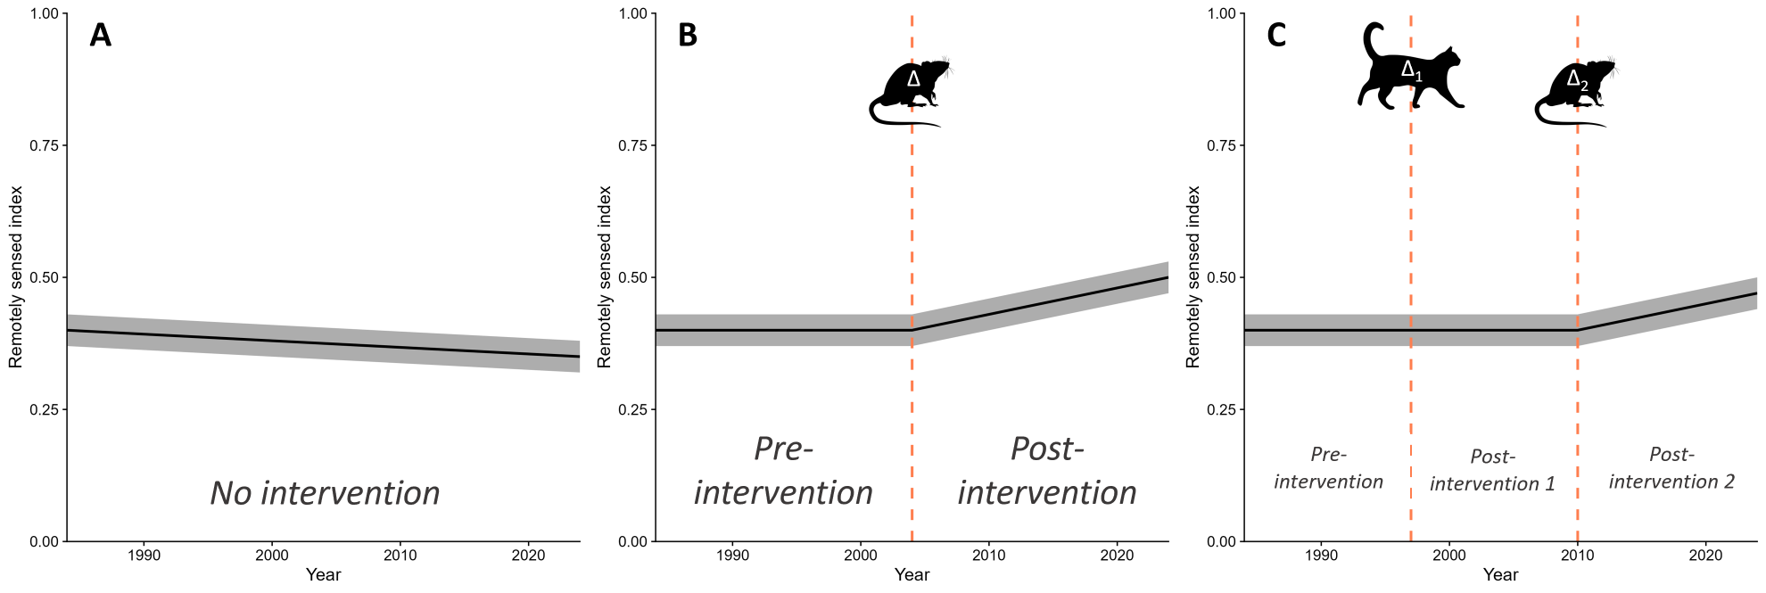
Figure S1. Example time-series illustrating time periods considered in analysis and derivation of change. (A) Islands without interventions were modeled as a simple time-series. (B) Islands with one intervention (or those with multiple, the ultimate year was chosen as the intervention date) were fit as a single interrupted time-series; we derived changes that occurred during the pre- and post-intervention periods, and quantified the change (Δ) that occurred between these periods. (C) Islands with two interventions were fit with two interruptions; we derived changes that occurred during the pre-, post1- and post2-intervention periods, and quantified the changes (Δ₁ and Δ₂) that occurred between sequential periods. Rat (Rattus sp.) and cat (Felis sp.) icons are public domain (CC0 1.0) and accessed from PhyloPic. Interactive leaflet maps (Cheng et al. 2025) and downloadable raster data are available through our web application, Island Vital Signs (Windschitl et al. In Review): https://islandconservation.shinyapps.io/island-vital-signs/.
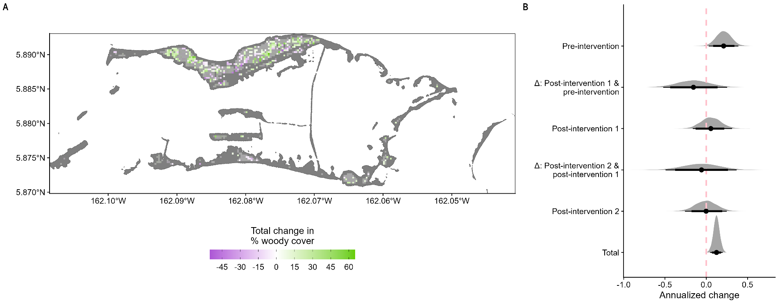
Figure S2. Cumulative and annualized rates of change in woody vegetation cover (WC; expressed in % cover) for the full time-series (2000 – 2023) derived from a baseline model for Palmyra Atoll, USA (5°53’N, 162°04’W; c. 3 km²). (A) Map of change in WC for each c. 30-m pixel. Pale areas were those that did not show strong, directional change in WC, while dark colors illustrate posterior support for directional change (purple = decreasing cover, green = increasing cover). Dark gray areas are those not included in modeling. Over the full 23-year monitoring period, the mean cumulative change in WC was 2.97% (85% HPDI: 1.67% – 4.26%) though only 17.3% of the land area exhibited increases in WC. (B) Annualized rates of change in WC detected across the atoll during distinct intervention periods. Pre-intervention = time when invasive black rats (Rattus rattus) and copra plantations (Cocos nucifera) were unmanaged. Post-intervention 1 = time after black rat removal. Post-intervention 2 = time after Cocos removal. Deltas show the mean change that occurred between time periods. Points indicate mean, thick bars are 85% continuous HPDIs, and thin bars are 95% continuous HPDIs.
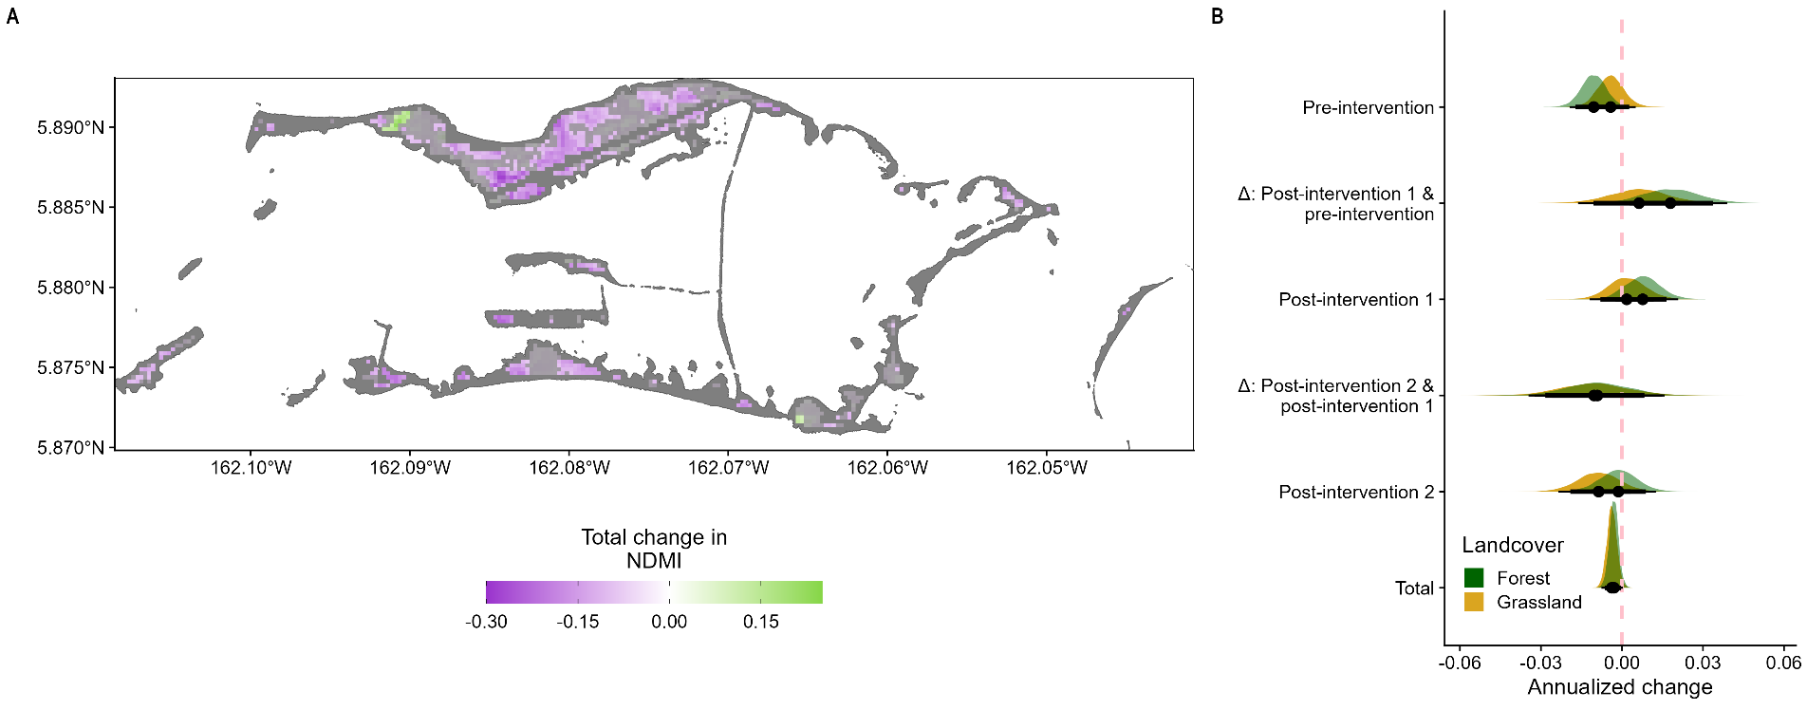
Figure S3. Cumulative and annualized rates of change in vegetation moisture (NDMI; expressed in units of NDMI) for the full time-series (2000 – 2023) derived from a landcover model for Palmyra Atoll, USA (5°53’N, 162°04’W; c. 3 km²). (A) Map of change in NDMI for each 30-m pixel. Pale areas were those that did not show strong, directional change in vegetation moisture, while dark colors illustrate posterior support for directional change (purple = decreasing moisture, green = increasing moisture). Dark gray areas are those not included in modeling. Forested areas on Palmyra declined in NDMI by -0.07 (85% HPDI: -0.13 – -0.01) while grasslands declined by -0.09 (85% HPDI: -0.15 – -0.02), with 46.0% of the land area having experienced declines in NDMI. (B) Annualized rates of change in NDMI detected across the atoll for two different landcover classifications during distinct intervention periods. Pre-intervention = time when invasive black rats (Rattus rattus) and copra plantations (Cocos nucifera) were unmanaged. Post-intervention 1 = time after black rat removal. Post-intervention 2 = time after Cocos removal. Deltas show the mean change that occurred between time periods. Time periods are shown for forest and grassland areas. Points indicate mean, thick bars are 85% continuous HPDIs, and thin bars are 95% continuous HPDIs. Table S9 shows differences between levels in panel B.
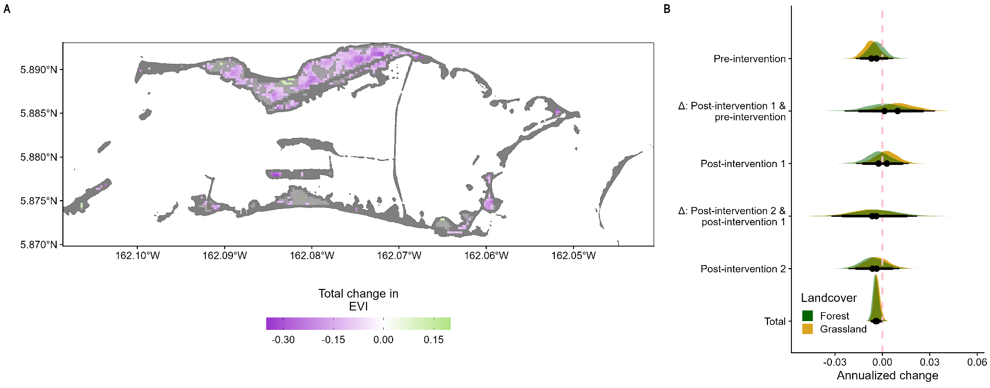
Figure S4. Cumulative and annualized rates of change in productivity (EVI; expressed in units of EVI) for the full time-series (2000 – 2023) derived from a landcover model for Palmyra Atoll, USA (5°53’N, 162°04’W; c. 3 km²). (A) Map of change in EVI for each 30-m pixel. Pale areas were those that did not show strong, directional change in productivity, while dark colors illustrate posterior support for directional change (purple = decreasing productivity, green = increasing productivity). Dark gray areas are those not included in modeling. In forested areas, EVI declined by -0.10 (85% HPDI: -0.17 – -0.04) and -0.08 (85% HPDI: -0.15 – -0.02) in grasslands, with 55.9% of the land area declining in EVI. (B) Annualized rates of change in EVI detected across the atoll for two different landcover classifications during distinct intervention periods. Pre-intervention = time when invasive black rats (Rattus rattus) and copra plantations (Cocos nucifera) were unmanaged. Post-intervention 1 = time after black rat removal. Post-intervention 2 = time after Cocos removal. Deltas show the mean change that occurred between time periods. Time periods are shown for forest and grassland areas. Points indicate mean, thick bars are 85% continuous HPDIs, and thin bars are 95% continuous HPDIs. Table S9 shows differences between levels in panel B.
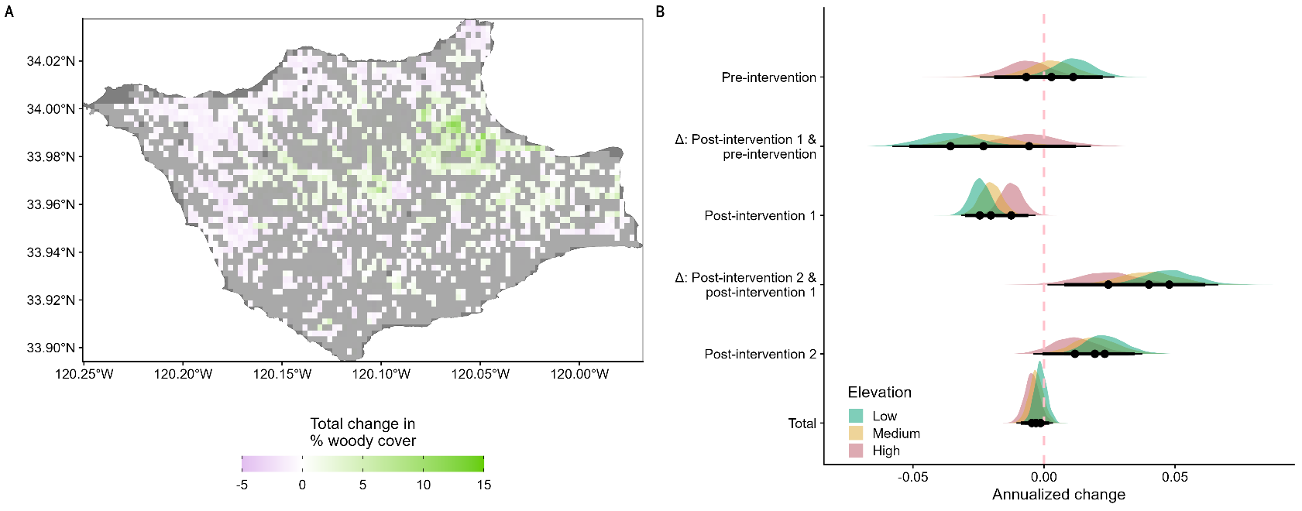
Figure S5. Cumulative and annualized rates of change in woody vegetation cover (WC; expressed in % cover) for the full time-series (1985 – 2024) derived from an elevation model for Santa Rosa Island, Channel Islands, USA (33°58’N, 120°06’W; c. 215 km²). (A) Map of change in WC for each c. 300-m pixel. Pale areas were those that did not show strong, directional change in WC, while dark colors illustrate posterior support for directional change (purple = decreasing cover, green = increasing cover). Dark gray areas are those not included in modeling. Low elevation areas increased in WC by 0.88% (85% HPDI: 0.39% – 1.49%), 1.18% (85% HPDI: 0.55% – 1.85%) in mid-elevation areas, and 1.38% (85% HPDI: 0.76% – 2.14%) in high-elevation areas, with 54.6% of the land area increasing in WC. (B) Annualized rates of change in WC detected across the island during distinct intervention periods. Pre-intervention = time when invasive pigs (Sus scrofa), domestic cattle (Bos taurus), elk (Cervus elaphus nelsoni), and mule deer (Odocoileus hemionus) were present. Post-intervention 1 = time after pig and cattle removal. Post-intervention 2 = time after elk and mule deer removal. Deltas show the mean change that occurred between time periods. Time periods are shown for low elevation (-1 SD), mid-elevation (mean), and high elevation (1 SD) areas. Points indicate mean, thick bars are 85% continuous HPDIs, and thin bars are 95% continuous HPDIs. Table S9 shows differences between levels in panel B.
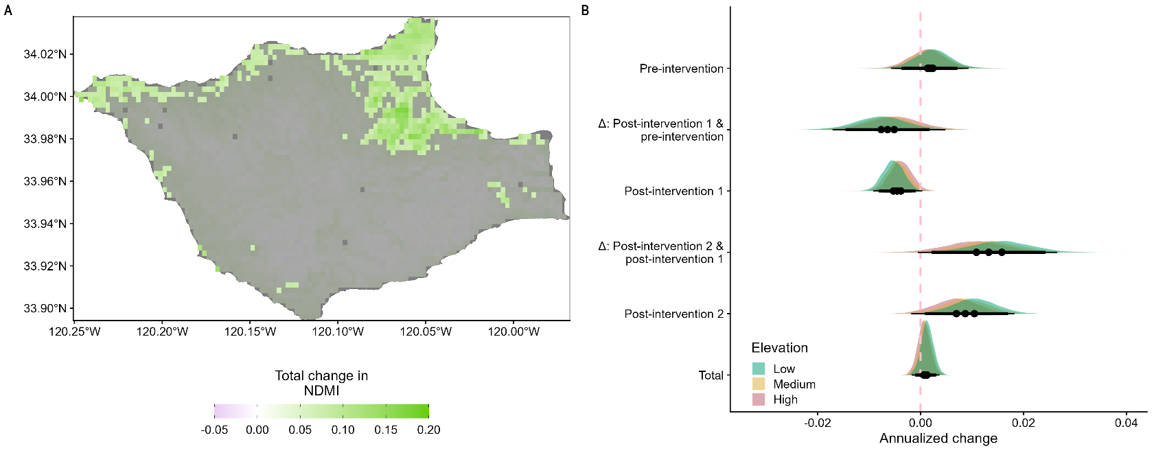
Figure S6. Cumulative and annualized rates of change in vegetation moisture (NDMI; expressed in units of NDMI) for the full time-series (1985 – 2024) derived from an elevation model for Santa Rosa Island, Channel Islands, USA (33°58’N, 120°06’W; c. 215 km²). (A) Map of change in NDMI for each c. 300-m pixel. Pale areas were those that did not show strong, directional change in vegetation moisture, while dark colors illustrate posterior support for directional change (purple = decreasing moisture, green = increasing moisture). Dark gray areas are those not included in modeling. NDMI remained stable across elevations, with 0.02 (85% HPDI: -0.05 – 0.09), 0.01 (85% HPDI: -0.06 – 0.08), and 0.00 (85% HPDI: -0.07 – 0.07) in low, mid, and high elevation areas, respectively, and only 3.6% of the land area increased in NDMI. (B) Annualized rates of change in NDMI detected across the island during distinct intervention periods. Pre-intervention = time when invasive pigs (Sus scrofa), domestic cattle (Bos taurus), elk (Cervus elaphus nelsoni), and mule deer (Odocoileus hemionus) were present. Post-intervention 1 = time after pig and cattle removal. Post-intervention 2 = time after elk and mule deer removal. Deltas show the mean change that occurred between time periods. Time periods are shown for low elevation (-1 SD), mid-elevation (mean), and high elevation (1 SD) areas. Points indicate mean, thick bars are 85% continuous HPDIs, and thin bars are 95% continuous HPDIs. Table S9 shows differences between levels in panel B.
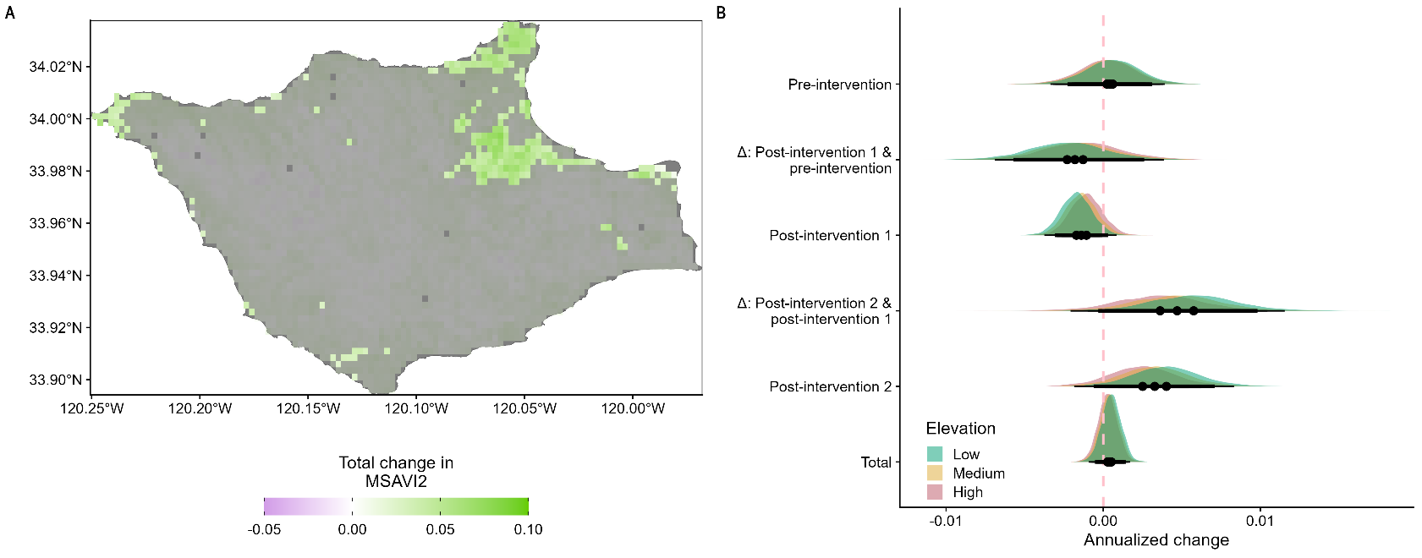
Figure S7. Cumulative and annualized rates of change in productivity (MSAVI2; expressed in units of MSAVI2) for the full time-series (1985 – 2024) derived from an elevation model for Santa Rosa Island, Channel Islands, USA (33°58’N, 120°06’W; c. 215 km²). (A) Map of change in MSAVI2 for each c. 300-m pixel. Pale areas were those that did not show strong, directional change in productivity, dark colors illustrate posterior support for directional change (purple = decreasing productivity, green = increasing productivity). Dark gray areas are those not included in modeling. Mean cumulative change in MSAVI2 in low elevation areas was 0.01 (85% HPDI: -0.03 – 0.04), 0.00 (85% HPDI: -0.03 – 0.04) in mid-elevation areas, and 0.00 (85% HPDI: -0.04 – 0.03) in high-elevation areas, and just 1.65% of the land area increased in MSAVI2. (B) Annualized rates of change in MSAVI2 detected across the island during distinct intervention periods. Pre-intervention = time when invasive pigs (Sus scrofa), domestic cattle (Bos taurus), elk (Cervus elaphus nelsoni), and mule deer (Odocoileus hemionus) were present. Post-intervention 1 = time after pig and cattle removal. Post-intervention 2 = time after elk and mule deer removal. Deltas show the mean change that occurred between time periods. Time periods are shown for low elevation (-1 SD), mid-elevation (mean), and high elevation (1 SD) areas. Points indicate mean, thick bars are 85% continuous HPDIs, and thin bars are 95% continuous HPDIs. Table S9 shows differences between levels in panel B.
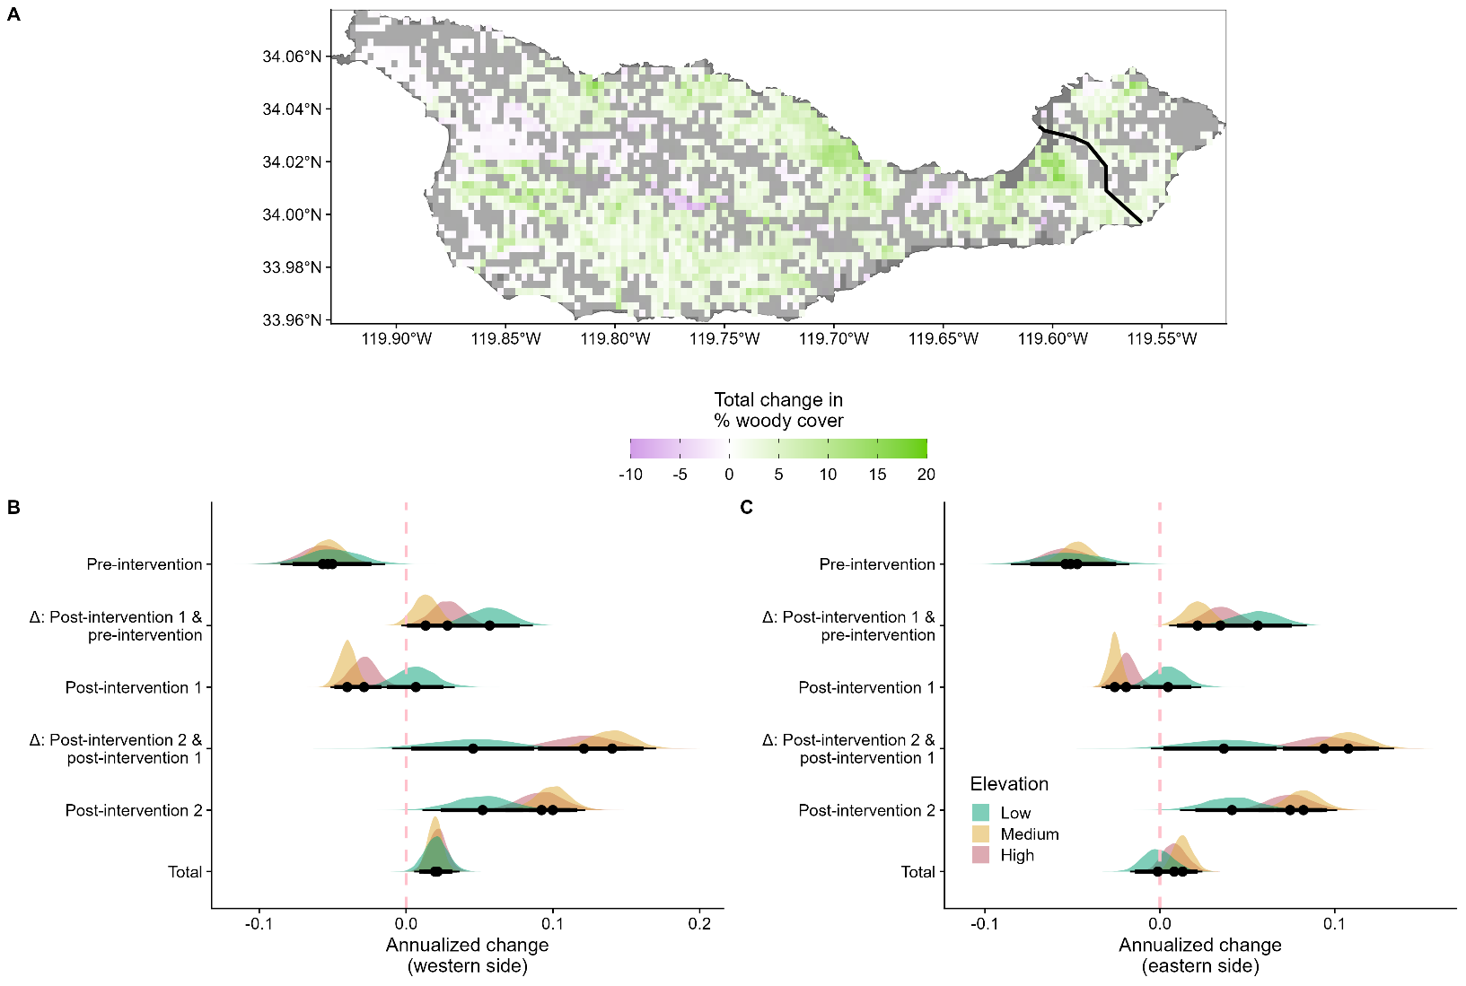
Figure S8. Cumulative and annualized rates of change in woody vegetation cover (WC; expressed in % cover) for the full time-series (1985 – 2023) derived from an elevation model for Santa Cruz Island, Channel Islands, USA (34°00’N, 119°43’W; c. 250 km²). (A) Map of change in WC for each c. 300-m pixel. Pale areas were those that did not show strong, directional change in WC, while dark colors illustrate posterior support for directional change (purple = decreasing cover, green = increasing cover). Dark gray areas are those not included in modeling. At Santa Cruz, invasive sheep (Ovis aries) removal occurred at two different times as land was managed by different agencies. The black line indicates the historical ownership boundary that determined the timing of sheep removal: land west of this boundary (TNC) had sheep removed in 1990, whereas lands east (NPS) were cleared by 2000. Although the ownership boundary has since shifted west after TNC transferred c. 8,500 ac to NPS in 2000, the line shown reflects the boundary used to distinguish spatiotemporal responses to sheep removal and does not reflect the current property boundary. On the western side of the island (c. 225.1 km²), WC in low elevation areas marginally increased by 0.33% (85% HPDI: -0.08% – 0.70%), marginally declined by -0.04% (85% HPDI: -0.56% – 0.41%) in mid-elevation areas, and increased by 0.51% (85% HPDI: 0.22% – 0.84%) in high-elevation areas. On the smaller eastern side (c. 25.2 km²), WC increased across all elevations: 0.84% (85% HPDI: 0.46% – 1.18%) in low elevations, 0.80% (85% HPDI: 0.35% – 1.23%) in mid-elevation areas, and 0.77% (85% HPDI: 0.48% – 1.04%) in high-elevation areas. (B) Annualized rates of change in WC detected across during distinct intervention periods on the western side and (C) annualized rates of change on the eastern side. Pre-intervention = time when invasive sheep and pigs (Sus scrofa) were present. Post-intervention 1 = time after sheep removal. Post-intervention 2 = time after pig removal. Deltas show the mean change that occurred between time periods. Time periods are shown for low elevation (-1 SD), mid-elevation (mean), and high elevation (1 SD) areas. Points indicate mean, thick bars are 85% continuous HPDIs, and thin bars are 95% continuous HPDIs. Table S9 shows differences between levels in panels B and C.
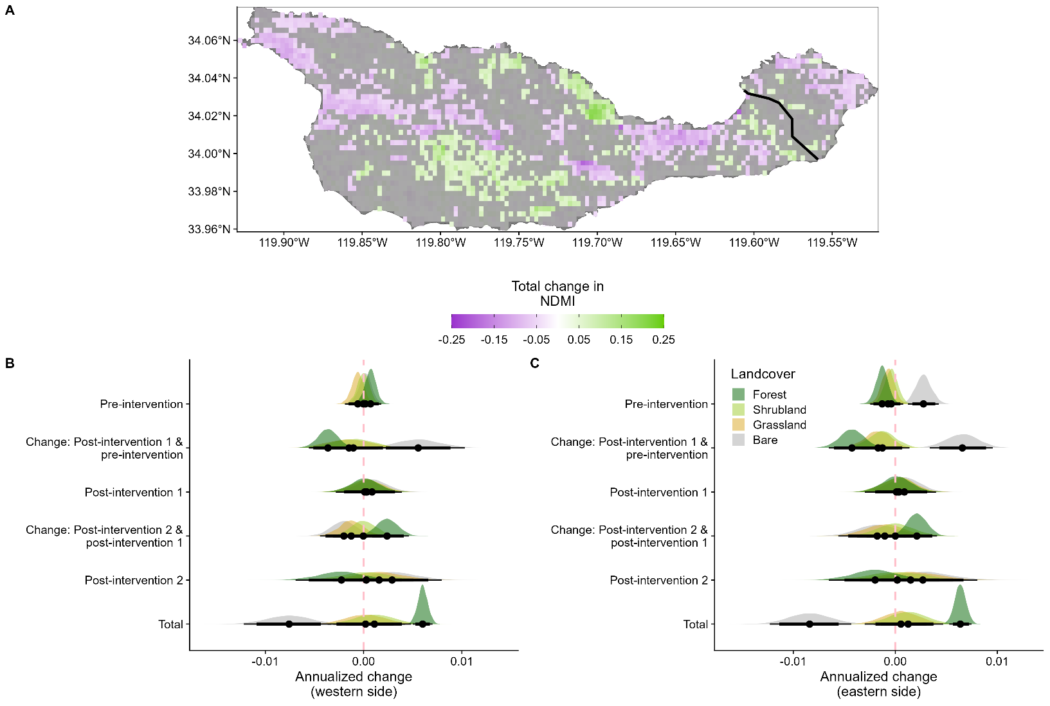
Figure S9. Cumulative and annualized rates of change in vegetation moisture (NDMI; expressed in units of NDMI) for the full time-series (1985 – 2023) derived from a landcover model for Santa Cruz Island, Channel Islands, USA (34°00’N, 119°43’W; c. 250 km²). (A) Map of change in NDMI for each c. 300-m pixel. Pale areas were those that did not show strong, directional change in vegetation moisture, while dark colors illustrate posterior support for directional change (purple = decreasing moisture, green = increasing moisture). Dark gray areas are those not included in modeling. At Santa Cruz, invasive sheep (Ovis aries) removal occurred at two different times as land was managed by different agencies. The black line indicates the historical ownership boundary that determined the timing of sheep removal: land west of this boundary (TNC) had sheep removed in 1990, whereas lands east (NPS) were cleared by 2000. Although the ownership boundary has since shifted west after TNC transferred c. 8,500 ac to NPS in 2000, the line shown reflects the boundary used to distinguish spatiotemporal responses to sheep removal and does not reflect the current property boundary. On the western side of the island (c. 225.1 km²), forested areas increased in NDMI by 0.11 (85% HPDI: 0.07 – 0.15), showed minimal change in shrublands (-0.03, 85% HPDI: -0.06 – 0.01) and grasslands (-0.02, 85% HPDI: -0.06 – 0.02), and declined by -0.05 (85% HPDI: -0.09 – -0.01) in barren areas. On the eastern side (c. 25.2 km²), change in NDMI from forested areas was 0.01 (85% HPDI: -0.03 – 0.05), -0.02 (85% HPDI: -0.05 – 0.01) in shrubland, 0.00 (85% HPDI: -0.03 – 0.03) in grassland, and 0.03 (85% HPDI: -0.01 – 0.06) in barren areas. (B) Annualized rates of change in NDMI detected across the island during distinct intervention periods on the western side and (C) annualized rates of change on the eastern side. Pre-intervention = time when invasive sheep and pigs (Sus scrofa) were present. Post-intervention 1 = time after sheep removal. Post-intervention 2 = time after pig removal. Deltas show the mean change that occurred between time periods. Time periods are shown for forest, shrubland, grassland, and barren areas. Points indicate mean, thick bars are 85% continuous HPDIs, and thin bars are 95% continuous HPDIs. Table S9 shows differences between levels in panels B and C.
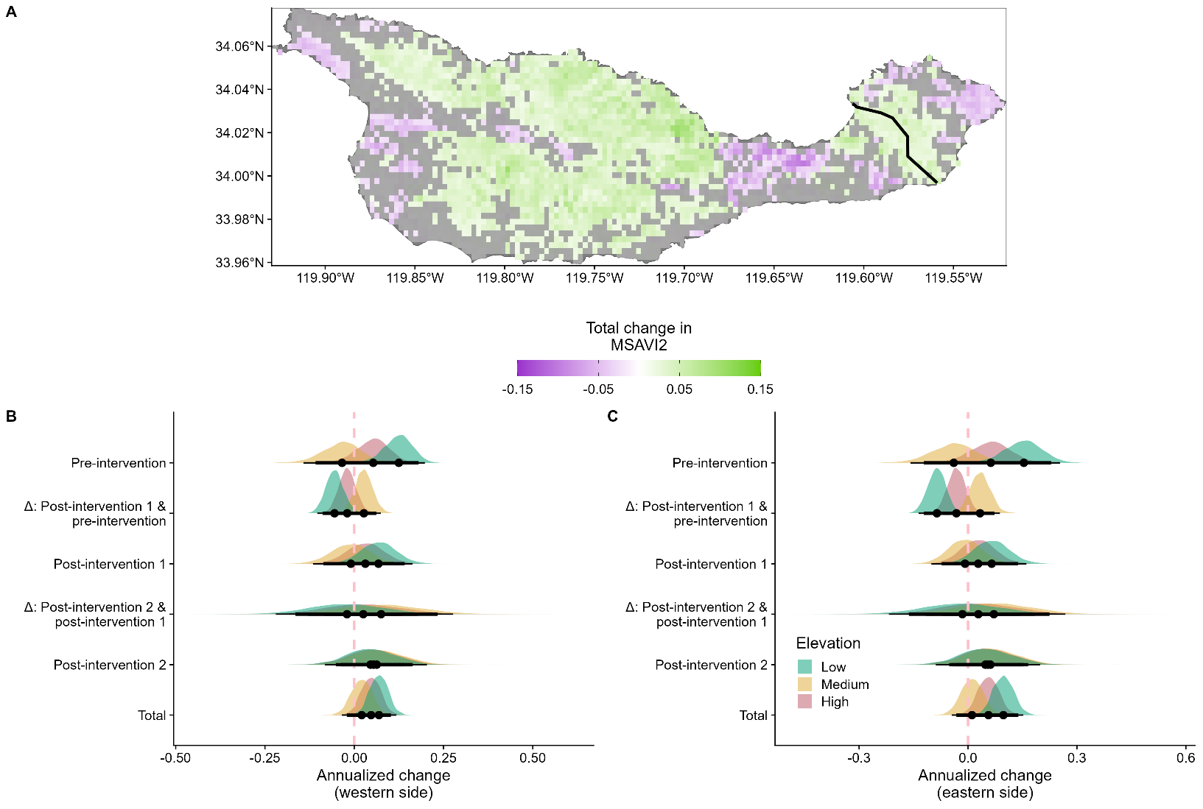
Figure S10. Cumulative and annualized rates of change in productivity (MSAVI2; expressed in units of MSAVI2) for the full time-series (1985 – 2023) derived from an elevation model for Santa Cruz Island, Channel Islands, USA (34°00’N, 119°43’W; c. 250 km²). (A) Map of change in MSAVI2 for each c. 300-m pixel. Pale areas were those that did not show strong, directional change in productivity, while dark colors illustrate posterior support for directional change (purple = decreasing productivity, green = increasing productivity). Dark gray areas are those not included in modeling. At Santa Cruz, invasive sheep (Ovis aries) removal occurred at two different times as land was managed by different agencies. The black line indicates the historical ownership boundary that determined the timing of sheep removal: land west of this boundary (TNC) had sheep removed in 1990, whereas lands east (NPS) were cleared by 2000. Although the ownership boundary has since shifted west after TNC transferred c. 8,500 ac to NPS in 2000, the line shown reflects the boundary used to distinguish spatiotemporal responses to sheep removal and does not reflect the current property boundary. On the western side of the island (c. 225.1 km²), mean cumulative change in MSAVI2 from low elevation areas was 0.02 (85% HPDI: 0.01 – 0.04), 0.04 (85% HPDI: 0.02 – 0.05) in mid-elevation areas, and 0.00 (85% HPDI: -0.01 – 0.02) in high-elevation areas. On the eastern side (c. 25.2 km²), mean cumulative change in MSAVI2 from low elevation areas was 0.02 (85% HPDI: 0.00 – 0.03), 0.03 (85% HPDI: 0.01 – 0.04) in mid-elevation areas, and 0.01 (85% HPDI: -0.01 – 0.02) in high-elevation areas. (B) Annualized rates of change in MSAVI2 detected across the island during distinct intervention periods on the western side and (C) annualized rates of change on the eastern side. Pre-intervention = time when invasive sheep and pigs (Sus scrofa) were present. Post-intervention 1 = time after sheep removal. Post-intervention 2 = time after pig removal. Deltas show the mean change that occurred between time periods. Time periods are shown for low elevation (-1 SD), mid-elevation (mean), and high elevation (1 SD) areas. Points indicate mean, thick bars are 85% continuous HPDIs, and thin bars are 95% continuous HPDIs. Table S9 shows differences between levels in panels B and C.
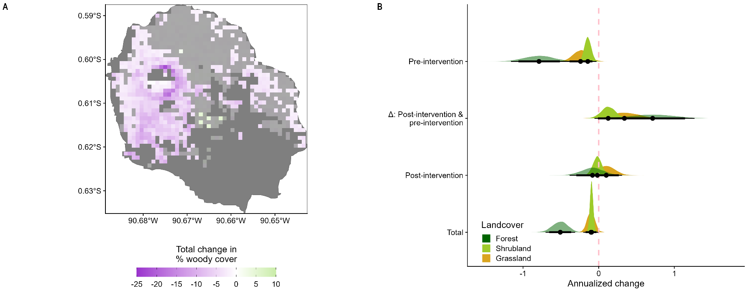
Figure S11. Cumulative and annualized rates of change in woody vegetation cover (WC; expressed in % cover) for the full time-series (1994 – 2023) derived from a landcover model for Isla Pinzón, Islas Galápagos, Ecuador (00°36’S, 90°39’W; c. 18 km²). (A) Map of change in WC for each c. 90-m pixel. Pale areas were those that did not show strong, directional change in WC, while dark colors illustrate posterior support for directional change (purple = decreasing cover, green = increasing cover). Dark gray areas are those not included in modeling. In forested areas, mean cumulative change was -15.33% (85% HPDI: -19.60% – -10.91%), -2.83% (85% HPDI: -3.74% – -1.87%) in shrubland, and -3.05% (85% HPDI: -5.21% – -0.86%) in grasslands, with 31.57% of the land area decreasing in WC. (B) Annualized rates of change in WC detected across the island during distinct intervention periods. Pre-intervention = time when invasive black rats (Rattus rattus) were present. Post-intervention = time after rat removal. Deltas show the mean change that occurred between time periods. Time periods are shown for forest, shrubland, and grassland areas. Points indicate mean, thick bars are 85% continuous HPDIs, and thin bars are 95% continuous HPDIs. Table S9 shows differences between levels in panel B.
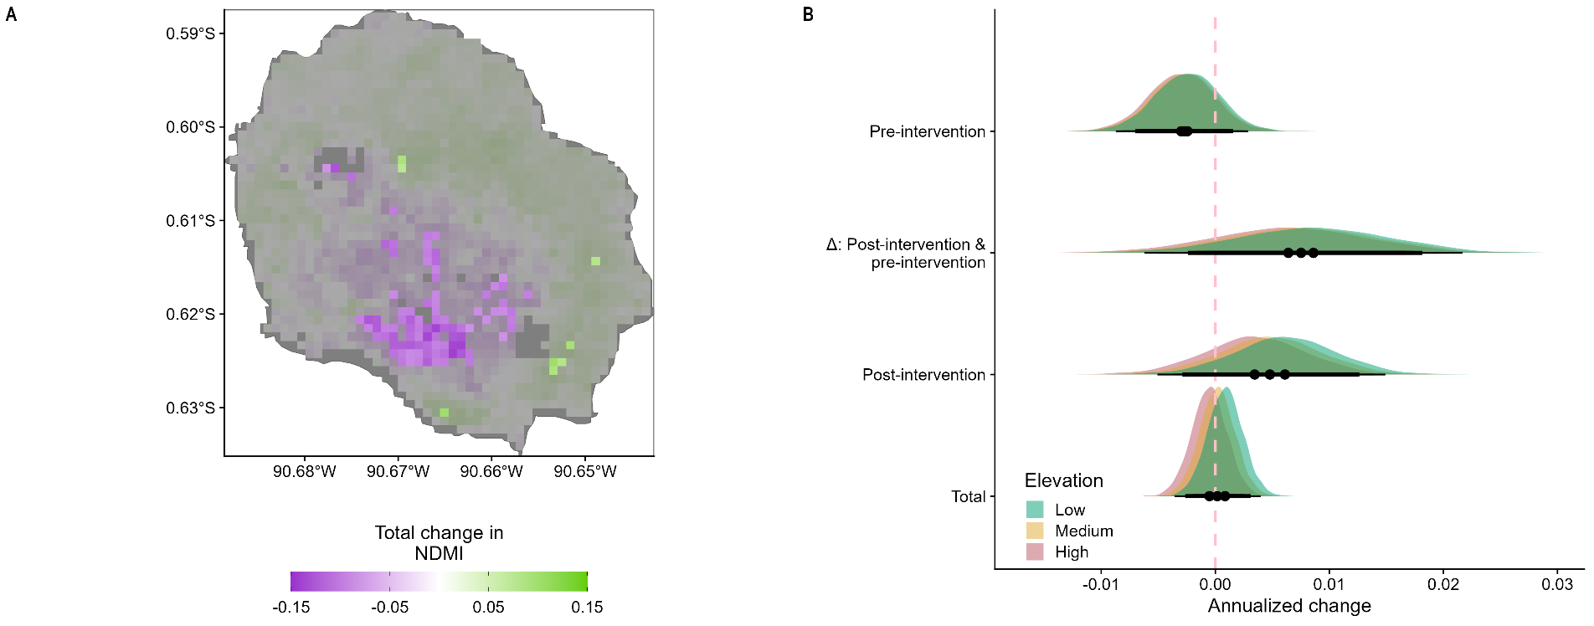
Figure S12. Cumulative and annualized rates of change in vegetation moisture (NDMI; expressed in units of NDMI) for the full time-series (1991 – 2023) derived from an elevation model for Isla Pinzón, Islas Galápagos, Ecuador (00°36’S, 90°39’W; c. 18 km²). (A) Map of change in NDMI for each c. 90-m pixel. Pale areas were those that did not show strong, directional change in vegetation moisture, while dark colors illustrate posterior support for directional change (purple = decreasing moisture, green = increasing moisture). Dark gray areas are those not included in modeling. NDMI showed little overall change. Mean cumulative change in NDMI from low elevation areas was 0.03 (85% HPDI: -0.04 – 0.10), 0.01 (85% HPDI: -0.06 – 0.08) in mid-elevation areas, and -0.02 (85% HPDI: -0.09 – 0.06) in high-elevation areas, and only 0.47% of the land area had increased in NDMI. (B) Annualized rates of change in NDMI detected across the island during distinct intervention periods. Pre-intervention = time when invasive black rats (Rattus rattus) were present. Post-intervention = time after rat removal. Deltas show the mean change that occurred between time periods. Time periods are shown for low elevation (-1 SD), mid-elevation (mean), and high elevation (1 SD) areas. Points indicate mean, thick bars are 85% continuous HPDIs, and thin bars are 95% continuous HPDIs. Table S9 shows differences between levels in panel B.
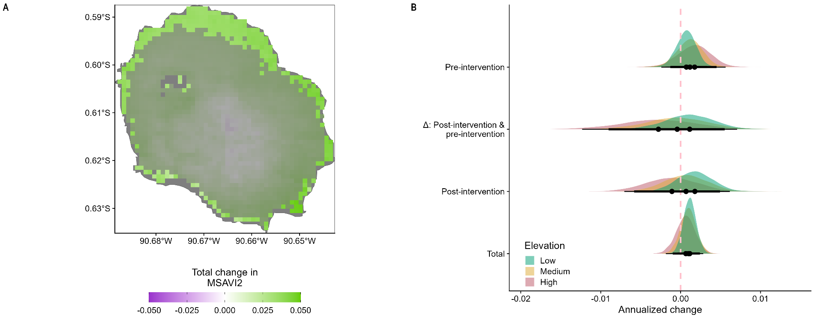
Figure S13. Cumulative and annualized rates of change in productivity (MSAVI2; expressed in units of MSAVI2) for the full time-series (1991 – 2023) derived from an elevation model for Isla Pinzón, Islas Galápagos, Ecuador (00°36’S, 90°39’W; c. 18 km²). (A) Map of change in MSAVI2 for each c. 90-m pixel. Pale areas were those that did not show strong, directional change in productivity, while dark colors illustrate posterior support for directional change (purple = decreasing productivity, green = increasing productivity). Dark gray areas are those not included in modeling. Mean cumulative change in MSAVI2 from low elevation areas was 0.04 (85% HPDI: 0.00 – 0.08), 0.03 (85% HPDI: -0.01 – 0.08) in mid-elevation areas, and 0.02 (85% HPDI: -0.03 – 0.08) in high-elevation areas, and only 15.81% of the land area increased in MSAVI2. (B) Annualized rates of change in MSAVI2 detected across the island during distinct intervention periods. Pre-intervention = time when invasive black rats (Rattus rattus) were present. Post-intervention = time after rat removal. Deltas show the mean change that occurred between time periods. Time periods are shown for low elevation (-1 SD), mid-elevation (mean), and high elevation (1 SD) areas. Points indicate mean, thick bars are 85% continuous HPDIs, and thin bars are 95% continuous HPDIs. Table S9 shows differences between levels in panel B.
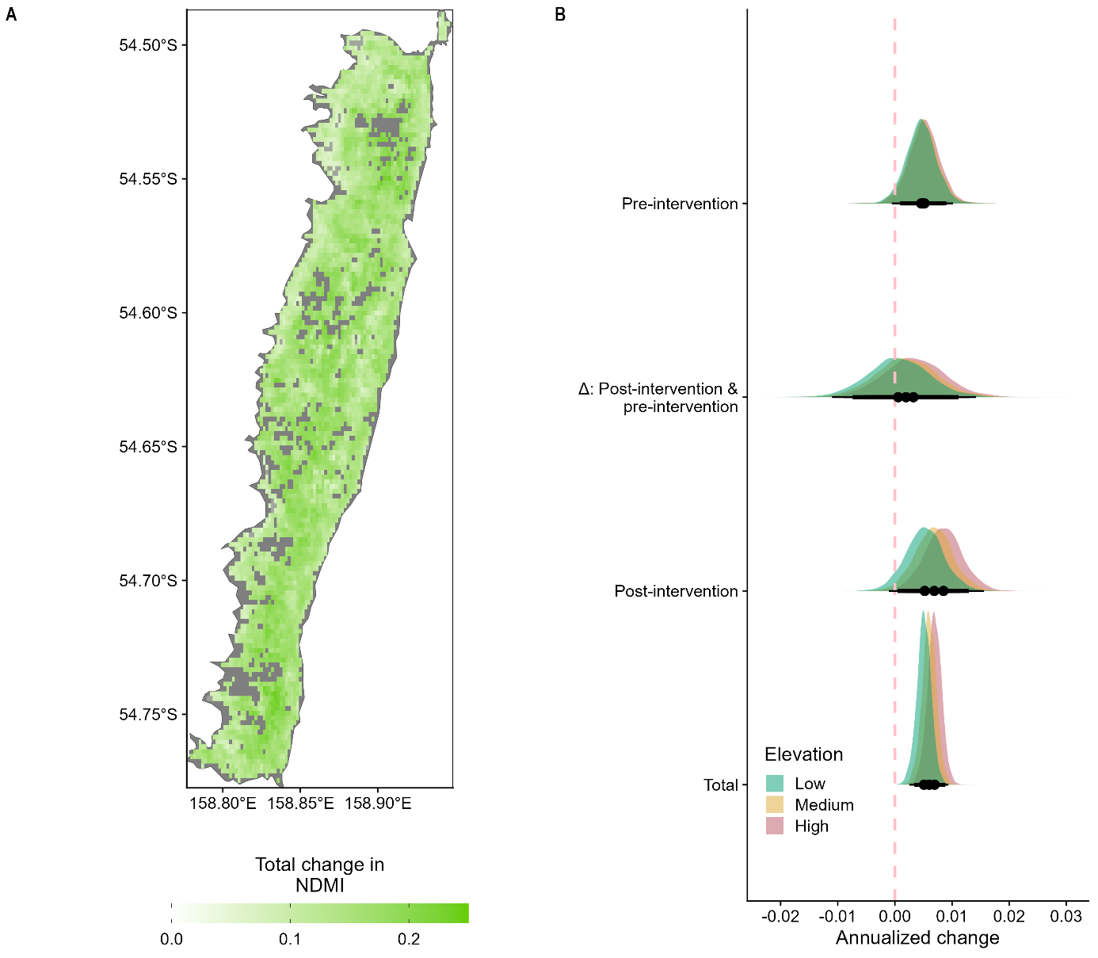
Figure S14. Cumulative and annualized rates of change in vegetation moisture (NDMI; expressed in units of NDMI) for the full time-series (2000 – 2023) derived from an elevation model for Macquarie Island, Australia (54°37’S, 158°51’E; c. 130 km²). (A) Map of change in NDMI for each c. 300-m pixel. Pale areas were those that did not show strong, directional change in vegetation moisture, while dark colors illustrate posterior support for directional change (purple = decreasing moisture, green = increasing moisture). Dark gray areas are those not included in modeling. Mean cumulative change in NDMI in low elevation areas was 0.12 (85% HPDI: 0.08 – 0.17), 0.14 (85% HPDI: 0.10 – 0.19) in mid-elevation areas, and 0.17 (85% HPDI: 0.12 – 0.21) in high-elevation areas, with 91.02% of the land area increasing in NDMI. (B) Annualized rates of change in NDMI detected across the island during distinct intervention periods. Invasive species removals from Macquarie were temporally staggered; goats (Capra hircus) were removed in 1957, domestic cats (Felis catus) in 2000, and black rats (Rattus rattus), house mice (Mus musculus), and European rabbits (Oryctolagus cuniculus) in 2011 and declared cleared in 2014 (DIISE 2019). Pre-intervention = after goat and cat removal, but before the removal of rodents and rabbits. Post-intervention = all invasive mammals removed. Deltas show the mean change that occurred between time periods. Time periods are shown for low elevation (-1 SD), mid-elevation (mean), and high elevation (1 SD) areas. Points indicate mean, thick bars are 85% continuous HPDIs, and thin bars are 95% continuous HPDIs. Table S9 shows differences between levels in panel B.
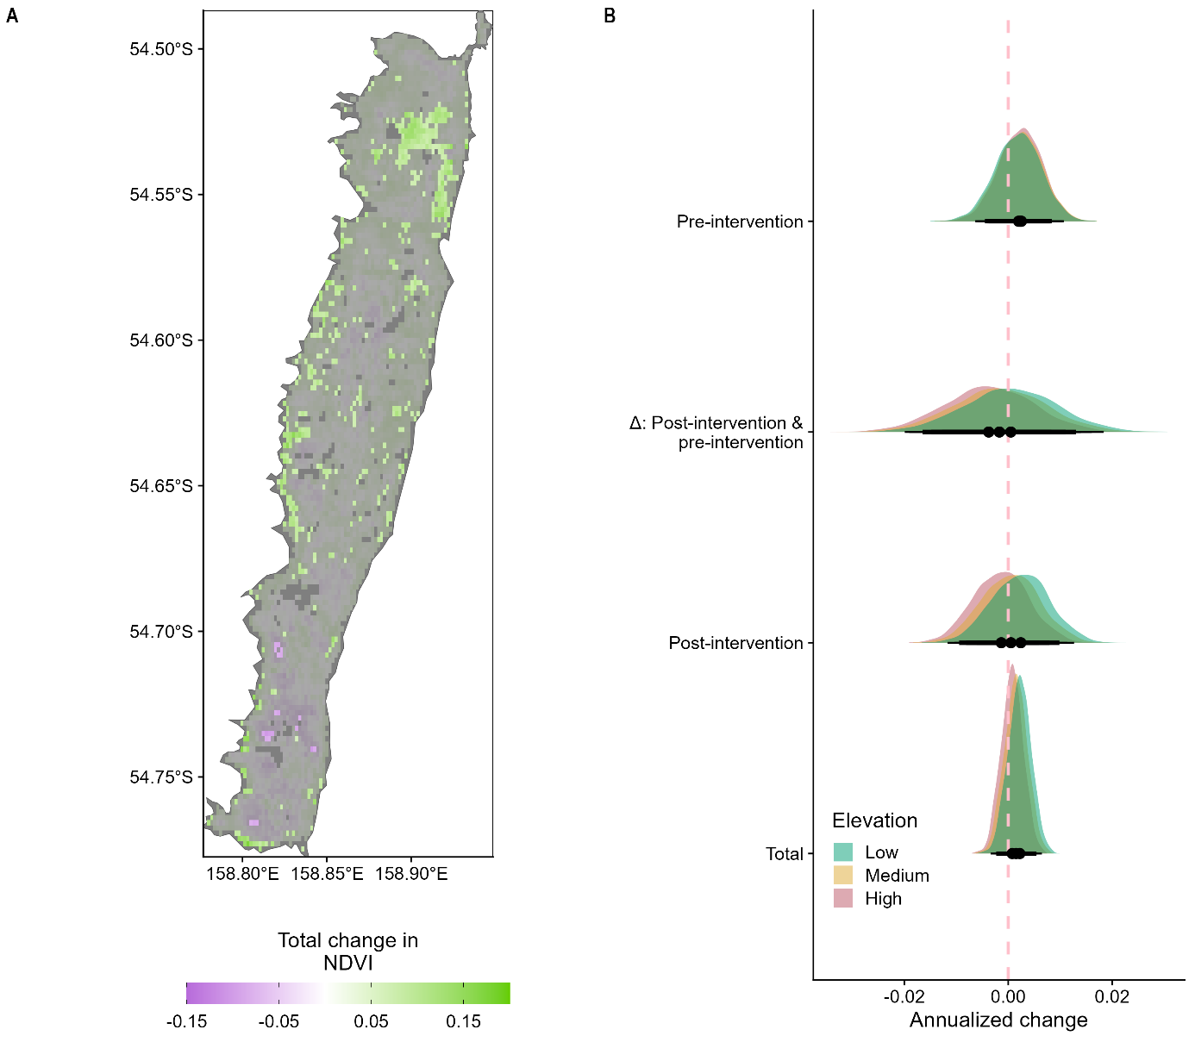
Figure S15. Cumulative and annualized rates of change in productivity (NDVI; expressed in units of NDVI) for the full time-series (2000 – 2023) derived from an elevation model for Macquarie Island, Australia (54°37’S, 158°51’E; c. 130 km²). (A) Map of change in NDVI for each c. 300-m pixel. Pale areas were those that did not show strong, directional change in productivity, while dark colors illustrate posterior support for directional change (purple = decreasing productivity, green = increasing productivity). Dark gray areas are those not included in modeling. Mean cumulative change in NDVI from low elevation areas was 0.05 (85% HPDI: -0.02 – 0.13), 0.04 (85% HPDI: -0.04 – 0.11) in mid-elevation areas, and 0.02 (85% HPDI: -0.06 – 0.09) in high-elevation areas, and only 10.77% of the land area increasing in NDVI. (B) Annualized rates of change in NDVI detected across the island during distinct intervention periods. Invasive species removals from Macquarie were temporally staggered; goats (Capra hircus) were removed in 1957, domestic cats (Felis catus) in 2000, and black rats (Rattus rattus), house mice (Mus musculus), and European rabbits (Oryctolagus cuniculus) in 2011 and declared cleared in 2014 (DIISE 2019). Pre-intervention = after goat and cat removal, but before the removal of rodents and rabbits. Post-intervention = all invasive mammals removed. Deltas show the mean change that occurred between time periods. Time periods are shown for low elevation (-1 SD), mid-elevation (mean), and high elevation (1 SD) areas. Points indicate mean, thick bars are 85% continuous HPDIs, and thin bars are 95% continuous HPDIs. Table S9 shows differences between levels in panel B.

References
Anderson, A., T. O'Regan, P. Parata-Goodall, M. Stevens, and T. M. Tau. 2021. "A southern Māori perspective on stories of Polynesian polar voyaging." Polar Record 57: e42. https://doi/org/10.1017/S0032247421000693
Anderson, R. S., S. Starratt, R. M. Brunner Jass, and N. Pinter. 2010. "Fire and vegetation history on Santa Rosa Island, Channel Islands, and long-term environmental change in southern California." Journal of Quaternary Science 25, no. 5: 782–797. https://doi/org/10.1002/jqs.1358.
Beltran, R. S., N. Kreidler, D. H. Van Vuren, et al. 2014. "Passive recovery of vegetation after herbivore eradication on Santa Cruz Island, California." Restoration Ecology 22, no. 6: 790–797. https://doi/org/10.1111/rec.12144.
Bergstrom, D. M., P. K. Bricher, B. Raymond, et al. 2015. "Rapid collapse of a sub-Antarctic alphine ecosystem: The role of climate and pathogens." Journal of Applied Ecology 52, no. 3: 774–783. https://doi/org/10.1111/1365-2664.12436.
Bergstrom, D. M., C. R. Dickson, D. J. Baker, J. Whinam, P. M. Selkirk, and M. A. McGeoch. 2021. "Ecosystem collapse on a sub-Antarctic Island." In Ecosystem Collapse and Climate Change, edited by J. G. Canadell & R. B. Jackson, 13–25. Cham, Switzerland: Springer Nature.
Bergstrom, D. M., A. Lucieer, K. Kiefer, et al. 2009. "Indirect effects of invasive species removal devastate World Heritage Island." Journal of Applied Ecology 46, no. 1: 73–81. https://doi/org/10.1111/j.1365-2664.2008.01601.x.
Bricher, P. K., A. Lucieer, J. Shaw, A. Terauds, and D. M. Bergstrom. 2013. "Mapping sub-Antarctic cushion plants using random forests to combine very high resolution satellite imagery and terrain modeling." PLoS One 8, no. 8: e72093. https://doi/org/10.1371/journal.pone.0072093.
Bürkner, P.-C. 2017. "brms: An R package for Bayesian multilevel models using Stan." Journal of Statistical Software 80, no. 1: 1–28. https://doi/org/10.18637/jss.v080.i01.
Burnett, M. W., T. D. White, D. J. McCauley, G. A. De Leo, and F. Micheli. 2019. "Quantifying coconut palm extent on Pacific islands using spectral and textural analysis of very high resolution imagery." International Journal of Remote Sensing 40, no. 19: 7329–7355. https://doi/org/10.1080/01431161.2019.154440.
Carpenter, B., A. Gelman, M. D. Hoffman, et al. 2017. "Stan: A probabilistic programming language." Journal of Statistical Software 76: 1–32. https://doi/org/10.18637/jss.v076.i01.
Cayot, L. J. 2021. "Pinzón Island: A century of zero tortoise hatchlings to a growing population." In Galapagos Giant Tortoises, edited by J. P. Gibbs, L. J. Cayot, & W. Tapia Aguilera, 451–464. Cambridge, MA: Academic Press.
Cheng, J., B. Schloerke, B. Karambelkar, Y. Xie, and G. Aden-Buie. 2025. "leaflet: Create interactive web maps with the Javascript 'Leaflet' library. R package ver. 2.2.3.9000."
Clark, D. A. 1981. "Foraging patterns of black rats across a desert-montane forest gradient in the Galápagos Islands." Biotropica 13, no. 3: 182–194.
Clark, S. 2015. Creation of the Santa Rosa Island herbarium and repeat photo analysis on Santa Rosa Island, California. California State University Channel Islands, Camarillo, California, USA.
Cohen, B., C. Cory, J. Menke, and A. Hepburn. 2009. "A spatial database of Santa Cruz Island vegetation." In Proceedings of the 7th California Islands Symposium, edited by C. C. Damiani & D. K. Garcelon, 229–244. Arcata, CA: Institute for Wildlife Studies.
Copson, G., and J. Whinam. 1998. "Response of vegetation on subantarctic Macquarie Island to reduced rabbit grazing." Australian Journal of Botany 46, no. 1: 15–24. https://doi/org/10.1071/BT96123.
Dickson, C. R., D. J. Baker, D. M. Bergstrom, R. H. Brookes, J. Whinam, and M. A. McGeoch. 2021. "Widespread dieback in a foundation species on a sub-Antarctic World Heritage Island: Fine-scale patterns and likely drivers." Austral Ecology 46, no. 1: 52–64. https://doi/org/10.1111/aec.12958.
DIISE. 2019. "The Database of Island Invasive Species Eradications, developed by Island Conservation, Coastal Conservation Action Laboratory UCSC, IUCN SSC Invasive Species Specialist Group, University of Auckland and Landcare Research New Zealand." Retrieved from http://diise.islandconservation.org
FAO. 2012. Global ecological zones for FAO forest reporting: 2010 update. Rome, Italy: FAO.
Fischer, D. T. 2007. Ecological and Biogeographical Impacts of Fog and Stratus Clouds on Coastal Vegetation, Santa Cruz Island, CA. University of California Santa Barbara, Santa Barbara, CA.
Fitzgerald, N. B., J. B. Kirkpatrick, and J. J. Scott. 2021. "Rephotography, permanent plots and remote sensing data provide varying insights on vegetation change on subantarctic Macquarie Island, 1980-2015." Austral Ecology 46: 762–775. https://doi/org/10.1111/aec.13015.
Franklin, K., M. Khalsa, S. Hunter, S. Kropidlowski, P. Carr, and A. Wegmann. 2024. "Conservation management of an abandoned copra plantation at Palmyra Atoll, Northern Line Islands, Pacific Ocean." Conservation Evidence 21: 1–5. https://doi/org/10.52201/CEJ21/WTTF3018.
Gabry, J., R. Češnovar, A. Johnson, et al. 2024. "cmdstanr: R interface to 'CmdStan'." Retrieved from https://mc-stan.org/cmdstanr/
Gabry, J., D. Simpson, A. Vehtari, M. Betancourt, and A. Gelman. 2019. "Visualization in Bayesian workflow." Journal of the Royal Statistical Society Series A: Statistics in Society 182, no. 2: 389–402. https://doi/org/10.1111/rssa.12378.
Gao, B.-C. 1996. "NDWI – A normalized difference water index for remote sensing of vegetation liquid water from space." Remote Sensing of Environment 58, no. 3: 257–266. https://doi/org/10.1016/S0034-4257(96)00067-3.
Gelfand, A. E. 1996. "Model determination using sampling-based methods." In Markov Chain Monte Carlo in Practice, edited by W. R. Gilks, S. Richardson, & D. J. Spiegelhalter, 145–162. Boca Raton, FL: Chapman & Hall/CRC.
Gelfand, A. E., D. K. Dey, and H. Chang. 1992. Model determination using predictive distributions with implementation via sampling-based methods. Technical report No. 462. Stanford, CA: Stanford University Department of Statistics.
Gelman, A., and D. B. Rubin. 1992. "Inference from iterative simulation using multiple sequences." Statistical Science 7, no. 4: 457–511. https://doi/org/10.1214/ss/1177011136.
Hamann, O. 1981. "Plant communities of the Galápagos Islands." Dansk Botanisk Arkiv 34: 1–183.
Hijmans, R., A. Brown, and M. Barbosa. 2026. "terra: Spatial data analysis. R package ver. 1.9-27." https://doi/org/10.32614/CRAN.package.terra.
Hindell, M. A., and H. R. Burton. 1988. "The history of the elephant seal industry at Macquarie Island and an estimate of the pre-sealing numbers." Papers and Proceedings of the Royal Society of Tasmania 122, no. 1: 159–176.
Honzák, M., G. Roberts, B. J. Cosentino, et al. 2024. "Toward the quantification of the climate co-benefits of invasive mammal eradication on islands: A scalable framework for restoration monitoring." Environmental Research Letters 19: 114018. https://doi/org/0.1088/1748-9326/ad77b7.
Jiang, Z., A. R. Huete, K. Didan, and T. Miura. 2008. "Development of a two-band enhanced vegetation index without a blue band." Remote Sensing of Environment 112: 3833–3845. https://doi/org/10.1016/j.rse.2008.06.006.
Jones, J. A., S. A. Junak, and R. J. Paul. 1993. "Progress in mapping vegetation on Santa Cruz Island and a preliminary analysis of relationships with environmental factors." In Proceedings of the Third California Islands Symposium, edited by F. G. Hochberg, 97–104. Santa Barbara, CA: Santa Barbara Museum of Natural History.
Junak, S., D. A. Knapp, J. R. Haller, R. Philbrick, A. Schoenherr, and T. Keeler-Wolf. 2007. "The California Channel Islands (3rd ed.)." In Terrestrial vegetation of California, edited by M. G. Barbour, T. Keeler-Wolf, & A. A. Schoenherr, 229–252. Berkeley, CA: University of California Press.
Kirkpatrick, J. B., and J. J. Scott. 2002. "Change in undisturbed vegetation on the coastal slopes of subantarctic Macquarie Island, 1980-1995." Arctic, Antarctic, and Alpine Research 34, no. 3: 300–307. https://doi/org/10.1080/15230430.2002.12003498.
Kitchner, A., and S. Harris. 2013. Macquarie Island vegetation (2nd ed. ed.). Hobart, Tasmania, Australia: Department of Parimary Industries, Parks, Water and Environment,.
Klinger, R. C., P. Schuyler, and J. D. Sterner. 2002. "The response of herbaceous vegetation and endemic plant species to the removal of feral sheep from Santa Cruz Island, California." In Turning the tide: The eradication of invasive species, edited by C. R. Veitch & M. N. Clout, 141–154. Gland, Switzerland and Cambridge, UK: IUCN SSC Invasive Species Specialist Group.
Klinger, R. C., P. T. Schuyler, and J. D. Sterner. 1994. "Vegetation response to the removal of feral sheep from Santa Cruz Island." In The 4th California Islands Symposium: Update on the Status of Resources, edited by W. L. Halvorson & G. J. Maender, 341–350. Santa Barbara, CA: Santa Barbara Museum of Natural History.
Krauss, K. W., J. A. Duberstein, N. Cormier, H. S. Young, and S. A. Hathaway. 2015. "Proximity to encroaching coconut palm limits native forest water use and persistence on a Pacific atoll." Ecohydrology 8, no. 8: 1514–1524. https://doi/org/10.1002/eco.1601.
Lane, T. 2015. Viewing vegetation change on Santa Rosa Island: A photo-point study. California State University Channel Islands, Camarillo, California, USA.
Livingston, D. S. 2016. Island legacies: A history of the islands within Channel Islands National Park. Historic Resource Study. Technical Report to the National Parks Service. Inverness, CA.
Lombardo, C. A., and K. R. Faulkner. 2000. "Eradication of feral pigs (Sus scrofa) from Santa Rosa Island, Channel Islands National Park, California." In Proceedings of the fifth California Islands symposium, edited by D. H. Browne, H. Chaney, & K. Mitchell, 300–306. Santa Barbara, CA: Santa Barbara Museum of Natural History.
Longley-Wood, K., M. Engels, K. D. Lafferty, J. P. McLaughlin, and A. Wegmann. 2022. "Transforming Palmyra Atoll to native-tree dominance will increase net carbon storage and reduce dissolved organic carbon reef runoff." PLoS One 17, no. 1: e0262621. https://doi/org/10.1371/journal.pone.0262621.
MacFarland, C. G., J. Villa, and B. Toro. 1974. "The Galápagos giant tortoises (Geochelone elephantopus). Part I: Status of the surviving populations." Biological Conservation 6, no. 2: 118–133. https://doi/org/10.1016/0006-3207(74)90024-X.
McEachern, A. K., T. Atwater, P. W. Collins, K. R. Faulkner, and D. V. Richards. 2016. "Managed island ecosystems." In Ecosystems of California, edited by H. Mooney & E. S. Zavaleta, 755–778.
McEachern, A. K., K. A. Chess, and K. G. Niessen. 2010. "Field surveys of rare plants of Santa Cruz Island, California, 2003-2006: Historical records and current distributions." Reston, VA: U.S. Geological Survey Scientific Investigations Report 2009-5264.
Meeder, A., R. Klinger, J. Knapp, and J. Yost. 2025. "Plant composition dynamics following non-native ungulate removal: Convergence, divergence, and novel ecosystems." Ecological Applications 35, no. 7: e70114. https://doi/org/10.1002/eap.70114.
Miller-ter Kuile, A., D. Orr, A. Bui, et al. 2021. "Impacts of rodent eradication on seed predation and plant community biomass on a tropical atoll." Biotropica 53, no. 1: 232–242. https://doi/org/10.1111/btp.12864.
Minnich, R. A. 1980. "Vegetation of Santa Cruz and Santa Catalina Islands." In The California Islands: Proceedings of a multidisciplinary symposium, edited by D. M. Power, 123–138. Santa Barbara, CA: Santa Barbara Museum of Natural History.
Patton, J. L., S. H. Yang, and P. Myers. 1975. "Genetic and morphological divergence among introduced rat populations (Rattus rattus) of the Galápagos archipelago, Ecuador." Systematic Biology 24, no. 3: 296–310. https://doi/org/10.1093/sysbio/24.3.296.
Pebesma, E. 2018. "Simple features for R: Standardized support for spatial vector data." The R Journal 10, no. 1: 439–446.
Pesendorfer, M. B., C. M. Baker, M. Stringer, et al. 2018. "Oak habitat recovery on California's largest islands: Scenarios for the role of corvid seed dispersal." Journal of Applied Ecology 55, no. 3: 1185–1194. https://doi/org/10.1111/1365-2664.13041.
Petterolli, N., J. O. Vik, A. Mysterud, J.-M. Gallard, C. J. Tucker, and N. C. Stenseth. 2005. "Using the satellite-derived NDVI to assess ecological responses to environmental change." Trends in Ecology & Evolution 20, no. 9: 503–510. https://doi/org/10.1016/j.tree.2005.05.011.
Qi, J., A. Chehbouni, A. R. Huete, Y. H. Kerr, and S. Sorooshian. 1994a. "A modified soil adjusted vegetation index." Remote Sensing of Environment 48, no. 2: 119–126. https://doi/org/10.1016/0034-4257(94)90134-1.
Qi, J., Y. H. Kerr, and A. Chehbouni. 1994b. "External factor consideration in vegetation index development." Proceedings of Physical Measurements and Signatures in Remote Sensing ISPRS 723: 730.
R Core Team. 2024. R: A language and environment for statistical computing (ver. 4.4.2). Vienna, Austria: R Foundation for Statistical Computing.
Raymond, B., J. McInnes, J. M. Dambacher, S. Way, and D. M. Bergstrom. 2011. "Qualitative modelling of invasive species eradication on subantarctic Macquarie Island." Journal of Applied Ecology 48: 181–191. https://doi/org/10.1111/j.1365-2664.2010.01916.x.
Rodriguez, D., and C. B. Williams. 2025. "Channel Islands National Park: Vegetation classification and mapping project report. Science Report NPS/SR-2025/293." Fort Collins, CO: National Park Service.
Rueda, D., V. Carrion, P. A. Castaño, et al. 2019. "Preventing extinctions: Planning and undertaking invasive rodent eradication from Pinzon Island, Galapagos." In Island Invasives: Scaling Up to Meet the Challenge, edited by C. R. Veitch, M. N. Clout, A. R. Martin, J. C. Russell, & C. J. West, 51–56. Gland, Switzerland: IUCN.
Russell, J. C. 2011. "Indirect effects of introduced predators on seabird islands." In Seabird Islands: Ecology, Invasion, and Restoration, edited by C. P. H. Mulder, W. B. Anderson, D. R. Towns, & P. J. Bellingham, 261–280. New York, NY: Oxford University Press.
Scott, J. J., and J. B. Kirkpatrick. 2008. "Rabbits, landslips and vegetation change on the coastal slopes of subantarctic Macquarie Island, 1980-2007: Implications for management." Polar Biology 31: 409–419.
Scott, J. J., and J. B. Kirkpatrick. 2013. "Changes in the cover of plant species associated with climate change and grazing pressures on the Macquarie Island coastal slopes, 1980-2009." Polar Biology 36: 127–136. https://doi/org/10.1007/s00300-012-1243-y.
Sexton, J. O., X.-P. Song, M. Feng, et al. 2013. "Global, 30-m resolution continuous fields of tree cover: Landsat-based rescaling of MODIS vegetation continuous fields with lidar-based estimates of error." International Journal of Digital Earth 6, no. 5: 427–448. https://doi/org/10.1080/17538947.2013.786146.
Shaw, J., A. Terauds, and D. Bergstrom. 2011. "Rapid commencement of ecosystem recovery following aerial baiting on sub-Antarctic Macquarie Island." Ecological Management & Restoration 12, no. 3: 241–244. https://doi/org/10.1111/j.1442-8903.2011.00611.x.
Springer, K. 2018. "Eradication of invasive speces on Macquarie Island to restore the natural ecosystem." In Recovering Australian Threatened Species: A Book of Hope, edited by D. Lindenmayer, J. C. Z. Woinarski, P. Latch, & S. Garnett, 13–22. Clayton South, Victoria, Australia: CSIRO Publishing.
Starcevich, L. A., C. Murray, L. F. Lee, C. B. Williams, and K. McEachern. 2025. "Analysis of trends in terrestrial vegetation at Mediterranean Coast Network parks: Channel Islands National Park." Fort Collins, CO.
Struckhoff, M. A. 2019. "Woody species crown and vegetation community data, Palmyra Atoll, 2016: U.S. Geological Survey data release."
Summers, R., J. Masukawa, and B. D. Hartman. 2018. "The influence of slope on vegetation recovery following nonnative grazer removal on Santa Rosa Island, California." Western North American Naturalist 78, no. 4: 787–798.
Taylor, A., T. Biswas, J. M. Randall, K. Klausmeyer, and B. Cohen. 2020. "Parched pines: A quantitative comparison of two multi-year droughts and associated mass mortalities of bishop pine (Pinus muricata) on Santa Cruz Island, California." Remote Sensing in Ecology and Conservation 6, no. 1: 20–34. https://doi/org/10.1002/rse2.123.
Thomson, D. M., A. K. McEachern, E. L. Schultz, et al. 2022. "Diverse native island flora show rapid initial recovery after exotic herbivore removal on Santa Rosa Island, California." Biological Invasions 24: 1635–1649. https://doi/org/10.1007/s10530-022-02735-4.
U.S. Fish and Wildlife Service [USFWS]. 2022. Endangered and Threatened Wildlife and Plants; Removing Island Bedstraw (Galium buxifolium) and Santa Cruz Island Dudleya (Dudleya nesiotica) from the List of Endangered and Threatened Plants and Draft Post-Delisting Monitoring Plan. Docket No. FWS-R8-ES-2022-0066. Ventura, CA: U.S. Fish and Wildlife Service, Pacific Southwest Region.
van der Werff, H. H. 1978. The vegetation of the Galápagos Islands. Zierikzee, Holland.
Vehtari, A., A. Gelman, and J. Gabry. 2017. "Practical Bayesian model evaluation using leave-one-out cross-validation and WAIC." Statistics and Computing 27: 1413–1432. https://doi/org/10.1007/s11222-016-9696-4.
Wauchope, H. S., T. Amano, J. Geldmann, et al. 2021. "Evaluating impact using time-series data." Trends in Ecology & Evolution 36, no. 3: P196–205. https://doi/org/10.1016/j.tree.2020.11.001.
Wegmann, A., E. N. Flint, S. White, et al. 2012. "Pushing the envelope in paradise: A novel approach to rat eradication at Palmyra Atoll." In Proceedings of the Vertebrate Pest Conference, edited by R. M. Timm, 48–53. CA, USA: University of California Davis.
Williams, L. K., C. Howard, and J. J. Scott. 2016. "Change in the distribution of the indigenous grass Poa litorosa on sub-Antarctic Macquarie Island following the eradication of rabbits." Papers and Proceedings of the Royal Society of Tasmania 150, no. 2: 1–8. https://doi/org/10.26749/rstpp.150.2.1.
Wilson, E. H., and S. A. Sader. 2002. "Detection of forest harvest type using multiple dates of Landsat TM imagery." Remote Sensing of Environment 80, no. 3: 385–396. https://doi/org/10.1016/S0034-4257(01)00318-2.
Windschitl, E., M. N. Call, C. N. Wails, et al. In Review. "Island Vital Signs: A data-driven tool to monitor vegetation trends and guide island restoration." Island Invasives: Charting the Future.
Wolf, C. A., H. S. Young, K. M. Zilliacus, et al. 2018. "Invasive rat eradication strongly impacts plant recruitment on a tropical atoll." PLoS One 13, no. 7: e0200743. https://doi/org/10.1371/journal.pone.0200743.
Woolsey, J., C. Hanna, K. McEachern, S. Anderson, and B. D. Hartman. 2018. "Regeneration and expansion of Quercus tomentella (island oak) groves on Santa Rosa Island." Western North American Naturalist 78, no. 4: 758–767. https://doi/org/10.3398/064.078.0415.
Wu, D., X. Zhao, S. Liang, et al. 2015. "Time-lag effects of global vegetation responses to climate change." Global Change Biology 21: 3520–3531. https://doi/org/10.1111/gcb.12945.
Young, H. S., A. Miller-ter Kuile, D. J. McCauley, and R. Dirzo. 2017. "Cascading community and ecosystem consequences of introduced coconut palms (Cocos nucifera) in tropical islands." Canadian Journal of Zoology 95, no. 3: 139–148. https://doi/org/10.1139/cjs-2016-0107.
Young, H. S., T. K. Raab, D. J. McCauley, A. A. Briggs, and R. Dirzo. 2010. "The coconut palm, Cocos nucifera, impacts forest composition and soil characteristics at Palmyra Atoll, Central Pacific." Journal of Vegetation Science 21, no. 6: 1058–1068. https://doi/org/10.111/j.1654-1103.2010.01219.x.

