Supplemental Tables & Figures:

Supplemental Table 1. Incidence Rate Ratios of factors associated with severe outcomes among the total (A), AHD (B), and non-AHD populations (C)

Supplemental Figure 1. Sex-based time trends in admissions with AHD (A) and non-AHD (B) New HIV diagnoses during admission (C)
Legend: Line graph showing the annual proportions of male and female sex among those with AHD (A), without AHD (B), and New HIV diagnoses during admission (C)

Supplemental Table 1. Incidence Rate Ratios of factors associated with severe outcomes among the total (A), AHD (B), and non-AHD populations (C)
A. Total Population
Covariate | IRR | 95% CI | P
Year of Admission | 1.01 | [0.98, 1.04] | 0.429
Age | 1.01 | [1.00, 1.02] | 0.001
Female Sex | 1.06 | [0.90, 1.24] | 0.474
Black/Mixed Race | 1.09 | [0.93, 1.29] | 0.288
New HIV | 1.36 | [1.11, 1.66] | 0.002
CD4 cell count (cells/mm³)
<50 | 2.76 | [1.93, 3.93] | <0.001
50-199 | 2.27 | [1.61, 3.21] | <0.001
200-349 | 1.30 | [0.87, 1.94] | 0.204
>350 | 1.43 | [0.90, 2.28] | 0.126
Bacterial Pneumonia | 1.73 | [1.43, 2.10] | <0.001
Sepsis | 2.93 | [2.39, 3.59] | <0.001
Nosocomial Infection | 2.41 | [1.95, 2.98] | <0.001
Pneumocystis Pneumonia | 2.56 | [2.06, 3.18] | <0.001
Tuberculosis | 1.64 | [1.35, 2.03] | <0.001
Progressive multifocal leukoencephalopathy | 1.74 | [1.10, 2.76] | 0.018
Esophageal Candida | 0.68 | [0.47, 0.99] | 0.046
Malignancy, excluding opportunists | 3.17 | [2.44, 4.11] | <0.001
B. AHD
Covariate | IRR | 95% CI | P
Year of Admission | 1.03 | [1.00, 1.06] | 0.072
Age | 1.01 | [1.00, 1.02] | 0.008
Female Sex | 1.07 | [0.91, 1.27] | 0.418
Black/Mixed Race | 1.04 | [0.87, 1.25] | 0.663
New HIV | 1.39 | [1.13, 1.71] | 0.002
CD4 Cell Count
<50 | 2.64 | [1.08, 6.43] | 0.032
50-199 | 2.20 | [0.91, 5.33] | 0.081
200-349 | 1.80 | [0.69, 4.68] | 0.226
>350 | 1.91 | [0.66, 5.55] | 0.235
Bacterial Pneumonia | 1.53 | [1.23, 1.89] | <0.001
Sepsis | 2.81 | [2.25, 3.50] | <0.001
Nosocomial Infection | 2.45 | [1.94, 3.09] | <0.001
Tuberculosis | 1.51 | [1.22, 1.86] | <0.001
PML | 1.71 | [1.10, 2.67] | 0.018
Pneumocystis Pneumonia | 2.48 | [2.00, 3.07] | <0.001
Esophageal Candida | 0.63 | [0.43, 0.95] | 0.026
Malignancy, excluding opportunists | 2.92 | [2.11, 4.05] | <0.001
C. Non-AHD
Covariate | IRR | 95% CI | P
Year of Admission | 0.93 | [0.87, 1.00] | 0.048
Age | 1.02 | [1.00, 1.03] | 0.008
Female Sex | 1.08 | [0.72, 1.63] | 0.710
Black/Mixed Race | 1.35 | [0.91, 2.00] | 0.135
New HIV | 1.41 | [0.66, 3.00] | 0.376
CD4 Cell Count (cells/mm³)
200-349 | 0.76 | [0.47, 1.22] | 0.261
>500 | 0.74 | [0.43, 1.28] | 0.283
Bacterial Pneumonia | 2.63 | [1.65, 4.19] | <0.001
Sepsis | 3.35 | [2.09, 5.37] | <0.001
Nosocomial Infection | 2.72 | [1.67, 4.44] | <0.001
Malignancy | 4.15 | [2.61, 6.61] | <0.001

Supplemental Figure 1. Sex-based time trends in admissions with AHD (A) and non-AHD (B) New HIV diagnoses during admission (C)
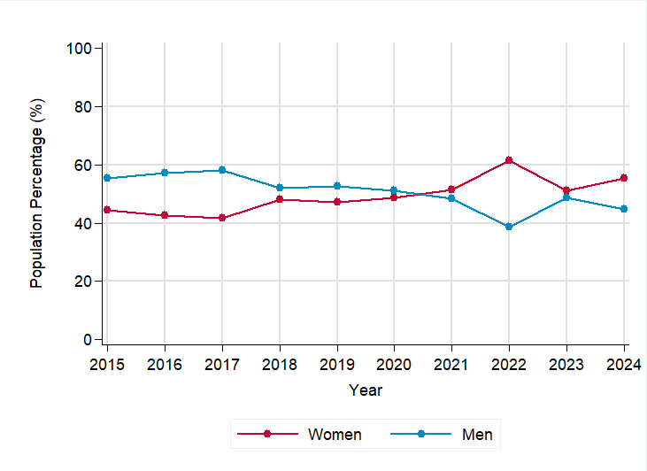
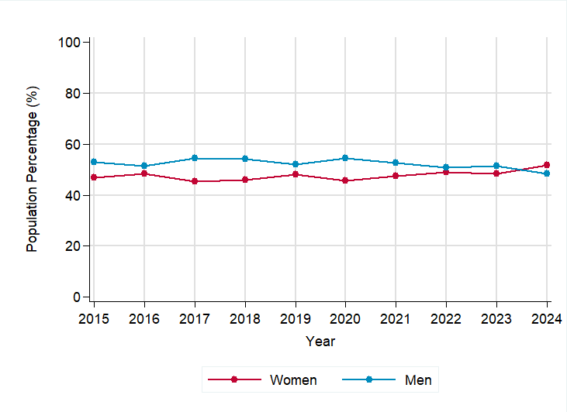
Supplemental Figure 1A
Supplemental Figure 1B

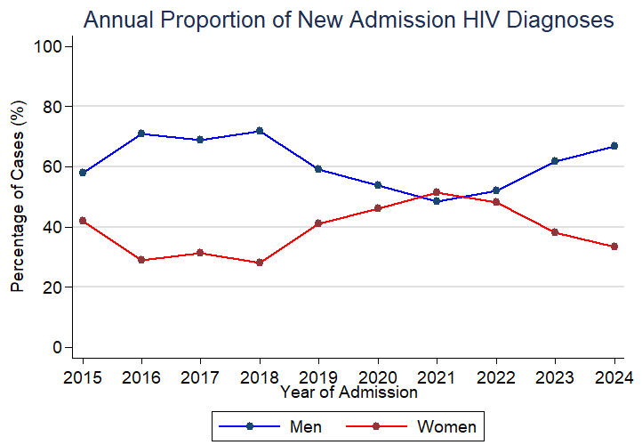
Supplemental Figure 1. Line graph showing the annual proportions of male and female sex among those with AHD (A), without AHD (B), and New HIV diagnoses during admission (C)
Supplemental Figure 1C

