Supplementary figures
Figure S1
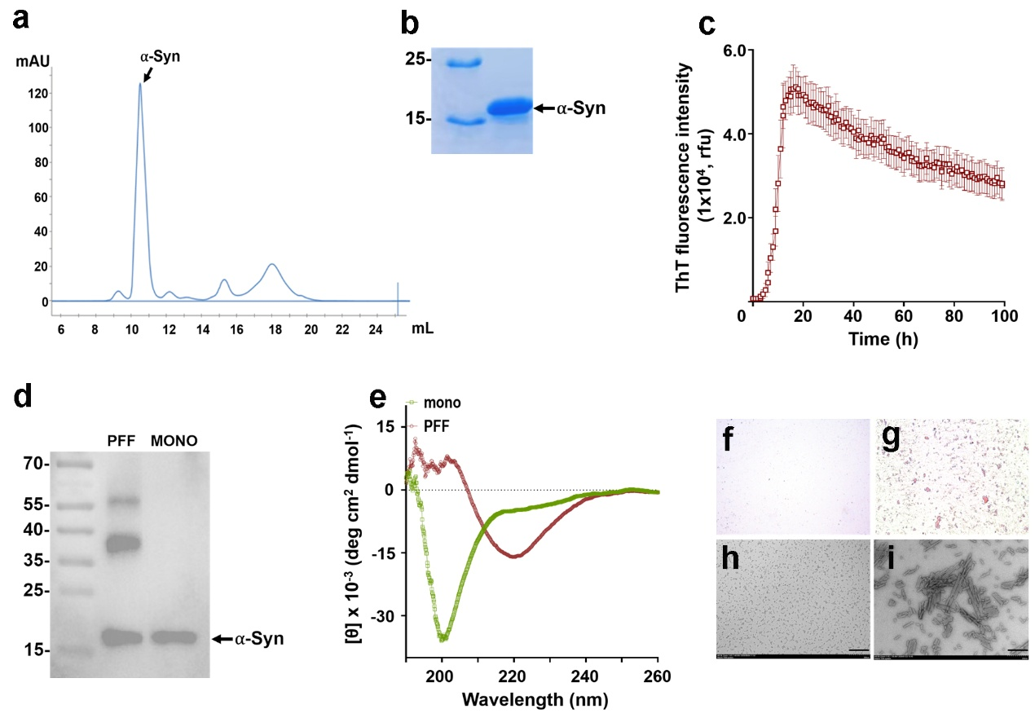
Fig. S1 Preparation and characterization of recombinant mouse αSyn and its pre-formed fibrils (PFFs).
a A representative fast protein liquid chromatography (FPLC) elution profile of purified recombinant mouse αSyn, showing a single peak corresponding to an apparent molecular mass of ~14.9 kDa, consistent with the theoretical mass. b A representative Coomassie Blue-stained SDS-PAGE gel of the recombinant protein, which bears an N-terminal methionine and a 6×His tag. c ThT fluorescence kinetic traces (mean ± SD of ThT fluorescence intensity) recorded during αSyn aggregation to generate PFFs using a BMG plate reader with a consistently shaking and real-time monitoring (n = 3). d Representative western blotting of monomeric αSyn and αSyn-PFFs probed with the anti-αSyn antibody D37A6. The monomer migrates at ~15–16 kDa, whereas PFFs display additional immunoreactive bands at ~35–40 kDa and above ~55–57 kDa, likely corresponding to dimeric and tetrameric oligomeric species, respectively. e A representative Far-UV circular dichroism (CD) spectra of monomeric (green) and fibrillar (red) αSyn. The monomer exhibits a predominantly unstructured protein that may also possess a small amount of a helical structure, whereas PFFs show a single minimum at 218 nm, typical of β-sheet structure. f-g A representative CRS of the monomeric αSyn (f) or αSyn-PFFs (g). Magnification: 20 x. Positive staining (indicative of amyloid deposition) was observed exclusively in the PFF samples but not in the monomers. h-i Representative TEM images of the corresponding αSyn-monomers and PFFs. Abundant fibrillar structures are present in the PFF samples (i), while the monomers show no detectable fibril structure (h). Scale bar: 200 nm.

Figure S2
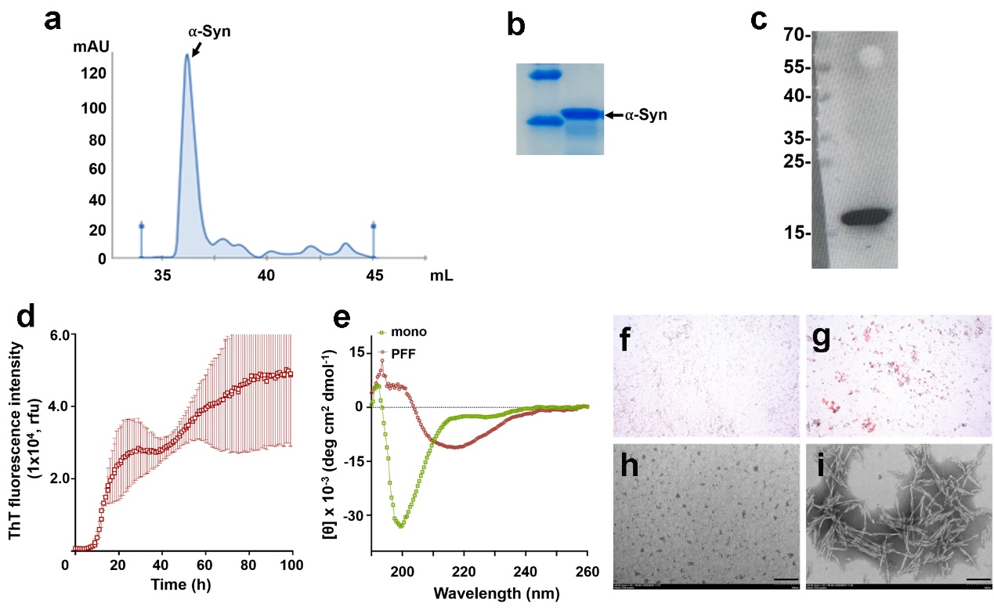
Fig. S2 Preparation and characterization of recombinant human wild-type αSyn and its PFFs.
a A representative fast protein liquid chromatography (FPLC) elution profile of purified recombinant human wild-type αSyn, showing a single peak corresponding to an apparent molecular mass of ~14.9 kDa, consistent with the theoretical mass. b A representative Coomassie Blue-stained SDS-PAGE gel of the recombinant protein, which bears an N-terminal methionine and a 6 × His tag. c Representative western blotting of monomeric αSyn probed with the anti-αSyn antibody MJFR1. The monomer migrates at ~15–16 kDa. d ThT fluorescence kinetic traces (mean ± SD of Th T fluorescence intensity) recorded during αSyn aggregation to generate PFFs using a BMG plate reader with a consistently shaking and real-time monitoring (n = 3). e A representative Far-UV CD spectra of monomeric (green) and fibrillar (red) αSyn. The monomer exhibited a predominantly unstructured protein that may also possess a small amount of a helical structure, whereas PFFs showed a single minimum at 218 nm, typical of β-sheet structure. f-g A representative CRS of the monomeric αSyn (f) or αSyn-PFFs (g). Magnification: 20 x. Positive staining (indicative of amyloid deposition) was observed exclusively in the PFF samples but not in the monomers. h-i Representative TEM images of the corresponding αSyn-monomers and PFFs. Abundant fibrillar structures are present in the PFF samples (i), while the monomers show no detectable fibril structure (h). Scale bar: 200 nm.

Figure S3
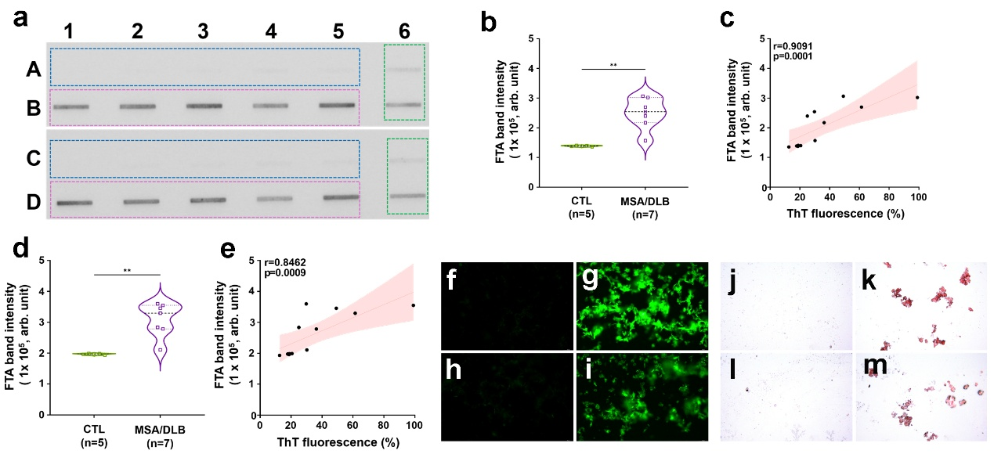
Fig. S3 Characterization of αSyn aggregates in RT-QuIC reaction end-products seeded with skin samples from patients with MSA and DLB, compared with CTL subjects.
a Representative FTA blots of RT-QuIC end-products of skin αSyn from patients with MSA (rectangle with red dotted line), DLB (rectangle with green dotted line) or CTLs (rectangle with blue dotted line) probed with MJFR14 (upper panel: A and B) or D37A6 (lower panel: C and D). b Violin scatter plots quantifying FTA band intensities for CTL (n = 5) and MSA/DLB (n = 7) end-products based on the upper panel of panel a (probed with MJFR14). Band intensity was significantly higher in the MSA/DLB group compared to the CTL group (p < 0.01). c Correlation between FTA band intensity probed with MJFR14 and ThT fluorescence intensity across all samples. A positive correlation was observed (Spearman's ρ = 0.9091, p = 0.0001). d Violin scatter plots quantifying FTA band intensities for CTL (n = 5) and MSA/DLB (n = 7) end-products based on the lower panel of panel a (probed with D37A6). Band intensity was significantly higher in the MSA/DLB group compared to the CTL group (p < 0.01). e Correlation between FTA band intensity probed with D37A6 and ThT fluorescence intensity across all samples. A positive correlation was observed (Spearman's ρ = 0.8462, p = 0.0009). FM of CTL samples showed no staining (f), whereas MSA end-product samples exhibited intense fluorescent αSyn aggregates (g). FM of CTL samples showed no staining (h), whereas DLB end-product samples exhibited intense fluorescent αSyn aggregates (i). CRS demonstrated positive red-stained amyloid deposits in MSA and DLB end-products (k, m), which are absent in CTL samples (j, l). Magnification for all FM and CRS panels: 20 x.

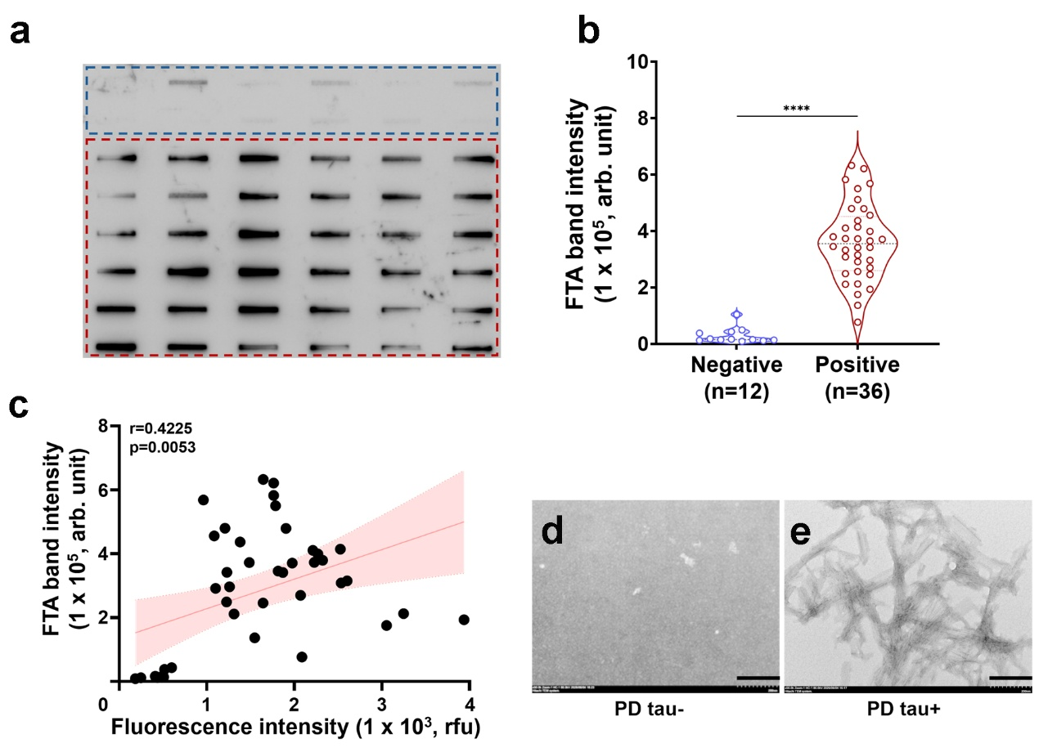
Figure S4

Fig. S4 Characterization of tau aggregates in RT-QuIC end-products derived from skin samples of the PD patients.
Endpoint reaction products of RT-QuIC assay of skin samples from PD patients with positive and negative tau-seeding activity, respectively, were analyzed by FTA and TEM. a A representative FTA immunoblotting with the anti-tau antibody R4 revealed an intense tau band in tau-positive PD-seeded reactions (red dotted line), whereas tau-negative PD-seeded products exhibited only minimal signal (blue dotted line). b Violin scatter plots of the FTA tau band intensity of RT-QuIC end-products from the positive (n=36) and negative (n=12) skin-tau seeding activity from PD cases. The band intensity was significantly higher in the positive tau-seeding activity than in negative tau-seeding activity cases (p < 0.0001). c Correlation between FTA band intensity and ThT fluorescence intensity. A weak-to-moderate positive correlation was observed (Spearman's ρ = 0.4225, p = 0.0053). TEM imaging confirmed the presence of abundant, typical amyloid fibrils in positive tau-seeding activity (e), whereas no fibrillar or filamentous material was detectable in negative tau-seeding activity-seeded samples (d). Scale bars for TEM images (d, e): 200 nm.
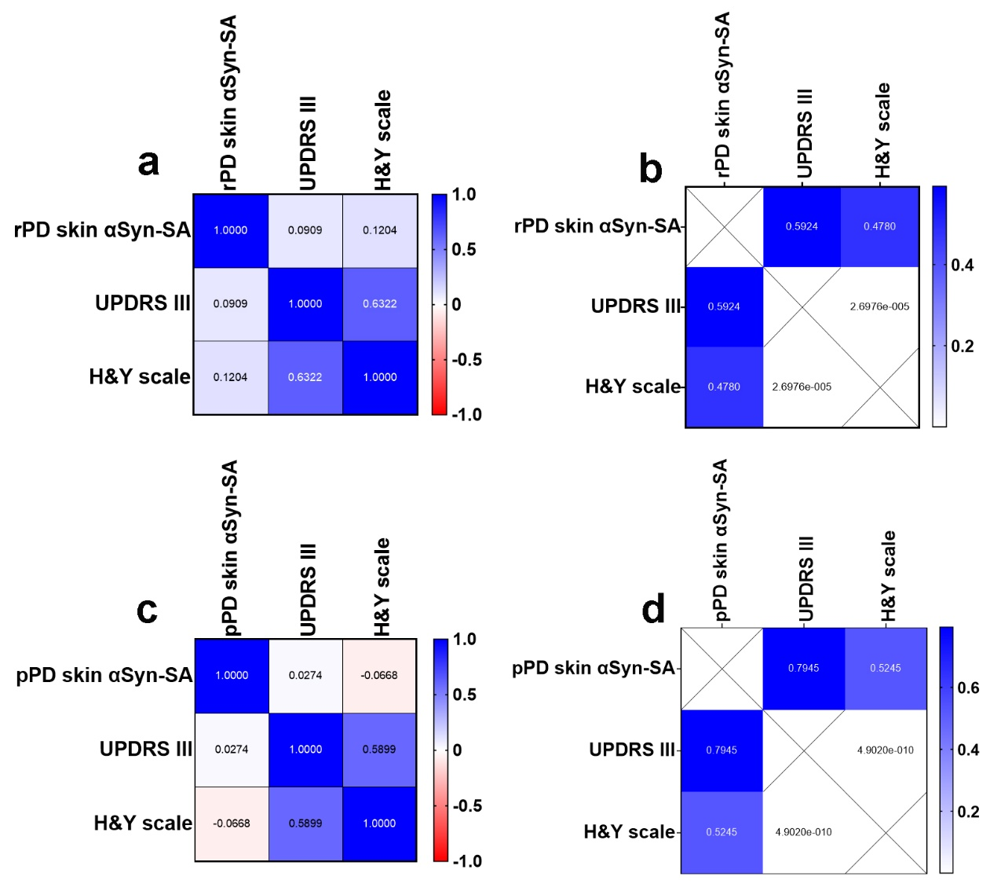
Figure S5

Fig. S5 Association between skin αSyn-seeding activity and motor impairment in PD patients.
a-b Retrospective cohort (rPD): correlations between skin αSyn-seeding activity (skin αSyn-SA) and UPDRS III motor scores, and H&Y scale. c-d Prospective cohort (pPD): correlations between skin αSyn-SA and UPDRS III, and H&Y scale. In both cohorts, UPDRS III and H&Y stage demonstrated a significant moderate positive intercorrelation (rPD: r = 0.6322, p = 2.70 x10⁻⁵; pPD: r = 0.5899, p = 4.90 x 10⁻¹⁰). However, no significant correlation was observed between skin αSyn-seeding activity and either clinical measure in the retrospective (all p > 0.05) or prospective (all p > 0.05) cohorts.

Figure S6
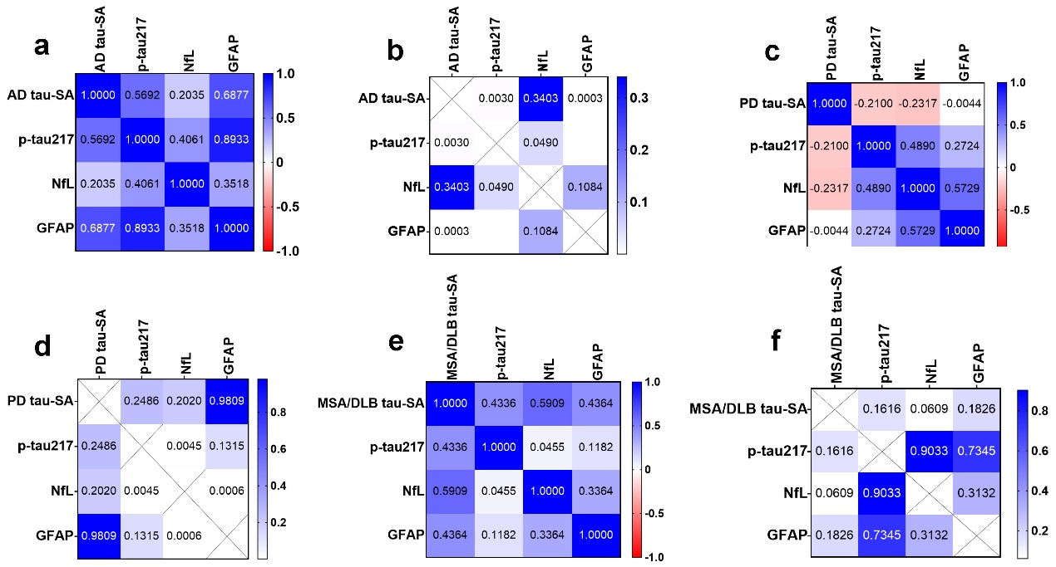
Fig. S6. Associations between skin tau-SA and Simoa-detected plasma biomarkers in AD, PD, and MSA/DLB patients.
a–b In AD patients, skin tau-SA showed a significant moderate positive correlation with plasma p-tau217 (r = 0.5692, p = 0.003) and GFAP (r = 0.6877, p = 0.0003), but not with NfL (r = 0.2035, p = 0.3403 > 0.05). Among the plasma biomarkers, p-tau217 correlated strongly with GFAP (r = 0.8933, p < 0.0001) and moderately with NfL (r = 0.4061, p = 0.049). c–d In PD patients, skin tau-SA did not correlate with any of the plasma biomarkers (all p > 0.05). However, a moderate correlation was observed between plasma p-tau217 and NfL (r = 0.4890, p = 0.0045 < 0.01). e–f In MSA/DLB patients, no significant correlations were found between skin tau-SA and any plasma biomarkers (all p > 0.05), nor among the plasma biomarkers themselves (all p > 0.05).

Figure S7
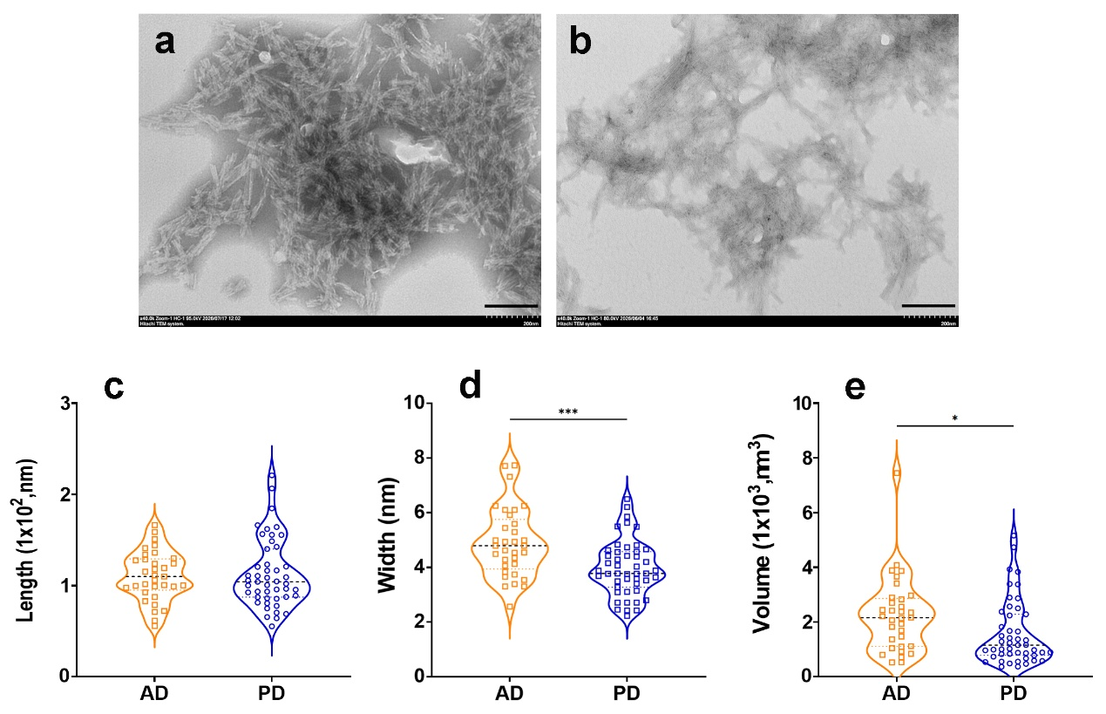
Fig. S7 Morphological characterization of tau fibrils generated by RT‑QuIC from skin samples of AD and PD patients.
End‑products from skin tau‑seeded RT‑QuIC reactions (using 4R tau fragment as the substrate) from AD (n = 3) and PD (n = 3) patients were analyzed by TEM. Representative images are shown in panels a–b. Abundant fibrillar aggregates were readily detected in RT-QuIC end‑products from both AD and PD skin samples. Quantitative image analysis showed that distinct morphological differences were observed between the two groups: AD‑seeded tau fibrils exhibited significantly greater width and larger volume than PD‑seeded aggregates (d, e), whereas no significant difference in length was found between the two fibril types (c). Each dot represents an individual fibril measured from each condition. Scale bars: 200 nm. *p < 0.05; **p < 0.01.

