Supplementary Material 3

GRACE Evaluation
Grounded Review and Assessment of Computational Evidence (GRACE) framework, is a human-centred reflexive framework for evaluating quality of outputs generated by NLP-based topic modelling. GRACE has been published as a pre-print and is currently under review. Please see - DOI: https://preprints.jmir.org/preprint/91433
GRACE includes 15 items centred around four domains: interpretability, actionability, nuance, and redundancy. Please see the table below for items which are scored out of 5 using a Likert scale ‘Strongly disagree’ (1) to ‘strongly agree’ (5).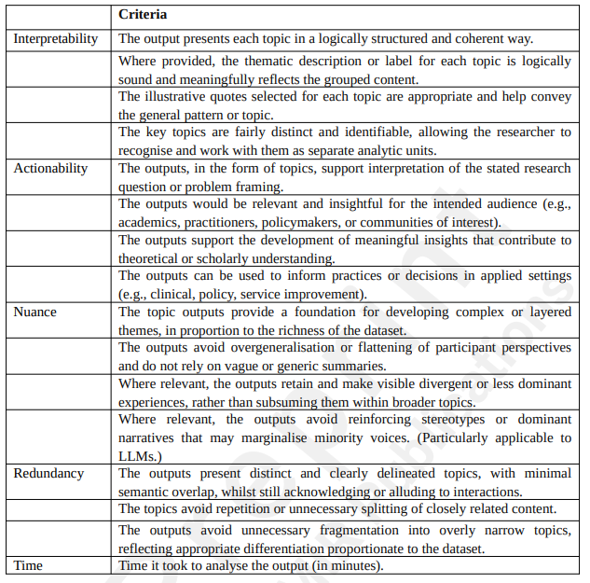

Method
Following completion of the analytical process described in Stage 4 in the main paper, using the GRACE framework, two researchers independently scored the functionality of the model in each of the four domains and wrote notes justifying their scoring. They then met to discuss and come to a consensus of scoring and overall evaluation of functionality. The lead author reviewed the scores, notes and transcript of the meeting to complete the evaluation of quality of outputs. The outcome of this evaluation is discussed below.

Findings
The table below summarises the GRACE evaluation of quality of NLP outputs. The evaluation showed high interpretability, with topics generally clear and easy to follow. Actionability was moderate to high, offering theoretical insights, but perhaps a lack of relevance for clinical or policy application. Nuance was moderate to high, capturing layered and contradictory perspectives, despite the limited depth of YouTube comments. Redundancy was low to moderate, with topics largely distinct and overlaps reflecting the complexity of the dataset rather than duplication. A summary of these findings is included in the ‘strengths and limitation’ section of the main paper.

Scoring and discussion summary of GRACE evaluation undertaken by EW and AV
Domain | Mean Score out of 5 | Discussion summary
Interpretability | 4.17 (High) | The outputs were viewed as generally clear, logical, and easy to follow. The spreadsheet structure, with the top 30 high‑fit quotes per topic, helped interpret topics. 4/5 topics were immediately recognizable on initial reading which reinforced confidence in interpretability. A few comments didn’t fully fit their assigned topic, but were redistributed to other topics/themes following human interpretation. Overall, the model provided coherent and interpretable topics.
Actionability | 3.67 (moderate to high) | The topics were considered relevant to the research question and provided insight into public discourse around nicotine pouches. The outputs supported theoretical contributions, especially around identity, tobacco industry scepticism, identifying health risks, and cessation patterns. However, the practical utility of some themes may be lacking (e.g., niche identity debates) for clinicians or policymakers. While the model captured discourse well, it is questionable whether this type of data translates into actionable recommendations. Overall, actionability was judged moderate, valuable for scholarship but more limited for applied settings.
Nuance | 3.67 (moderate to high) | The outputs captured layered and contradictory meanings, including conflicting views on harm, addiction, and morality. Responses contained diverse tones and contradictions, expert posturing, cynicism, and defensiveness. However, YouTube comments are not deeply narrative by nature, which limits the nuance achievable. The model forced best fit across 5 topics, meaning divergent experiences or cross‑cutting issues (e.g., identity and tobacco-industry suspicion) were co‑located rather than separated. However, the ‘human-in-control’ approach allowed researchers to draw out this nuance. Overall, the model produced conceptually rich themes relative to the dataset type.
Redundancy | 3.67 (reverse: low-to-moderate) | Topics were judged to be fairly distinct overall, with only modest overlap. Identity, addiction and tobacco-industry suspicion themes appeared across multiple topics, but in the each instance had a different analytic focus, making overlap more complementary than problematic. One topic contained two clear themes (identity and gum health), which blurred boundaries slightly. Identity and tobacco-industry suspicion cross-cut across topics and caused discussion on whether cross‑cutting themes should be considered separate ‘human led’ topics or analytic enhancements to machine generated topics. Overall, redundancy was assessed as acceptable given model constraints and the limited depth of the data.
Total | 3.79 | Overall, the analysis was scored moderate to high quality of outputs.

