Similarity Solution of the Fractional Time Independent Advection-Diffusion Equation in Two Dimensions

Khaled S.M. Essa^{1a}, Ahmed M. Mosallem^{1b} and Fawzia Mubarak²
^{1a} Egyptian Atomic Energy Authority, (EAEA), Nuclear Research Center (NRC), Mathematics and Theoretical Physics Dept. Cairo, Egypt, mohamedksm56@yahoo.com, Khaled.sadek@eaea.org.eg orcid.org/0000-0003-1477-5475,
^{1b}Egyptian Atomic Energy Authority, (EAEA), Nuclear Research Center (NRC), Mathematics and Theoretical Physics, ahmedmetwally77@hotmail.com, Ahmed.mosallem@eaea.sci.eg
² Egyptian Atomic Energy Authority (EAEA), Nuclear and Radiological Safety Research Center (NRSRC), Nuclear Fuel Cycle Safety Dept , Cairo, Egypt, fawziamubarak@yahoo.com, Orcid: 0000-0003-2258-8362, fawzia.mubarak @eaea .org.eg

Abstract

The similarity solution method was used to solve the two-dimensional, time-independent partial differential diffusion equation that took into account changes in wind speed and vertical vortex diffusion under atmospheric instability. Concentrations were computed and compared to sulfur dioxide (SO₂) concentrations measured across the Prairie-Grass experiment in the United States. Applying a similarity solution often used appropriate computing performance and precision. We can infer that the numerical similarity solution yields dependable answers with a respectable level of accuracy. We find that all fractional predicted concentrations of SO₂ are inside a factor of two with the observed concentrations except at distance 400m in the Prairie-Grass experiment are outside a factor of two. We find that all fractional predicted concentrations of SO₂ inside a factor of two with the observed concentrations except at distance 400m in the Prairie-Grass experiment. A fractional predicted concentrations at x=50, 100, 200 and 800 when $α=0.85$ achieved 63%, 0.99%, 100% and 0.84% respectively.
Keywords: Similarity Solution Method; Prairie-Grass Experiment; Sulfur Dioxide Concentrations.

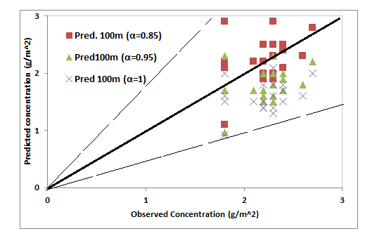
Fig. (1) Comparisons between Predicated and Observed crosswind concentration ${\overline{C}}_{y}\left(x,z\right)$ during Prairie Grass for unstable condition experiment at 100m.

