Supplementary Note 1. Model equations, parameters, and numerical methods.

S1.1 Governing equations
The TECP model is defined by the following eight coupled partial differential equations for the state variables soil moisture θ (volumetric water content, 0≤θ≤1), water vapour concentration C_{v}, absolute temperature T (K), oxygen volume fraction O₂, carbon dioxide volume fraction CO₂, active biomass B (relative index), mycorrhizal stress signal S (mol m⁻³), and mycelium density M (dimensionless):
$$\begin{matrix}\frac{∂θ}{∂t}=∇⋅\left(K∇θ\right)−U−E+C_{\text{cond}} & \text{(S1)}\end{matrix}$$
$$\begin{matrix}\frac{∂C_{v}}{∂t}=∇⋅\left(D_{v}∇C_{v}\right)+E+T_{r}−C_{\text{cond}} & \text{(S2)}\end{matrix}$$
$$\begin{matrix}\frac{∂T}{∂t}=∇⋅\left(k_{T}∇T\right)−L_{v}C_{\text{cond}}+Q_{\text{bio}}+Q_{\text{rad}}−P_{\text{elt}}M_{\text{ceil}} & \text{(S3)}\end{matrix}$$
$$\begin{matrix}\frac{∂O_{2}}{∂t}=∇⋅\left(D_{\text{gas}}∇O_{2}\right)+P_{\text{photo}}−R−O_{\text{2,cons}} & \text{(S4)}\end{matrix}$$
$$\begin{matrix}\frac{∂{CO}_{2}}{∂t}=∇⋅\left(D_{\text{gas}}∇{CO}_{2}\right)−P_{\text{photo}}+R+{CO}_{\text{2,prod}} & \text{(S5)}\end{matrix}$$
$$\begin{matrix}\frac{∂B}{∂t}=Y_{B}P_{\text{photo}}−R+γ\frac{S^{n}}{K_{m}^{n}+S^{n}}B & \text{(S6)}\end{matrix}$$
$$\begin{matrix}\frac{∂S}{∂t}=∇⋅\left(D_{\text{myco}}∇S\right)+χ∇⋅\left(S∇M\right)+k_{\text{prod}}max\left(0,P_{\text{seuil}}−P_{\text{photo}}\right)+k_{\text{basal}}−λ_{S}S & \text{(S7)}\end{matrix}$$
$$\begin{matrix}\frac{∂M}{∂t}=∇⋅\left(D_{M}∇M\right)+γ_{M}S\left(1−\frac{M}{M_{\text{max}}}\right)M_{\text{soil}}−δ_{M}M & \text{(S8)}\end{matrix}$$
The auxiliary terms and parameter values are defined below.
Evaporation: $E=εθ\left(T−273\right),ε={10}^{−3}$ (dimensionless)
Root uptake: $U=uθM_{\text{uptake}},u=0.02$ (dimensionless)
Transpiration: $T_{r}=τBM_{\text{transp}},τ=5×{10}^{−4}$ (dimensionless)
Condensation: $C_{\text{cond}}=k_{\text{cond}}max\left(0,RH−{RH}_{\text{sat}}\right)M_{\text{ceil}},RH=\frac{C_{v}}{C_{v,\text{sat}}},C_{v,\text{sat}}=0.03,{RH}_{\text{sat}}=0.6,k_{\text{cond}}=0.5$
Photosynthesis: $P_{\text{photo}}=P_{\text{max}}\frac{{CO}_{2}}{{CO}_{2}+k_{{CO}_{2}}}f_{T}\left(T\right)θBM_{\text{photo}},P_{\text{max}}=0.01,k_{{CO}_{2}}=0.05$
Temperature dependence: $f_{T}\left(T\right)=max\left(0,exp\left(−{\left(\frac{T−T_{\text{opt}}}{T_{\text{range}}}\right)}^{2}\right)\right),T_{\text{opt}}=298\text{ K},T_{\text{range}}=10\text{ K}$
Respiration: $R=R_{\text{maint}}Bmax\left(0.1,1+0.05\left(T−T_{\text{opt}}\right)\right)M_{\text{resp}},R_{\text{maint}}=0.002$
Metabolic heat: $Q_{\text{bio}}=η_{\text{heat}}R,η_{\text{heat}}=0.05$
Radiative heat: $Q_{\text{rad}}=α_{\text{heat}}P_{\text{max}}M_{\text{photo}},α_{\text{heat}}=0.5$
Crew consumption and production: $O_{2,\text{cons}}=\frac{0.84}{86400}×0.001,{CO}_{2,\text{prod}}=\frac{1.0}{86400}×0.001$
Mycorrhizal network parameters:
k_{prod}=0.01, P_{seuil}=10⁻⁶, k_{basal}=10⁻⁵, λ_{S}=0.1, γ_{M}=0.05, δ_{M}=0.01, M_{max}=1, n=2, K_{m}=0.01, χ=10⁻³
Diffusion coefficients:
K=10⁻⁶, D_{v}=10⁻⁵, k_{T}=0.5, D_{gas}=2×10⁻⁵, D_{myco}=10⁻⁴, D_{M}=10⁻⁶
Latent heat (effective, dimensionless):
L_{v}=0.5
All parameters have been scaled to a dimensionless form following a conservative adimensionalisation that preserves the ratios of the original physical terms (see Supplementary Information S2).

S1.2 Boolean masks and volume fractions
Five spatially varying Boolean masks M_{k}(x)∈{0,1} confine each biological or physical process to its appropriate sub-volume. The reactor is divided into a continental biome (left, x<x_{mid}, soil surface z_{sol}=0.4, maximum foliage height z_{plant,max}=0.8) and a marsh biome (right, x≥x_{mid}, z_{sol}=0.2, z_{plant,max}=0.6). The mid-height of the foliage is z_{resp}=(z_{sol}+z_{plant,max})/2.
The masks are defined as follows:
- M_{photo}=1 for z_{sol}≤z≤z_{resp}
- M_{resp}=1 for 0≤z≤z_{resp}
- M_{transp}=1 for z_{sol}≤z≤z_{resp}
- M_{uptake}=1 for 0≤z≤z_{sol} (M_{soil}=M_{uptake}, i.e., the root-zone mask)
- M_{ceil}=1 for z>0.9 (Peltier module)
The effective volume fractions f_{k}=⟨M_{k}⟩, computed analytically, are: f_{photo}=0.20, f_{resp}=0.40, f_{transp}=0.20, f_{uptake}=0.30, f_{ceil}=0.10 (Table 1 of the main text). Figure S1 shows the vertical profiles of the masks for each biome.

S1.3 Numerical methods
Homogeneous steady state and stability analysis. When spatial gradients are neglected, ∇θ=0, ∇C_{v}=0, …, and the divergence terms vanish. The homogeneous reduction (∇≡0) yields an eight-dimensional algebraic system F(x)=0 that is solved using the Newton-Krylov solver fsolve (SciPy 1.11). Quadratic penalty functions confine each variable to its physically admissible range. Multiple initial guesses are supplied to probe coexisting states: a mycorrhiza-free guess [0.3,0.02,298,0.21,0.001,0.1,0.0,0.0], and guesses with an active impulse (S₀=0.01, M₀=0.1). The 8×8 Jacobian matrix is computed by first-order forward finite differences with step size ϵ=10⁻⁸. Eigenvalues are obtained with numpy.linalg.eig. A steady state is classified as stable if max(ℜ(λ))<−10⁻¹⁰, unstable if >+10⁻¹⁰, and marginal otherwise.
Bifurcation sweep. The cooperation coefficient γ is varied in [−0.05,0.30] in 35 equally spaced steps. For each γ, a forced initial impulse (S₀=0.01, M₀=0.1) is imposed to probe the “On” branch. The steady state, Jacobian, and max(ℜ(λ)) are recorded.
3D deterministic and stochastic simulations. The full PDEs are discretised on a 17×17×17 grid with spacing Δx=Δy=Δz=0.05 m using the finite-volume library FiPy 3.4 and a time step Δt=0.1 s. Deterministic simulations are run for 5000 time steps (500 s of model time) without the mycorrhizal compartment, and for 20 000 time steps (2000 s) with the Wood Wide Web active. Stochastic simulations add Gaussian white noise to the Peltier power and the day/night cycle. Phase portraits (W_{L},W_{R}) (mean soil moisture of the left and right halves of the torus) are recorded, together with entropy production σ=∣∇T∣²/T² and condensation efficiency η=L_{v}C_{cond}/P_{elt}.
Stroboscopic Poincaré section and return maps. The external forcing is a sinusoidal modulation of the maximum photosynthetic rate with period τ_{force} (50 s in the baseline dimensionless simulation, 24 h in the dimensionally-resolved V10). The stroboscopic Poincaré section records the state vector at every integer multiple of the forcing period. Return maps x_{n+1}=f(x_{n}) are constructed for the mean CO₂ concentration. A stable fixed point of this map, with slope smaller than one at the intersection with the identity line, corresponds to a stable forced limit cycle of the continuous-time system.
Re-dimensionnalisation and parameter sweeps (V10). To separate biological timescales, the dimensionless parameters are re-scaled using experimentally informed factors (see Supplementary Information S2). Fast processes (photosynthesis, respiration) retain the baseline timescale, while slow processes (mycelial growth, signal kinetics) are slowed by factors up to 168. The forcing period is set to 24 h to match the Earth diurnal cycle. Two types of parameter sweeps are performed:
- 2D sweep: γ∈{0.010,0.013,0.016,0.020,0.025}, signal speed ∈{4,8,16,32,64,128,168}. Each combination is simulated for 30 days.
- 1D sweeps: γ∈{0.03,0.04,0.05,0.06,0.08,0.10,0.15,0.20,0.25} at fixed signal speeds of 4, 8, 16, 32, 64, and 168. Each simulation runs for 30 days.
The critical cooperation coefficient γ_{crit} is defined as the γ value at which the final CO₂ exceeds the plateau value (at γ=0.03) by 20 %.

Table 1. Effective volume fractions derived from the five Boolean masks.
Process | Symbol | Volume fraction
Photosynthesis | f_{photo} | 0.20
Respiration | f_{resp} | 0.40
Transpiration | f_{transp} | 0.20
Root uptake | f_{uptake} | 0.30
Peltier cooling | f_{ceil} | 0.10

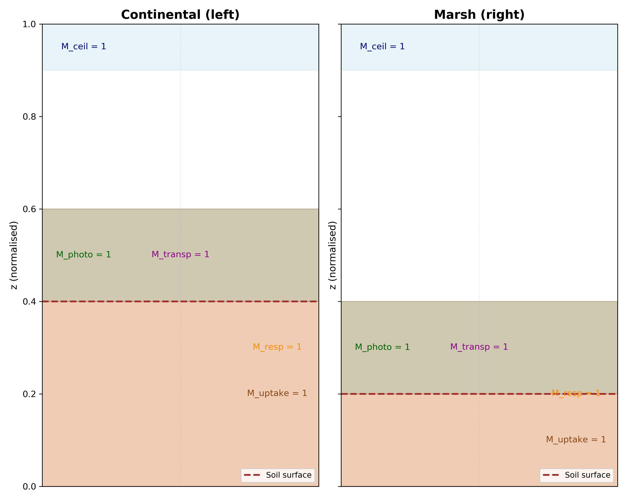
Figure S1. Boolean masks of the TECP (High-resolution version of Fig. 1).
See legend of Fig. 1 in the main text.

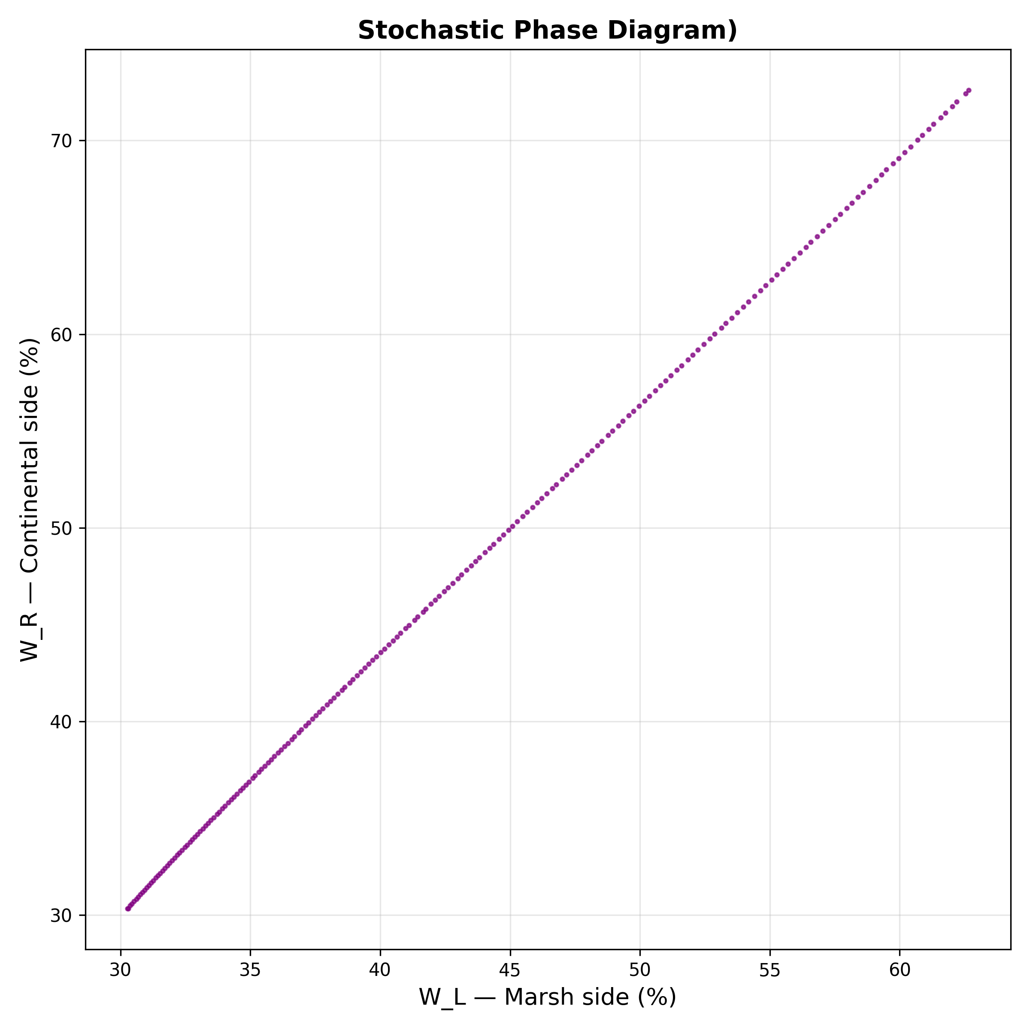
Figure S2. Stochastic phase diagram under Gaussian noise. Scatter plot of mean soil moisture in the left (W_{L}, marsh) and right (W_{R}, continental) biomes under Gaussian noise applied to the Peltier power and the day/night cycle. The cloud remains confined along the diagonal, showing that random fluctuations alone do not break the spatial symmetry of the system. Structural asymmetry is required to activate the Wood Wide Web.

Supplementary Note 2. Dimensional analysis and parameter correspondence.

S2.1 Conservative adimensionalisation
The physical equations involve coefficients spanning several orders of magnitude (e.g., L_{v}=2.26×10⁶ J kg⁻¹, k_{T}≈0.5 W m⁻¹ K⁻¹). Direct numerical integration causes Jacobian stiffness and solver divergence. We therefore introduce characteristic scales that map the physical system onto a dimensionless form where all terms are of comparable magnitude, preserving the topology of the bifurcation structure.
The characteristic scales are:
Quantity | Symbol | Value
Reference temperature | T₀=T_{opt} | 298 K
Length | L | 1 m
Time | τ | 100 s
Thermal power density | Q₀ | 500 W m⁻³
Condensation mass rate | C₀ | 10⁻⁵ kg m⁻³ s⁻¹

All variables are replaced by their dimensionless counterparts:
$\tilde{T}=\frac{T}{T_{0}}$ ; $\tilde{∇}=L∇$ ; $\tilde{t}=\frac{t}{τ}$
The source terms are scaled as:
$\tilde{P_{elt}}=\frac{P_{elt}}{Q_{0}}$ ; $\tilde{L_{v}}=\frac{L_{v}C_{0}}{Q_{0}}$ ; $\tilde{k_{T}}=\frac{k_{T}T_{0}}{L^{2}Q_{0}τ}$
The three governing dimensionless numbers are:
- Modified Rayleigh number: ${Ra}^{\text{*}}=\frac{Q_{0}L^{2}}{k_{T}T_{0}}$
- Jakob number: $Ja=\frac{L_{v}C_{0}}{Q_{0}}$
- Biological Damköhler number: $Da=\frac{P_{max}τ}{{L^{2}}/{D_{gas}}}$
With the chosen scales, Ra∗∼1, Ja∼1, and Da∼1, ensuring that all terms in the dimensionless equations are of order unity.

S2.2 Correspondence between dimensionless and physical parameters
Table S2.1 provides the mapping from the dimensionless parameter values used in the TECP code to their approximate physical equivalents, based on the above scaling. Parameters that are intrinsically dimensionless (e.g., Hill coefficient n, volume fractions) are indicated as such.

Table S2.1 – Dimensionless-to-physical parameter correspondence.
Dimensionless parameter | Code value | Physical equivalent (approx.) | Comments
P_{elt} | 0.01 | ∼5 W m⁻³ | Peltier cooling power density
L_{v} | 0.5 | ∼1.13×10⁶ J kg⁻¹ | Effective latent heat of condensation
D_{gas} | 2×10⁻⁵ | 2×10⁻⁵ m² s⁻¹ | Gas diffusivity (same order as physical value)
P_{max} | 0.01 | ∼5×10⁻⁴ s⁻¹ | Maximum photosynthetic rate
R_{maint} | 0.002 | ∼10⁻⁴ s⁻¹ | Maintenance respiration rate
γ_{M} | 0.05 (dimensionless), 0.08 (V10) | ∼5×10⁻⁴ s⁻¹ (dimensionless), ∼4.8×10⁻⁶ s⁻¹ (V10) | Mycelial growth rate
λ_{S} | 0.1 (dimensionless), 0.08 (V10) | ∼10⁻³ s⁻¹ (dimensionless), ∼4.8×10⁻⁶ s⁻¹ (V10) | Signal decay rate
k_{prod} | 0.01 | ∼10⁻⁴ s⁻¹ | Signal production rate
K_{m} | 0.01 | - | Half-saturation constant (dimensionless)
n | 2 | - | Hill coefficient (dimensionless)
f_{photo} | 0.20 | - | Volume fraction (dimensionless)
f_{resp} | 0.40 | - | Volume fraction (dimensionless)
f_{transp} | 0.20 | - | Volume fraction (dimensionless)
f_{uptake} | 0.30 | - | Volume fraction (dimensionless)
f_{ceil} | 0.10 | - | Volume fraction (dimensionless)

S2.3 Scale factors for the dimensionally-resolved model (V10)
To separate the biological timescales that are artificially compressed in the dimensionless model, we introduce experimentally informed scale factors. Each process is assigned a factor s_{i}=τ_{i}/τ_{base}, where τ_{base}=1 h (3600 s) is the reference timescale (the approximate response time of photosynthesis to a change in light intensity). The factors are:
Process | Scale factor s_{i} | Biological justification
Photosynthesis (P_{max}) | 1 | Response to light occurs within minutes to hours
Respiration (R_{maint}) | 1 | Tightly coupled to photosynthetic activity
Evapotranspiration (E, T_{r}) | 1 | Driven by diurnal cycle
Condensation / thermal exchange | 1 | Fast physical processes
Mycelial growth (γ_{M}, δ_{M}) | 168 | Hyphal extension operates on a daily to weekly scale
Mycorrhizal signalling (λ_{S}, k_{prod}, k_{basal}) | 4–168 | Signal propagation ranges from hours (jasmonate) to days (nutrient transport); swept to identify the critical range
Biomass growth (Y_{B}) | 168 | Plant biomass accumulates over weeks

These factors are applied to the dimensionless rates as multiplicative corrections, ensuring that the fast and slow processes evolve on distinct, physically plausible timescales while preserving the topological structure of the bifurcation diagram.

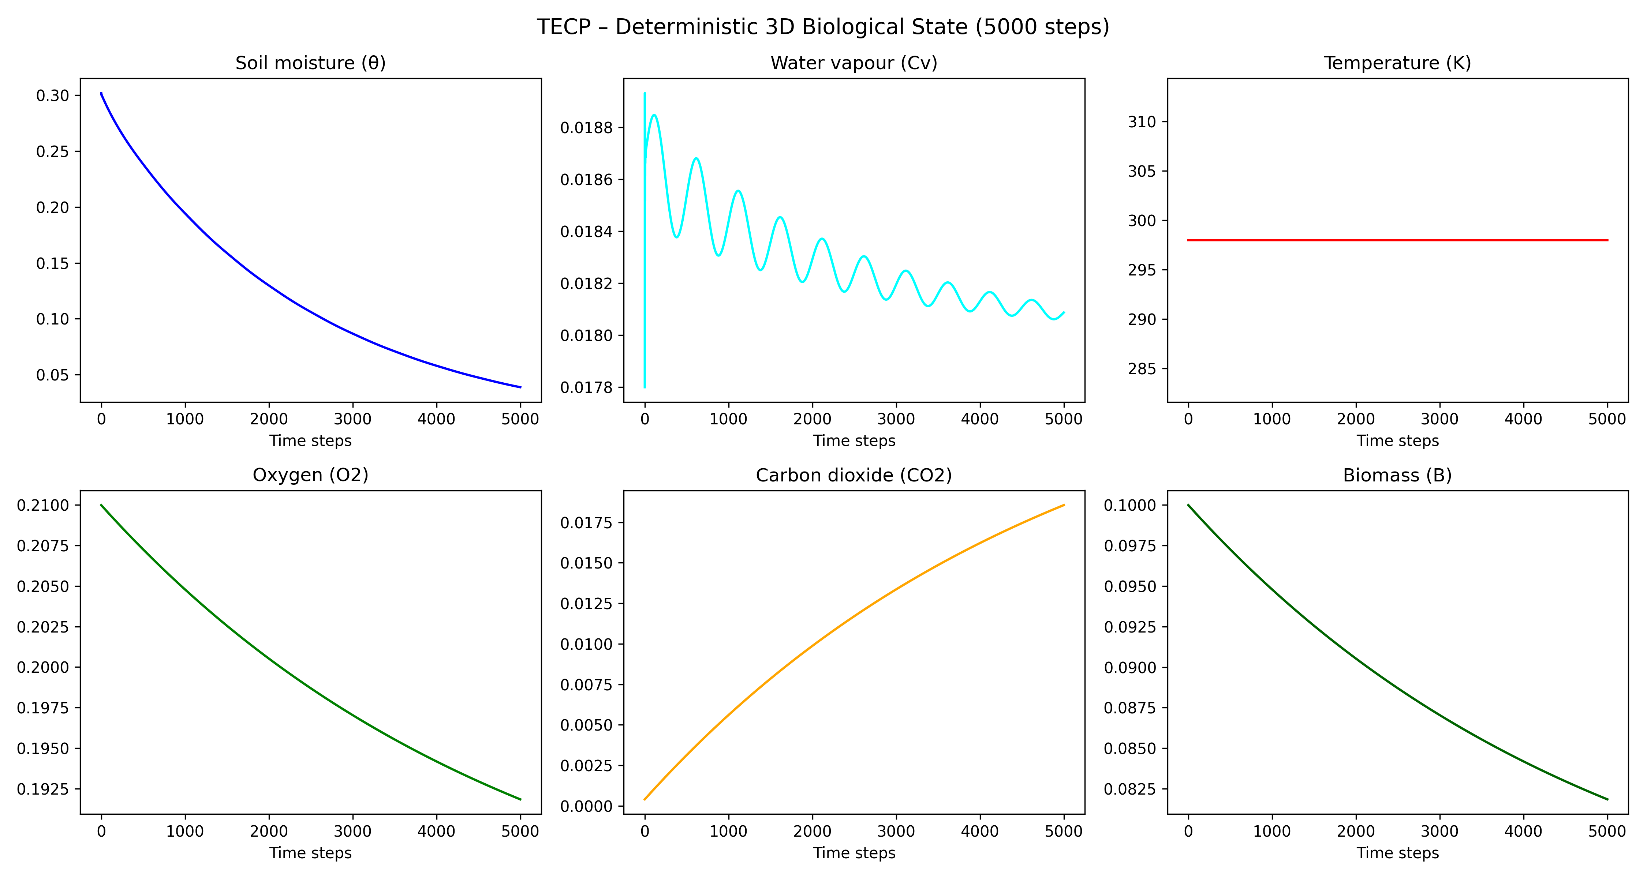
Figure S3. Deterministic 3D biological state variables (High-resolution version of Fig. 3).
See legend of Fig. 3 in the main text.

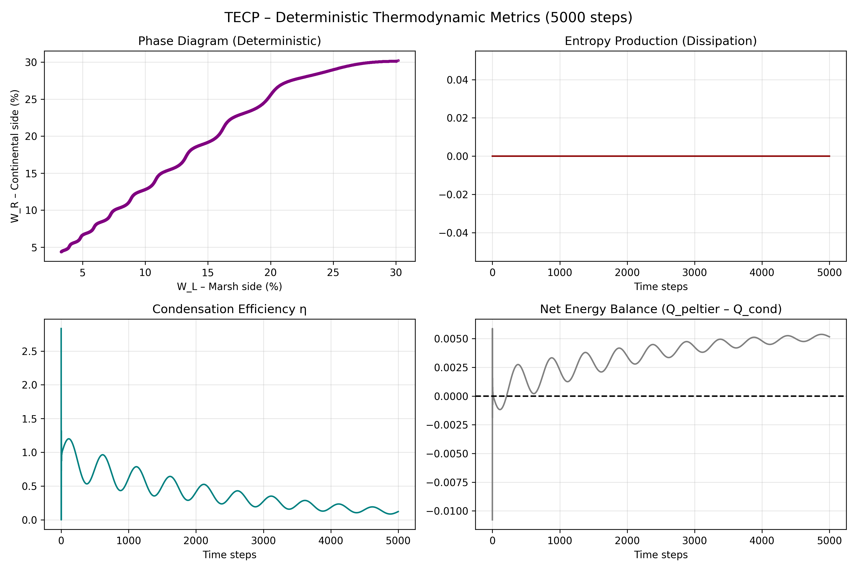
Figure S4. Deterministic thermodynamic metrics (High-resolution version of Fig. 4).
See legend of Fig. 4 in the main text.

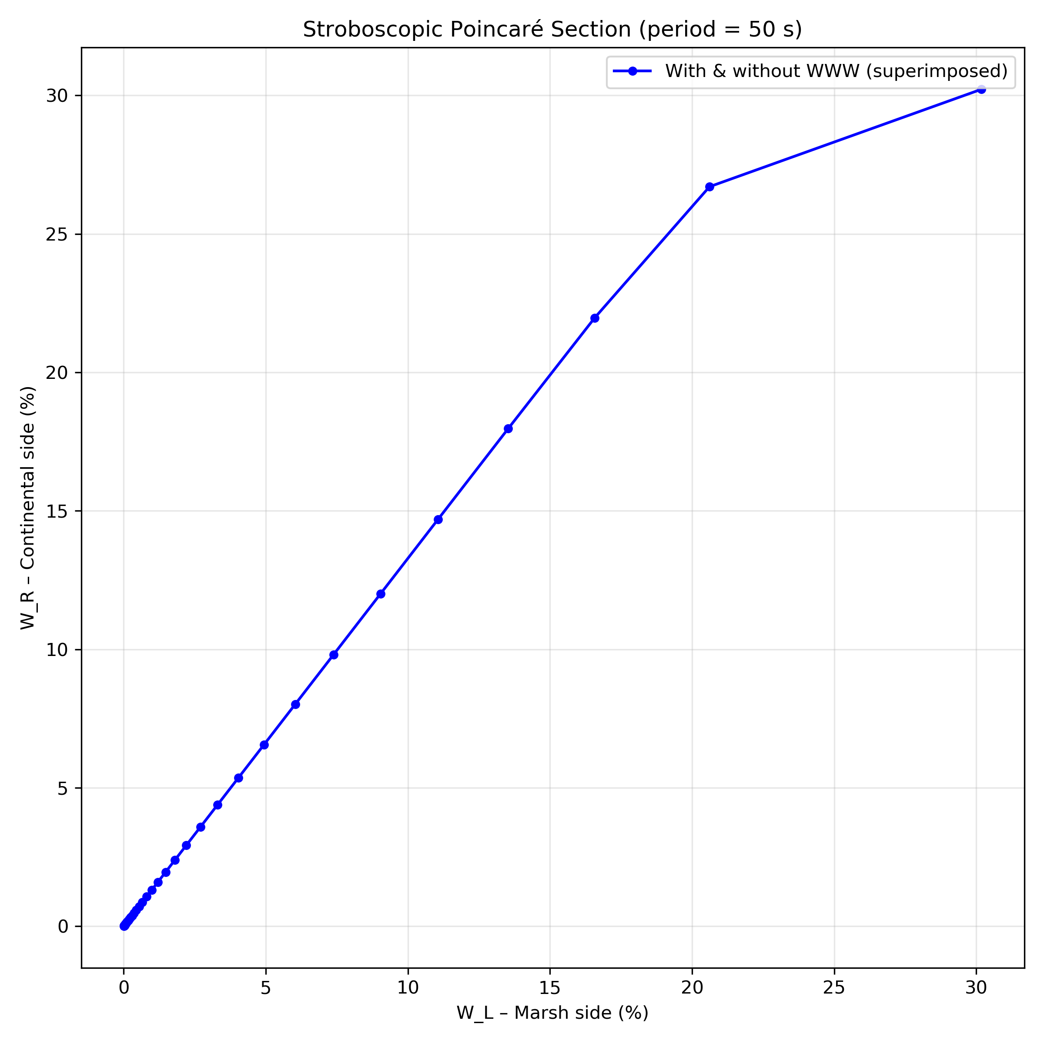

Figure S5. Stroboscopic Poincaré sections (High-resolution version of Fig. 6).
See legend of Fig. 6 in the main text.

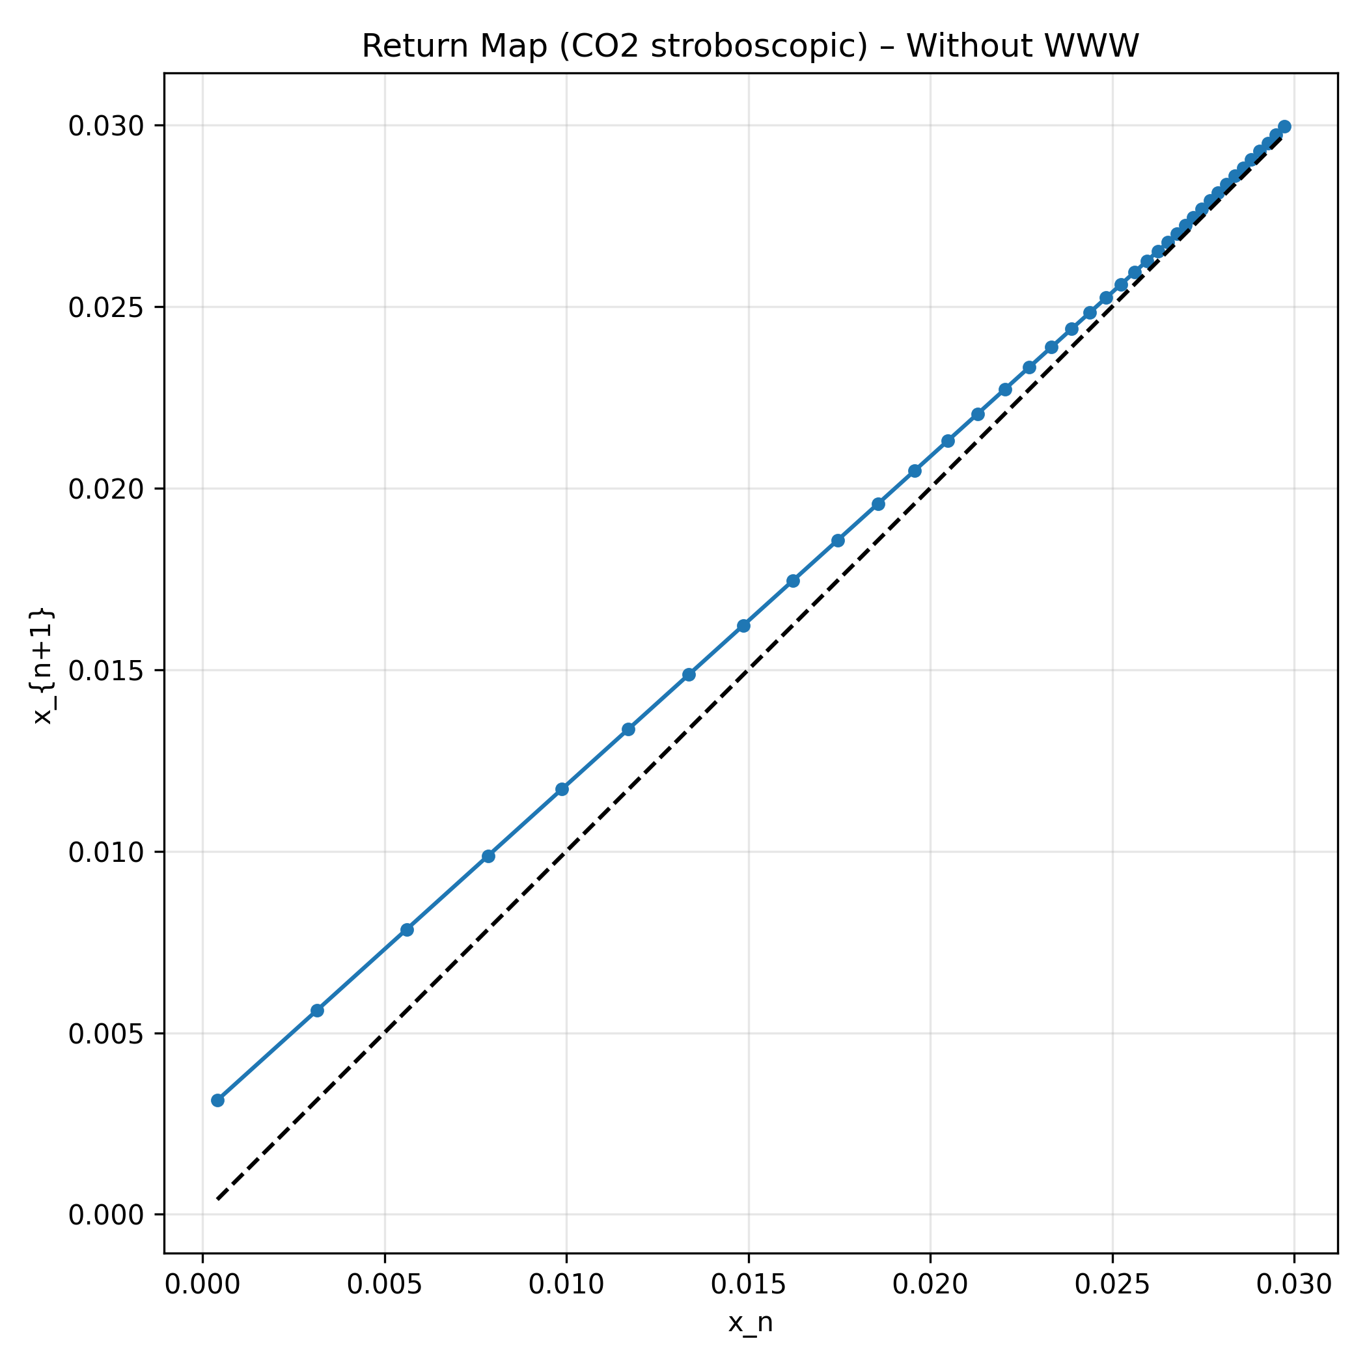
Figure S5. Return maps (CO₂ stroboscopic) without WWW (High-resolution version of Fig. 6).
See legend of Fig. 6 in the main text.

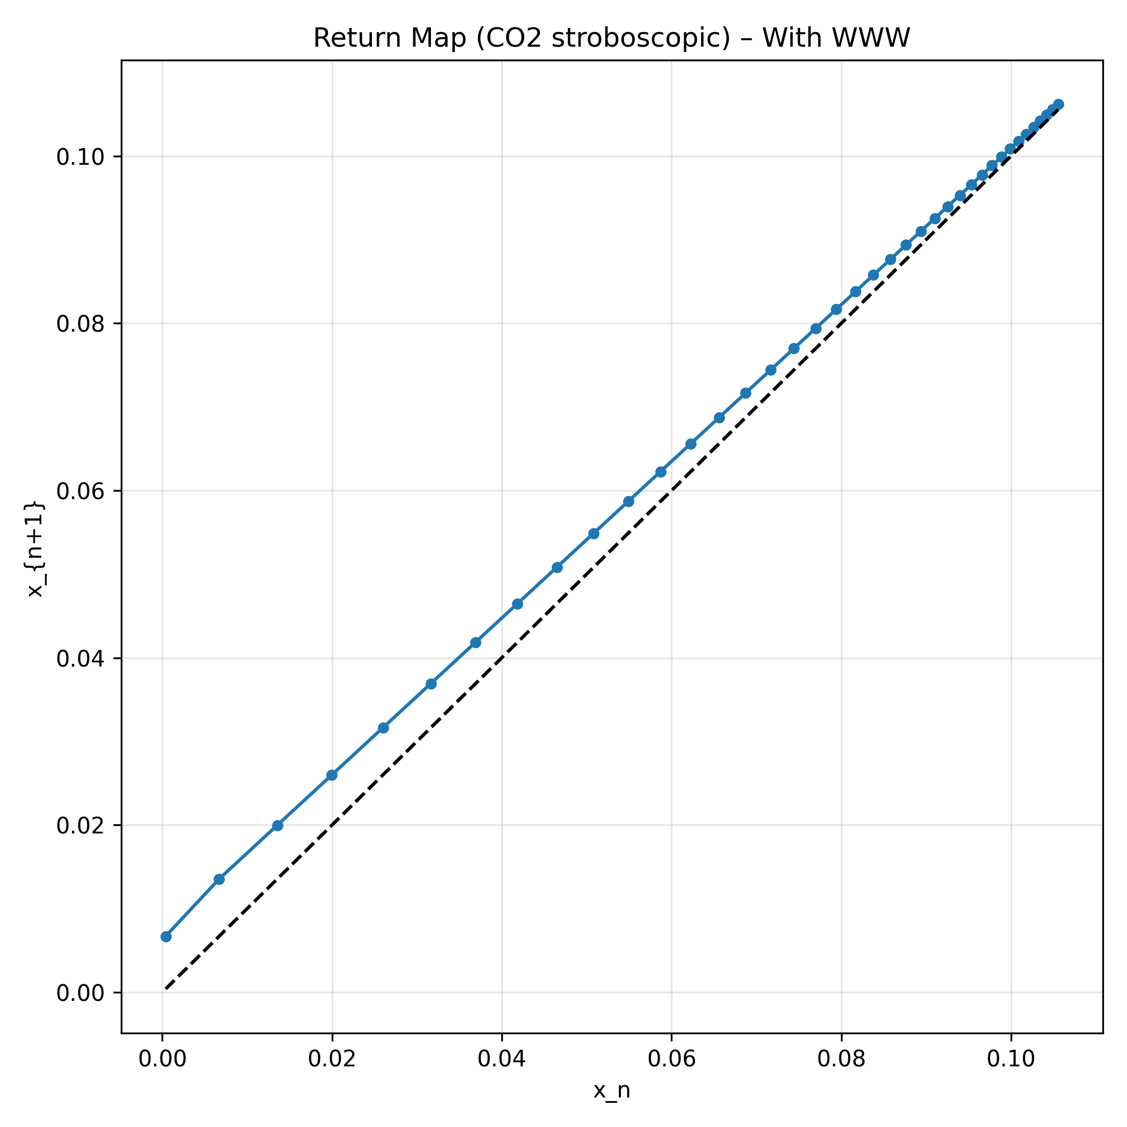
Figure S5. Return maps (CO₂ stroboscopic) with WWW (High-resolution version of Fig. 6).
See legend of Fig. 6 in the main text.

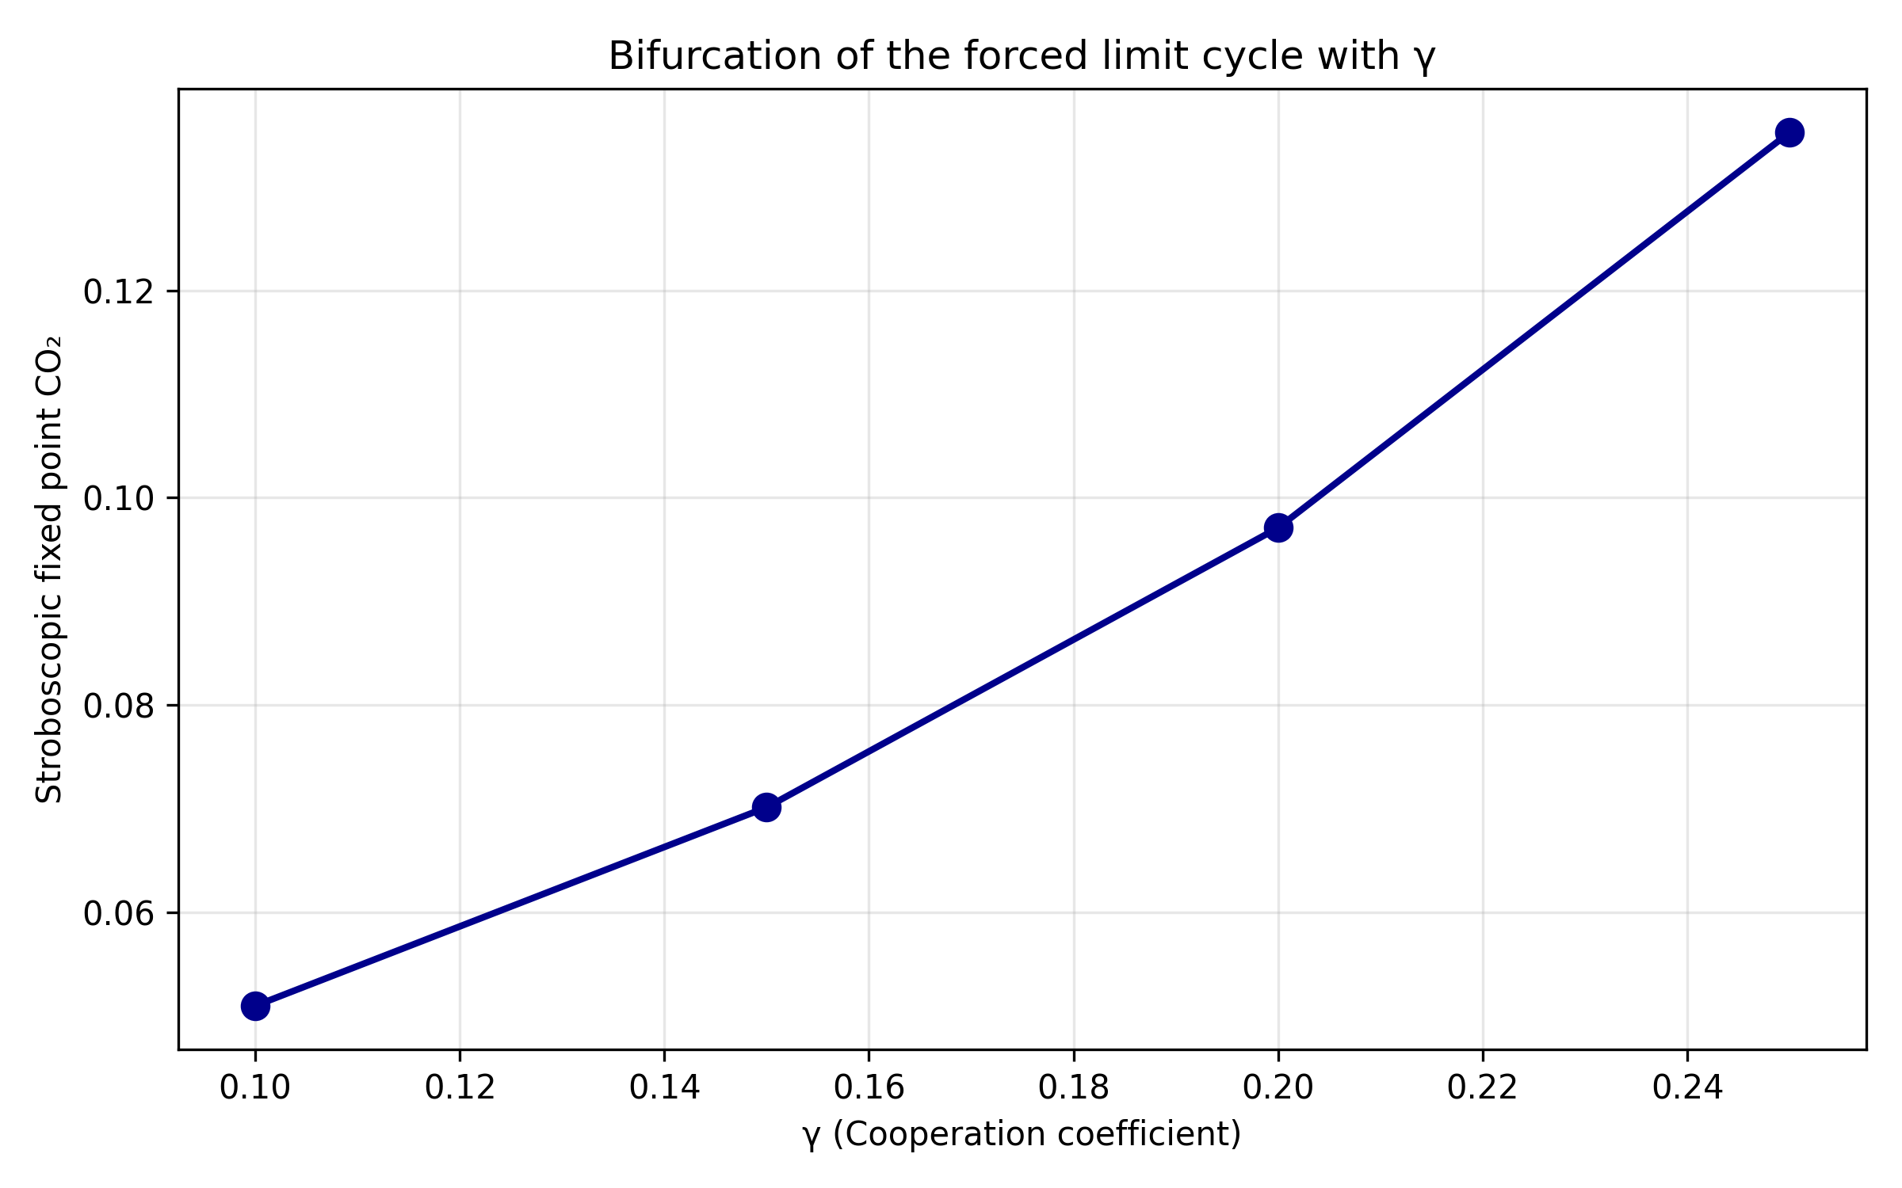
Figure S6. Bifurcation of the forced limit cycle with γ (High-resolution version of Fig. 7).
See legend of Fig. 7 in the main text.

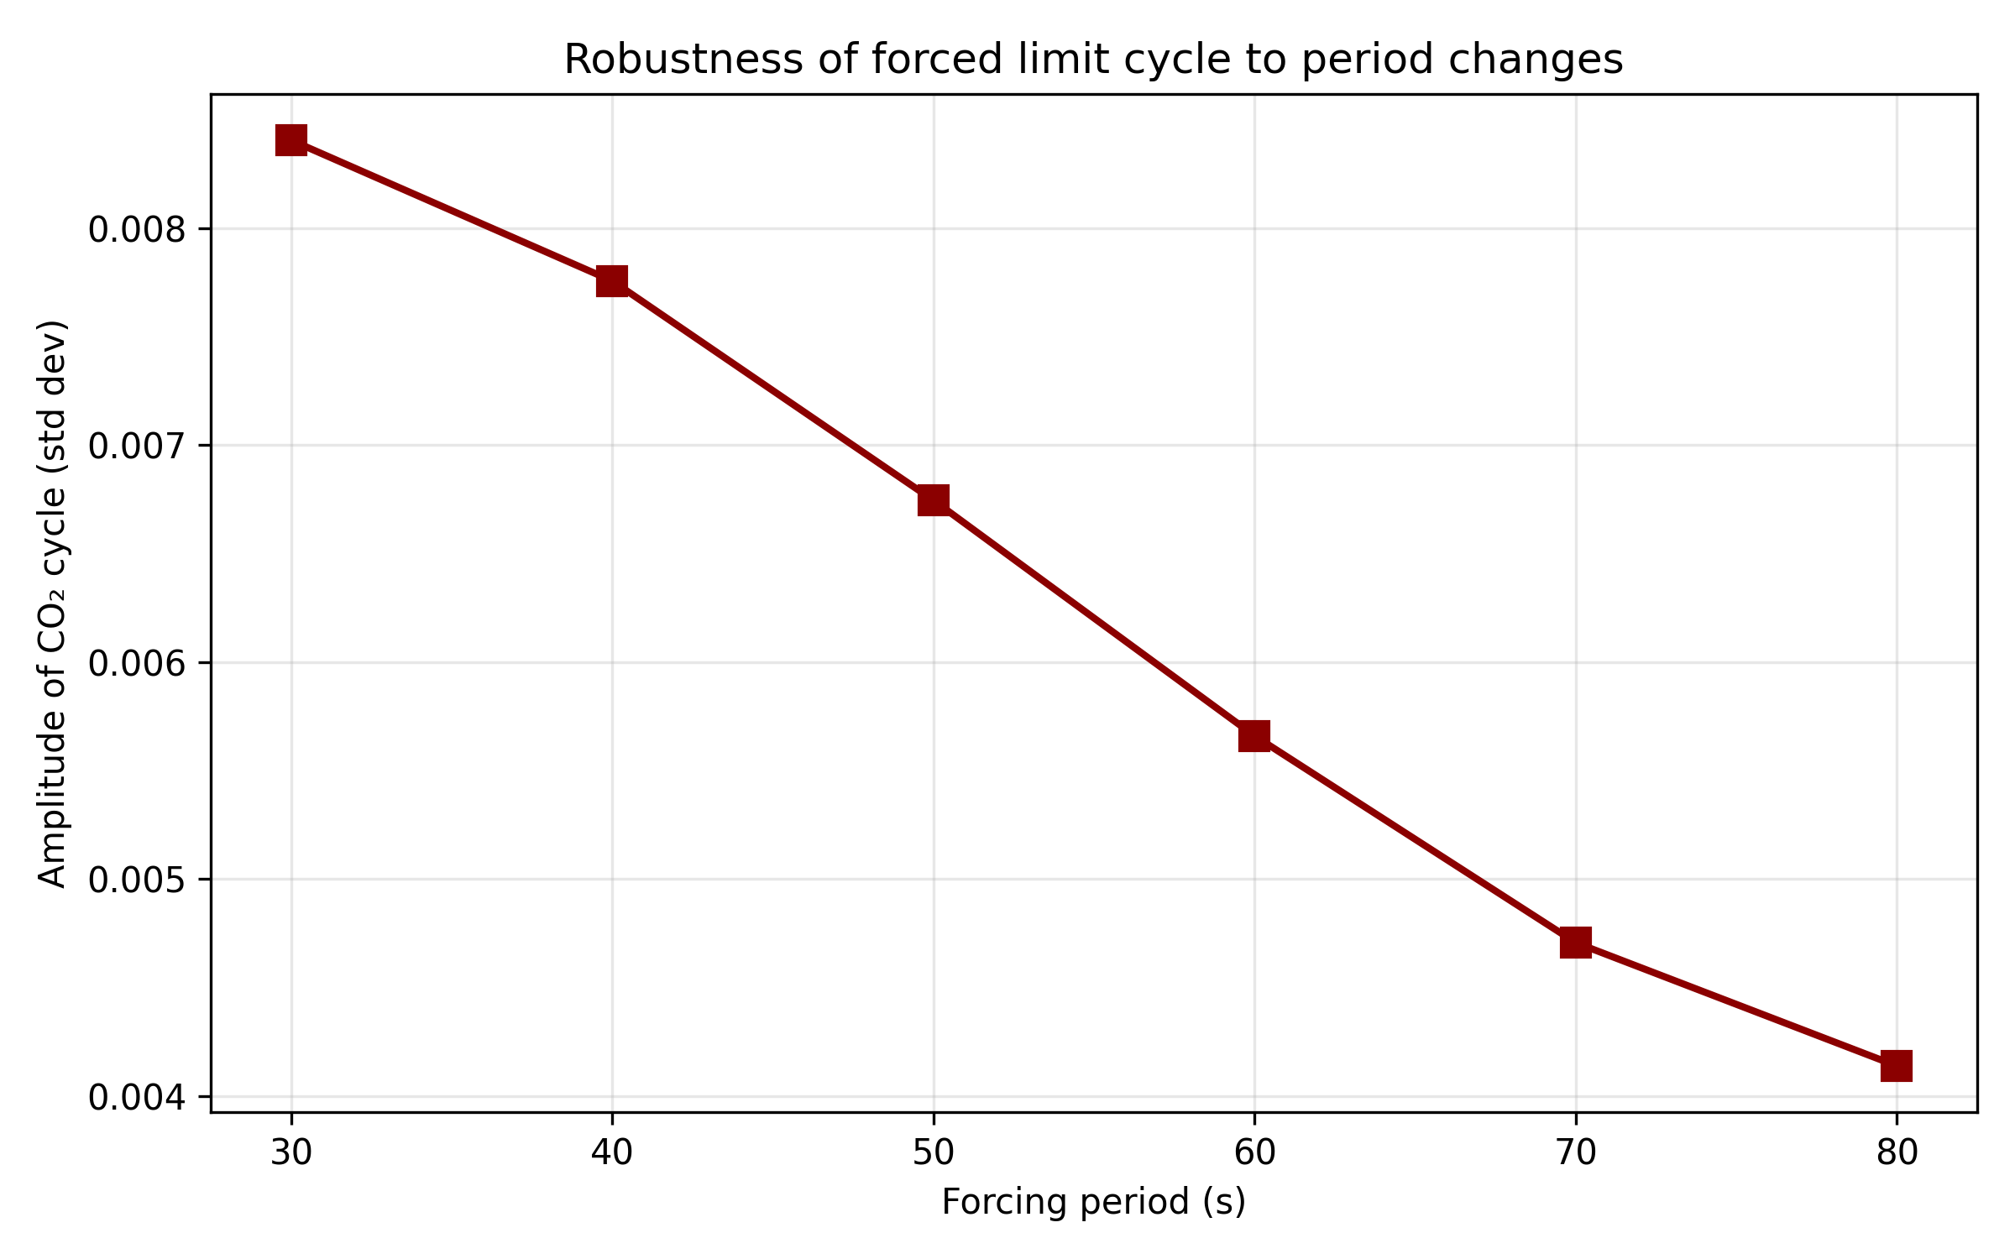
Figure S6. Robustness of the forced limit cycle to period changes (High-resolution version of Fig. 7). See legend of Fig. 7 in the main text.

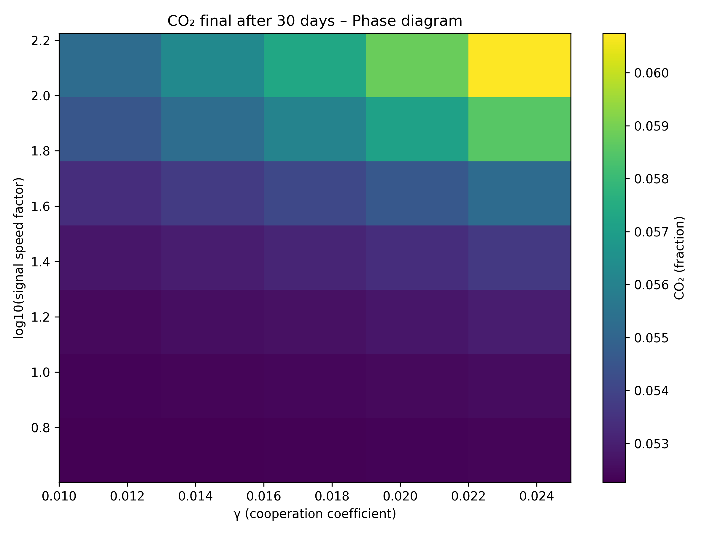
Figure S7. 2D heatmap of parametric resilience (High-resolution version of Fig. 8).
See legend of Fig. 8 in the main text.

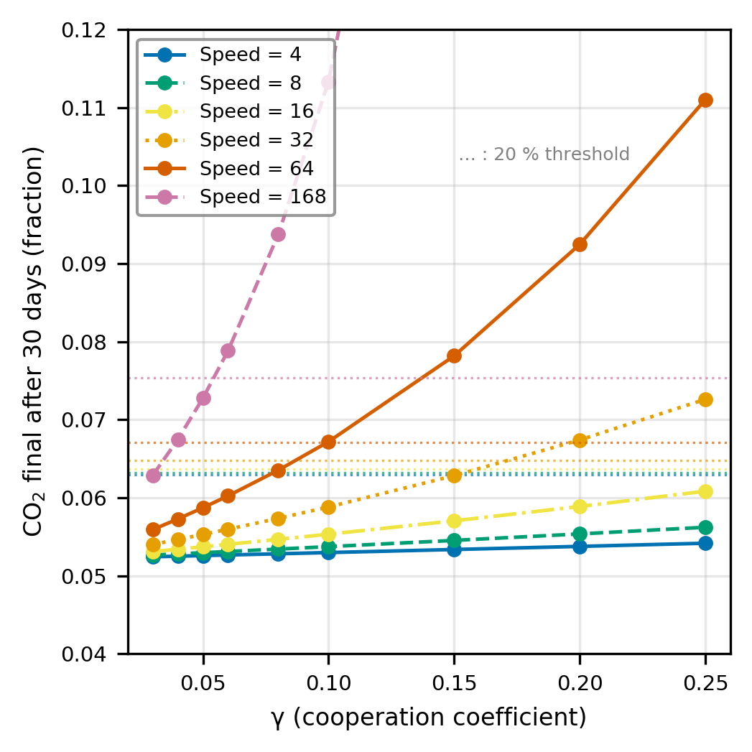
Figure S8. 1D sweeps at three signal speeds (High-resolution version of Fig. 9).
See legend of Fig. 9 in the main text.

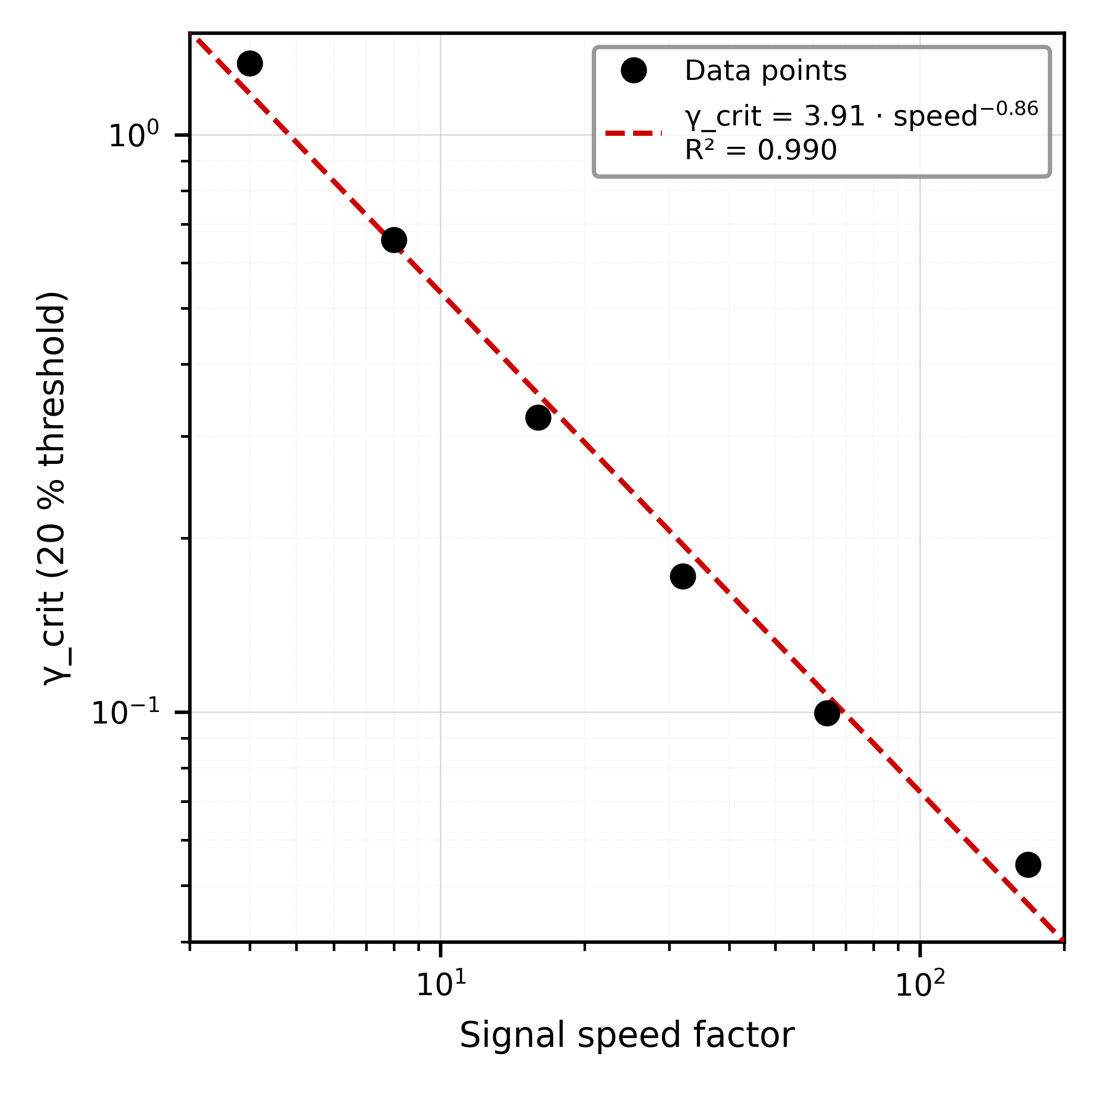
Figure S9. Power-law fit (High-resolution version of Fig. 10).
See legend of Fig. 10 in the main text.

Supplementary Note 3. Code availability and Zenodo repository.

Code availability. All simulation code is archived on Zenodo (version 3, DOI: 10.5281/zenodo.21721670). The repository includes the FiPy 3D solver, the homogeneous analysis scripts, the stroboscopic analysis code, the Boolean mask builder, and the parameter sweep scripts.

