Red Blood Cell Transfusion Exposure Is Linked to Lower CD8+ T-Cell Counts in Very Low Birthweight Infants
Niclas Oßmann ¹, Mats Ingmar Fortmann¹, Kirstin Faust¹, Julia Pagel^{1,2}, Martin Demmert¹, Christoph Härtel³, Alexander Humberg^{4,*}
Supplementary Material
- Supplementary Information
  - Definitions of clinical outcomes
Bronchopulmonary dysplasia (BPD) was defined as the requirement for supplemental oxygen and/or respiratory support (including continuous positive airway pressure or invasive mechanical ventilation) at 36 weeks’ postmenstrual age (23).
Intraventricular hemorrhage (IVH) was defined as hemorrhage involving the ventricular system and graded according to Papile (24).
Culture-proven sepsis was defined by the presence of clinical signs of infection in combination with a positive blood culture identifying a pathogenic microorganism. Contaminants (e.g., coagulase-negative staphylococci) were only considered if accompanied by clinical symptoms and/or laboratory evidence of infection (e.g., elevated CRP). Presence of clinical signs consistent with infection (e.g., temperature instability, apnea, bradycardia, feeding intolerance, respiratory deterioration) together with laboratory abnormalities (e.g., elevated CRP or leukocyte changes), in the absence of a positive blood culture, and requiring antibiotic therapy for ≥5 days.
Spontaneous intestinal perforation (SIP) was defined as isolated intestinal perforation occurring without radiological or intraoperative evidence of necrotizing enterocolitis, typically presenting with sudden abdominal distension and pneumoperitoneum, and characterized by focal perforation without extensive bowel inflammation or necrosis.
Necrotizing enterocolitis (NEC) was defined as inflammatory necrosis of the intestine diagnosed according to modified Bell’s staging criteria (≥ stage II), based on clinical signs (e.g., abdominal distension, bloody stools) and radiological findings (e.g., pneumatosis intestinalis, portal venous gas).
Retinopathy of prematurity (ROP) was defined as retinal vascular disease of preterm infants classified according to the International Classification of Retinopathy of Prematurity (ICROP), based on stage (1–5), zone, and presence of plus disease.
  - Recorded variables
Respiratory variables comprised start and end dates of oxygen therapy, and the mode of respiratory support (e.g., CPAP, high-flow nasal cannula, invasive ventilation). Transfusion variables were abstracted from transfusion records (intensive care charts, transfusion protocols) and orders from the Institute of Transfusion Medicine. Captured variables included product type (RBC, platelet concentrate, or fresh frozen plasma), date/time, indication (e.g., anemia, bleeding, perioperative transfusion, volume replacement), and transfused volume (mL). To ensure internal validity, transfusions were cross-checked across documentation sources to minimize misclassification and duplicate entries.
  - Timing of blood sampling
Blood samples were assigned to predefined postnatal time points based on the day of life (DOL). To account for variability in clinical sampling, time windows were defined around each target time point. Specifically, samples were included as follows:
Day of life 7: samples obtained between DOL 5–8
Day of life 14: samples obtained between DOL 12-15
Day of life 21: samples obtained between DOL 19-22
Day of life 28: samples obtained between DOL 26–29
Day of life 35: samples obtained between DOL 33-36
Day of life 42: samples obtained between DOL 40–43
If multiple samples were available within a given time window, the sample closest to the target day of life was selected for analysis.

- Supplementary Figures
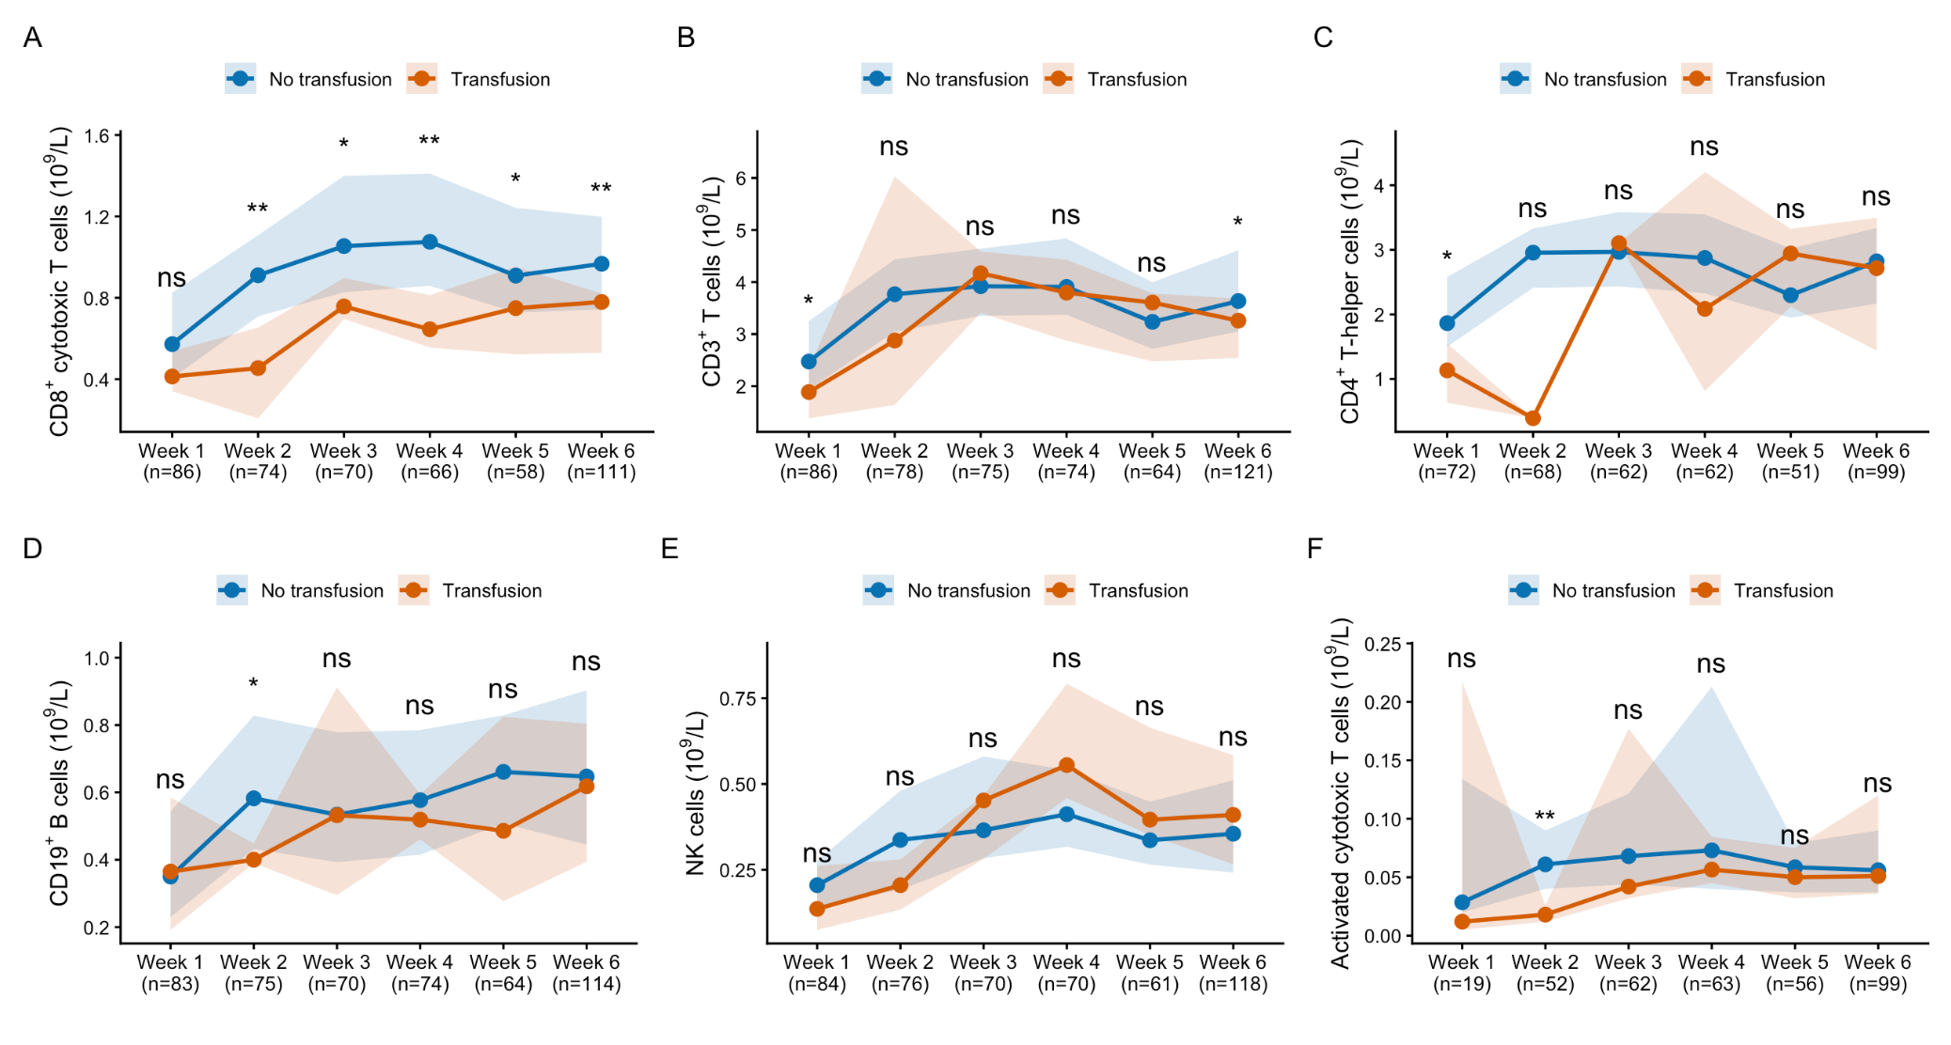
Supplementary Figure 1. Longitudinal changes in immune cell populations in very low birth weight infants stratified by transfusion exposure over the first 6 weeks of life. Data are presented as median values with shaded areas indicating 95% confidence interval. (A) NK cells (CD3⁻CD16⁺CD56⁺), (B) B cells (CD3⁻CD19⁺), (C) activated T cells (CD3⁺HLA-DR⁺), (D) T-helper cells (CD3⁺CD4⁺), (E) T cells (CD3⁺), and (F) white blood cell counts. Comparisons between transfused and non-transfused infants were performed at each time point. Statistical significance is indicated as follows: ns, not significant; *p < 0.05; **p < 0.01 (Mann-Whitney U test).
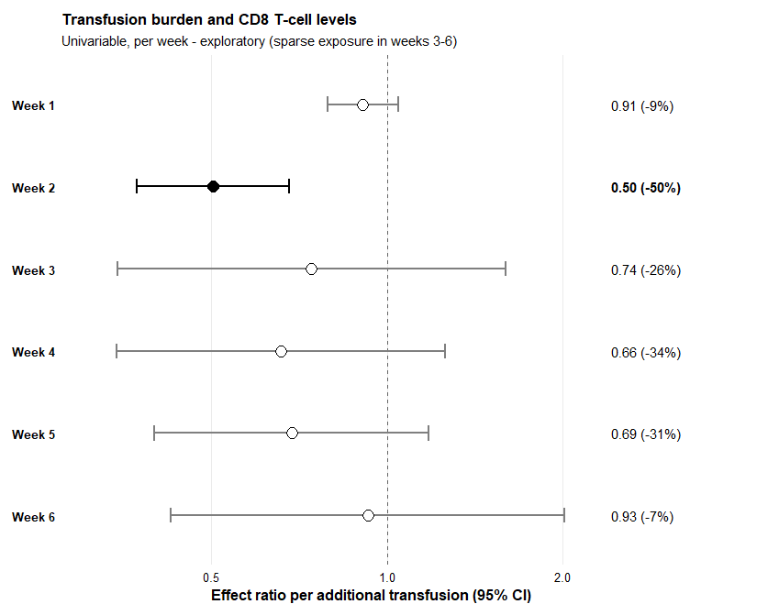
Supplementary Figure 2. Dose-response relationship between RBC transfusion burden and CD8+ T cell counts. Forest plots showing effect ratios with 95% confidence intervals from univariable linear regression models with log-transformed CD8+ T cell counts as the dependent variable. (A) Number of RBC transfusions received within each postnatal week (incident exposure); (B) cumulative number of RBC transfusions received up to each measurement day (cumulative exposure). Effect estimates are presented as ratios (exponentiated coefficients) per additional transfusion, with values <1 indicating lower CD8+ T cell levels and values >1 indicating higher levels. The dashed vertical line represents the null value (effect ratio = 1). Filled circles denote statistically significant associations (p < 0.05); open circles denote non-significant associations. The number of infants with a CD8+ T cell measurement at each time point is given in parentheses. The number of transfusions was derived from daily transfusion indicators (days of life 0–42).

- Supplementary Tables
Immunophenotype (gating definition) | Cell population
CD3+ | T cells
CD3+CD4+ | T-helper cells
CD3+CD8+ | Cytotoxic T cells
CD3−CD19+ | B cells
CD3−CD16+CD56+ | Natural killer (NK) cells
CD3+CD8+HLA-DR+ | Activated cytotoxic T cells
Supplementary Table 1. Flow cytometry panel. Immunophenotypic definitions of the flow cytometry lymphocyte panel. − denotes absence and + denotes presence of the respective surface marker; HLA-DR was used as the T-cell activation marker.

Immune cell subset (cells ×10⁹/L) | Week | No transfusion, median (IQR) | Transfusion, median (IQR) | p-value
T cells (CD3+)
 | Week 1 | 2.47 (1.94–3.25) | 1.89 (1.38–2.35) | 0.020
 | Week 2 | 3.77 (3.05–4.44) | 2.88 (1.64–6.03) | 0.431
 | Week 3 | 3.92 (3.35–4.64) | 4.17 (3.41–4.59) | 0.952
 | Week 4 | 3.91 (3.37–4.84) | 3.80 (2.87–4.43) | 0.290
 | Week 5 | 3.23 (2.72–4.00) | 3.61 (2.48–3.78) | 0.531
 | Week 6 | 3.63 (3.05–4.61) | 3.26 (2.54–3.68) | 0.030
T-helper cells (CD3+CD4+)
 | Week 1 | 1.86 (1.50–2.58) | 1.13 (0.63–1.55) | 0.017
 | Week 2 | 2.96 (2.41–3.33) | 0.39 (0.39–0.39) | 0.059
 | Week 3 | 2.97 (2.43–3.58) | 3.10 (3.10–3.10) | 0.871
 | Week 4 | 2.87 (2.33–3.55) | 2.09 (0.81–4.20) | 0.412
 | Week 5 | 2.30 (1.95–3.02) | 2.94 (2.12–3.32) | 0.503
 | Week 6 | 2.82 (2.17–3.34) | 2.72 (1.44–3.50) | 0.725
Cytotoxic T cells (CD3+CD8+)
 | Week 1 | 0.57 (0.41–0.82) | 0.41 (0.34–0.54) | 0.050
 | Week 2 | 0.91 (0.71–1.11) | 0.45 (0.21–0.65) | 0.003
 | Week 3 | 1.05 (0.83–1.40) | 0.76 (0.70–0.90) | 0.018
 | Week 4 | 1.07 (0.86–1.41) | 0.65 (0.56–0.81) | 0.006
 | Week 5 | 0.91 (0.73–1.24) | 0.75 (0.52–0.95) | 0.019
 | Week 6 | 0.97 (0.74–1.20) | 0.78 (0.53–0.82) | 0.004
B cells (CD3−CD19+)
 | Week 1 | 0.35 (0.23–0.54) | 0.36 (0.19–0.58) | 0.905
 | Week 2 | 0.58 (0.43–0.83) | 0.40 (0.39–0.45) | 0.030
 | Week 3 | 0.53 (0.39–0.78) | 0.53 (0.29–0.91) | 0.782
 | Week 4 | 0.58 (0.41–0.79) | 0.52 (0.46–0.59) | 0.426
 | Week 5 | 0.66 (0.51–0.83) | 0.49 (0.28–0.82) | 0.070
 | Week 6 | 0.65 (0.45–0.90) | 0.62 (0.39–0.80) | 0.344
NK cells (CD3−CD16+CD56+)
 | Week 1 | 0.20 (0.14–0.28) | 0.14 (0.07–0.26) | 0.183
 | Week 2 | 0.34 (0.19–0.48) | 0.20 (0.13–0.28) | 0.171
 | Week 3 | 0.36 (0.28–0.58) | 0.45 (0.28–0.48) | 0.674
 | Week 4 | 0.41 (0.32–0.54) | 0.56 (0.46–0.79) | 0.065
 | Week 5 | 0.34 (0.27–0.45) | 0.40 (0.35–0.66) | 0.096
 | Week 6 | 0.35 (0.24–0.51) | 0.41 (0.27–0.58) | 0.355
Activated T cells (CD3+HLA-DR+)
 | Week 1 | 0.029 (0.020–0.134) | 0.012 (0.005–0.217) | 0.359
 | Week 2 | 0.061 (0.040–0.090) | 0.018 (0.012–0.026) | 0.009
 | Week 3 | 0.068 (0.044–0.121) | 0.042 (0.032–0.177) | 0.394
 | Week 4 | 0.073 (0.040–0.213) | 0.057 (0.045–0.085) | 0.484
 | Week 5 | 0.059 (0.037–0.079) | 0.050 (0.032–0.075) | 0.484
 | Week 6 | 0.056 (0.037–0.090) | 0.051 (0.036–0.120) | 0.886
Supplementary Table 2. Immune cell subsets according to transfusion status across the first six postnatal weeks. Values are median (interquartile range, IQR) in cells ×10⁹/L for infants without and with RBC transfusion; p-values are from Mann-Whitney U tests comparing the two groups at each week (Week 1 = day 7, Week 2 = day 14, Week 3 = day 21, Week 4 = day 28, Week 5 = day 35, Week 6 = day 42). Where only one transfused infant contributed to a given week, the IQR collapses to the single observed value. White blood cell counts are not shown.

Window / day | n | Effect ratio (95% CI) | p | R² | Pearson r (p) | Spearman ρ (p)
Per week (transfusions within the week)
Week 1 (LT0–7) | 86 | 0.90 (0.81–1.01) | 0.076 | 0.037 | −0.19 (0.076) | −0.22 (0.044)
Week 2 (LT8–14) | 74 | 0.50 (0.37–0.68) | <0.001 | 0.224 | −0.47 (<0.001) | −0.20 (0.088)
Week 3 (LT15–21) | 70 | 0.67 (0.43–1.03) | 0.069 | 0.048 | −0.22 (0.069) | −0.22 (0.065)
Week 4 (LT22–28) | 66 | 0.66 (0.34–1.26) | 0.200 | 0.026 | −0.16 (0.200) | −0.21 (0.093)
Week 5 (LT29–35) | 58 | 0.66 (0.50–0.87) | 0.004 | 0.137 | −0.37 (0.004) | −0.36 (0.006)
Week 6 (LT36–42) | 111 | 0.73 (0.46–1.14) | 0.162 | 0.018 | −0.13 (0.162) | −0.13 (0.174)
Cumulative (transfusions up to the day)
to day 7 | 86 | 0.90 (0.81–1.01) | 0.076 | 0.037 | — | —
to day 14 | 74 | 0.82 (0.76–0.89) | <0.001 | 0.252 | — | —
to day 21 | 70 | 0.93 (0.88–0.99) | 0.017 | 0.081 | — | —
to day 28 | 66 | 0.90 (0.84–0.97) | 0.005 | 0.119 | — | —
to day 35 | 58 | 0.96 (0.92–0.99) | 0.006 | 0.126 | — | —
to day 42 | 111 | 0.96 (0.93–0.99) | 0.017 | 0.051 | — | —
Supplementary Table 3. Dose-response associations between the number of RBC transfusions and CD8+ T-cell counts. Effect ratio = exp(β) per additional transfusion from univariable linear regression with log-transformed CD8+ T-cell counts as the dependent variable. Pearson correlations were computed on the log scale and Spearman correlations on untransformed values.

