Supplementary Tables and Figures
Title: Circulating plasma microRNA expression profiles associated with virological failure and HIV drug resistance among adults receiving second-line protease inhibitor-based antiretroviral therapy in Zimbabwe
Supplementary Table 1. GenBank Accession Numbers for HIV-1 Sequences Generated in the Study
Study Sample ID | GenBank Isolate | GenBank Accession No.
R1 | DR303 | PX475452.1
N1 | DR211 | PX475431.1
R2 | DR353 | PX475473.1
N2 | DR437 | PX475494.1
R3 | DR354 | PX475474.1
N3 | DR407 | PX475489.1
R4 | DR373 | PX475479.1
N4 | DR336 | PX475467.1
R5 | DR383 | PX475482.1
N5 | DR546 | PX475509.1
R6 | DR375 | PX475480.1
N6 | DR384 | PX475483.1
R7 | DR528 | PX475505.1
N7 | DR365 | PX475477.1
R8 | DR414 | PX475490.1
N8 | DR350 | PX475471.1
R9 | DR306 | PX475453.1
N9 | DR290 | PX475447.1
R10 | DR388 | PX475484.1
N10 | DR265 | PX475444.1
R11 | DR496 | PX475501.1
N11 | DR541 | PX475508.1
R12 | DR509 | PX475502.1
N12 | DR474 | PX475499.1
R13 | DR532 | PX475506.1
N13 | DR395 | PX475486.1
R14 | DR547 | PX475510.1
N14 | DR188 | PX475423.1
R15 | DR536 | PX475507.1
N15 | DR069 | PX475388.1
R16 | DR527 | PX475504.1
N16 | DR043 | PX475379.1
R17 | DR397 | PX475487.1
N17 | DR122 | PX475402.1
R18 | DR416 | PX475491.1
N18 | DR059 | PX475386.1
R19 | DR349 | PX475470.1
N19 | DR112 | PX475398.1
R20 | DR381 | PX475481.1
N20 | HDR206 | PX475591.1
R21 | DR389 | PX475485.1
N21 | HDR244 | PX475613.1
R22 | DR372 | PX475478.1
N22 | HDR296 | PX475642.1
R23 | DR334 | PX475465.1
N23 | HDR276 | PX475632.1
R24 | DR327 | PX475460.1
N24 | HDR259 | PX475621.1
R25 | DR335 | PX475466.1
N25 | HDR003 | PX475513.1
R26 | DR328 | PX475461.1
N26 | HDR005 | PX475515.1
R27 | DR329 | PX475462.1
N27 | HDR030 | PX475532.1
R28 | DR421 | PX475493.1
N28 | HDR040 | PX475538.1
R29 | DR461 | PX475497.1
N29 | HDR084 | PX475567.1
R30 | DR448 | PX475496.1
N30 | HDR090 | PX475572.1
R31 | DR419 | PX475492.1
N31 | HDR100 | PX475578.1
R32 | DR398 | PX475488.1
N32 | HDR102 | PX475580.1
R33 | DR359 | PX475476.1
N33 | HDR219 | PX475596.1
R34 | DR351 | PX475472.1
R35 | DR344 | PX475469.1
R36 | DR343 | PX475468.1
R37 | DR332 | PX475464.1
R38 | DR330 | PX475463.1
R39 | DR324 | PX475459.1
R40 | DR320 | PX475457.1
R41 | DR312 | PX475454.1
R42 | DR300 | PX475451.1
R43 | DR292 | PX475449.1
R44 | DR291 | PX475448.1
R45 | DR256 | PX475441.1
R46 | DR255 | PX475440.1

Sequences were generated and deposited as part of a previously reported companion analysis of this study population, and are reproduced here for reference in relation to the virological failure with resistance (VF-R) and virological failure without resistance (VF-NR) classifications used in the present study.

Supplementary Table 2. TaqMan™ MicroRNA Assays used in the study

Target | Assay ID | Mature miRNA Sequence (5′→3′) | Manufacturer
hsa-miR-29a-3p | 002112 | UAGCACCAUCUGAAAUCGGUUA | Thermo Fisher Scientific
hsa-miR-146a-5p | 000468 | UGAGAACUGAAUUCCAUGGGUU | Thermo Fisher Scientific
hsa-miR-150-5p | 000473 | UCUCCCAACCCUUGUACCAGUG | Thermo Fisher Scientific
hsa-miR-93-5p | 001090 | CAAAGUGCUGUUCGUGCAGGUAG | Thermo Fisher Scientific
hsa-miR-484-5p | 001821 | UCAGGCUCAGUCCCCUCCCGAU | Thermo Fisher Scientific
hsa-miR-16-5p | 000391 | UAGCAGCACGUAAAUAUUGGCG | Thermo Fisher Scientific
cel-miR-39-3p | 000200 | UCACCGGGUGUAAAUCAGCUUG | Thermo Fisher Scientific
Bottom of Form
The TaqMan™ MicroRNA Assays used in this study are proprietary hydrolysis probe-based assays. The mature miRNA target sequences recognised by each assay are provided together with the corresponding Thermo Fisher Scientific Assay IDs. Primer and hydrolysis probe sequences are proprietary information and are therefore not publicly disclosed by the manufacturer.

Supplementary Table 3. Expression stability assessment of candidate endogenous reference genes
Candidate Reference Gene | Mean Cq | Overall SD (Cq units) | CV (%) | VS SD (n=40) | VF-NR SD (n=33) | VF-R SD (n=46) | Selected for Normalisation
miR-16-5p | 23.40 | 2.16 | 9.23 | 1.87 | 2.29 | 2.16 | No
miR-93-5p | 31.85 | 1.04 | 3.26 | 0.92 | 1.22 | 1.02 | Yes
miR-484-5p | 29.35 | 0.68 | 2.33 | 0.62 | 0.71 | 0.71 | Yes
Abbreviations: Cq, quantification cycle; CV, coefficient of variation; SD, standard deviation; VF-NR, virological failure without resistance; VF-R, virological failure with resistance; VS, virologically suppressed. Candidate reference genes were evaluated using expression variability across study groups. miR-93-5p and miR-484-5p demonstrated the lowest overall variability and were selected as endogenous normalisation controls, using their geometric mean (calculated as the arithmetic mean of Cq values).

Supplementary Table 4. Exploratory distribution of circulating plasma miRNA expression among HIV-negative healthy controls.

Variable | miR-29a-3p | miR-146a-5p | miR-150-5p
Controls analysed | 27 | 27 | 27
Quantifiable (Cq ≤35), n (%) | 15 (55.6%) | 16 (59.3%) | 18 (66.7%)
Undetermined or Cq >35, n (%) | 12 (44.4%) | 11 (40.7%) | 9 (33.3%)
Median Cq (IQR)* | 33.22 (32.77–34.33) | 34.08 (33.55–34.52) | 32.52 (31.95–33.46)
Abbreviations: Cq, quantification cycle; IQR, interquartile range. Median Cq were calculated among quantifiable samples only (Cq ≤35). Exploratory descriptive analysis only; HIV-negative healthy controls were not included in inferential statistical comparisons because of the limited number of samples with quantifiable expression for all three target miRNAs.
*Among quantifiable samples only.

Supplementary Figure 1: Association between circulating miR-146a-5p expression and HIV drug-resistance mutation burden among participants with virological failure.

A
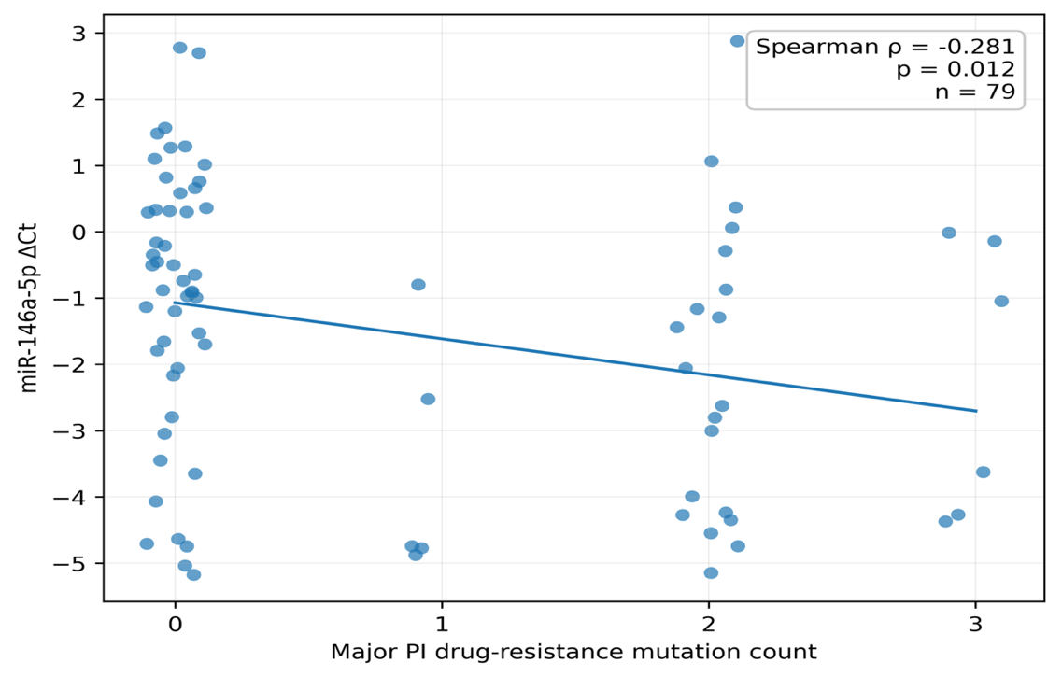

B
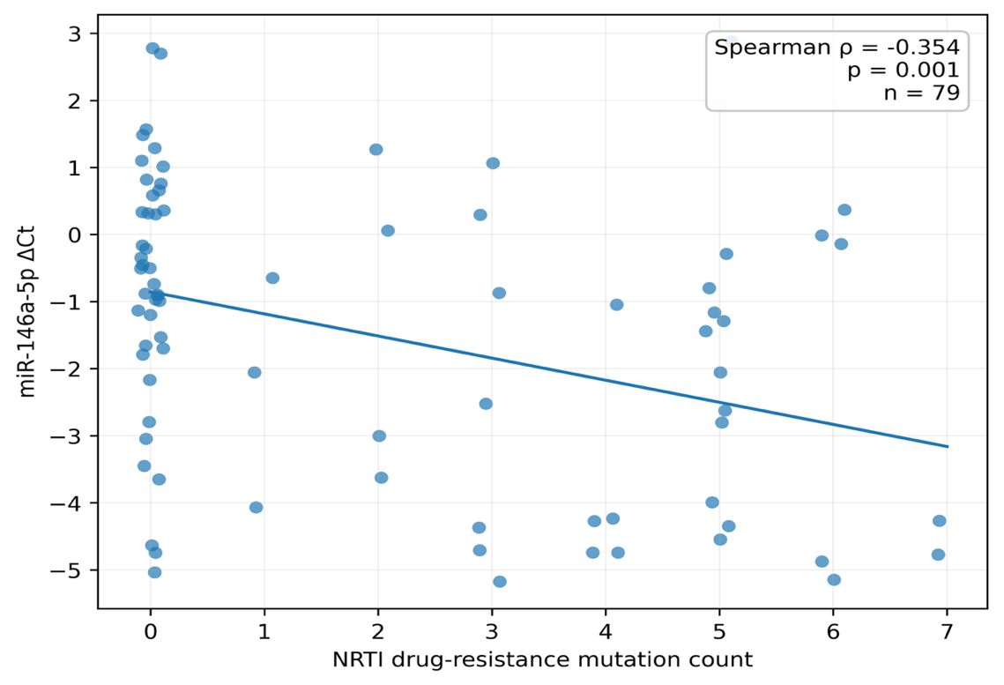
Abbreviations: NRTI, nucleoside reverse-transcriptase inhibitor; PI, protease inhibitor; ΔCq, difference in quantification cycle relative to the reference miRNA. Scatter plots show the relationship between miR-146a-5p ΔCq and (A) the number of major protease inhibitor (PI) drug-resistance mutations and (B) the number of nucleoside reverse-transcriptase inhibitor (NRTI) drug-resistance mutations among participants with virological failure (n = 79). Data points were horizontally jittered to improve visualisation where multiple observations shared the same mutation count. Lines represent fitted linear trends for visualisation only. Associations were assessed using Spearman’s rank correlation. Lower ΔCq values indicate higher relative miR-146a-5p expression.
Supplementary Table 5. Raw Spearman correlations between circulating plasma miRNAs and clinical characteristics
Variable | n | miR-146a-5p ρ (raw p) | miR-150-5p ρ (raw p) | miR-29a-3p ρ (raw p)
Overall cohort
Viral load | 119 | 0.252 (0.006) | −0.322 (<0.001) | −0.365 (<0.001)
ART duration | 113 | 0.121 (0.203) | −0.227 (0.016) | −0.359 (<0.001)
PI duration | 119 | −0.006 (0.949) | −0.090 (0.330) | −0.070 (0.451)
Virological failure subgroup
Viral load | 79 | −0.058 (0.609) | −0.029 (0.798) | −0.014 (0.902)
Major PI mutation count | 79 | 0.281 (0.012) | −0.107 (0.349) | −0.117 (0.307)
NRTI mutation count | 79 | 0.354 (0.001) | −0.050 (0.659) | −0.158 (0.165)
NNRTI mutation count | 79 | 0.225 (0.046) | −0.214 (0.058) | −0.230 (0.041)
Abbreviations: ρ, Spearman's rank correlation coefficient; ART, antiretroviral therapy; PI, protease inhibitor; NRTI, nucleoside reverse transcriptase inhibitor; NNRTI, non-nucleoside reverse transcriptase inhibitor. Raw (unadjusted) Spearman correlation coefficients (ρ) and corresponding P values are presented for transparency. Statistical inference in the main manuscript is based on the Benjamini–Hochberg-adjusted q-values reported in Table 4.

Supplementary Table 6. Estimated predictive values of circulating plasma miRNA models for virological failure

Biomarker model | AUC | Sensitivity (%) | Specificity (%) | PPV (20%) | NPV (20%) | PPV (25%) | NPV (25%) | PPV (30%) | NPV (30%)
miR-146a-5p | 0.704 | 40.5 | 97.5 | 80.2 | 86.8 | 84.4 | 83.1 | 87.4 | 79.3
miR-150-5p | 0.734 | 59.5 | 85.0 | 49.8 | 89.4 | 56.9 | 86.3 | 63.0 | 83.0
miR-29a-3p | 0.768 | 59.5 | 87.5 | 54.3 | 89.6 | 61.3 | 86.6 | 67.1 | 83.4
Three-miRNA panel | 0.893 | 87.3 | 82.5 | 55.5 | 96.3 | 62.5 | 95.1 | 68.1 | 93.8
Abbreviations: AUC, area under the receiver operating characteristic curve; NPV, negative predictive value; PPV, positive predictive value; VF, virological failure. Sensitivity and specificity were determined at the Youden-optimal threshold using the current study dataset. Positive predictive value (PPV) and negative predictive value (NPV) were subsequently estimated assuming virological failure prevalences of 20%, 25%, and 30%. Because predictive values are prevalence-dependent, these estimates may vary across clinical settings. The reported sensitivity and specificity represent apparent in-sample performance and require prospective external validation.

