Supplementary Information
Photothermal and photoacoustic performances of atomically precise Au₁₀₃S(p-MBT)₄₂ nanoclusters
Hao Wang^{1†}, Ying An^{2†}, Wei Zhang³, Yiqi Tian¹, Peng Lan⁴, Meng Zhou⁴, Gongde Wu,⁵ Weiping Ding¹, Yan Zhu¹*, Huangxian Ju²*, Xu Liu^{1,3}*
¹State Key Laboratory of Coordination Chemistry, Key Laboratory of Mesoscopic Chemistry of Ministry of Education, School of Chemistry and Chemical Engineering, Nanjing University, Nanjing 210023, China.
Hao Wang, Yiqi Tian, Weiping Ding, Yan Zhu & Xu Liu
²State Key Laboratory of Analytical Chemistry for Life Science, School of Chemistry and Chemical Engineering, Nanjing University, Nanjing 210023, China.
Ying An & Huangxian Ju
³Institute for Energy Research, Jiangsu University, Zhenjiang 212013, China.
Wei Zhang & Xu Liu
⁴Hefei National Research Center for Physical Sciences at the Microscale, University of Science and Technology of China, Hefei, 230026, China.
Peng Lan & Meng Zhou
⁵School of Environment Engineering, Nanjing Institute of Technology, Nanjing 211167, China.
Gongde Wu

†H. W. and Y. A. contributed equally to this work.
*Email: zhuyan@nju.edu.cn; hxju@nju.edu.cn; xuliu@nju.edu.cn

Computational details
All quantum chemistry calculations in this work were conducted using the ORCA 6.1.0 package.^{S1-17} Geometry optimizations were carried out using the PBE functional combined with Grimme’s D3 dispersion correction with Becke–Johnson damping (D3BJ) and the def2-SVP basis set. The def2/J auxiliary basis set was employed to accelerate Coulomb integral evaluation. Subsequently, the B3LYP functional with D3(BJ) dispersion correction and the def2-SVP basis set was applied to calculate the simulated UV-vis spectra. To accelerate the excited-state calculations, the simplified Tamm-Dancoff approximation (sTDA) was employed with an energy window threshold of 3.5 eV. To reduce computational cost, the outer organic ligands were replaced by methyl (-CH₃) groups.

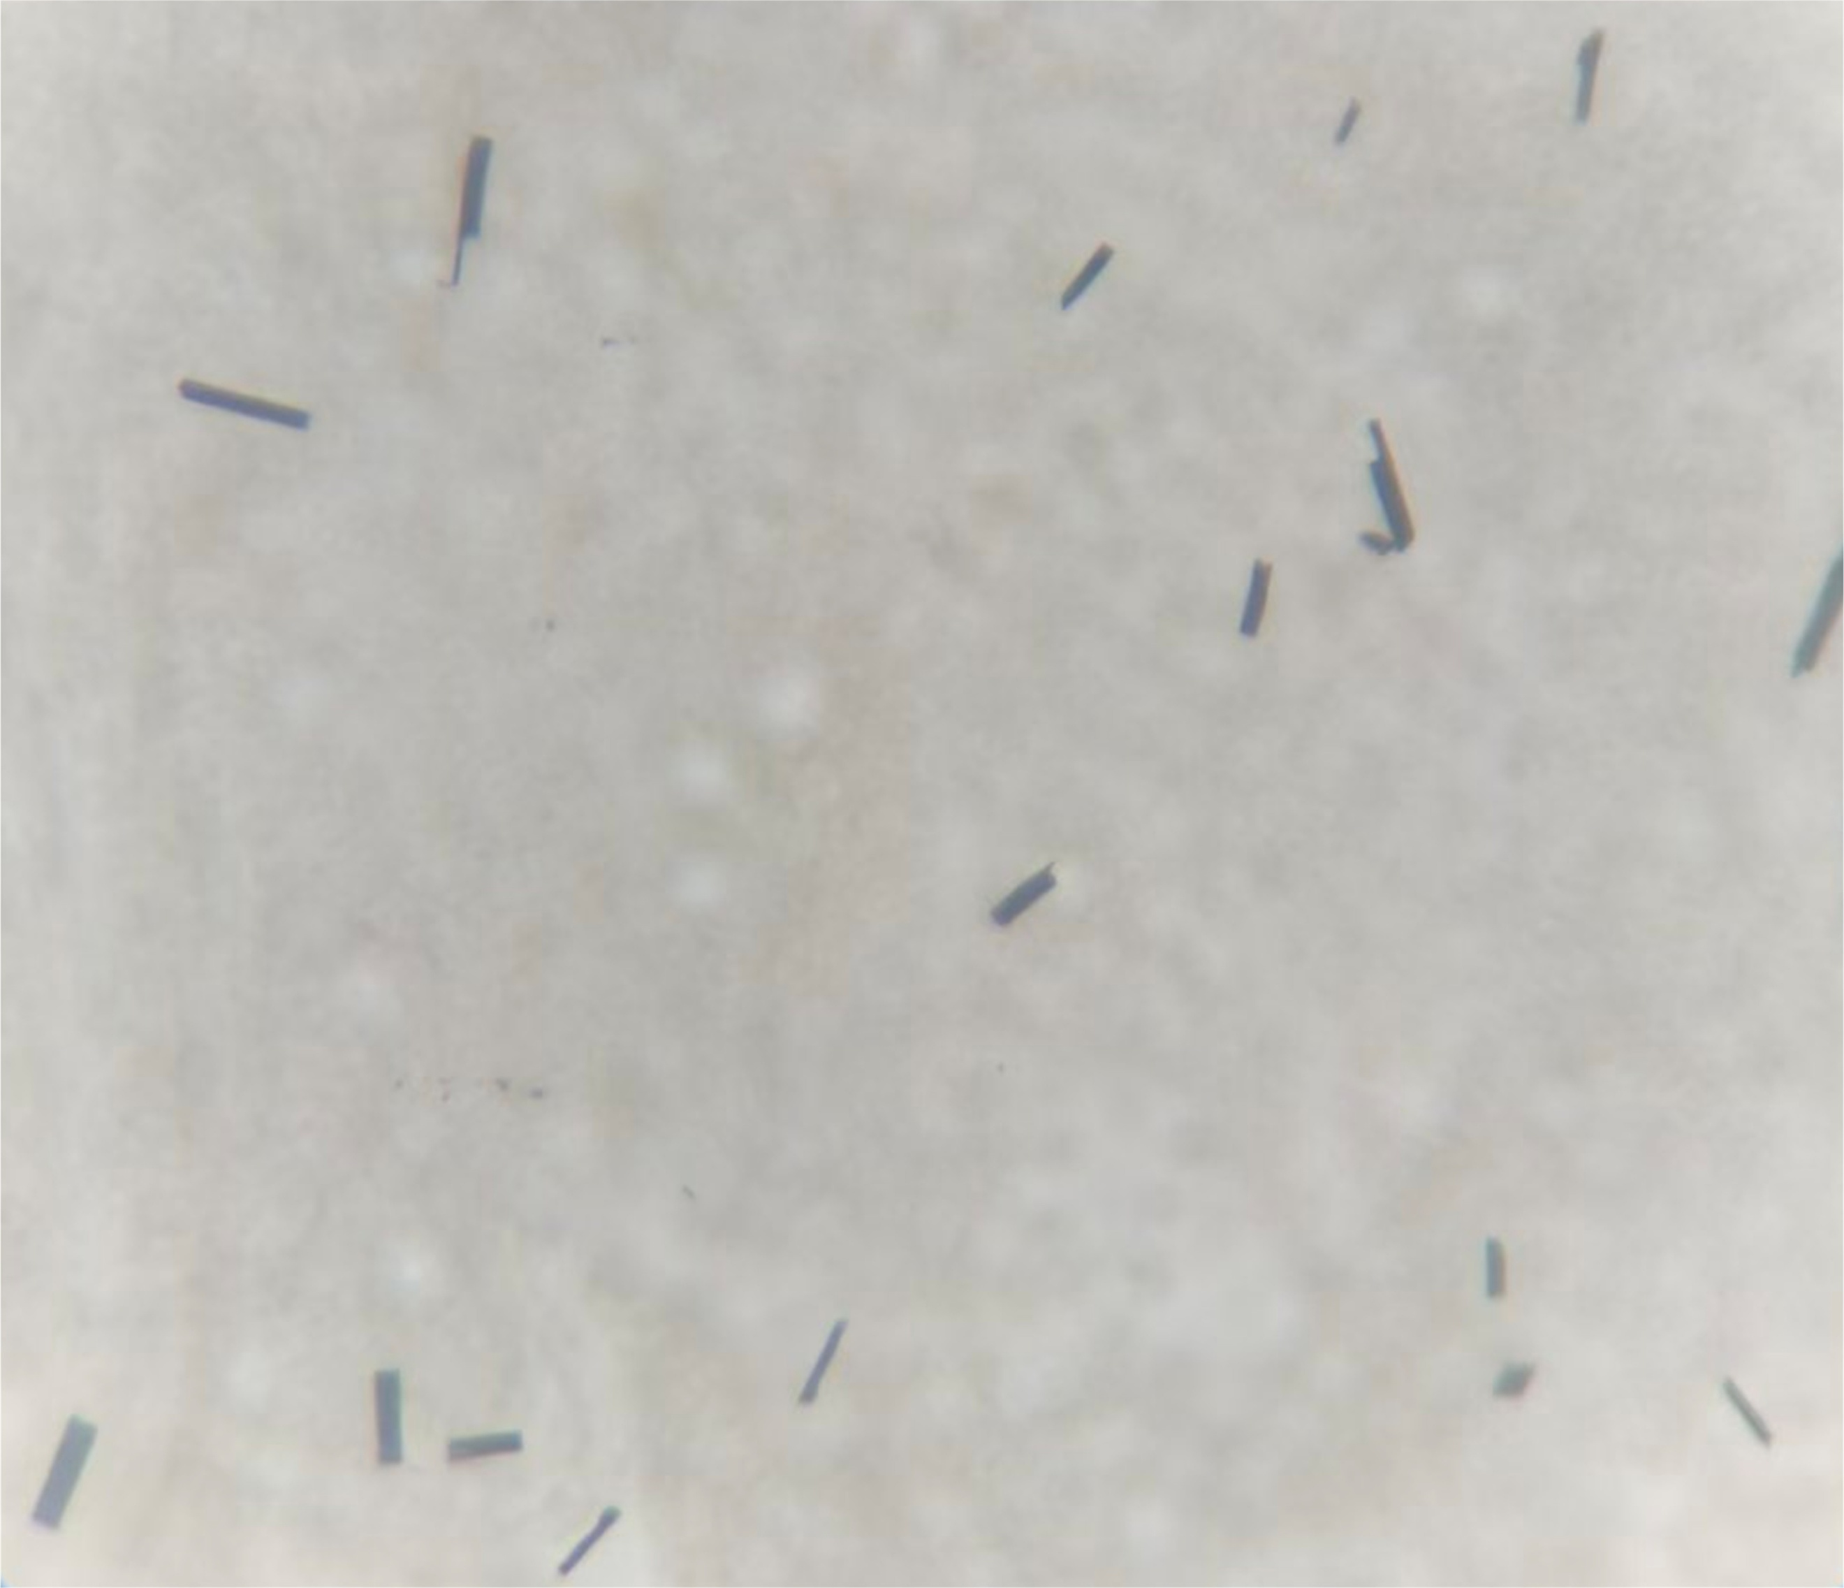
Supplementary Fig. 1 Microscopic photograph of Au₁₀₃S(p-MBT)₄₂ crystals.

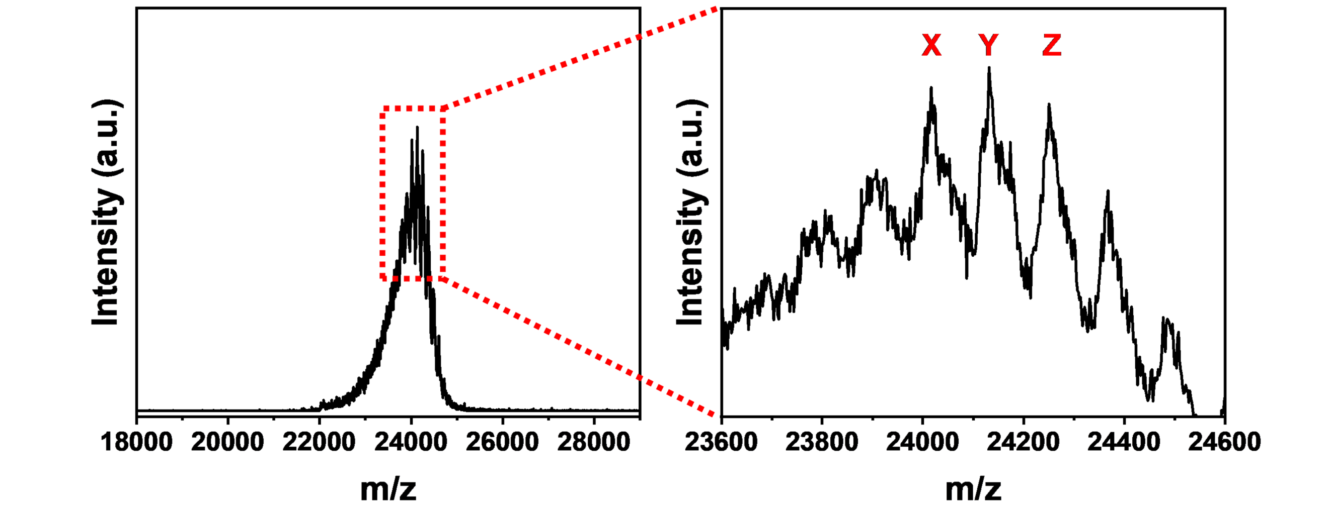
Supplementary Fig. 2 Matrix-assisted laser desorption/ionization time of flight mass spectrometry (MALDI-TOF-MS) data of Au₁₀₃S(p-MBT)₄₂ nanocluster in the positive ion mode.
Note: The peaks of X/Y/Z can be assigned to {[Au₁₀₃S(p-MBT)₄₂]-[Au₃S(p-MBT)₃]-4(p-MBT)}⁺, {[Au₁₀₃S(p-MBT)₄₂]-[Au₃S(p-MBT)₃]-3(p-MBT)}⁺, and {[Au₁₀₃S(p-MBT)₄₂]-[Au₃S(p-MBT)₃]-2(p-MBT)}⁺. These fragmentary molecules were obtained from the ionization process, wherein the surface motifs such as Au₃S(p-MBT)₃ and p-MBT ligand could be taken off from the total structure of Au₁₀₃S(p-MBT)₄₂ nanocluster.

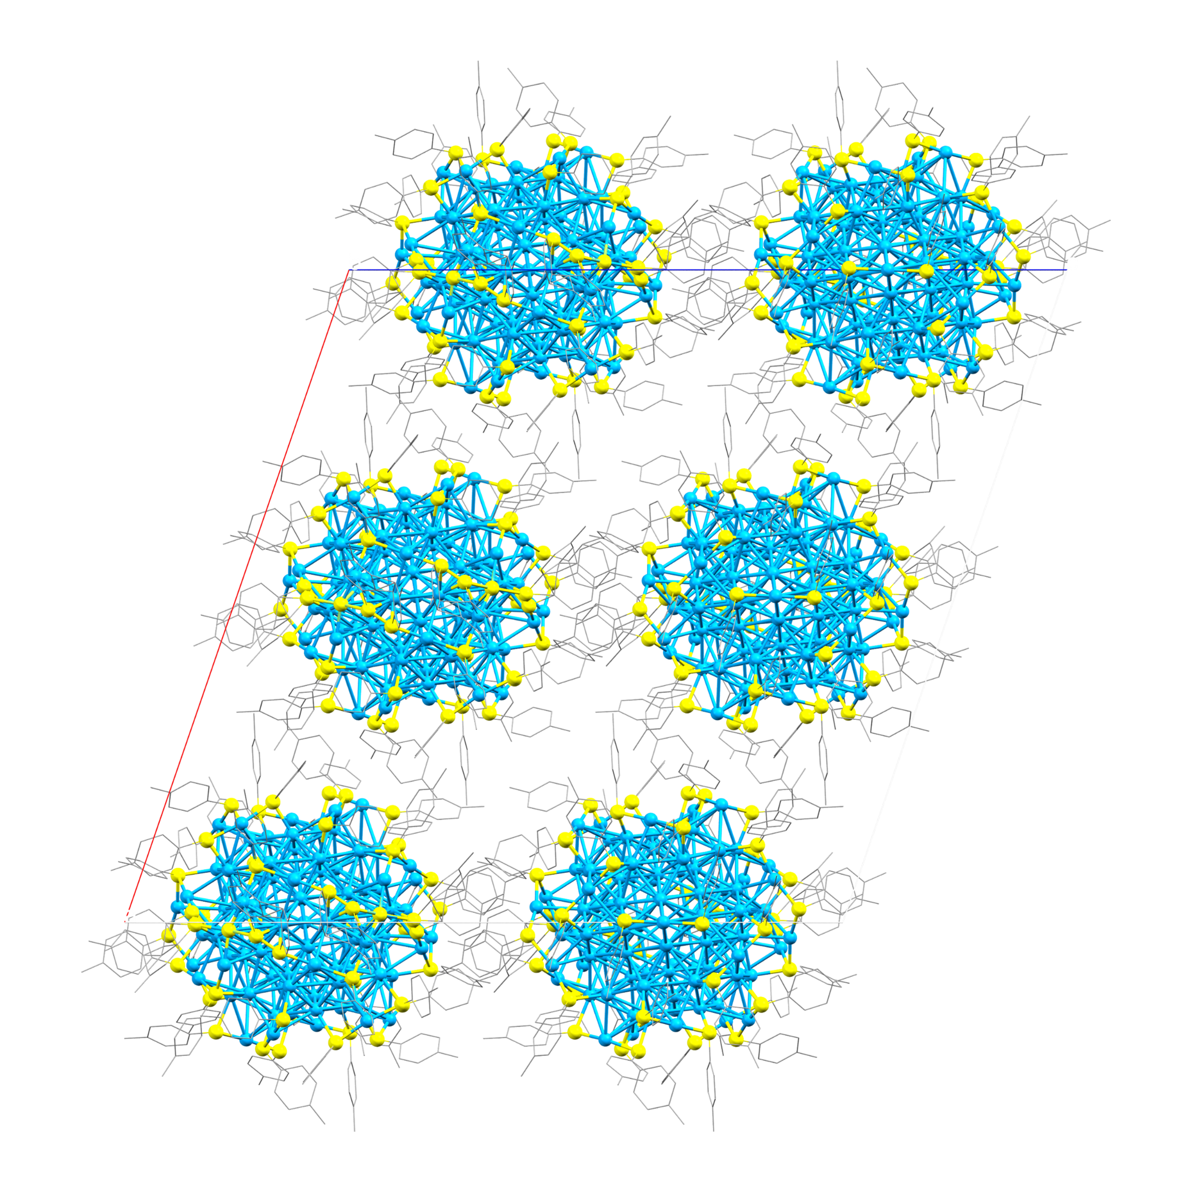
Supplementary Fig. 3 The arrangement of Au₁₀₃S(p-MBT)₄₂ nanocluster in monoclinic unit cell along y axis.

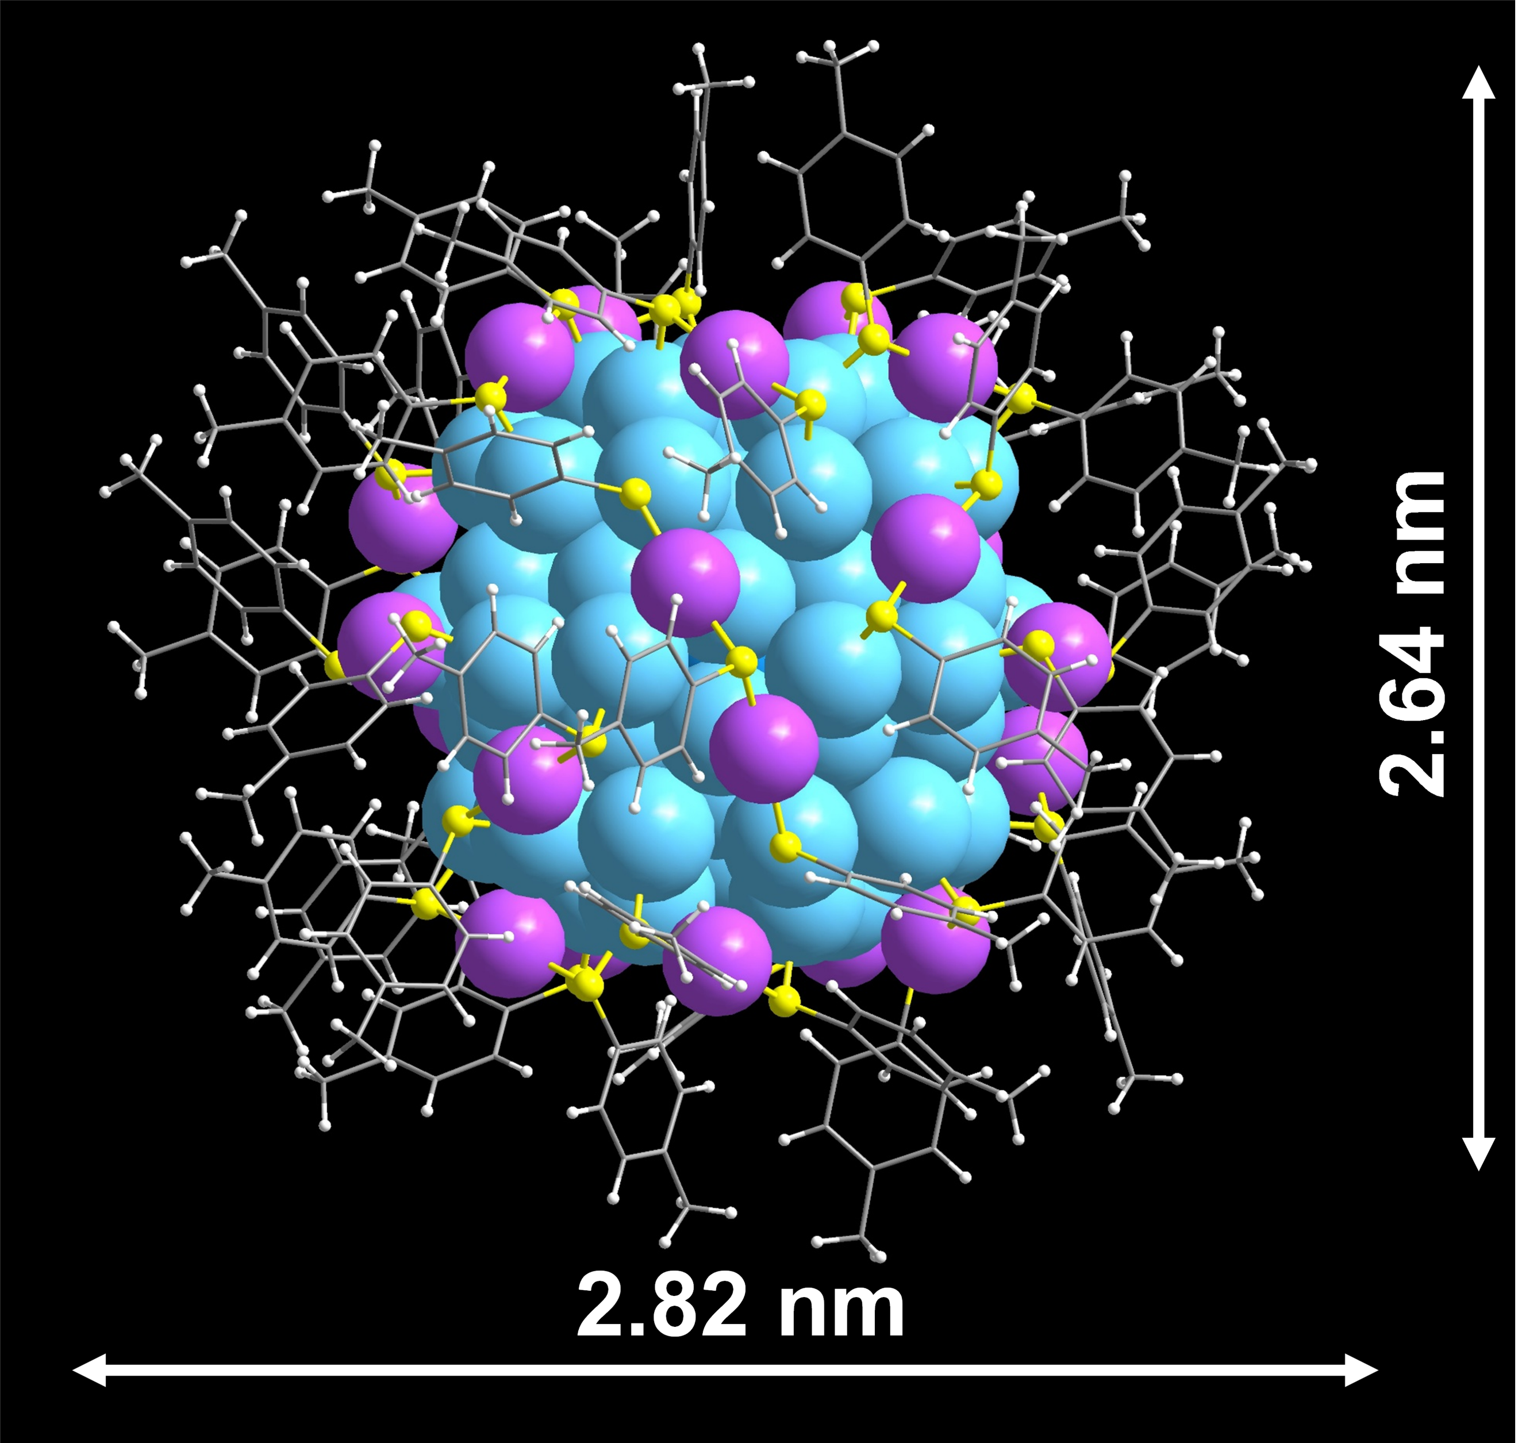
Supplementary Fig. 4 Total structure of the Au₁₀₃S(p-MBT)₄₂ nanocluster. Color labels: purple/blue = Au, yellow/gray = S, blue gray = C, and white = H.

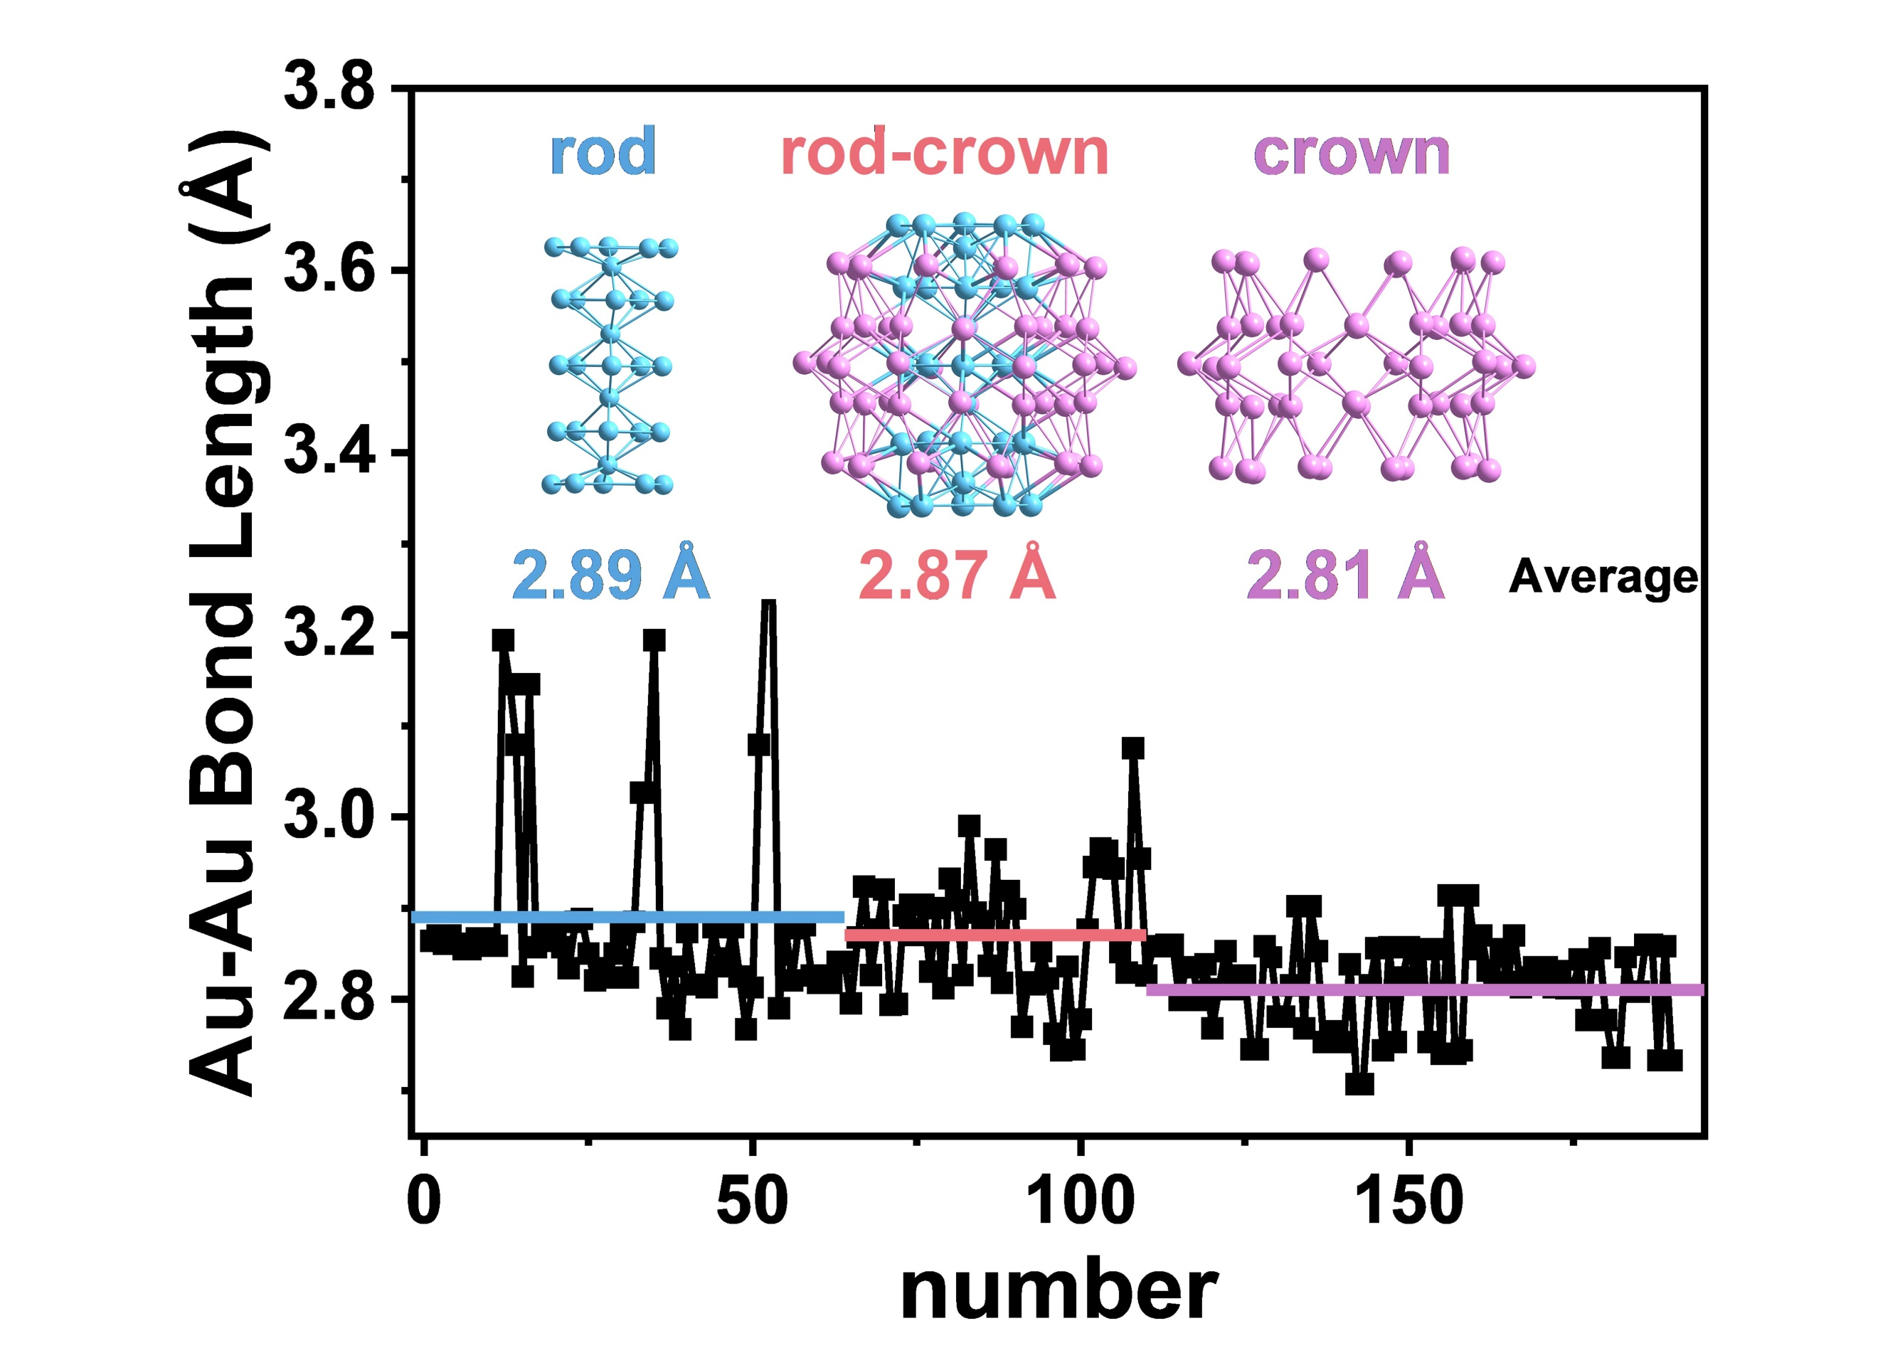
Supplementary Fig. 5 Distribution of Au-Au bond length in the Au₇₉ core of Au₁₀₃S(p-MBT)₄₂ nanocluster.

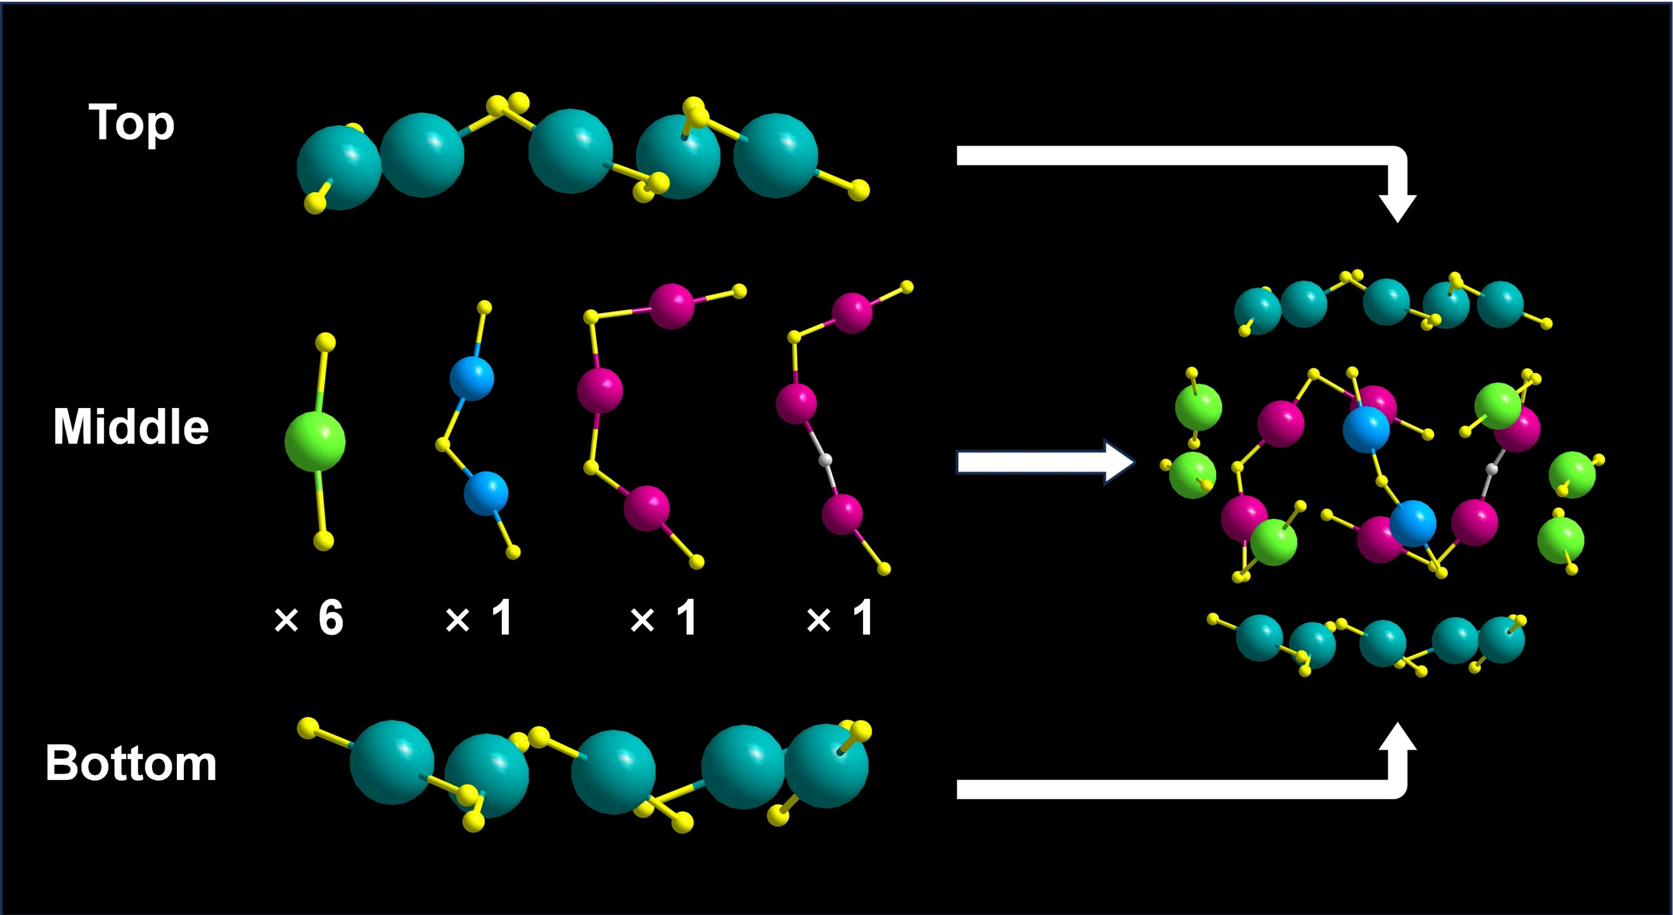
Supplementary Fig. 6 Surfacial staples in Au₁₀₃S(p-MBT)₄₂ nanocluster. Color labels: yellow/gray = S, olive/blue/green/magenta = Au, C and H atoms are omitted for clarity.

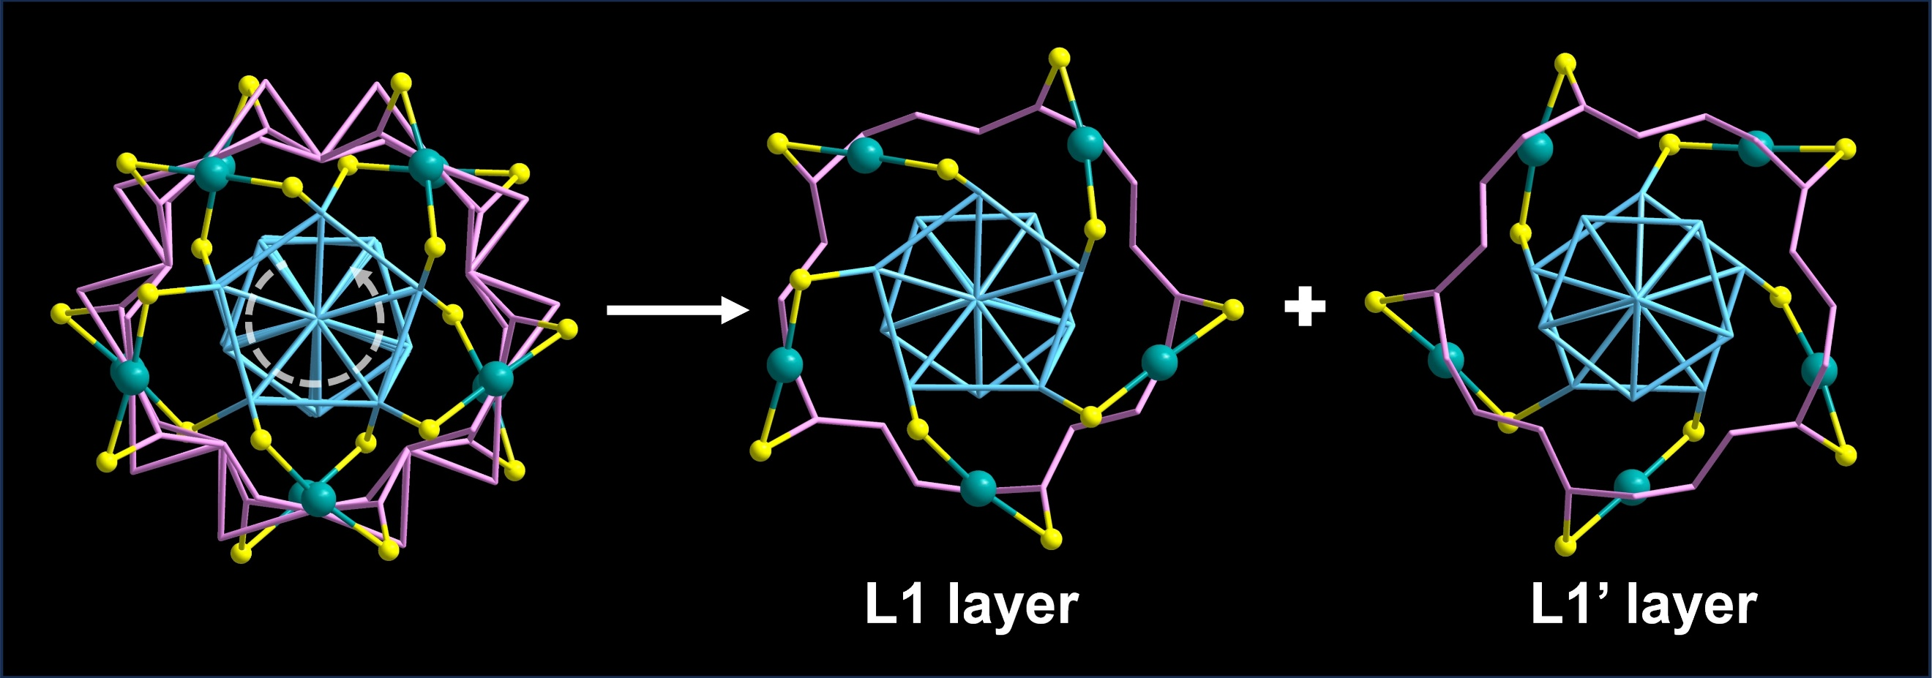
Supplementary Fig. 7 The arrangement of ten monomeric staples of Au(p-MBT)₂ staples around the Au₇₉ core. Color labels: yellow = S, pink/sky blue/olive = Au, C and H atoms are omitted for clarity.

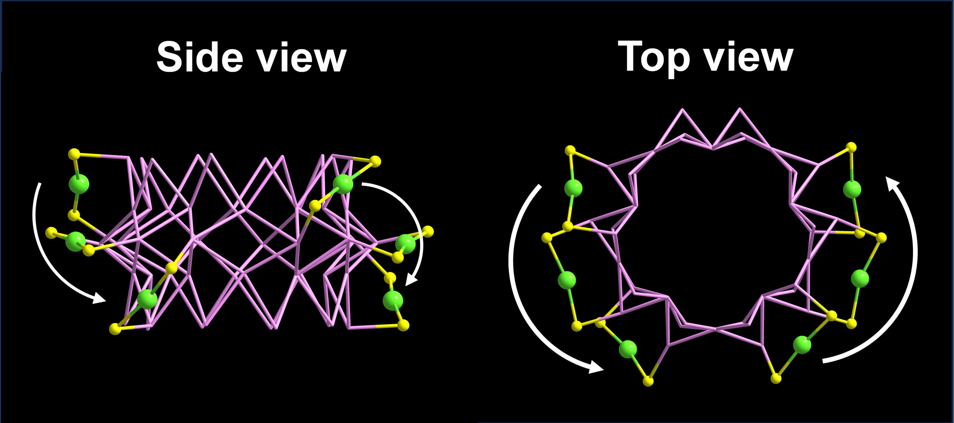
Supplementary Fig. 8 The asymmetric arrangement of Au(p-MBT)₂ staples around the Au₅₀ shell. Color labels: yellow = S, pink/green = Au, C and H atoms are omitted for clarity.

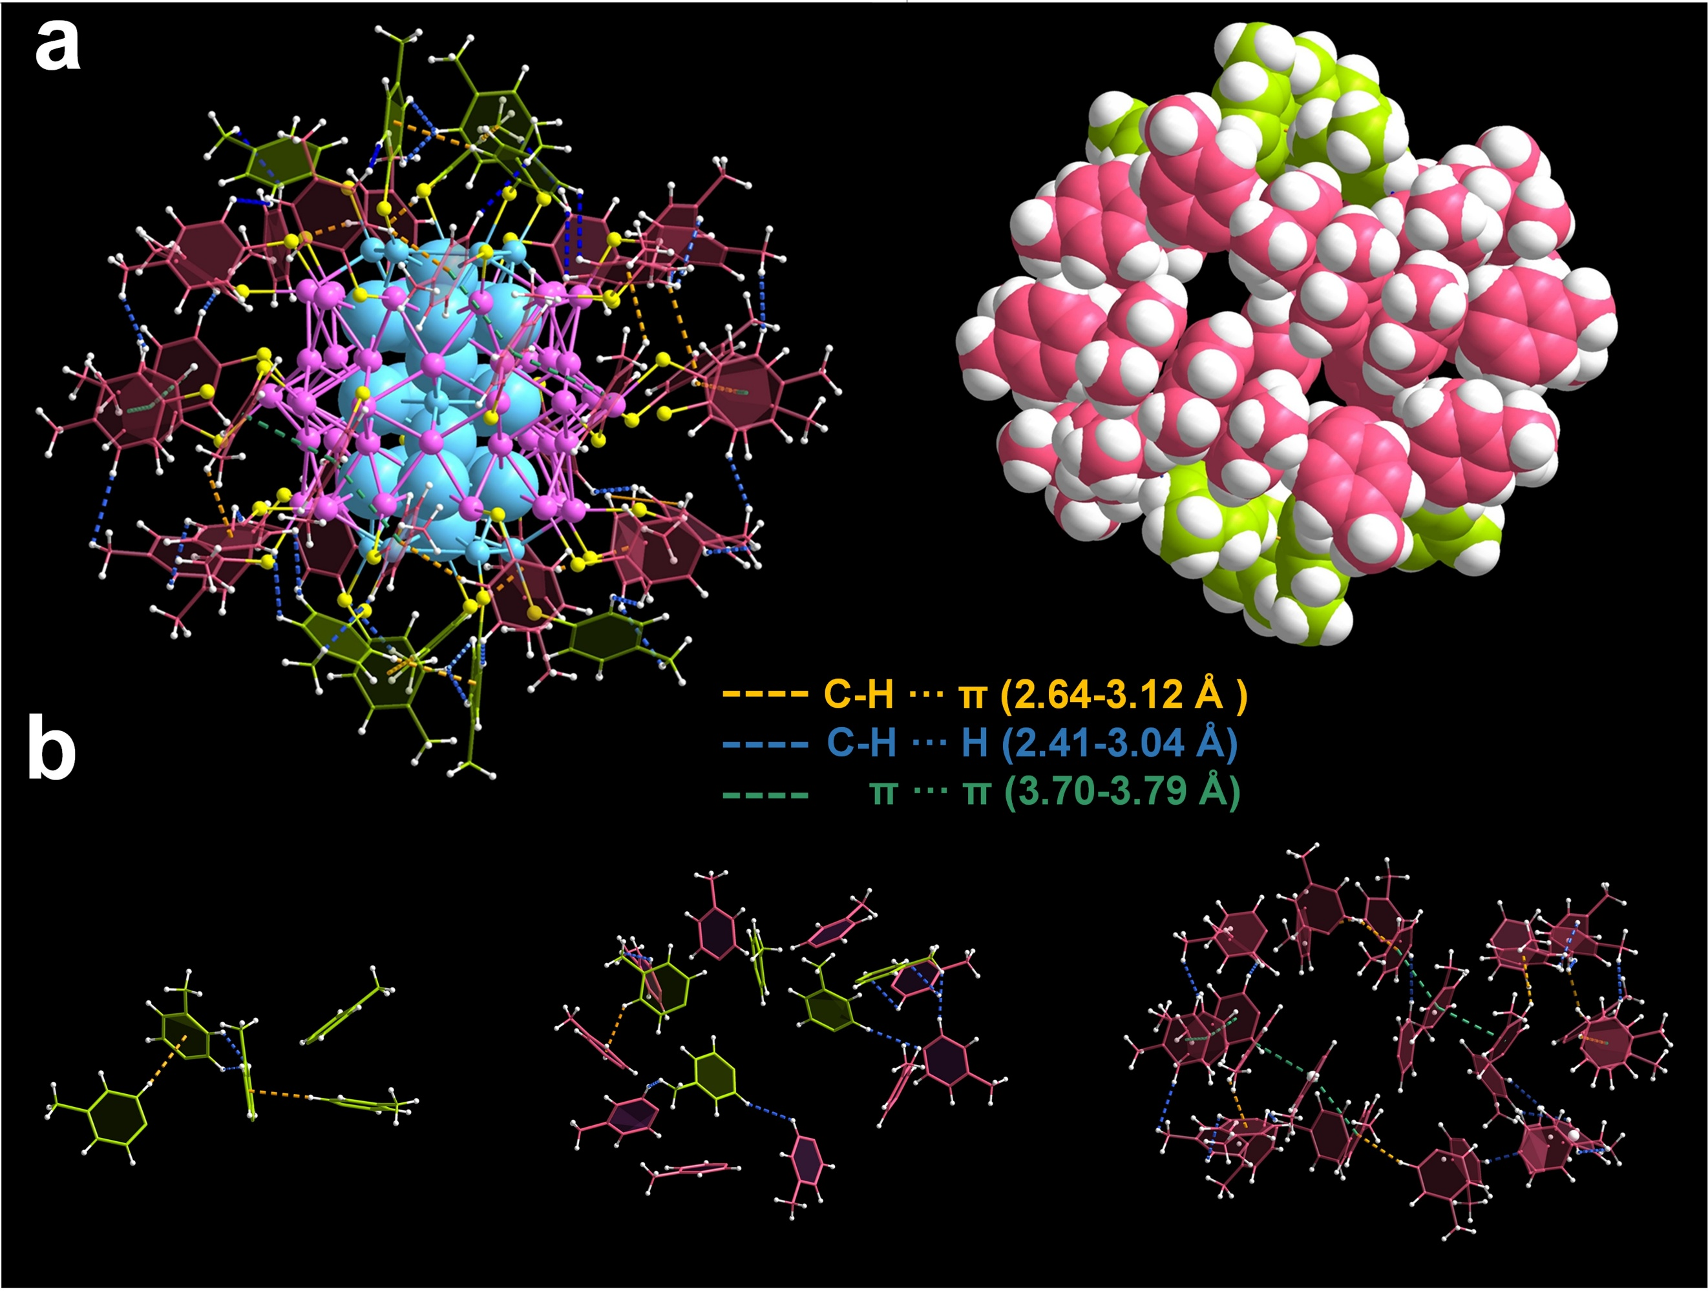
Supplementary Fig. 9 Intramolecular interactions of Au₁₀₃S(p-MBT)₄₂ nanocluster. (a) H-H, C-H···π, and π···π interactions in ball-and-stick model (left) and space-filling model (right). (b) Intramolecular interactions among the ligands from the Au₂₉ top/bottom (left), the Au₅₀ shell (right), and the boundary between Au₂₉ kernel and Au₅₀ shell (middle). Color labels: yellow = S, pink/sky blue = Au, lime/magenta = C and white = H.

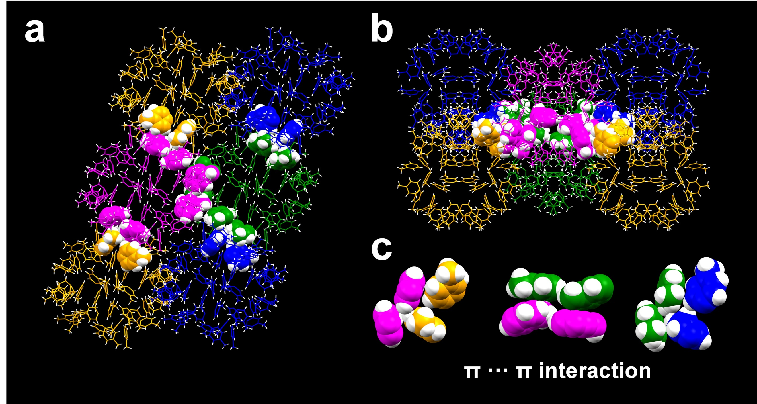
Supplementary Fig. 10 Intermolecular interactions of Au₁₀₃S(p-MBT)₄₂ in the unit cell along (a) y axis and (b) z axis. (c) The typical π···π interactions between Au₁₀₃S(p-MBT)₄₂ molecules. Color labels: lilac/blue/green/orange = C, white = H.

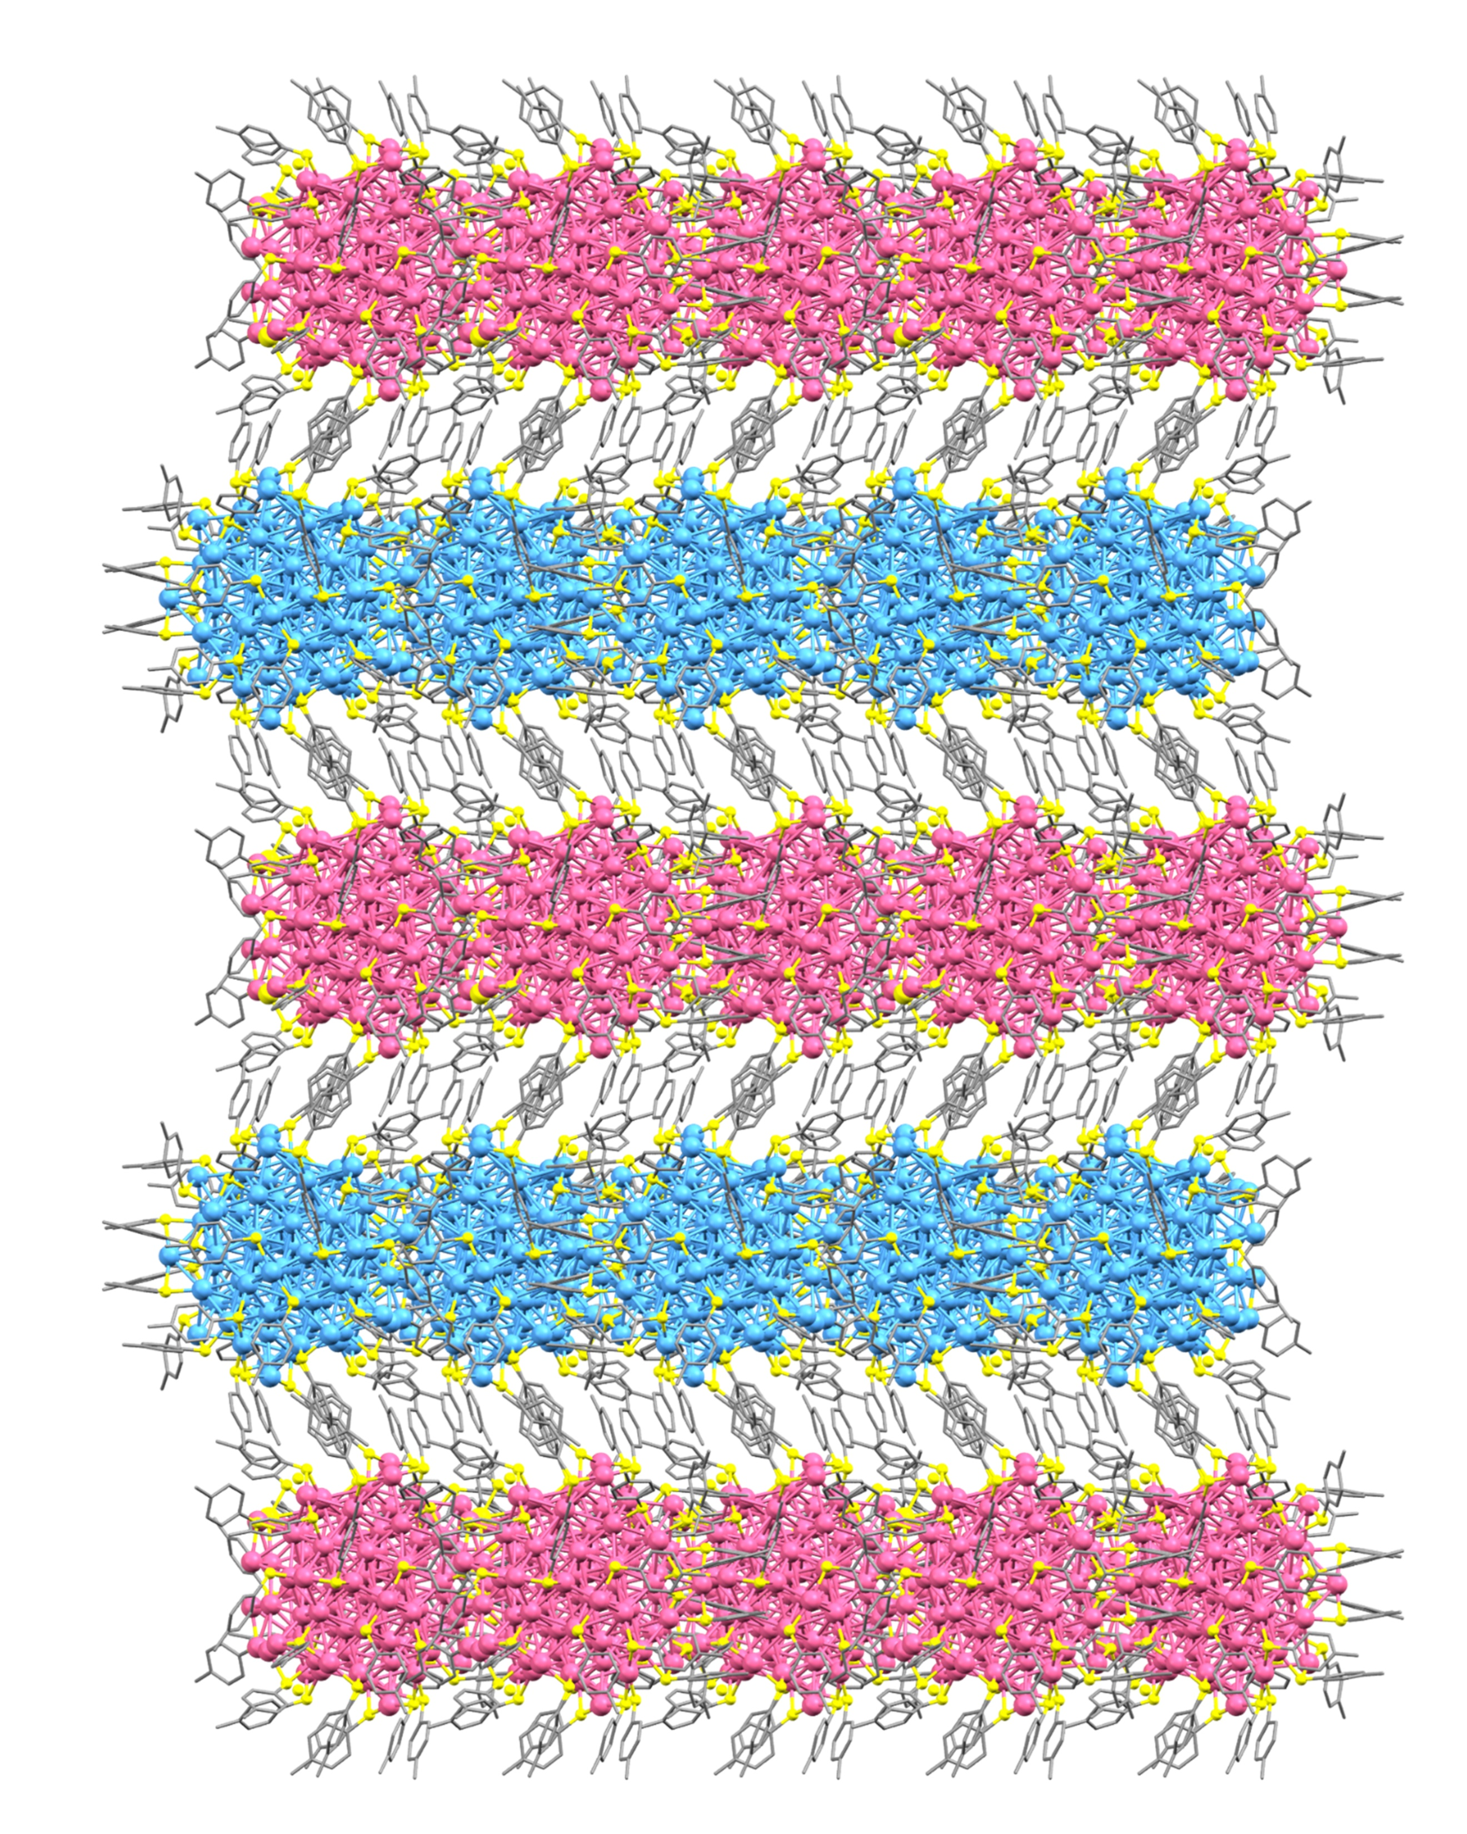
Supplementary Fig. 11 Packing mode of Au₁₀₃S(p-MBT)₄₂ nanocluster in single crystal along x axis.

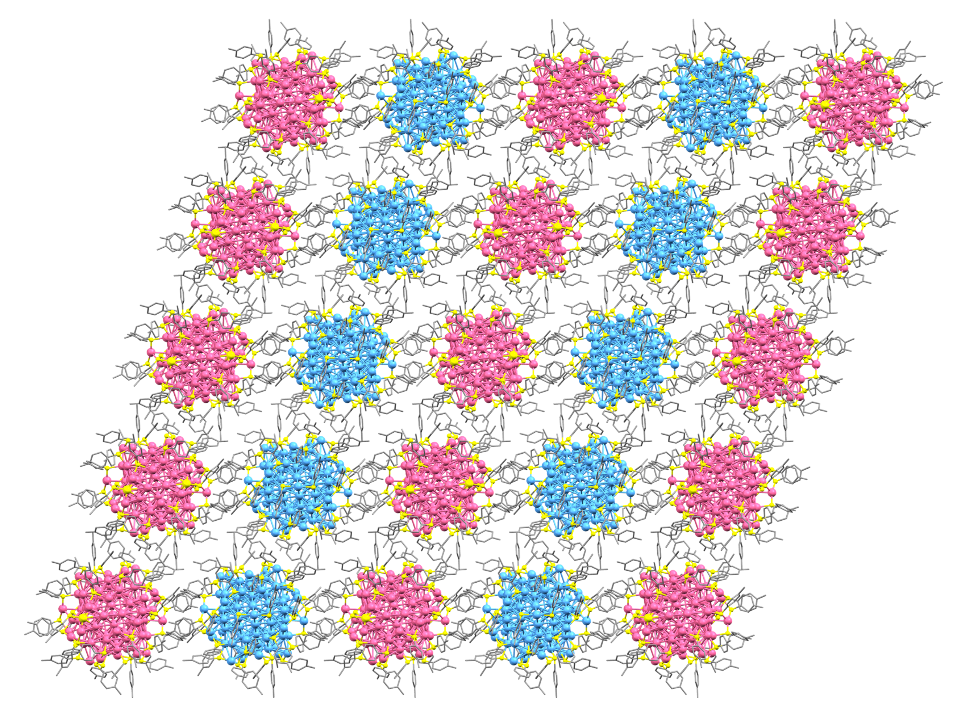
Supplementary Fig. 12 Packing mode of Au₁₀₃S(p-MBT)₄₂ nanocluster in single crystal along y axis.

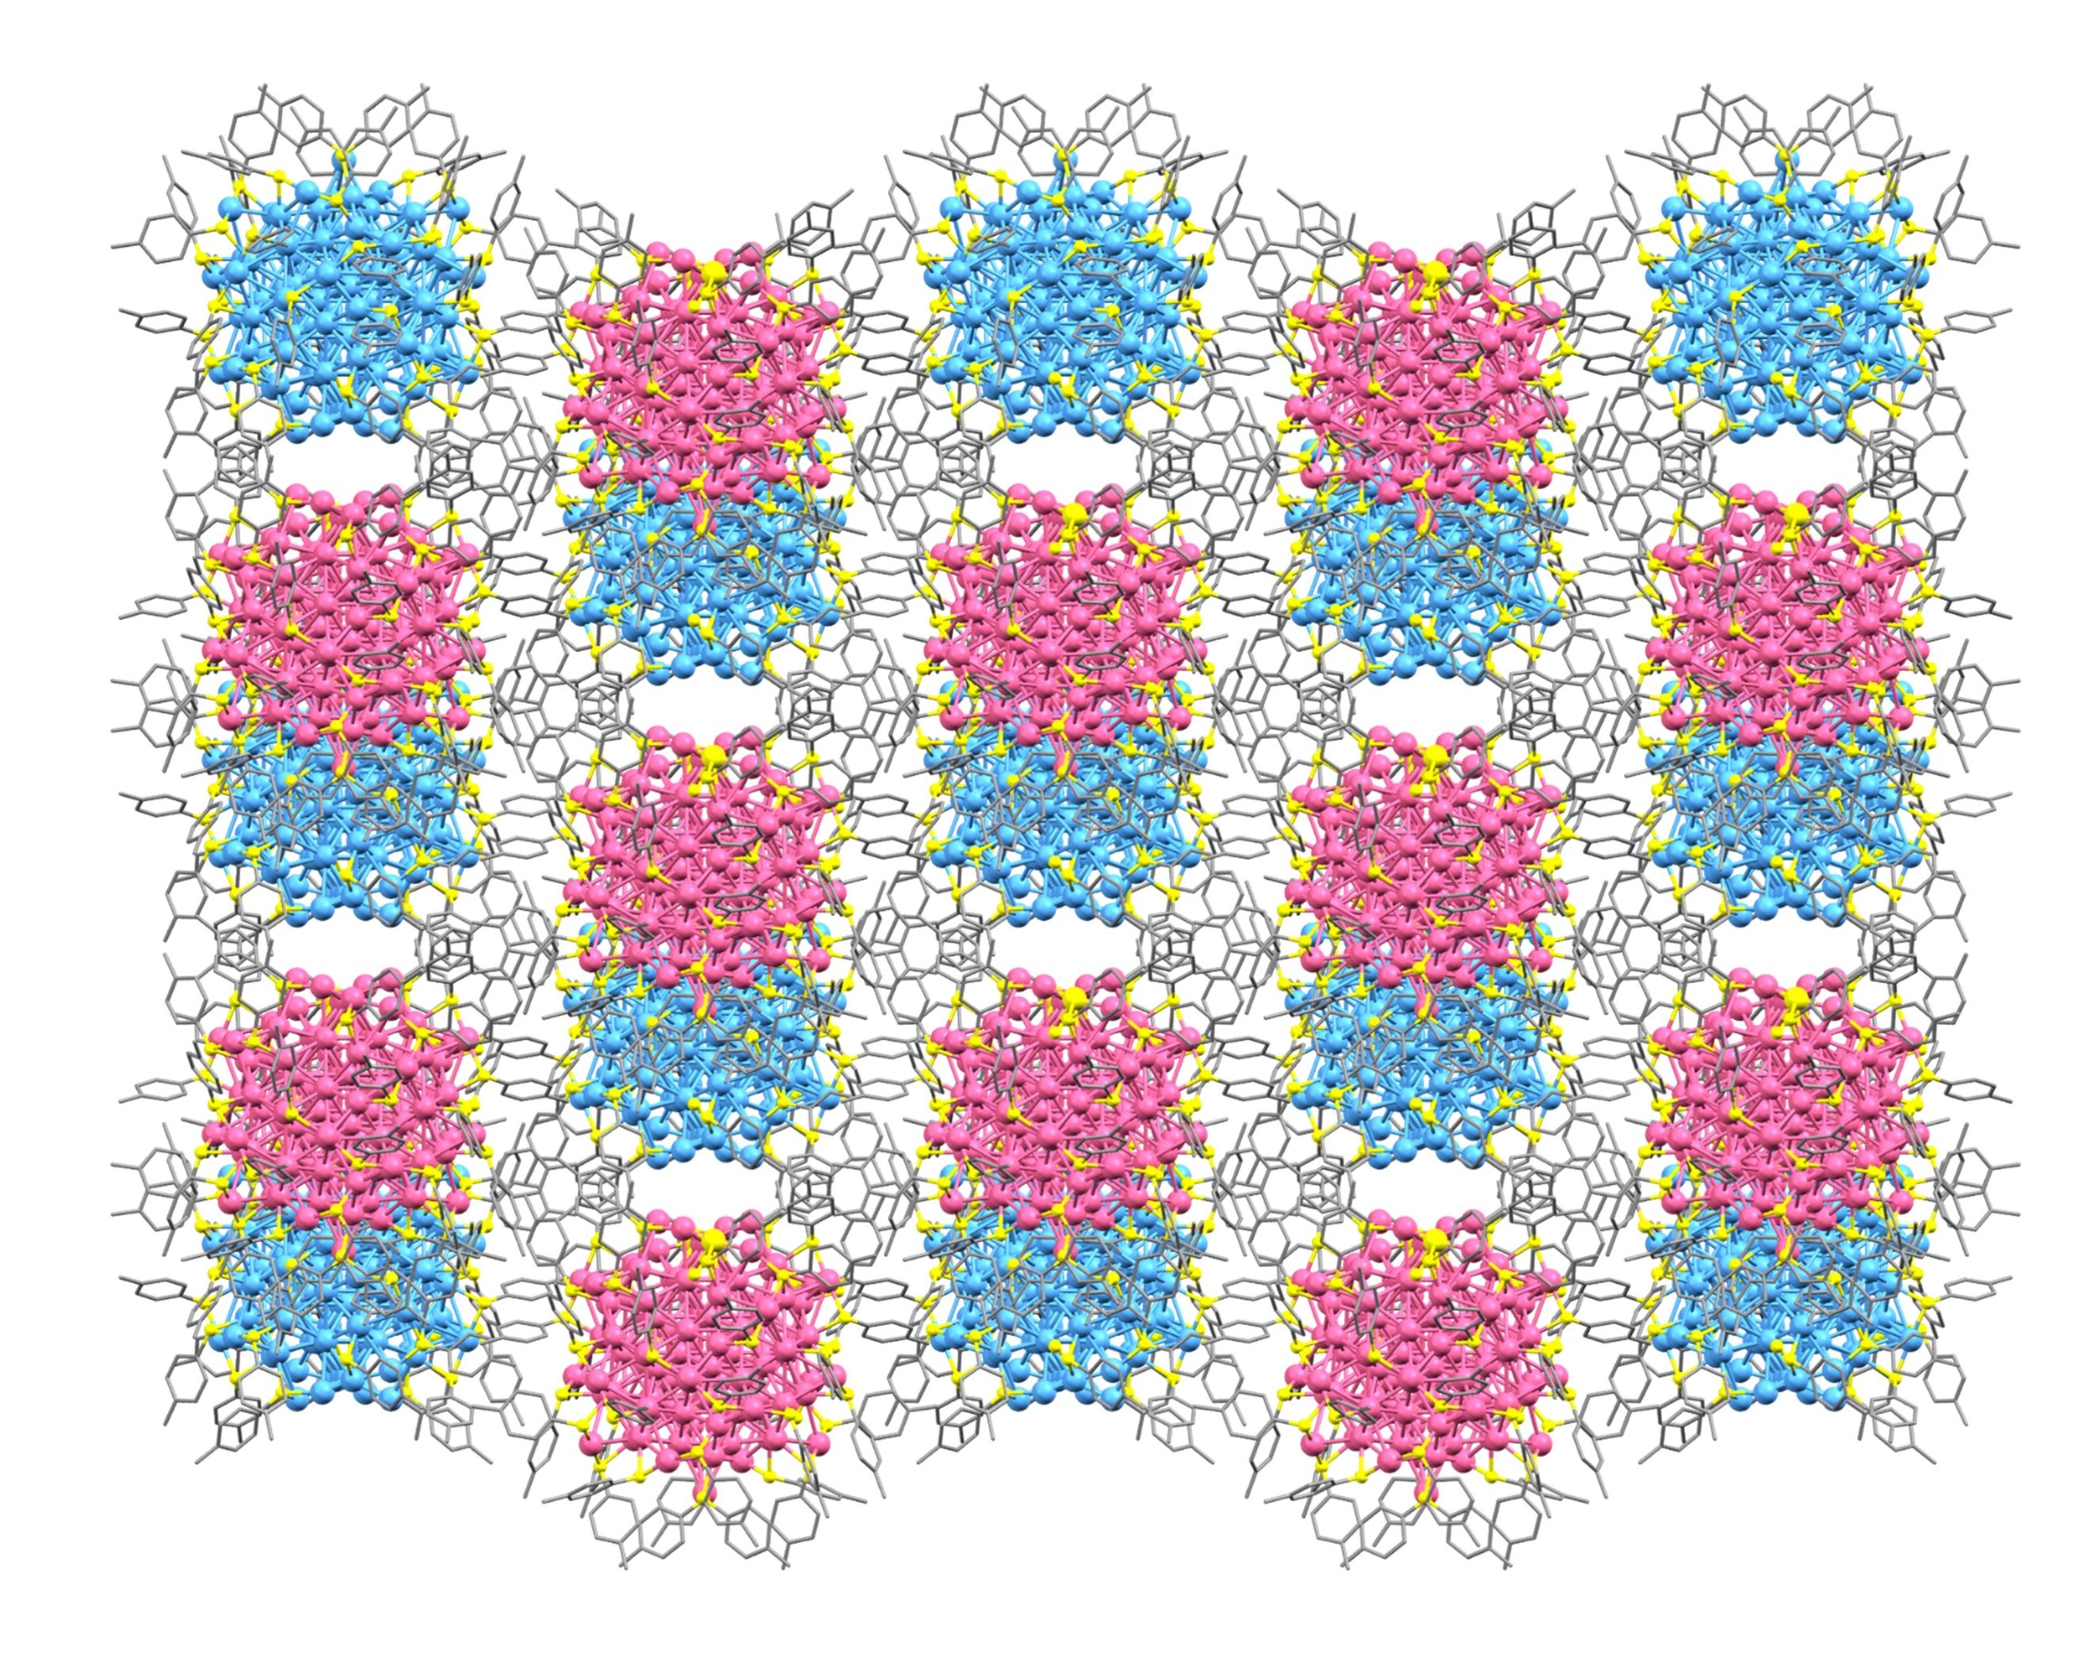
Supplementary Fig. 13 Packing mode of Au₁₀₃S(p-MBT)₄₂ nanocluster in single crystal along z axis.

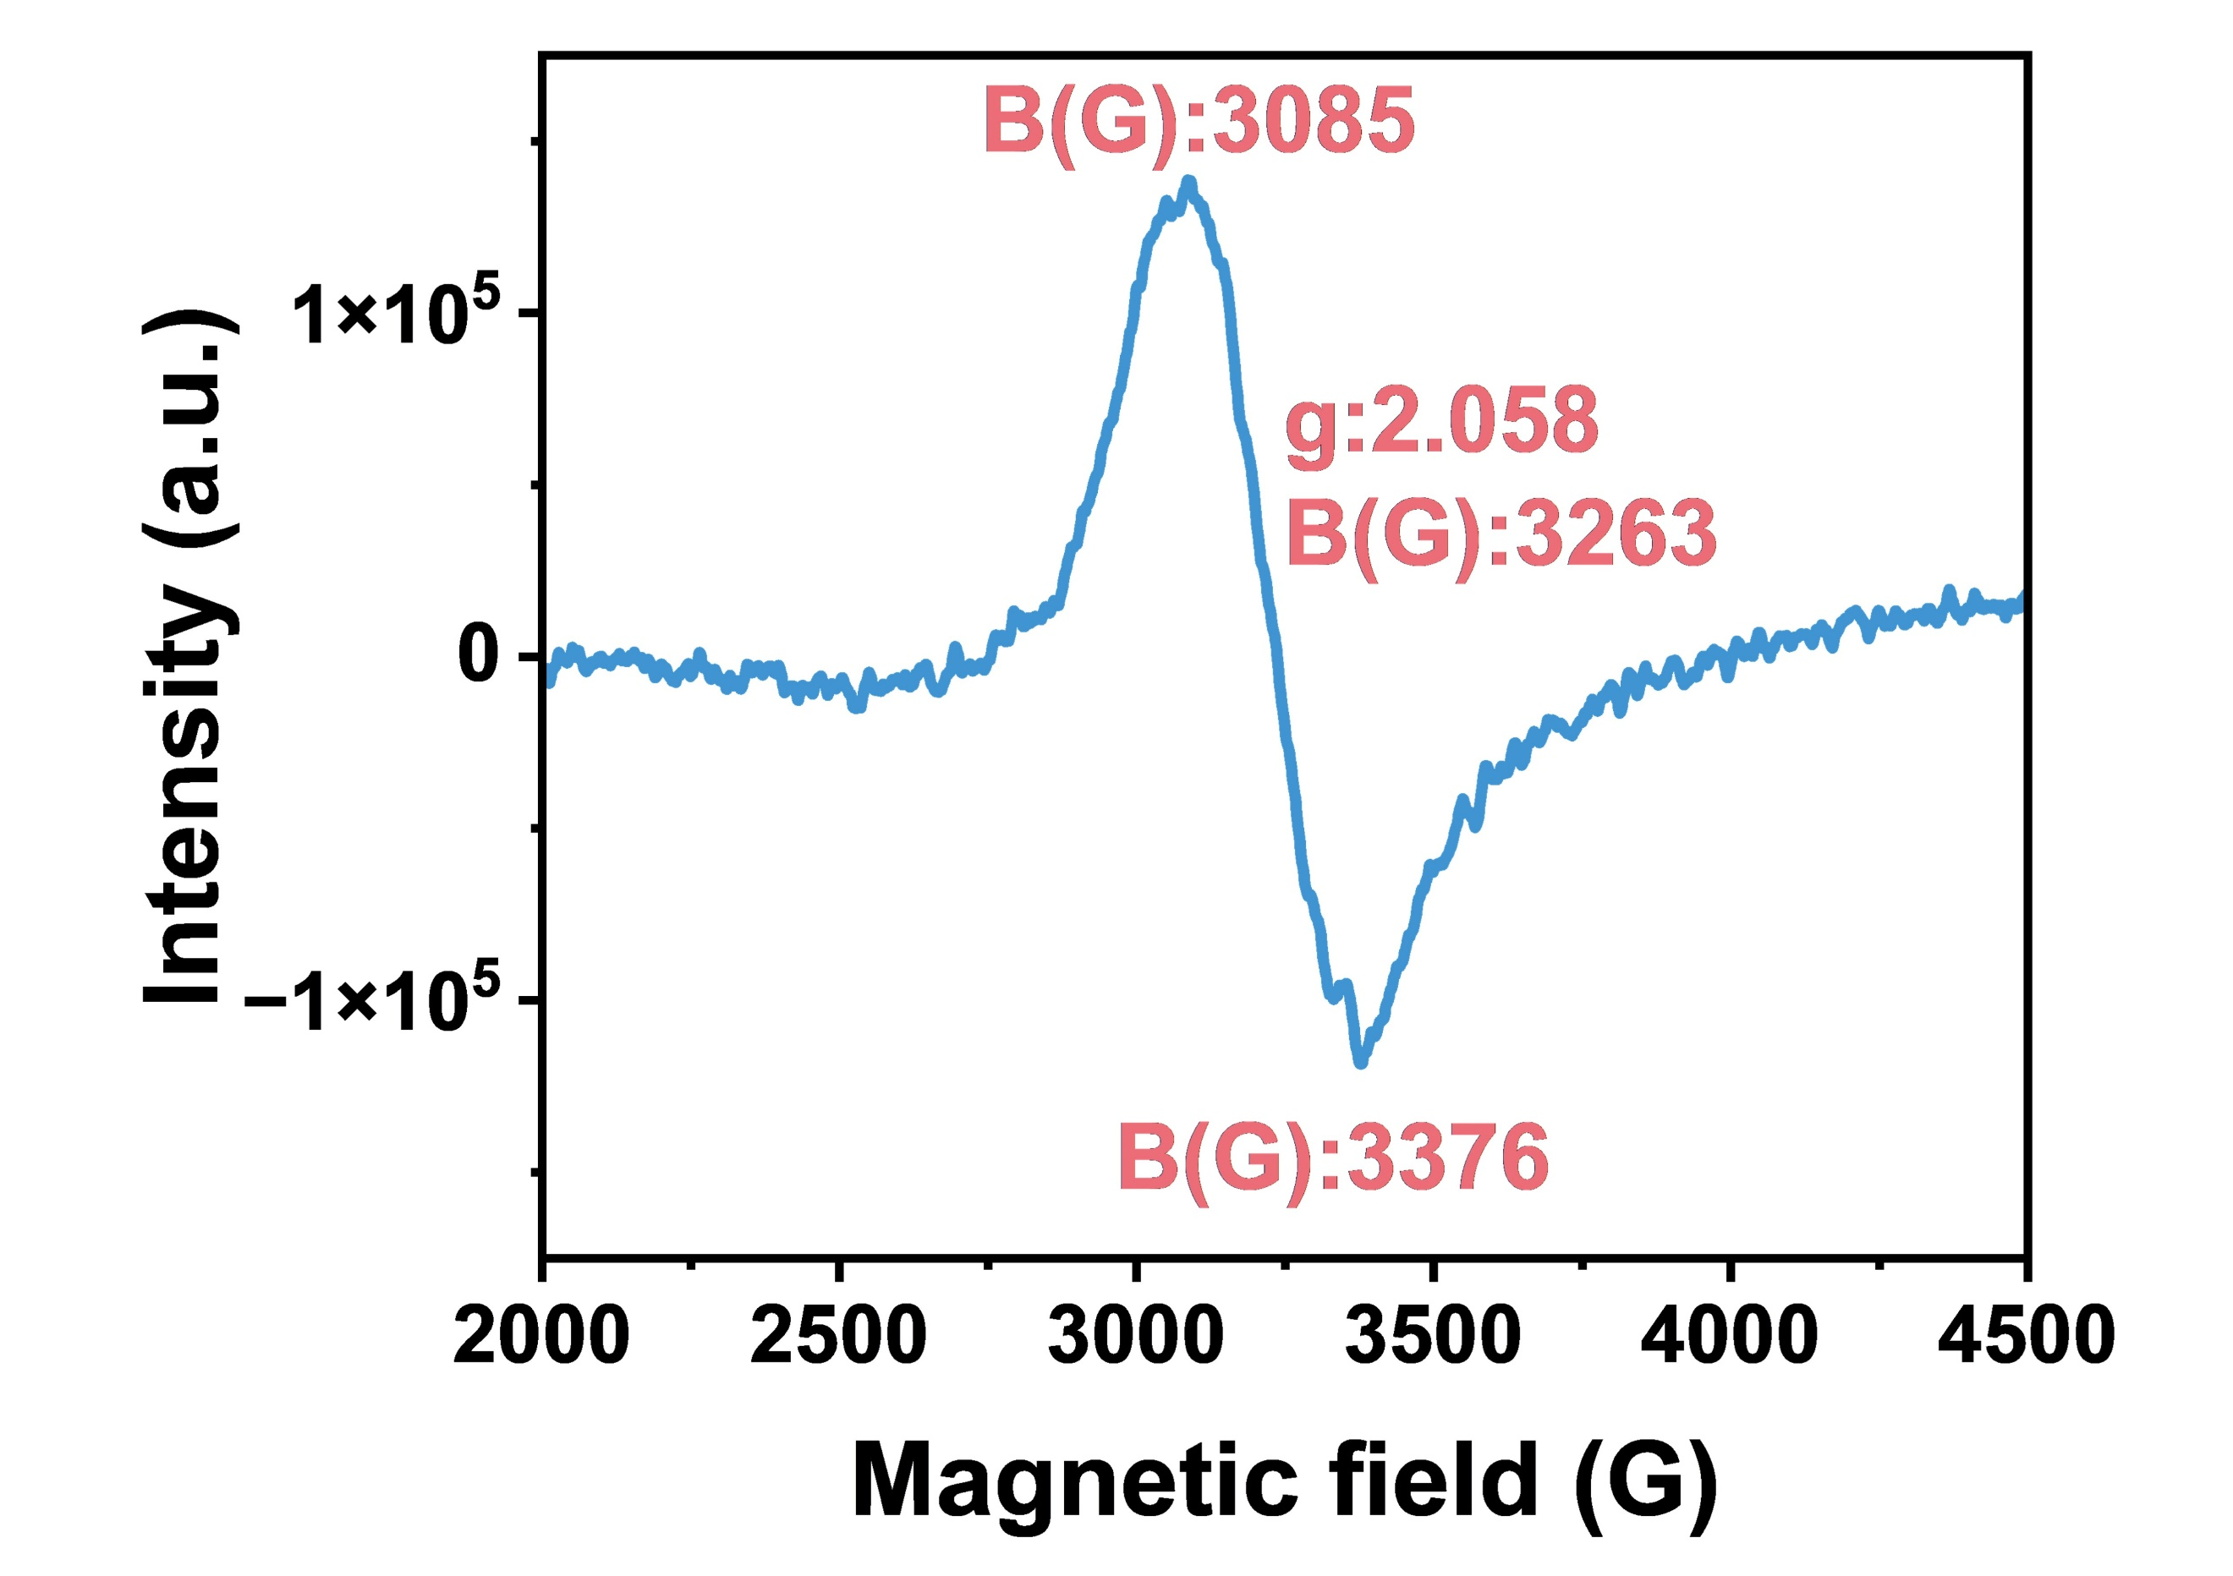
Supplementary Fig. 14 Electron Spin Resonance (EPR) spectra of Au₁₀₃S(p-MBT)₄₂ nanocluster at 2K.

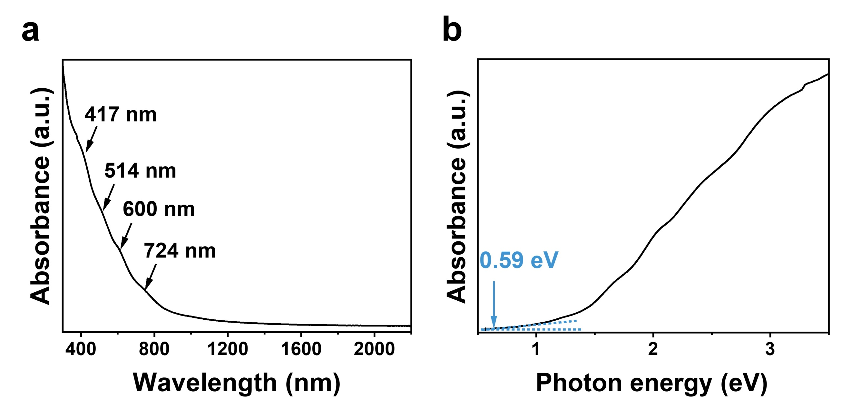
Supplementary Fig. 15 Ultraviolet-visible-near infrared spectroscopy (UV-vis-NIR) of Au₁₀₃S(p-MBT)₄₂ nanocluster based on the wavelength scale (a) and the energy scale (b).

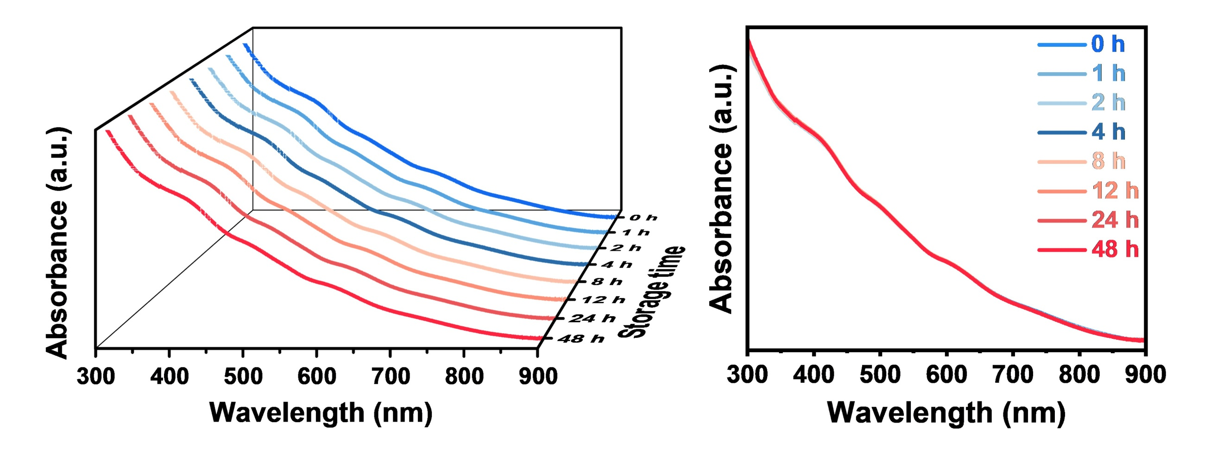
Supplementary Fig. 16 Time-dependent absorption spectra of Au₁₀₃S(p-MBT)₄₂ nanocluster dissolved in THF.

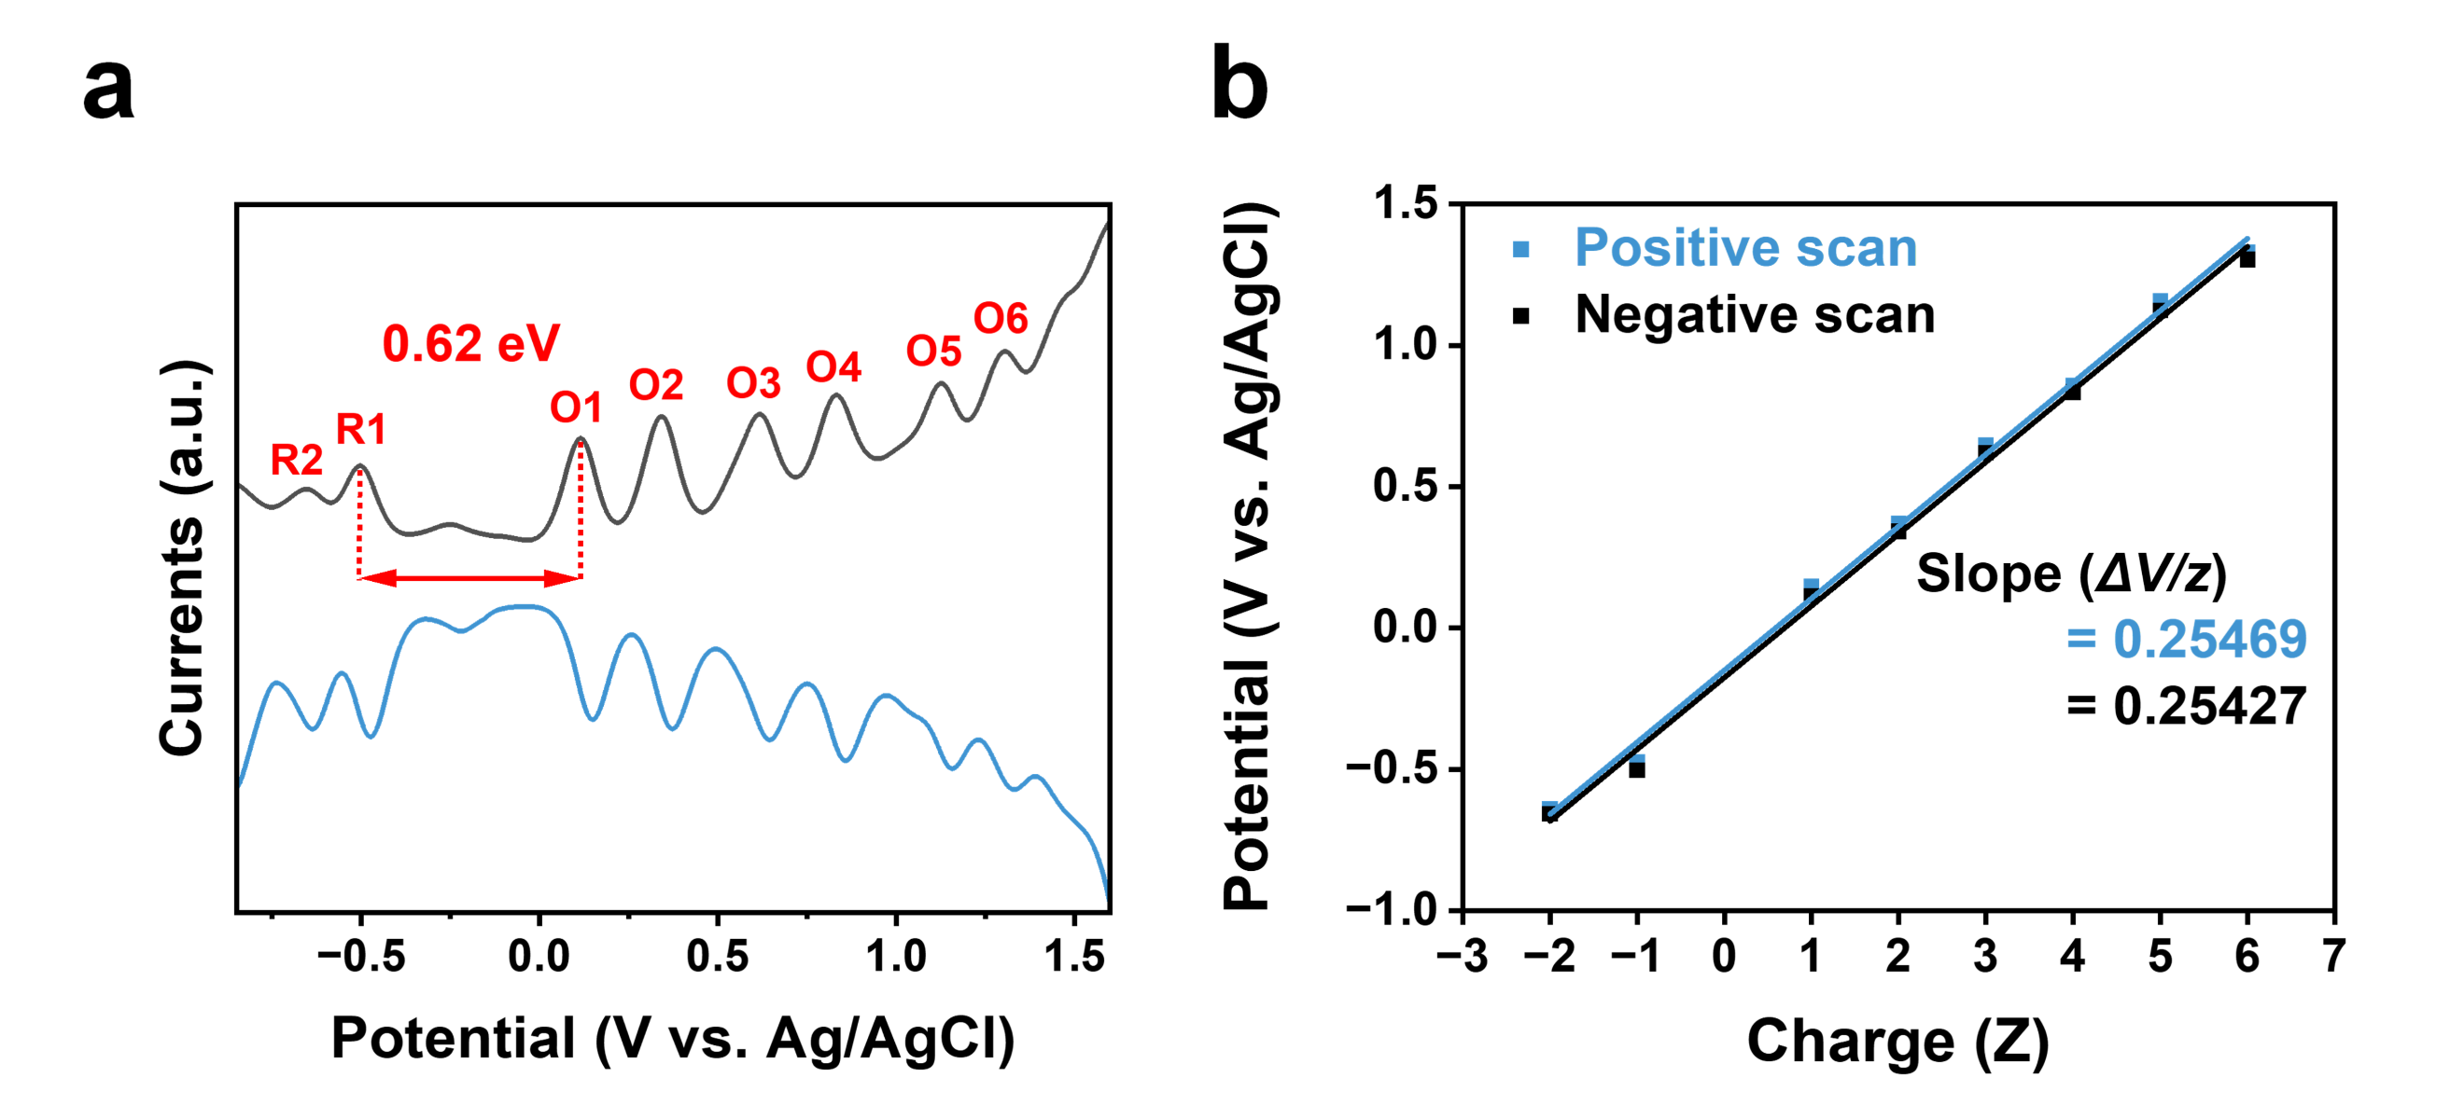
Supplementary Fig. 17 (a) Differential pulse voltammetry (DPV) of Au₁₀₃S(p-MBT)₄₂ nanocluster. The concentration of Au₁₀₃S(p-MBT)₄₂ nanocluster is ~10 mg mL⁻¹ in CH₂Cl₂ with 0.1 M Bu₄NPF₆ (tetrabutyl hexafluorophosphate). (b) z-plots of formal potentials of charging events vs. charge state for Au₁₀₃S(p-MBT)₄₂ nanocluster (z).

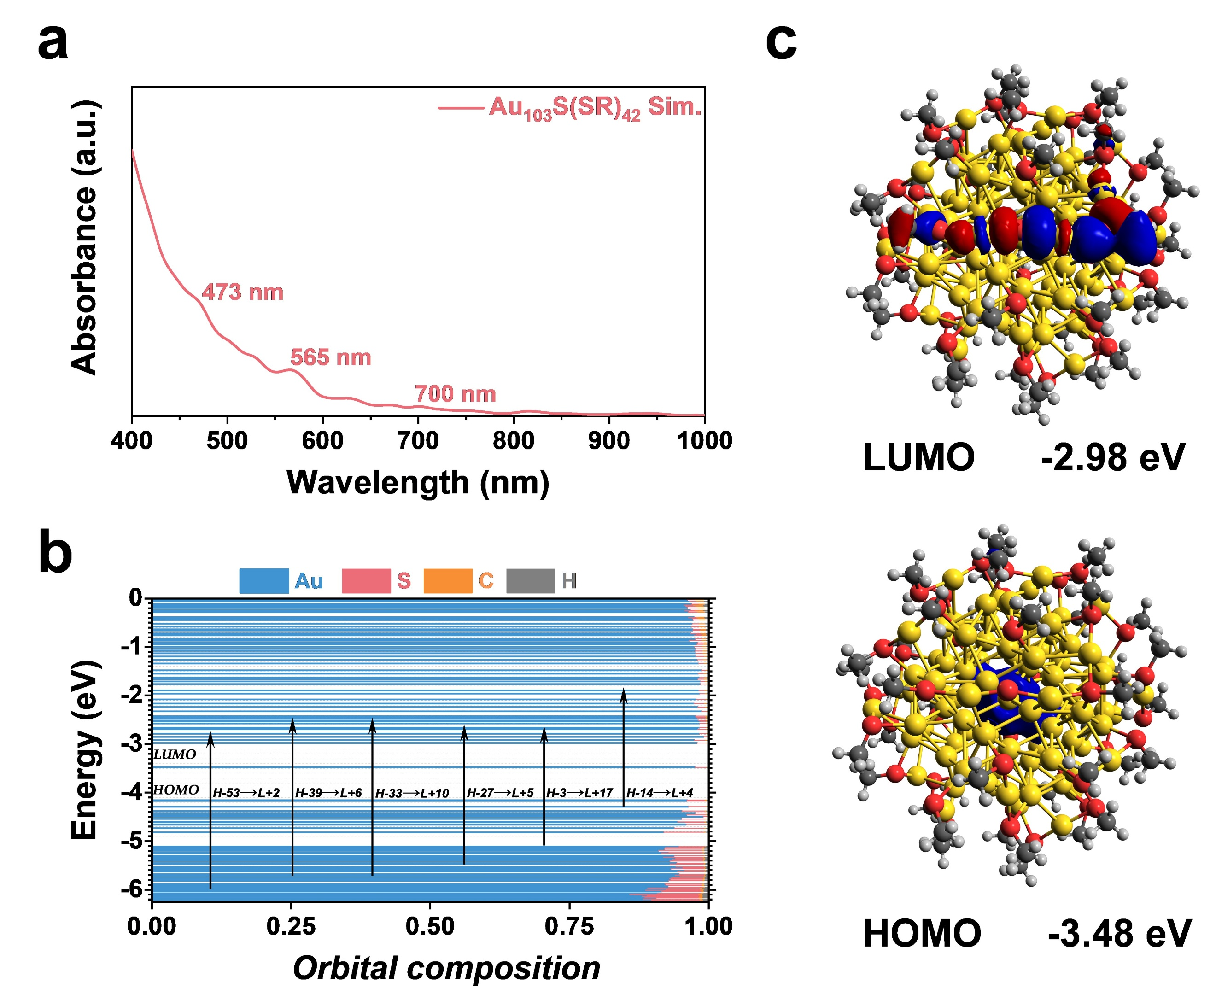
Supplementary Fig. 18 (a) Simulated UV-vis spectrum, (b) Kohn-Sham molecular orbital energy levels diagram, and (c) HOMO and LUMO orbital topologies of the Au₁₀₃S(p-MBT)₄₂ nanocluster.

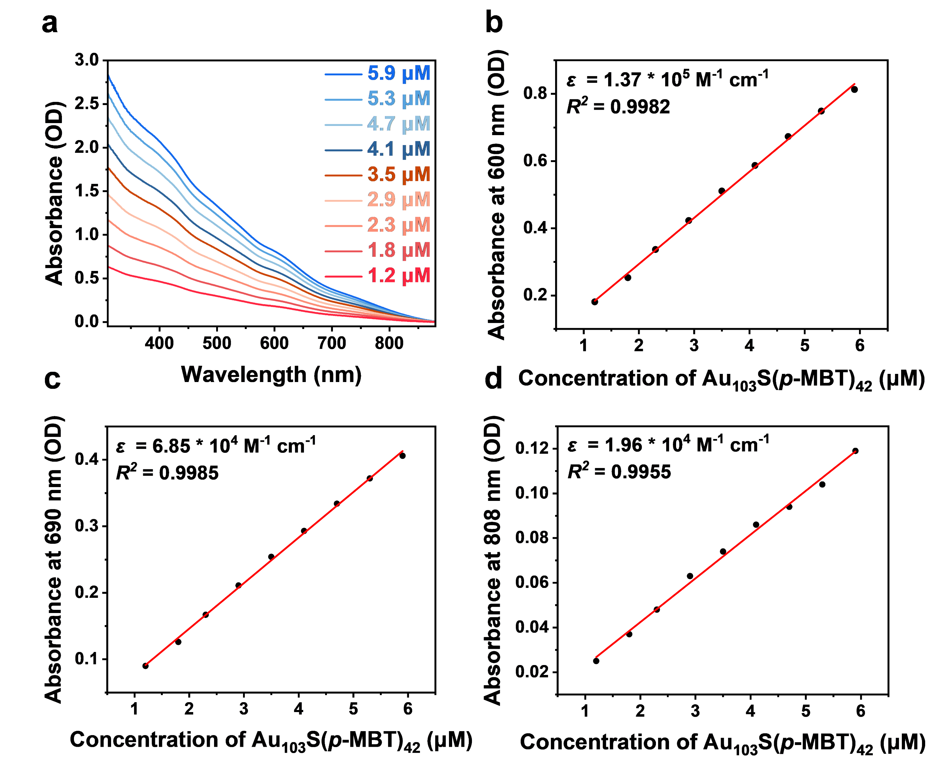
Supplementary Fig. 19 (a) Absorption spectra of Au₁₀₃S(p-MBT)₄₂ nanocluster with different concentrations in the range of 320-880 nm, and the corresponding molar extinction coefficients calculated by the Lambert-Beer law at (b) 600 nm, (c) 690 nm, and (d) 808 nm.

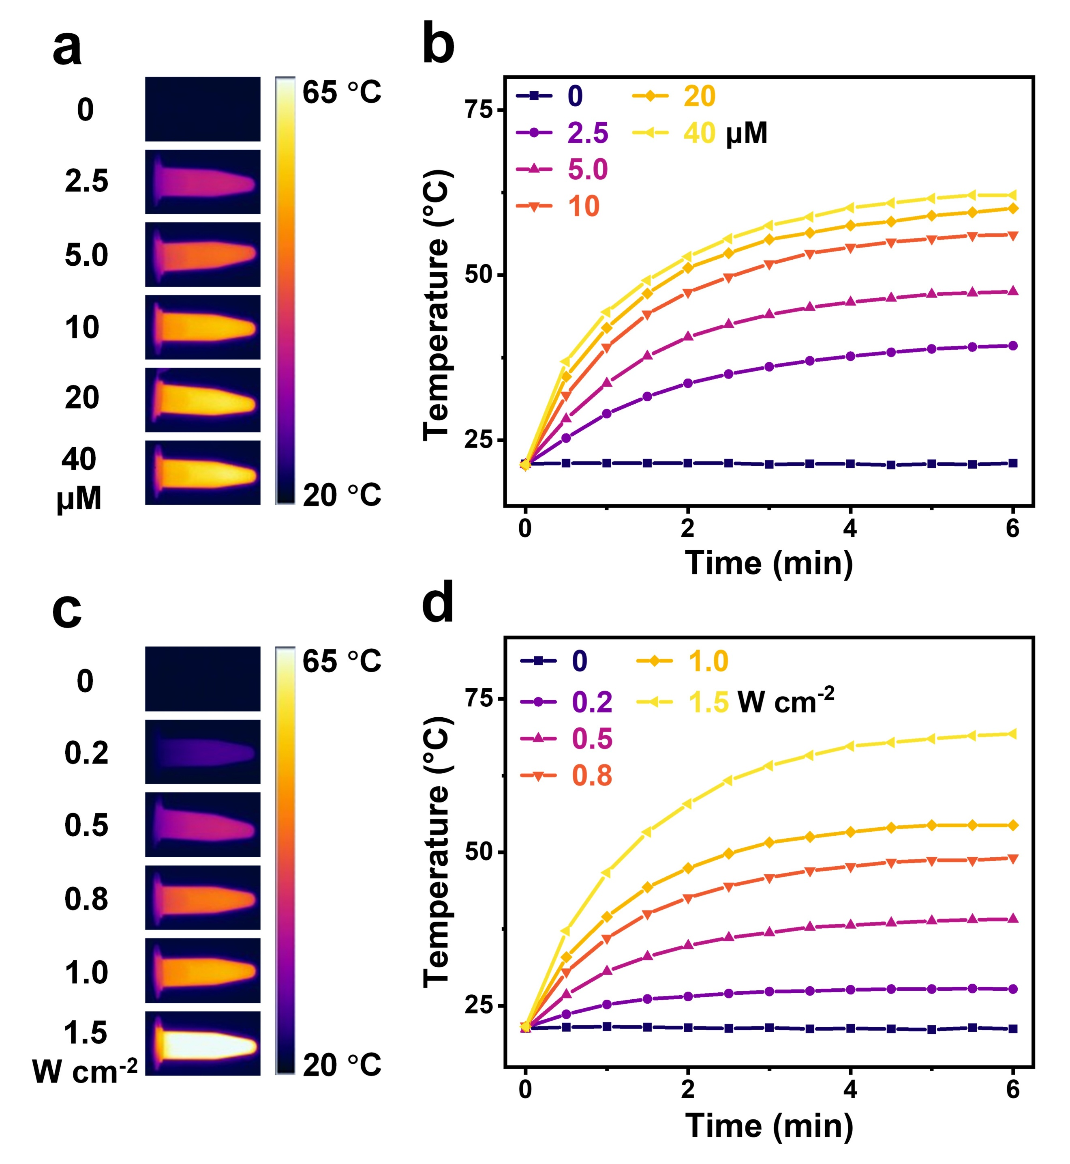
Supplementary Fig. 20 (a) Photothermal images and (b) time-dependent temperatures of Au₁₀₃S(p-MBT)₄₂ nanocluster in THF at 1.0 W cm⁻² with different concentrations. (c) Photothermal images and (d) time-dependent temperatures of Au₁₀₃S(p-MBT)₄₂ nanocluster in THF at 10 μM with different power densities. Laser wavelength = 690 nm.

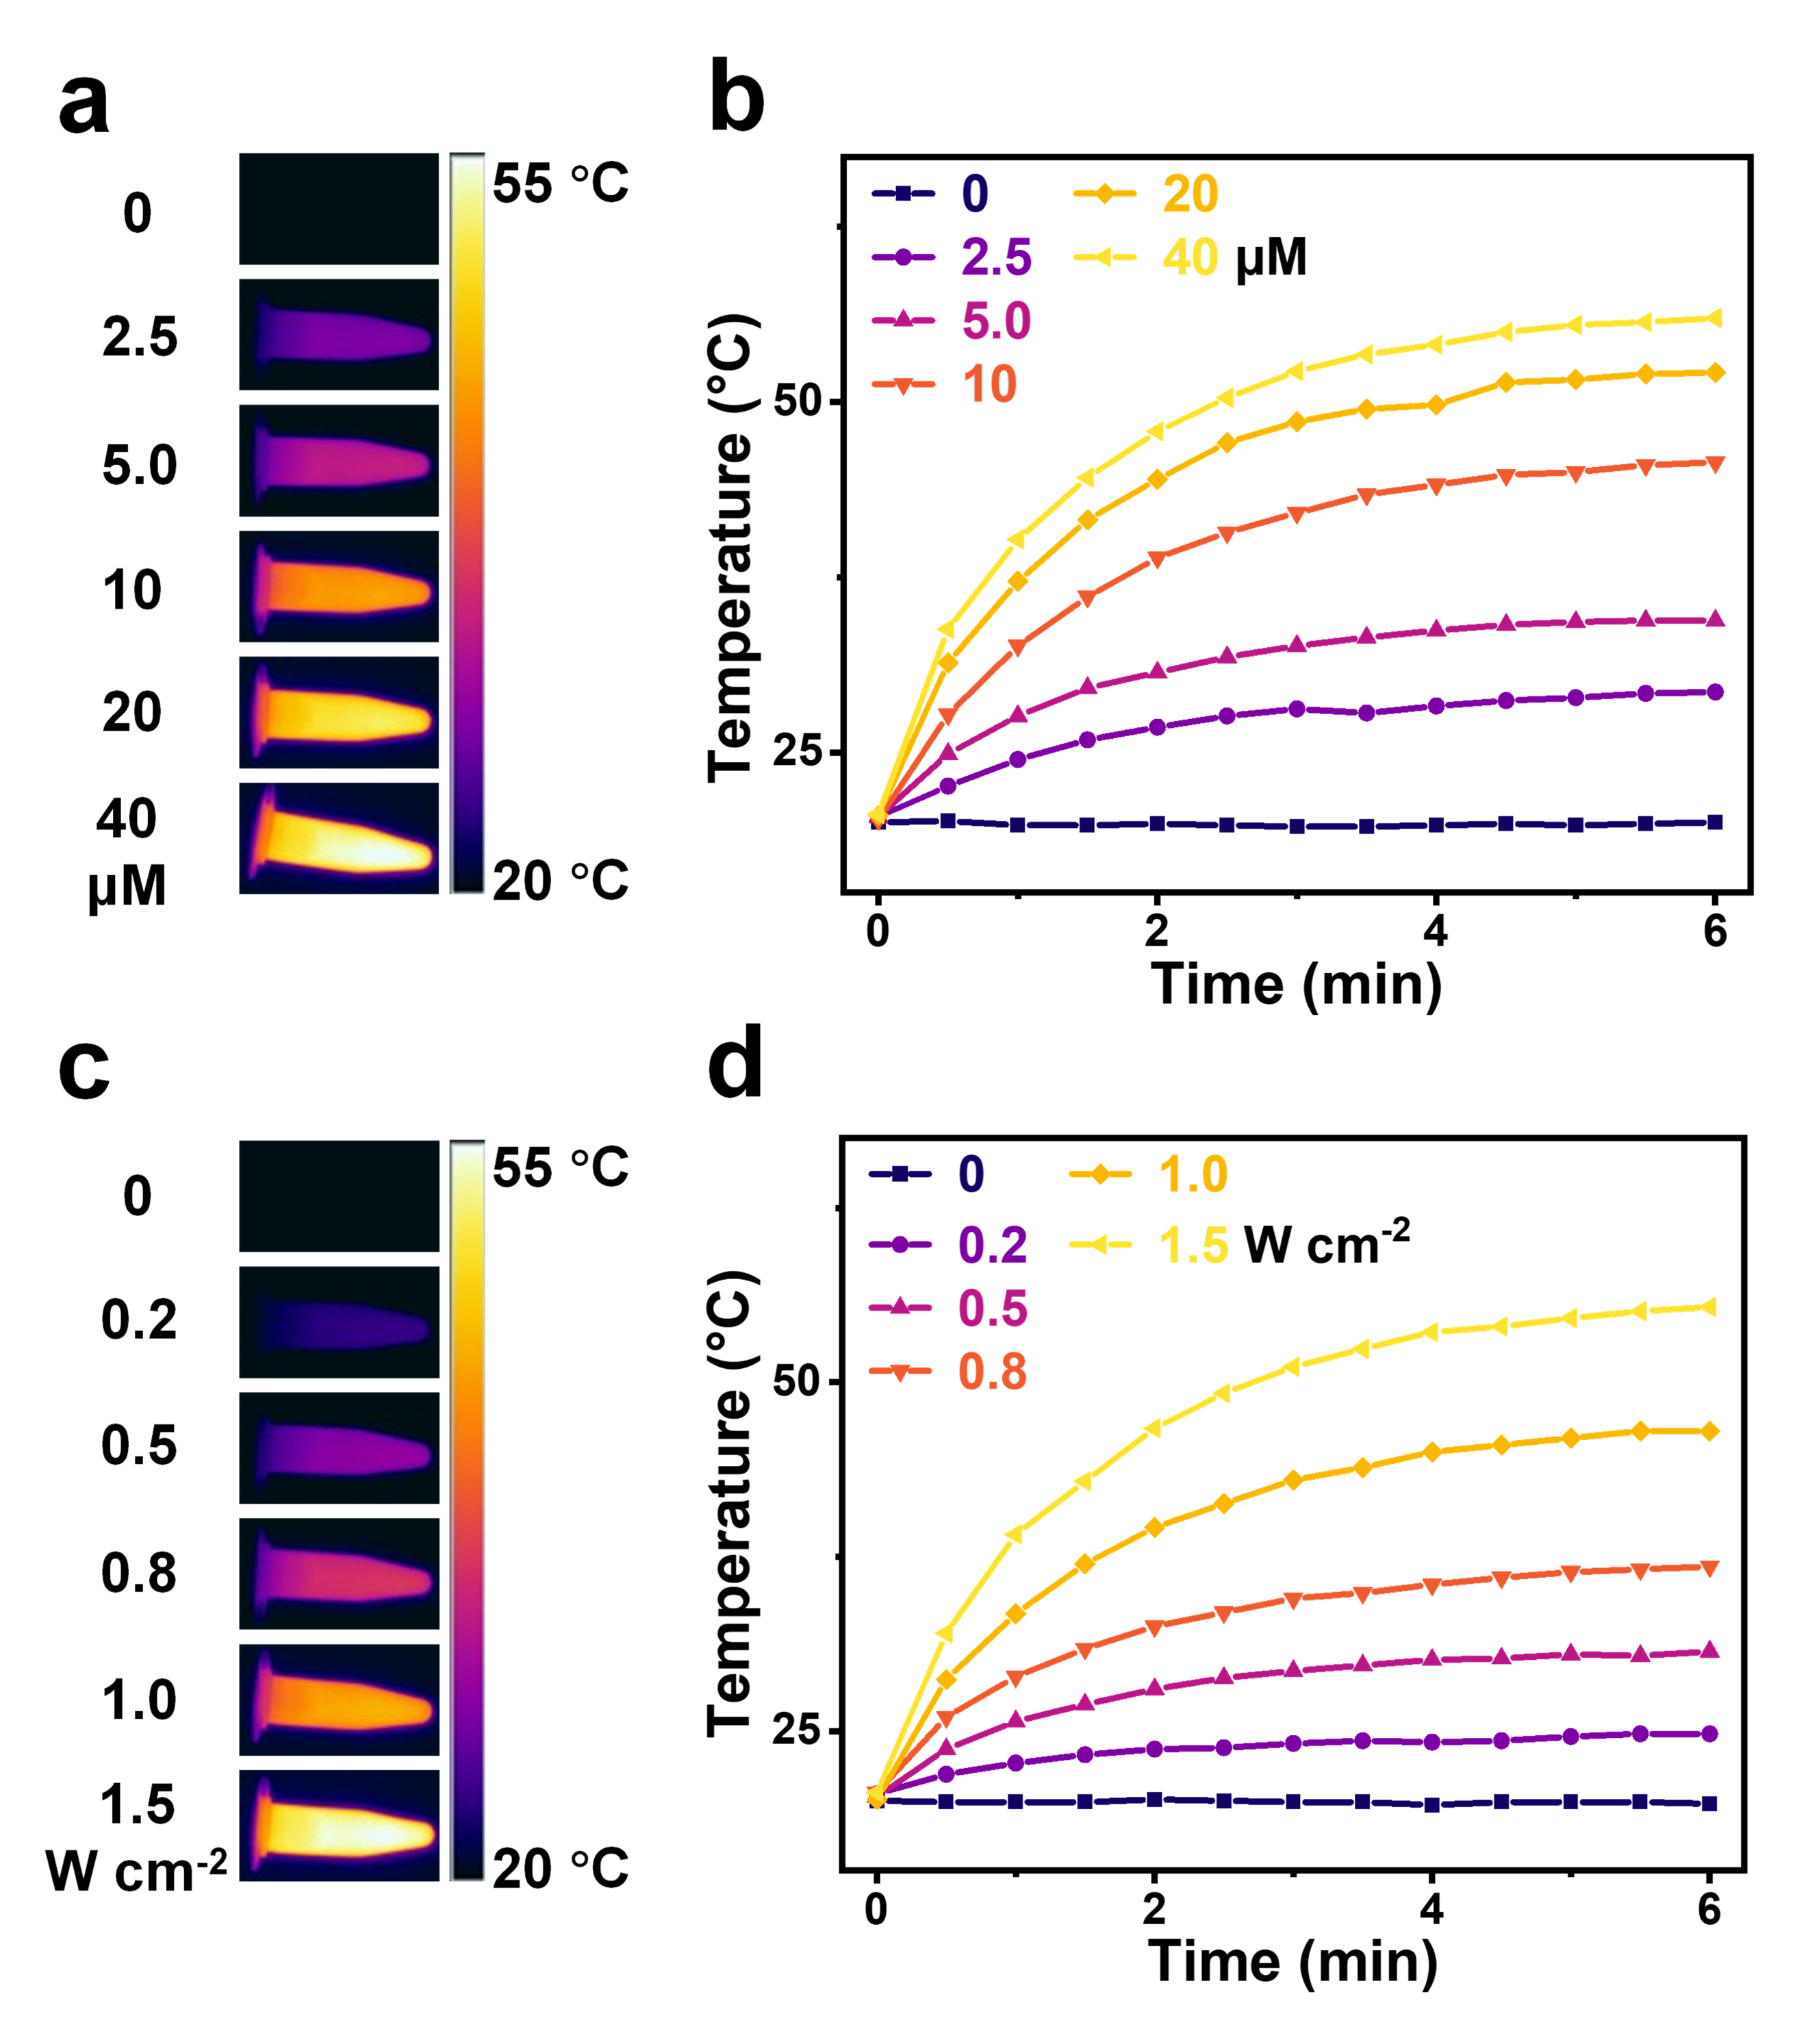
Supplementary Fig. 21 (a) Photothermal images and (b) time-dependent temperatures of Au₁₀₃S(p-MBT)₄₂ nanocluster in THF at 1.0 W cm⁻² with different concentrations. (c) Photothermal images and (d) time-dependent temperatures of Au₁₀₃S(p-MBT)₄₂ nanocluster in THF at 10 μM with different power densities. Laser wavelength = 808 nm.

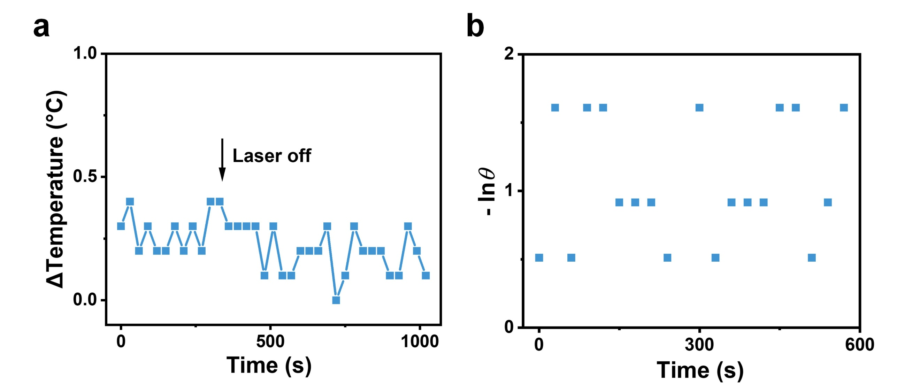
Supplementary Fig. 22 (a) Temperature change of THF under 690 nm laser irradiation (1.0 W cm⁻²), and (b) plot of cooling time vs. -lnθ obtained during the cooling stage (after the laser was turned off).

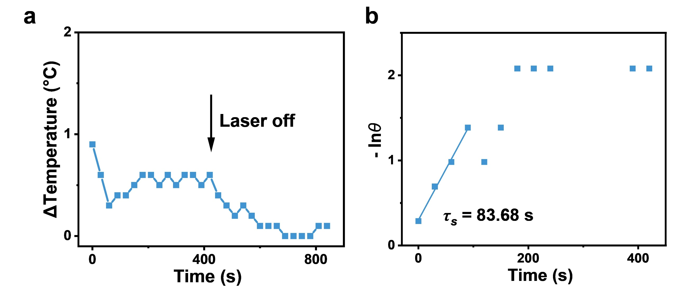
Supplementary Fig. 23 (a) Temperature change of THF under 808 nm laser irradiation (1.0 W cm⁻²), and (b) plot of cooling time vs. -lnθ obtained during the cooling stage (after the laser was turned off).

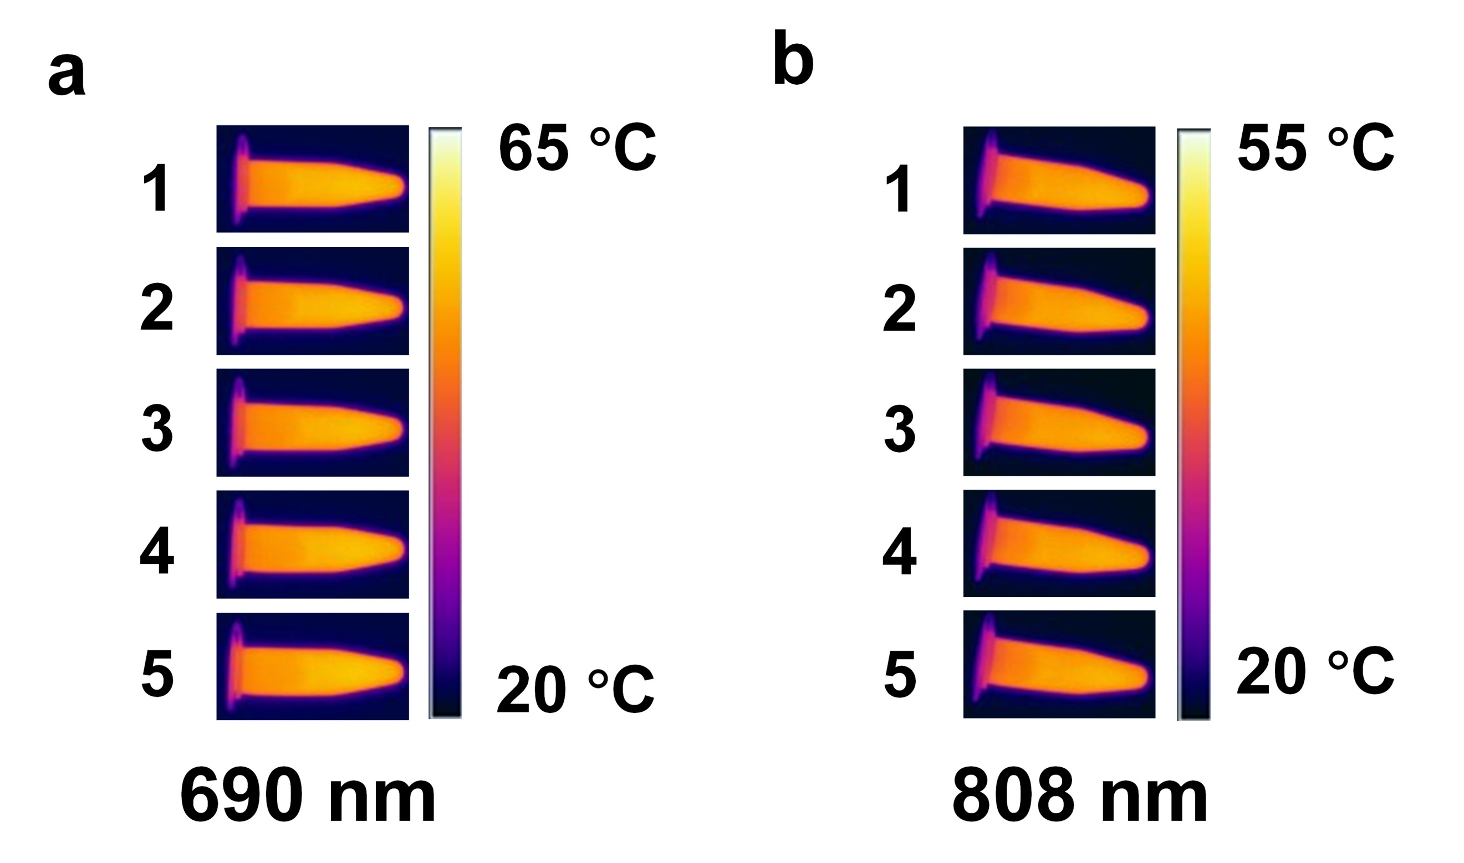
Supplementary Fig. 24 Photothermal images of Au₁₀₃S(p-MBT)₄₂ nanocluster at the maximum temperature for five cycles at (a) 690 nm and (b) 808 nm.

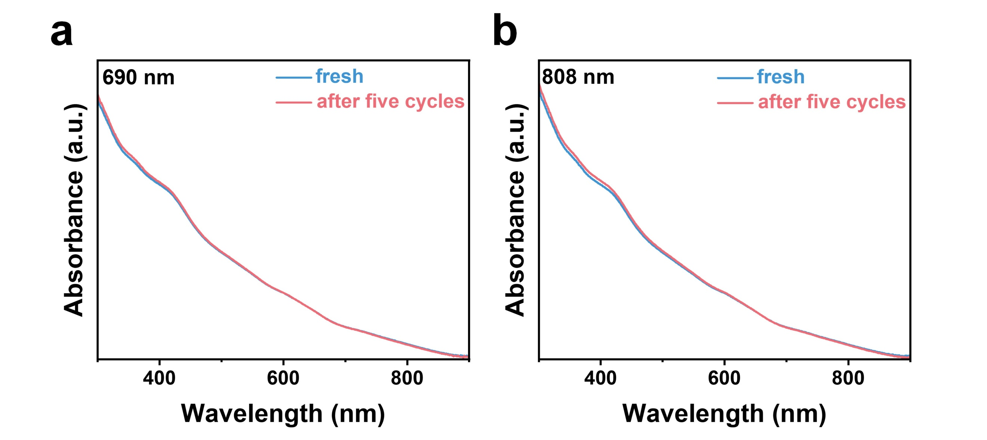
Supplementary Fig. 25 The absorption spectra of Au₁₀₃S(p-MBT)₄₂ nanocluster before and after five cycles at (a) 690 nm and (b) 808 nm (b).

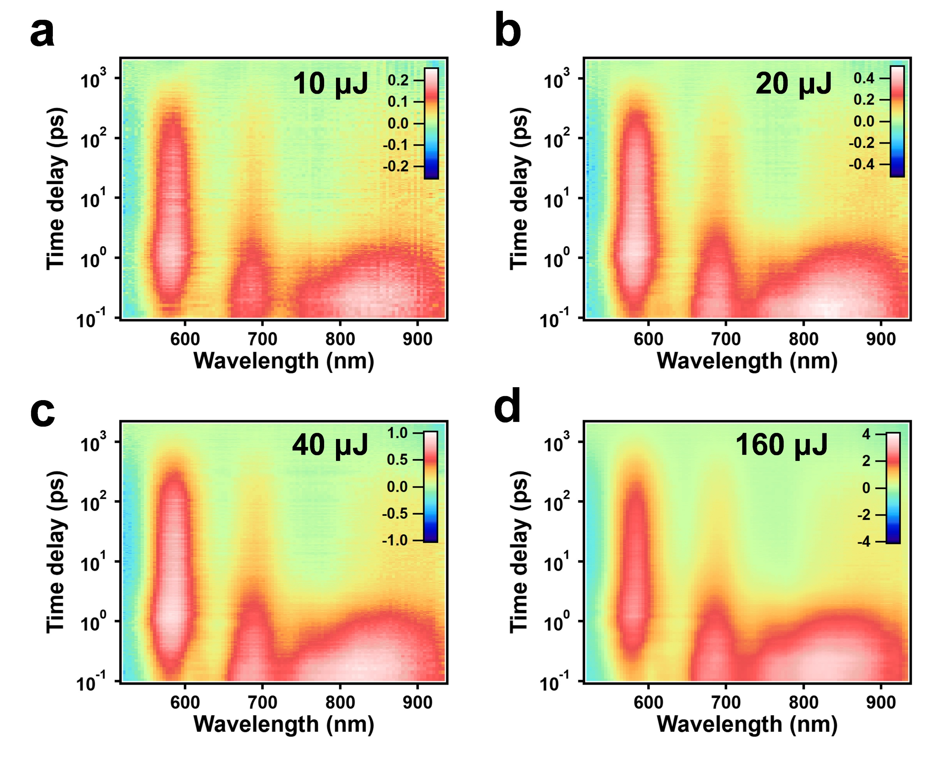
Supplementary Fig. 26 Femtosecond transient absorption data (fs-TA) data map of Au₁₀₃ with 475 nm excitation at different pump fluences: (a) 10 μJ, (b) 20 μJ, (c) 40 μJ, and (d) 160 μJ.

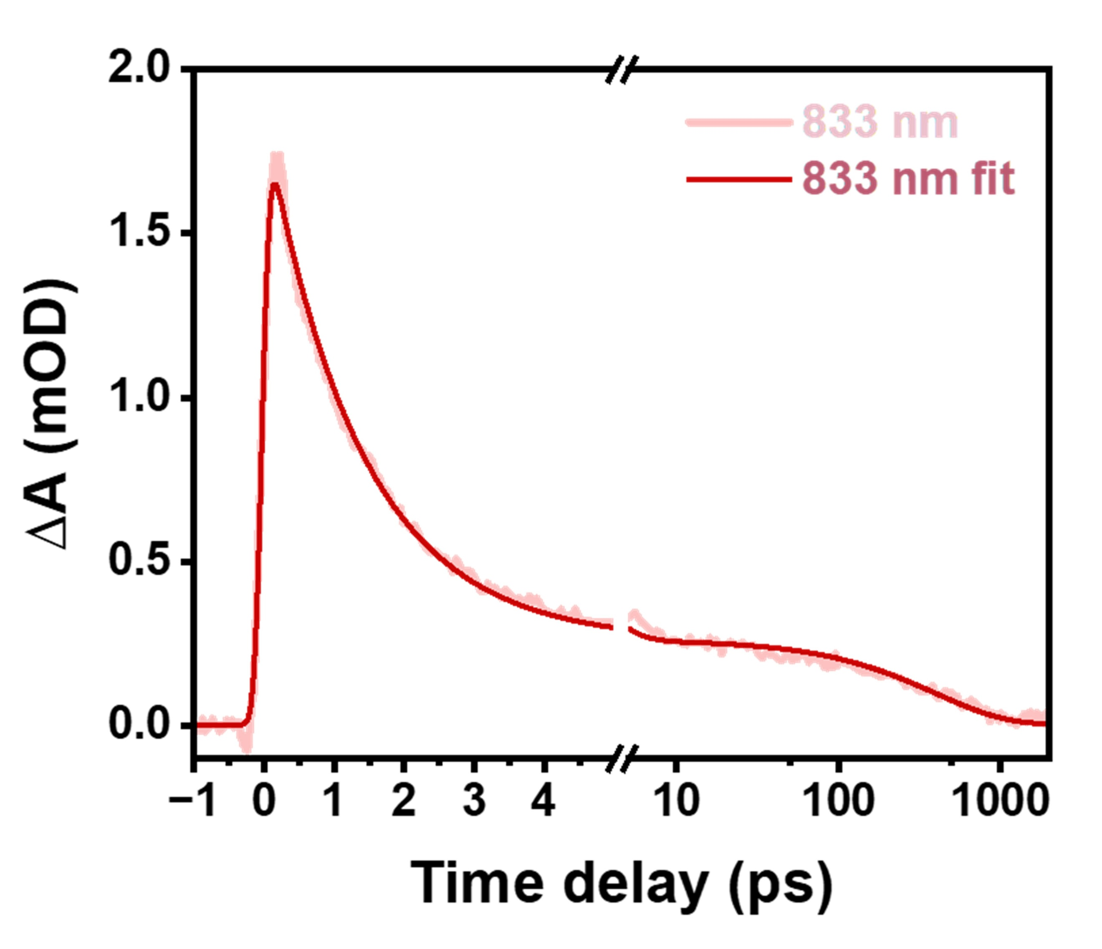
Supplementary Fig. 27 TA kinetic traces probed at 833 nm and the corresponding fits.

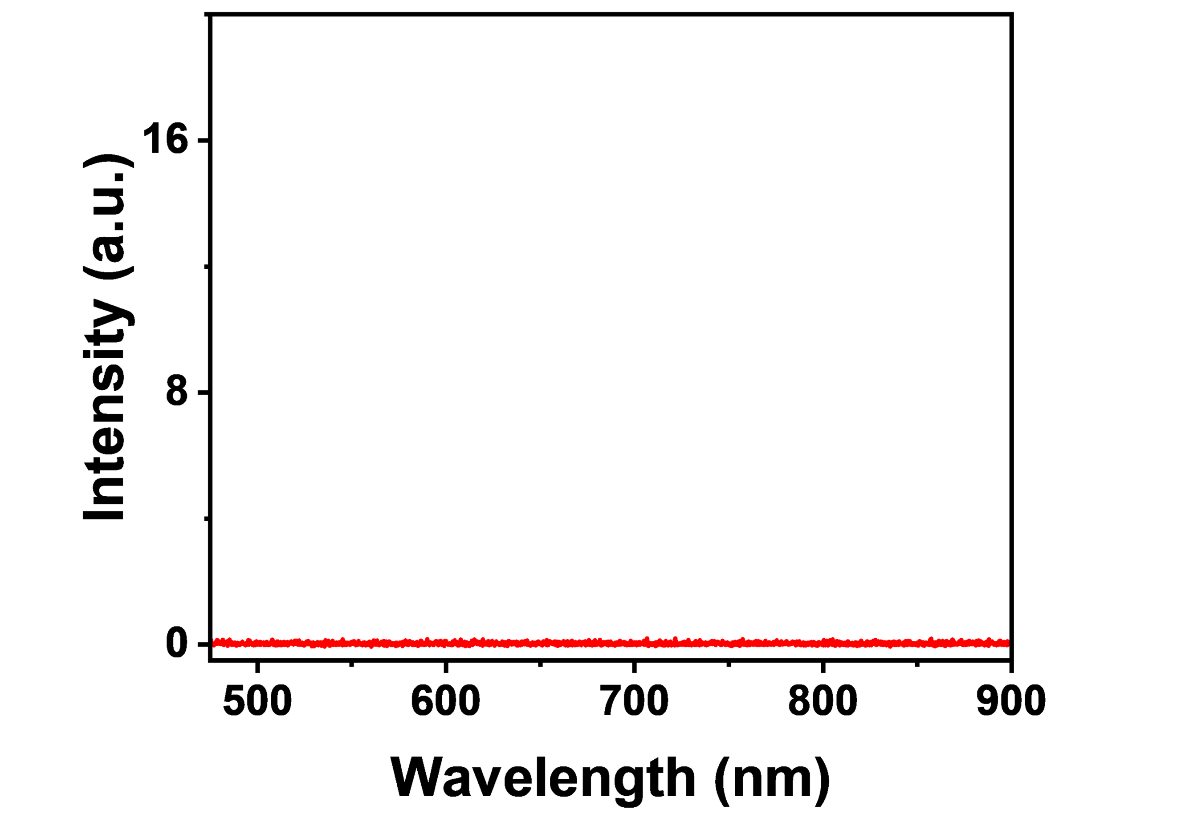
Supplementary Fig. 28 Emission spectrum of 20 μM Au₁₀₃S(p-MBT)₄₂ nanocluster solution in the range of 480-900 nm. Excitation: 450 nm.

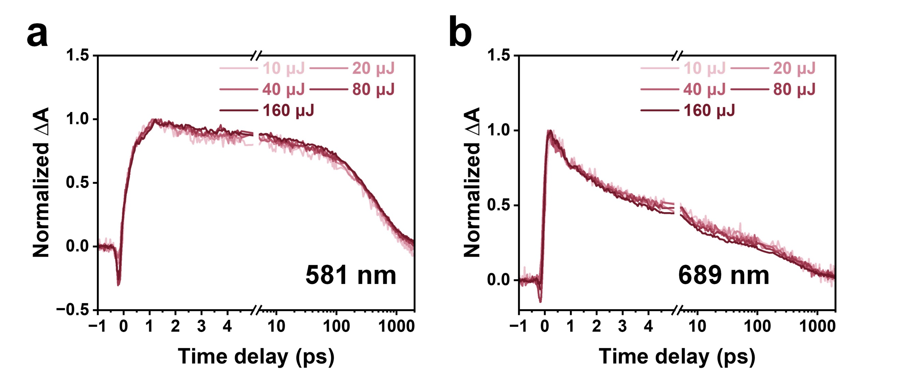
Supplementary Fig. 29 Normalized TA kinetic traces at different pump fluences probed at other different wavelengths: (a) 581 nm and (b) 689 nm.

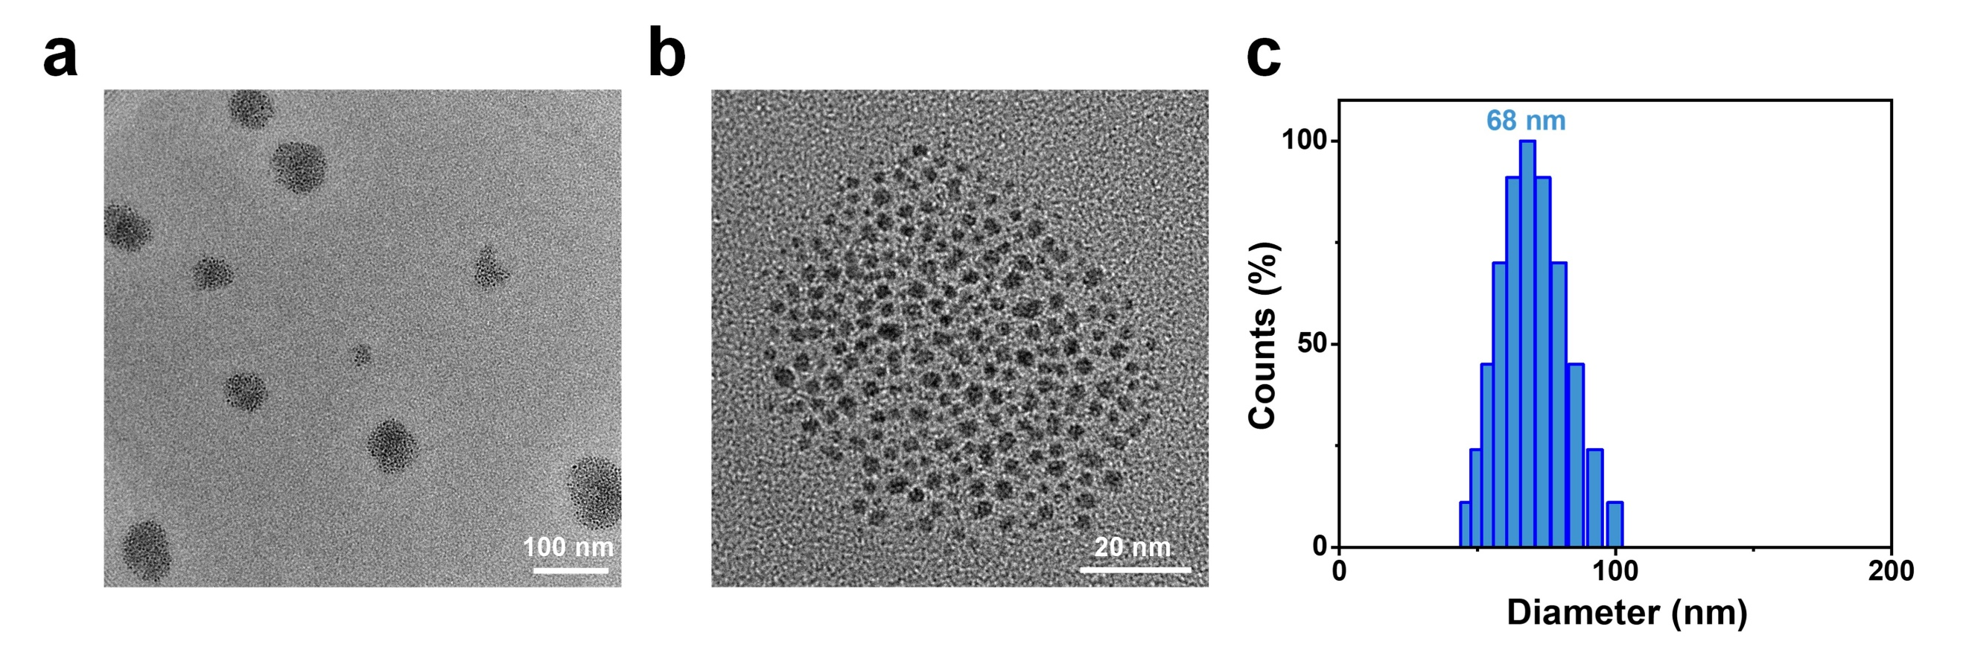
Supplementary Fig. 30 (a) and (b) TEM images of Au₁₀₃@PEG nanoparticles. (c) The size distribution of Au₁₀₃@PEG nanoparticles (~68 nm).

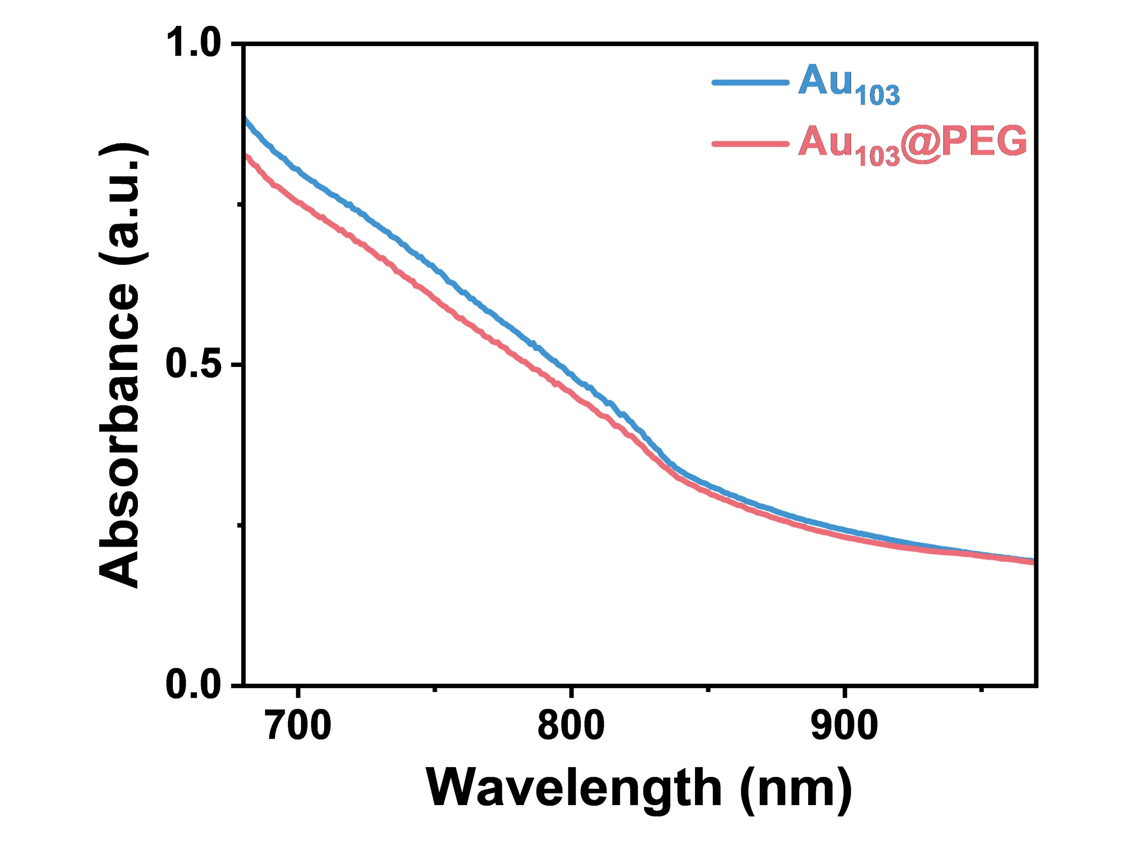
Supplementary Fig. 31 Absorption spectra of Au₁₀₃S(p-MBT)₄₂ in THF and Au₁₀₃@PEG in H₂O with the same concentration of Au₁₀₃S(p-MBT)₄₂ nanoclusters.

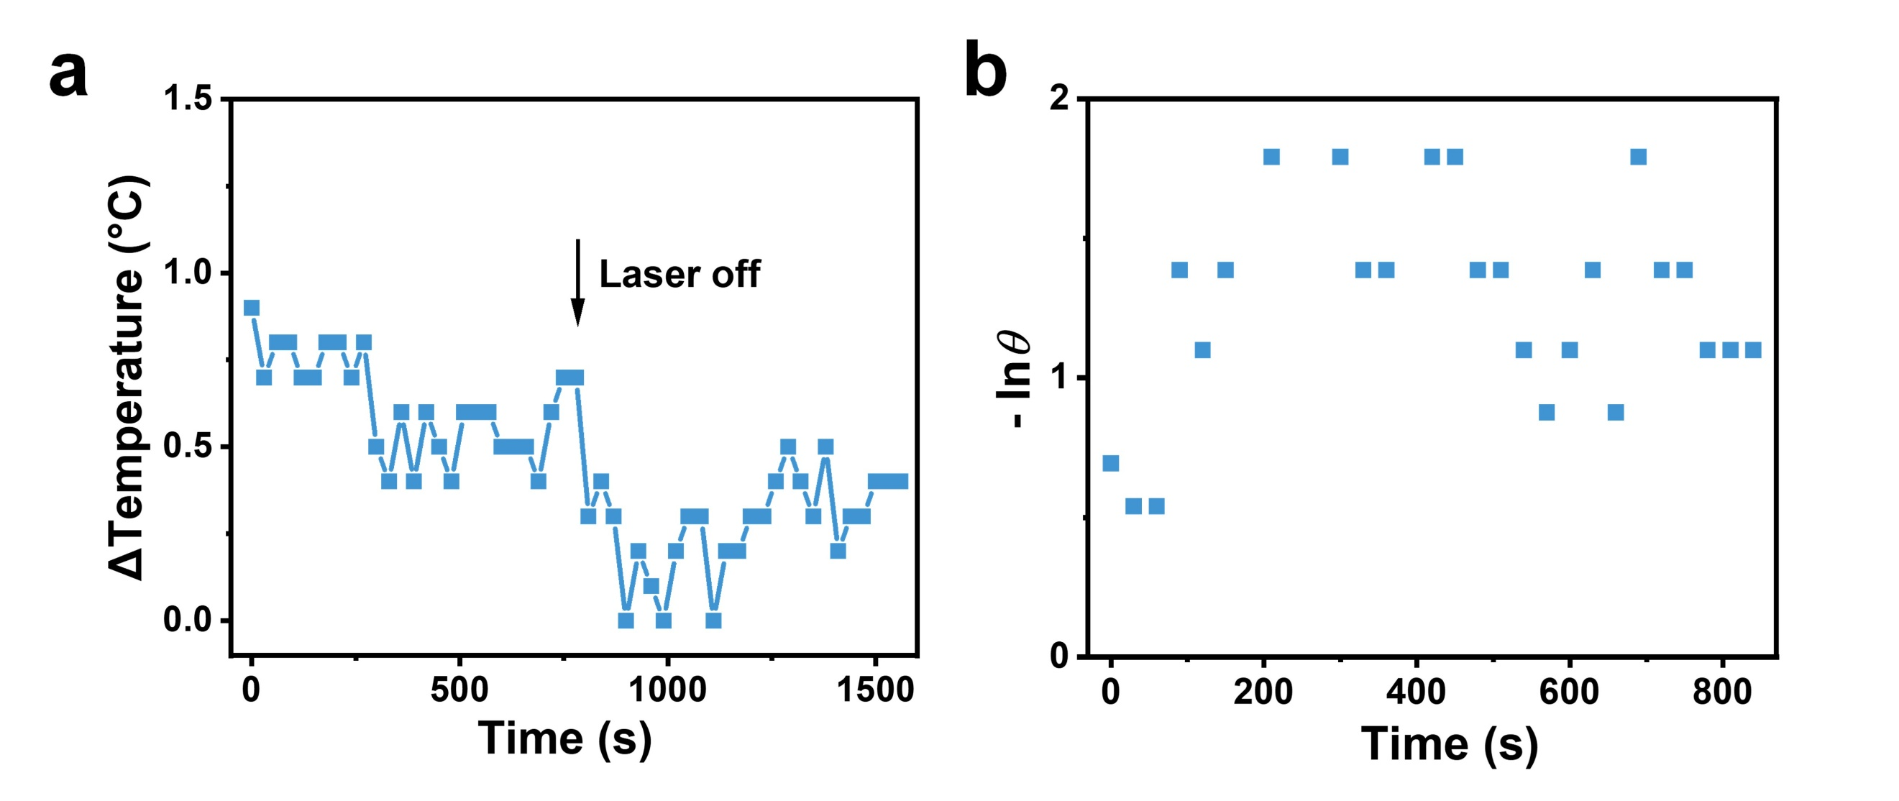
Supplementary Fig. 32 (a) Temperature change of H₂O under 690 nm laser irradiation (1.0 W cm⁻²), and (b) plot of cooling time vs. -lnθ obtained during cooling stage (after the laser was turned off).

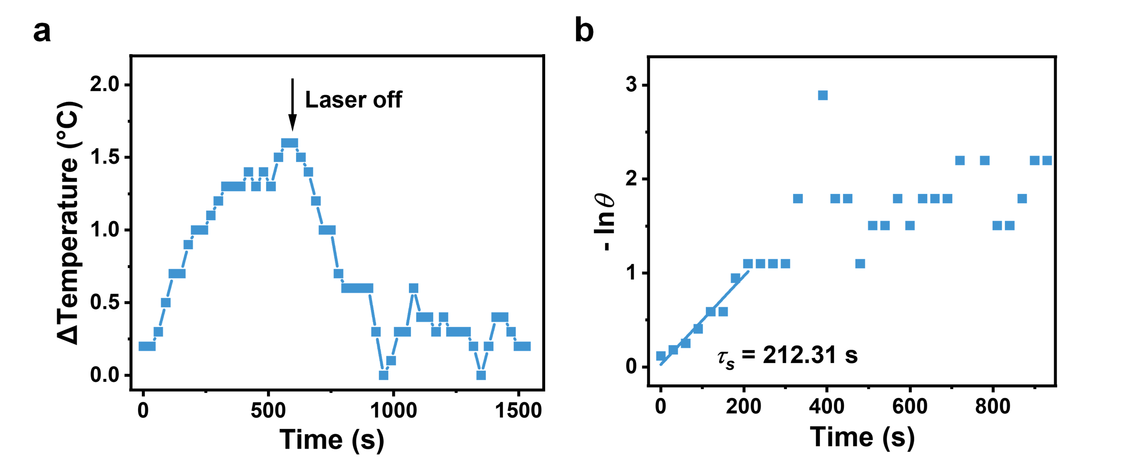
Supplementary Fig. 33 (a) Temperature change of H₂O under 808 nm laser irradiation (1.0 W cm⁻²), and (b) plot of cooling time vs. -lnθ obtained during cooling stage (after the laser was turned off).

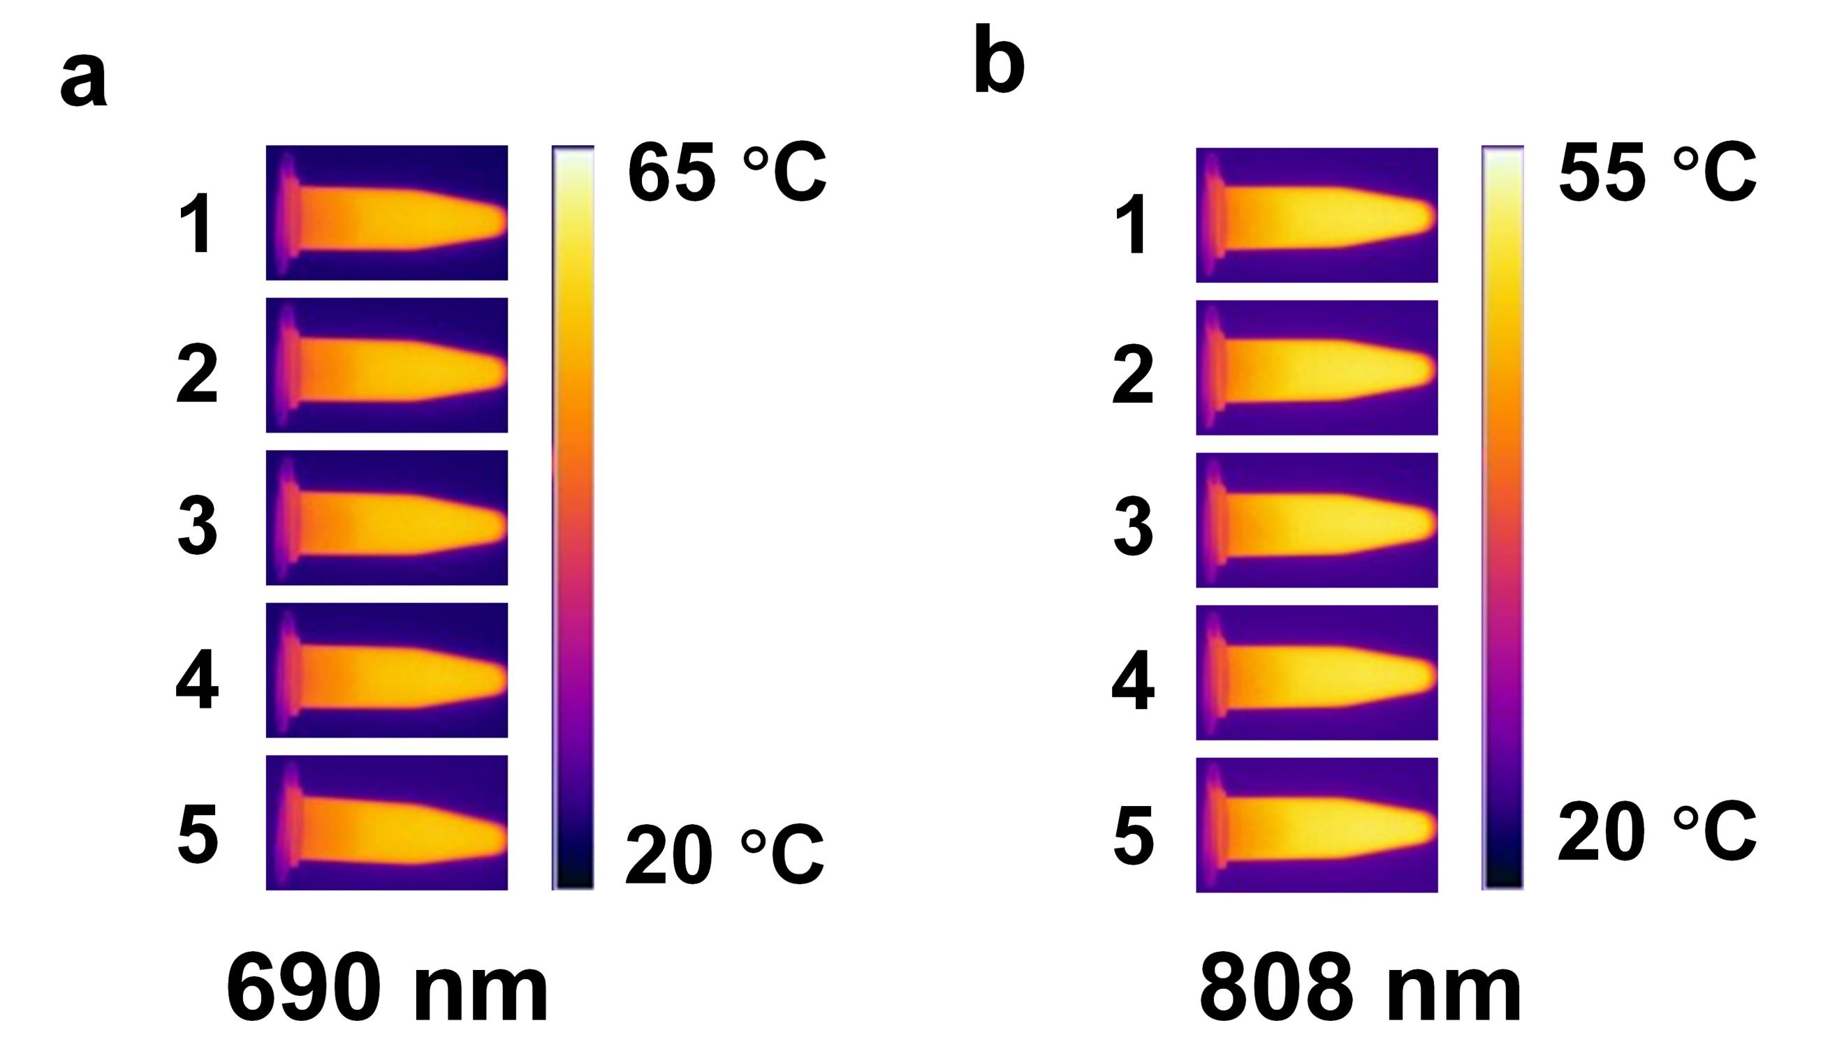
Supplementary Fig. 34 Photothermal images of Au₁₀₃@PEG at the maximum temperature for five cycles at (a) 690 nm and (b) 808nm.

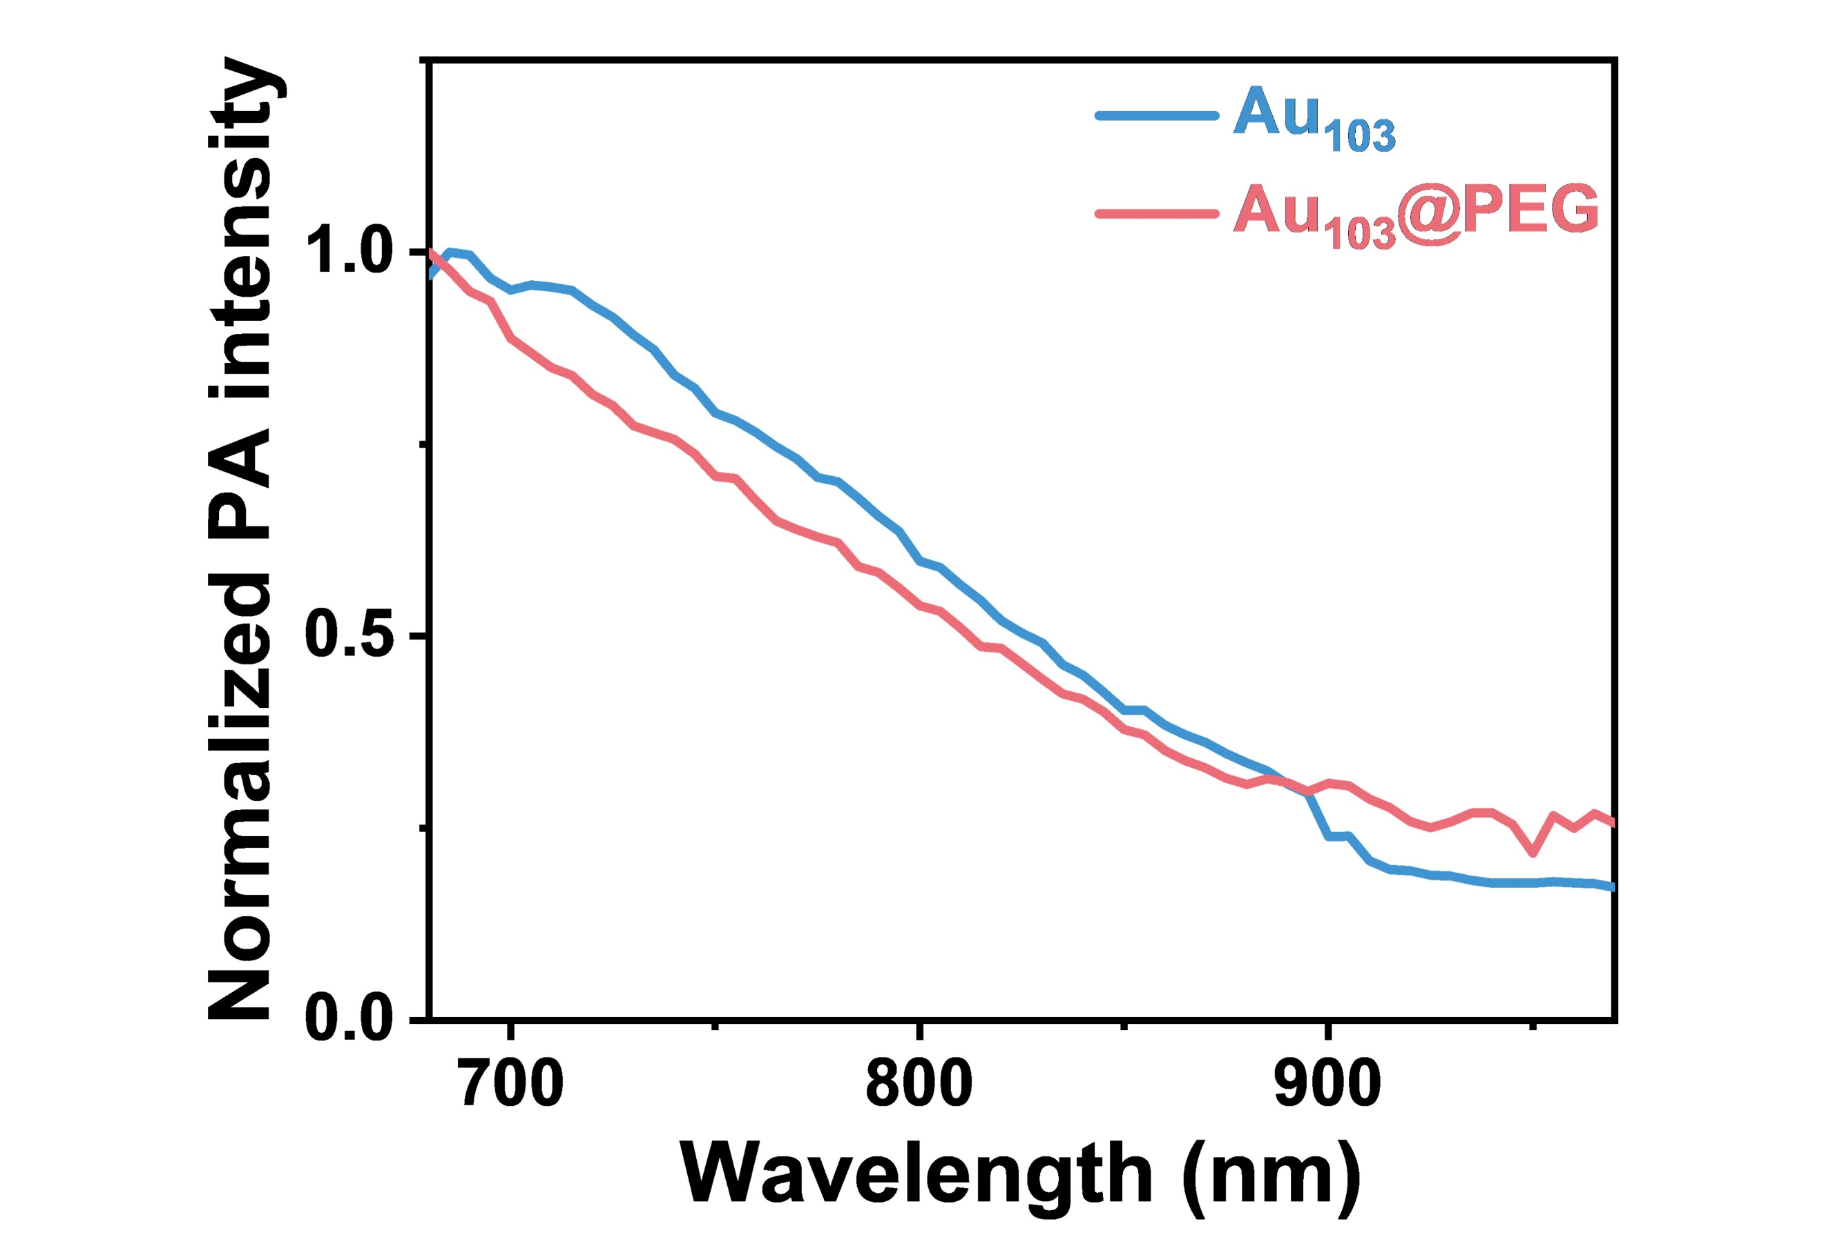
Supplementary Fig. 35 Normalized photoacoustic spectra of Au₁₀₃S(p-MBT)₄₂ nanocluster in THF and Au₁₀₃@PEG in H₂O in the range of 680-970 nm.

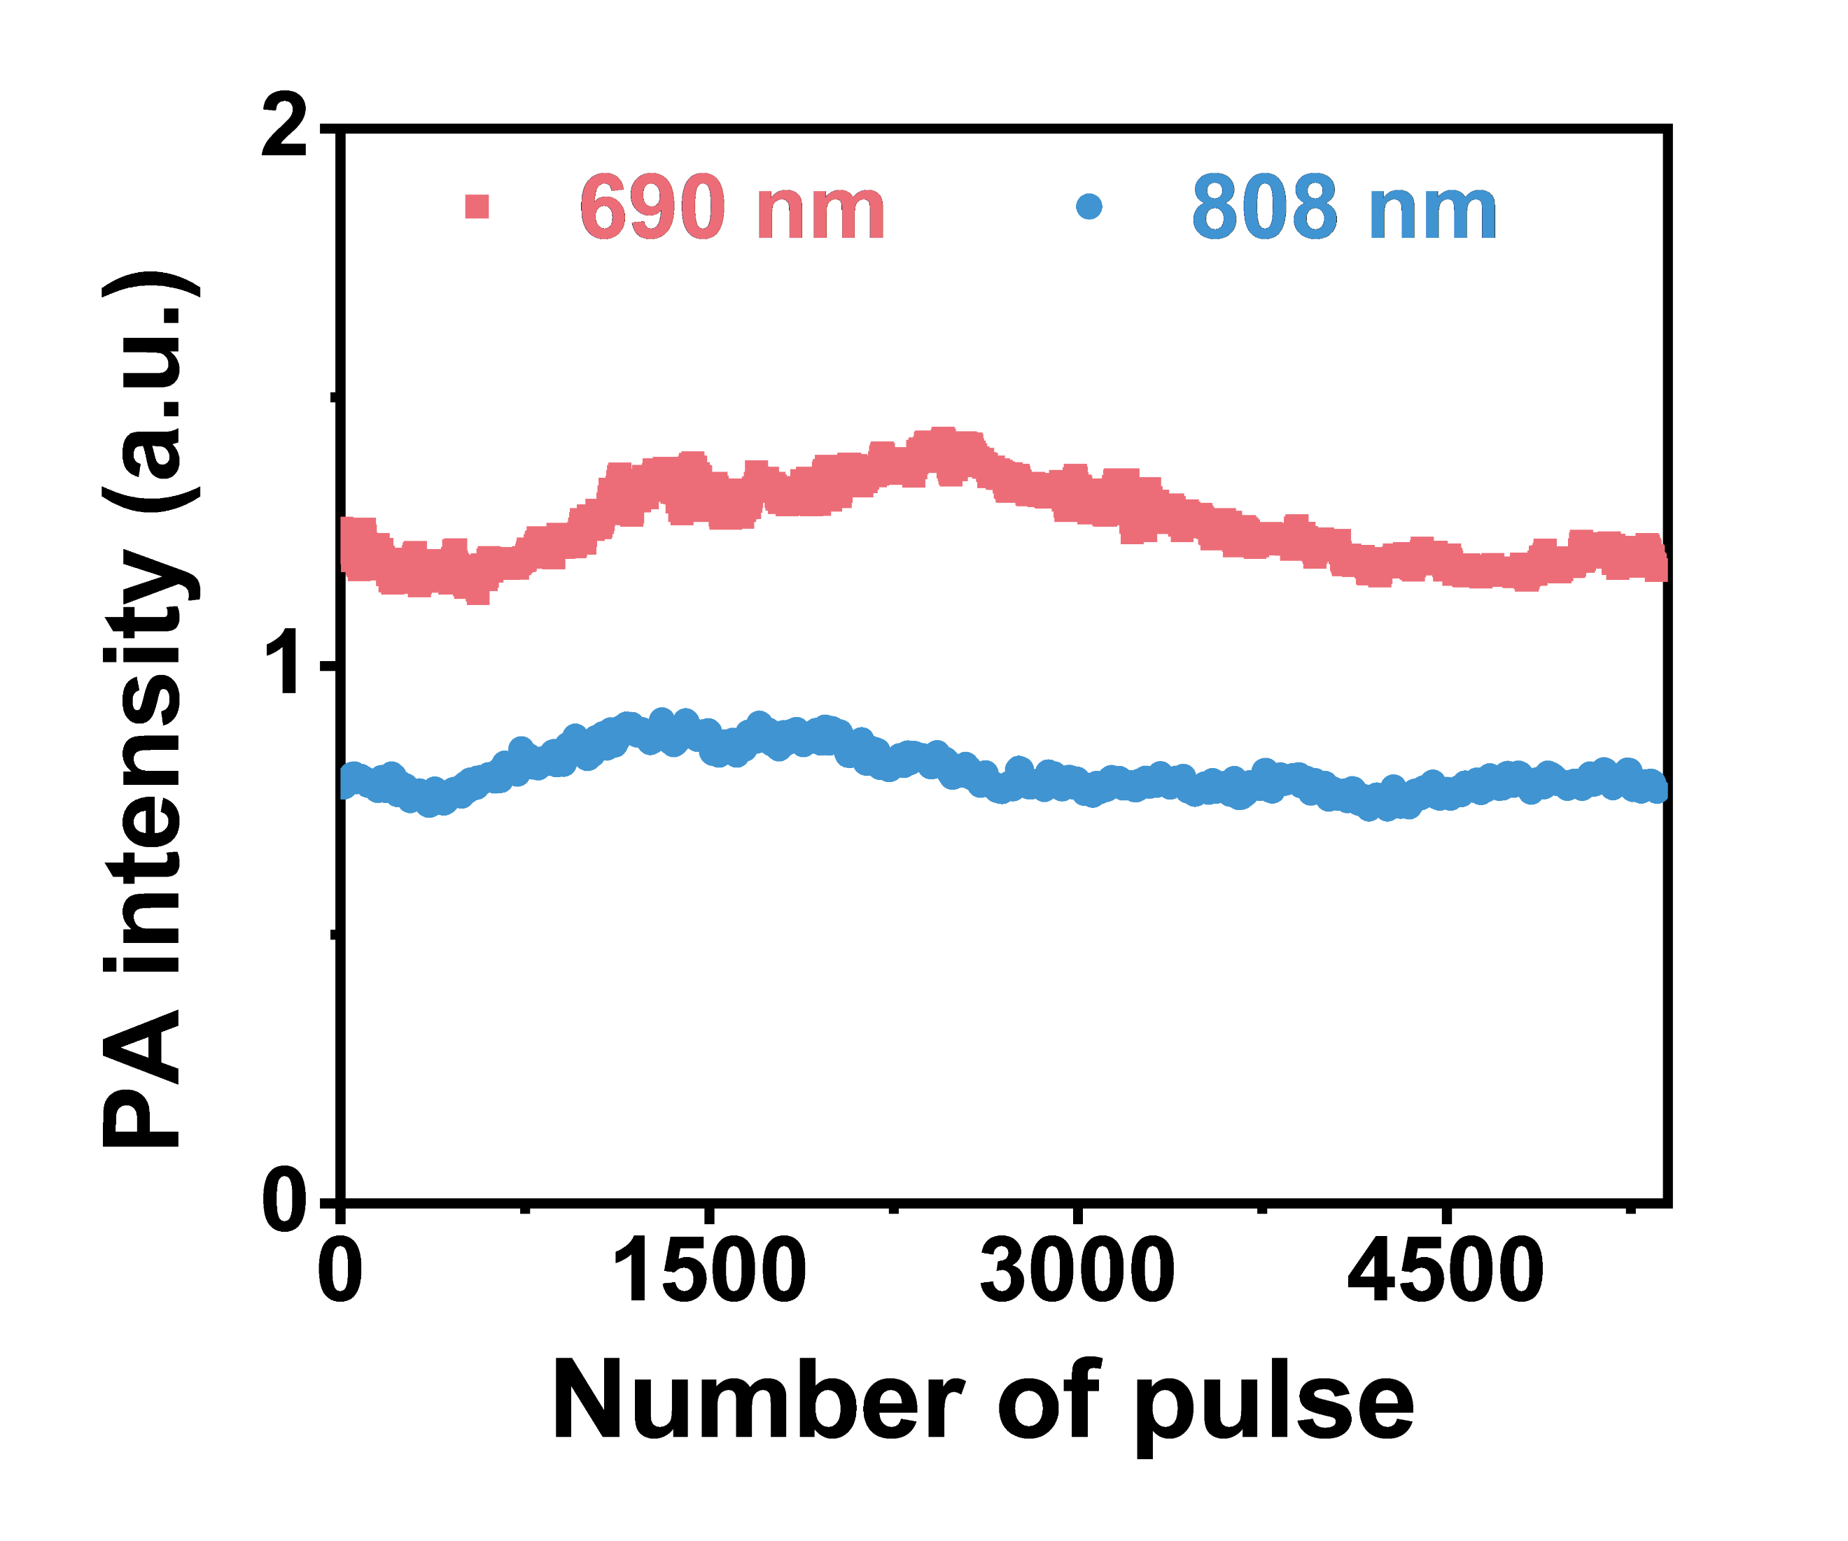
Supplementary Fig. 36 The dependence of photoacoustic intensity on the number of laser pulse at 690 nm and 808 nm for Au₁₀₃@PEG.

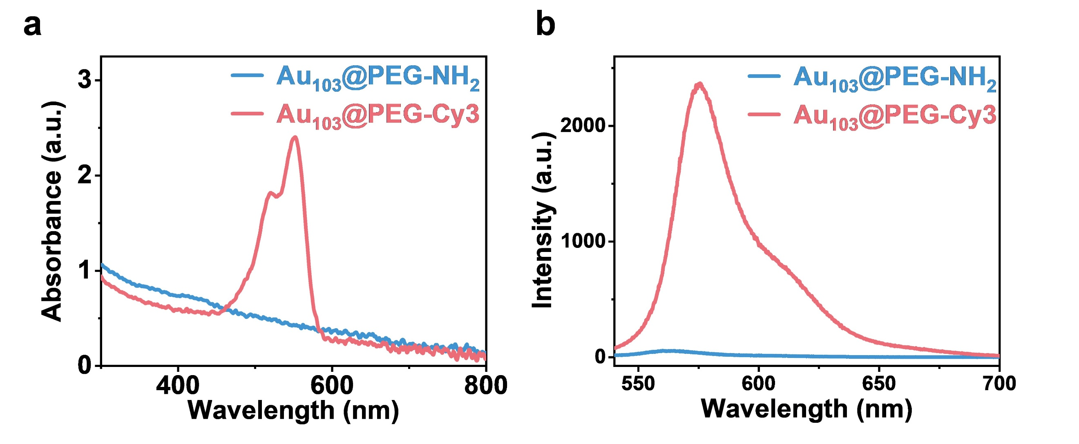
Supplementary Fig. 37 (a) Absorption spectra and (b) fluorescence spectra of Au₁₀₃@PEG-NH₂ and Au₁₀₃@PEG-Cy3 (Concentration of Au₁₀₃S(p-MBT)₄₂ = 2.5 μM) in PBS. Excitation: 520 nm.
Note: Compared to amino-functionalized Au₁₀₃@PEG-NH₂, Au₁₀₃@PEG-Cy3 exhibited a distinct absorption at ~550 nm and an intensified emission at ~575 nm derived from Cy3, verifying the successful conjugation of fluorescent molecules.

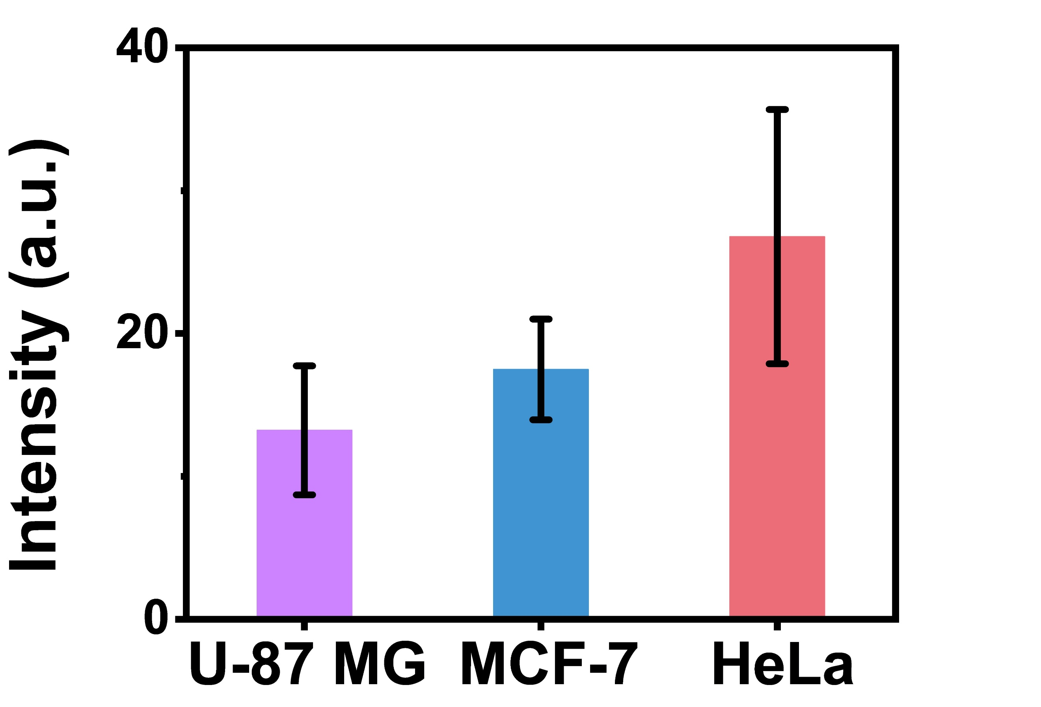
Supplementary Fig. 38 Quantitative Cy3 fluorescence intensity of cells with the uptake of Au₁₀₃@PEG-Cy3. Data are presented as mean ± SD (n ≥ 35).
Note: HeLa cells displayed the strongest Cy3 fluorescence intensity, suggesting a greater uptake of Au₁₀₃@PEG-Cy3. In fact, the order of fluorescence intensity for the three cell lines (HeLa > MCF-7 > U-87 MG) could account for their differences in photoacoustic intensity.

Supplementary Table 1 Crystal data and structure refinement for Au₁₀₃S(p-MBT)₄₂ nanocluster.
Empirical formula | C₂₉₄H₂₉₄Au₁₀₃S₄₃
Formula weight | 25493.41
Temperature [K] | 223.00
Wavelength | 1.34139 Å
Crystal system | Monoclinic
Space group | C2/c
Unit cell dimensions | a = 41.342(3) Å | α = 90°
 | b = 26.2378(19) Å | β = 108.975(2) °
 | c = 43.027(3) Å | γ = 90°
Volume [Å³] | 44135(5)
Z | 4
ρ_{calcd} [g cm⁻³] | 3.837
μ [mm⁻¹] | 44.697
F (000) | 43532.0
Crystal size | 0.13 × 0.11 × 0.08 mm³
Index ranges | -49 ≤ h ≤ 49, -31 ≤ k ≤ 31, -50 ≤ l ≤ 51
Reflections collected | 300592
Independent reflections | 39379 [R_{int} = 0.1202, Rσ= 0.0735]
Data / restraints / parameters | 39379 / 6078 / 2144
Goodness-of-fit on F² | 1.152
Final R indices [I>2σ(I)] | R₁ = 0.1030, wR₂ = 0.2950
R indices (all data) | R₁ = 0.1461, wR₂ = 0.3299
Largest diff. peak and hole [e.Å⁻³] | 5.85 and -5.04

Charge state | Potential (V) | ΔV (V) | Charge state | Potential (V) | ΔV (V)
-3/-2 | -0.658 | 0.154 | -3/-2 | -0.64 | 0.166
-2/-1 | -0.504 | 0.618 | -2/-1 | -0.474 | 0.632
0/1 | 0.114 | 0.228 | 0/1 | 0.148 | 0.222
1/2 | 0.342 | 0.278 | 1/2 | 0.37 | 0.276
2/3 | 0.62 | 0.214 | 2/3 | 0.646 | 0.212
3/4 | 0.834 | 0.29 | 3/4 | 0.858 | 0.298
4/5 | 1.124 | 0.18 | 4/5 | 1.156 | 0.174
5/6 | 1.304 |  | 5/6 | 1.33
Supplementary Table 2 The DPV response details of Au₁₀₃S(p-MBT)₄₂ nanoclusters in the entire potential window of -0.75 - 1.5 V.

Supplementary Table 3 Photothermal parameters of Au₁₀₃S(p-MBT)₄₂ and Au₁₀₃@PEG irradiated with two different laser wavelengths. T_{max}: the maximum temperature; ΔT_{max}: the maximum lifted temperature; I: laser power density; A: absorbance of nanoclusters or nanoparticles at irradiation wavelength; τ_{s}: system time constant; η: photothermal conversion efficiency.
Nanocluster | Laser wavelength  (nm) | T_{max}  (°C) | ∆T_{max}  (°C) | A | I  (W cm⁻²) | τ_{s}  (s) | η (%)
Au₁₀₃S(p-MBT)₄₂ | 690 | 56.1 | 34.8 | 0.81 | 1 | 121.07 | 51.4
Au₁₀₃S(p-MBT)₄₂ | 808 | 47.2 | 27.4 | 0.46 | 1 | 126.58 | 49.1
Au₁₀₃@PEG | 690 | 56.9 | 33.9 | 0.79 | 1 | 220.26 | 66.8
Au₁₀₃@PEG | 808 | 51.5 | 27.5 | 0.43 | 1 | 242.72 | 61.1

Supplementary References
- Neese, F. Software update: the ORCA program system—Version 6.0. Wiley Interdiscip. Rev.: Comput. Mol. Sci. 15, e70019 (2025).
- Neese, F. & Olbrich, G. Efficient use of the resolution of the identity approximation in time-dependent density functional calculations with hybrid density functionals. Chem. Phys. Lett. 362, 170-178 (2002).
- Neese, F. An improvement of the resolution of the identity approximation for the formation of the Coulomb matrix. J. Comput. Chem. 24, 1740-1747 (2003).
- Neese, F., Wennmohs, F., Hansen, A. & Becker, U. Efficient, approximate and parallel Hartree-Fock and hybrid DFT calculations. A ‘chain-of-spheres’ algorithm for the Hartree-Fock exchange. Chem. Phys. 356, 98-109 (2009).
- Grimme, S., Antony, J., Ehrlich, S. & Krieg, H. A consistent and accurate ab initio parametrization of density functional dispersion correction (DFT-D) for the 94 elements H-Pu. J. Chem. Phys. 132, 154104 (2010).
- Grimme, S., Ehrlich, S. & Goerigk, L. Effect of the damping function in dispersion corrected density functional theory. J. Comput. Chem. 32, 1456-1465 (2011).
- Helmich-Paris, B., Souza, B., Neese, F. & Izsák, R. An improved chain of spheres for exchange algorithm. J. Chem. Phys. 155, 104109 (2021).
- Helmich-Paris, B. A trust-region augmented Hessian implementation for restricted and unrestricted Hartree-Fock and Kohn-Sham methods. J. Chem. Phys. 154, 164104 (2021).
- Neese, F. The SHARK integral generation and digestion system. J. Comput. Chem. 44, 381 (2023).
- Izsák, R. & Neese, F. An overlap fitted chain of spheres exchange method. J. Chem. Phys. 135, 144105 (2011).
- Izsák, R., Hansen, A., & Neese, F. The resolution of identity and chain of spheres approximations for the LPNO-CCSD singles Fock term. Mol. Phys. 110, 2413-2417 (2023).
- Neese, F. The ORCA program system. Wiley Interdiscip. Rev.: Comput. Mol. Sci. 2, 73-78 (2012).
- Izsák, R., Neese, F. & Klopper, W. Robust fitting techniques in the chain of spheres approximation to the Fock exchange: The role of the complementary space. J. Chem. Phys. 139, 094111 (2013).
- Neese, F. Software update: the ORCA program system, version 4.0. Wiley Interdiscip. Rev.: Comput. Mol. Sci. 8, e1327 (2018).
- Neese, F., Wennmohs, F., Becker, U. & Riplinger, C. The ORCA quantum chemistry program package. J. Chem. Phys. 152, 224108 (2020).
- Neese, F. Software update: The ORCA program system—Version 5.0. Wiley Interdiscip. Rev.: Comput. Mol. Sci. 12, e1606 (2022).
- Neese, F. Approximate second-order SCF convergence for spin unrestricted wavefunctions. Chem. Phys. Lett. 325, 93-98 (2000).

