Supplementary Figures S1 to S3

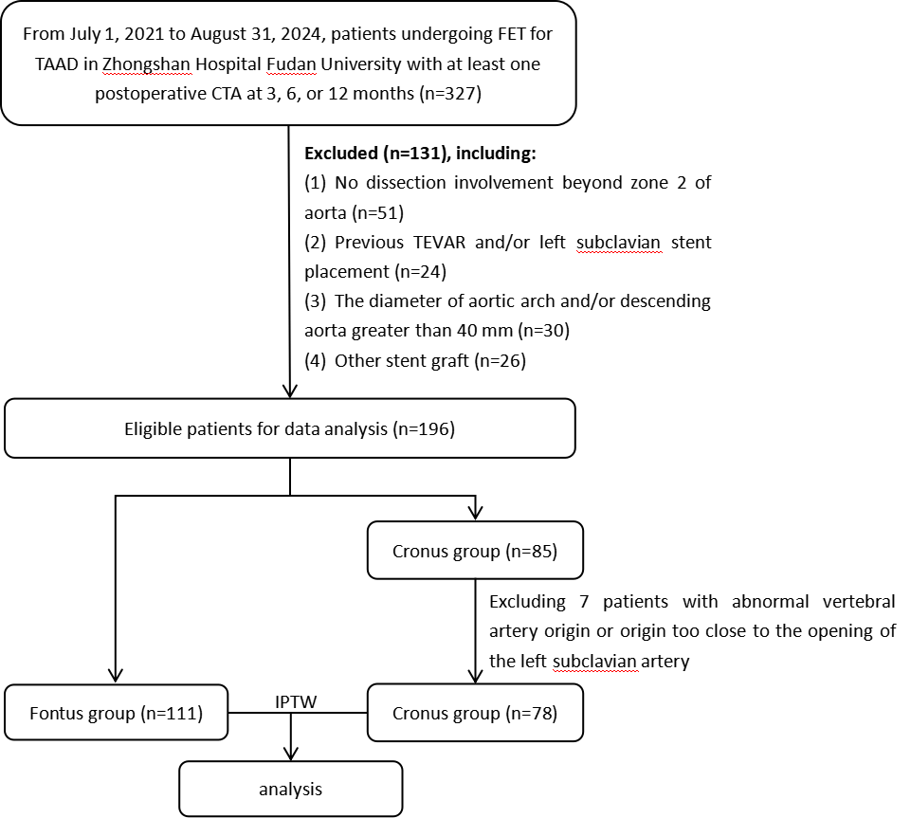

Figure S1: Flow chart for selection of the study population. TAAD, type A aortic dissection; TEVAR, thoracic endovascular aneurysm repair; CTA, computed tomography angiography

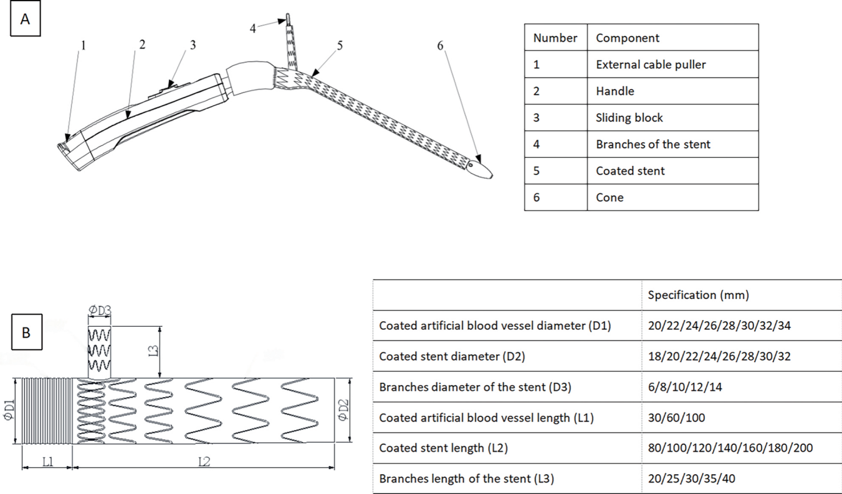

Figure S2: Fontus Device Description and Model Selection. (A) Schematic diagram and components. (B) Available sizes. (Reproduced from Zhang W et al., Int J Cardiol 431 (2025) 133268; Used with permission.)

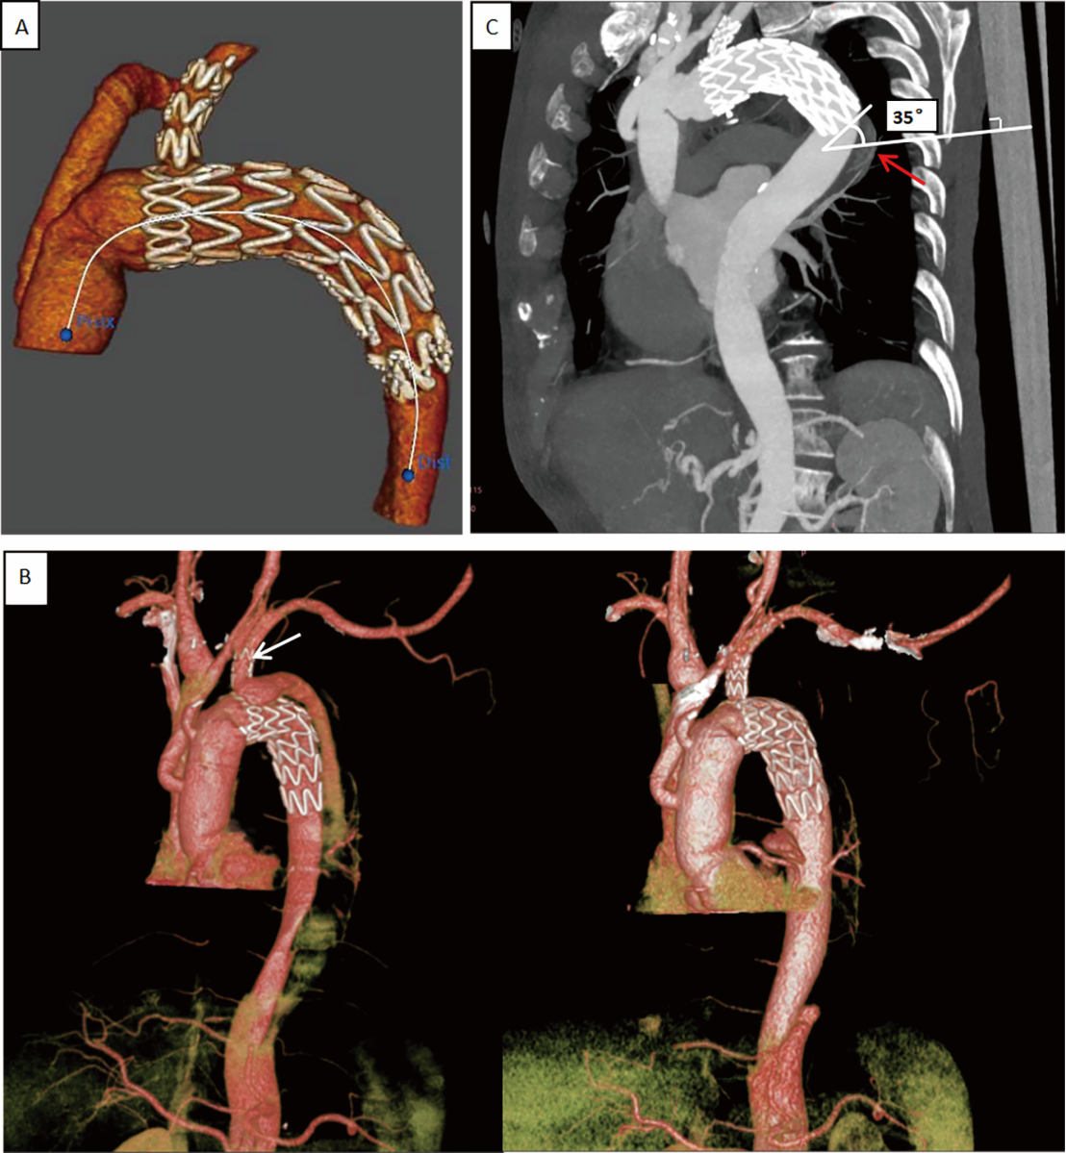
Figure S3: Fontus Stent CT Imaging Findings. (A) 3D reconstruction post-Fontus placement. (B) Branch endoleak (white arrow) and its spontaneous resolution at six months. (C) Sagittal reconstruction of dSINE (red arrow) caused by excessive distal angulation. (LSA, Left Subclavian Artery; dSINE, Distal Stent Graft-Induced New Entry.)

