Supplementary Information
A physics-based framework for monitoring global temperature surges
Shoshiro Minobe, Erik Behrens, Kirsten L. Findell, Erich M. Fischer, Benoit Meyssignac, Takuro Michibata & Rowan Sutton

Supplementary Note 1 | Idealized examples of the one-year budget
To aid interpretation of the budget decomposition (Fig. 2b), this note illustrates equation (2) for three idealized histories of the subsurface reservoir, with the radiative term and C set to zero. Equation (2) then reduces to (A+O₁₀₀)(t) = (A+O₁₀₀)(t − 1yr) + S(t), with S(t) = −Δ_{1yr}(O_{sub}) = −[O_{sub}(t) − O_{sub}(t − 1yr)], a trailing one-year difference of the subsurface reservoir. We consider three cases, for all of which both (A+O₁₀₀) and O_{sub} are zero for t < 0. Energy conservation then requires (A+O₁₀₀)(t) = −O_{sub}(t) at every later time.
Supplementary Fig. 1 shows the three cases, each defined by a different history of the subsurface reservoir. (a) Constant uptake: O_{sub} rises at a constant rate, so (A+O₁₀₀) falls steadily. (b) Release followed by stop: O_{sub} declines for one year and then holds its new level, so (A+O₁₀₀) rises to a peak at t = 1yr and stays there indefinitely. (c) Release followed by equal uptake: O_{sub} declines for one year and recovers over the next, so (A+O₁₀₀) rises and then returns to zero rather than settling at a new level.
These cases are useful to understand some features in Fig. 2b. Because this figure plots S and the carryover rather than O_{sub} itself, each case also shows how these two terms divide one history between them. In case (a) the subsurface takes up heat at a constant rate, resulting in constant cooling of (A+O₁₀₀), which is due to the decrease of S in the first year and to the carryover term thereafter. This situation is analogous to the prolonged La Niña of 2020–2023 and to the La Niña of 2024–25. In case (b) S rises in the first year and falls in the second year by the same amount. In the first year, while O_{sub} is declining the carryover is still zero, so S alone carries the rise of (A+O₁₀₀). In the second year, i.e., after the release stops, O_{sub} and thus (A+O₁₀₀) do not change, accompanied by compensation between the carryover and S terms. This is reminiscent of the compensation between these two terms after the 2023/24 El Niño. In case (c) S falls further than it rose and turns negative, so (A+O₁₀₀) returns to its earlier level, as it did over 2016–17 after the 2015/16 El Niño.
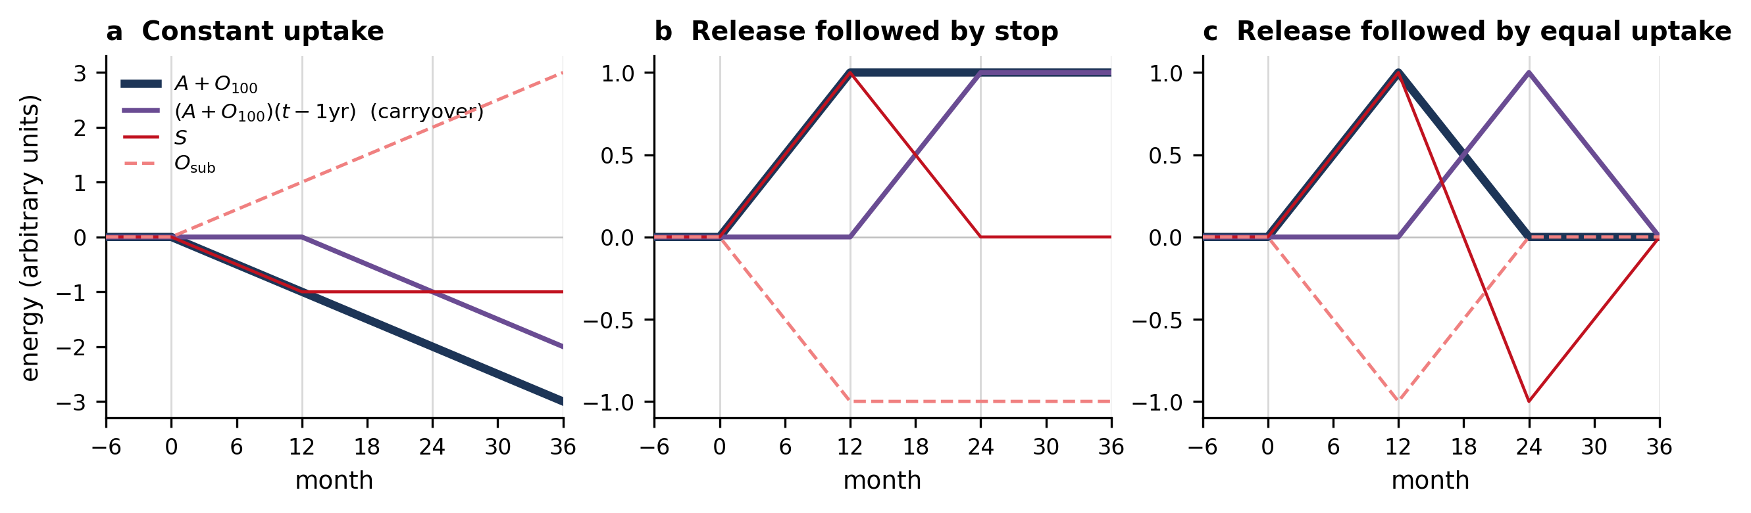
Supplementary Fig. 1 | Idealized behaviour of the one-year budget. Equation (2) with the radiative term and C set to zero, for three prescribed histories of the subsurface reservoir O_{sub} (light red dashed): a, constant uptake; b, release followed by stop; c, release followed by equal uptake. Also shown are (A+O₁₀₀) (dark blue), its carryover (A+O₁₀₀)(t − 1yr) (purple) and the subsurface term S (red), in arbitrary units.

Supplementary Note 2 | Construction of the one-year outlook and its uncertainty budget
As set out in Methods, “Outlook for the coming year” and “Uncertainty”, the outlook evaluates equation (2) at every month of the coming year. Of the terms on its right-hand side, the carryover (A+O₁₀₀)(t − 1yr) and the background uptake C are known, and the other two must be estimated: the one-year integral of EEI and the subsurface exchange S. The former is obtained by extrapolating the trend of the observed EEI, the latter from scenarios based on the record of past El Niño releases. This note has three parts: (1) the trend fit and the months it supplies, (2) carrying the release scenarios into the outlook, and (3) the prediction uncertainty of the radiative term.
1. The one-year EEI integral.
After the end of the CERES record (May 2026) the net radiation of each projected month is the sum of the 2005–2024 monthly climatology for that calendar month and an anomaly given by an extrapolated linear trend. The linear trend is estimated from the series of one-year integrals of the net radiation anomaly R′, the departure from that same climatology, formed for each year from 2001 to 2025 (non-overlapping calendar years, n = 25) and dated at the midpoint of the twelve months each spans. The fitted value is a(t − t₀) + b, in which t is the centre of the month being estimated, t₀ is the centre of the fit period (1 July 2013), a = 0.73 ZJ yr⁻¹ per year (0.45 W m⁻² decade⁻¹) and b = −0.9 ZJ. The intercept b is the mean of the anomaly integrals over the fit period (2001–2025) with respect to the climatology reference period (2005–2024). Projected EEI is then given by the monthly climatology plus [a(t − t₀) + b]/12, evaluated at the centre of each projected month. The same trend is used in every calendar month, because the CERES record shows no statistically significant seasonal dependence of the trend (not shown).
Part of the window of this one-year integral is observed and part is projected. For example, the integral for a target month of January 2027 runs from the centre of January 2026 to the centre of January 2027, using thirteen monthly values with the first and the last given half weight. In this integral window, the data from January to May 2026 are observed and the data from June 2026 to January 2027 are projected.
2. Carrying the release scenarios into the outlook.
The heat released by the tropical-Pacific subsurface during an El Niño is represented by three scenarios built on observed trajectories, as set out in Methods, “Outlook for the coming year”. To carry an observed trajectory into the outlook, the 3-month-smoothed S series of the event is shifted in time, separately for each of the three OHC products (ORAS5, IAP and EN4.2), so that its release peak occurs in January 2027. At the last observed month (May 2026 after 3-month smoothing) the shifted S does not in general equal the observed S of the same product, and this offset is removed by a correction that decays linearly to zero at the release peak. Each of the three curves is therefore continuous with the observed S of its own product and passes exactly through that product’s peak value for the event. Their spread supplies the time-resolved scenario uncertainty.
3. Prediction uncertainty of the radiative term.
The uncertainty of the one-year integral of projected EEI is the ±1 sigma prediction interval about the fitted trend,
$$σ_{prd}=σ_{J}\sqrt{1+1/n+(t^{*}−t_{0})^{2}/S_{tt}}$$
where $σ_{J}$ is the standard deviation of the detrended one-year-integral residuals (5.5 ZJ), n = 25 is the number of annual integrals fitted, t* is the time for which the integral is predicted, that is the midpoint of the one-year window ending at the horizon, t₀ is the centre of the fit period as above (1 July 2013), and Stt=i​(ti−t0)2 is formed from the times t_{i} of the fitted integrals. Multiplied by $σ_{J}^{2}$, the three terms under the root give the variance of an integral about the line, the variance of the fitted line’s level, and the variance contributed by its slope error over the extrapolation distance. The residual scatter $σ_{J}$ is evaluated on one-year integrals rather than monthly R, so that the noise unit matches the forecast quantity. This gives $σ_{prd}$ = 6.0 ZJ, the value used in equation (3).

