Supplementary Material
Joint assessment of the uric acid-to-HDL cholesterol ratio and the triglyceride-glucose index for predicting incident metabolic syndrome in Chinese adults aged 45 years and older: a prospective cohort study based on CHARLS
Weiqiang Qin1, Changqin Xu2, Lan Mai3, Xiaoling Yi2
1 South Campus Outpatient Department, Sun Yat-sen Memorial Hospital, Sun Yat-sen University, Guangzhou, 510000, Guangdong, China
2 Emergency Department, Sun Yat-sen Memorial Hospital, Sun Yat-sen University, Guangzhou, 510000, Guangdong, China
3 Department of Preventive Health Care, Sun Yat-sen Memorial Hospital, Sun Yat-sen University, Guangzhou, 510000, Guangdong, China
Corresponding author: Xiaoling Yi (email: yixling@mail.sysu.edu.cn)

Supplementary Figures
Figure S1. Dot-whisker plot of four-group cumulative incidence of metabolic syndrome (with 95% CIs).
Incident MetS rates were 11.7% (low-UHR/low-TyG, n=1,039), 11.3% (high-UHR/low-TyG, n=736), 23.6% (low-UHR/high-TyG, n=736), and 24.7% (high-UHR/high-TyG, n=1,039). See Table 2 for numerators/denominators.
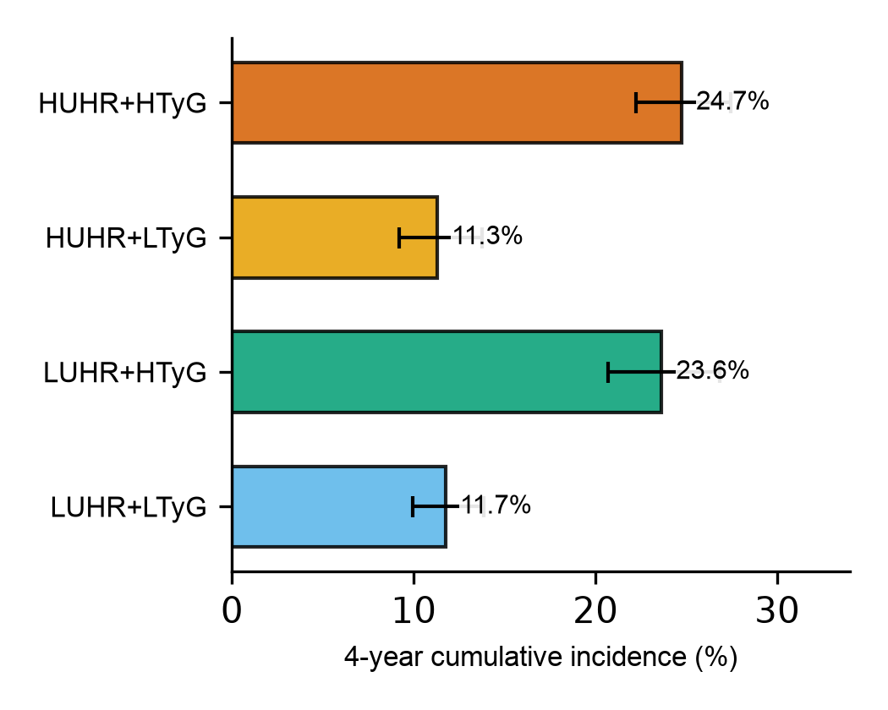

Figure S2. Decision curve analysis (DCA) for metabolic syndrome prediction.
Compares the base model, the base + UHR + TyG model, and a treat-all strategy in the complete-case set (n = 3,503). The augmented model yielded consistently higher net benefit across the 10%–40% threshold range.
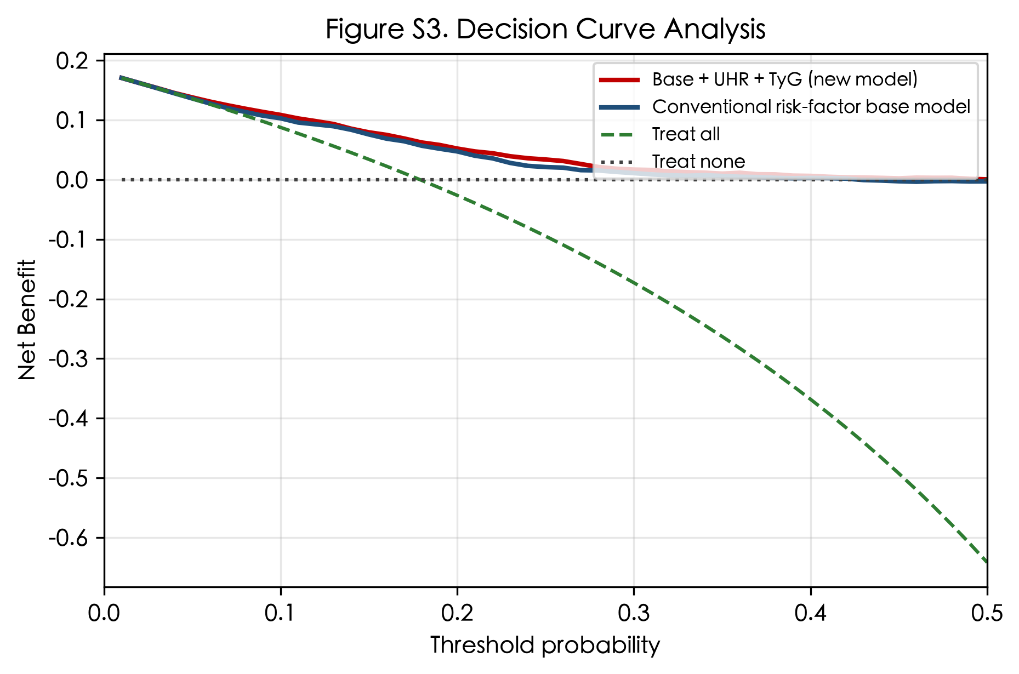

Figure S3. Joint UHR×TyG predicted-probability surface (heat map) for incident metabolic syndrome.
Medians marked; four quadrants defined by UHR and TyG medians. Predicted probability rose from ~12% (low-UHR/low-TyG) to ~25% (high-UHR/high-TyG), with mixed quadrants ~11–24%, indicating an additive rather than synergistic contribution, consistent with the four-group exposure classification in Table 6.
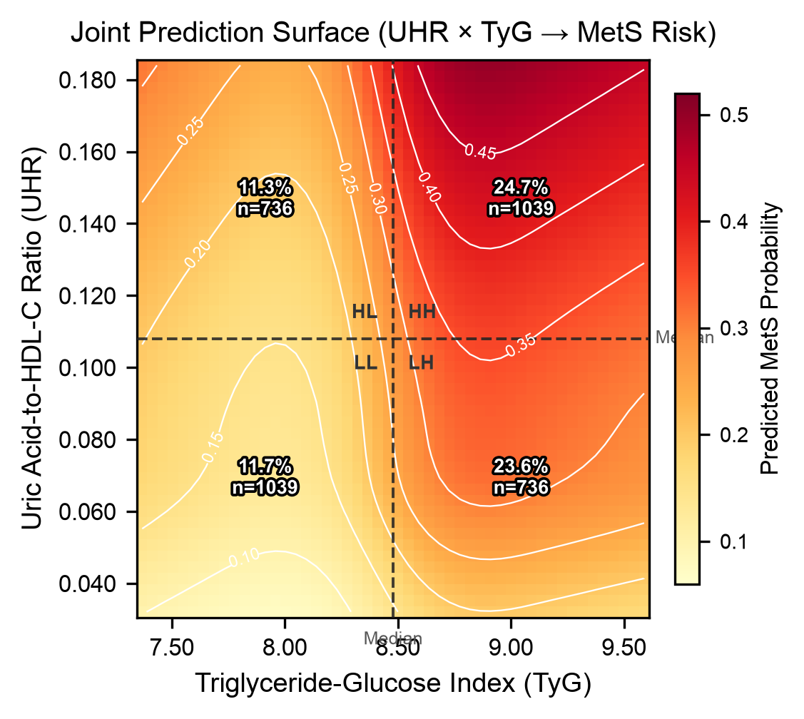

Figure S4. Distribution of MetS component counts by exposure group.
Component count (0–5), baseline MetS excluded (reflecting accumulation during follow-up); mean ± SD: low/low 1.24 ± 1.06, high/low 1.25 ± 1.04, low/high 1.67 ± 1.19, high/high 1.71 ± 1.19 (P < 0.001).
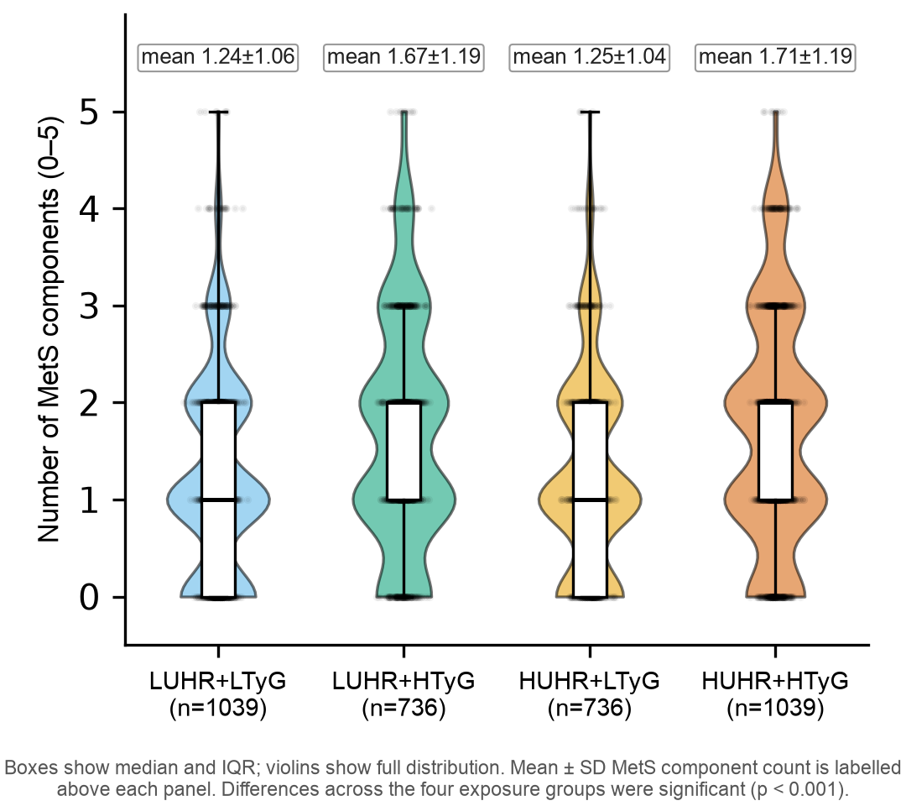

Supplementary Tables
Table S1. Incremental discrimination (C-statistic / AUC) of adding UHR and TyG to the conventional base model.
Base model included age, sex, education, marital status, urban/rural residence, BMI, smoking, and drinking. AUCs by DeLong; 95% CIs from bootstrap. Complete-case set (n = 3,503; 636 events).
Model | C-statistic (95% CI)
Base model (conventional risk factors) | 0.720 (0.699–0.740)
Base + UHR | 0.731 (0.711–0.751)
Base + TyG | 0.737 (0.717–0.757)
Base + UHR + TyG | 0.743 (0.723–0.763)

STROBE Checklist (Cohort Studies)
Item No. | Recommendation | Reported on Page / Section | Comments
**Title and abstract**
1 | (a) Indicate the study's design with a commonly used term in the title or the abstract | Title & Abstract | "Prospective Cohort Study" in title
 | (b) Provide in the abstract an informative and balanced summary of what was done and what was found | Abstract | Structured abstract: Background, Methods, Results, Conclusion
**Introduction**
2 | Background/rationale: explain the scientific background and rationale for the investigation being reported | Introduction | MetS burden in China, dual-pathway framework (inflammation/oxidative stress → insulin resistance), research gap
3 | Objectives: state specific objectives, including any prespecified hypotheses | Introduction (last paragraph) | Independent and joint associations of UHR and TyG with incident MetS; additive vs. supra-additive effect
**Methods**
4 | Study design: present key elements of study design early in the paper | Methods – Study Design and Population | Prospective cohort; CHARLS (2011→2015); 4-year fixed follow-up interval
5 | Setting: describe the setting, locations, and relevant dates, including periods of recruitment, exposure, follow-up, and data collection | Methods – Study Design and Population | 28 provinces, 150 counties, 450 communities in China; Wave 1 (2011) baseline, Wave 3 (2015) endpoint
6 | (a) Participants: give eligibility criteria, sources and methods of selection, and methods of follow-up | Methods – Study Design and Population | Four exclusion criteria: baseline MetS, missing MetS components, missing UA, missing covariates; Figure 1 flowchart
 | (b) Methods of follow-up | Methods – Study Design and Population | Biennial survey with fixed 4-year interval; Wave 3 used as endpoint for all participants
7 | Variables: clearly define all outcomes, exposures, predictors, potential confounders, and effect modifiers | Methods – Outcome Definition, Exposure Assessment, Covariates | MetS (modified ATP III + Asian WC cutoffs); UHR (UA/HDL-C per SD) and TyG (ln[TG×FPG/2] per SD) with dual-unit formula; joint four-group classification by median split (UHR=0.075, TyG=0.997); covariates with overadjustment rationale; sex as effect modifier
8 | Data sources/measurement: for each variable of interest, give sources of data and details of methods of assessment (measurement) | Methods – Outcome Definition, Exposure Assessment, Covariates | CHARLS standardized protocols; BP: mean of 3 seated readings; WC: midpoint measurement; fasting blood: China CDC central laboratory at both waves
9 | Bias: describe any efforts to address potential sources of bias | Methods – Covariates, Statistical Analysis | Overadjustment: TG/HDL-C/FPG excluded from models; component overlap bias discussed in Limitations (Sixth); E-values for unmeasured confounding; Schoenfeld residuals for PH assumption; sensitivity analysis substituting WC for BMI; complete-case analysis with justification for excluding smoking/drinking (54%–64% missing)
10 | Study size: explain how the study size was arrived at | Methods – Study Design and Population; Figure 1 | N = 3,550 after sequential exclusions, detailed in flowchart
11 | Quantitative variables: explain how quantitative variables were handled in the analyses | Methods – Statistical Analysis | Continuous variables: median [IQR], per-SD increment; RCS with df=3 and reference at medians; display ranges truncated at 5th–95th percentiles
12 | (a) Statistical methods: describe all statistical methods, including those used to control for confounding | Methods – Statistical Analysis | Cox proportional hazards (Efron ties), 3-tier covariate models; Kruskal-Wallis test for between-group comparisons; χ² test for categorical variables
 | (b) Methods for subgroups and interactions | Methods – Statistical Analysis, Supplementary Analyses | Prespecified subgroups (age, sex, BMI, hypertension, diabetes/IFG, urban/rural); multiplicative interaction (Wald test for product term); additive interaction (RERI/AP/S with 2,000 bootstrap percentile CIs); RCS joint dose-response heatmap
 | (c) Explain how missing data were addressed | Methods – Covariates | Complete-case analysis; smoking (≈54% missing) and alcohol (≈64% missing) excluded—their inclusion would halve the sample, with missingness potentially tied to exposure, introducing selection bias risk exceeding confounding control benefit
 | (d) If applicable, explain how loss to follow-up was addressed | Methods – Study Design and Population | Fixed 4-year interval design; all included participants had complete Wave 3 outcome data
 | (e) Describe any sensitivity analyses | Methods – Supplementary Analyses | WC replacing BMI in Model 3; E-value for unmeasured confounding
**Results**
13 | (a) Report numbers of individuals at each stage of study | Results – Baseline Characteristics; Figure 1 | Flowchart: total → eligible → included (N = 3,550; 636 events)
 | (b) Give reasons for non-participation at each stage | Figure 1 | Exclusion reasons listed in flowchart (baseline MetS, missing components, missing UA, missing covariates)
 | (c) Consider use of a flow diagram | Figure 1 | Study flowchart included (Figure 1)
14 | (a) Give characteristics of study participants | Results – Baseline Characteristics; Table 1 | Demographics, anthropometrics, blood pressure, laboratory parameters, exposure indices, baseline MetS components (by four-group cross-classification)
 | (b) Indicate number of participants with missing data for each variable | Table 1 footnote | Smoking (53% missing; N available = 1,654), drinking (62% missing; N available = 1,328)
 | (c) Summarise follow-up time | Table 1 – Outcomes | 4.0 years (fixed interval)
15 | Outcome data: report numbers of outcome events or summary measures over time | Results – Baseline Characteristics; Table 1 | 636 incident MetS (17.9%); cumulative incidence: 11.7% / 11.3% / 23.6% / 24.7% across the four groups
16 | (a) Give unadjusted estimates and, if applicable, confounder-adjusted estimates and their precision | Results – UHR and TyG and New-Onset MetS; Table 2 | Model 1 (unadjusted), Model 2 (+age, sex), Model 3 (fully adjusted) with 95% CIs; P for trend
 | (b) Report category boundaries when continuous variables were categorized | Methods – Exposure Assessment | Overall median split: UHR = 0.075, TyG = 0.997
 | (c) If relevant, consider translating estimates of relative risk into absolute risk for a meaningful time period | Results – Baseline Characteristics | 4-year cumulative incidence per group (11.7%–24.7%)
17 | Other analyses done: report other analyses done | Results | multiplicative interaction (per-SD product P = 0.72; four-group categorical P = 0.57); additive interaction (RERI = 0.692, 95% CI 0.008–1.479; AP = 0.215; SI = 1.454); RCS dose-response (UHR non-linearity P = 0.209; TyG non-linearity P < 0.001); subgroup forest plot (all subgroup interaction P > 0.05 (no sex interaction)); C-statistic (0.743); E-value (4.55/3.63); WC sensitivity analysis (aOR = 2.74)
**Discussion**
18 | Key results: summarise key results with reference to study objectives | Discussion – Main Findings | Four findings enumerated: joint aOR = 3.22, TyG > UHR dominance, additive pattern (RERI non-significant), sex interaction
19 | Limitations: discuss limitations of the study, taking into account sources of potential bias or imprecision | Discussion – Study Limitations | Six limitations: (1) fixed 4-year follow-up with single baseline exposure; (2) smoking/drinking excluded (54%–64% missing); (3) limited to Chinese adults ≥45 years, and UHR definition (UA/HDL-C) differs from prior UA/creatinine ratio; (4) exploratory subgroups; (5) RERI non-significant—limited power (N = 3,550, 636 events); (6) component overlap between UHR/TyG and MetS diagnostic criteria
20 | Interpretation: give a cautious overall interpretation of results considering objectives, limitations, multiplicity of analyses, results from similar studies, and other relevant evidence | Discussion – Main Findings, Dual-Pathway Joint Effects, Clinical Implications | Conservative interpretation: additive rather than supra-additive pattern; dual assessment retains clinical value (24.7% incidence in high-risk group) regardless of interaction significance; compared with prior single-pathway studies
21 | Generalisability: discuss the generalisability (external validity) of the study results | Discussion – Study Limitations | Limited to Chinese adults ≥45 years; requires validation in younger and multi-ethnic cohorts
**Other information**
22 | Funding: give the source of funding and the role of the funders for the present study | Declarations – Funding | Funding sources are declared in the manuscript's Declarations – Funding section; specific funder name and grant number to be completed by the authors prior to submission.
Status | Items
Fully reported | 1–18, 19–21
Partially reported | 6(b) — no formal loss-to-follow-up analysis, mitigated by fixed 4-year design
Missing | 22 — Funding section present in Declarations; funder details to be completed prior to submission.
Change | STROBE Item(s)
Schoenfeld PH test with real results (all models P > 0.05) | 9, 12(a)
Follow-up: "4.0 (fixed interval)" (replaces "4.0 ± 0.0") | 6(b), 14(c)
Component overlap bias discussion added as Sixth limitation | 9, 19
References expanded to 30 (added TyG meta [26], UHR meta [27], additive interaction tutorial [28], Chinese MetS prevalence [29], Korean UA longitudinal [30]) | 7, 12(b)
Conservative additive interaction interpretation throughout (RERI narrative downgrade) | 18, 20
Humanizer: promotional language and AI writing patterns removed | 2, 18, 20
TyG dual-unit formula (mmol/L equivalent) | 7
Additive interaction guidance citation [28] | 12(b)

