In vitro efficacy of an automatic UVC-LED device for disinfection of the stethoscope diaphragm against bacteria, fungi and enveloped respiratory viruses

by Davide Amodeo^{1,*}, Anna Carmina De Francesco¹, Giulia Nuredini¹, Diana Mihaela Constanda¹, Caterina Fazzi¹, Alessandro Manenti², Emanuele Montomoli^{1,2,3}, Ilaria Manini^{1,3}, Serena Marchi^{1,3}

¹ Department of Molecular and Developmental Medicine, University of Siena, Siena, Italy.

² VisMederi Srl, Siena, Italy.

³ Interuniversity Research Centre on Influenza and Other Transmissible Infections (CIRI-IT), Genoa, Italy.

* Corresponding author: davide.amodeo2@unisi.it

Supplementary Information

Supplementary Figure 1. Full-length uncropped agarose gel corresponding to Figure 5
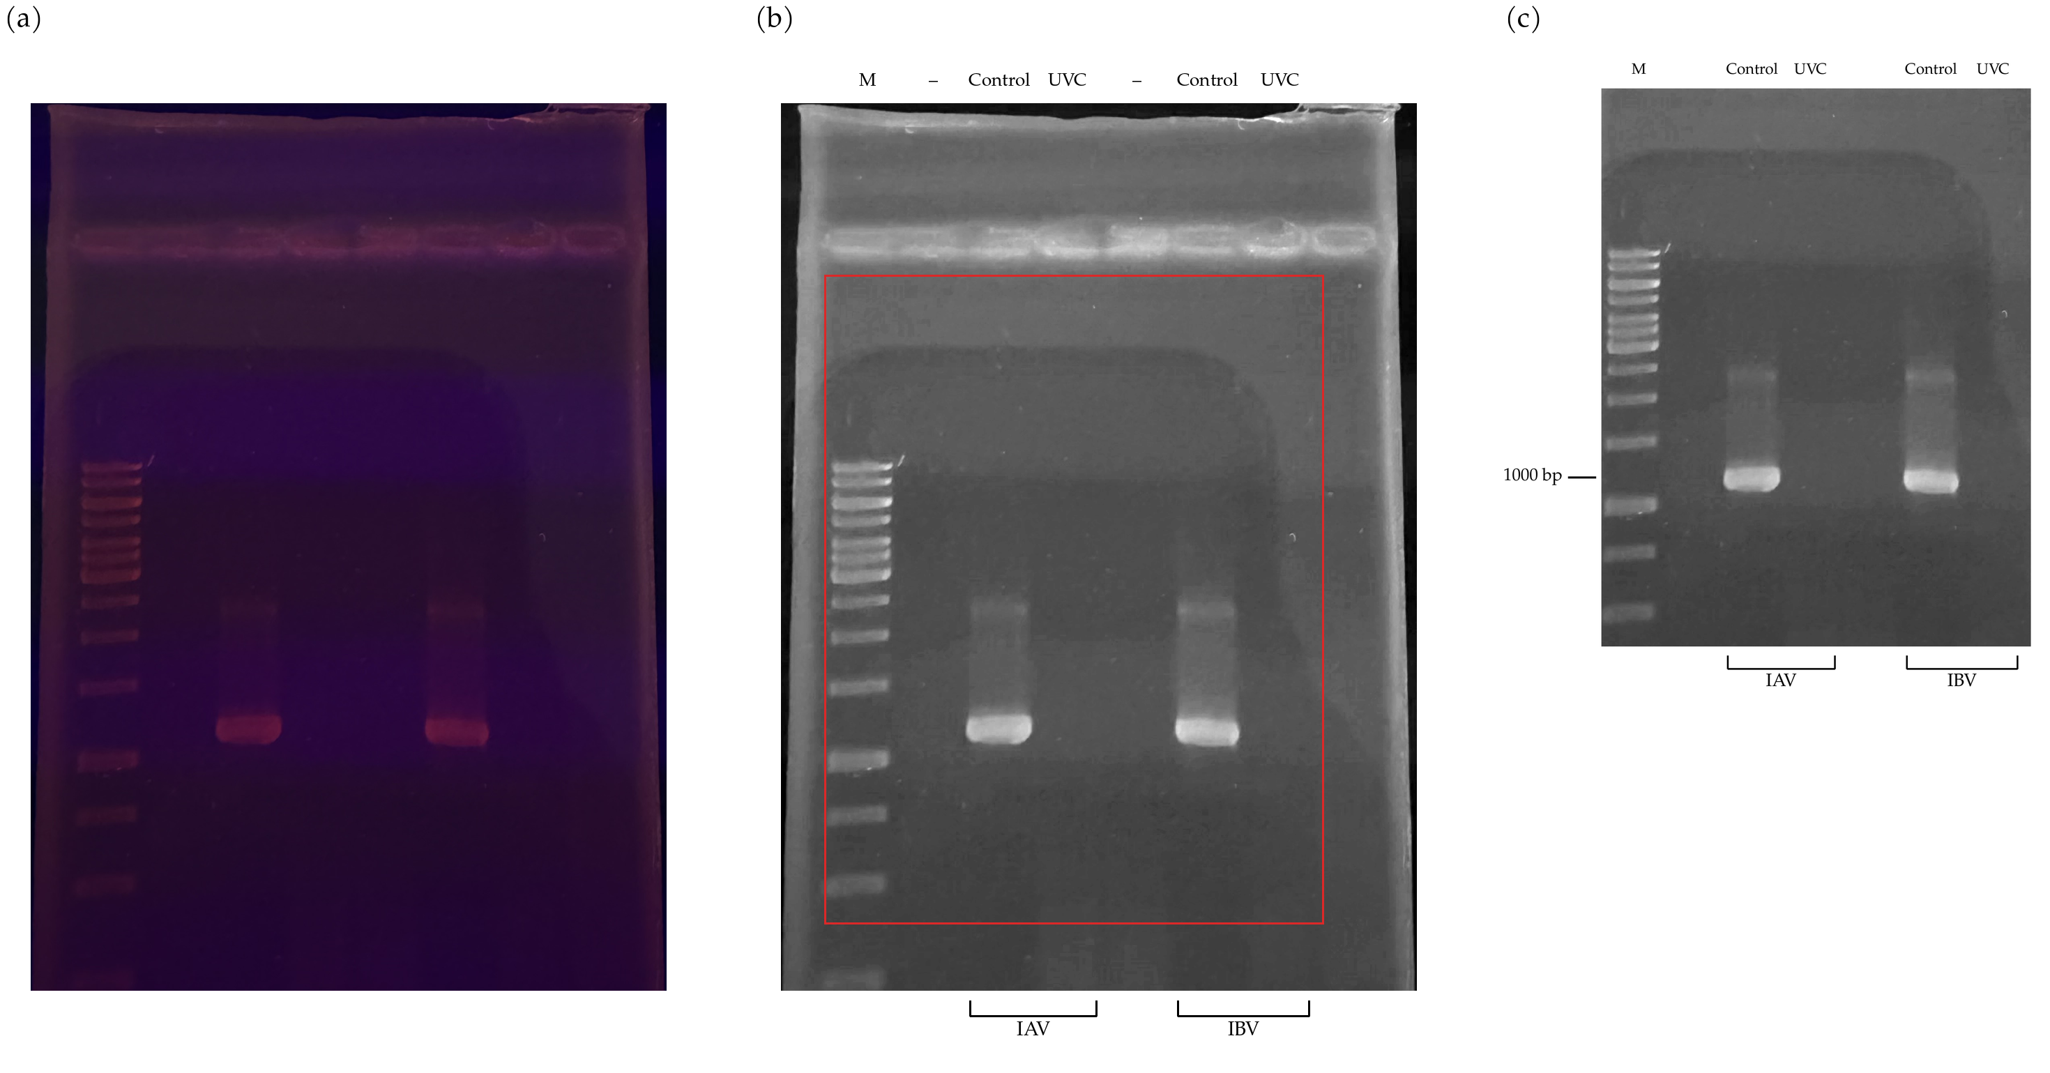
Supplementary Figure 1. The complete gel from which Figure 5 was taken, at three stages. (a) The photograph exactly as acquired, without any adjustment of brightness, contrast or colour. (b) The same photograph after the single linear whole-image adjustment, with all seven lane positions annotated; dashes mark the two wells that were left unloaded, and the outlined rectangle is the region reproduced in Figure 5. (c) Figure 5 as published. Panels (a) and (b) show the entire gel, wells included. Long-range RT-PCR products of the PA gene are visible only in the two non-irradiated control lanes; the lanes loaded with the products of the UVC-treated samples are indistinguishable from the unloaded lanes and from the surrounding gel (Supplementary Table S1).

Supplementary Table 1. Lane-by-lane quantification of the gel shown in Figure 5
Lane | Content | Mean intensity (a.u.) | Background SD (a.u.) | Signal-to-noise | % of lane 3
1 | Molecular weight marker | n.a. | n.a. | n.a. | n.a.
2 | Not loaded | 0.12 | 0.33 | 0.4 | 0.4
3 | IAV, non-irradiated control | 30.45 | 0.32 | 96.6 | 100.0
4 | IAV, UVC 150 s | 0.27 | 0.30 | 0.9 | 0.9
5 | Not loaded | -0.09 | 0.29 | -0.3 | -0.3
6 | IBV, non-irradiated control | 31.83 | 0.23 | 137.3 | 104.5
7 | IBV, UVC 150 s | -0.04 | 0.42 | -0.1 | -0.1

Supplementary Table 1. Intensities were measured on the unprocessed photograph, in the red channel, within a fixed rectangular region placed at the migration position of the long-range PA product and centred on each lane; the local background estimated by a median filter was subtracted. The background standard deviation was measured in the same lanes in a region of the gel containing no product. Values for the marker lane are not applicable, because no ladder band migrates at that position. Both irradiated lanes fall within the range of the two unloaded lanes, at about 1% or less of the corresponding control, which confirms that no product was recovered after a single 150 s UVC cycle.

Supplementary Table 2. Run-level amplicon sequencing metrics
Sample | Reference genome assigned | Total input reads | Mapped reads (%) | Median depth (×) | Genome ≥10× (%) | Segments recovered
IAV, non-irradiated control | A/Human/New York City/PV34639/2021 (H1N1)pdm09 | 4,030,936 | 99.48 | 109 | 71.1 | 8 / 8
IAV, UVC 150 s | A/Human/New York City/PV34639/2021 (H1N1)pdm09 | 2,277,174 | 57.78 | 1 | 41.3 | 7 / 8
IBV, non-irradiated control | B/Brisbane/60/2008 | 2,663,386 | 99.85 | 69 | 61.2 | 8 / 8
IBV, UVC 150 s | B/Florida/29/2016 | 1,443,292 | 39.42 | 0 | 26.1 | 5 / 8

Supplementary Table 2. Libraries were prepared with the Illumina Microbial Amplicon Prep assay and the Influenza A/B primer pool and sequenced on a MiSeq i100. Reads were processed with DRAGEN Microbial Amplicon v1.1.0, which assigns each sample independently to the closest genome in its reference panel; the genome assigned to each sample is reported. The two influenza B samples were assigned to different panel genomes, so their coverage figures refer to references of different total length, 14,646 nt and 9,787 nt. Mapped reads and total input reads are taken from the DRAGEN mapping metrics; median depth, breadth of coverage and the number of segments recovered are taken from the per-genome summary after duplicate removal.

Supplementary Table 3. Segment-resolved amplicon sequencing metrics
Sample | Segment | Accession | Reference length (nt) | Reads | Median depth (×) | Callable (%)
IAV control | 1 PB2 | ON531356 | 2,341 | 89,840 | 3 | 35.8
 | 2 PB1 | ON620930 | 2,274 | 21,070 | 30 | 81.2
 | 3 PA | ON531357 | 2,233 | 42,534 | 5 | 46.6
 | 4 HA | ON531358 | 1,777 | 73,398 | 1745 | 98.6
 | 5 NP | ON531359 | 1,565 | 2,509 | 64 | 98.4
 | 6 NA | ON531360 | 1,458 | 82,281 | 14 | 52.1
 | 7 M1 | ON531361 | 1,027 | 69,606 | 5606 | 97.6
 | 8 NS1 | ON531362 | 891 | 126,457 | 13280 | 97.2
IAV UVC 150 s | 1 PB2 | ON531356 | 2,341 | 76,799 | 0 | 29.4
 | 2 PB1 | ON620930 | 2,274 | 22,085 | 0 | 26.7
 | 3 PA | ON531357 | 2,233 | 43,569 | 0 | 29.3
 | 4 HA | ON531358 | 1,777 | 28,175 | 1 | 46.5
 | 5 NP | ON531359 | 1,565 | 3,425 | 0 | 22.6
 | 7 M1 | ON531361 | 1,027 | 25,734 | 47 | 97.6
 | 8 NS1 | ON531362 | 891 | 18,014 | 1147 | 97.2
IBV control | 1 PB1 | KC866603 | 2,369 | 56,146 | 2166 | 61.3
 | 2 PB2 | KC866604 | 2,396 | 65,158 | 24 | 64.9
 | 3 PA | KC866602 | 2,305 | 25,053 | 3 | 39.7
 | 4 HA | KX058884 | 1,885 | 5,123 | 14 | 53.3
 | 5 NP | KC866605 | 1,844 | 68,000 | 64 | 55.9
 | 6 NA | FJ766839 | 1,557 | 9,032 | 20 | 50.9
 | 7 M1 | KC866607 | 1,189 | 33,448 | 974 | 97.1
 | 8 NS1 | KC866606 | 1,101 | 1,930 | 128 | 96.8
IBV UVC 150 s | 1 PB1 | KX920661 | 2,340 | 16,161 | 0 | 19.9
 | 3 PA | KX920663 | 2,276 | 12,257 | 0 | 34.4
 | 4 HA | KX920664 | 1,856 | 204 | 0 | 15.9
 | 5 NP | KX920665 | 1,784 | 51,150 | 0 | 23.3
 | 6 NA | KX920666 | 1,531 | 1,225 | 1 | 38.7

Supplementary Table 3. Segments absent from a sample were not recovered by the pipeline and are omitted from the corresponding block. In the irradiated influenza A sample the neuraminidase segment was not recovered and every segment longer than 1.5 kb fell to a median depth of at most one read, while the two shortest segments, M and NS, retained their control breadth. In the irradiated influenza B sample the PB2, M and NS segments were not recovered and no segment retained a median depth above one read.

