From escalator region to escalator system: the life-course division of labor in South Korea's internal migration, 2006–2025

Online Appendix
Appendix A1. Data and spatial harmonization: details and verification
A1.1 Boundary events and correspondence rules. Between 2001 and 2025, 83 area codes outside the constant 229-municipality roster arose from ten types of boundary event: routine city–district aggregation (35 districts to 12 cities); the Changwon consolidation (2010); the foundation of Sejong (2012); city promotions (Dangjin 2012; Yeoju 2013); the Cheongju consolidation (2014); a district renaming (Michuhol, 2018); wholesale provincial recoding (Gangwon 42→51, 2023; Jeonbuk 45→52, 2024); the transfer of Gunwi to Daegu (2024); district re-establishment in Bucheon (2024); and legacy Jeju codes. All events were resolved by many-to-one relabelling; no imputation was performed at any point, since boundary change relocates flows between codes without loss.
A1.2 Transition-year aggregation. In years when superseded and successor codes coexist with partial-year records, both were aggregated to the constant unit. Aggregated totals restore continuity with adjacent years — e.g., Cheonan 2008: 130,363 (old code) + 154,957 (new codes) = 285,320, against 281,359 (2007) and 278,725 (2009); Changwon 2010: 249,309 + 204,080 = 453,389, against 435,644 (2009) and 465,881 (2011). Truncating either code family would delete roughly half a year of flows.
A1.3 End-to-end verification. Aggregating the MDIS microdata to ten-year age bands reproduces the harmonized register panel exactly in all 36,592 region–year–age cells (2006–2025), and annual person totals match register totals to the person once the excluded predecessor county of Sejong is accounted for.
Table A1. Annual inter-municipal migration on the harmonized geography.
Year | Inter-municipal movers | Share aged 20–39 (%) | Within-municipality moves | Regions
2006 | 5,703,587 | 48.5 | 6,937,885 | 228
2007 | 5,615,647 | 47.7 | 6,558,967 | 228
2008 | 5,422,312 | 46.7 | 6,424,550 | 228
2009 | 5,244,209 | 45.5 | 6,250,966 | 228
2010 | 5,072,010 | 45.8 | 6,086,442 | 228
2011 | 4,946,688 | 45.1 | 6,229,528 | 228
2012 | 4,663,112 | 45.3 | 5,599,313 | 229
2013 | 4,532,300 | 44.9 | 5,706,104 | 229
2014 | 4,663,885 | 44.7 | 5,870,380 | 229
2015 | 4,741,266 | 44.5 | 5,966,492 | 229
2016 | 4,538,135 | 45.0 | 5,536,184 | 229
2017 | 4,452,826 | 45.4 | 5,222,190 | 229
2018 | 4,520,418 | 45.9 | 5,227,859 | 229
2019 | 4,444,572 | 46.8 | 4,984,748 | 229
2020 | 4,809,085 | 47.0 | 5,523,780 | 229
2021 | 4,564,314 | 47.8 | 4,869,700 | 229
2022 | 3,978,607 | 48.8 | 3,916,247 | 229
2023 | 3,973,999 | 48.9 | 3,915,094 | 229
2024 | 4,041,782 | 49.2 | 4,042,807 | 229
2025 | 4,021,952 | 49.4 | 3,779,024 | 229
Note: Movers = persons changing municipality of residence within the year on the constant 229-region geography; within-municipality moves are excluded from all analyses (robustness check in Appendix A2). Regions = municipalities present in the panel (Sejong from 2012). Source: authors’ calculations from Statistics Korea migration registers.
Appendix A2. Alternative specifications
Table A2. Agreement of alternative specifications with the reference partition (ARI, calibration sample, K = 6).
Specification | ARI | Note
Unrotated [in-rate, out-rate] features | 0.425 | Merges escalator, landing-zone and reception markers into one component — the collinearity motivating the rotation (Section 3.2)
Scale-free net/turnover (MEI-type) ratios | 0.467 | Discards intensity information
k-means on reference features | 0.695 | Algorithmic robustness
Within-municipality moves included | 0.411 | Amplitude distorted by internal-mobility shares (attenuation 0.45–0.66 across regions)
Sub-period recalibration (2008–13 / 2014–19 / 2020–25) | 0.73 / 0.76 / 0.62 | Component-mean correlations 0.91 / 0.94 / 0.88 — role definitions stable: change is reconfiguration, not redefinition
Note: ARI = adjusted Rand index against the reference partition. Alternative denominators (approximate mid-year averages) leave calibration assignments essentially unchanged (ARI = 0.958, common 2009–2025 window). Source: authors’ calculations.
Appendix A3. Selecting the number of roles: diagnostics
Figure A3 reports (a) BIC and ICL over K = 3–12 on the calibration sample and (b) bootstrap stability (mean ARI over region-resampled refits). Both information criteria decline monotonically to the search boundary while minimum component sizes collapse (n = 1–2 for K ≥ 8), consistent with additional components absorbing outlying regions rather than substantive structure; a synthetic experiment with known K reproduces this behavior when serially dependent annual observations are pooled, and recovers the true K when period means with diagonal covariances are used (calibration as in Section 3.3). Under the pre-stated protocol — stability plateau (ARI 0.60–0.66 for K = 5–8), minimum component size ≥ 10, and correspondence with the audit archetypes — K = 5 fails the archetype criterion (landing-zone and high-turnover reception profiles merge) and K ≥ 7 adds components without interpretive gain (at K = 7 the escalator component is retained intact, splitting none of its 17 members). K = 6 is used throughout.
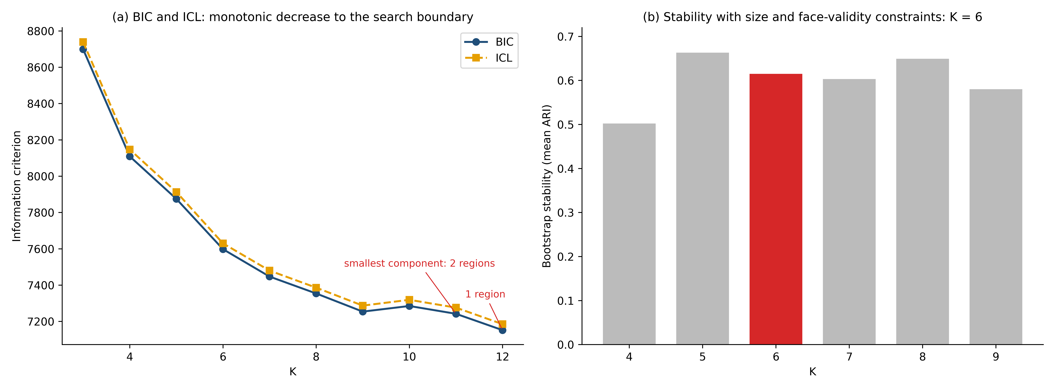
Figure A3. Diagnostics for the number of roles K.
Note: (a) Information criteria (BIC, ICL) on the calibration sample; (b) bootstrap stability, mean adjusted Rand index over region-resampled refits. Source: authors’ calculations.
Appendix A4. Membership uncertainty and discriminant validity
A4.1 Membership uncertainty. Mean modal membership under the corrected scoring is 0.76 (47% of regions ≥ 0.80). Fifty-one regions (22%) fall below 0.60 and are boundary cases between adjacent roles (Table A4). These regions motivate the use of membership probabilities as the measurement of record.
Table A4. Boundary regions (maximum average corrected membership below 0.60).
Region | Modal role | Max membership
Gyeongsan, Gyeongbuk | Landing zone | 0.339
Seogwipo, Jeju | Supplier–return | 0.346
Yuseong-gu, Daejeon | Landing zone | 0.349
Hanam, Gyeonggi | Gradual outflow | 0.366
Hongseong, Chungnam | Low-mobility anchor | 0.376
Dong-gu, Busan | Escalator | 0.399
Gwangsan-gu, Gwangju | Landing zone | 0.399
Yeoju, Gyeonggi | Landing zone | 0.413
Dongducheon, Gyeonggi | Gradual outflow | 0.421
Yeonje-gu, Busan | Gradual outflow | 0.425
Gwacheon, Gyeonggi | High-turnover reception | 0.447
Goyang, Gyeonggi | Landing zone | 0.449
Muan, Jeonnam | High-turnover reception | 0.450
Anseong, Gyeonggi | Landing zone | 0.458
Uiwang, Gyeonggi | Gradual outflow | 0.462
Pyeongtaek, Gyeonggi | Landing zone | 0.470
Sokcho, Gangwon | Gradual outflow | 0.480
Dalseong, Daegu | Landing zone | 0.484
Uijeongbu, Gyeonggi | Gradual outflow | 0.486
Wanju, Jeonbuk | High-turnover reception | 0.490
Jeungpyeong, Chungbuk | Landing zone | 0.492
Nam-gu, Gwangju | Gradual outflow | 0.499
Gimpo, Gyeonggi | Landing zone | 0.507
Wando, Jeonnam | Supplier–return | 0.515
Suwon, Gyeonggi | Gradual outflow | 0.515
Dong-gu, Gwangju | High-turnover reception | 0.516
Siheung, Gyeonggi | Landing zone | 0.517
Ulju, Ulsan | Landing zone | 0.519
Mungyeong, Gyeongbuk | Supplier–return | 0.525
Yesan, Chungnam | Supplier–return | 0.528
Gijang, Busan | Landing zone | 0.529
Naju, Jeonnam | Supplier–return | 0.534
Icheon, Gyeonggi | Low-mobility anchor | 0.538
Mokpo, Jeonnam | Gradual outflow | 0.538
Namdong-gu, Incheon | Gradual outflow | 0.540
Ansan, Gyeonggi | Gradual outflow | 0.544
Damyang, Jeonnam | Supplier–return | 0.545
Seocheon, Chungnam | Low-mobility anchor | 0.545
Saha-gu, Busan | Low-mobility anchor | 0.555
Dong-gu, Ulsan | Gradual outflow | 0.560
Dongdaemun-gu, Seoul | Escalator | 0.563
Dong-gu, Daejeon | Gradual outflow | 0.564
Gangdong-gu, Seoul | Gradual outflow | 0.566
Buk-gu, Busan | Gradual outflow | 0.568
Sejong | High-turnover reception | 0.570
Osan, Gyeonggi | Landing zone | 0.575
Gapyeong, Gyeonggi | Supplier–return | 0.577
Buk-gu, Ulsan | Landing zone | 0.584
Jincheon, Chungbuk | Landing zone | 0.588
Dangjin, Chungnam | Low-mobility anchor | 0.591
Gongju, Chungnam | Supplier–return | 0.592
Note: Regions in ascending order of maximum membership; modal role under corrected scoring, 2008–2025 average. Source: authors’ calculations.
A4.2 Roles are not spatial communities. A connectivity-based clustering (pooled OD composition profiles, spectral reduction, K = 6) recovers geographically contiguous communities and agrees with the role partition only at ARI = 0.11. Functional roles, defined by age-schedule shape, are therefore close to orthogonal to spatial communities defined by exchange intensity — the measured structure is not a repackaging of regional adjacency.
Appendix A5. Longitudinal validation: inference details
Table A5. Diagonal-minus-placebo differences Δ(a,k) with cluster-bootstrap 95% confidence intervals (B = 400).
Arrival age | k = 3 | k = 5 | k = 7 | k = 10
25 | −0.116 [−0.162, −0.073] | −0.152 [−0.198, −0.106] | −0.099 [−0.158, −0.037] | −0.088 [−0.143, −0.031]
28 | −0.120 [−0.153, −0.094] | −0.130 [−0.161, −0.094] | −0.123 [−0.157, −0.086] | −0.121 [−0.156, −0.077]
32 | ≈ 0 (all CIs cover zero)
Note: Δ(a,k) as in equation (4). Grid inference (B = 250) across arrival ages 20–40 at the five-year horizon: Δ significantly negative at ages 23 and 25–30 (peak −0.224 at age 26); positive but non-significant at 20–22 (up to +0.090, CI [−0.001, +0.175]); indistinguishable from zero from age 31 onward. Source: authors’ calculations from MDIS microdata.
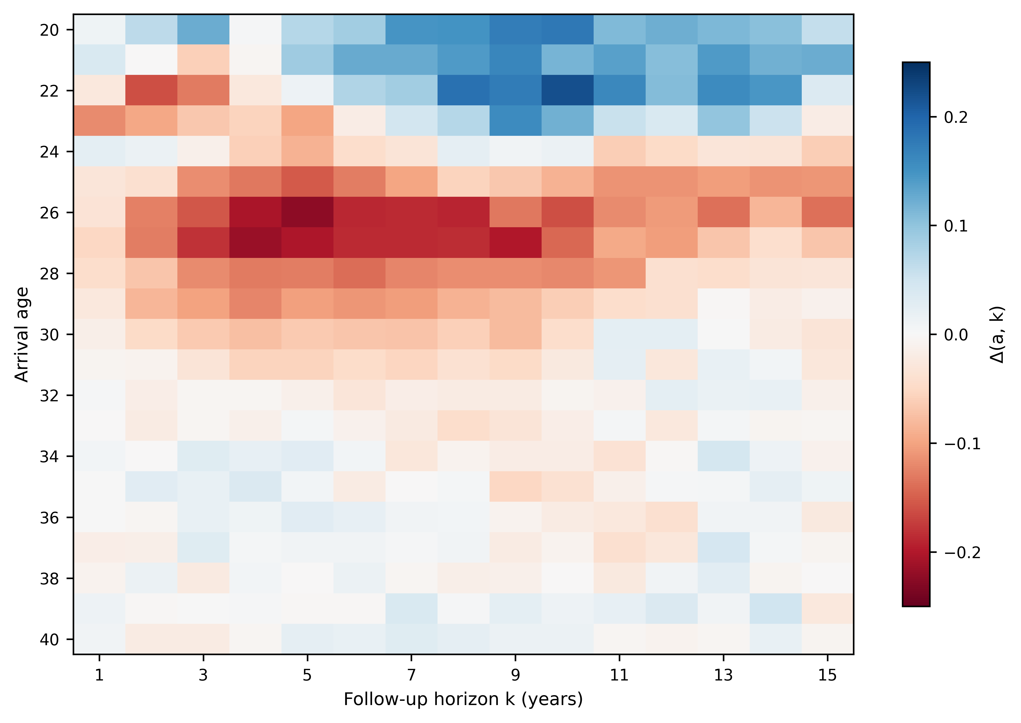
Figure A5. Cohort-specific onward migration across the full arrival-age grid.
Note: Cells show Δ(a,k) over arrival ages 20–40 and horizons 1–15 (red = excess exit, blue = retention): retention for arrivals at 20–22 (Δ up to +0.09 at k = 5), peak excess exit at arrival age 26 (Δ = −0.224 at k = 5), and null effects from arrival age 31 onward. For contrast, aggregate lagged band correlations dip at k = 5–7 for every age pairing including mechanism-free placebos (business-cycle confounding), and decade-cumulated designs are dominated by profile persistence (r = +0.89). Source: authors’ calculations from MDIS microdata.

