Supplementary Table S1. Clinical Outcomes According to Polypharmacy Status Among Geriatric Patients

Variable | No Polypharmacy (n=59) | Polypharmacy (n=92) | p value
Clinical outcomes
Length of hospital stay, days  (mean rank) | 61.98 | 84.99 | 0.002
Overall 28-day outcome
(overall p=0.535)
Discharged | 54 (91.5) | 79 (85.9) | 0.295
ICU transfer | 1 (1.7) | 5 (5.4)
Ongoing hospitalization | 2 (3.4) | 3 (3.3)
Death | 2 (3.4) | 5 (5.4) | 0.705

Supplementary Table S2. ROC Analysis of Frailty Instruments for Prediction of Poor 28-Day Outcome Among Geriatric Patients
Frailty Instrument | AUC | 95% CI | p-value
FRAIL Score | 0.696 | 0.579–0.813 | 0.007
Clinical Frailty Scale | 0.823 | 0.702–0.944 | <0.001
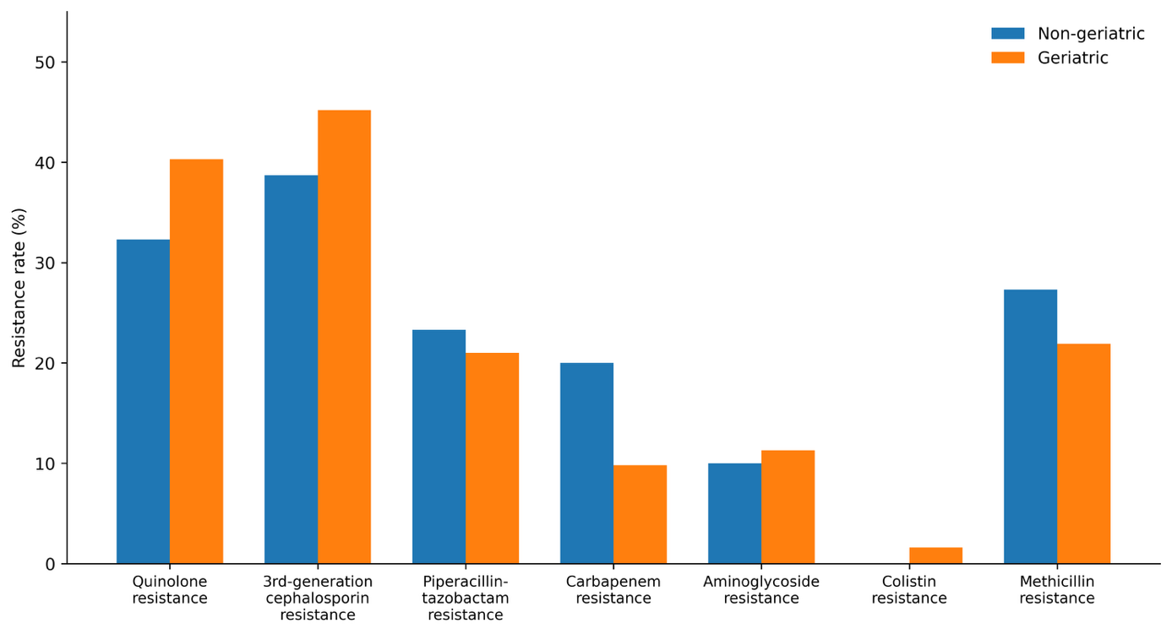

Supplementary Figure S1. Comparison of antimicrobial resistance rates between geriatric and non-geriatric patients.

