Supporting Information
Hydrogen Bonding-Driven Structural and Mechanical Regulation of Poly(ε-caprolactone)-Based Polyurethane with Poly(glycolic acid)

Han Wu¹, Wenjie Pan², Yuan Gao², Mingyang Wang², Zhenbo Ning², Ni Jiang²*

¹ China Institute of Atomic Energy. Beijing 102413, China
² Beijing Laboratory of Biomedical Materials, State Key Laboratory of Organic-Inorganic Composites, College of Life Science and Technology, Beijing University of Chemical Technology, Beijing 100029, China

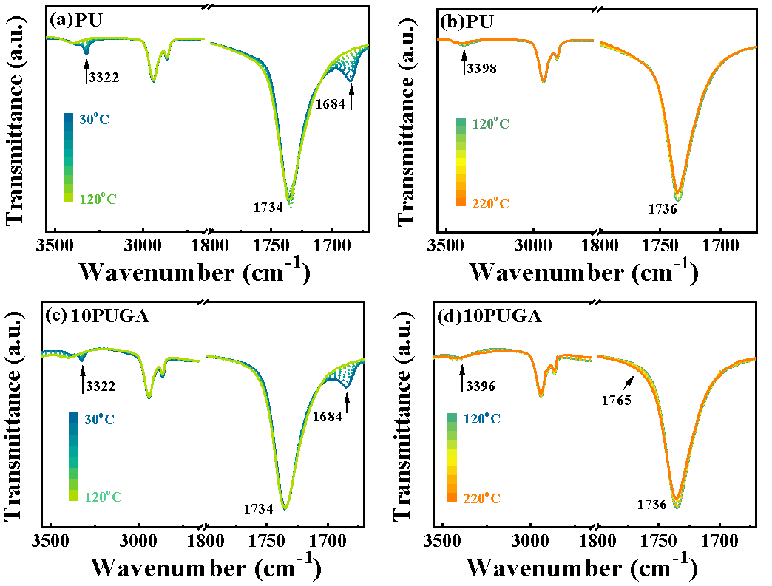
Fig. S1. The in situ FTIR spectra of (a,b) PU and (c,d) 10PUGA from 30ºC to 220ºC.

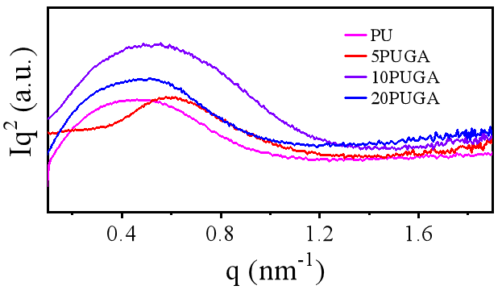
Fig. S2. The Lorentz-corrected SAXS profiles of PU and PUGAs.
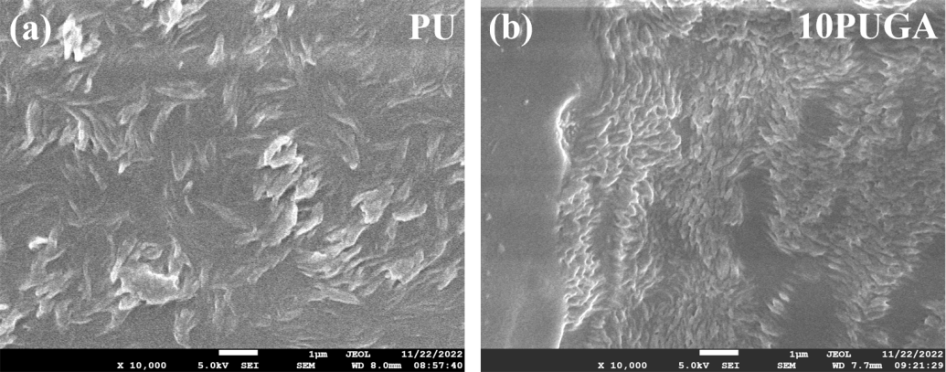
Fig. S3. SEM images of tensile-fractured surfaces of (a) PU and (b) 10PUGA.

Table S1. The q_{max} and long period (L) of PU and PUGAs
Sample | q_{max} (nm⁻¹) | L (nm)
PU | 0.465 | 13.5
5PUGA | 0.563 | 11.2
10PUGA | 0.540 | 11.6
20PUGA | 0.507 | 12.4

Table S2. Thermal properties of PU and PUGAs
Sample | T_{c(PCL)} (°C) | ΔH_{c(PCL)} (J/g) | T_{m(PCL)} (°C) | ΔH_{m(PCL)} (J/g) | T_{m(PGA)} (°C)
PU | 1.9 | 28.3 | 43.5 | 28.6 | -
5PUGA | -4.6 | 26.3 | 43.1 | 27.4 | -
10PUGA | -5.6 | 25.5 | 39.9 | 25.6 | 200.1
20PUGA | -10.8 | 22.4 | 35.9 | 23.0 | 199.9

Table S3. Mechanical properties of PU and PUGAs
Sample | Tensile strength (MPa) | Elongation at break (%) | Tensile toughness (MJ·m⁻³)
PU | 17.7±1.8 | 832.3±77.6 | 109.1±16.6
5PUGA | 26.0±5.7 | 1090.6±136.3 | 164.3±42.1
10PUGA | 54.1±4.8 | 1389.0±45.4 | 329.0±36.7
20PUGA | 43.3±0.1 | 1191.7±70.6 | 245.2±13.3

