Supplementary material

(–)-ESI-MS of mannoheptulose (m/z 209.0668 [M – H]–).
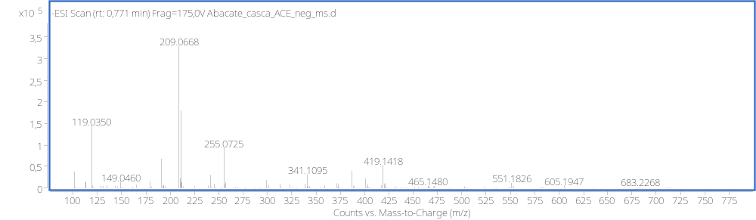
(–)-ESI-MS/MS of at mannoheptulose at 15 eV (m/z 209.0668 [M – H]–).
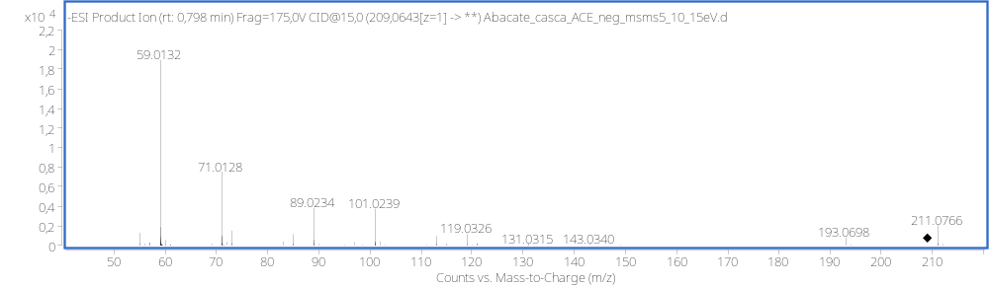
(–)-ESI-MS of Malic acid (m/z 133 .0144 [M – H]–).
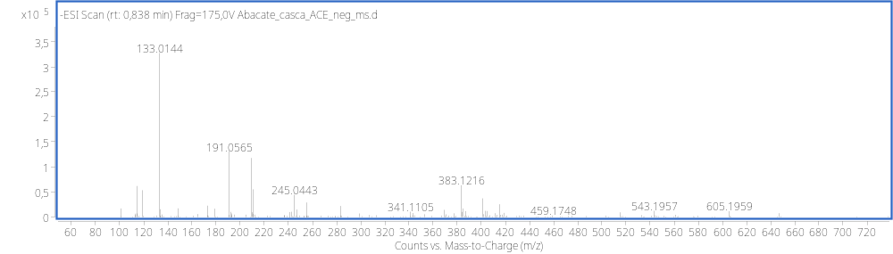
(–)-ESI-MS/MS of Malic acid at 20 eV (m/z 133 .0144 [M – H]–).
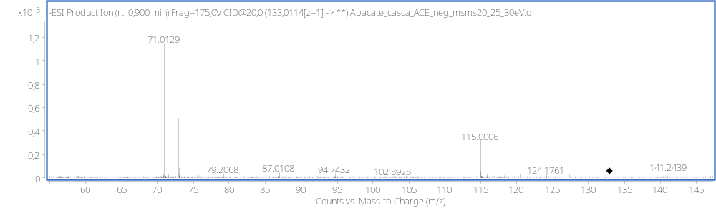

(–)-ESI-MS of Quinic acid (m/z 191.0565 [M – H]–).
(–)-ESI-MS/MS of Quinic acid (m/z 191.0565 [M – H]–).
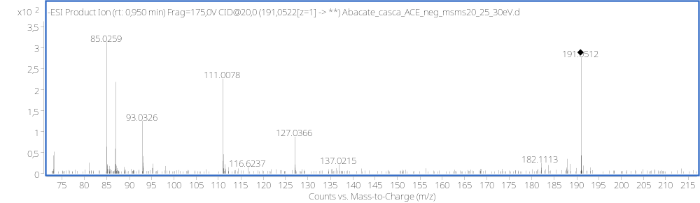
(–)-ESI-MS of Succinic acid (m/z 117.0194 [M – H]–).
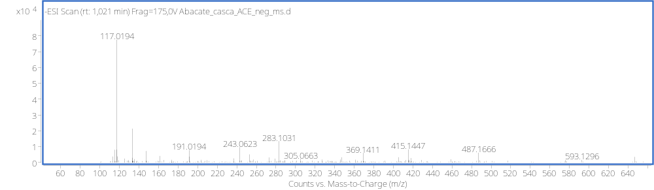
(–)-ESI-MS/MS of Succinic acid at 15 eV (m/z [M – H]–).
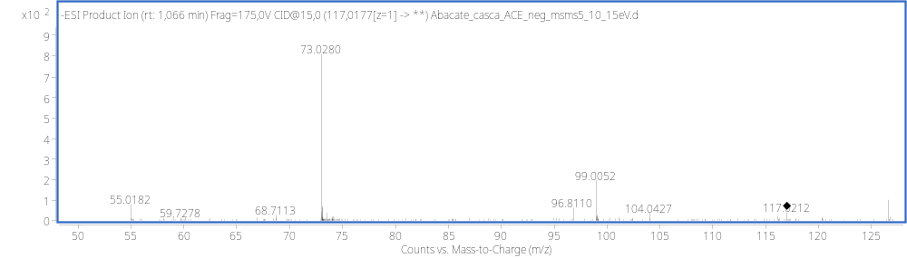

(–)-ESI-MS of Dihydroxybenzoic acid glucoside (m/z 315.0718 [M – H]–).
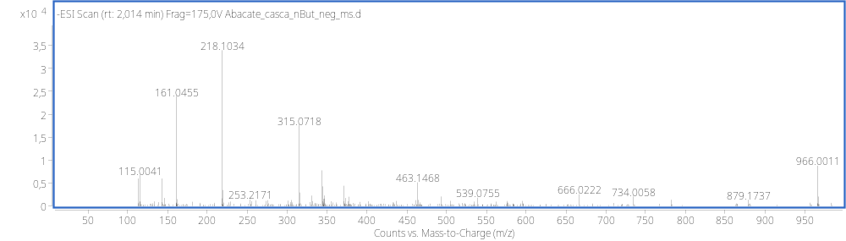
(–)-ESI-MS/MS of Dihydroxybenzoic acid glucoside at (m/z 315.0718 [M – H]–).
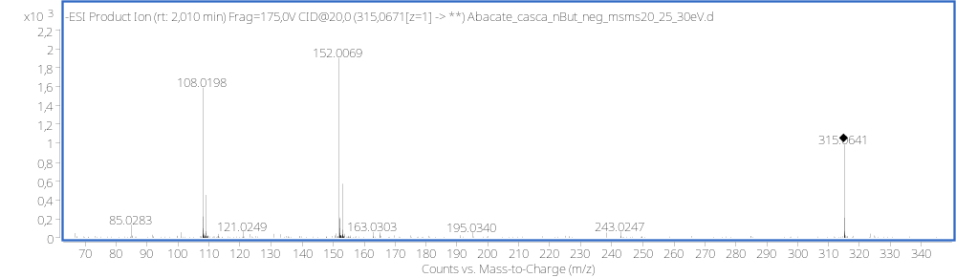
(–)-ESI-MS of Hydroxytyrosol Glucoside (m/z 315.1085 [M – H]–).
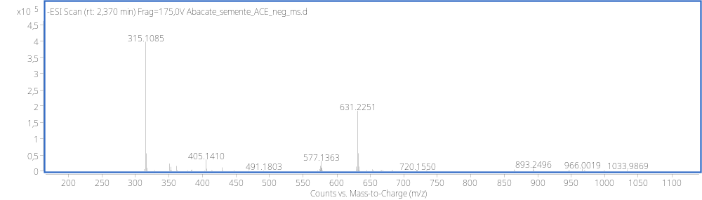
(–)-ESI-MS/MS of Hydroxytyrosol Glucoside at (m/z 315.1085 [M – H]–).
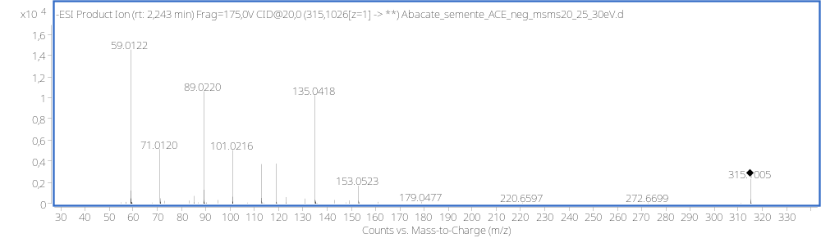

(–)-ESI-MS of Chlorogenic acid isomer I (m/z 353.0881 [M – H]–).
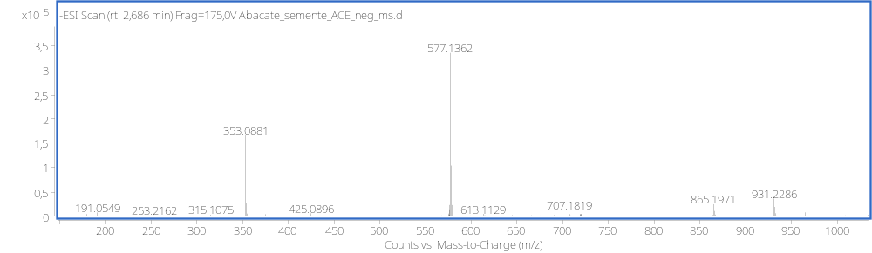
(–)-ESI-MS/MS of Chlorogenic acid isomer I at 20 eV (m/z 353.0881 [M – H]–).
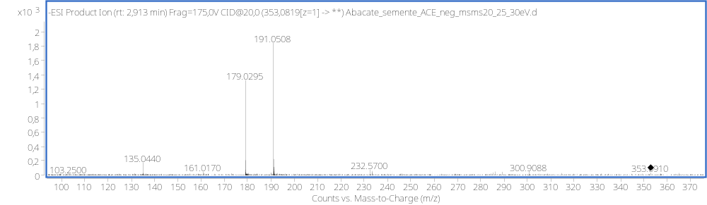
(–)-ESI-MS of Caffeic acid glucoside (m/z 341.1084 [M – H]–).
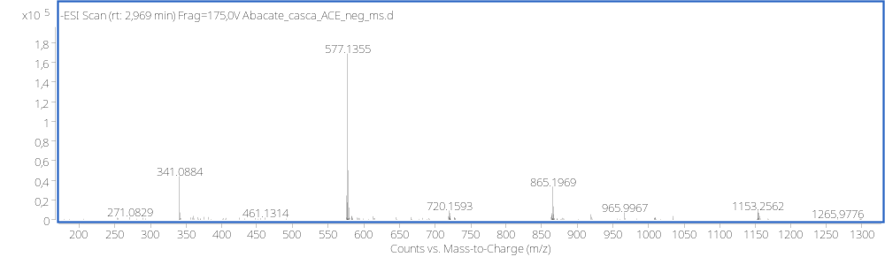
(–)-ESI-MS/MS of Caffeic acid glucoside at 25 eV (m/z 341.1084 [M – H]–).
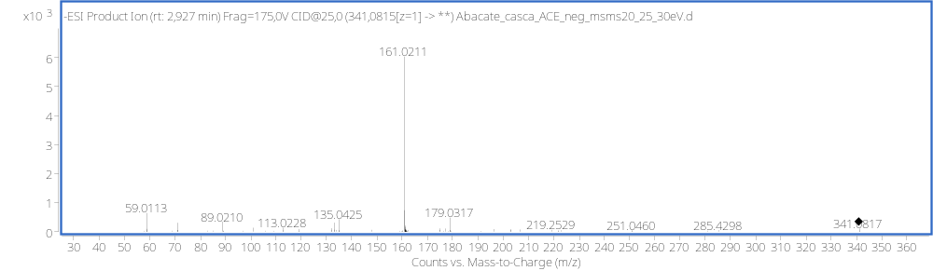

(–)-ESI-MS of Procyanidin B-type ((epi)catechin dimer) Isomer I (m/z 577.1355 [M – H]–).
(–)-ESI-MS/MS of Procyanidin B-type ((epi)catechin dimer) Isomer I at 20 eV (m/z 577.1355 [M – H]–).
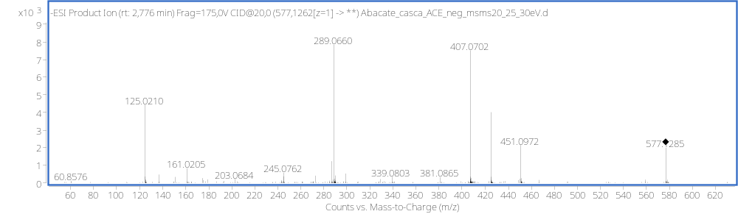
(–)-ESI-MS of Procyanidin B-type ((epi)catechin quatramer) isomer I (m/z 1153.2611 [M – H]–).
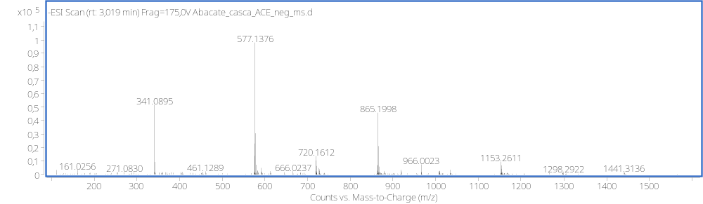
(–)-ESI-MS/MS of Procyanidin B-type ((epi)catechin quatramer) isomer I at 30 eV (m/z 1153.2611 [M – H]–).
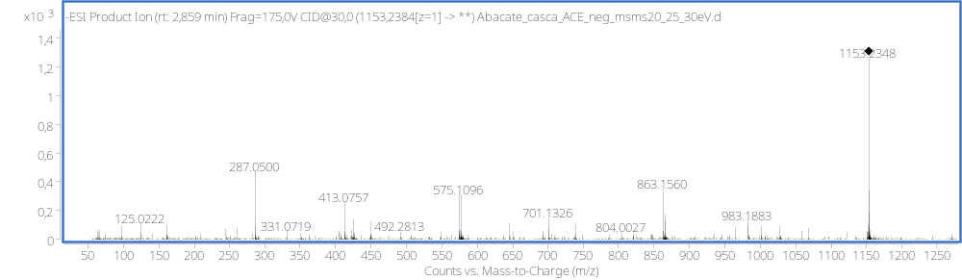

(–)-ESI-MS of Procyanidin trimer B-type ((epi)catechin trimer) isomer I (m/z 865.1976 [M – H]–).
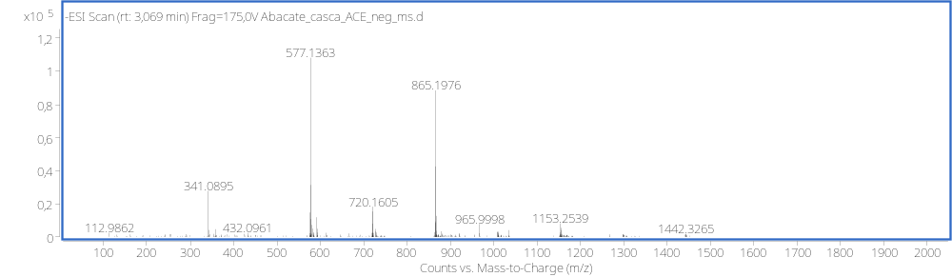
(–)-ESI-MS/MS of Procyanidin trimer B-type ((epi)catechin trimer) isomer I (m/z 865.1976 [M – H]–).
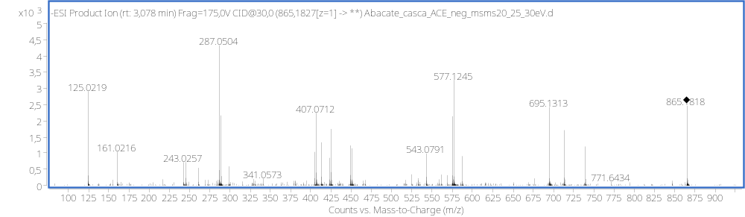
(–)-ESI-MS of coumaroylquinic acid (m/z 337.0931 [M – H]–).
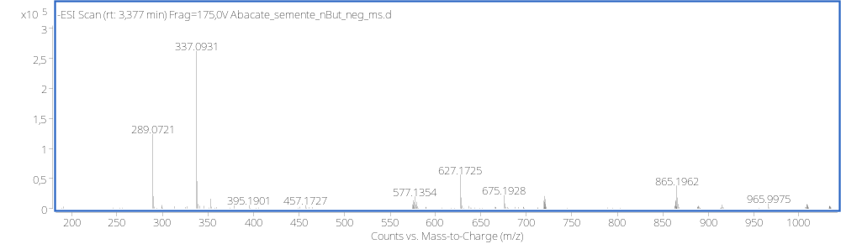
(–)-ESI-MS/ms of coumaroylquinic acid at (m/z 337.0931 [M – H]–).
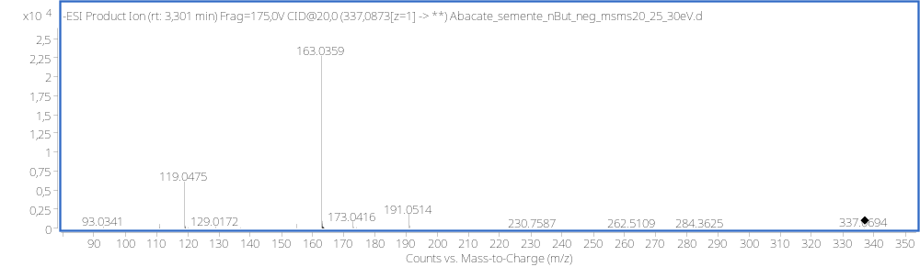

(–)-ESI-MS of catechin (m/z 289.0721 [M – H]–).
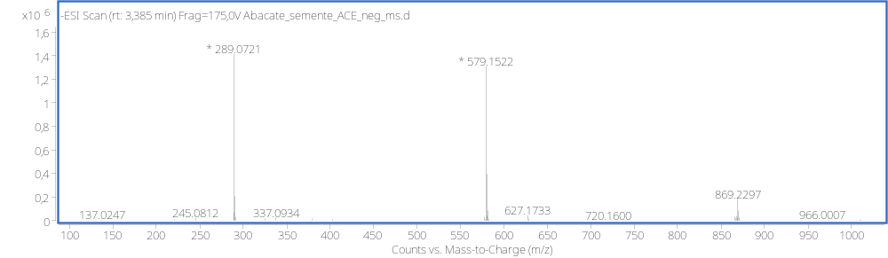
(–)-ESI-MS/MS of catechin at (m/z 289.0721 [M – H]–).
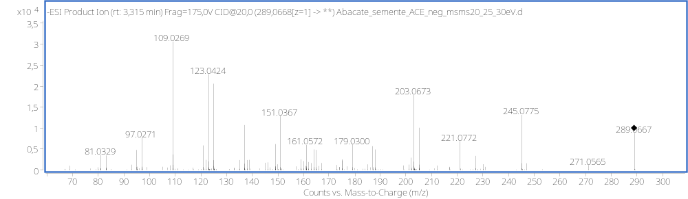
(–)-ESI-MS of Procyanidin B-type ((epi)catechin dimer) isomer II (m/z 577.1360 [M – H]–).
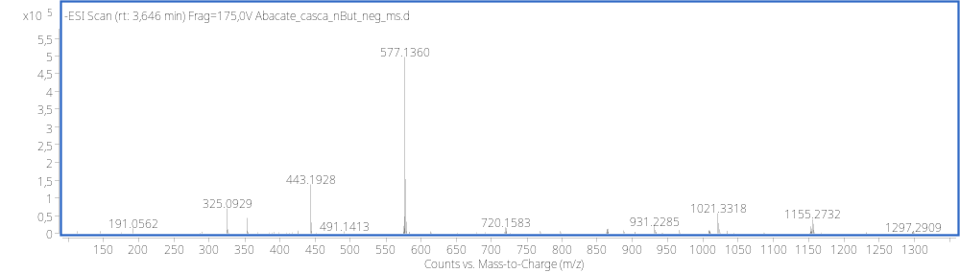
(–)-ESI-MS/MS of Procyanidin B-type ((epi)catechin dimer) isomer II at 20 eV (m/z 577.1360 [M – H]–).
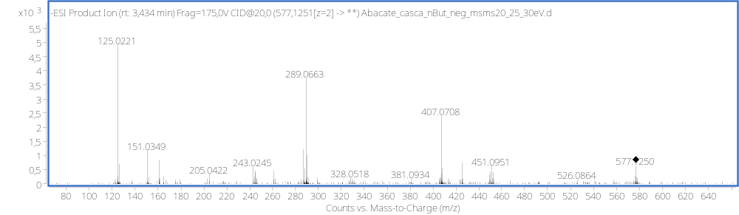

(–)-ESI-MS of Procyanidin trimer A-type ((epi)catechin trimer) (m/z 863.1829 [M – H]–).
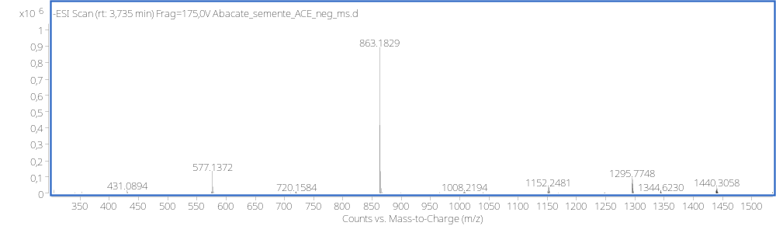
(–)-ESI-MS/MS of Procyanidin trimer A-type ((epi)catechin trimer) at 30 eV (m/z 863.1829 [M – H]–).
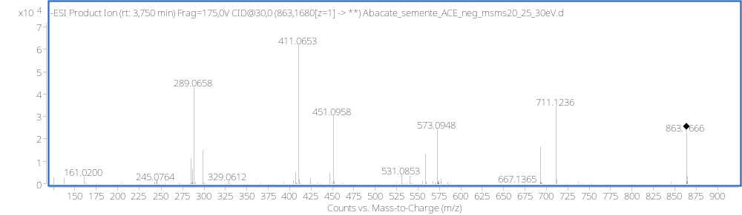
(–)-ESI-MS of Chlorogenic acid isomer II (m/z 353.0884 [M – H]–).
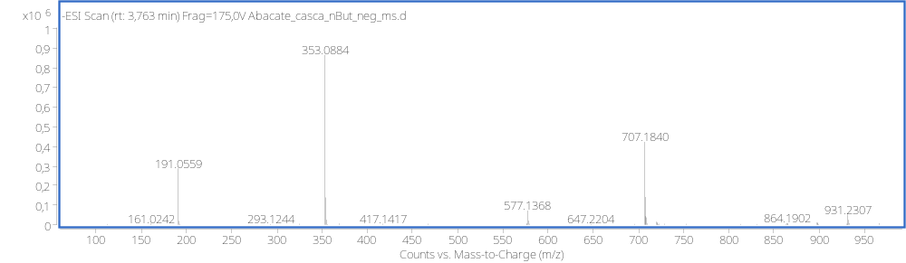
(–)-ESI-MS/MS of Chlorogenic acid isomer II at (m/z 353.0884 [M – H]–).
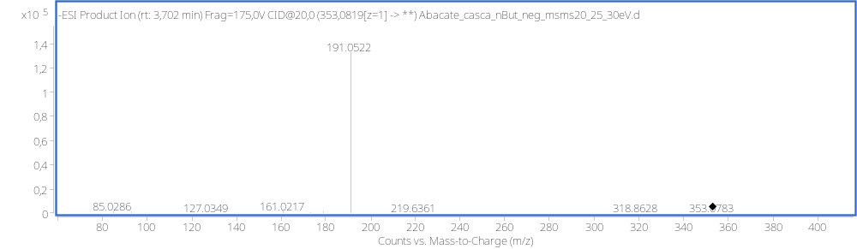

(–)-ESI-MS of Procyanidin B-type ((epi)catechin trimer) isomer II (m/z 865.1977 [M – H]–).
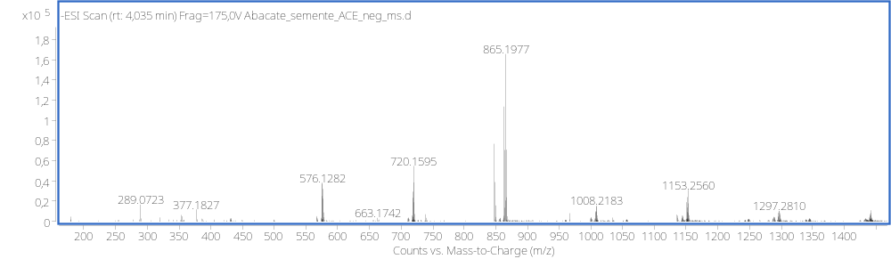
(–)-ESI-MS/MS of Procyanidin B-type ((epi)catechin trimer) isomer II at 25 eV (m/z 865.1977 [M – H]–).
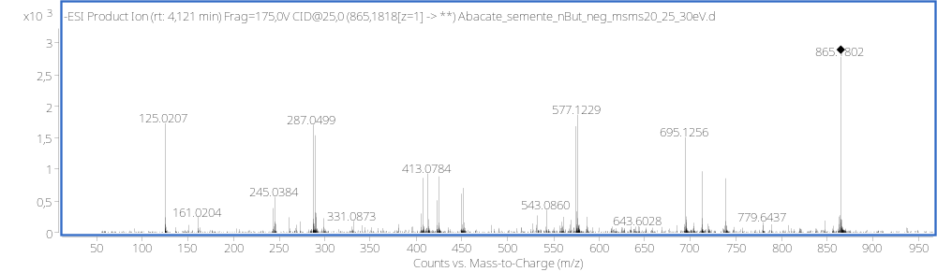
(–)-ESI-MS of Procyanidin B-type ((epi)catechin pentamer) (m/z 720.1609 [M – 2H]–).
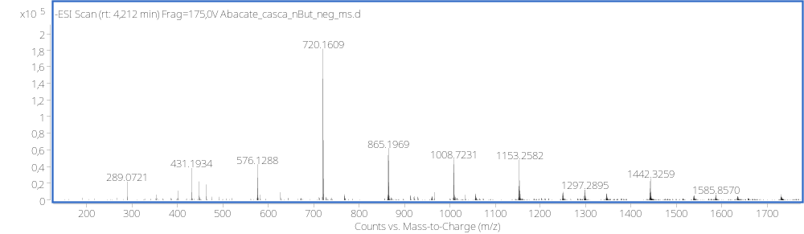
(–)-ESI-MS/MS of Procyanidin B-type ((epi)catechin pentamer) at 20 eV (m/z 720.1609 [M – 2H]–).
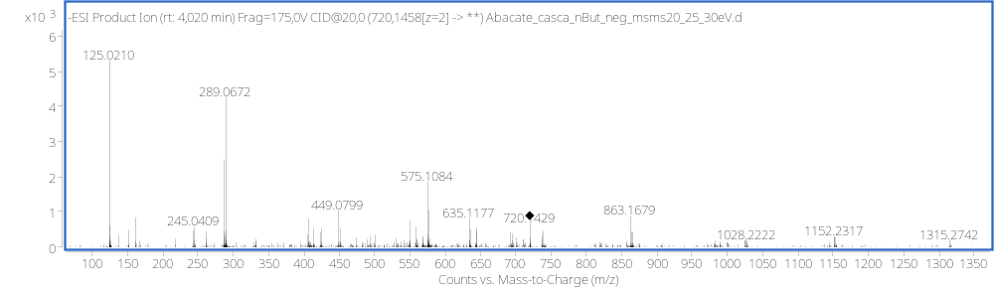

(–)-ESI-MS of Procyanidin B-type ((epi)catechin heptamers) (m/z 1008.7231
[M – 2H]–).
(–)-ESI-MS/MS of Procyanidin B-type ((epi)catechin heptamers) at 20 eV (m/z 1008.7231 [M – 2H]–).
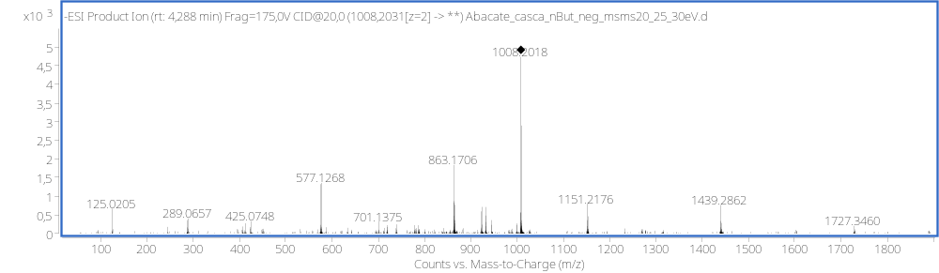
(–)-ESI-MS of Procyanidin B-type ((epi)catechin quatramer) isomer II (m/z 1153.2582 [M – H]–).
(–)-ESI-MS of Procyanidin B-type((epi)catechin hexamers) (m/z 864.1904 [M – 2H]–).
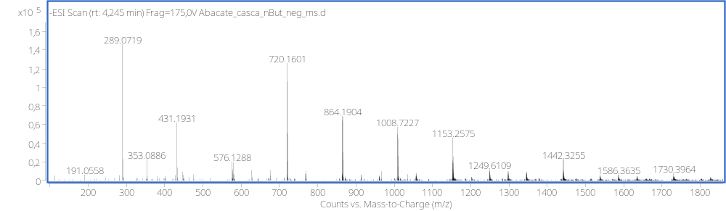

(–)-ESI-MS of epicatechin (m/z 289.0719 [M – H]–).
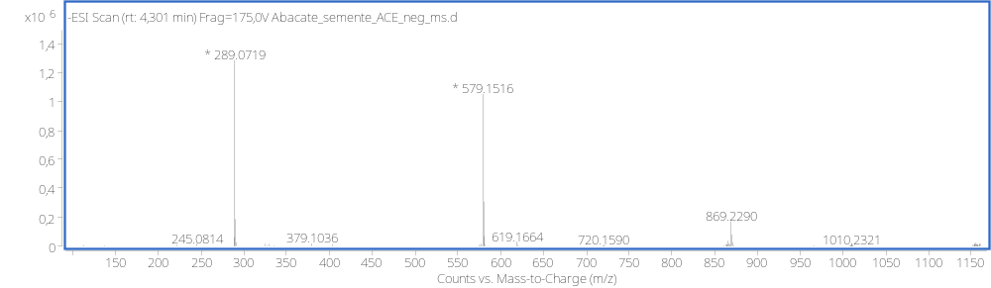
(–)-ESI-MS/MS of epicatechin at 20 eV (m/z 289.0719 [M – H]–).
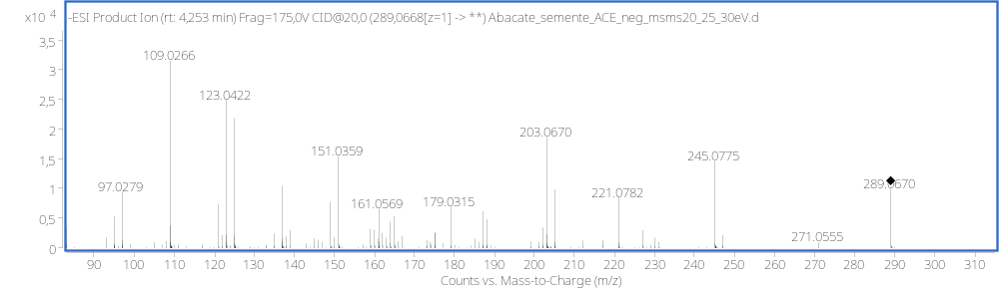
(–)-ESI-MS of coumaric acid (m/z 163.0403 [M – H]–).
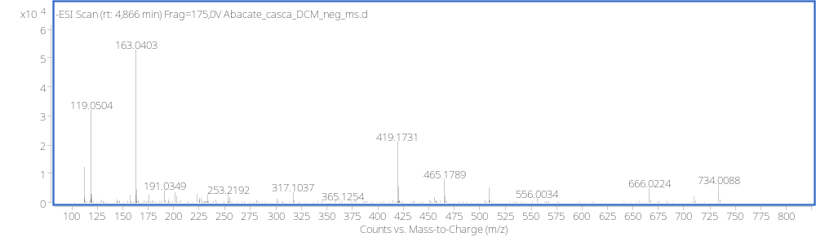
(–)-ESI-MS/MS of coumaric acid at 15 eV (m/z 163.0403 [M – H]–).
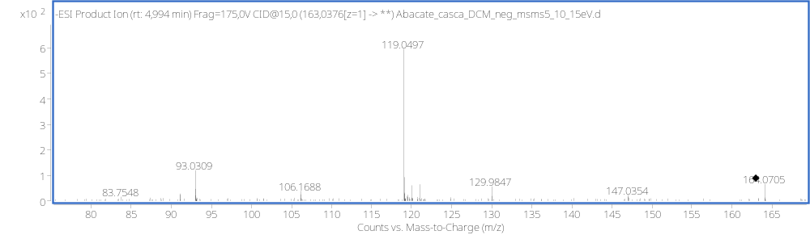

(–)-ESI-MS of Procyanidin A-type ((epi)catechin dimer) (m/z 575.1186 [M – H]–).
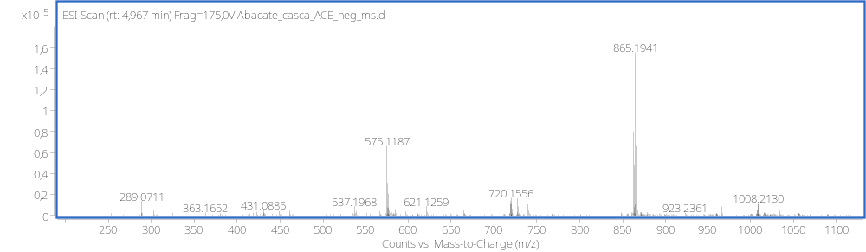
(–)-ESI-MS/MS of Procyanidin A-type at 20 eV (m/z 575.1186 [M – H]–).
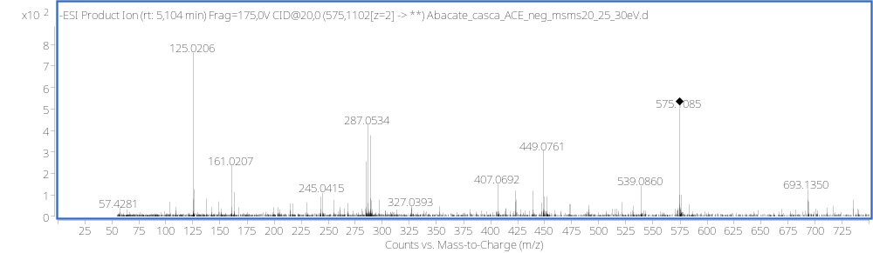
(–)-ESI-MS of Procyanidin B-type ((epi)catechin dimer) isomer III (m/z 577.1354 [M – H]–).
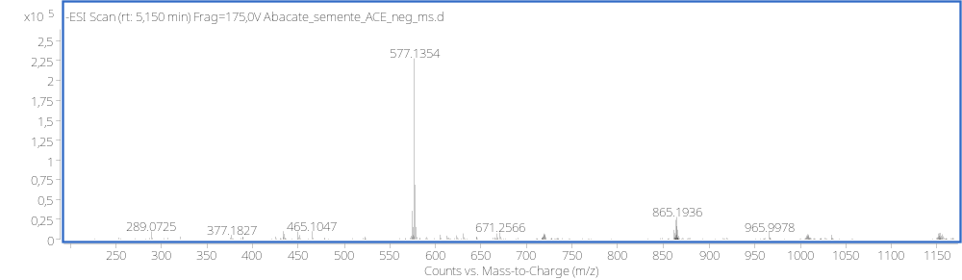
(–)-ESI-MS/MS of Procyanidin B-type ((epi)catechin dimer) isomer III at 15 eV (m/z 577.1354 [M – H]–).
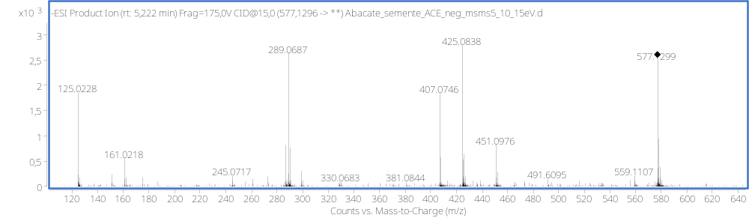

(–)-ESI-MS of Ferulic acid (m/z 193.0508 [M – H]–).
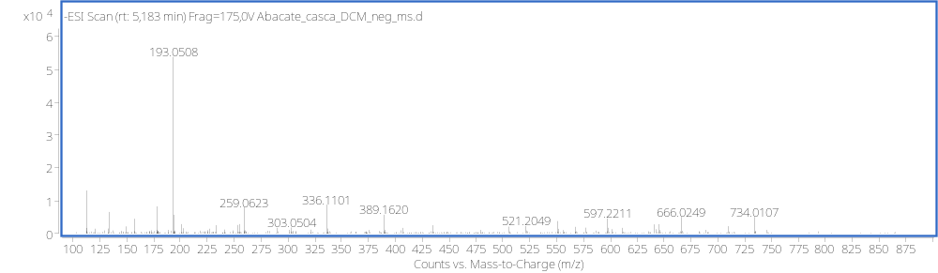
(–)-ESI-MS of Ferulic acid at 20 eV (m/z 193.0508 [M – H]–).
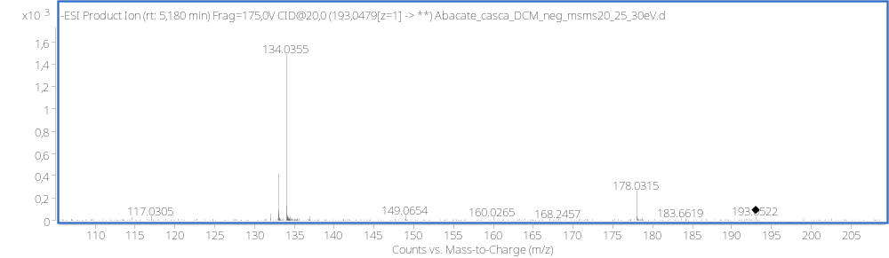
(–)-ESI-MS of Syringaresinol-glucoside (m/z 579.2095 [M – H]–).
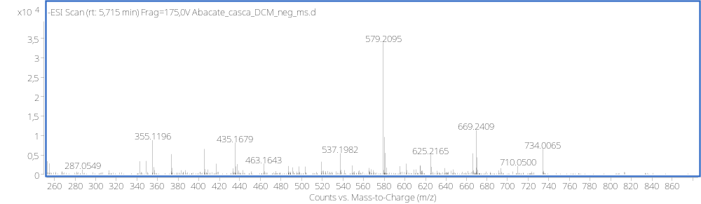
(–)-ESI-MS of Syringaresinol-glucoside at 20 eV (m/z 579.2095 [M – H]–).
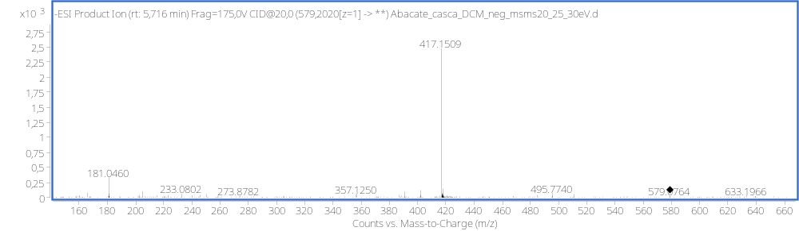

(–)-ESI-MS of Quercetin-O-hexoside (m/z 463.0878 [M – H]–).
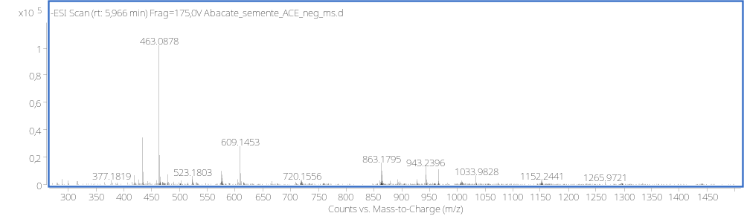
(–)-ESI-MS/MS of Quercetin-O-hexoside at 20 eV (m/z 463.0878 [M – H]–).
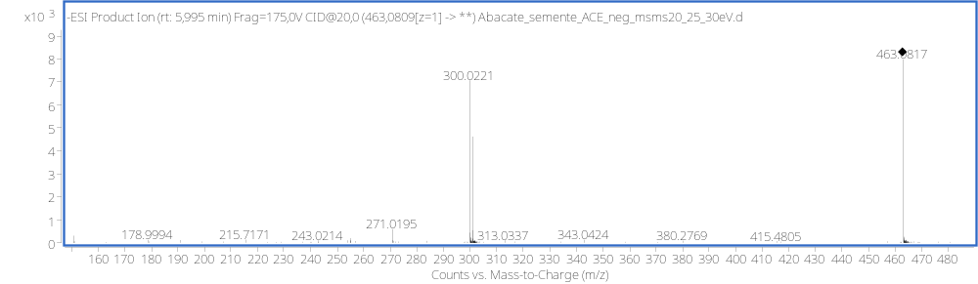
(–)-ESI-MS of Phloretin-C-hexoside (Nothofagin) (m/z 435.1306 [M – H]–).
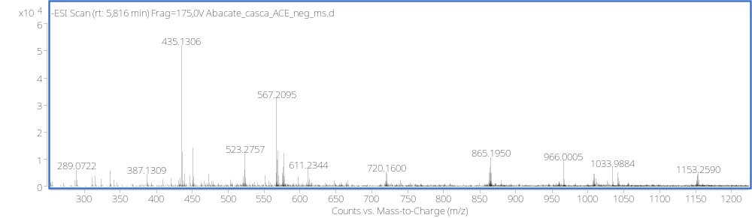
(–)-ESI-MS/MS of Phloretin-C-hexoside (Nothofagin) at 20 eV (m/z 435.1306 [M – H]–).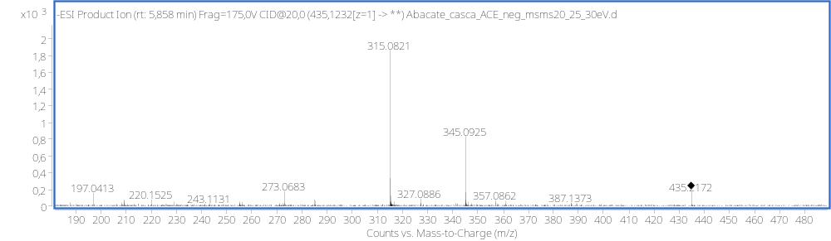

(–)-ESI-MS of Quercetin-O-glucuronic acid (m/z 477.0689 [M – H]–).
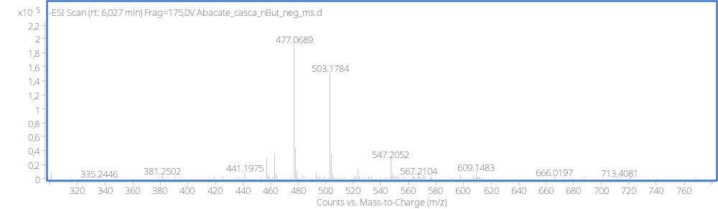
(–)-ESI-MS/MS of Quercetin-O-glucuronic acid at (m/z 477.0689 [M – H]–).
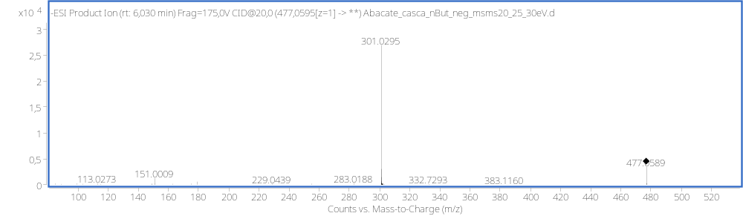
(–)-ESI-MS of Quercetin-O- rhamnoside (m/z 447.0934 [M – H]–).
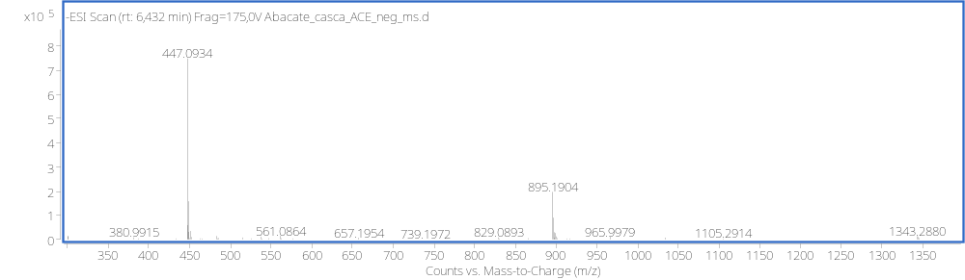
(–)-ESI-MS/MS of Quercetin-O- rhamnoside at 20 eV (m/z 447.0934 [M – H]–).
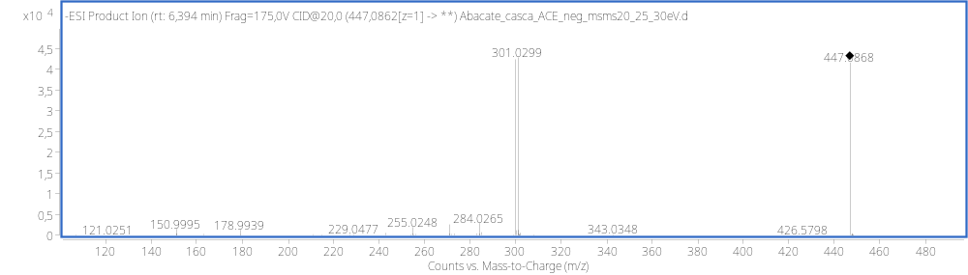

(–)-ESI-MS of Abscisic acid (m/z 263.1293 [M – H]–).
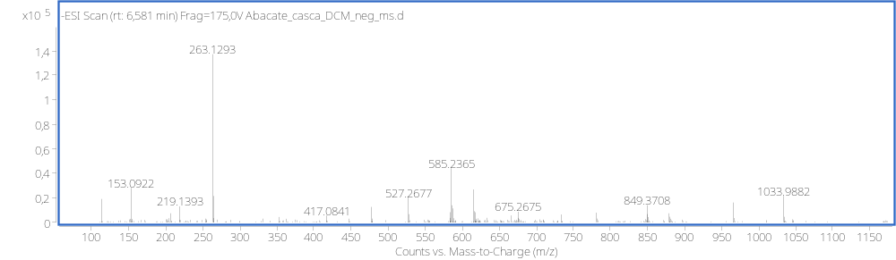
(–)-ESI-MS/MS of Abscisic acid at 15 eV (m/z 263.1293 [M – H]–).
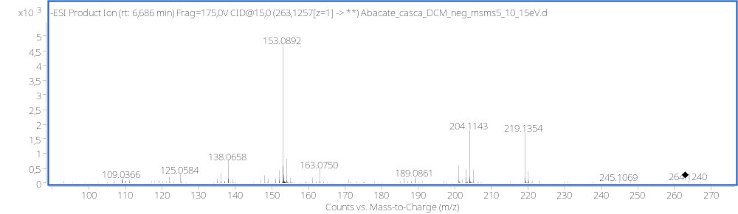
(–)-ESI-MS of ferulic acid (m/z 207.0662 [M – H]–).
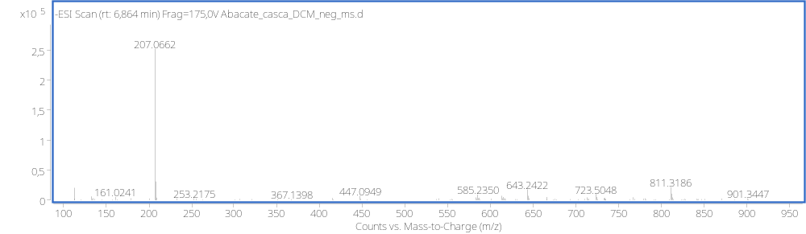
(–)-ESI-MS/MS of ferulic acid at 20 eV (m/z 207.0662 [M – H]–).
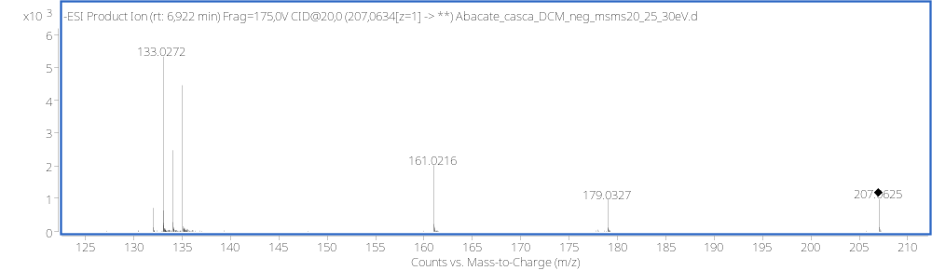

(–)-ESI-MS of Kaempferol-O-rhamnoside (m/z 431.0975 [M – H]–).
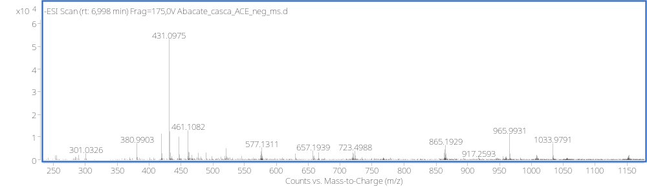
(–)-ESI-MS/MS of Kaempferol-O-rhamnoside at 20 eV (m/z 431.0975 [M – H]–).
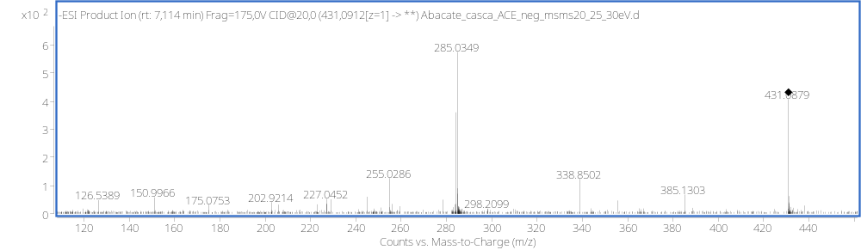
(–)-ESI-MS of Isorhamnetin-O-rhamnoside (m/z 461.1087 [M – H]–).
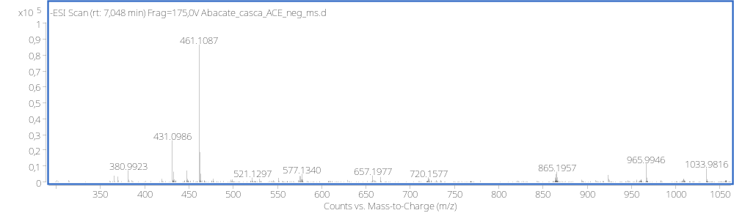
(–)-ESI-MS/MS of Isorhamnetin-O-rhamnoside at 30 eV (m/z 461.1087 [M – H]–).
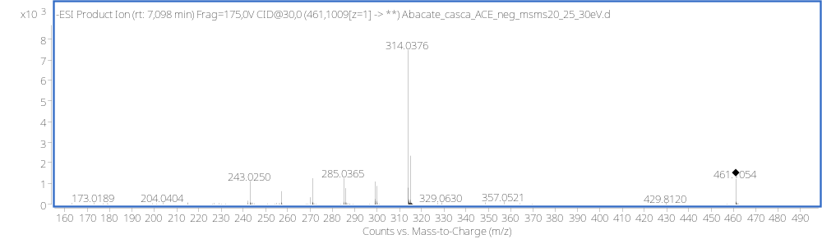

(–)-ESI-MS of Quercetin (m/z 301.0361 [M – H]–).
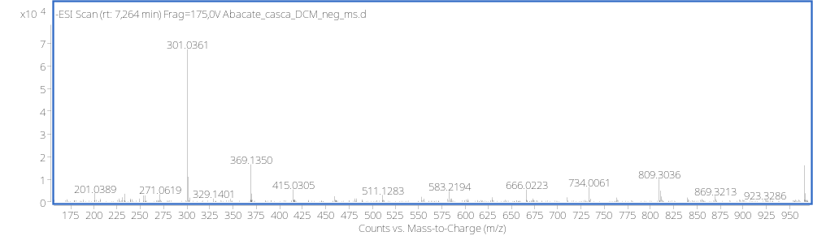
(–)-ESI-MS/MS of Quercetin at (m/z 301.0361 [M – H]–).
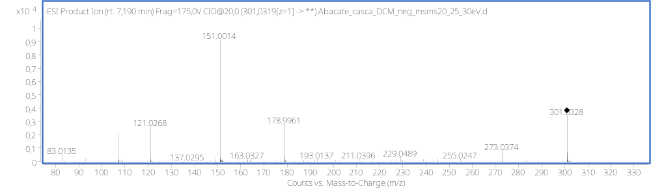
(–)-ESI-MS of Quercetin-O-p-coumaroyl)-rhamnoside 593.1300 (m/z [M – H]–).
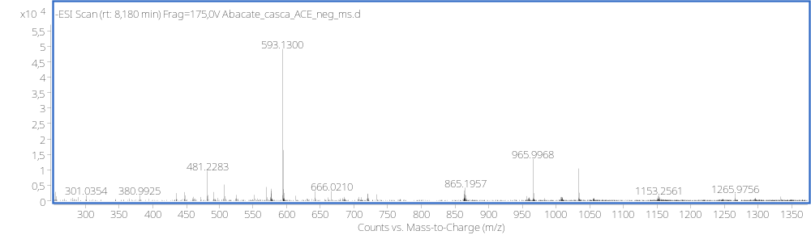
(–)-ESI-MS/MS of Quercetin-O-p-coumaroyl)-rhamnoside at (m/z 593.1300 (m/z [M – H]–).
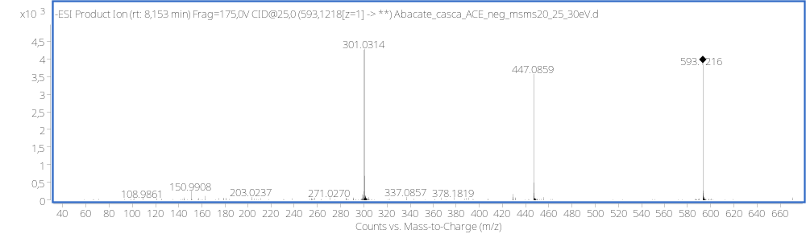

(–)-ESI-MS of Quercetin-O-(O-caffeoyl-O-p-coumaroyl)-rhamnoside (m/z 755.1626 [M – H]–).
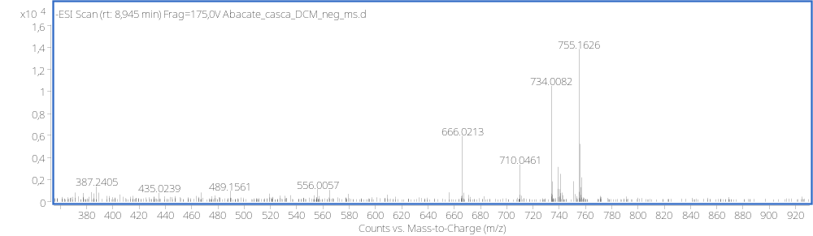
(–)-ESI-MS/MS of Quercetin-O-(O-caffeoyl-O-p-coumaroyl)-rhamnoside at 30 eV (m/z [M – H]–).
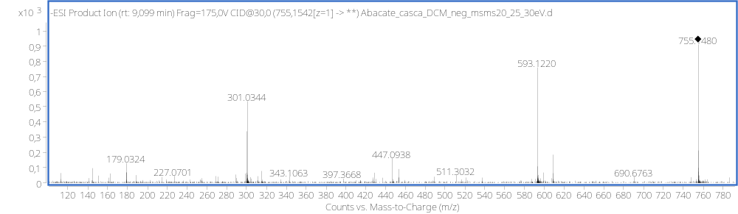
(–)-ESI-MS of Quercetin-O-(di-O-p-coumaroyl)-rhamnoside (m/z 739.1678 [M – H]–).
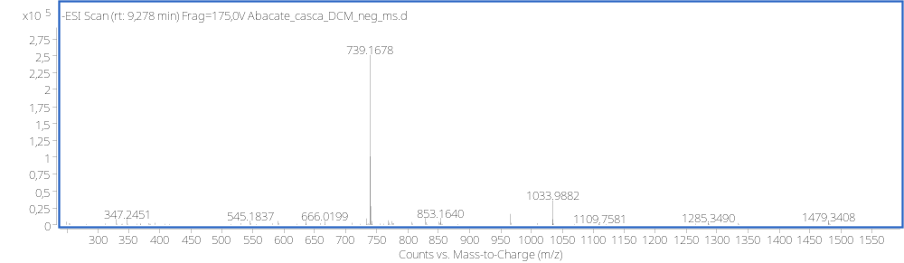
(–)-ESI-MS/MS of Quercetin-O-(di-O-p-coumaroyl)-rhamnoside at 30 eV (m/z 739.1678 [M – H]–).
