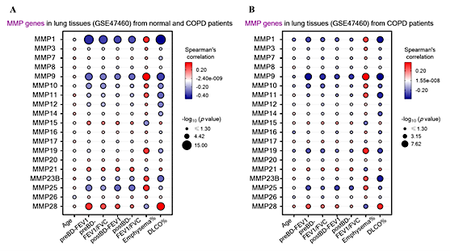
SI 1. The RNA analysis of lung tissues of normal control and COPD patients (GSE47460). (A) MMP-28 expression in normal control and COPD group, showed positive correlation with lung function and negative correlation with the severity of emphysema. In contrast, MMP-1, 9, and 25 showed negative correlation with lung functions and positive correlation with emphysema severity. (B) MMP-28 expression in only COPD group, showed the same expression pattern which was positive correlation with lung function and negative with emphysema severity.
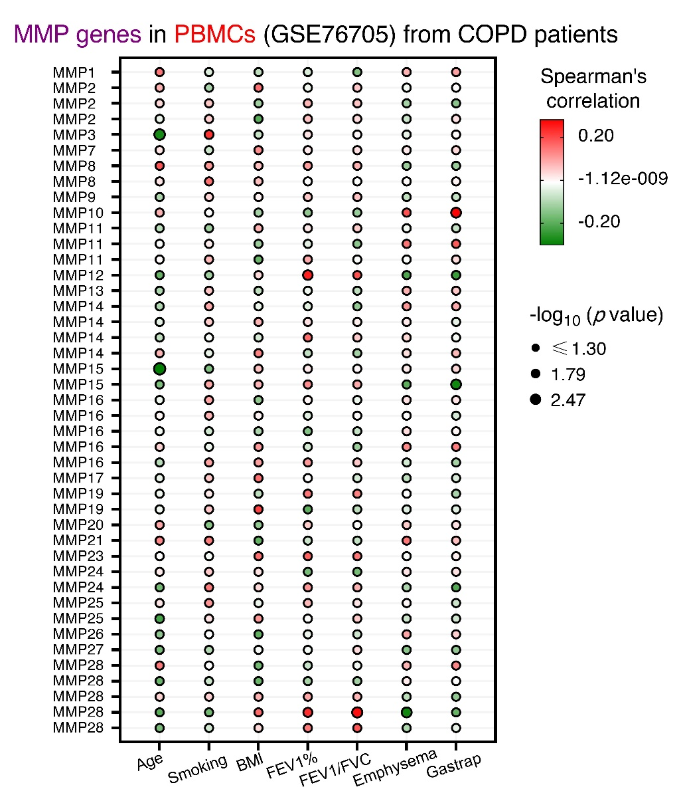
SI 2. RNA analysis of peripheral blood mononuclear cell (PBMC) from COPD patients (GSE76705). MMP-28 showed positive correlation with FEV1%, FEV/FVC, and negative correlation with emphysema, age, smoking and Gastrap.

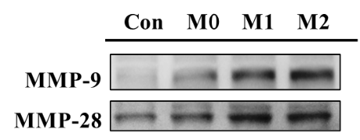
A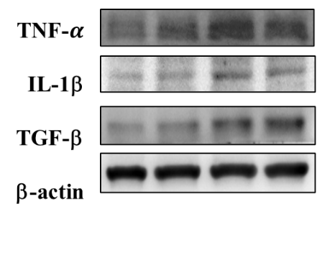 B
C D
EF
SI 3. The cytokine expression during the polarization of THP-1 cells into M0, M1, and M2 macrophage phenotypes. (A) MMP-9 expression increased during macrophage polarization, whereas MMP-28 expression was highest in M2 macrophages. The expression level was summarized as fold changes. (B) MMP-9 was prominent in M1 and M2 phenotypes. (C) MMP-28 was associated with M1 and M2. (D) TNF-α was more prominent with M1. (E) IL-1b was more prominent with M1 too. (F) TGF-b was more in M2 but in general it’s the same level in all phenotypes.
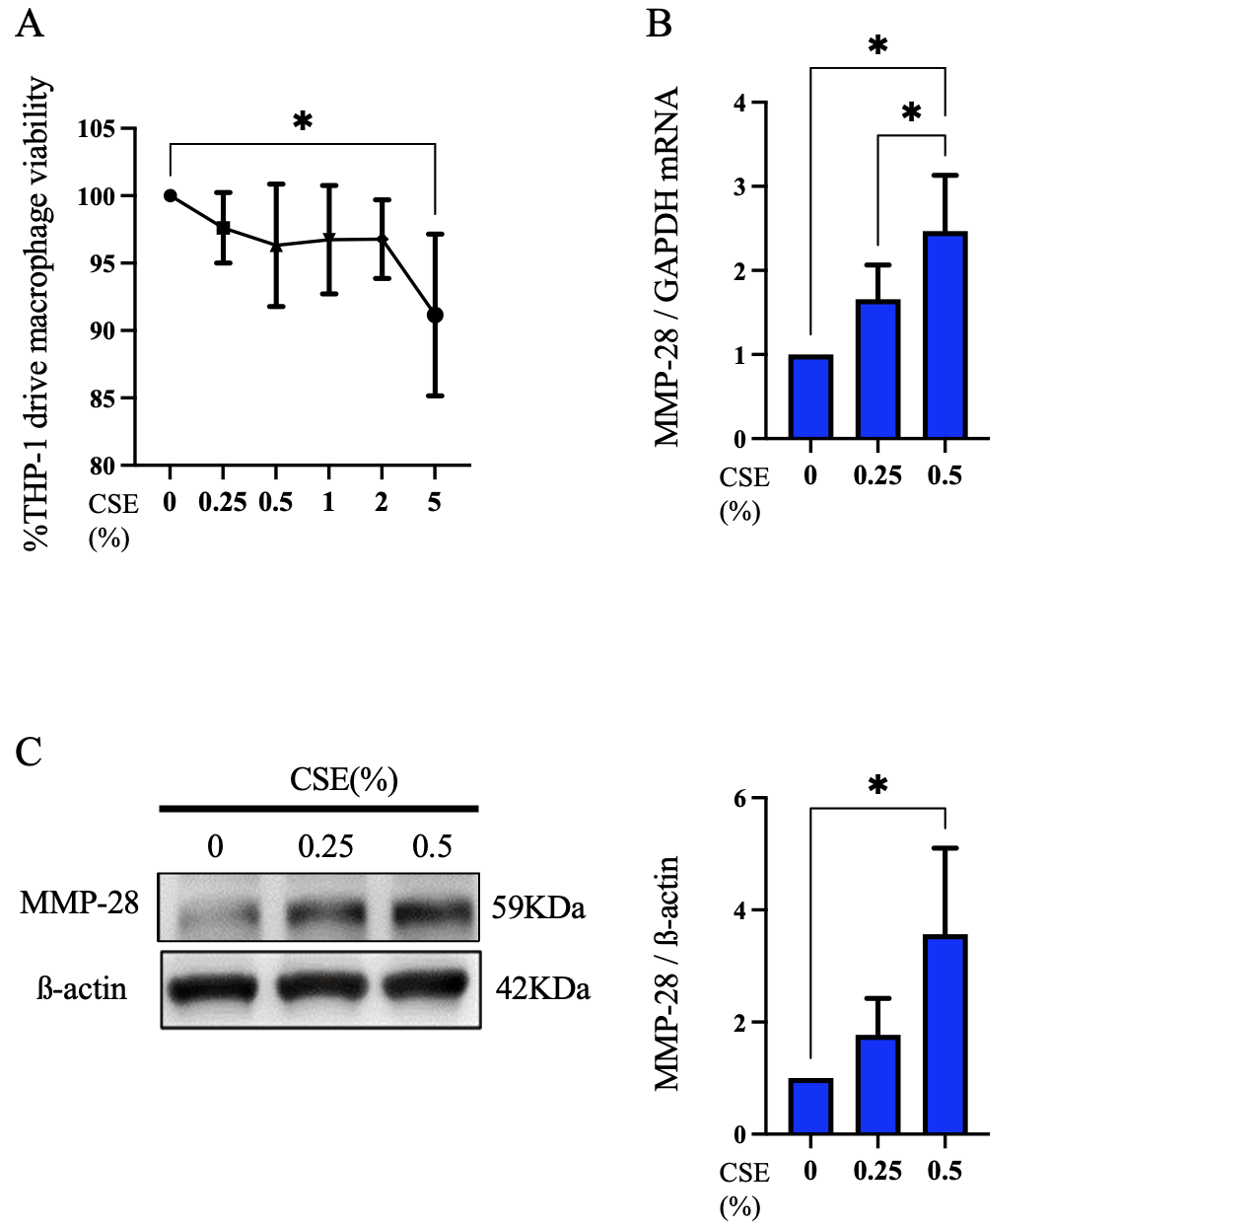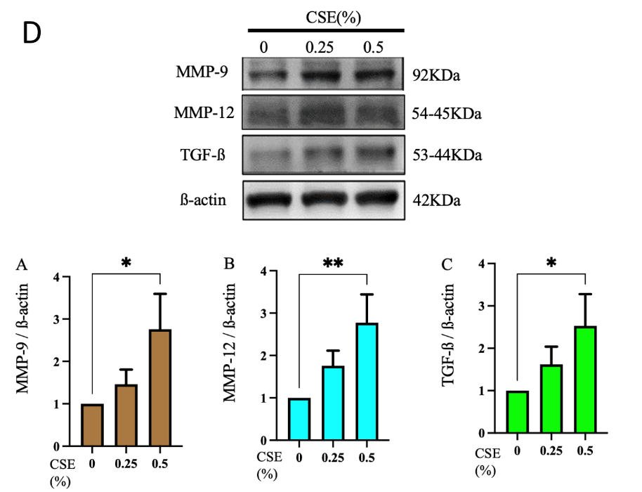
SI 4. Cigarette smoke extract (CSE) induces MMP-28 and extracellular matrix–related remodeling factors in THP-1–derived macrophages. (A) concentrations of CSE between 0.25%–2.00% exhibited low cytotoxicity (cell viability is above 90%), indicating a safe range for subsequent experiments. (B) The expression of mRNA of MMP-28 from THP-1 derived macrophages were induced by CSE. (C) Consistently, protein expression level showed a corresponding expression of MMP-28 protein with CSE exposure. (D) Moreover, as CSE exposure increased, the expression of tissue remodeling proteins, MMP-9, MMP-12, and TGF-β, which were produced by THP-1 macrophages, were markedly elevated. This suggests that CSE promotes macrophage-mediated extracellular matrix remodeling, which may contribute to tissue damage or pathological changes.

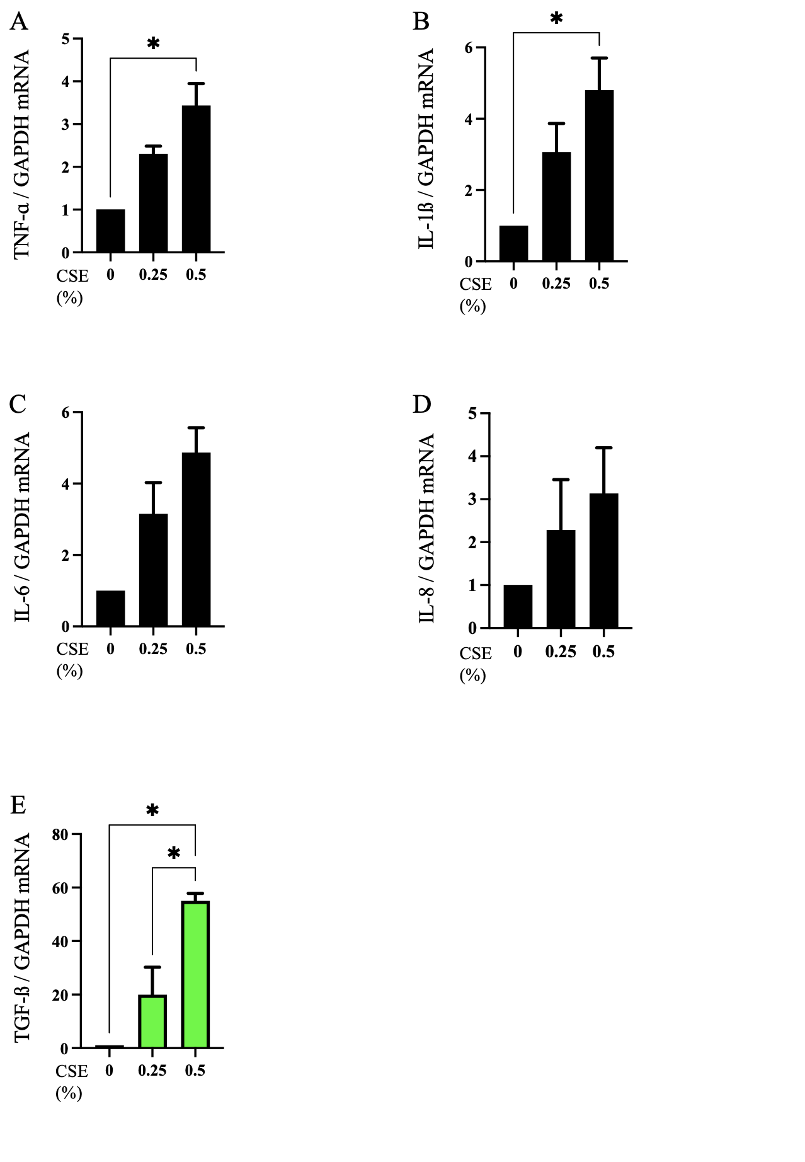
SI 5. CSE enhanced the expression of M1- and M2-associated cytokines. (A)-(D) Gene expression of M1-related cytokines: TNF-a, IL-1b, IL-6 and IL-8 was assessed in THP-1-derived macrophages after 72-hour stimulation with or without CSE (n = 3), to evaluate the effect of CSE on macrophage polarization. (E) Gene expression of M2-related cytokine: TGF-b was assessed under the same conditions (n = 3). This indicates that CSE does not drive macrophages toward a single polarization state, but rather induces a mixed M1/M2 phenotype, suggesting a complex inflammatory and remodeling response that may contribute to chronic tissue damage and dysregulated immune processes. The data was expressed as the mean ± SD and statistically analyzed by one-way ANOVA: *P < 0.05
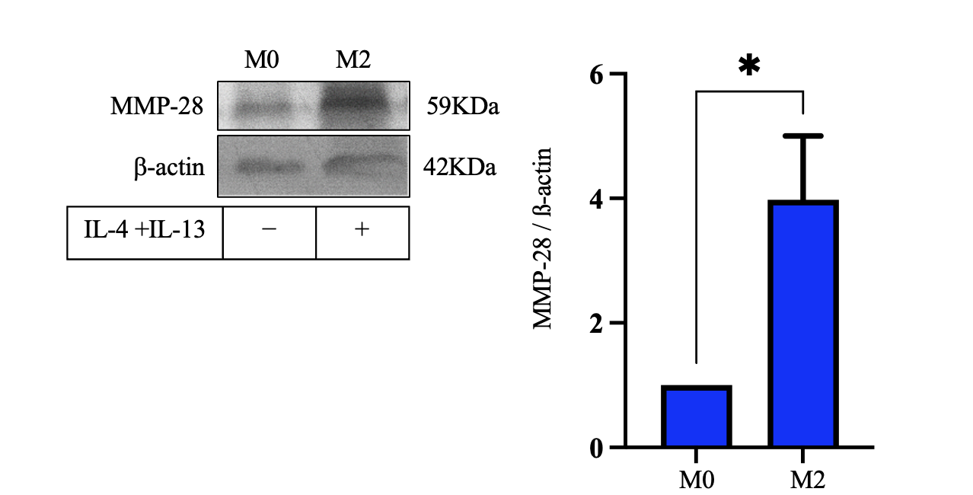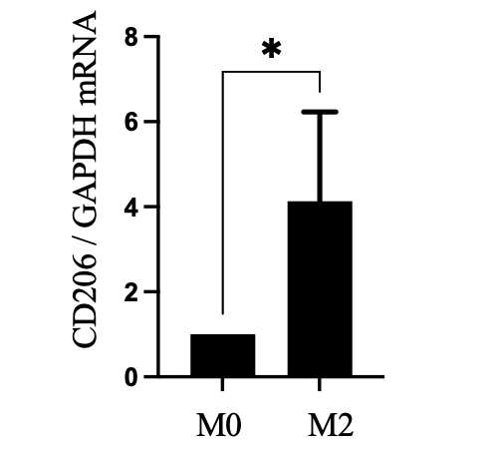
SI 6. Protein expression level showed that M2 expression was elevated by stimulation of IL-4 + IL-13. The expression level was quantified in the bar chart, and the expression was significant elevated. The functional marker, CD206 expression was elevated significant too.

