Supplementary Methods
LA-ICPMS
Zircon grains were separated from rocks using standard techniques, annealed at 900ºC for 60 hours in a muffle furnace, and randomly selected grains were mounted in epoxy and polished until their centres were exposed. Cathodoluminescence (CL) images were obtained with a JEOL JSM-300 scanning electron microscope and Gatan MiniCL. Zircon was analysed by laser ablation inductively coupled plasma mass spectrometry (LA-ICPMS) using a ThermoElectron X-Series II quadrupole ICPMS and New Wave Research UP-213 Nd:YAG UV (213 nm) laser ablation system. In-house analytical protocols, standard materials, and data reduction software were used for acquisition and calibration of U–Pb dates and a suite of high field strength elements (HFSE) and rare earth elements (REE). Zircon was ablated with a laser spot of 25 µm wide using fluence and pulse rates of 5 J/cm² and 5 Hz, respectively, during a 45 second analysis (15 second gas blank, 30 second ablation) that excavated a pit ~25 µm deep. Ablated material was carried by a 1.2 L/min He gas stream to the nebulizer flow of the plasma. Quadrupole dwell times were 5 ms for Si and Zr, 200 ms for ⁴⁹Ti and ²⁰⁷Pb, 80 ms for ²⁰⁶Pb, 40 ms for ²⁰²Hg, ²⁰⁴Pb, ²⁰⁸Pb, ²³²Th, and ²³⁸U and 10 ms for all other HFSE and REE; total sweep duration is 950 ms. Background count rates for each analyte were obtained prior to each spot analysis and subtracted from the raw count rate for each analyte. For concentration calculations, background-subtracted count rates for each analyte were internally normalized to ²⁹Si and calibrated with respect to NIST SRM-610 and -612 glasses as the primary standards. Ablations pits that appear to have intersected glass or mineral inclusions were identified based on Ti and P signal excursions, and associated sweeps were discarded. U–Pb dates from these analyses are considered valid if the U–Pb ratios appear to have been unaffected by the inclusions. Signals at mass 204 were normally indistinguishable from zero following subtraction of mercury backgrounds measured during the gas blank (<1000 cps ²⁰²Hg), and thus dates are reported without common Pb correction. Rare analyses that appear contaminated by common Pb were rejected based on mass 204 greater than baseline. Temperature was calculated from the Ti-in-zircon thermometer¹. Because there are no constraints on the activity of TiO₂ in the source rocks, an average value in crustal rocks of 0.8 was used.
Data were collected in two experiments in August 2019 and February 2020 (Table S1). For U–Pb and ²⁰⁷Pb/²⁰⁶Pb dates, instrumental fractionation of the background-subtracted ratios was corrected, and dates were calibrated with respect to interspersed measurements of zircon standards and reference materials. The primary standards Plešovice zircon² or FC1 (1098 Ma, unpublished data, Boise State University) was used to monitor time-dependent instrumental fractionation based on two analyses for every 10 analyses of unknown zircon. A secondary correction to the ²⁰⁶Pb/²³⁸U dates was made based on results from the zircon standards Seiland (530 Ma, unpublished data, Boise State University), Zirconia (327 Ma, unpublished data, Boise State University) and 91500 (ref³), which were treated as unknowns and measured once for every 10 analyses of unknown zircon. These results showed a linear age bias of several percent that is related to the ²⁰⁶Pb count rate. The secondary correction is thought to mitigate matrix-dependent variations due to contrasting compositions and ablation characteristics between the Plešovice zircon and other standards (and unknowns).
Radiogenic isotope ratio and age error propagation for all analyses includes uncertainty contributions from counting statistics and background subtraction. The standard calibration uncertainty for U/Pb is the local standard deviation of the polynomial fit to the fractionation factor of Plešovice versus time and for ²⁰⁷Pb/²⁰⁶Pb is the standard error of the mean of the fractionation factor of Plešovice. These uncertainties are 0.5–0.7% (2σ) for ²⁰⁶Pb/²³⁸U and 0.4% (2σ) for ²⁰⁷Pb/²⁰⁶Pb. Age interpretations are based on ²⁰⁶Pb/²³⁸U. Errors on dates are 2σ.

CA-TIMS
U–Pb dates were obtained by the chemical abrasion isotope dilution thermal ionization mass spectrometry (CA-TIMS) method from analyses composed of single zircon grains or fragments of grains (Table S2 & Figure S1), modified after Mattinson et al.⁴. Zircon was separated from rocks using standard techniques, placed in a muffle furnace at 900°C for 60 hours in quartz beakers, mounted in epoxy, and polished until the centres of the grains were exposed. Cathodoluminescence (CL) images were obtained with a JEOL JSM-1300 scanning electron microscope and Gatan MiniCL (Figure S2 & S3). Zircon was removed from the epoxy mounts for dating based on CL images for eight samples and based on LA-ICPMS dates from three samples.
Zircon was put into 3 ml Teflon PFA beakers and loaded into 300 μl Teflon PFA microcapsules. Fifteen microcapsules were placed in a large-capacity Parr vessel and the zircon partially dissolved in 120 μl of 29 M HF for 12 hours at 190°C. Zircon was returned to 3 ml Teflon PFA beakers, HF was removed, and zircon was immersed in 3.5 M HNO₃, ultrasonically cleaned for an hour, and fluxed on a hotplate at 80°C for an hour. The HNO₃ was removed and zircon was rinsed twice in ultrapure H₂O before being reloaded into the 300 μl Teflon PFA microcapsules (rinsed and fluxed in 6 M HCl during sonication and washing of the zircon) and spiked with the EARTHTIME mixed ²³³U–²³⁵U–²⁰⁵Pb tracer solution or EARTHTIME mixed ²³³U–²³⁵U–²⁰²Pb-–²⁰⁵Pb tracer solution or Boise State University BSU-1B mixed ²³³U–²³⁵U–²⁰⁵Pb tracer solution. Zircon was dissolved in Parr vessels in 120 μl of 29 M HF with a trace of 3.5 M HNO₃ at 220°C for 48 hours, dried to fluorides, and re-dissolved in 6 M HCl at 180°C overnight. U and Pb were separated from the zircon matrix using an HCl-based anion-exchange chromatographic procedure⁵, eluted together and dried with 2 µl of 0.05 N H₃PO₄.
Pb and U were loaded on a single outgassed Re filament in 5 µl of a silica-gel/phosphoric acid mixture⁶, and U and Pb isotopic measurements made on a GV Isoprobe-T multicollector thermal ionization mass spectrometer equipped with an ion-counting Daly detector. Pb isotopes were measured by peak-jumping all isotopes on the Daly detector for 100 to 160 cycles and corrected for 0.16 ± 0.03%/a.m.u. (1σ error) mass fractionation. Transitory isobaric interferences due to high-molecular weight organics, particularly on ²⁰⁴Pb and ²⁰⁷Pb, disappeared within approximately 60 cycles, while ionization efficiency averaged 10⁴ cps/pg of each Pb isotope. Linearity (to ≥1.4 x 10⁶ cps) and the associated deadtime correction of the Daly detector were monitored by repeated analyses of NBS982, and have been constant since installation. Uranium was analyzed as UO₂⁺ ions in static Faraday mode on 10¹² ohm resistors for 300 cycles, and corrected for isobaric interference of ²³³U¹⁸O¹⁶O on ²³⁵U¹⁶O¹⁶O with an ¹⁸O/¹⁶O of 0.00206. Ionization efficiency averaged 20 mV/ng of each U isotope. U mass fractionation was corrected using the known ²³³U/²³⁵U ratio of the tracer solution.
U–Pb dates and uncertainties were calculated using the algorithms of Schmitz & Schoene⁷, calibration of the Boise State University BSU-1B tracer solution of ²³⁵U/²⁰⁵Pb of 77.93 and ²³³U/²³⁵U of 1.007066, calibration of the ET535 tracer solution⁸ of ²³⁵U/²⁰⁵Pb = 100.233, ²³³U/²³⁵U = 0.99506, and ²⁰⁵Pb/²⁰⁴Pb = 11268, calibration of the ET2535 tracer solution⁵¹ of ²³⁵U/²⁰⁵Pb = 100.233, ²³³U/²³⁵U = 0.99506, ²⁰⁵Pb/²⁰⁴Pb = 8474, and ²⁰²Pb/²⁰⁵Pb = 0.99924, U decay constants recommended by ref.⁹, and ²³⁸U/²³⁵U of 137.818 (ref.¹⁰). ²⁰⁶Pb/²³⁸U ratios and dates were corrected for initial ²³⁰Th disequilibrium using D_{Th/U} = 0.20 ± 0.05 (1σ) and the algorithms of Crowley et al.¹¹, resulting in an increase in the ²⁰⁶Pb/²³⁸U dates of ~0.09 Ma. All common Pb in analyses was attributed to laboratory blank and subtracted based on the measured laboratory Pb isotopic composition and associated uncertainty. U blanks are estimated at 0.013 ± 0.009 pg (1σ).
Weighted mean ²⁰⁶Pb/²³⁸U dates were calculated from equivalent dates (probability of fit (pof) >0.05) at the young end of age spectra in the igneous samples using Isoplot 3.0 (ref.^{10,12}). Errors on the weighted mean dates are given as ± x / y / z, where x is the internal error based on analytical uncertainties only, including counting statistics, subtraction of tracer solution, and blank and initial common Pb subtraction, y includes the tracer calibration uncertainty propagated in quadrature, and z includes the ²³⁸U decay constant uncertainty propagated in quadrature. Internal errors should be considered when comparing our dates with ²⁰⁶Pb/²³⁸U dates from other laboratories that used the same tracer solutions or a tracer solution that was cross calibrated using EARTHTIME gravimetric standards. Errors including the uncertainty in the tracer calibration should be considered when comparing our dates with those derived from other geochronological methods using the U-Pb decay scheme (e.g., laser ablation ICPMS). Errors including uncertainties in the tracer calibration and ²³⁸U decay constant¹⁰ should be considered when comparing our dates with those derived from other decay schemes (e.g., ⁴⁰Ar/³⁹Ar, ¹⁸⁷Re–¹⁸⁷Os). Errors for weighted mean dates and dates from individual grains are given at 2σ.

Results
Six grains from the Dundee Rhyodacite (sample 1683223) yield CA-TIMS dates with a weighted mean of 253.10 ± 0.07 / 0.14 / 0.30 Ma (MSWD = 0.6, pof = 0.68). This is the interpreted eruption age of the rhyodacite (Table S3).
Five grains from the Magistrate Ignimbrite (sample 1683222) yield CA-TIMS dates with a weighted mean of 253.46 ± 0.09 / 0.16 / 0.31 Ma (MSWD = 1.3, pof = 0.29). This is the interpreted eruption age of the ignimbrite deposit (Fig. S1).
Six grains from the Parlour Mountain Leucomonzogranite (sample 1954029) yield CA-TIMS dates with a weighted mean of 255.08 ± 0.08 / 0.15 / 0.31 Ma (MSWD = 1.2, probability of fit = 0.29). This is the interpreted emplacement age of the leucomonzogranite.
Six grains from the Gwydir River monzogranite (sample 1954030) were analysed by CA-TIMS, and the three youngest dates yield a weighted mean of 252.76 ± 0.12 / 0.17 / 0.32 Ma (MSWD = 2.6, probability of fit = 0.08). This is the interpreted emplacement age of the monzogranite. Three grains that yielded dates of 253.14 ± 0.17 to 252.95 ± 0.19 Ma are interpreted as having inherited components.
Six grains from the Regional Felsic Dyke Swarm (sample 1954031 [200801607]) were analysed by CA-TIMS, and the three youngest dates yield a weighted mean of 254.62 ± 0.13 / 0.18 / 0.32 Ma (MSWD = 0.2, probability of fit = 0.83). This is the interpreted emplacement age of the dyke swarm. Three grains that yielded dates of 256.01 ± 0.22 to 255.19 ± 0.17 Ma are interpreted as having inherited components.
Six grains from the Emmaville rhyolite (sample 2105111) were analysed by CA-TIMS, and the five youngest dates yield a weighted mean of 253.59 ± 0.08 / 0.15 / 0.31 Ma (MSWD = 1.5, pof = 0.20). This is the interpreted eruption age of the Emmaville deposit (Fig. S1). One grain that yielded a date of 253.80 ± 0.18 Ma is interpreted as having an inherited component.
Six grains from the Attunga Volcanics (sample 2120076) yield CA-TIMS dates with a weighted mean of 254.58 ± 0.07 / 0.14 / 0.31 Ma (MSWD = 0.3, pof = 0.89). This is the interpreted eruption age of the volcanic deposit (Fig. S1).
Six grains from the Uralla Volcanics (sample 2120074) were analysed by CA-TIMS, and the four youngest dates yield a weighted mean of 253.70 ± 0.11 / 0.16 / 0.32 Ma (MSWD = 1.3, pof = 0.26). This is the interpreted eruption age of the volcanic deposit (Fig. S1). Two grains that yielded dates of 255.18 ± 0.18 and 255.17 ± 0.27 Ma are interpreted as having inherited components.
Six grains from the Kurrajong Park Volcanics (sample 2120077) were analysed by CA-TIMS, and the four youngest dates yield a weighted mean of 255.48 ± 0.07 / 0.15 / 0.31 Ma (MSWD = 1.4, pof = 0.23). This is the interpreted eruption age of the volcanic deposit (Fig. S1). One grain that yielded a date of 255.96 ± 0.17 Ma is interpreted as having an inherited component.
Forty grains from the Kings Plain Ignimbrite (sample 19KP02) analysed by LA-ICPMS yield dates of 272 ± 12 to 246 ± 5 Ma. Seven grains were analysed by CA-TIMS, and the four youngest dates yield a weighted mean of 253.70 ± 0.11 / 0.16 / 0.32 Ma (MSWD = 1.3, pof = 0.26). This is the interpreted eruption age of the ignimbrite deposit (Fig. S1). Two grains that yielded dates of 256.34 ± 0.08 and 256.20 ± 0.08 Ma are interpreted as having inherited components.
Fifty-three grains from the Annalee Pyroclastics (sample PB-19-WVG-01B) analysed by LA-ICPMS yield dates of 264 ± 9 to 227 ± 13 Ma. Eight grains were analysed by CA-TIMS, and the four youngest dates yield a weighted mean of 256.19 ± 0.09 / 0.16 / 0.31 Ma (MSWD = 1.2, pof = 0.32). This is the interpreted eruption age of the pyroclastic deposit (Fig. S1). Four grains that yielded dates of 257.41 ± 0.19 to 256.58 ± 0.18 Ma are interpreted as having inherited components.
Thirty-nine grains from the Weean Ignimbrite (sample 19GI05) analysed by LA-ICPMS yield dates of 270 ± 10 to 248 ± 8 Ma. Ten grains were analysed by CA-TIMS, and the four youngest dates yield a weighted mean of 257.55 ± 0.05 / 0.13 / 0.30 Ma (MSWD = 2.0, pof = 0.12). Six grains that yielded dates of 258.97 ± 0.11 to 257.76 ± 0.12 Ma are interpreted as having inherited components (Fig. S1).

Volume calculations
Surface area calculations were based on geological maps from the southern New England Orogen in New South Wales and Queensland provided by the appropriate government surveys and refined based on direct field observations (Figs 2 & S4)¹³⁻¹⁵. The contiguous volcanic and plutonic outcrop in the southern New England Orogen is the most representative of addition rates along the Eastern Australia margin in the Permian (Fig. 2). Much of the arc in northern Queensland is poorly exposed due to the occurrence of abundant younger sedimentary cover sequences, and it also lacks abundant volcanic material. The surface areas were determined for regions via the removal of appropriate Tertiary basaltic and alluvial cover that obscures clear geological relationships (Fig. S5a). The volcanic and plutonic outcrops occur as inliers within the Tertiary basalt flows across most of the southern New England Orogen, consistent with the lateral continuity across the field area. A map of the geological relationships with the Tertiary cover is provided in Figure S4. Much of the Wandsworth Volcanic Group is weathered away or stoped out by extensive younger plutonism. The total volcanic sequence is predicted to have a thickness of 6500–8000 m based on mapped relationships and geophysical surveys^{16,17}. The exposed domains primarily reflect thick ignimbrite deposits preserved in caldera infill, with erosion of up to 3–4 km apparent in surrounding areas¹⁸. It is unclear how much erosion occurred between individual ignimbrite deposits, although thick coeval volcaniclastic sediments are common. A more conservative estimate of the eruption volume was established based on the full aerial extent of all Wandsworth members and their mapped thicknesses in the orogen (Fig. 2).
Magma addition rates were calculated using the surface area of exposed volcanic and plutonic rock in the southern New England Orogen (Fig. S5a)¹⁹. Magma addition rates were determined utilising the observed volcanic thicknesses¹⁶ and the assumption that the plutons extend to the calculated source depth (likely Moho), which is consistent with geophysical observations along the margin (Fig. 2)¹⁷ as well as observations of the make-up of the lower crust in exposed arc sequences²⁰⁻²². Depth estimates for the crustal thickness were calculating using Sr/Y ratios²³ of the volcanic and plutonic rocks²⁴ that were screened for the appropriate geochemical compositions (SiO₂ 55–70 wt.%; Mg 1–6 wt.%; Rb/Sr>0.2)²³ for the depth calculation (Fig. S5b). All crustal thicknesses are relative thin for arc systems consistent with tectonic interpretation for the margin, and the substantial sub-arc mantle input in the New England batholith²⁵⁻²⁷. For each 5 Myr age bin the depth estimates were averaged to restrict variability associated with the spectrum of magma compositions erupted over the period. Published (SHRIMP and LA-ICPMS) age dates (128 in total) were compiled across the granite and volcanic rocks in the southern New England section of the margin²⁸⁻⁴¹, with only lithological units with suitable ages utilised in the volume calculations (Fig. 2). Comparison of high-precision CA-TIMS dates of the ignimbrites established here and those published for the tephra in the proximal sedimentary basin are all based on analysis from the Boise Isotope Laboratory.
Diversity curve
The Genera diversity curve is extracted from the records of the Paleobiology database (https://paleobiodb.org/#/) on the 12th of March 2020 for the geological period ~265–245 Ma. The diversity curve is based on the sample-in-bin correction to account for biases in the fossil preservation record and occurrence intervals⁴². The bins are plotted at their mid-point on Figure 4 for clarity.
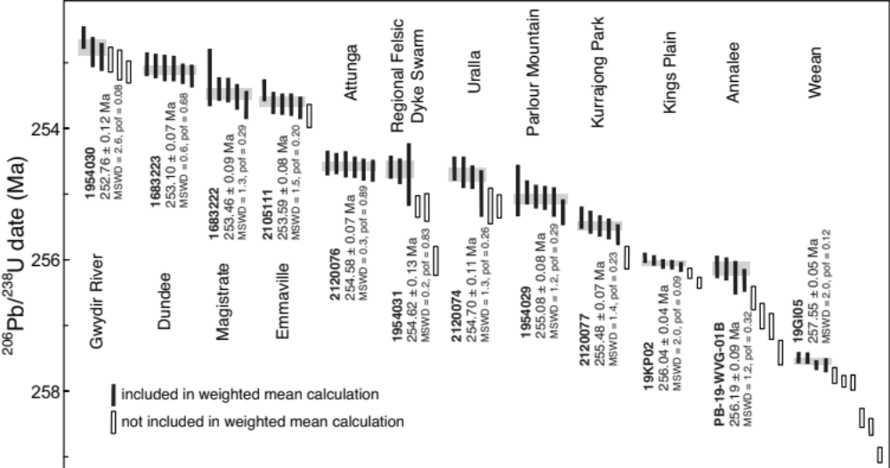
Supplementary Figure S1 Plot of ²⁰⁶Pb/²³⁸U dates obtained by CA-TIMS. Plotted with Isoplot 3.0 (ref.¹²). Weighted mean dates are shown and represented by the grey boxes. The ages included or precluded for the weighted mean calculations are displayed by black and white bars encompassing errors at 2σ.
Supplementary Figure S2 Representative collated images of analysed zircon grains from the Wandsworth Volcanic Group and New England Batholith. The top panel is reflected light images, the middle panel are incident light images and bottom panel is cathodoluminescence (CL) images. Individual samples are labelled.
Supplementary Figure S3 Representative cathodoluminescence (CL) images of zircon from the Kings Plain Ignimbrite (19KP02), the Annalee Pyroclastics (01B) and the Weean Ignimbrite (19GI05).
Supplementary Figure S4 Geological map of the southern New England Orogen, with Cenozoic cover, displaying spatio-temporal relationships of magmatism and the Wandsworth Volcanic Group from c. 300–200 Ma.

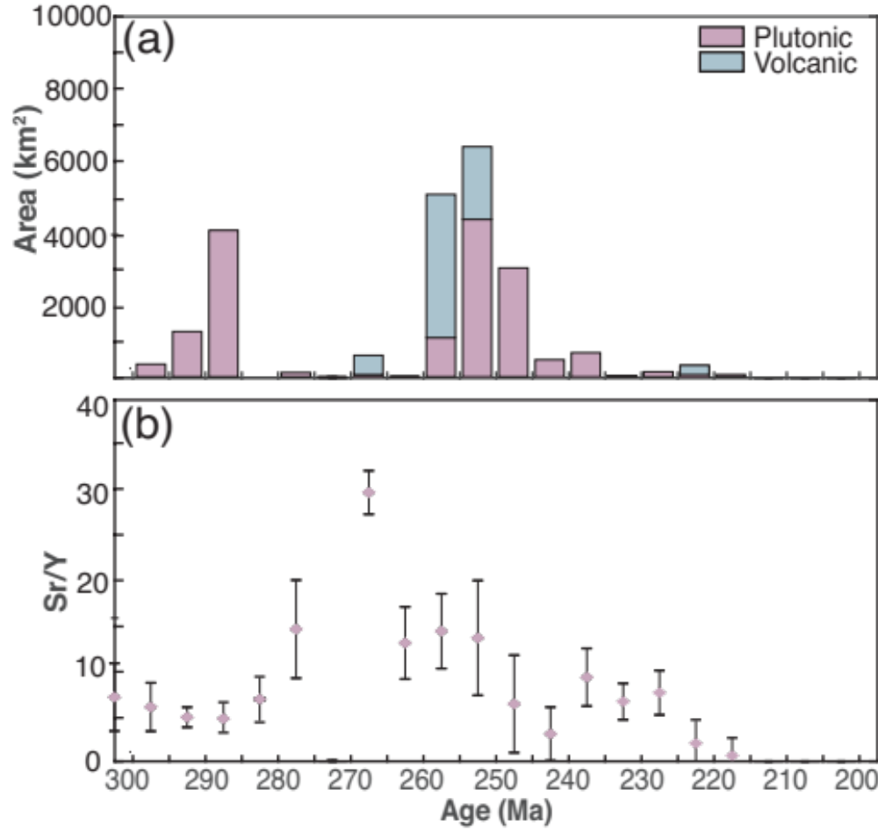
Supplementary Figure S5 (a) Histogram of exposed surface area of volcanic and pluton rocks along the eastern Australia margin during the Permian–Triassic. (b) Average Sr/Y ratios of volcanic or plutons rocks during the Permian–Triassic, uncertainty bounds encompass 1σ distribution.

Supplementary Table S1 CA-TIMS U–Pb zircon analysis for the Wandsworth Volcanic Group. Includes concordia plots of U–Pb CA-TIMS dates plotted with Isoplot 3.0 (ref.¹²). Errors are at 2σ.
Supplementary Table S2 LA-ICPMS U–Pb zircon analysis of the Wandsworth Volcanic Group.

Supplementary Table S3 Wandsworth Volcanic Group sample location and age summary
sample | location (GDA94) |  | Unit of Wandsworth | Lithology | age | error
 | eastings | northings | Volcanic Group |  | (Ma) | (Ma)
1954030 | 151.28453 | -30.38234 |  | Gwydir River monzogranite | 252.76 | 0.12
1683223 | 151.854300 | -29570198 | Eastern Belt | Dundee Rhyodacite | 253.10 | 0.07
1683222 | 152.04143 | -29.394355 | Eastern Belt | Magistrate Ignimbrite | 253.46 | 0.09
2105111 | 151.787400 | -29.633820 | Eastern Belt | Emmaville rhyolite | 253.59 | 0.08
2120076 | 150.984157 | -30.903532 | Southern Belt | Attunga Volcanics | 254.58 | 0.07
1954031 | 151.38793 | -30.27895 |  | Regional Felsic Dyke Swarm | 254.62 | 0.13
2120074 | 151.426452 | -30.638020 | Southern Belt | Uralla Volcanics | 254.70 | 0.11
1954029 | 151.43438 | -30.26323 |  | Parlour Mountain monzogranite | 255.08 | 0.08
2120077 | 151.292309 | -30.511789 | Western Belt | Kurrajong Park Volcanics | 255.48 | 0.04
19KP02 | 151.29387 | -29.55939 | Western Belt | Kings Plain Ignimbrite | 256.04 | 0.04
01B | 151.666023 | -30.373781 | Western Belt | Annalee Pyroclastics | 256.19 | 0.09
19GI05 | 151.27186 | -29.54802 | Western Belt | Weean Ignimbrite | 257.55 | 0.05

References
1 Watson, E. B., Wark, D. A. & Thomas, J. B. Crystallization thermometers for zircon and rutile. Contributions to Mineralogy and Petrology 151, 413–433 (2006).
2 Sláma, J. et al. Plešovice zircon — A new natural reference material for U–Pb and Hf isotopic microanalysis. Chemical Geology 249, 1–35, doi:https://doi.org/10.1016/j.chemgeo.2007.11.005 (2008).
3 Wiedenbeck, M. et al. Three natural zircon standards for U-Th-Pb, Lu-Hf, trace element and REE analyses. Geostandards Newsletter 19, 1–23, doi:10.1111/j.1751-908X.1995.tb00147.x (1995).
4 Mattinson, J. M. Zircon U–Pb chemical abrasion (“CA-TIMS”) method: Combined annealing and multi-step partial dissolution analysis for improved precision and accuracy of zircon ages. Chemical Geology 220, 47–66, doi:https://doi.org/10.1016/j.chemgeo.2005.03.011 (2005).
5 Krogh, T. E. Zircon U–Pb chemical abrasion (“CA-TIMS”) method: Combined annealing and multi-step partial dissolution analysis for improved precision and accuracy of zircon ages. Chemical Geology 220, 47–66, doi:https://doi.org/10.1016/j.chemgeo.2005.03.011 (2005).
6 Gerstenberger, H. & Haase, G. A highly effective emitter substance for mass spectrometric Pb isotope ratio determinations. Chemical Geology 136, 309–312, doi:https://doi.org/10.1016/S0009-2541(96)00033-2 (1997).
7 Schmitz, M. D. & Schoene, B. Derivation of isotope ratios, errors, and error correlations for U-Pb geochronology using 205Pb-235U-(233U)-spiked isotope dilution thermal ionization mass spectrometric data. Geochemistry, Geophysics, Geosystems 8, doi:10.1029/2006gc001492 (2007).
8 Condon, D. J., Schoene, B., McLean, N. M., Bowring, S. A. & Parrish, R. R. Metrology and traceability of U–Pb isotope dilution geochronology (EARTHTIME Tracer Calibration Part I). Geochimica et Cosmochimica Acta 164, 464–480, doi:https://doi.org/10.1016/j.gca.2015.05.026 (2015).
9 Jaffey, A. H., Flynn, K. F., Glendenin, L. E., Bentley, W. C. & Essling, A. M. Precision Measurement of Half-Lives and Specific Activities of $^{235}\mathrm{U}$ and $^{238}\mathrm{U}$. Physical Review C 4, 1889–1906, doi:10.1103/PhysRevC.4.1889 (1971).
10 Hiess, J., Condon, D. J., McLean, N. & Noble, S. R. 238U/235U Systematics in Terrestrial Uranium-Bearing Minerals. Science 335, 1610–1614, doi:10.1126/science.1215507 (2012).
11 Crowley, J. L., Schoene, B. & Bowring, S. A. U-Pb dating of zircon in the Bishop Tuff at the millennial scale. Geology 35, 1123–1126, doi:10.1130/g24017a.1 (2007).
12 Ludwig, K. R. User’s manual for Isoplot 3.00. (Berkley Geochronology Center, 2003).
13 Offenburg, A. C. & Pogson, D. J. (Geological Survey of New South Wales, Sydney, 1973).
14 Cranfield, L. C., Whitaker, W. G. & Green, P. M. (Geological Survey of Queensland, Brisbane, 1978).
15 Shaw, S. E. & Flood, R. H. The New England Batholith, eastern Australia: Geochemical variations in time and space. Journal of Geophysical Research: Solid Earth 86, 10530–10544, doi:10.1029/JB086iB11p10530 (1981).
16 Barnes, R. G., Brown, R. E., Brownlow, J. W. & Stroud, W. J. Late Permian volcanics in New England. Quarterly Note of the Geological Survey of New South Wales 84, 1–36 (1991).
17 Finlayson, D. M. & Collins, C. D. N. Lithospheric velocity structures under the southern New England Orogen: Evidence for underplating at the Tasman Sea margin. Australian Journal of Earth Sciences 40, 141–153, doi:10.1080/08120099308728071 (1993).
18 Kohn, B. et al. Shaping the Australian crust over the last 300 million years: insights from fission track thermotectonic imaging and denudation studies of key terranes. Australian Journal of Earth Sciences 49, 697–717 (2002).
19 Milan, L. A. et al. A New Reconstruction for Permian East Gondwana Based on Zircon Data From Ophiolite of the East Australian Great Serpentinite Belt. Geophysical Research Letters 48, e2020GL090293, doi:https://doi.org/10.1029/2020GL090293 (2021).
20 Timothy, C., Geoffrey, L. C., Nathan, R. D., Sandra, P. & Adrianna, R. Orthopyroxene–omphacite- and garnet–omphacite-bearing magmatic assemblages, Breaksea Orthogneiss, New Zealand: Oxidation state controlled by high-P oxide fractionation. Lithos 216-217, 1-16, doi:https://doi.org/10.1016/j.lithos.2014.11.019 (2015).
21 Chapman, T., Clarke, G. L. & Daczko, N. R. Crustal Differentiation in a Thickened Arc—Evaluating Depth Dependences. Journal of Petrology 57, 595-620, doi:10.1093/petrology/egw022 (2016).
22 Jagoutz, O. & Behn, M. D. Foundering of lower island-arc crust as an explanation for the origin of the continental Moho. Nature 504, 131-134, doi:10.1038/nature12758 (2013).
23 Chapman, J. B., Ducea, M. N., DeCelles, P. G. & Profeta, L. Tracking changes in crustal thickness during orogenic evolution with Sr/Y: An example from the North American Cordillera. Geology 43, 919–922, doi:10.1130/g36996.1 (2015).
24 Bryant, C. J. A compendium of granites of the southern new England Orogen, eastern Australia. (Geological Survey of New South Wales, Sydney, 2017).
25 Phillips, G., Landenberger, B. & Belousova, E. A. Building the New England Batholith, eastern Australia—Linking granite petrogenesis with geodynamic setting using Hf isotopes in zircon. Lithos 122, 1–12, doi:https://doi.org/10.1016/j.lithos.2010.11.005 (2011).
26 Shaw, S., Flood, R. & Pearson, N. The New England Batholith of eastern Australia: Evidence of silicic magma mixing from zircon 176Hf/177Hf ratios. Lithos 126, 115–126 (2011).
27 Kemp, A., Hawkesworth, C., Collins, W., Gray, C. & Blevin, P. Isotopic evidence for rapid continental growth in an extensional accretionary orogen: The Tasmanides, eastern Australia. Earth and Planetary Science Letters 284, 455–466 (2009).
28 Anderson, J. R., Fraser, G. L., McLennan, S. M. & Lewis, C. J. A U–Pb geochronology compilation for northern Australia. Report No. 2017/22, (Geoscience Australia, 2017).
29 Belousova, E. A., Griffin, W. L. & O'Reilly, S. Y. Zircon Crystal Morphology, Trace Element Signatures and Hf Isotope Composition as a Tool for Petrogenetic Modelling: Examples From Eastern Australian Granitoids. Journal of Petrology 47, 329–353, doi:10.1093/petrology/egi077 (2005).
30 Bodorkos, S. et al. U–Pb ages from the central Lachlan Orogen and New England Orogen, New South Wales. Report No. Record 2016/21, (Geoscience Australia, 2016).
31 Cawood, P. A., Pisarevsky, S. A. & Leitch, E. C. Unraveling the New England orocline, east Gondwana accretionary margin. Tectonics 30, doi:10.1029/2011tc002864 (2011).
32 Chisholm, E. I., Blevin, P. L. & Simpson, C. J. New SHRIMP U–Pb zircon ages from the New England Orogen, New South Wales: July 2012–June 2014. Report No. Record 2014/13, (Geoscience Australia, 2014).
33 Chisholm, E. I., Blevin, P. L. & Simpson, C. J. New SHRIMP U–Pb zircon ages from the New England Orogen, New South Wales:July 2010–June 2012. Report No. Record 2014/13, (Geoscience Australia, 2014).
34 Chisholm, E.-K. I., Simpson, C. & Blevin, P. New SHRIMP U–Pb Zircon Ages from the New England Orogen, New South Wales: July 2010-June 2012. (Geoscience Australia, 2014).
35 Cross, A. & Blevin, P. L. Summary of results for the joint GSNSW–GA geochronology project. Report No. Record GS2013/0426, (Geoscience Australia, 2013).
36 Craven, S. J., Daczko, N. R. & Halpin, J. A. Thermal gradient and timing of high-T–low-P metamorphism in the Wongwibinda Metamorphic Complex, southern New England Orogen, Australia. Journal of Metamorphic Geology 30, 3–20, doi:10.1111/j.1525-1314.2011.00949.x (2012).
37 Black, L. P. U–Pb zircon ages obtained during 2006/07 for NSW Geological Survey projects. (Geoscience Australia, 2007).
38 Rosenbaum, G., Li, P. & Rubatto, D. The contorted New England Orogen (eastern Australia): New evidence from U-Pb geochronology of early Permian granitoids. Tectonics 31, doi:10.1029/2011tc002960 (2012).
39 Walthenberg, K., Blevin, P. L., Bull, K. F., Cronin, D. E. & Armistead, S. E. New SHRIMP U–Pb zircon ages from the Lachland Orogen and the New England Orogen, New South Wales: mineral systems projects, July 2015–June 2016. Report No. Record 2016/28, (Geoscience Australia, 2016).
40 Walthenberg, K., Blevin, P. L., Bodorkos, S. & Cronin, D. E. New SHRIMP U–Pb ages from the New England Orogen, New South Wales: July 2014–June 2015. Report No. Record 2015/28, (Geoscience Australia, 2015).
41 Jeon, H., Williams, I. S. & Chappell, B. W. Magma to mud to magma: Rapid crustal recycling by Permian granite magmatism near the eastern Gondwana margin. Earth and Planetary Science Letters 319-320, 104–117, doi:https://doi.org/10.1016/j.epsl.2011.12.010 (2012).
42 Alroy, J. et al. Phanerozoic trends in the global diversity of marine invertebrates. Science 321, 97–100 (2008).

