Supplementary Material S1
Rituals on the move? Unusual dietary habits among non-local elite female “priestesses” at the Hallstatt period cemetery of Modřice, Czech Republic
Zdeněk Vytlačil¹, Petr Kos², Zdeněk Tvrdý³, Roman Skála⁴, Sylva Drtikolová Kaupová¹
1 - Department of Anthropology, National Museum, Václavské naměstí 68, 115 79 Praha 1, Czech Republic
2 – Ústav archeologické památkové péče Brno, v.v.i., Kaloudova 1321/30, 614 00 Brno, Czech Republic
3 – Institute of Geology of the Czech Academy of Sciences, Rozvojová 269, CZ-165 00 Prague 6 – Lysolaje, Czech Republic
3 – Anthropos Institute, Moravian Museum, Zelný trh 6, 659 37 Brno, Czech Republic
4 – Institute of Geology of the Czech Academy of Sciences, Rozvojová 269, 165 00 Prague 6, Czech Republic
Corresponding author: ZV – zdenek.vytlacil@nm.cz

Reference data for Sr analysis and local ⁸⁷Sr/⁸⁶Sr range estimation
Geological background
Geologically, Modřice is located in the Dyje–Svratka Valley, a depression between the Bohemian Massif and the Carpathian Mountains. The site itself is situated on a loess terrace on the right bank of the Svratka river, close to its confluence with the Bobrava River. The loess fields continue both north and south of Modřice. East of the site lies the Svratka River floodplain, followed by the mix of Quaternary fluvial sediments, Neogene marine sediments and loess fields. West of the site the Proterozoic metamorphic and plutonic rocks of the Bobrava Highlands are located. A simplified geological map is provided in Figure S1.
Material and Methods
To estimate the local ⁸⁷Sr/⁸⁶Sr range in the vicinity of Modřice, five homogenised plant samples, two water samples and ten samples of pig tooth enamel were collected, supplemented by five samples of human bone. Locations of the sampling sites are shown in Figure S1, with the GPS coordinates provided in the Supplementary Material S2. As fertilisers alter soil and plant ⁸⁷Sr/⁸⁶Sr ratios (Hill et al. 2024; 2025), the intensive agricultural exploitation of the landscape severely limited the availability of the plant samples, which were therefore collected at only five sampling sites. This also resulted in an apparent underrepresentation of presumably the most important areas for food production: the Quaternary loess and the Svratka river floodplain surrounding Modřice.
A homogenised plant sampling approach (Johnson 2018) was applied. At each sampling site, leaves from multiple typically local plant species were collected within a radius of approximately 15 m and, where available, included trees, shrubs and grasses. The leaves were air-dried and stored in sealed plastic bags. Prior to Sr analysis, the leaves were cleaned with deionised water. A section of each leaf was collected, manually crushed and mixed with other specimens from the same sampling site. This mixture was then ashed at 650 °C for 6 hours and stored in sealed microtubes. Prio to the isotope measurements, ash was treated with 14M HNO₃ with 24M HF at 160 °C for 16 hours, dried, dissolved with 14M HNO₃ 28% hydrogen peroxide, dried again and redissolved in 1ml of 1M HNO₃.
Water samples from Svratka and Bobrava rivers were collected in sealed plastic containers and stored at near zero temperature. The water samples were treated repeatedly with 14M HNO₃ with 28% hydrogen peroxide. After drying, the residue was redissolved in 1ml of 1M HNO₃.
Animal tooth enamel samples were treated in the same manner as the human samples. The same applies to bone samples with the exclusion of the acetic acid treatment. All further treatment and isotope measurements followed the protocol described in the main text of the manuscript.
Fig. S1. Simplified geological map of the Modřice area. Green dots represent plant sampling sites, blue water sampling sites. Orange star marks the location of the cemetery. Modified after Czech Geological Survey (2025).

Results and local range estimation
Measured ⁸⁷Sr/⁸⁶Sr ratios are shown in Figures S1 and S2 and provided in Supplementary Material S2. Plants growing on Proterozoic metamorphic rocks west of Modřice, near Želešice (ZEL sample), yielded a lower-than-expected ⁸⁷Sr/⁸⁶Sr ratio of 0.7109. A higher ⁸⁷Sr/⁸⁶Sr ratio (0.7116) was measured in plants growing on a Proterozoic biotite granodiorites mixed with Quaternary loess at the foot of the hills near Hajany (HAJ). This ratio corresponds rather well with that measured in the water from the Bobrava River, which traverses the old bedrock of the Bohemian Massif and displays a slightly elevated ⁸⁷Sr/⁸⁶Sr ratio of 0.71192 (BOBR). Neogene calcareous clay and Quaternary fluvial sands and gravels west of Modřice, at Rebešovice (REB) and Rajhradice (OPA), had similar ⁸⁷Sr/⁸⁶Sr ratios of 0.7101 and 0.7103, respectively. The homogenised plant sample from the Svratka river floodplain (BAZ), however, showed an unexpectedly high ⁸⁷Sr/⁸⁶Sr ratio (0.71239). This ratio is substantially higher than that measured in the water from the Svratka river (0.70972), which is striking. The BAZ ⁸⁷Sr/⁸⁶Sr ratio is also higher than the ratio of the Bobrava river water (0.71192) for which an influence of old rock formations of the Bohemian Massif is expected. Considering that plant samples from the neighbouring loess fields and Cenozoic fluvial sediments also yielded notably lower ⁸⁷Sr/⁸⁶Sr ratios (0.71006 and 0.71030, respectively), it was concluded that BAZ sample had likely been contaminated by modern human activities. This is further supported by the location of the BAZ sampling site within a pheasantry that, according to our information, is managed by the university and used for teaching and research purposes. Consequently, a higher risk of modern anthropogenic contamination was expected, and the BAZ sample was excluded from the local range estimation.
The tooth enamel samples of archaeofauna had an average ⁸⁷Sr/⁸⁶Sr ratio of 0.71086±0.00029. This is somewhat elevated relative to those of the plant samples collected east of the Svratka River, which may suggest that these pigs were kept in the more radiogenic western hills. Among all reference sample types, the archaeofaunal enamel samples exhibit the lowest variability in ⁸⁷Sr/⁸⁶Sr ratios, indicating no apparent non-local origin of these pigs.
Based on the available data, the local ⁸⁷Sr/⁸⁶Sr ratios are expected to lie within the range of 0.7097-0.7119. The presence of old magmatic and metamorphic rock formations west of Modřice, however, warrants caution. Given that the burial ground at Modřice was located in an area of a highly fertile loess fields and Svratka river floodplain, we consider it reasonable to expect that the majority of the agricultural production was concentrated in these lowland areas, which are intensively farmed even today. Only a limited contribution of strontium derived from the Bohemian Massif to the diet of the population was thus expected. The estimated local range, therefore, likely overestimates the influence of these more radiogenic areas and may not accurately reflect the actual biostrontium in the diet of the population.
Five randomly selected ground up human bone samples, leftovers from the dietary analysis, were included in the reference dataset for the Sr analysis as well. They were included as a tentative proxy of the soil based of the susceptibility of the uncremated bones to diagenetic contamination (Budd et al. 2000; Hoppe et al. 2003). The usability of human bones is rather limited, however, as it is not possible to distinguish between biogenic and diagenetic strontium. The highly variable bone ⁸⁷Sr/⁸⁶Sr ratios, ranging from 0.70978 to 0.71112, suggest that some biogenic strontium was likely preserved in at least some of the analysed bones. Based on this, the bones were considered unreliable and they were not used in the local range estimation. If bone samples are included the range increases slightly to 0.7096-0.7119. This, however, possesses no change to the interpretation of the measured human data.
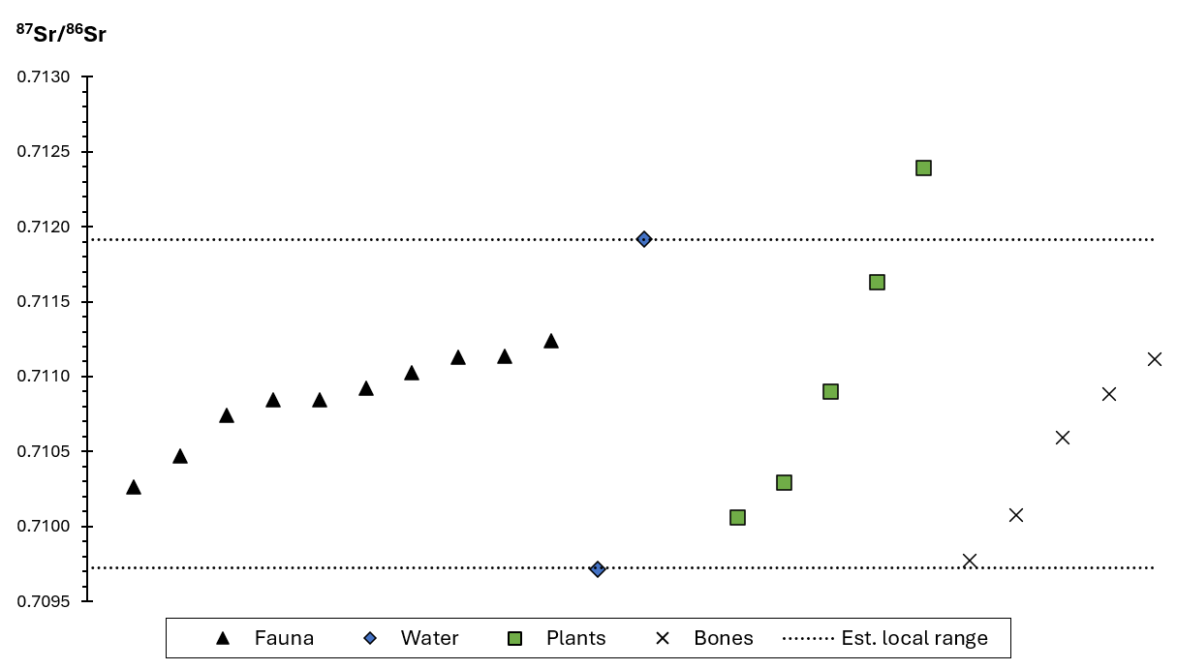
Fig. S2. Measured ⁸⁷Sr/⁸⁶Sr ratios of the reference samples from the Modřice area. Fauna consists of tooth enamel from pigs excavated at the site.
References:
Budd P, Montgomery J, Barreiro B, Thomas RG (2000) Differential diagenesis of strontium in archaeological human dental tissues. Appl Geochem 15 (5), 687–694. https://doi.org/10.1016/S0883-2927(99)00069-4
Czech Geological Survey (2025) Geological map 1:50 000 [online]. Czech Geological Survey, Praha. Accessed 9.7.2025 from https://mapy.geology.cz/geocr50/
Hill RC, Williams GD, Wang Z, Hu J, El-Hasan T, Duckworth OW, Schnug E, Bol R, Singh A, Vengosh A (2024) Tracing the environmental effects of mineral fertilizer application with trace elements and strontium isotope variations. Environ Sci Technol Lett 11(6):604-610.
Hill RC, Pieńkowska A, Merbach I, Reitz T, Muehe EM, Vengosh A (2025) Impacts of fertilization on metal (loid) transfer from soil to wheat in a long-term fertilization experiment–using ⁸⁷Sr/⁸⁶Sr isotopes as metal (loid) tracer. Environ Int 2025, 109851. https://doi.org/10.1016/j.envint.2025.109851
Hoppe KA, Koch PL, Furutani TT (2003) Assessing the preservation of biogenic strontium in fossil bones and tooth enamel. Int J Osteoarchaeol 13(1–2):20–28. https://doi.org/10.1002/oa.663
Johnson LJ (2018) Finding Radiogenic Sr-Isotope Biospheres: Can a Home in Britain Be Found for People with High ⁸⁷Sr/⁸⁶Sr? Doctoral dissertation. Durham University, Durham.

ATR-FTIR Spectroscopy
Powdered samples of the cremated bones were placed atop the attenuated total reflectance (ATR) diamond assembly of a Thermo Fisher Nicolet iS50 Fourier transform infrared (FTIR) spectrometer (housed in Institute of Geology of the Czech Academy of Sciences, Prague). The FTIR spectra were collected over a 4000–400 cm⁻¹ wavenumber range with a resolution of 4 (data spacing of ~1.93 cm⁻¹), accumulating 64 scans. Background was collected every 15 minutes and automatically subtracted on data collection. Complete data treatment was carried out with the OMNIC program package, including baseline removal and correction for use of an ATR geometry. For subsequent graphical presentation the spectra were normalized, scaled to a common amplitude and stacked by a constant absorbance axis offset in Excel (Fig. S3). Band positions and intensities to calculate selected parameters demonstrating the degree of alteration of bone tissue were determined using Fityk software version 1.3.1 (Wojdyr 2010). These parameters are listed in Table S1.
Table S1. Parameters of the quality of bones derived from ATR-FTIR data.
Grave # | CI | C/P | C/C | CN/P | OH/P | HATI | API | BPI
838 | 4.72 | 0.126 | 1.29 | 0.013 | 0.320 | 4.25 | 0.0005 | 0.298
839 | 5.33 | 0.079 | 1.36 | 0.095 | 0.333 | 5.17 | 0.0048 | 0.194
891 | 5.07 | 0.082 | 1.37 | 0.008 | 0.417 | 6.37 | 0.0045 | 0.189
895 | 4.69 | 0.080 | 1.31 | 0.070 | 0.319 | 6.11 | 0.0023 | 0.207
1802 | 4.56 | 0.158 | 1.29 | 0.060 | 0.245 | 2.19 | 0.0010 | 0.379
1861 | 4.89 | 0.116 | 1.26 | 0.086 | 0.271 | 3.88 | 0.0018 | 0.272
1862 | 5.45 | 0.075 | 1.34 | 0.024 | 0.315 | 5.41 | 0.0029 | 0.179
2845 | 4.77 | 0.114 | 1.25 | 0.011 | 0.384 | 5.61 | 0.0017 | 0.259
2892 | 5.39 | 0.058 | 1.55 | 0.032 | 0.407 | 6.55 | 0.0193 | 0.138
2893 | 5.69 | 0.059 | 1.18 | 0.157 | 0.328 | 5.62 | 0.0032 | 0.139
2895 | 5.07 | 0.062 | 1.38 | 0.076 | 0.389 | 7.30 | 0.0039 | 0.149
3800 | 5.40 | 0.089 | 1.25 | 0.009 | 0.414 | 6.25 | 0.0000 | 0.206
3800-2 | 4.54 | 0.102 | 1.36 | 0.013 | 0.338 | 6.52 | 0.0028 | 0.238
3805 | 5.43 | 0.065 | 1.58 | 0.129 | 0.290 | 3.95 | 0.0237 | 0.151
3807a | 4.94 | 0.097 | 1.26 | 0.034 | 0.418 | 6.75 | 0.0007 | 0.228
3809 | 4.87 | 0.131 | 1.31 | 0.025 | 0.338 | 3.94 | 0.0014 | 0.303
3810 | 5.92 | 0.053 | 1.59 | 0.023 | 0.463 | 6.56 | 0.0178 | 0.125
3810a | 5.90 | 0.055 | 1.48 | 0.014 | 0.466 | 7.08 | 0.0067 | 0.123
3810b | 5.55 | 0.063 | 1.35 | 0.041 | 0.430 | 6.63 | 0.0026 | 0.151
3810c | 5.82 | 0.072 | 1.38 | 0.011 | 0.433 | 6.27 | 0.0025 | 0.165
3813 | 5.07 | 0.078 | 1.25 | 0.136 | 0.387 | 6.61 | 0.0009 | 0.191
3814 | 5.27 | 0.091 | 1.37 | 0.120 | 0.331 | 4.72 | 0.0040 | 0.223
3814b | 4.98 | 0.102 | 1.29 | 0.111 | 0.291 | 4.24 | 0.0013 | 0.244
3817 | 4.95 | 0.037 | 1.51 | 0.053 | 0.484 | 8.11 | 0.0252 | 0.086
Listed parameters:
CI (Crystallinity index): Termine and Posner (1966), Weiner and Bar-Yosef (1990).
C/P (Carbonate to phosphate ratio): Wright and Schwarcz (1996), Thompson et al. (2009)
C/C (Carbonate to carbonate ratio): Thompson et al. (2009)
CN/P (Cyanamide content): Zazzo et al. (2013)
OH/P (Amount of OH groups): Snoeck et al. (2014)
API (Relative amount of A-type carbonate to phosphate): Sponheimer and Lee-Thorp (1999)
BPI (Relative amount of B-type carbonate to phosphate): LeGeros and LeGeros (1983)

References:
LeGeros RZ, LeGeros JP (1983) Carbonate analyses of synthetic, mineral and biological apatites. J Dent Res 62(2 Suppl), 259.
Snoeck C, Lee-Thorp JA, Schulting RJ (2014) From bone to ash: Compositional and structural changes in burned modern and archaeological bone. Palaeogeogr Palaeoclimatol Palaeoecol 416:55–68. https://doi.org/10.1016/j.palaeo.2014.08.002
Sponheimer M, Lee-Thorp JA (1999) Alteration of enamel carbonate environments during fossilization. J Archaeol Sci 26:143–150. https://doi.org/10.1006/ jasc.1998.0293.
Termine JD, Posner AS (1966) Infrared analysis of rat bone: age dependency of amorphous and crystalline mineral fractions. Science 153:1523–1525. https://doi.org/10.1126/science.153.3743.1523
Thompson TJU, Gauthier M, Islam M (2009) The application of a new method of Fourier Transform Infrared Spectroscopy to the analysis of burned bone. J Archaeol Sci 36:910–914. https://doi.org/10.1016/j.jas.2008.11.013
Weiner S, Bar-Yosef O (1990) States of preservation of bones from prehistoric sites in the Near East: a survey. J Archaeol Sci 17:187–196. https://doi.org/10.1016/0305-4403(90)90058-D
Wright LE, Schwarcz HP (1996) Infrared and isotopic evidence for diagenesis of bone apatite at Dos Pila, Guatemala: palaeodietary implications. J Archaeol Sci 23:933–944. https://doi.org/10.1006/jasc.1996.0087
Zazzo A, Lebon M, Chiotti L, Comby C, Delqué-Količ E, Nespoulet R, Reiche I (2013) Can we use calcined bones for ¹⁴C dating the paleolithic? Radiocarbon 55(2–3):1409–1421. https://doi.org/10.1017/S0033822200048347
Wojdyr M (2010) Fityk: a general-purpose peak fitting program. J Appl Cryst 43:1126–1128. https://doi.org/10.1107/S0021889810030499

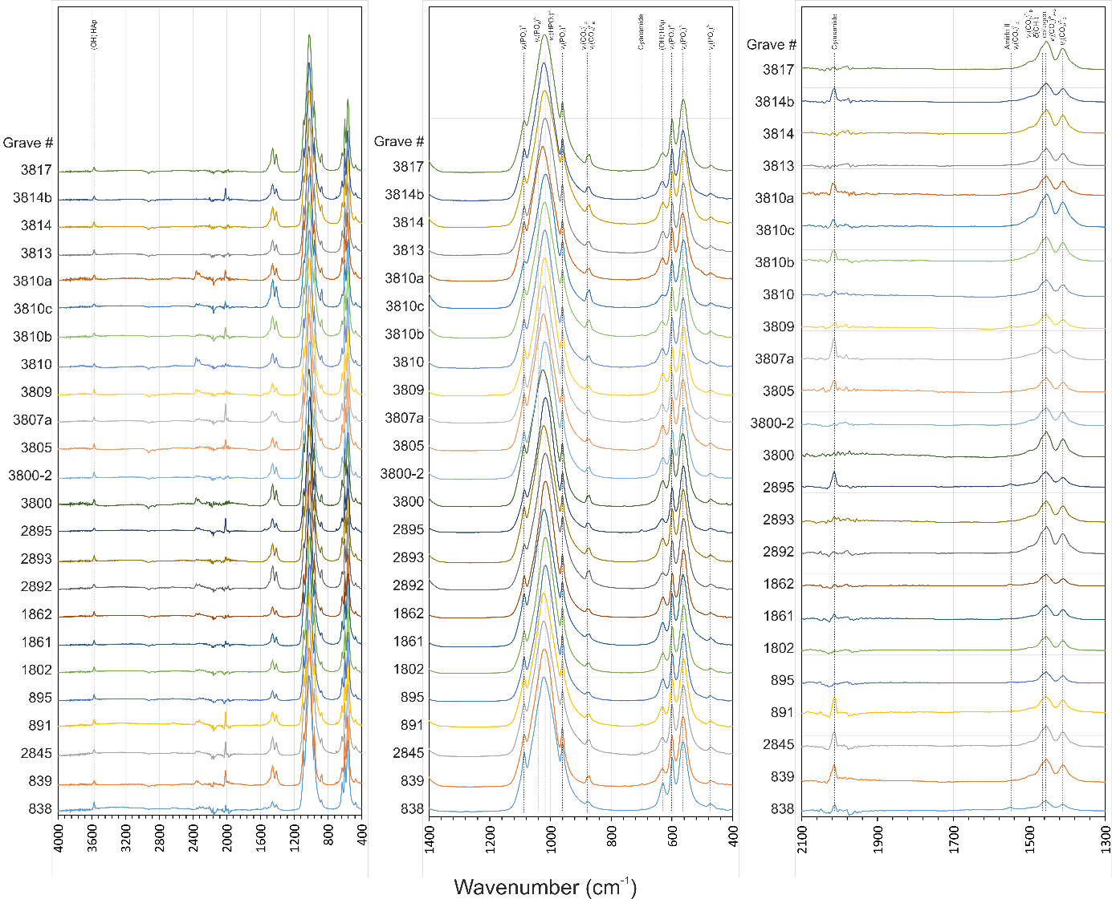
Figure S3. ATR-FTIR spectra of the analysed cremated bones from Modřice cemetery. The prominent absorption bands show the presence of phosphate and carbonate groups, while marked amide/collagen vibrations are missing.

