Supplement of

Period-dependent decoupling of light absorption and absorption efficiency in methanol-soluble BrC in Southwest China
Zhuoer Dong^{1,2}, Xiao Guo¹, Yali Liu³, Minxia Shen¹, Yifan Zhang³, Lu Li¹, Yue Cao³, Yingkun Jiang³, Qian Wang^{1,2}, Zirou Zeng^{1,2}, Wenting Dai^{1,4}, Jianjun Li^{1,2,4*}
¹State Key Laboratory of Loess Science, Institute of Earth Environment, Chinese Academy of Sciences, Xi'an, 710061, China;
²University of Chinese Academy of Sciences, Beijing, China;
³Xi’an Institute for Innovative Earth Environment Research, Xi’an, China;
⁴National Observation and Research Station of Regional Ecological Environment Change and Comprehensive Management in the Guanzhong Plain, Xi’an, China.

*Corresponding author: Jianjun Li, e-mail address: lijj@ieecas.cn

Estimation of the relative abundances and light absorption contributions of individual chromophores
The measured chromophores included the quantified PAHs, oxygenated PAHs (OPAHs), and nitrophenols (Li et al., 2020). The abundance of each individual chromophore relative to OC was calculated from its atmospheric mass concentration and the corresponding bulk OC concentration as follows:
$F_{OC,i}=\frac{{10}^{-3}C_{i}}{C_{OC}}×100\%$ (eq S1)
where $F_{OC,i}$ is the chromophore-to-OC mass ratio of compound i; $C_{i}$ is the atmospheric mass concentration of compound i in ng m⁻³; and $C_{OC}$ is the corresponding OC concentration in µg m⁻³. The factor 10⁻³ converts ng m to µg m⁻³.
The mass absorption coefficients of individual chromophores at 365 nm (MAC_{i,365}) were obtained from published measurements using authentic standards. The absorption coefficient attributable to compound i at 365 nm was estimated as:
$ABS_{i,365}={10}^{-3}C_{i}MAC_{i,365}$ (eq S2)
where ABS_{i,365} the is estimated absorption coefficient of compound i at 365 nm in Mm⁻¹; C_{i} is its atmospheric mass concentration in ng m⁻³; and MAC_{i,365} is its mass absorption coefficient at 365 nm in m² g⁻¹. The factor 10⁻³ converts C_{i}MAC_{i,365} to Mm⁻¹. The compound-specific MAC_{i,365} values, surrogate assignments, and corresponding literature sources are summarized in Table S2.
The contribution of each individual chromophore to the absorption of methanol-soluble BrC at 365 nm was calculated as:
$F_{Abs365,i}=\frac{{ABS}_{i,365}}{{Abs}_{MS-BrC,365}}×100\%$ (eq S3)
where F_{Abs365,i} is the percentage contribution of compound $i$to methanol-soluble BrC absorption at 365 nm, and Abs_{MS-BrC,365} is the measured absorption coefficient of the corresponding methanol extract at 365 nm in Mm⁻¹.
The relative abundances and absorption contributions of PAHs, OPAHs, nitrophenols, and the total measured chromophores were first summed from the corresponding individual compounds within each sample. The sample-level results were subsequently summarized as the mean and standard deviation for the EDS, LDS, and WS periods. Compounds without reliable MAC₃₆₅ values or appropriate surrogate compounds were included in the concentration-based analysis but excluded from the absorption-contribution calculation (Yuan et al., 2020). The estimation assumes that the absorption contributions of individual compounds are linearly additive and that their optical properties in the methanol extracts are comparable to those determined using authentic standards. The use of optical parameters from structurally similar surrogate compounds introduces additional uncertainty into the estimated absorption contributions.

Compounds | Whole period |  | EDS |  | LDS |  | WS
Compounds | range | mean | range | mean | range | mean | range | mean
I. PAHs
phenanthrene | 0.07-5.5 | 1.4±1.3 | 0.07-4.3 | 1.4±1.4 | 0.7-5.5 | 2.1±1.3 | 0.1-4.7 | 0.8±1
anthracene | 0.02-0.9 | 0.2±0.2 | 0.02-0.09 | 0.1±0 | 0.06-0.9 | 0.3±0.2 | 0.02-0.5 | 0.1±0.1
fluoranthene | 0.01-1 | 0.3±0.2 | 0.1-0.3 | 0.2±0.1 | 0.02-1 | 0.5±0.2 | 0.01-0.5 | 0.1±0.1
pyrene | 0.02-1.1 | 0.3±0.3 | 0.1-0.5 | 0.3±0.1 | 0.2-1.1 | 0.6±0.3 | 0.02-0.3 | 0.1±0.1
benzo(a)anthracene | 0.006-2.2 | 0.5±0.5 | 0.06-0.7 | 0.3±0.2 | 0.3-1.6 | 1±0.4 | 0.006-0.5 | 0.1±0.1
chrysene | 0.01-1.8 | 0.4±0.5 | 0.05-0.4 | 0.3±0.1 | 0.2-1.5 | 0.9±0.4 | 0.01-0.5 | 0.1±0.1
benzo(b)fluoranthene | 0.02-9 | 2±2 | 0.4-2.5 | 1.5±0.8 | 0.9-7.6 | 3.6±1.6 | 0.02-1.8 | 0.4±0.4
benzo(k)fluoranthene | 0.008-2.5 | 0.5±0.5 | 0.1-0.6 | 0.4±0.2 | 0.3-1.8 | 1±0.4 | 0.008-0.4 | 0.1±0.1
benzo(a)fluoranthene | 0.008-1.9 | 0.4±0.4 | 0.1-0.5 | 0.3±0.1 | 0.2-1.3 | 0.7±0.3 | 0.008-0.4 | 0.1±0.1
benzo(e)pyrene | 0.03-6.4 | 1.5±1.4 | 0.5-2.4 | 1.3±0.7 | 1-5.1 | 2.6±1 | 0.03-1.3 | 0.4±0.4
benzo(a)pyrene | 0.009-5.9 | 1±1.1 | 0.2-1.4 | 0.7±0.4 | 0.5-3.3 | 1.9±0.8 | 0.009-0.7 | 0.2±0.2
perylene | 0.008-1.3 | 0.3±0.3 | 0.08-0.4 | 0.2±0.1 | 0.1-1 | 0.5±0.2 | 0.008-0.2 | 0.1±0.1
indeno[123-cd]pyrene | 0.004-13.8 | 2.4±2.8 | 0.08-3.1 | 1.2±1.1 | 0.3-8.5 | 4.1±2.1 | 0.004-2.5 | 0.5±0.8
benzo(ghi)perylene | 0.002-9.2 | 1.9±2 | 0.2-2.9 | 1.1±1 | 0.5-6.2 | 3.2±1.4 | 0.002-1.9 | 0.5±0.6
dibenzo(a,h)anthracene | 0.003-4.1 | 0.5±0.8 | 0.01-0.4 | 0.1±0.1 | 0.02-4.1 | 0.9±0.1 | 0.002-2 | 0.1±0.1
II. OPAHs
Benzathrone | 0.005-3.2 | 0.7±0.7 | 0.2-0.8 | 0.5±0.2 | 0.3-2.4 | 1.3±0.5 | 0.05-0.6 | 0.1±0.1
6H-Benzo(cd)pyrene-6-one | 0.006-13.6 | 2.4±2.8 | 0.3-3 | 1.1±0.8 | 0.5-8.8 | 4.3±2.1 | 0.06-2.2 | 0.5±0.7
III. Nitrophenols
4NP | 0.006-0.6 | 0.11±0.1 | 0.006-0.07 | 0.04±0.02 | 0.02-0.6 | 0.2±0.2 | 0.008-0.06 | 0.02±0.01
4NC | 0.008-14 | 2±3.5 | 0.02-0.7 | 0.3±0.2 | 0.03-11.3 | 4.8±3.8 | 0.008-0.2 | 0.05±0.06
4M5NC | 0.01-8.5 | 1.2±1.7 | 0.03-0.2 | 0.1±0.07 | 0.1-8.5 | 2.7±2 | 0.01-2.8 | 0.3±0.7
Table S1 Concentrations of the measured chromophores during the whole campaign and different atmospheric periods.

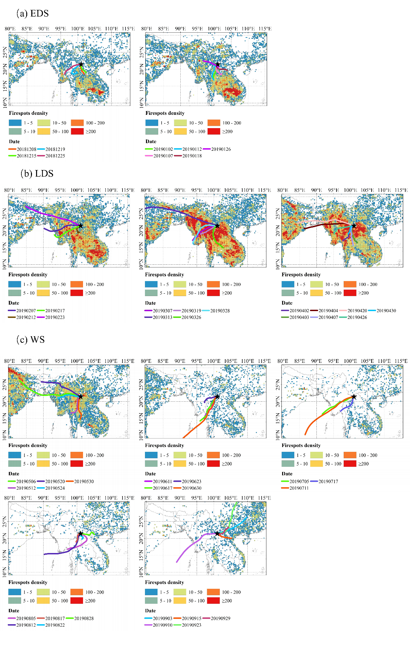

Figure S1 Backward air-mass trajectories and regional fire-spot distributions during the EDS, LDS, and WS periods. Reproduced from Dong et al. (2026)

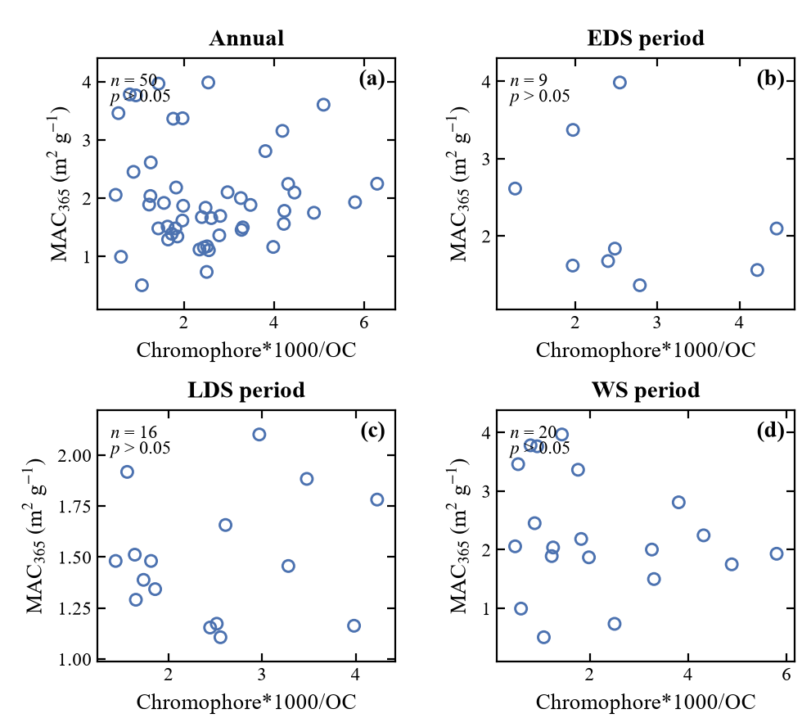
Figure S2 Relationships between MAC₃₆₅ and the total measured chromophore-to-OC mass ratio during the entire campaign and different atmospheric periods.

Dong, Z., Liu, Y., Guo, X., Yu, J., Shen, M., Qi, W., Zhang, Y., Li, L., Cao, Y., Jiang, Y., Wang, Q., Li, S., Dai, W., Li, J., 2026. Molecular characteristics of organic aerosols and impacts of transboundary biomass burning in Southwest China. J. Hazard. Mater. 509. https://doi.org/10.1016/j.jhazmat.2026.142035.
Li, J., Zhang, Q., Wang, G., Li, J., Wu, C., Liu, L., Wang, J., Jiang, W., Li, L., Ho, K.F., Cao, J., 2020. Optical properties and molecular compositions of water-soluble and water-insoluble brown carbon (BrC) aerosols in northwest China. Atmos. Chem. Phys. 20(8), 4889–4904. https://doi.org/10.5194/acp-20-4889-2020.
Yuan, W., Huang, R.J., Yang, L., Guo, J., Chen, Z., Duan, J., Wang, T., Ni, H., Han, Y., Li, Y., Chen, Q., Chen, Y., Hoffmann, T., O'Dowd, C., 2020. Characterization of the light-absorbing properties, chromophore composition and sources of brown carbon aerosol in Xi'an, northwestern China. Atmos. Chem. Phys. 20(8), 5129–5144. https://doi.org/10.5194/acp-20-5129-2020.

