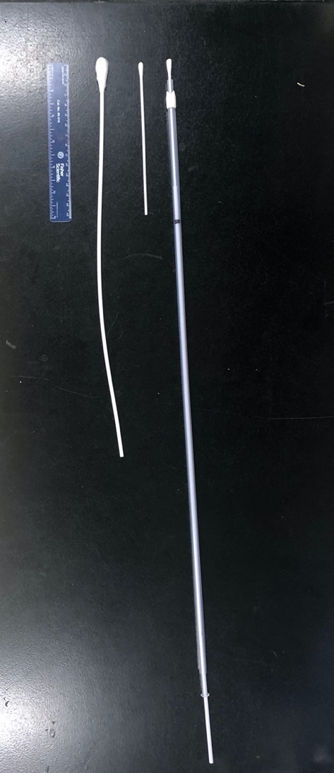
Figure S1. Photograph of swabs used for upper respiratory tract sampling. From top to bottom: double-guarded swab (DG), nasal swab (NS), and proctology swab (PS);15 cm ruler included for scale.

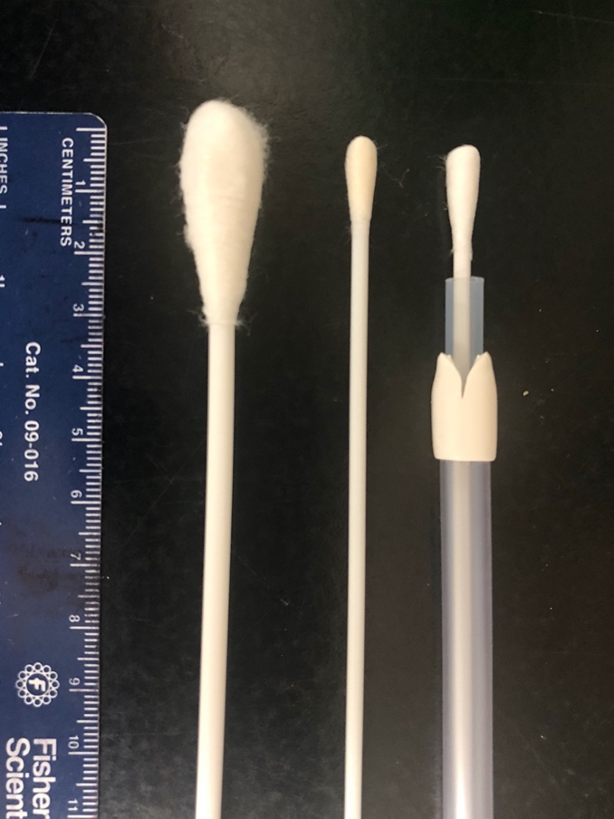

Figure S2. Photograph of swab tips used for upper respiratory tract sampling. From top to bottom: double-guarded swab (DG), nasal swab (NS), and proctology swab (PS); 15 cm ruler included for scale.
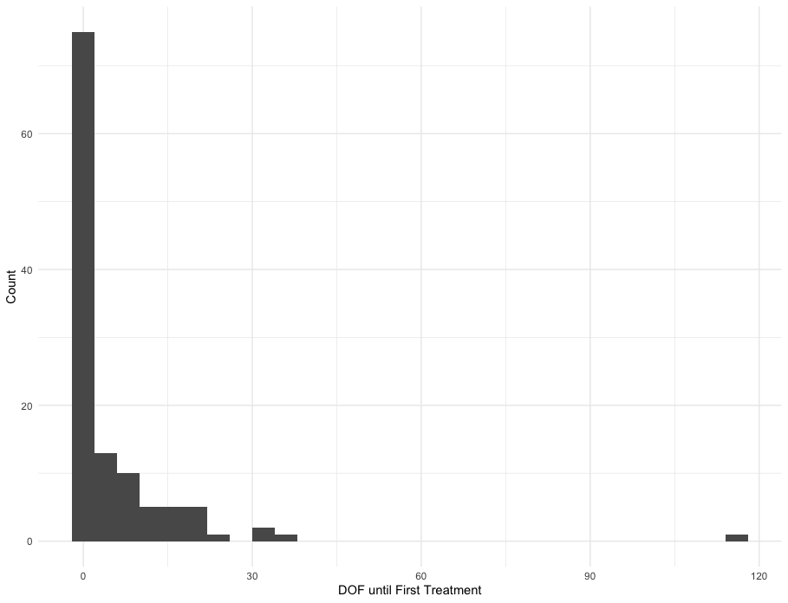
Figure S3. Histogram of days on feed at feedlot until first treatment for BRD for 120 cattle sampled at 14 DOF.
Figure S4. Histogram of days on feed at feedlot until first treatment for BRD for first group of 60 cattle sampled at 14 DOF.
Figure S5. Histogram of days on feed at feedlot until first treatment for BRD for second group of 60 cattle sampled at 14 DOF.

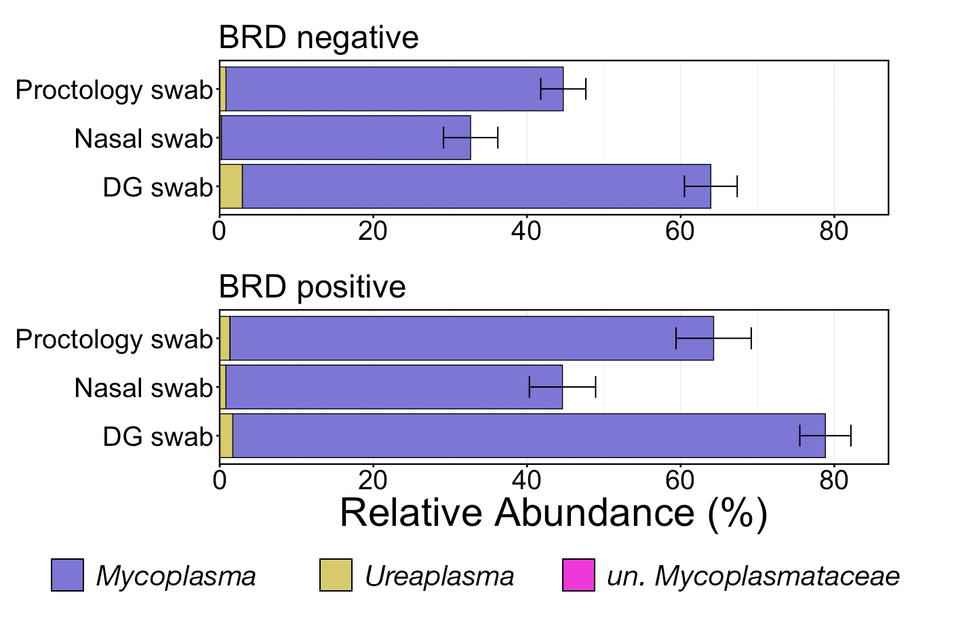
Figure S6. Bar plot demonstrating the relative abundances of the two detected Mycoplasmataceae genera and unclassified Mycoplasmataceae ASVs within BRD negative and BRD positive animals as collected with DG swabs, nasal swabs, or proctology swabs. Error bars demonstrate the standard error of the mean relative abundance of Mycoplasmataceae. All detected taxa within Mycoplasmataceae are displayed in the legend. Abbreviations: un., unclassified

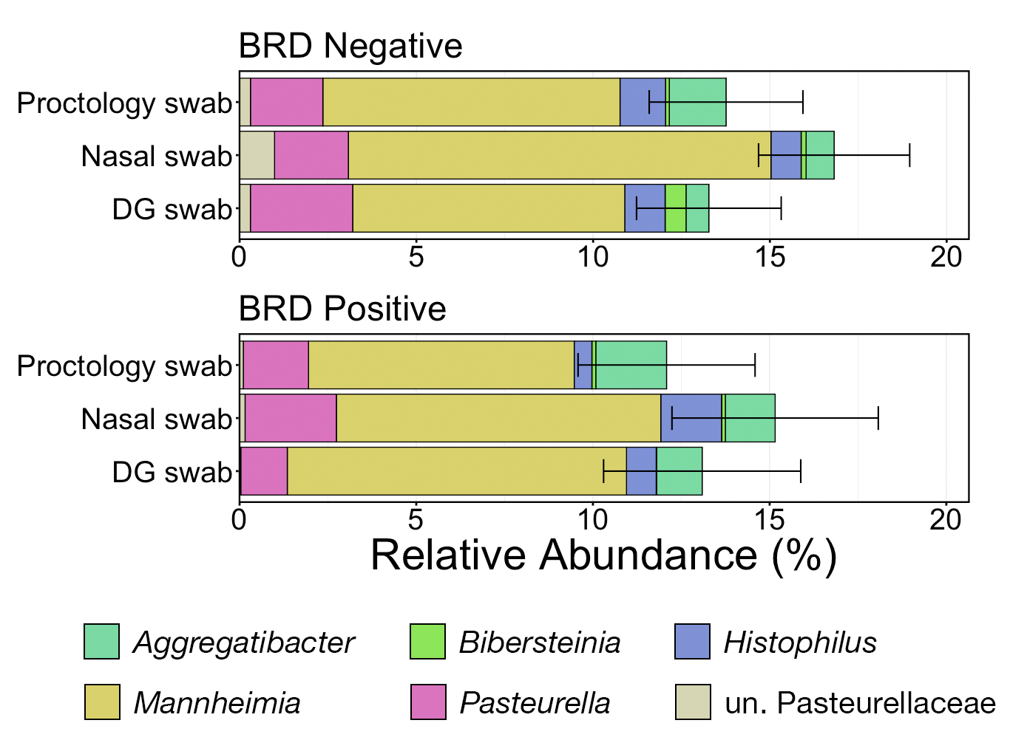
Figure S7. Bar plot demonstrating the relative abundances of the eight detected Pasteurellaceae genera and unclassified Pasteurellaceae ASVs within BRD negative and BRD positive animals as collected with DG swabs, nasal swabs, or proctology swabs. Error bars demonstrate the standard error of the mean relative abundance of Pasteurellaceae. The six most abundant genera across all samples are displayed in the legend. Abbreviations: un., unclassified

